

Planning

Delegated Officer Report

Summary of application details
Application reference: | PLA-2026-000641
Application type: | Consent to display an advertisement
Proposal: | Installation of 1no. internally illuminated projecting sign and 1no. internally illuminated individual letter fascia sign.
Site address: | 28 Market Street Manchester M4 3AT
Ward(s): | Piccadilly
Date application valid: | 10 June 2026
Applicant name: | Mr Majid Shah
Agent (if any): | Mr Ian Allerston
Case officer: | Ciara Gettinby
Recommendation: | Approve
Date of recommendation: | 30 July 2026

Description of site, building and/or area
This application relates to 28 Market Street which operates on the ground floor as a commercial unit. The property is attached to the Arndale, with the Arndale food court situated above the applicant site and surrounding units. The applicant site is bounded by Market Street and Cross Street and to the West is Grade II Listed building, Royal Exchange. The building and surrounding units are of a similar age and design consisting of fully glazed shop fronts, considered to be of a modern design.

The surrounding area is commercial in nature, undergoing redevelopment in 1996. This particular area of Market Street has been pedestrianised and has a high amount of footfall as it is one of the most visited areas for shopping and other commercial uses. Market Street offers strong sustainable transport links including Metrolink and bus stops.

Site Photos
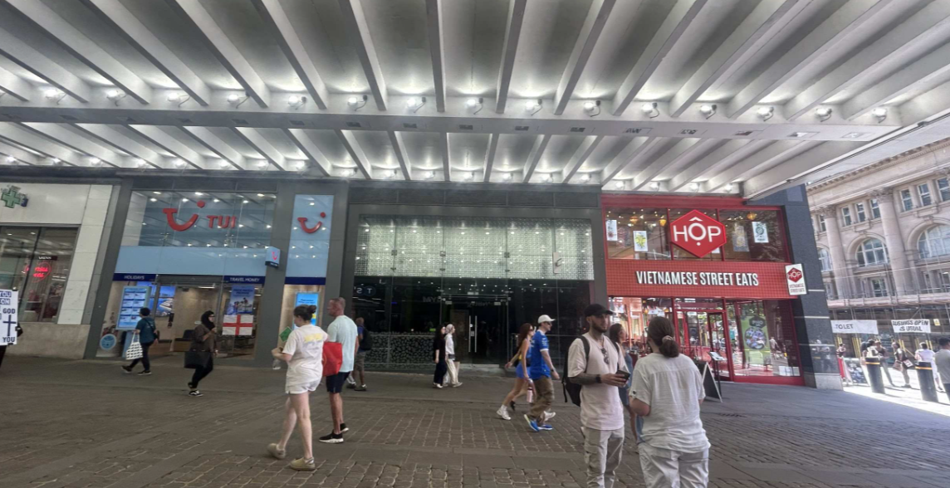

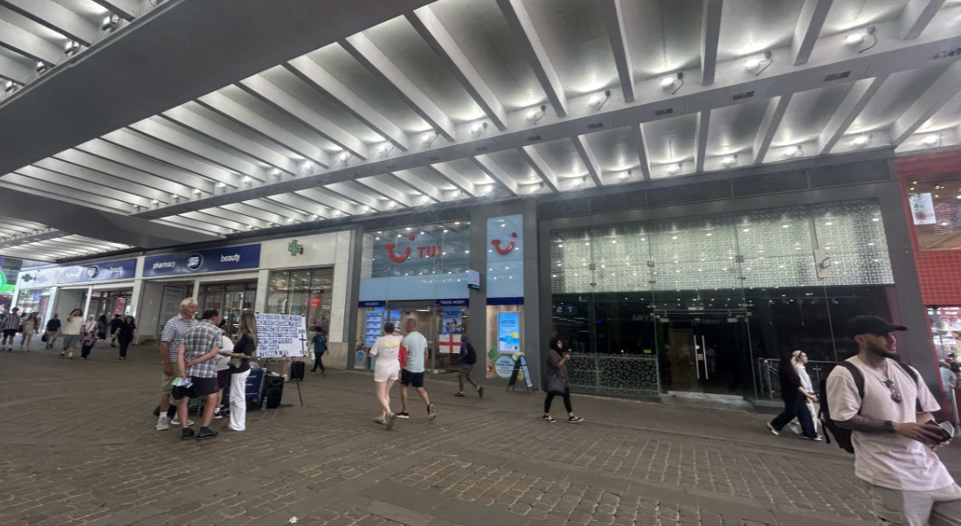

Description of development
Advertisement consent is sought for the installation of 1no. internally illuminated projecting sign and 1no. internally illuminated individual letter fascia sign.

Proposed Plans
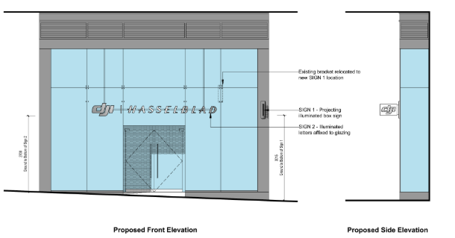

Consultation, notification and publicity responses

Consultations
Environmental Health- no objections but have recommended a condition to be attached to this report and decision notice.

MCC Highway Services- no objections.

Notifications and publicity
Publicity, notification letters was issued to surrounding properties, no comments or objections received.

Relevant policies

The Town and County Planning (Control of Advertisements) Regulations 2007
The Local Planning Authority shall exercise its powers under these Regulations in the interests of amenity and public safety, taking into account-

- The provisions of the development plan, so far they are material; and
- Any other relevant factors

2.

- Factors relevant to amenity include the general characteristics of the locality, including the presence of any feature of historic, architectural, cultural or similar interest;
- Factors relevant to the public safety include-

- The safety of persons using any highway, railway, waterway, etc..
- Whether the display of an advertisement in question is likely to obscure or hinder the ready interpretation of, any traffic sign, railway signal or aid
- Whether the display of an advertisement in question is likely to hinder the operation of any device used for the purpose of security or surveillance or for measuring the speed of any vehicle

3. In taking account of factors relevant to amenity, the local planning authority may, if it thinks fit, disregard any advertisement that is being displayed.

4. Unless it appears to the Local Planning Authority to be required in the interests of amenity or public safety, an express consent for the display of advertisements shall not contain any limitation or restriction relating to the subject matter, content or design of what is to be displayed.

The following policies are considered relevant in the consideration of this application:

Places for Everyone- A long term plan of nine Greater Manchester districts for jobs, new homes and sustainable growth, it has been published by the GMCA on behalf of the nine districts (Bolton, Bury, Rochdale, Oldham, Tameside, Stockport, Manchester, Trafford, Salford, Wigan) and took into effect and become part of the statutory development plan on March 21, 2024.

The Manchester Core Strategy- Development Plan Document 2012- 2027 (The Core Strategy) was adopted by the City Council on the 11th of July 2012, it is a key document for the local plan which provides a framework that planning applications are assessed against.

Policy DM1- Development Management
Policy SP1- Spatial Principles

Unitary Development Plan (UDP)- The UDP has been superseded by the Core Strategy Development Plan, but certain policies are still considered relevance:

-Policy 14 – Shopfronts and related signs

Other Material Considerations:

The Shopfront and Design Guide (Adopted 2024)

The National Planning Policy Framework (2024)- The Government’s own planning policies for England and how they are expected to be applied.

-Chapter 12- Achieving well-designed and beautiful places

The DRAFT National Planning Policy Framework (December 2025)- The Government’s new national planning policies and how they are to be implemented through local authorities. Whilst this is a draft NPPF for consultation it is considered that the development proposals are in accordance with the general thrust of policy contained within it.

Assessment
The advertisement regulations require that applications for shop signs be considered only in the interests of amenity and public safety. An assessment of the proposals under these criteria is outlined below.

Visual Amenity

Chapter 12 of the National Planning Policy Framework requires that when assessing design quality Local Planning Authorities will consider what ‘will function well and add to overall quality of the area’…’are visually attractive’ and ‘are sympathetic to local character and history, including the surrounding built environment and landscape setting.’

The proposed fascia sign would be composed of individual illuminated letters affixed to the shop front glazing. The use of individual letters is acceptable under the requirements of the Shopfront and Design Guide, and the overall scheme is considered to be in character with the surrounding advertising environment. The proposed is considered to be an improvement to the existing shopfront as the fascia sign would line up with the neighbouring fascia boards/ signs, creating a consistent and continuous fascia level across the neighbouring units.

Additionally, the projecting sign would also be considered an improvement to the existing visual amenity of the shopfront as the 30mm width would be in line with local guidance in the Shopfront and Design Guide. Additionally, the projecting sign would also be located off the glazing and in line with the fascia sign to be more consistent with the neighbouring units as set out in Policy DC14 of the UDP.

The materials to be used are considered to be acceptable given that the fascia sign would be made from steel and the projecting sign would be made from opaque acrylic and stainless steel, which is considered to be of standard materials for applications of this nature. Policy DM1 and the Shopfront and Design Guide require that proposed advertisements are commensurate in scale to their proposed locations, in which the proposed is considered to be.

A materials condition has been attached to ensure that materials are adhered to pursuant with the Manchester Core Strategy Development Plan Document Policies SP1 and DM1.

Public Safety
Signage would be installed so not to exceed illuminance level of 300cd/m2. As part of the assessment of this application, Environmental Health and MCC Highway Services were consulted and no objections were received. As such, there are no public safety concerns associated with this proposal, pursuant to Policy DC14 and DM1. As part of the assessment of this application, Environmental Health and MCC Highway Services were consulted and no objections were received.

Other Legislative Requirements

Equality Act 2010
Section 149 (Public Sector Equality Duty) of the Equality Act 2010 requires due regard to the need to: Eliminate unlawful discrimination, harassment and victimisation and other conduct prohibited by the Act and; Advance equality of opportunity between persons who share a protected characteristic and persons who do not share it. The Equality Duty does not impose a legal requirement to conduct an Equality Impact Assessment. Compliance with the Equality Duty involves consciously thinking about the aims of the Equality Duty as part of the process of decision-making.

Human Rights Act 1998 considerations
This application needs to be considered against the provisions of the Human Rights Act 1998. Under Article 6, the applicants (and those third parties, including local residents, who have made representations) have a right to a fair hearing and to this end the local planning authority must give full consideration to their comments.

Protocol 1 Article 1, and Article 8 where appropriate, confer(s) a right of respect for a person’s home, other land and business assets. In taking account of all material considerations, including Council policy as set out in the Core Strategy and saved polices of the Unitary Development Plan, the Director of Planning, Building Control & Licensing has concluded that some rights conferred by these articles on the applicant(s)/objector(s)/resident(s) and other occupiers and owners of nearby land that might be affected may be interfered with but that that interference is in accordance with the law and justified by being in the public interest and on the basis of the planning merits of the development proposal. She believes that any restriction on these rights posed by the recommendation given is proportionate to the wider benefits of and that such a decision falls within the margin of discretion afforded to the Council under the Town and Country Planning Acts.

Conclusion
Given the above issues, it is considered that the advertisements are acceptable in terms of its impact upon visual amenity and public safety in accordance with Policies SP1, DM1 of the Core Strategy, Policy DC15 of the UDP, Chapter 12 of the NPPF.

Recommendation: Approve

Conditions attached to this decision

- No advertisement is to be displayed without the permission of the owner of the site or any other person with an interest in the site entitled to grant permission.

No advertisement shall be sited or displayed so as to:
(a) endanger persons using any highway, railway, waterway, dock, harbour or aerodrome (civil or military);
(b) obscure, or hinder the ready interpretation of, any traffic sign, railway signal or aid to navigation by water or air; or
(c) hinder the operation of any device used for the purpose of security or surveillance or for measuring the speed of any vehicle.

Any advertisement displayed, and any site used for the display of advertisements, shall be maintained in a condition that does not impair the visual amenity of the site. Any structure or hoarding erected or used principally for the purpose of displaying advertisements shall be maintained in a condition that does not endanger the public. Where an advertisement is required under these Regulations to be removed, the site shall be left in a condition that does not endanger the public or impair visual amenity.

- The development hereby approved shall be carried out in accordance with the following documents:

Location Plan, ref- 1164 01

Received 10 June 2026

Proposed Signage- Projecting sign, ref- 1164 06

Received 27 July 2026

Proposed Signage General Arrangement, ref- 1164 05

Received 29 July 2026

Reason- to ensure that the development is carried out in accordance with the approved plans, pursuant to saved policy DC1 of the Unitary Development Plan for the City of Manchester and policies SP1 and DM1 of the Manchester Core Strategy.

