

Planning

Delegated Officer Report

Summary of application details
Application reference: | OTH-2026-000595
Application type: | Non-Material Amendment
Proposal: | Non-Material Amendment to planning permission 143898/JO/2025 to undertake elevational alterations.
Site address: | Lancaster, Dobson, Lincoln And Shackleton Courts Audax And Underhill Walks Avro Hollows Croydon Drive Manchester
Ward(s): | Miles Platting & Newton Heath
Date application valid: | 02 July 2026
Applicant name: | Housing Operations, Capital Programmes and Procurement
Agent (if any): | Colin Savage
Case officer: | Katie Raw
Recommendation: | Approve
Date of recommendation: | 29 July 2026

Description of site, building and/or area
The application site relates to Lancaster, Dobson, Lincoln And Shackleton Courts, Audax And
Underhill Walks, Avro Hollows within the north Manchester ward of Miles Platting & Newton
Heath. The application site relates to 4no. 1960s high rise blocks and 2no. low rise terraced
blocks (1,2 and 3 bedroom flats) along Croydon Drive. The high rise flats are 15 storeys in
height and are sited at the centre, north east, south east and south west of the site. The towers
are constructed of reinforced concrete with concrete infill panels and have previously received
an external wall insulation. The low rise blocks relate to Audax Walk (16 no. units) and Underhill
Walk (8no. units) which are sited to the north west of the site. The low rise blocks are
constructed with brick and pitched tiled roofs.

The immediate context is residential in nature, except for the south of the site which faces onto
the railway line in connection with Clayton Vale.

Description of development
The current application seeks Non-Material Amendment to planning permission 143898/JO/2025 to undertake elevational alterations. The amendment would relate to the high rise blocks only and the amendment would involve an addition of a 10 mm day joint within the render positioned at window head level at each floor level to all elevations. This amendment has been requested to improve the external finish and texture due to sequencing of the construction with regards to access and health and safety of operatives.

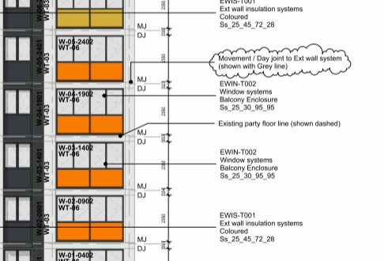
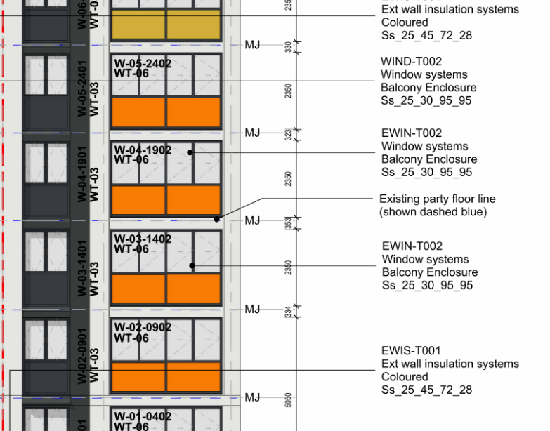

Example: Approved Elevation (left hand image) and proposed elevation with amendment shown by bubbled text and grey lines (right hand image) (South & West Lancaster Court)

The scheme of 143898/JO/2025 received approval for variation of Conditions 2 (Specified Plans) and 3 (Materials) attached to 138916/FO/2023 to allow alterations to design changes to materials, fenestration (including fans), louvres, balcony detailing and rooftop plant, approved 24 December 2025.

The host permission 138916/FO/2023 approved consent for the recladding of existing tower blocks and low rise flats, together with associated elevational alterations, approved 5 April 2024.

(Further) Relevant planning history
CDN/25/0907- Discharge of Conditions 4 (Construction Management Plan) and 5(a) (Acoustic
Insulation) attached to planning permission 138916/FO/2023.
Approved 5 December 2025.

097779/FO/2011/N1- Lancaster Court, Dobson Court, Shackleton Court And Lincoln Court-
Elevational alterations including wall insulation, window replacement and installation of PV
panels to southern elevations of existing multi storey flats.
Approved 2 February 2012.

Further planning history can be found prior to the current plan policy of 2012.

Consultation, notification and publicity responses

Consultations

N/A.

Notifications and publicity

N/A.

Relevant policies
The National Planning Policy Framework (NPPF) (December 2024)

The document sets out the Government's Planning Policies for England and how these are
expected to be applied. At the heart of the Framework is a presumption in favour of sustainable
development in terms, "For plan-making" and "For decision-taking", (paragraph 11).
Paragraph 8 - Achieving sustainable development means that the planning system has three
overarching objectives, which are interdependent and need to be pursued in mutually
supportive ways (so that opportunities can be taken to secure net gains across each of the
different objectives):
a) an economic objective
b) a social objective
c) an environmental objective

The following specific policies are considered to be particularly relevant to the proposed
development:
Chapter 8. Promoting healthy and safe communities
Chapter 12. Achieving well-designed places

Draft National Planning Policy Framework (16th December 2025)

The government has published a consultation National Planning Policy Framework which is intended to improve housebuilding rates through a clearer, more predictable and faster policy basis for decision and plan making.

Of relevance to the application proposals the draft NPPF makes it clear that local planning authorities should amongst other things:
-Work with the applicant in a positive and proactive manner, where necessary seeking solutions to problems arising from initial proposals, to enable a timely decision.
-Take account of planning matters raised during any pre-application engagement, including any positive responses to this engagement, as well as representations on the proposals.
-Decisions on development proposals should apply a presumption in favour of sustainable development and this means that for development within settlements should be approved unless the benefits of doing so would be substantially outweighed by any adverse effects, when assessed against the national decision-making policies in this Framework.

The Manchester Core Strategy Development Plan Document 2012-2027 ("the Core Strategy")
was adopted by the City Council on 11th July 2012. Updated March 2024 following the adoption
of Places for Everyone Joint Development Plan

The Core Strategy is the key document in Manchester's Local Development Framework. It
replaces significant elements of the Unitary Development Plan (UDP) as the document that sets
out the long term strategic planning policies for Manchester's future development. Of relevance
are:
Policy DM1 (Development Management);
Policy SP1 (Spatial Principles);
Policy EN1 (Design Principles and Strategic Character Areas);
Policy EN4 (Reducing CO2 Emissions by Enabling Low and Zero Carbon Development).

Unitary Development Plan Saved Policies (1995)

Large elements of the UDP have been superseded by the Core Strategy. The following saved
policies are of relevance in the consideration of this application:
DC1 Residential Extensions
DC1.1 In determining planning applications for extensions to residential properties, the Council
will have regard to:
a. the general character of the property;
b. the effect upon the amenity of neighbouring occupiers;
c. the desirability of enabling people to adapt their houses in appropriate ways to meet changing
household needs;
d. the overall appearance of the proposal in the street-scene;
e. the effect of the loss of any on-site carparking.

DC1.2 Extensions to residential properties will be allowed subject to compliance with other
relevant policies of the Plan and the following criteria:
a. they are not excessively large or bulky (for example, resulting in structures which are not
subservient to original houses or project out too far in front of the original buildings);
b. they do not create an undue loss of sunlight, daylight or privacy;
c. they are not out of character with the style of development in the area or the surrounding streetscene by virtue of design, use of materials or constructional details;
d. they would not result in the loss of off-street car-parking, in a situation where there is so severe an existing on-street parking problem that unacceptable additional pressures would be created.

DC1.3 Notwithstanding the generality of the above policies, the Council will not normally approve:
a. rearward extensions greater than 3.65m (12 ft) in length;
b. 2-storey extensions with a flat roof, particularly those which would be visible from the public
highway;
c. 2-storey extensions to terraced properties which occupy the full width of the house;
d. flat roofed extensions to bungalows;
e. extensions which conflict with the Council's guidelines on privacy distances (which are
published as supplementary guidance).

As a guide, and without prejudice to the generality of this policy, the Council will normally permit
2-storey house extensions which, when built, would leave a minimum of 1.52m (5 ft) between the side wall and the common boundary, and which meet the other requirements of this policy.
Proposals which cannot meet these requirements will be judged on their merits, but with weight
being given to (a) and (c) above.

DC1.6 For the avoidance of doubt, policies DC1.1 to DC1.4 apply to domestic houses, flats,
houses in multiple occupation, nursing homes, rest homes and hotels.

DC26. Noise and Development
DC26.1 states the Council intends to use the development control process to reduce the impact
of noise on people living and working in, or visiting, the City. In giving effect to this intention, the
Council will consider both:
a. the effect of new development proposals which are likely to be generators of noise; and
b. the implications of new development being exposed to existing noise sources which are
effectively outside planning control.

DC26.2 states new noise sensitive developments (including large scale changes of use of
existing land or buildings) such as housing, schools, hospitals, or similar activities, will be
permitted subject to their not being in locations which would expose them to high noise levels
from existing uses or operations, unless the effects of the noise can realistically be reduced. In
giving effect to this policy, the council will take account both of noise exposure at the time of
receiving a planning application and of any increase that may reasonably be expected in the
foreseeable future.

DC26.4 states where the council believes that an existing noise source might result in an
adverse impact upon a proposed new development, or where a new proposal might generate
potentially unacceptable levels of noise, it will in either case require the applicant to provide an
assessment of the likely impact and of the measures he proposes to deal satisfactorily with it.
Such measures might include the following
a) engineering solutions, including reduction of noise at source, improving sound insulation of
sensitive buildings or screening by purpose-built barriers
b) layout solutions, including consideration of the distance between the source of the noise and
the buildings or land affected by it and screening by natural barriers or other buildings or
noncritical rooms within a building; and
c) administrative steps, including limiting the operating times of the noise source, restricting
activities allowed on the site or specifying an acceptable noise limit.
Any or all these factors will be considered appropriate for inclusion in conditions on any
planning permission

DC26.5 states the council will control noise levels by requiring, where necessary, high levels of
noise insulation in new development as well as noise barriers where this is appropriate.

Guide to Development in Manchester Supplementary Planning Document and Planning
Guidance, Adopted April 2007

The Guide aims to help to develop and enhance a unique and positive sense of place within
Manchester and its neighbourhoods. The guidance is grouped under seven key principles
recognised by CABE as being those urban design characteristics which create successful
places. These are: character and context, continuity and enclosure, ease of movement, quality
of the public realm, diversity, legibility, and adaptability. It advises that high quality design is a
vital attribute of successful neighbourhoods.

Of relevance are paragraphs 2.3, 2.7, 2.14 and 2.16.

Places for Everyone

Places for Everyone is a long-term plan of nine Greater Manchester districts for jobs, new
homes, and sustainable growth. It has been published by the GMCA on behalf of the nine
districts and took effect and became part of the statutory development plan on March 21, 2024.
The Plan and its policies are now a material planning consideration in the determination of
planning applications. The Plan and its policies must therefore be given full weight in the
planning balance.

The policy is of relevance:
JP- S1- Sustainable development.

Assessment

Principle of Amendment

Through the current application, consent is sought for Non-Material Amendment to planning permission 143898/JO/2025 to undertake elevational alterations. The amendment would relate to the high rise blocks only and the amendment would involve an addition of a 10 mm day joint within the render positioned at window head level at each floor level to all elevations. This amendment has been requested to improve the external finish and texture due to sequencing of the construction with regards to access and health and safety of operatives, and due to the need for scaffolding and resultant appearance as a result of removing the scaffolding. The changes would have a marginal impact on the overall design and appearance of the site and would be considered non-material changes. In addition, it would not alter the character or appearance of the building or site, nor would it significantly affect the relationship of the development to its context.

Residential Amenity

The proposed 10 mm day joint within the render positioned at window head level at each floor level to all elevations due to its nature would not give rise to any adverse residential amenity implications in respect of overlooking, loss of light or creating an overbearing feature, as it would not be visible from the resident’s apartments.

Overall, the amendments would not have an adverse impact upon residential amenity and so be pursuant to Policy DC1 of the UDP and Core Strategy policies SP1 and DM1.

Visual Amenity

The proposed 10 mm day joint within the render positioned at window head level at each floor level to all elevations would result in a small intrusion at all elevations. Whilst the day joints may be more visible at the lower levels when stood close to the flat blocks, due to the 15 storeys of the buildings and the small intrusions, it would be difficult to see the amendments from far away.

As such, the amendment would not result in an overly visible structure and so is not considered to give rise to harm in relation to visual amenity.

Overall, the amendments would not have an adverse impact upon visual amenity and so be pursuant to Policy DC1 of the UDP and Core Strategy policies SP1 and DM1.

Design, Scale and Appearance

The 10 mm day joint within the render positioned at window head level at each floor level to all elevations has been requested to improve the external finish and texture due to sequencing of the construction with regards to access and health and safety of operatives, and due to the need for scaffolding and resultant appearance as a result of removing the scaffolding.

The amendment would add a small addition to the elevations but given the width is not considered to give rise to an overly large or intrusive feature and would not detract from the works proposed for the high rise blocks.

The revised arrangement is considered acceptable in respect of size and form and would constitute small addition to the elevations.

As such, the proposal would be considered pursuant to Policy DC1 of the UDP and Core Strategy policies SP1 and EN1, in respect of design.

Conclusion- Non-Material Change

Following an assessment of the details submitted, it can be confirmed that the proposed amendment is considered to be of a non-material nature and is considered to be acceptable to the City Council as the Local Planning Authority. The City Council is satisfied that the proposed
change would have no material impact upon the character of the development or in terms of visual/residential amenity.

Other Legislative Requirements

Equality Act 2010
Section 149 (Public Sector Equality Duty) of the Equality Act 2010 requires due regard to the need to: Eliminate unlawful discrimination, harassment and victimisation and other conduct prohibited by the Act and; Advance equality of opportunity between persons who share a protected characteristic and persons who do not share it. The Equality Duty does not impose a legal requirement to conduct an Equality Impact Assessment. Compliance with the Equality Duty involves consciously thinking about the aims of the Equality Duty as part of the process of decision-making.

Human Rights Act 1998 considerations
This application needs to be considered against the provisions of the Human Rights Act 1998. Under Article 6, the applicants (and those third parties, including local residents, who have made representations) have a right to a fair hearing and to this end the local planning authority must give full consideration to their comments.

Protocol 1 Article 1, and Article 8 where appropriate, confer(s) a right of respect for a person’s home, other land and business assets. In taking account of all material considerations, including Council policy as set out in the Core Strategy and saved polices of the Unitary Development Plan, the Director of Planning, Building Control & Licensing has concluded that some rights conferred by these articles on the applicant(s)/objector(s)/resident(s) and other occupiers and owners of nearby land that might be affected may be interfered with but that that interference is in accordance with the law and justified by being in the public interest and on the basis of the planning merits of the development proposal. She believes that any restriction on these rights posed by the recommendation given is proportionate to the wider benefits of and that such a decision falls within the margin of discretion afforded to the Council under the Town and Country Planning Acts.

Article 35 Declaration
N/A.

Recommendation: Approve

