Planning

Growth & Development

Delegated officer report for planning application

Application no. 138831/FO/2023
Date registered valid: 18 December 2023
Proposal: Erection of a ground plus 28-storey building plus plant level, comprising purpose-built student accommodation (PBSA -Sui Generis) and other associated works including public realm, secure cycle parking and servicing arrangements.
Address: Plot 11 Block C, First Street South , Manchester, M15 6JE
Ward(s): Deansgate Ward
Hulme Ward
Applicant: Downing Living (Manchester South) Ltd Partnership Inc
Agent (if any): Mr Cameron Radford Deloitte LLP
Case officer: Angela Leckie
Tel: 0161 234 4651
Email: angela.leckie@manchester.gov.uk
Recommendation: Minded to approve
Date of recommendation: 25-04-24

Application details

Type of application: Full Application Consent

Development type: Major Other

Date of site visit:

Standard consultations:
Printed: 25 January 2024 Expired: 24 February 2024

Neighbour notifications
Printed: 25 January 2024 Expired: 24 February 2024

Site notice
Posted: 20 December 2023 Expired: 19 January 2024

Press advert
Published: 30 January 2024 Expired: 29 February 2024Published: 2 January 2024 Expired: 8 February 2024

Departure from Development Plan: No

Environmental Statement: RECV

Description of site/building

This 0.23 ha site is bounded by land on which a co-living scheme of up to 45 storeys (125573/FO/2019), is being developed at Newcastle Street, Mancunian Way, and Medlock Street. Three buildings are being built and this application relates to an area known as Plot C where a fourth building of 10 to 17 was previously approved. The principle of a taller building on this site has therefore been established.

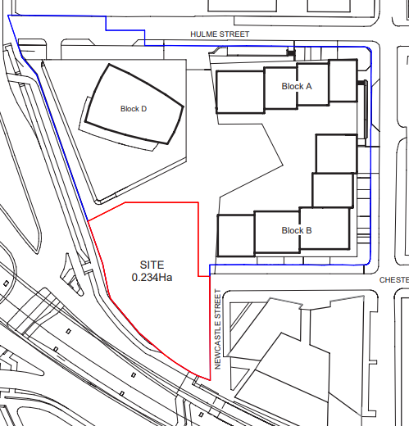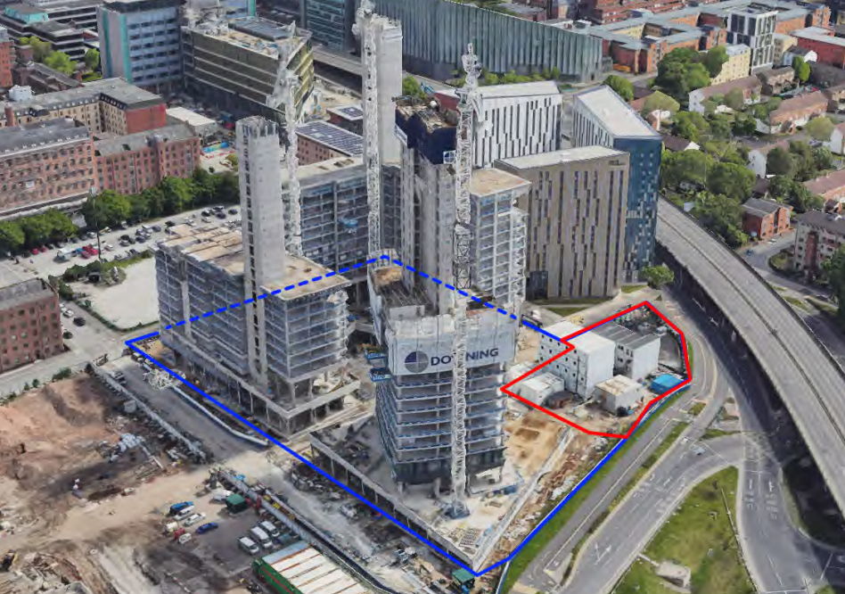

Application Site Site with Blocks A, B and D under construction

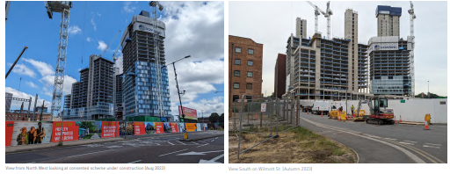
Views of under construction Blocks A, B and D

This area is partially used as a temporary site compound but is otherwise vacant and comprises hardstanding with minimal vegetation. Vehicular access is from Newcastle Street. To the south are trees and vegetation with 3 mature/ semi mature trees and 4 groups of smaller trees.

The site is in the First St SRF which has been a regeneration priority for over 20 years. It has been transformed by developments including Home, Grade A, offices at No.1 and No.8 First Street, the Innside Hotel, Serviced Accommodation, a MSCP and high quality public realm.

Immediately to the north, a nine storey office building (132600) and a 14 storey PBSA development, with a ground floor food-hall (136170) are under construction. The adjacent Plot 10a has consent for an office development (136043).

Construction is well underway on the Co-living scheme which will deliver 1,894 bedspaces, communal areas, active uses and extensive public realm.

First Street has a crucial role to play in continuing the growth and expansion of the City Centre and is expected to support 10,000 jobs.

The Mancunian Way is to the south and PBSA of 8 to 18 storeys is to the east. Beyond this are low rise homes in Hulme. The nearest residential properties in Hulme are at Loxford Court, approximately 60m to the south. There is a pedestrian route from Hulme at the junction of Clarendon Street and Newcastle Street, under the Mancunian Way, to Plot 11.

On the opposite side of Medlock Street, consent has been granted at One Medlock Street (Premier Inn) for a 38 storey PBSA scheme (1,014 bedspaces) and a 13-storey office building. (135419). Beyond this is Canvas PBSA which has 807 beds and Great Jackson Street, where large scale residential schemes are progressing.

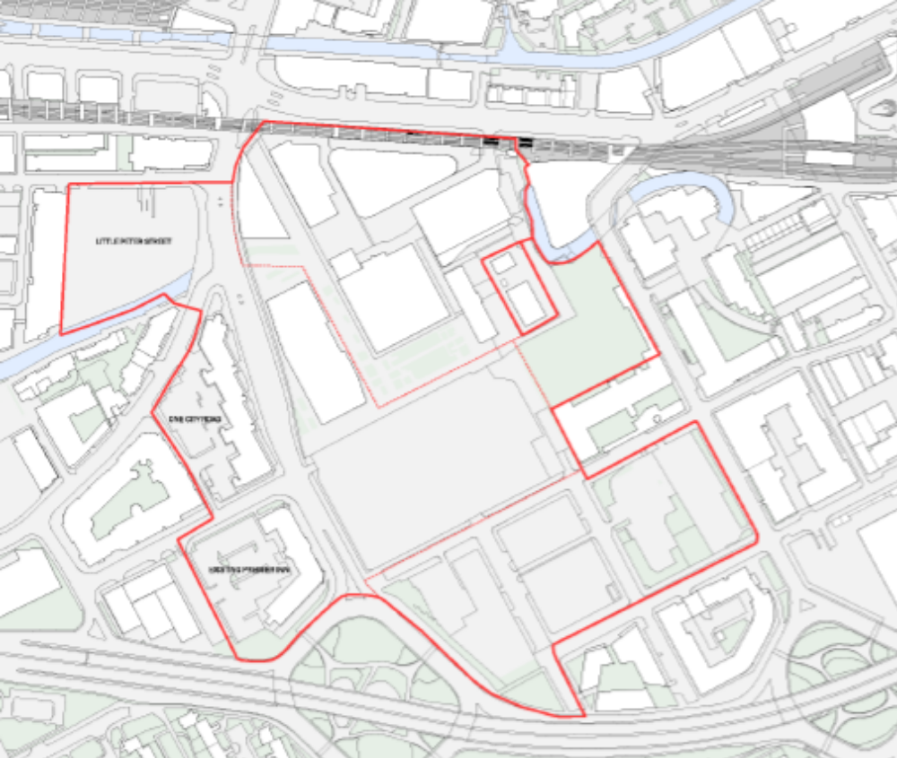

First Street SRF Area 2020

The site is close to Oxford Road and Deansgate Station’s and the Deansgate/ Castlefield Tram stop. There are high-frequency bus routes on Cambridge Street, Medlock Street, Oxford Road and Whitworth Street West. The free Metroshuttle service stops on Medlock Street.
Circle Square, The Civic Quarter, Knott Mill /Whitworth Street West, Great Jackson Street, and Hulme are nearby. There has been significant residential growth in the southern part of the City Centre but despite significant investment, further development is required at First Street.

There are several listed buildings nearby including Mackintosh Mill and Cambridge Mill which are Grade II listed. The site is not in a conservation area but the Castlefield and Whitworth Street Conservation Areas are 500m and 550m away. The site is in Flood Risk Zone 1 (low risk) and in a critical drainage area.

Significant improvements to traffic and pedestrian flows around the Medlock Street roundabout have removed the underpasses to Hulme. All new crossings are at grade with dedicated cycle lanes linking into the wider network. A new crossing was added at Newcastle Street to provide a better connection from First Street to Hulme.

Description of Development

Construction has commenced on the majority of the 2021 consent, but no work has been carried out at this site. A 322 bed Part-10, part-13 and part-17 storeys Co-living building was proposed at this site.

This proposal is for a 29 storey PBSA block including a podium, which would provide 555 bedspaces split between clusters (43.4%) and Studios (56.6%).

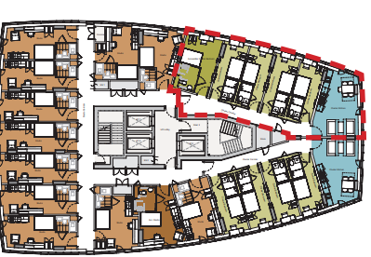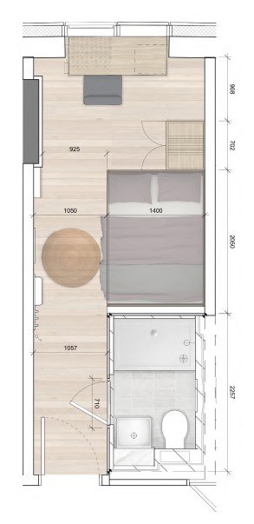

Typical Tower Plan with 5 bed cluster highlighted Typical Cluster Bedroom Layout
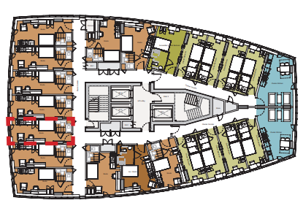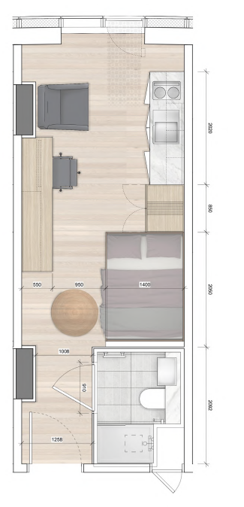

Typical Tower Plan with typical studio highlighted Typical Studio Layout

The cluster bedrooms would typically be 14m2, in groups of 4 and 5 beds with a shared kitchen and living space. The rooms include: double bed, shower pod, wardrobe and study desk. Shared kitchen spaces would have a full kitchen, sofas, a TV and a dining table. The Studio bedrooms would be typically 21m2 and include: double bed, shower pod, wardrobe, large study desk, kitchenette, chair and TV.

27 (5%) of rooms are capable of being fully accessible. Those units would be split equally between clusters and studios. 11 (2%) of studios for those with accessibility needs would fitted out from the outset. The remainder will be M4 (2) adaptable to be tailored to specific needs when requested.

20% (111 bed spaces) of units within the clusters would be provided as affordable units. There is an aspiration that these are provided under a nomination agreement with Manchester Metropolitan University (‘MMU’).

The main entrance foyer would include seating, residents lounge, cinema room, gym / wellness centre and a laundry room. There would also be a management suite, accessed only by staff, and other back of house areas.

On the 1st floor would be a cycle hub, a further residents lounge, with access to the external terrace suitable for seating as well as holding small classes for residents (yoga etc.), a kitchen and space for private dining and kitchen and study spaces split into smaller rooms with pods / desks etc.

There would be an onsite staff presence 24 hours a day. A Management, Wellbeing and Tenure Plan sets out: arrangements for staffing including on-site staff and their areas of responsibility; tenancy management, agreements and handbook / resident information; management of post and deliveries; wellbeing and pastoral care; security and complaints procedure; health and Safety

A member of the management team would be in residence each weekday as a minimum between 8am and 6pm. Outside of these hours the reception would be staffed via security personnel and there will be a contact number and escalation procedure available to get in touch with a member of the management team.

The management team would ensure that an inclusive communal atmosphere is maintained by arranging, hosting and monitoring events such as cooking classes, gym classes, film and ‘event TV’ nights, motivational talks, quizzes etc. The management team would be the first point of contact as well as preventing any anti-social behaviour and managing deliveries and collections including collection and emptying of bins. A holding area for hot food deliveries would enable delivery riders/drivers to drop off or wait in a dedicated internal area, removing the need for an external waiting area and reducing congestion in the public realm. All deliveries and collections would adhere to the local loading restrictions in place and couriers and residents will be informed of the specific loading bay locations on Chester Street and Botanic Way.

The landscaping would include 38 trees and a mature tree would be retained. An area of green open space would be retained and enhanced at the southern end of Newcastle Street. Enhanced connectivity would be provided with a stronger connection through to Hulme via Newcastle Street.

2 parking spaces are proposed for disabled students on Chester Street. There would be 86 secure cycle parking spaces, with bikes for hire, and 12 for visitors in the public realm. 30 spaces would be provided for personal bikes. Access for servicing, deliveries and waste collection will be from a dedicated lay-by on Newcastle St.

Residents would put waste in sacks in the cluster kitchens and then in the ground floor refuse store. The building management team take rubbish to the collection point on the collection days. Refuse collection would be by a private company and this arrangement would be secured in the S106 agreement.

The façades would be a mix of light and dark unitised glass curtain walling. Natural ventilation would be provided through anodized metal panels. The podium would be clad in a green glazed brick.

The maximum height would be 85.7m above ground level. The development is expected to achieve a Breeam Very Good rating.

In support of the application the applicants have stated the following:

- The Site has an extant permission, as part of Plot 11, where of co-living buildings are consented. This scheme would maintain the fundamental design principles and a cohesive design approach but provides a more appropriate and demanded use (PBSA) in a more elegant massing.

- The 555 student bedspaces in The Corridor, close to the City’s university campuses; the Council’s preferred location for PBSA would address demand and reduce pressure on mainstream housing. 111 beds would be affordable there is an aspiration that these would be secured for MMU students through a nomination agreement helping to meet an identified shortfall.

- The proposal would create 273 FTE jobs per annum during construction and 41 FTE’s jobs once operational. During the construction phase, c.£32m GVA will be added to the economy and £3.6m during the operational phase.

- The proposal would be highly sustainable. The soft landscaping includes tree planting and would help a 71% BNG and improve air quality.

- The animation of the area would create a more welcoming pedestrian environment. The active frontages and increased activity proposal would create 24hr natural surveillance and discourage anti-social behaviour.

- Compared with the previously approved Block C there would be:

- Improved public realm –The revised Block C footprint allows for a significant increase to the size (uplift of 220 sq. m.)

- Enhanced connectivity – Through the revised layout, a stronger connection through to Hulme via Newcastle Street is established. The enhanced public park will provide a key entry marker to the City Centre.

- An increase in the size of public park by 220 sq.m approx

- A new path / connection added through the park would link Newcastle St and Medlock St.

- The creation of a private external terrace would result in greater passive surveillance

- There would be an increase of active frontage 56%

This planning application has been supported by the following information:

Application forms and certificates and plans; Design and Access Statement; Landscaping Strategy; Planning and Tall Buildings Statement; Statement of Community Consultation; Heritage Statement; Energy Statement and Environmental Standards Statement; Circular Economy Statement; BREEAM Assessment ;Ventilation Strategy; Ecological Survey; Arboricultural Impact Assessment; Phase 1 and 2 Geo-environmental Assessment; Flood Risk / Drainage Strategy; Transport Statement and Interim Travel Plan; Fire Statement, Crime Impact Statement; TV Reception Survey; Broadband Connectivity Assessment; Student Management and Well Being Plan; Design and Access Statement; Local Labour Agreement; and Environmental Statement including Chapters on Air Quality, Climate Change, Human Health, Noise and Vibration, Socio-Economic Impact, Daylight, Sunlight and Overshadowing, Townscape and Visual Impact, Wind Microclimate and Ground Conditions.

Consultations

Publicity – The occupiers of adjacent premises have been notified and the proposals have been advertised in the local press as a major development, accompanied by an Environmental Assessment, affecting the setting of a listed building, as affecting the setting of a conservation area and as affecting a public right of way. Site notices have also been placed adjacent to the site.

2 objections have been received. These are summarised below

Impacts on Amenity
- The development would add to existing excessive noise from students.
- There would be direct overlooking into adjacent homes.

Highways and Traffic Management Issues
- The use would mean sever peaks of vehicular demand at the beginning and end of the academic year. There is no evidence the necessary mitigations needed to facilitate the arrival of 555 students in a limited time frame. This is evidenced at Cambridge Hall and Oxford Court which are 4/5 storeys high, house fewer students, but cause major issues.
- Increasing the number of beds from 332 to 555 (70%) and a change in demographic would place an untenable burden on Cambridge Street leading to a cul-de-sac in Newcastle Street. This will lead to increased conflicts between pedestrian, cyclist and vehicle users. Service vehicles will be unable to access the site. This would denigrate the public realm.
- Construction vehicles will access the site along Cambridge Street and construction will take approximately 2.5 years to complete. While the plans detail how construction vehicles and workers will enter and exit the site, they do not detail the provisions for the public to safely negotiate around the site? We already see the broken pavements and dangerous trip hazards along Cambridge Street caused by construction vehicles damaging the walkway. Also, with a temporary exit from the site onto Medlock Street how do the developers plan to manage both cyclist and pedestrian safety with construction traffic crossing their path?

Refuse Management
- Waste Management document 138831_FO_2023-STUDENT MANAGEMENT WELLBEING PLAN states Within the refuse and recycling store, the bins will be rotated regularly for effective bin chute usage. The residents will be responsible for the deposit of all refuse and recycling into refuse chutes, accessible at each floor level. The chute provides for waster segregation at source. However, the floor plans provided do not show any refuse chutes? Looks like a poorly consider waste management system.
- The increased number of beds and changed use increases the number and frequency of refuse collection. The wheeling out of 17 large bins 3 times a week will increase the amount of litter in the local environment and again denigrate the public realm.

Lift Provision
- The proposal shows only 3 lifts, is this sufficient to meet the 555 occupants and other building function needs? Having reviewed most of the documentation I can find no reference to any analysis having been carried in order to establish that 3 lifts would be sufficient. An American web site suggests that: there should be one elevator for every 90 units. A maximum of 150 feet from the elevators to the farthest elevator is a must. City apartments and really high priced units can require an elevator for every 50 – 60 units. If this was applied then around 6 lifts would be required. 3 lifts would be detrimental to the inhabitants lived experience.
General
- Why build more student accommodation instead there should be more facilities for local residents who live here for years, 365 days a year, maybe build a supermarket, shopping area in its place so we don't rely on 1 store Asda that's already struggling under student pressure and availability.
- The revised plan for block C means the loss of 332 council tax liable beds to be replaced with 555 student beds (not liable to council tax). This means a loss to Manchester City council of £270,000 p.a. (£2.73m over 10 years) in council tax revenue. The increased bed capacity from 332 beds to 555 (a 67% increase) will place additional demands on the council to provide services at an additional cost.

A 2nd round of notification resulted in 1 further objection the grounds of which are summarised below:

Sunlight and Daylight

28 storeys is too high, too wide and would adversely affect the light we have enjoyed for the last 24 unbroken years at City South.
Air Quality Impacts
The development would bring a vast increase in air pollution,
Impact on Residential Amenity
Having 28 storeys of students might take the noise away from Didsbury and south Manchester but it would bring it to River Street instead. It is a good strategic decision to bring students together out of family homes in south Manchester - 10 storeys of them might be manageable but not 28 storeys. Particularly as the developer contributes to the conservative party and have a track record of ignoring existing residents.
Highways and Transport Impacts
There will be an increase in car traffic, lorry traffic, refuse wafting down our already filthy uncleared streets.
General
The development would create a strain on facilities, urban infrastructure such as drains and refuse.

Historic England – No comments.

Highways Services- No objections subject to conditions relating to cycling off-site highways works, student Move In / Move Out strategy , servicing and waste management , travel plan and construction management.

Environmental Health – (Street Management and Enforcement) - Recommends conditions relating to the acoustic insulation and any associated plant and equipment, fume extraction, the storage and disposal of refuse, the hours during which deliveries can take place, air quality and the management of construction.

Greater Manchester Police (Design for Security) – No objection so long as the recommendations of the Crime Impact Statement are implemented.

Greater Manchester Ecology Group – No comments.

Flood Risk Management Team – recommend that Green Sustainable Urban Drainage Systems are maximised, and conditions should ensure surface water drainage works are implemented in accordance with Suds National Standards and to verify these objectives.

Environment Agency –Have no objection but recommend conditions relating ground contamination, and piling.

HSE (Gateway One) – Are satisfied with the fire safety design to the extent that it affects land use planning.

United Utilities – Have objected on the basis that more information is required but have recommended a condition if the LPA are minded to approve.

Work and Skills – Recommend a local labour condition for the construction and end use phases which requires a report of local labour achievements.

Greater Manchester Archaeological Unit – Note that an archaeological excavation was undertaken at the site by Pre-Construct Archaeology (PCA) and an assessment report of the results (dated June 2017) was submitted as part of an application (CDN/18/0326) to discharge Condition 25 of application 111170/FO/2016/C1. Consequently, there are no significant archaeological remains that would be impacted upon by development of Block C. However they have raised concerns that the wider archaeological investigations within First Street which include this site have not been adequately disseminated.

Active Travel England – Have made comments in relation to the inadequacy of the level of on site parking provision and the need to upgrade local highway connectivity for active travel to be promoted through a travel plan.

Natural England – No objection

Canal and Rivers Trust – No comments.

Cadent Gas – No objection

University of Manchester – No comments

Manchester Metropolitan University - No comments

Manchester Airport Safeguarding Office – No objections

National Air Traffic Safety (NATS) – No objections

Neighbourhood Services (Arboriculture)- No objections

Issues

The Development Plan

The Development Plan consists of: The Manchester Core Strategy (2012); and Saved policies of the Unitary Development Plan for the City of Manchester (1995). The Core Strategy is the key document and sets out the long-term strategic planning policies for Manchester's future development.

A number of UDP policies have been saved. Planning applications in Manchester must be decided in accordance with the Core Strategy and saved UDP policies as directed by section 38 (6) of the Planning and Compulsory Purchase Act 2004 unless material considerations indicate otherwise.

Manchester Core Strategy Development Plan Document (July 2012): The relevant policies within the Core Strategy are as follows:

Strategic Spatial Objectives

The Core Strategy contains a number of Strategic Spatial Objectives that form the basis of the policies as follows:

SO1. Spatial Principles development in this highly accessible location would reduce the need to travel by private car and support the sustainable development of the City and help to mitigate climate change.

SO2. Economy The scheme would provide jobs during construction and in operation in a highly accessible location. The employment would support the City’s economic performance, reduce economic, environmental and social disparities, and help to create inclusive sustainable communities.

S03 Housing – The scheme would provide student accommodation in a highly accessible and sustainable location, close to the Universities.

S05. Transport The proposal would be highly accessible, reduce the need to travel by private car and use public transport effectively.

S06. Environment The proposal would protect and enhance the natural and built environment and ensure the sustainable use of natural resources to: mitigate and adapt to climate change; support biodiversity and wildlife; improve air, water and land quality; and, ensure that the City is inclusive and attractive to residents, workers, investors and visitors.

Policy SP 1 (Spatial Principles) - The proposal would have a positive impact on visual amenity and the character of the area. The building would be high quality and complement existing and recent developments.

Policy CC3 Housing – Around 3500 homes are expected to be built each year in Manchester. The proposal would contribute to the overall Core Strategy housing targets for the City Centre by providing PBSA that could free up other housing.

Policy CC5 (Transport) - The proposal would be accessible by a variety of modes of sustainable transport and would help to improve air quality.

Policy CC6 (City Centre High Density Development) – This would be a high density development and use the site efficiently.

Policy CC7 (Mixed Use Development) – The ground floor amenity space would add to activity.

Policy CC8 (Change and Renewal) – Jobs would be created during construction and in the building management.

Policy CC9 (Design and Heritage) - The design would be high quality. Its impact on the settings of nearby listed buildings and conservation areas is discussed in more detail in the report.

Policy CC10 (A Place for Everyone) – The proposals would complement the regeneration of First Street, broaden the range of housing in the City Centre and would be accessible.

Policy H1 Overall Housing Provision - The development would provide PBSA, help to create a mixed use community and contribute to the ambition of building 90% of new housing on brownfield sites.

Policy H12 Purpose Built Student Accommodation - the provision of PBSA is supported where it would satisfies the criteria below. Priority will be given to schemes which are part of the universities' redevelopment plans or which are being progressed in partnership with the universities, and which clearly meet Manchester City Council's regeneration priorities.

1. Sites should be in close proximity to the University campuses or to a high frequency public transport route which passes this area.

2. The Regional Centre, including the Oxford Road Corridor, is a strategic area for low and zero carbon decentralised energy infrastructure. Proposals that fall within this area will be expected to take place in the context of the energy proposals plans required by Policy EN 5.

3. High density developments should be sited in locations compatible with existing developments and initiatives, and where retail facilities are within walking distance. Proposals should not lead to an increase in on-street parking in the surrounding area.

4. Proposals that can demonstrate a positive regeneration impact in their own right will be given preference over other schemes. This can be demonstrated for example through impact assessments on district centres and the wider area. Proposals should contribute to providing a mix of uses and support district and local centres, in line with relevant Strategic Regeneration Frameworks, local plans and other masterplans as student accommodation should closely integrate with existing neighbourhoods to contribute in a positive way to their vibrancy without increasing pressure on existing neighbourhood services to the detriment of existing residents.

5. Proposals should be designed to be safe and secure for their users and avoid causing an increase in crime in the surrounding area. Consideration needs to be given to how proposals could assist in improving the safety of the surrounding area in terms of increased informal surveillance or other measures to contribute to crime prevention.

6. Consideration should be given to the design and layout of the accommodation and siting of individual uses within the development in relation to adjacent uses. The aim is to ensure that there is no unacceptable effect on residential amenity in the surrounding area through increased noise, disturbance or impact on the streetscene either from the proposal or when combined with existing accommodation.

7. Where appropriate proposals should contribute to the re-use of Listed Buildings and other buildings with a particular heritage value.

8. Consideration should be given to provision and management of waste disposal facilities that will ensure that waste is disposed of in accordance with the waste hierarchy set out in Policy EN 19, within the development at an early stage.

9. Developers will be required to demonstrate that there is a need for additional student accommodation or that they have entered into a formal agreement with a university, or another provider of higher education, for the supply of all or some of the bedspaces.

10.Applicants/developers must demonstrate to the Council that their proposals for PBSA are deliverable.

The proposals are in accordance with this policy and this is discussed in detail below:

Policy T1 (Sustainable Transport) – The proposal would encourage modal shift away from car travel to more sustainable alternatives and would improve pedestrian routes and the pedestrian environment and would prioritise pedestrian and disabled people, cyclists and public transport.

Policy T2 (Accessible Areas of Opportunity and Need) – The proposal would be accessible by a variety of sustainable transport modes and students would be able to walk to their place of study.

Policy EN1 (Design Principles and Strategic Character Areas) - The design would enhance the character of the area and the image of Manchester. It would respond positively at street level and enhance legibility. The positive aspects of the design are discussed in more detail below.

Policy EN2 (Tall Buildings) - This proposal would be appropriately located, contribute to sustainability and place making and would regenerate a brownfield site. It would complement the City’s built assets and make a positive contribution to the evolution of a unique, attractive and distinctive City, including its skyline.

Policy EN3 (Heritage) – The impact on the settings of the nearby listed buildings and conservation areas is discussed in more detail later in the report.

Policy EN5 (Strategic Areas for low and zero carbon decentralised energy Infrastructure) the building has an energy strategy. There are no plans for district heating or other infrastructure in the local area. The energy systems which would be incorporated into the development could connect to any future infrastructure.

Policy EN6 (Target Framework for CO2) - An Energy Statement sets out how the development would comply with the target framework for CO2 reductions from low or zero carbon energy supplies.

Policy EN8 (Adaptation to Climate Change) – The development would seek a BREEAM Excellent rating.

Policy EN15 (Biodiversity and Geological Conservation) – The site has low value in terms of ecology and biodiversity enhancements are proposed.

Policy EN16 (Air Quality) - The proposal would be highly accessible by all forms of public transport and reduce reliance on cars and minimise traffic emissions. Parking is not proposed, cycling would be encouraged and rental bikes provided. Dust suppressions measures would be used during construction.

Policy EN17 (Water Quality) – An assessment of the site’s ground and groundwater conditions shows the proposal would be unlikely to cause contamination to surface watercourses and the impact on water quality can be controlled by a condition.

Policy EN18 (Contaminated Land and Ground Stability) - A desk study identifies possible risks arising from ground contamination and the impact could be controlled through a condition.

Policy EN19 (Waste) - The proposal would be consistent with the principles of waste hierarchy. A Waste Management Strategy sets out how waste production would be minimised during construction and operation. The onsite management team would ensure the various waste streams are managed.

Policy DM1 (Development Management) – Design, scale and layout of the building and impacts on amenity are considered in full in the report.

DM2 (Aerodrome safeguarding) - The proposal would not impact on aerodrome safety.

PA1 (Developer Contributions) - Discounted accommodation is proposed and would be secured through a legal agreement. As the waste collections are reliant on private collections, this would be secured through the legal agreement to ensure it remains in place for the lifetime of the proposal.

For the above reasons and those in the main body of the report, the proposal would be consistent with Core Strategy policies.

The Unitary Development Plan for the City of Manchester (1995)

The Unitary Development Plan for the City of Manchester was adopted in 1995. However, it has now been largely replaced by the Manchester Core Strategy. There are some saved policies which are considered relevant and material and therefore have been given due weight in the consideration of this planning application.

The relevant policies are as follows:

Saved Policy DC18.1 Conservation Areas – The proposal would not impact on any conservation areas.

Saved Policy DC19.1 Listed Buildings – The proposal would not have an impact on the settings of the nearby listed buildings. This is discussed in more detail below.

Saved Policy DC20 Archaeology – An archaeological desk based assessment concludes that the archaeological interest in the site is negligible and as such no further investigation is warranted.

DC22 (Footpath Protection) – The ground floor activity and repaving would improve pedestrian routes in the local area.

Saved Policy DC26.1 and DC26.5 Development and Noise – The application is supported by acoustic assessments and the proposal would not have a detrimental impact on the amenity of surrounding occupiers through noise. This is discussed in more detail below.

Other material policy considerations

Places for Everyone

The Inspectors’ Report on the examination of the Places for Everyone plan was published on 15 February 2024. The Inspectors’ Report sets out and justifies their recommendations in relation to the plan, and they have concluded that all legal requirements have been met and that with the recommended main modifications set out in the appendix to their report, the Places for Everyone plan is ‘sound’.

The nine constituent local authorities will now consider the Inspectors’ Report and the adoption of Places for Everyone, with the plan going to the Full Council meeting in Manchester on 20 March 2024. The first Council meetings to approve the plan will be Salford and Wigan (28 February).

There will be a period of six-week post adoption (i.e. from 21 March) when a judicial review challenge may be made. This will trigger a process of consideration by the Courts as to whether a JR is sufficient grounds to be heard (there is a one-step oral hearing appeal process if a Judge decides to reject the ground for a JR from the outset).

Given the stage the Plan has reached, the Plan and its policies is now a material planning consideration in the determination of planning applications. The Plan and its policies must therefore be given significant weight in the planning balance.

The relevant policies in the Plan are as follows:

Objective 1: Meet our housing need – this proposal would provide 555 student bedrooms. Providing student accommodation in a sustainable location is an essential component of the City’s housing strategy.

Objective 2: Create neighbourhoods of choice – this proposal would develop a brownfield site close to jobs, amenities and public transport.

Objective 3: Playing our part in ensuring a thriving and productive economy in all parts of Greater Manchester – jobs would be created during construction and when the development is operational.

Objective 4: Maximise the potential arising from our national and international assets – the proposal would provide an appropriate development on a strategic through route removing a vacant and poor quality site from the area creating a high quality development with enhanced street level activity and legibility.

Objective 5: Reduce inequalities and improve prosperity – The site is close to employment and educational opportunities.

Objective 6: Promote the sustainable movement of people, goods and information – The proposal would be within walking distance to Oxford Road and Deansgate stations, Metrolink stops and have with access to the local bus corridor on Oxford.

Objective 7: Playing our part in ensuring that Greater Manchester is a more resilient and carbon neutral city-region – This low carbon development includes Air Source Heat Pumps and areas of planting within the public realm. This and bat and bird boxes which could be secured via conditions would improve on site biodiversity.

Objective 8: Improve the quality of our natural environment and access to green spaces – biodiversity would be improved and surface water would be managed.

Objective 9: Ensure access to physical and social infrastructure – There are amenities and services nearby.

Objective 10: Promote the health and wellbeing of communities – travel planning would promote use of public transport and the use the local amenities.

Policy JP-Strat1: Core Growth Area- The development would support economic growth. The 555 student bedrooms would support the student accommodation pipeline and employment and economic growth. It would create job during construction and when in operation.

Policy JP- Strat2: City Centre- This would be a high density scheme in a highly sustainable location. The biodiversity would be improved.

Policy JP-S2: Carbon and Energy – The proposal would exceed the requirements under Part L 2022.

Policy JP-S5: Flood Risk and the Water Environment – The development would have an integrated drainage scheme that would minimise surface water run off.

Policy JP-S6: Clean Air – An accessible parking space would be provided adjacent to the site. Construction activities can be mitigated to minimise the impact on local air quality.

Policy JP-S7: Resource Efficiency – Resources would be consumed during construction. On site demolition is limited. The proposal would be highly efficient and low carbon.

Policy JP-H3: Type, Size and Design of New Housing – The proposal would include 555 units in a mix of studios and clusters including 27 (11 studios) accessible units together with student amenities, management suite.

Policy JP-H4: Density of New Housing – This would be a high density development in a sustainable area.

Policy JP-G9: A Net Enhancement of Biodiversity and Geodiversity –Areas of planting within the public realm. This and bat and bird boxes which could be secured via conditions would improve on site biodiversity

JP-P1 Sustainable Places – The proposal would develop a vacant site. External amenity space and community space would support the community. The development would promote recycling.

Policy JP-P2: Heritage – The architecture and materiality would be high quality and minimise and impacts to nearby historic buildings.

Policy JP-C1: An Integrated Network – This is a highly sustainable location and is well connected to public transport, jobs, recreation and green infrastructure.

Policy JP-C4: Streets for All – The upgrade of the footways and cycleways would support an integrated network of street and improve permeability and accessibility to the city centre and the Oxford Road Corridor.

Policy JP-C7: Transport Requirements of New Development – The proposal would be connected to the infrastructure and nearby public transport. It would benefit from public realm improvements at the site and in the wider area.

The Guide to Development in Manchester Supplementary Planning Document and Planning Guidance (Adopted 2007)

This document provides guidance to help develop and enhance Manchester. In particular, the SPD seeks appropriate design, quality of public realm, facilities for disabled people (in accordance with Design for Access 2), pedestrians and cyclists. It also promotes a safer environment through Secured by Design principles, appropriate waste management measures and environmental sustainability.

Sections of relevance are:

Chapter 2 ‘Design’ – outlines the City Council’s expectations that all new developments should have a high standard of design making a positive contribution to the City’s environment.

- Paragraph 2.7 states that encouragement for “the most appropriate form of development to enliven neighbourhoods and sustain local facilities. The layout of the scheme and the design, scale, massing and orientation of its buildings should achieve a unified form which blends in with, and links to, adjacent areas.
- Paragraph 2.8 suggests that in areas of significant change or regeneration, the future role of the area will determine the character and design of both new development and open spaces. It will be important to ensure that the development of new buildings and surrounding landscape relates well to, and helps to enhance, areas that are likely to be retained and contribute to the creation of a positive identity.

- Paragraph 2.14 advises that new development should have an appropriate height having regard to the location, character of the area and specific site circumstances. Although a street can successfully accommodate buildings of differing heights, extremes should be avoided unless they provide landmarks of the highest quality and are in appropriate locations.

- Paragraph 2.17 states that vistas enable people to locate key buildings and to move confidently between different parts of the neighbourhood or from one area to another. The primary face of buildings should lead the eye along important vistas. Views to important buildings, spaces and landmarks, should be promoted in new developments and enhanced by alterations to existing buildings where the opportunity arises.

Chapter 8 ‘Community Safety and Crime Prevention’ – The aim of this chapter is to ensure that developments design out crime and adopt the standards of Secured by Design;

Chapter 11 ‘The City’s Character Areas’ – the aim of this chapter is to ensure that new developments fit comfortably into, and enhance the character of an area of the City, particularly adding to and enhancing the sense of place.

Manchester Residential Quality Guidance (2016)

The City Council’s Executive endorsed the Manchester Residential Quality Guidance. It is a material planning consideration in the determination of planning applications and weight should be given to it in decision making. It outlines the consideration, qualities and opportunities that will help to deliver high quality residential development as part of successful and sustainable neighbourhoods across Manchester. Above all the guidance seeks to ensure that Manchester can become a City of high-quality residential neighbourhood and a place for everyone to live. It outlines nine components that combine to deliver high quality residential development, and through safe, inviting neighbourhoods where people want to live. These nine components are: Make it Manchester; Make it bring people together; Make it animate street and spaces; Make it easy to get around; Make it work with the landscape; Make it practical; Make it future proof; Make it a home; and Make it happen.

Manchester Green and Blue Infrastructure Strategy 2015

The Manchester Green and Blue Infrastructure Strategy (G&BIS) sets out objectives for environmental improvements in relation to key objectives for growth and development. The vision for green and blue infrastructure in Manchester over the next 10 years is:

By 2025 high quality, well maintained green and blue spaces will be an integral part of all neighbourhoods. The city's communities will be living healthy, fulfilled lives, enjoying access to parks and greenspaces and safe green routes for walking, cycling and exercise throughout the city. Businesses will be investing in areas with high environmental quality and attractive surroundings, enjoying access to a healthy, talented workforce. New funding models will be in place, ensuring progress achieved by 2025 can be sustained and provide the platform for ongoing investment in the years to follow.

Four objectives have been established to enable the vision to be achieved:
1. Improve the quality and function of existing green and blue infrastructure, to maximise the benefits it delivers.

2. Use appropriate green and blue infrastructure as a key component of new developments to help create successful neighbourhoods and support the city's growth.

3. Improve connectivity and accessibility to green and blue infrastructure in the city and beyond

4. Improve and promote a wider understanding and awareness of the benefits that green and blue infrastructure provides to residents, the economy and the local environment.

Manchester Housing Strategy 2022-2032 – This seeks to deliver 36,000 new homes by 2032, including 10,000 affordable homes (some 28% of total delivery) and supports high density housing in the core of the conurbation. It also sets out the need for residents, including, to have access to good quality accommodation across different types, tenures, and price ranges. The proposal would contribute to achieving the above targets and growth priorities and would deliver 111 affordable rooms. The provision of affordable rooms is covered in more detail later in this Report.

MCC Executive Committee Reports on PBSA

The Council’s Executive Committee considered a report entitled ‘Consideration of
Policy H12: Purpose Built Student Accommodation Within the Changing Market Context’ in November 2019. This set out that there is an increasing scarcity of land within the City Centre, including within the Oxford Road Corridor. As such, there is a need for the finite amount of land to be used strategically to support the economic growth of the Corridor.

The report goes highlights an increasing number of international students who are typically choosing to live in the City Centre due to rising lifestyle expectations, property type and management; however, there has been a limited number of PBSA schemes delivered resulting in increasing pressure on the traditional rental market, coupled at a time with an increasing amount of non-student residential growth. These trends have contributed to an increasing rental level across the City and high levels of council tax exemptions in traditional market housing stock.

The report references that whilst Policy H12 remains relevant, market changes, which have seen higher numbers of second- and third-year students in particular living in the mainstream private rented sector in the city centre, dictate the need to review the interpretation and application of the Policy. The purpose of the review being to primarily respond to affordability challenges, the need for PBSA, and the need to locate accommodation in close proximity to the higher education institutions.

The Report sets out policy proposals in the application of Policy H12 in ensuring that the right mix of student housing is delivered, in the right parts of the city, to meet the demands of the evolving student population and the wider growth and regeneration objectives of MCC and its partners.

On 9 December 2020, the Executive considered a subsequent report titled Purpose Built Student Accommodation in Manchester, which concluded that the principles set out in the November Executive Report remain appropriate as providing context for the application of Core Strategy Policy H12. The Report concluded that, “While not formal policy, the recommendation is for this approach to be of material consideration in the application of Policy H12 when considering planning applications for purpose built student accommodation schemes.”

The Report therefore suggested that a refreshed approach to PBSA is required to ensure that the right mix of PBSA is delivered in the right parts of the City in order to cater to the demands of the evolving student population and wider economic growth of Manchester.

The Report noted that there is a need to provide balanced neighbourhoods that respond to all forms of housing need, including PBSA located in the Oxford Road Corridor, in proximity of the universities concluding that the Oxford Road Corridor is the appropriate location for such new PBSA.

The critical need to ensure there is a residential market, which meets the needs of students at an affordable price was also noted. The city cannot allow affordability to impact on the ability to attract and retain students from a range of backgrounds, and/or prohibit them from living in areas close to the university campuses

The policy consideration of this proposal has reflected these Reports.

Executive Report (31 May 2023) Purpose Built Student Accommodation in Manchester addressed issues that have arisen since the December 2020 report and established a pipeline of schemes to address a projected shortfall of accommodation up to 2030. It recognised that there is a shortage of PBSA in Manchester and that demand for PBSA could be between 5440 bed spaces (representing 1% growth per annum) and 11320 (2% growth per annum) up to 2030 with the actual demand based on a number of factors including the growth of the Universities, Government policy (tuition fees) and global factors. Demand needs to be reviewed regularly but 750 new spaces are expected to be required per annum up to 2030. The report addressed the Inspectors findings at the recent appeal at Deansgate South around the need for the Council to establish, monitor and manage a pipeline of scheme in order to demonstrate that demand for PBSA can be met in appropriate locations. The report identified a pipeline of sites that could be used for PBSA including those within the estate plans of the University of Manchester and Manchester Metropolitan University. The report stated that should there be sufficient opportunity, there would be no obvious need to significantly depart from Policy H12 which has largely been effective in managing the supply of PBSA. 20 sites were identified which could potentially support around 12,500 PBSA bedspaces. Their suitability, availability and deliverability were assessed to establish whether they are capable of meeting bedspace requirements, in line with identified and projected need. Whilst the application site has not been identified as one of the sites within the pipeline to meet demands in the City the 555 student beds, would bolster pipeline supply and provide considerable ease of pressure on current student accommodation strains.

This also need to be considered in the context of there being a finite number of sites which can accommodate PBSA in a sustainable manner given the need for these to be located close to the universities and associated facilities and service. It is also noted that the proposals have the support of MMU and that there is an aspiration to secure the 111 affordable rooms under a nomination agreement.

First Street (SRF) and Masterplan (2018) – The original First Street SRF in March 2011 aimed to create a new business destination within a mixed use neighbourhood. It recognised that First Street must be embedded within its wider neighbourhood in order to unlock its full potential and provide the stimulus for wider physical regeneration activity. An addendum to the SDF was endorsed in July 2020. Whilst the addendum is focused on the plots west of Medlock Street, it also reiterates the economic context of the regeneration area and the demand for office space in the city.

The SRF identifies three distinct areas: First Street North (FSN), First Street Central (FSC) and First Street South (FSS). Once completed, the area is expected to deliver up to 2.5 million sq. ft. of commercial space, 324,300 sq. ft. of retail, leisure and hotels, 1 million sq. ft residential development, 73,300 sq. ft. of civic, cultural and amenity space, 225,000 sq. ft of car parking and other uses. The area is identified as having the potential to support 10,000 jobs.

Plot 11 Block C lies within First Street South (FSS) which has been identified as a pivotal development site that will help to meet the regeneration ambitions sought by MCC within this part of the City Centre. The FSS character area, which is signposted for high-quality residential uses. In this context the proposed PBSA use is therefore an appropriate use for this location and will directly support the regeneration ambitions set out by the SRF.

The proposed emphasis on the provision of public open space and enhanced connectivity through the site, will better support key design and development objectives noted in the SRF. This reflects that proposals should include extensive, high-quality public realm and enhance connections towards the City Centre.

The proposals for Block C incorporate amendments to the size and orientation of the proposed park. The reorientation of Block C which would deliver a more functional larger space around this block which can be enjoyed by local residents and the people of Manchester.

Corridor Manchester (Strategic Spatial Framework) - The Corridor Manchester Partnership brings together Manchester City Council, the University of Manchester, Manchester Metropolitan University and the Central Manchester University Hospitals NHS Foundation Trust with the aim of generating further economic growth and investment in the knowledge economy for the benefit of the City Region.

Oxford Road Corridor (ORC) following the preparation of the Corridor Strategic Vision to 2025.

Corridor Manchester is a strategically important economic contributor and a key
growth area within the city. The Corridor Manchester Strategic Spatial Framework will build on this. This represents a long term spatial plan for the Corridor based on
recognition that there is an inadequate pipeline of space for businesses and
institutions within the Corridor to properly grow and realise their potential. This is evidently a constraint to the realisation of the Corridor Manchester vision. The Draft Framework seeks to strengthen the Corridor as a place to live, visit and work for students and knowledge workers from across the world. The strategy recognises that for the area to continue to be successful there needs to be a focus on the development of a cohesive, inclusive area. The development programme plans to deliver over 4 million sq ft of high quality commercial, leisure, retail, and residential space.

Corridor Manchester already contains one of the largest higher-education campuses in the UK with nearly 70,000 students studying at the University of Manchester, Manchester Metropolitan University and the Northern College of Music. These educational institutions are world renowned, and Manchester is recognised as a destination of choice for students across the globe.

Both the University of Manchester and Manchester Metropolitan University have put in place aspirational growth plans. This includes the University of Manchester’s proposed £1 billion capital investment programme which seeks to deliver the ‘world class estate’ needed to support its 2020 vision to be one of the leading universities in the world by 2020. Manchester Metropolitan University has recently published a ten year Estates Strategy which outlines a series of strategic investment proposal to the value of c£300m to support its University Strategy. The Strategy notes that over the next five years, the number of students studying at MMU will grow by 10%. This
concentration of students is very evidently a key part of the success of the Corridor.

It underpins and supports the research activities of the educational institutions, whilst the large population living, working and spending time in the Corridor give the area its vibrancy and contribute significantly to its large economic output.

However, Manchester is operating in a highly competitive higher education market. The City must continue to look to enhance the student experience if it is to maintain its position on the world stage and realise its growth aspirations for the Corridor. This is a key objective of the investment plans outlined by the universities as, at present, the future success of Manchester as a student destination will, in part, underpin the realisation of the Council’s aspirations for Corridor Manchester. This will require continued investment in the infrastructure which supports the student population and that ensures the student experience remains world renowned. This will include investment in educational facilities but also extends to transport infrastructure, retail
and leisure facilities and, critically, high quality and accessible residential
accommodation.

This is recognised by Corridor Manchester Strategic Spatial Framework, which states that:

“The investment of the universities and their recognition as world class institutions will undoubtedly result in an increasingly greater student intake from outside the region and internationally. This will drive demand for new student residential accommodation within the Corridor, in locations that are within a reasonable walking distance to the heart of the universities, over the lifetime of the strategy. This will include an upgrade of existing stock that is reaching the end of its life as well as additional provision. New student accommodation must incorporate a range of price points and be of a quality in terms of product, management and pastoral care that will safeguard the student experience, particularly for first year and overseas students”.

Whilst the SSF identifies the essential role that surrounding neighbourhoods, such as First Street, will play and how that role will be facilitated through the creation of hiqh quality connections and new public realm. It also establishes the principle that development of land in the Oxford Road Corridor should prioritise commercial or educational/research use, in order to maximise the growth potential of the Corridor, recognising the limited availability of land which is likely to become more and more of a significant challenge in terms of growth potential. The PBSA Reports detailed above acknowledge that given the finite supply of land that, student accommodation should, therefore, be in the right locations, in appropriate numbers, and only where it supports wider growth.

The SSF set out the benefits of clustering through good quality and legible north-south and east-west connections. The site is located within First Street and therefore within easy reach of the wider Oxford Road Corridor, it represents a key opportunity, in a sustainable, attractive location, which will support the City’s strategic growth objectives.

The proposed PBSA would support the enhancement of the student experience within the highly competitive higher education market detailed above. The provision of critical infrastructure in the form of accessible, quality, market facing residential accommodation would meet the demands of some students for an enhanced student experience. For these reasons and as discussed in more detail later in this Report would support the objectives of the SSF.

Manchester City Centre Strategic Plan- The Strategic Plan 2015-2018 updates the 2009-2012 plan. Overall, the City Centre plan seeks to “shape the activity that will ensure that the City Centre continues to consolidate its role as a major economic and cultural asset for Greater Manchester and the north of England”. This document seeks to align itself with the Manchester Strategy (January 2016) along with the Greater Manchester Strategy. It sets out the strategic action required to work towards achieving this over period of the plan, updates the vision for the city centre within the current economic and strategic context, outlines the direction of travel and key priorities over the next few years in each of the city centre neighbourhoods and describe the partnerships in place to deliver those priorities.

The site of the current planning application falls within the area designated as First Street South. The proposals subject to various caveats which are discussed in the issues section below would be in keeping with the aspiration set out for that area delivering the first stage of a new residential-led development at First Street South, of which PBSA can form a part, providing a new housing offer in the city centre.

Stronger Together: Greater Manchester Strategy 2016-2025 - This is the sustainable
community strategy for the Greater Manchester City Region. The Manchester Strategy 2016-25 also identifies a clear vision for Manchester’s future, where all residents can access and benefit from the opportunities created by economic growth. Over a thirty year programme of transformation, Manchester has become recognised as one of Europe’s most exciting and dynamic cities. It sets out a vision for Greater Manchester where by 2020, the City Region will have pioneered a new model for sustainable economic growth based around a more connected, talented and greener City Region and a high quality of life. All its residents are able to contribute to and benefit from sustained prosperity.

The proposed PBSA accommodation would support and align with the overarching programmes being promoted by the City Region via the GM Strategy.

Manchester Strategy (January 2016) The strategy sets the long term vision for Manchester’s future and how this will be achieved. An important aspect of this strategy is the City Centre and how it will be a key driver of economic growth and a major employment centre. Furthermore, increasing the level and range of residential accommodation is fundamental to achieving that vision.

The proposed development of the application site will clearly support and
align with the overarching programmes being promoted by the Strategy

National Planning Policy Framework (2021) The revised NPPF re-issued in December 2023. The document states that the ‘purpose of the planning system is to contribute to the achievement of sustainable development. The document clarifies that the ‘objective of sustainable development can be summarised as meeting the needs of the present without compromising the ability of future generations to meet their own needs’ (paragraph 7). In order to achieve sustainable development, the planning system has three overarching objectives – economic, social and environmental (paragraph 8).

Section 6 ‘Building a Strong, Competitive Economy’ states that Planning decisions should help create the conditions in which businesses can invest, expand and adapt. Significant weight should be placed on the need to support economic growth and productivity, taking into account both local business needs and wider opportunities for development (para 84).

The Proposed Development is anticipated to generate 273 full-time equivalent (FTE) per annum jobs during the construction phase, contributing c.£32m GVA to the economy. Once operational, the Proposed Development is anticipated to support 41 FTE jobs on and off-site and contribute c.£3.6m GVA to the local economy. The Applicant is committed to entering into local labour agreements with MCC to ensure the jobs created are for the people of Manchester.

Section 8 ‘Promoting Healthy and Safe Communities’ states that planning policies and decisions should aim to achieve healthy, inclusive, and safe places and beautiful buildings (para 96). The proposal would be safe and secure. Cycle parking is provided. A disabled parking bay would be provided available adjacent to the development with further spaces being available in the wider First Street Estate including within the nearby Multi Storey Car Park. New public realm and green infrastructure would be provided. The building would have a high quality and contextually appropriate appearance.

Section 9 ‘Promoting Sustainable Transport’ states that ‘significant development should be focused on locations which are or can be made sustainable, through limiting the need to travel and offering a genuine choice of transport modes. This can help to reduce congestion and emissions and improve air quality and public health’ (para 109).

In assessing applications for development, it should be ensured that: appropriate opportunities to promote sustainable transport modes can be – or have been – taken up, given the type of development and its location; safe and suitable access to the site can be achieved for all users; and, the design of streets, parking areas, other transport elements and the content of associated standards reflects national guidance including the National Design Guide and National Model Design Code; any significant impacts from the development on the transport network (in terms of capacity and congestion), or on highway safety, can be cost effectively mitigated to an acceptable degree (paragraph 114).

Developments should only be prevented or refused on highways grounds if there would be an unacceptable impact on highway safety, or the residual cumulative impacts on the road network would be severe (paragraph 115).

Within this context, applications for development should: give priority first to pedestrian and cycle movements, both within the scheme and with neighbouring areas; and second – so far as possible – to facilitating access to high quality public transport, with layouts that maximise the catchment area for bus or other public transport services, and appropriate facilities that encourage public transport use; address the needs of people with disabilities and reduced mobility in relation to all modes of transport; create places that are safe, secure and attractive – which minimise the scope for conflicts between pedestrians, cyclists and vehicles, avoid unnecessary street clutter, and respond to local character and design standards; allow for the efficient delivery of goods, and access by service and emergency vehicles; and, be designed to enable charging of plug-in and other ultra-low emission vehicles in safe, accessible and convenient locations. (paragraph 116).

All developments that generate significant amounts of movement should be required to provide a travel plan, and the application should be supported by a transport statement or transport assessment so that the likely impacts of the proposal can be assessed (paragraph 117). The site is well connected to all public transport modes which would encourage sustainable travel. There would be no unduly harmful impacts on the traffic network with physical and operational measures to promote non car travel. A travel plan would be secured as part of the conditions of the approval.

Section 11 ‘Making effective use of land’ states that ‘planning decisions should promote an effective use of land in meeting the need for homes and other uses, while safeguarding and improving the environment and ensuring safe and healthy living conditions’ (paragraph 123).

Planning decisions should: encourage multiple benefits from urban land, including through mixed use schemes and taking opportunities to achieve net environmental gains – such as developments that would enable new habitat creation; recognise that some undeveloped land can perform many functions, such as for wildlife, recreation, flood risk mitigation, cooling/shading, carbon storage or food production; give substantial weight to the value of using suitable brownfield land within settlements for identified needs, and support appropriate opportunities to remediate despoiled, degraded, derelict, contaminated or unstable land; promote and support the development of under-utilised land and buildings especially if this would help to meet identified needs for housing where land supply is constrained and available sites could be used more effectively; and, support opportunities to use airspace above existing residential and commercial premises for new homes. (paragraph 124)

Local Planning Authorities should take a positive approach to applications for alternative uses of land which is currently developed but not allocated for a specified purpose in plans, where this would help to meet identified development needs. In particular they should support proposal to: use retail and employment land for homes in areas of high housing demand, provided this would not undermine key economic sectors or site or the vitality and viability of town centres, and would be compatible with other policies in the Framework; make more effective use of sites that provide community services such as schools and hospitals (paragraph 127)

Planning policies and decisions should support development that makes efficient use of land, taking into account: the identified need for different types of housing and other forms of development, and the availability of land suitable for accommodating it; local market conditions and viability; the availability and capacity of infrastructure and services – both existing and proposed – as well as their potential for further improvement and the scope to promote sustainable travel modes that limit future car use; the desirability of maintaining an area’s prevailing character and setting (including residential gardens), or of promoting regeneration and change; the important of securing well designed, attractive and healthy spaces (paragraph 128).

The proposal would re-use a brownfield site currently used as a site compound and space and previously as a temporary surface car parking. The scale and density of the proposal is considered to be acceptable and represents and efficient use of land. The PBSA would meet known regeneration requirements in the area. The site is close to sustainable transport infrastructure. A travel plan would encourage the use public transport, walking and cycle routes to the site. There would be no car parking reducing car journeys associated with the development.

Section 12 ‘Achieving Well Designed Places’ states that ‘the creation of high quality, beautiful and sustainable buildings and places is fundamental to what the planning and development process should achieve. Good design is a key aspect of sustainable development, creates better places in which to live and work and helps make development acceptable to communities. Being clear about design expectations, and how these will be tested, is essential for achieving this. So too is effective engagement between applicants, communities, local planning authorities and other interest throughout the process’’ (paragraph 131).

Planning decisions should ensure that developments: will function well and add to the overall quality of the area, not just for the short term but over the lifetime of the development; are visually attractive as a result of good architecture, layout and appropriate and effective landscaping; are sympathetic to local character and history, including the surrounding built environment and landscape setting, while not preventing or discouraging appropriate innovation or change (such as increased densities); establish or maintain a strong sense of place, using the arrangement of streets, spaces, building types and materials to create attractive, welcoming and distinctive places to live, work and visit; optimise the potential of the site to accommodate and sustain an appropriate amount and mix of development (including green and other public spaces) and support local facilities and transport networks; and create places that are safe, inclusive and accessible and which promote health and well being, with a high standard of amenity for existing and future users and where crime and disorder, and the fear of crime, do not undermine the quality of life or community cohesion and resilience (paragraph 135).

Trees make an important contribution to the character and quality of urban environments and can also help to mitigate and adapt to climate change. Planning decisions should ensure that new streets are tree lined, that opportunities are taken to incorporate trees elsewhere in developments, that appropriate measures are in pace to ensure the long term maintenance of newly placed trees and that existing trees are retained wherever possible (paragraph 136).

Development that is not well designed should be refused, specifically where it fails to reflect local design policies and government guidance on design. Conversely, significant weight should be given to: development which reflects local design policies and government guidance on design, taking into account any local design guidance and supplementary planning documents such as design guides and codes; and/or outstanding or innovative design which promote high levels of sustainability, or help raise the standard of design more generally in an area so long as they fit in with the overall form and layout of their surroundings (paragraph 139).

The design would be highly quality and complement the distinctive architecture within the area. The building would be sustainable and low carbon. The Proposed Development would include biodiversity enhancements and green infrastructure.

Section 14 ‘Meeting the challenge of climate change, flooding and coastal change’ states that the planning system should support the transition to a low carbon future in a changing climate, taking full account of flood risk and coastal change. It should help to: shape places in ways that contribute to radical reductions in greenhouse gas emissions, minimise vulnerability and improve resilience; encourage the reuse of existing resources, including the conversion of existing buildings; and support renewable and low carbon energy and associated infrastructure (para 157).

New development should be planned for in ways that: avoid increased vulnerability to the range of impacts arising from climate change. When new development is brought forward in areas which are vulnerable, care should be taken to ensure that risks can be managed through suitable adaptation measures, including through the planning of green infrastructure; and can help to reduce greenhouse gas emissions, such as through its location orientation and design. Any local requirements for the sustainability of buildings should reflect the Government’s policy for national technical standards (paragraph 159).

In determining planning applications, Local Planning Authorities should expect new development to: comply with any development plan policies on local requirements of decentralised energy supply unless it can be demonstrated by the applicant, having regard to the type of development involved and its design, that this is not feasible or viable; and take account of landform, layout, building orientation, massing and landscaping to minimise energy consumption (paragraph 162).

The buildings fabric would be highly efficient, and it would be use only electricity for heating and other building services. The landscaping scheme would include trees and planting, Efficient drainage systems would manage water at the site.

Section 15 ‘Conserving and Enhancing the natural environment’ states that planning decision should contribute and enhance the natural and local environment by protecting valued landscapes, minimising impacts on and providing net gains for biodiversity, preventing new and existing development from contributing to unacceptable levels of sol, air, water or noise pollution or land instability and remediating contaminated land. High performing fabric would ensure no unduly harmful noise outbreak on the local area. Biodiversity improvements include trees and landscaping which is a significant improvement based on the current condition of the site.

Paragraph 189 outlines that planning decisions should ensure that a site is suitable for its proposed use taking account of ground conditions and any risks arising from contamination. There is contamination at the site from its former uses. The ground conditions are not usual or complex and can be appropriate remediated.

Paragraph 191 outlines that decisions should ensure that ne development is appropriate for its location taking into account the likely effects of pollution in health, living conditions and the natural environment. There would be some short term noise impacts associated with construction but these can be managed to avoid any unduly harmful impacts on amenity. There are no noise or lighting implications associated with the operation of the development.

Paragraph 192 states that decisions should sustain and contribute towards compliance with relevant limit values or national objectives for pollutants, taking into account the presence of Air Quality Management Areas and Clean Air Zones. Opportunities to improve air quality or mitigate impacts should be identified, such as through traffic and travel management, and green infrastructure provision and enhancement. The proposal would not worsen local air quality conditions and suitable mitigation can be put in place during construction. There would be a travel plan and access to public transport encouraging alterative travel choices.

Section 16 ‘Conserving and enhancing the historic environment’ states that in determining applications, Local Planning authorities should require an applicant to describe the significance of any heritage assets affected, including any contribution made by their setting. The level of detail should be proportionate to the assets’ importance and no more than is sufficient to understand the potential impact of the proposal on their significance. As a minimum the relevant historic environment record should have been consulted and the heritage assets assessed using appropriate expertise where necessary. Where a site on which development is proposed includes, or has the potential to include, heritage assets with archaeological interest, local planning authorities should require developers to submit an appropriate desk-based assessment and, where necessary, a field evaluation (para 200).

In determining applications, local planning authorities should take account of: the desirability of sustaining and enhancing the significance of heritage assets and putting them to viable uses consistent with their conservation; b) the positive contribution that conservation of heritage assets can make to sustainable communities including their economic vitality; and c) the desirability of new development making a positive contribution to local character and distinctiveness. (Paragraph 204).

In considering the impacts of proposals, paragraph 205 states that the impact of a proposal on the significance of a designated heritage asset, great weight should be given to the asset’s conservation (and the more important the asset, the greater the weight should be). This is irrespective of whether any potential harm amounts to substantial harm, total loss or less than substantial harm to its significance.

Paragraph 206 goes on to state that any harm to, or loss of, the significance of a designated heritage asset (from its alteration or destruction, or from development within its setting), should require clear and convincing justification.

Paragraph 208 states that where a development proposal will lead to less than substantial harm to the significance of a designated heritage asset, this harm should be weighed against the public benefits of the proposal including, where appropriate, securing its optimum viable use. The effect of an application on the significance of a non-designated heritage asset should be taken into account in determining the application. In weighing applications that directly or indirectly affect non-designated heritage assets, a balanced judgement will be required having regard to the scale of any harm or loss and the significance of the heritage asset (paragraph 209).

The proposal would not result in any degree of harm to heritage assets. This is considered in detail in the report. Paragraphs 10, 11, 12, 13 and 14 of the NPPF outline a “presumption in favour of sustainable development”. This means approving development, without delay, where it accords with the development plan and where the development is absent or relevant policies are out-of-date, to grant planning permission unless any adverse impacts of doing so would significantly and demonstrably outweigh the benefits when assessed against the NPPF.

Planning Policy Guidance (PPG) The relevant sections of the PPG are as follows:

Air Quality provides guidance on how this should be considered for new developments. Paragraph 8 states that mitigation options where necessary will be locationally specific, will depend on the proposed development and should be proportionate to the likely impact. It is important therefore that local planning authorities work with applicants to consider appropriate mitigation so as to ensure the new development is appropriate for its location and unacceptable risks are prevented. Planning conditions and obligations can be used to secure mitigation where the relevant tests are met.

Examples of mitigation include: • the design and layout of development to increase separation distances from sources of air pollution; • using green infrastructure, in particular trees, to absorb dust and other pollutants; • means of ventilation; • promoting infrastructure to promote modes of transport with low impact on air quality; • controlling dust and emissions from construction, operation and demolition; and • contributing funding to measures, including those identified in air quality action plans and low emission strategies, designed to offset the impact on air quality arising from new development.

Noise states that Local planning authorities’ should take account of the acoustic environment and in doing so consider: • whether or not a significant adverse effect is occurring or likely to occur; • whether or not an adverse effect is occurring or likely to occur; and • whether or not a good standard of amenity can be achieved.

Mitigating the noise impacts of a development will depend on the type of development being considered and the character of the proposed location. In general, for noise making developments, there are four broad types of mitigation:

- engineering: reducing the noise generated at source and/or containing the noise generated;

- layout: where possible, optimising the distance between the source and noise sensitive receptors and/or incorporating good design to minimise noise transmission through the use of screening by natural or purpose built barriers, or other buildings;

- using planning conditions/obligations to restrict activities allowed on the site at certain times and/or specifying permissible noise levels differentiating as appropriate between different times of day, such as evenings and late at night, and;

- mitigating the impact on areas likely to be affected by noise including through noise insulation when the impact is on a building.

Design states that where appropriate the following should be considered:

• layout – the way in which buildings and spaces relate to each other
• form – the shape of buildings
• scale – the size of buildings
• detailing – the important smaller elements of building and spaces
• materials – what a building is made from

Health and well being states opportunities for healthy lifestyles have been considered (e.g. planning for an environment that supports people of all ages in making healthy choices, helps to promote active travel and physical activity, and promotes access to healthier food, high quality open spaces and opportunities for play, sport and recreation);

Travel Plans, Transport Assessments in decision taking states that applications can positively contribute to:

• encouraging sustainable travel; • lessening traffic generation and its detrimental impacts; • reducing carbon emissions and climate impacts; • creating accessible, connected, inclusive communities; • improving health outcomes and quality of life; • improving road safety; and • reducing the need for new development to increase existing road capacity or provide new roads.

Heritage states that public benefits may follow from many developments and could be anything that delivers economic, social or environmental objectives as described in the National Planning Policy Framework (paragraph 8). Public benefits should flow from the Proposed Development. They should be of a nature or scale to be of benefit to the public at large and not just be a private benefit. However, benefits do not always have to be visible or accessible to the public in order to be genuine public benefits, for example, works to a listed private dwelling which secure its future as a designated heritage asset could be a public benefit.”

Public benefits may also include heritage benefits, such as: - Sustaining or enhancing the significance of a heritage asset and the contribution of its setting; - Reducing or removing risks to a heritage asset; - Securing the optimum viable use of a heritage asset in support of its long-term conservation. Other legislative requirements

Section 66 Listed Building Act requires the local planning authority to have special regard to the desirability of preserving the setting of listed buildings. This requires more than a simple balancing exercise and case law has considerable importance and weight should be given to any impact upon a designated heritage asset but in particular upon the desirability of preserving the setting with a strong presumption to preserve the asset.

S72 of the Listed Building Act 1990 provides that in considering whether to grant planning permission for development that affects the setting or character of a conservation area the local planning authority shall have special regard to the desirability of preserving or enhancing the character or appearance of that area.

S17 Crime and Disorder Act 1998 provides that in the exercise of its planning functions the Council shall have regard to the need to do all that it reasonably can to prevent crime and disorder

S149 (Public Sector Equality Duty) of the Equality Act 2010 requires due regard to the need to: Eliminate unlawful discrimination, harassment and victimisation and other conduct prohibited by the Act and; Advance equality of opportunity between persons who share a protected characteristic and persons who do not share it. The Equality Duty does not impose a legal requirement to conduct an Equality Impact Assessment. Compliance with the Equality Duty involves consciously thinking about the aims of the Equality Duty as part of the process of decision-making.

Environmental Impact Assessment

The applicant has submitted an Environmental Statement in accordance with the Town and Country Planning (Environmental Impact Assessment) (England and Wales) Regulations 2017 and has considered the following topic areas: - Construction Methodology and Phasing; - Sunlight and Daylight Assessment; - Wind Microclimate Assessment; - Cumulative Effects. The Proposed Development is an “Infrastructure Project” (Schedule 2, 10 (b)) as described in the EIA Regulations. An EIA has been undertaken covering the topic areas above as there are judged to be significant environmental impacts as a result of the development and its change from the current site condition as a cleared site.

The EIA has been carried out on the basis that the proposal could give rise to significant environmental effects.

In accordance with the EIA Regulations, this ES sets out the following information: - A description of the proposal comprising information about its nature, size and scale; - The data necessary to identify and assess the main effects that the proposal is likely to have on the environment;

- A description of the likely significant effects, direct and indirect on the environment, explained by reference to the proposals possible impact on human beings, water, air, climate, cultural heritage, townscape and the interaction between any of the foregoing material assets;

- Where significant adverse effects are identified with respect to any of the foregoing, mitigation measures have been proposed in order to avoid, reduce or remedy those effects; and

- Summary, in non-technical language, of the information specified above. It is considered that the environmental statement has provided the Local Planning Authority with sufficient information to understand the likely environmental effects of the proposals and any required mitigation. Conservation Area Designations

Principle of the redevelopment of the site, contribution to regeneration Principle and Socio Economic Impact

There has been a significant amount of regeneration in this area over the past 25 years as a result of private and public sector investment. Major redevelopment has and continues to take place at First St, but despite this, much remains to be done and this scheme would contribute to completing the regeneration of the area.

The growth and development of the higher education sector is critical to the City’s economic growth and the provision of PBSA is a key part of this. Attracting students ensures that Manchester remains globally competitive and builds upon its reputation as a world class place to study. 50% of graduates remain in the City, the second highest behind London, which makes a major contribution to the city’s economy and is vital to business growth and retention. There are important links between economic growth, regeneration, and the provision of homes, including PBSA in appropriate locations. This site is approximately 5 to 10 minutes from the higher education institutions in The Corridor.

The SRF promotes residential use at the site as part of wider aims of the SRF to secure investment and drive positive change. The land available to capture growth in the Corridor is finite and the use of this Plot for PBSA would support the growth potential identified above.

The proposal would deliver significant social, economic and environmental benefits. It would generate 273 full-time equivalent (FTE) jobs per annum during construction and contribute £32m GVA to the economy. Once operational, the proposal would support 41 FTE jobs on and off-site and contribute c.£3.6m GVA to the local economy. the students accommodated here are anticipated to deliver an annual net additional expenditure of £3.2m for the local area.

The development of this vacant, brownfield site would complement the regeneration of the area. The 555 bedspaces would contribute to the PBSA pipeline, close to universities, of which 20% would be affordable, there is an aspiration for this to be provided under a nomination agreement with MMU. This could free up HMO’s to provide family accommodation. A local labour proposal would be agreed to ensure local employment.

The proposed use is therefore considered to be consistent with the Core Strategy policies SP1, EC1, CC1, CC3, CC4, CC7, CC8, CC10, EN1 and DM1 together with the NPPF. It is however necessary to consider the potential impact of the development in terms of policy H12 ‘Purpose Built Student Accommodation’.

Principle of Student accommodation and compliance with Policy H12

Significant weight should be given to policy H12 ‘Purpose Built Student Accommodation’. The Executive reports in December 2020 and May 2023 on PBSA are a material consideration. Policy H12 outlines criteria which must be addressed.

The site is close to Oxford Road and close to the University Campuses and therefore meets the requirements of point 1 of Policy H12.

An Energy Strategy for Plot C has been submitted within this application and discussed below and would meet the requirements of point 2 of Policy H12.

The site’s prominent location lends itself to very high-density development in order to use the site efficiently. The PBSA would be in a vibrant, commercial led mixed-use area where existing residential development, including PBSA and Co-living exists, alongside F&B uses, hotel and cultural and visitor attractions. The area is a popular residential location.

The site is close to the MMU Science and Engineering Faculty Building and the MMU campus. The Site is also highly accessible by bike and is adjacent to the bee network and includes a cycle drop off zone as part of the Manchester Cycle Hire scheme.

There would be 2 dedicated accessible parking spaces in addition to the 28 in the First Street MSCP. There are 2 on-street parking bays where disabled drivers can park without payment or limit on the northern side of River Street. The Travel Plan and Student Management Strategy Students would encourage the use of sustainable transport and free bikes would be available on site. Students would be advised of parking restrictions as part of the travel information pack before the start of the academic year, with details of the sustainable travel opportunities for arrivals and departures. The proposal should not result in an increase in on-street parking. The proposal would meet the requirements of point 3 of Policy H12

The proposal would contribute to the pipeline of PBSA and address need identified in the May 2023 Executive report. This would reduce the demand by students on mainstream housing. It would support the objectives of the Oxford Road Corridor strategic spatial framework guide. It would re-use a brownfield site and create a high quality building. The proposal would meet the requirements of point 4 of Policy H12.

The site is used as a construction compound. Lighting and CCTV would enhance safety and security. There would be a 24 hour on site presence and the proposal would comply with the recommendations of the Crime Impact Statement. A condition should require Secured by Design accreditation. It is considered therefore that the proposal would meet the requirements of point 5 of Policy H12.

There would be no unacceptable amenity issues from noise or vibration, changes to the wind microclimate or through the loss of daylight or sunlight and there should be no increased noise from the use. The building would be subject to acoustic insulation levels and a Management Plan which could be a condition and ensure that the development would be well run and that its operation respects nearby residents. Arrivals would be managed to minimise disruption to residents and the highway. The proposal would meet the requirements of point 6 of Policy H12.

The site is vacant and does not contain any heritage assets. Impact on heritage assets in the surroundings have been assessed and there would be no harm to heritage assets. The proposal would meet the requirements of point 7 of Policy H12.

The PBSA management team would manage the waste and recycling strategy. Residents would transfer waste in sacks for each waste stream within the cluster kitchens / studio units and take then to the appropriate refuse containers on the ground floor. The management team would bring out to the collection point on the collection days. The Waste Management Strategy demonstrates that the bin stores can accommodate the number of bins provided it is collected by a Commercial Waste Operator which would be secured through a legal agreement. The proposal would meet the requirements of point 8 of Policy H12.

The need for additional PBSA and the issues that this has caused in the City has been recognised in City Council reports to the Executive. These include driving rents upwards such that Manchester is one of the most expensive UK cities for PBSA and students increasingly occupying mainstream housing stock. Students are choosing to live in family housing at the expense of working households. This has an impact on how affordable housing is, significantly reduces Council Tax revenue through student exemptions, and creates issues in terms of effective management and consequential impacts on amenity, neighbourliness, etc.

This has a detrimental impact on the housing market and inflates private sector rents, it also has an adverse impact on affected communities, with students living in accommodation not best suited to their needs. Providing high-quality PBSA helps to return accommodation to the mainstream market and supports the long term sustainability of affected communities. The proposal would meet the requirements of point 9 of Policy H12.

The applicant has delivered large and complex schemes in Manchester. Nationally they have delivered 20 schemes and have over 8,000 bedspaces completed and operating successfully across the country. They are fully committed to bringing forward the site with a target opening year of the 2026/27 academic year. The Applicant has their own development and construction arm which will construct Block C, subject to planning approval. T.hhe proposal would meet the requirements of point 10 of Policy H1

The proposal would fully comply with the requirements of policy H12 and with the detailed criteria in the December 2020 and May 2023 Executive reports and the principle of developing PBSA at the site is considered to be acceptable. The proposal complies with the aspirations of the Oxford Road Corridor Spatial Framework Guide by providing purpose built student accommodation within walking distance of the University Campuses.

Affordable student accommodation

There is no planning policy requirement to provide affordable accommodation within PBSA. However, the report to Executive in December 2020, recognised that a more diverse pipeline of PBSA is required. The applicant has offered to include affordable rented accommodation. 111 units would be available at a discounted rent and made available to students at a Manchester Higher Education Institution with an aspiration that this would be under a nomination agreement with MMU. These rooms would be the same size as all other rooms and located within the cluster units which has been expressed as a preference by MMU.

Affordable student accommodation is not required to make this development acceptable and is being offered on a voluntary basis by the applicant. It is not a material planning consideration in this instance.

It should be recognised though that the cost of PBSA is an issue that has been raised by student bodies and Manchester Universities and was identified as a key issue in the Executive reports. The provision of affordable student accommodation is necessary and essential to meet need and demand going forward. The affordable accommodation would be secured by a legal agreement.

Sustainability / Climate Change Mitigation: Building Design and Performance (operational and embodied carbon)

There is an economic, social and environmental imperative to improve the energy efficiency of buildings. Larger buildings should attain high standards of sustainability because of their high profile and impact. An energy strategy sets out how the operational and embodied carbon would contribute to Net Zero Carbon targets.

An Environmental Standards Statement and Circular Economy Statement assesses physical, social, economic and environmental effects in relation to sustainability objectives. It sets out measures that could be incorporated across the lifecycle of the scheme to ensure high levels of performance and long-term viability and ensure compliance with planning policy. Energy use would be minimised through good design in accordance with the Energy Hierarchy, improving the efficiency of the fabric and using passive servicing.

The Core Strategy requires developments to achieve a minimum 15% reduction in CO2 emissions (Part L 2010). The development would achieve an 7.28% improvement on Part L 2021. If the development was assessed using Part L 2010 there would be an improvement of 40.07% thereby significantly improving upon the 2010 Part L requirements and Core Strategy Policy EN6. A BREEAM pre-assessment demonstrates that the proposal can achieve an ‘Very Good’ rating.

The building would be all electric with Air Source Heat Pumps generating some low carbon heating and hot water. The infrastructure would allow the scheme to become zero carbon over time as the grid decarbonises.

Other energy efficiency measures which have been incorporated into the design include:

- High performance thermal insulation will ensure low U-values for all heat loss elements and heat loss minimised through the thermal envelope;

- Thermally efficient, 'A' rated, double glazed windows to optimise beneficial solar gains but limit the propensity for overheating;

- Low energy and LED lighting -to maximise operational efficiencies and lifespan of the fittings.

- Mechanical Verification Heat Recovery (MVHR) - to maintain a healthy living environment and further reduce heat loss and the energy demand of each zone.

The effects of the proposal on climate change would be mitigated wherever possible as directed by Policy EN8 (Adaptation to Climate Change). As several of the BREEAM credits, climate change would be considered in the design of the building envelope and services and the proposal would be future proofed where reasonably possible.

The ES demonstrates how the design, as far as reasonably practicable, minimises GHG emissions, maximises the potential for adaptation to climate change in the future, and minimises the risk of loss of operational performance due to the impacts of climate change on interdependent infrastructure.

Dense urban areas such as Manchester could face the risk of the Urban Heat Island (UHI) effect. To help protect and reduce the impact of this scheme, passive cooling measures such as trees and shading would be implemented in the public realm and as part of the landscaping of the roof terrace.

A net zero carbon built environment means addressing all construction, operation and demolition impacts to decarbonise the built environment value chain. Embodied carbon is a relatively new indicator and the availability of accurate data on the carbon cost of materials and systems is evolving. Embodied carbon benchmarks have been developed for various building types by Greater London Authority (GLA) and are provided within GLA’s Whole Life-Cycle Carbon Assessment guidance (March 2022). This is a useful benchmark against which to compare embodied carbon results for the proposal. The Embodied Carbon would be approximately 707 kgCO2 e/m2 and would be at the lower than that target.

A monitoring framework identifies a number of key activities would be benchmarked as follows: reduce demand for materials and minimise quantities used; source materials responsibly and sustainably; reduce the amount of construction waste; reduce the amount of operational waste; and reduce the quantity of other resources.

The following measures have been specified to help deliver a scheme that will prioritise reducing material demand and minimising quantities used in line with the waste hierarchy:

- Excavated material (such as soil and substructural elements) from construction works will be used, where practical, for landscaping;

- The structural design of the PBSA would reduce the quantity of concrete used;

- Robust materials such as permeable paving, block paving and stone will be utilised for hard landscaping minimising the frequency of replacement and maximising materials optimisation and extending replacement intervals;

- Where possible, precast concrete will be used to minimise the amount of concrete used during construction;

- Materials will be responsibly sourced from suppliers operating an Environmental Management System or procuring timber verified by either the Forest Stewardship Council (FSC) or Programme for the Endorsement of Forest Certification standard (PEFC);

- Materials sourced locally where feasible and viable, to minimise the impact of carbon dioxide emissions associated with the transportation of materials;

- Materials which are supported by Environmental Product Declarations (EPDs) will be favoured, to identify their environmental impacts early on;

- Materials will be specified to be recyclable and detachable where feasible and practicable;

- Select durable mechanical electrical and plumbing systems, with regular maintenance plans to extend their life; and

- Materials will be procured that adhere to specified durability standards to protect external surfaces. The aim being to extend replacement intervals.

The proposal would make a positive contribution to the City’s carbon reduction objectives and is, subject to the ongoing decarbonisation of the grid is capable of becoming Net Zero Carbon in the medium to long term whilst achieving significant CO2 reductions in the short term.

Design and CABE/ English Heritage Guidance on Tall Buildings

One of the main issues to consider is whether a 28 storey building is appropriate in this location and this needs to be assessed against the relevant policies in the NPPF and Core Strategy Policies that relate to Tall Buildings, and the criteria set out in the Guidance on Tall Buildings published by English Heritage and CABE.

Principle of height, massing and design

The Core Strategy requires tall buildings to create a unique, attractive, and distinctive City. They should enhance the character and distinctiveness of the area without adversely affecting valued townscapes or landscapes or intruding into important views. The site and its context undermine the quality and character of the townscape in the area and the lack of street level activity creates a poor impression.

Height in the area is mixed and includes former mills with Macintosh Mill, Chorlton Mill and Cambridge Mill (all Grade II listed) and Hotspur Press on Cambridge Street. The south and south west is dominated by the Mancunian Way and PBSA ranging from 8 to 18 storeys. Buildings under construction for the co-living scheme on Plot 11 range from 10 to 45 storeys. Beyond this is Great Jackson Street where large scale residential schemes are progressing.

The proposal would increase the height from the previously approved 10 to 17 storey tower to 29 storeys.
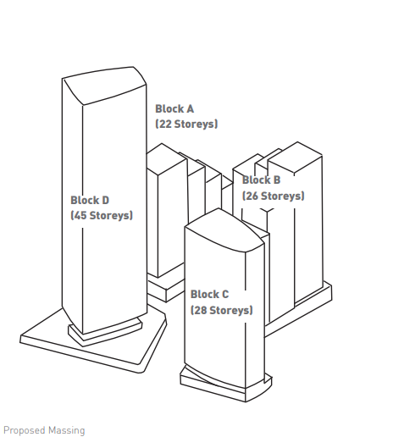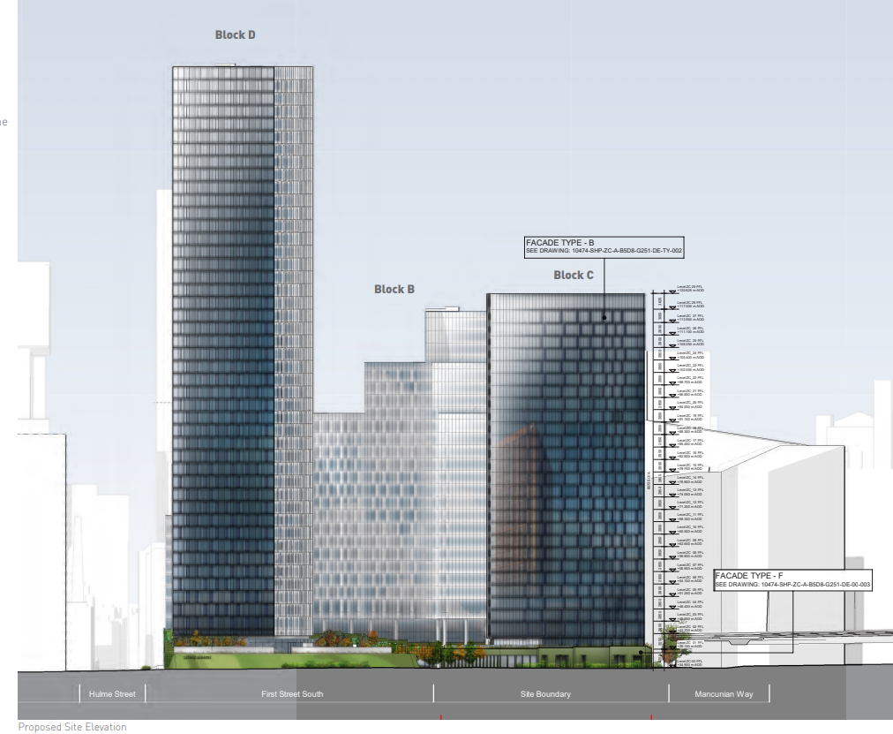

The development would comprise a tower and a podium. The stepped back form of the podium would break up its mass with the tallest step strongly defining the main entrance. The appearance of the tower would be similar to Block D and would be a gateway marker. Active frontages in the podium and the public space would activate the area.

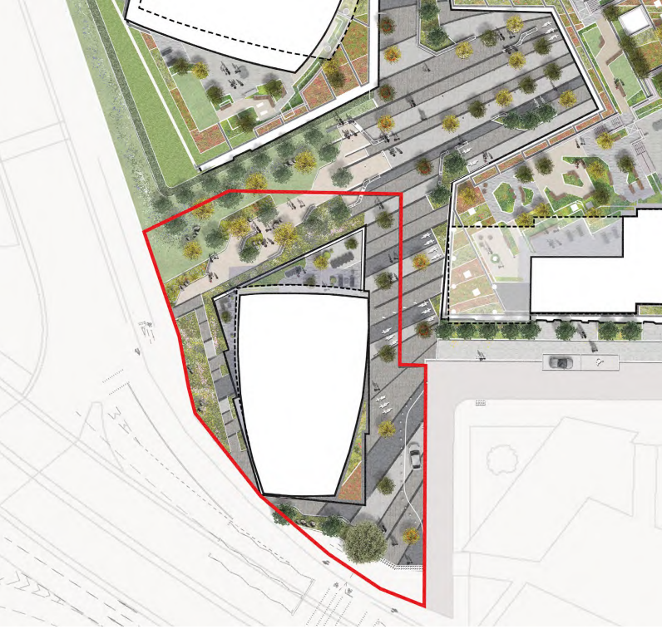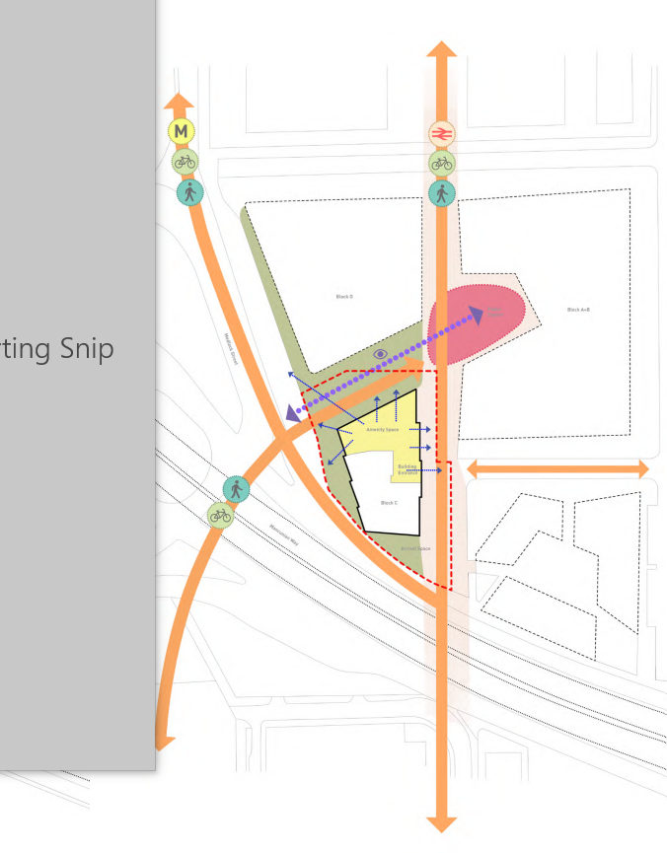

Building footprint and linkages

The site requires investment. It creates a poor impression and undermines the quality and character of the area. The proposal would use the site efficiently and would enhance the sense of place. The design would respond to its emerging context. A development of this scale is appropriate at this site so long as the impacts on the amenity of local residents are within acceptable levels.

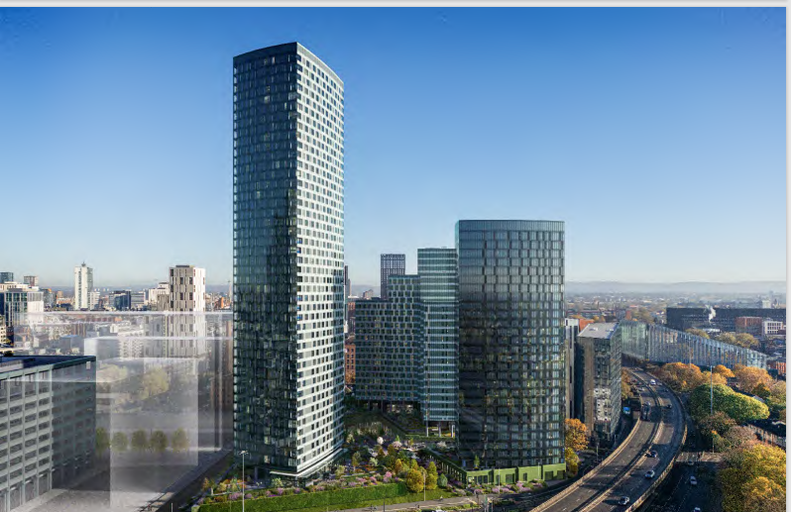

Credibility of the Design

Proposals of this nature are expensive to build so it is important to ensure that the design and architectural intent is maintained through the design, procurement and construction process. The design team recognises the high profile nature of the proposal and the design is appropriate for this prominent site and will match the quality of the buildings currently being constructed on the wider site. The range of technical expertise provided indicates that the design is technically credible. The design team is familiar with the issues associated with high quality development in city centre locations, with a track record and capability to deliver a project of the right quality. A contractor has been involved throughout the design process to ensure the high-quality vision is realised.

Contribution to public space and facilities

The public realm is a key component of the consented scheme for Plot 11 and should help to improve connections to and from Hulme. The proposals for Block C would increase size and orientation of the proposed park and create a more functional space. The number of trees would increase from 33 to 38 and the public spaces at ground floor would all be overlooked by stepped terraces. .

The revised proposals for Block C are integral to delivering the north to south route being constructed under 125573/FO/2019 would extends to Hulme. The revised proposals increase greening and planting along parts of Newcastle Street.

Relationship to Transport Infrastructure, Cycle Parking Provision and Servicing and Deliveries

The site is close to all sustainable transport modes including trains, trams and buses and has a Greater Manchester Accessibly Level of 8 which is very high. The public realm improvements would enhance links to public transport. A Transport Statement concludes that the impact on the local transport network would be minimal. A Travel Plan would make occupiers aware of sustainable options.

There is a MSCP close to the site (Q Car Park off River Street) 2 parking spaces for disabled people are proposed on Chester Street. The Q Car Park includes 28 spaces for disabled people. There are 3 on street parking bays for disabled people on the northern side of River Street between Medlock Street and James Grigor Square.

There would be 86 internal secure cycle parking spaces with bikes for hire and 30 spaces for personal bikes. 12 spaces for visitors and cycle deliveries would be provided in the public realm. There are further cycle stands for visitors at First Street including 28 spaces at James Grigor Square.

Access for servicing, deliveries, waste collection and taxi drop off and pick up would be from a dedicated layby on Newcastle Street.

The management team would manage deliveries on the resident’s behalf if they so wish. There would be dedicated postal storage areas in the reception and deliveries would be accepted between 08.00 and 23.00 only Residents would be notified of deliveries by the delivery firm or via a dedicated app.

Delivery riders/drivers would utilise a dedicated holding area for where they can drop off or wait in a dedicated internal area to either deliver the items or await the resident to come down.

Measures in the Move in and Move Out Management Plan would aim to minimise disruption to neighbouring premises and the local highway network. Residents’ pick-up / drop-off would be accommodated by car from on street Pay & Display area or using public car parks. Management staff would assist residents in locating their accommodation quickly and ensure that vehicles do not congest or congregate on the highway. Residents would book and confirm their arrival movements. There would be 3 sessions throughout the day. Staff would manage the loading and unloading and ensure that cars do not extend their waiting time. Cars would be directed to local car parks if they wish to stay longer (i.e. Parents/carers wishing to assist residents). Departures would occur over several month and align themselves with the academic years (May - July and August - September). Therefore, there is no mass departure event and clear departure policies would ensure that pick-up vehicles arrive at the designated loading bays where belongings can be quickly loaded. Highways support the submitted plan.

Conditions would require final details of the Waste Management Strategy, Travel Plan, Construction Management Plan, off-site highways works including pavement reinstatements and finishes and implementation of the Student Move in/ Move Out Management Plan and Management Strategy for taxis and deliveries.

The Head of Highways has no objections on this basis and no concerns about adverse impacts from any traffic generated. Comments from Active Travel England have been considered and reflected in terms of fit with the City Councils Strategic Transport Policies in their consultation response.

Impact on Designated and Non-Designated Heritage Assets and Townscape and Visual Impact Assessment

Design Issues, relationship to context and the effect on the Historic Environment. This considers the design in relation to context and its effect on key views, listed buildings, conservation areas, scheduled Ancient Monuments, Archaeology and open spaces. The potential heritage impacts are the impacts on the significance of designated and non-designated heritage assets, from development in the setting and impact on the setting of Macintosh Mill (1) on Cambridge Street Mill chimney stack at the junction with Cambridge Street (2), Chorlton New Mill (3) and attached chimney Chorlton Old Mill (4), Mill on Chester Street (5) and Chatham Mill (6) – all Grade II Listed.

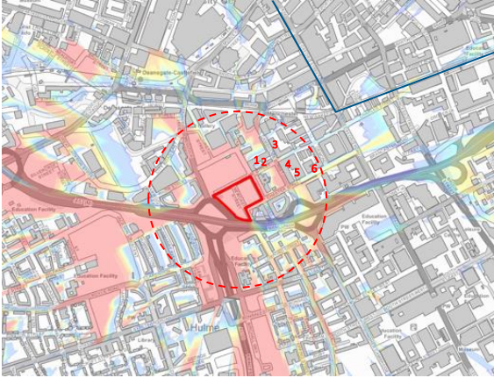
Designated Heritage Assets within a 300m boundary and Whitworth Street Conservation Area in blue

The Castlefield and Whitworth Street Conservation Areas are 500m and 550m away respectively.
Due to there location in relation to the proposal Chorlton new mill and the attached chimney (3), Chorlton Old Mill (4) and the Castlefield and Whitworth Street Conservation Areas have been scoped out.

The design was discussed widely at pre-application with stakeholders, including residents. This proposal seeks to minimise harm to adjacent heritage assets.

The effect on key views, listed buildings, conservation areas, archaeology and open spaces has been assessed. When seen from radial approaches, the density of the city centre skyline is evident. There are historic and larger, modern buildings nearby, but the proposal should not undermine the setting of heritage assets.

A Heritage Assessment used Historic England’s guidance on the Setting of Heritage Assets (Historic Environment Good Practice Advice in Planning Note 3, Second Edition). (December 2017) to assess the impact.. A Townscape and Visual Impact Assessment (TVLA) was undertaken in accordance with the methodology and approach set out in the ‘Guidelines for Landscape and Visual Impact Assessment’ (GLVIA) Third Edition’ (2013) – produced by the Landscape Institute (LI) and IEMA and Historic England Advice Note 4: Tall Buildings on 4 March 2022.

This has analysed the impact on the townscape. The TVIA identified 6 Townscape Character Areas for investigation and has considered impacts on significance from 14 key views which also considered the site’s wider heritage context. The impact on the setting of listed buildings in 1 of these views (View 1) were assessed for heritage impact. An additional 3 views (15,16, and 17) were added. The TVLA has included consideration of changes to townscape, changes to urban grain, changes to building heights and changes to site character.

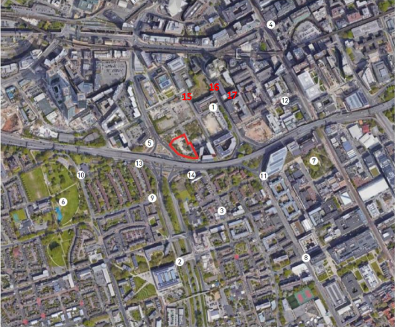
Locations of key viewpoints (site outlined in red and Deloitte viewpoints comprising 15, 16 and 17)

Cumulative Assessment

As the proposal is in a heavily developed urban area, limited long-distance views are available. From several viewpoints, there would be no visibility of cumulative developments. Where this is the case, or where the proposal would not be visible, views are not considered. Views that would experience a small magnitude of change or lower also excluded. From these viewpoints, under a baseline scenario in which there are further tall buildings in the view, it is not considered that the proposal would result in a greater magnitude of change than when considered in a baseline scenario which excludes cumulative developments.

The views assessed are those where the proposal and cumulative developments are visible. The assessment of cumulative visual effects focusses on the interaction between the proposal and cumulative developments which are visible in the same sector of the view. However, where there is likely to be a cumulative interaction with a development in close proximity in a different sector of the view, this is also described.
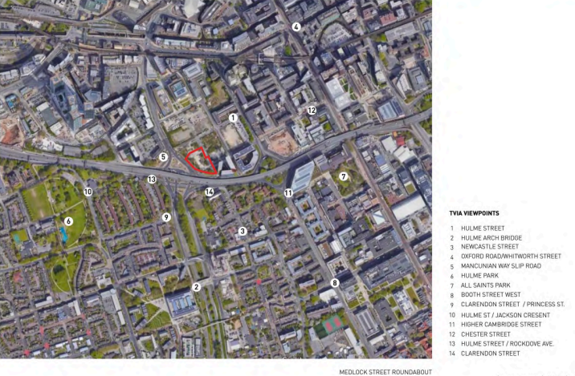
Plan of viewpoints

Construction Phase Impacts

During the construction phase, townscape and visual effects include site set up and compound, boundary fencing, site clearance, groundworks, access, and contractor parking, plant and equipment. The Construction Environmental Management Plan (CEMP) would control construction impacts and include the position of compounds and stockpiles, high quality site hoarding, and good site management, maintenance and housekeeping. Temporary effects during construction would be negligible to major-moderate.

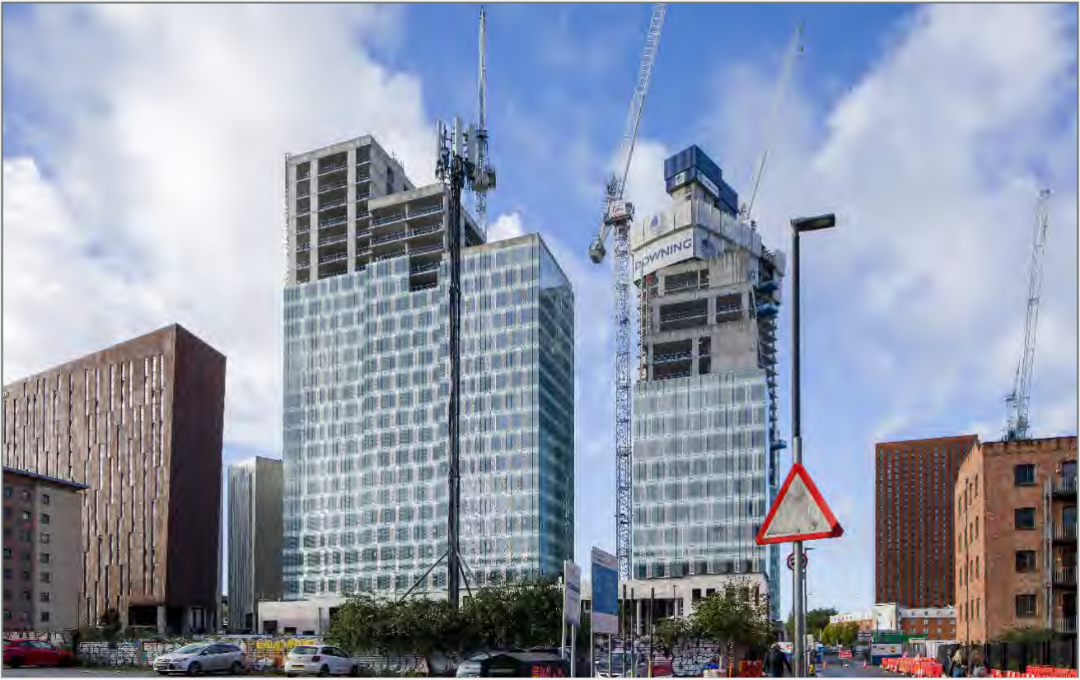
Viewpoint 1 Baseline

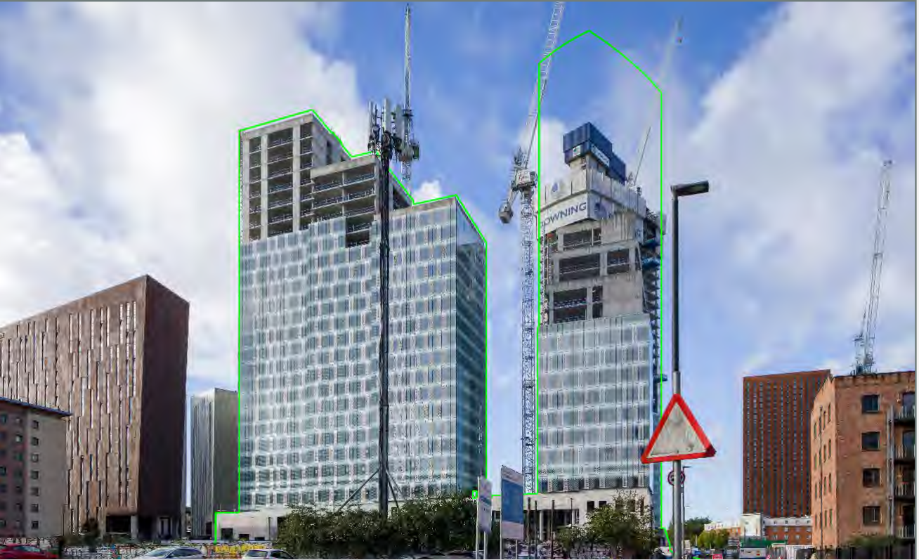
Viewpoint 1 Proposed
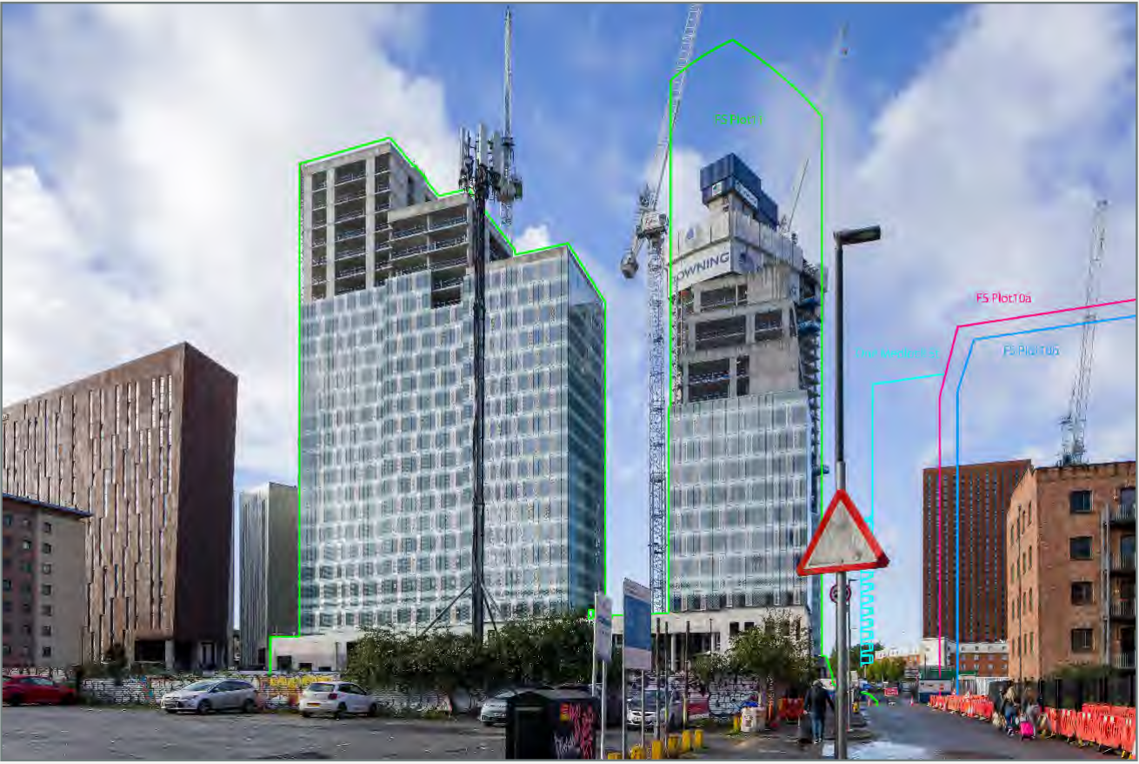
Viewpoint 1 Cumulative

Baseline: The townscape contains converted red-brick warehouses and imposing chimney stacks in a cluttered streetscape and pedestrian environment, with car parks and development plots. To the left beyond, Blocks A, B and D of First Street South are visible, and contain the view to the south-west. Modern PBSA at Parkway Gate are visible to the left of First Street South.This is a distinctive view of the townscape of red-brick warehouses recognised for their industrial significance, and their contrast with modern architectural styles.

Townscape Impact: The proposal would be fully screened by Block D. There may be glimpsed views towards it from the surrounding area, beyond the First Street South buildings. Where visible, it would be in keeping with the emerging pattern of tall buildings. The overall magnitude of change would be negligible. The effect would be not significant (moderate) / neutral.

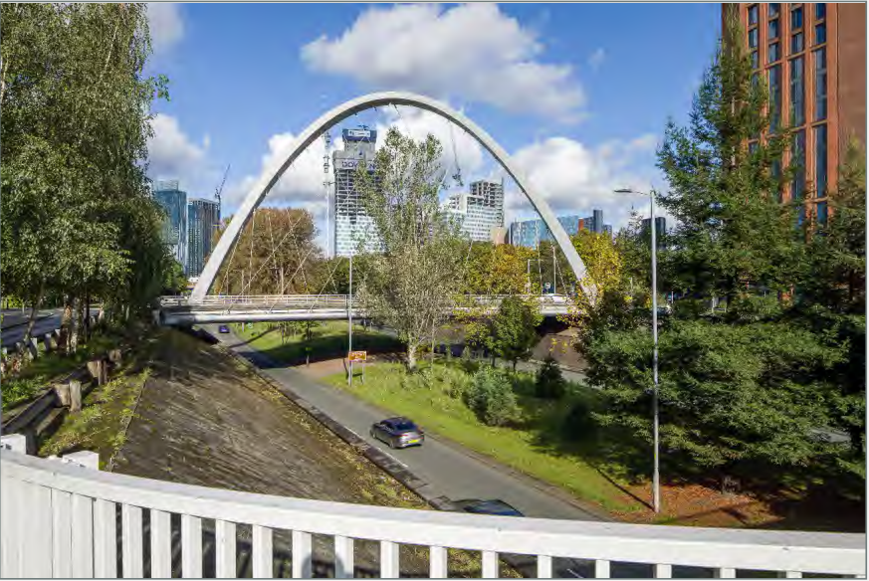
Viewpoint 2 Baseline

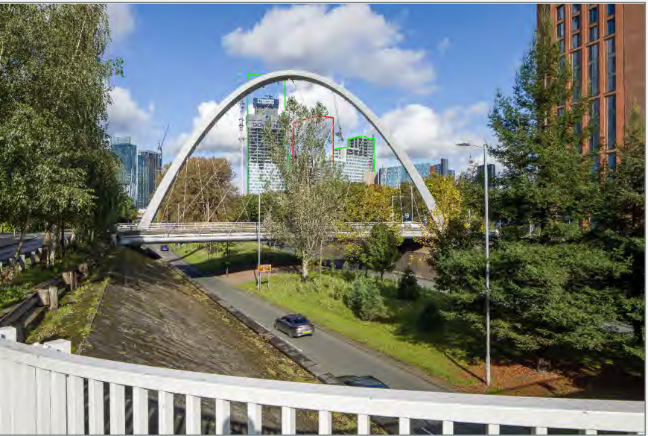
Viewpoint 2 Final
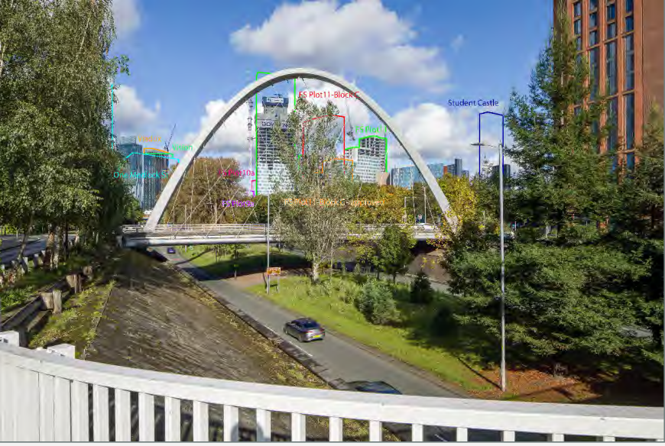
Viewpoint 2 Cumulative

Baseline: The view is partially channelled along Princess Road by the underpass and trees on the central reservation and embankments. The Hulme Arch Bridge is prominent. Blocks A, B and D are visible beyond the Arch, with some filtering provided by trees on Princess Road. Block D is a notable feature. The cluster of tall, PBSA blocks at Parkway Gate are visible beyond the Mancunian Way and trees. Several tall buildings are visible. The Beetham Tower and Viadux and homes in Hulme are to the west, and PBSA to the east. The view is dominated by the roads.

Townscape Impacts: Upper parts of the proposal would be seen beyond the Arch and views would be filtered by vegetation. The proposal would be seen between Blocks B and D of First Street South and would be taller than Block B but smaller than Block D. Overall, it would be in keeping with the townscape in the view. Its effect would be not significant (moderate) /neutral .

Cumulative Impacts: A number of cumulative schemes would be visible that extend and increase the scale of the city. The proposal would continue this effect. Its scale would be lower than committed schemes and smaller than Block D. It would not appear higher than Blocks B and D, while other cumulative developments would extend the influence of tall buildings over a wider extent. On balance, the additional cumulative magnitude of change would be small. The contribution of the proposal to the cumulative effect would not be significant.
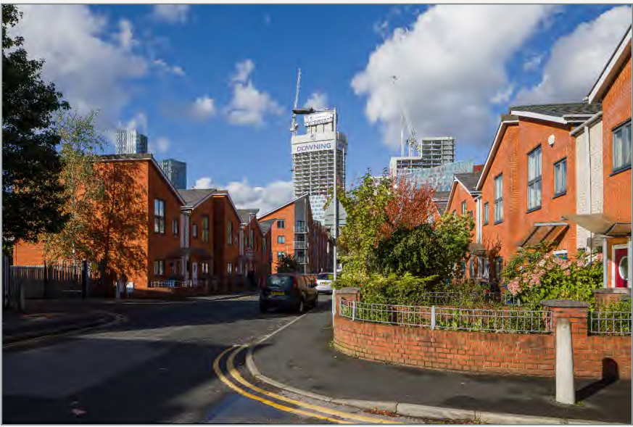

Viewpoint 3 Baseline

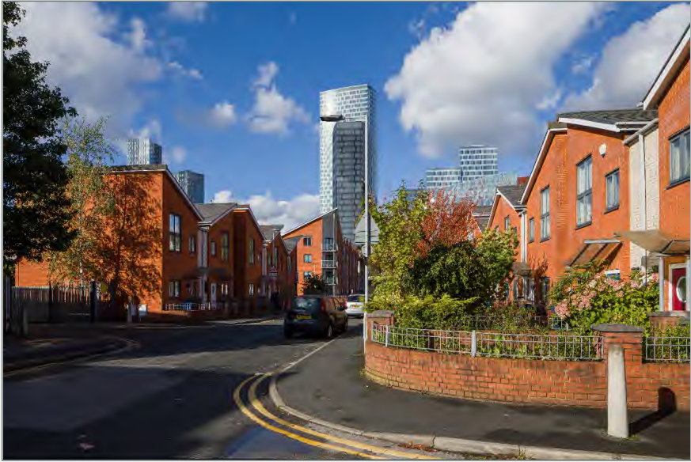
Viewpoint 3 Proposed

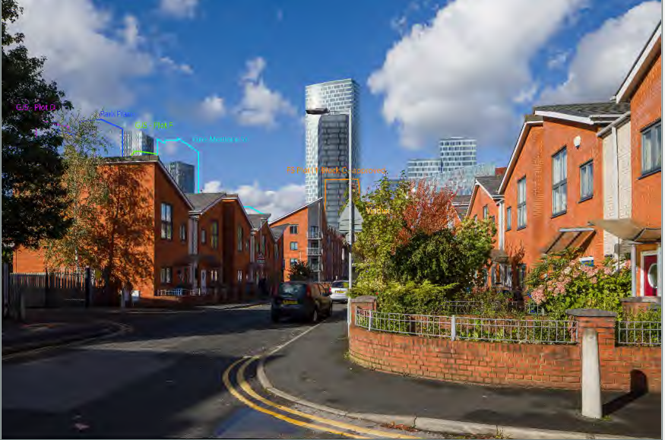
Viewpoint 3 Cumulative

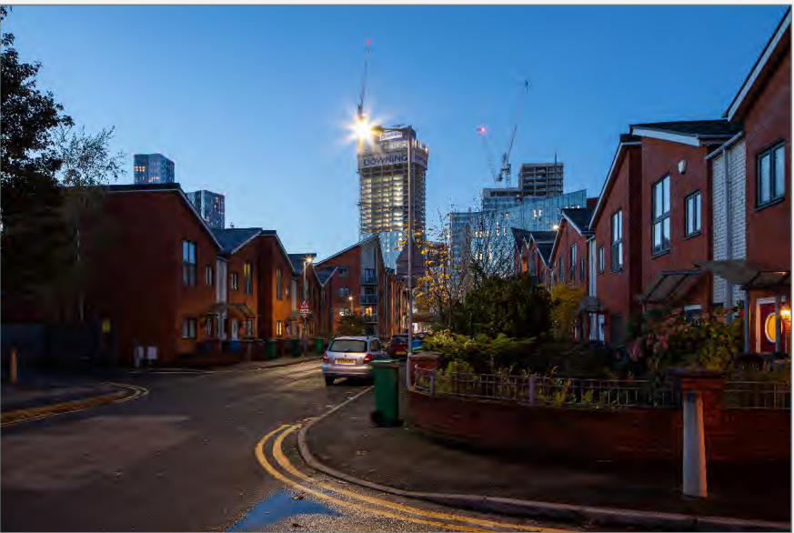
Viewpoint 3 Baseline (Dusk)
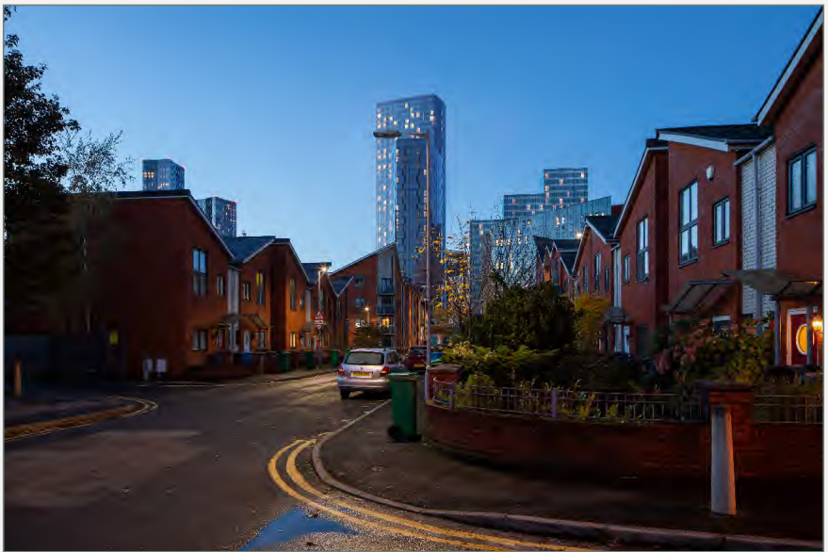
Viewpoint 3 Proposed (Dusk)

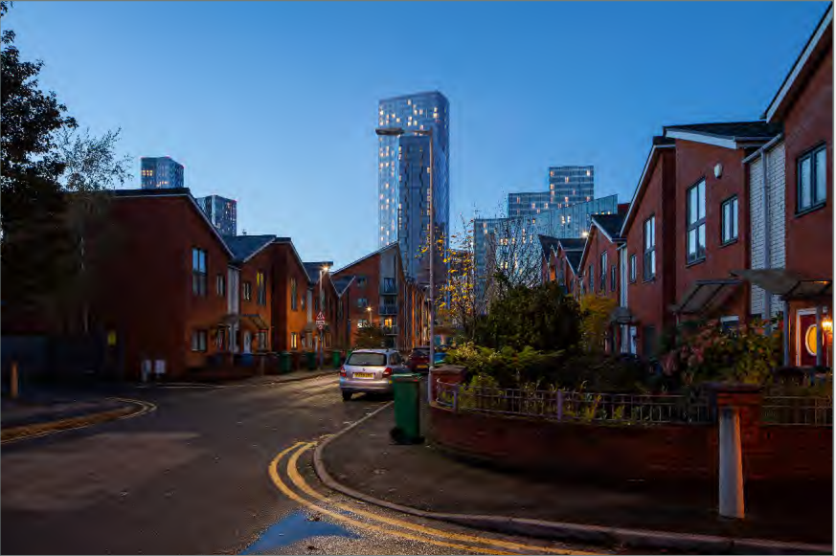
Viewpoint 3 Proposed (light removed)

Baseline: Several tall buildings can be seen in the backdrop, including Blocks B and D at First Street South, and Parkway Gate, beyond the Mancunian Way. Two buildings at Deansgate Square are also visible as well as the top of Great Jackson Street Plot F. There are a variety of architectural styles with glass towers rising above red-brick low rise homes.
Lighting sources include street lighting on Newcastle Street in the fore- to mid-ground and within residential development on Newcastle Street and Deansgate Square, First Street South and Parkway Gate.
Townscape Impacts: Upper parts of the proposal would be seen beyond the low-rise homes. The proposal would sit in the foreground of Block D with Block B further east. The building would be of a similar style to these existing taller buildings but would be closer. Its effect would be significant (moderate) / neutral. But not significantly greater than the impacts of the previously consented Block C.

Cumulative Impacts: A number of cumulative schemes, including One Medlock Street, Park Place , and Great Jackson Street Plot D , would be visible In front of the Deansgate Square towers. The proposal would be of a similar height as the committed schemes in the view, although this is partially due to its closer proximity to the viewpoint. It would be in the foreground of Block D. Other cumulative developments such as One Medlock St and Park Place would be seen to slightly extend the influence of tall buildings in the city centre backdrop, albeit contained within a relatively defined cluster and only their upper floors would be visible above the housing. The proposal would be closer to the viewpoint than these cumulative developments, which would emphasise its scale. The cumulative magnitude of change would be small, due to its closer proximity to the viewpoint and its contribution with One Medlock St and Park Place to an intensification of the effect of tall buildings in the city backdrop. However the additional effect is limited by it being contained in a view that is affected by the FSS blocks and the limited amount of the upper parts of One Medlock St and Park Place visible adjacent to Deansgate Sq. The additional contribution of the proposal would be not significant (minor)/ neutral.

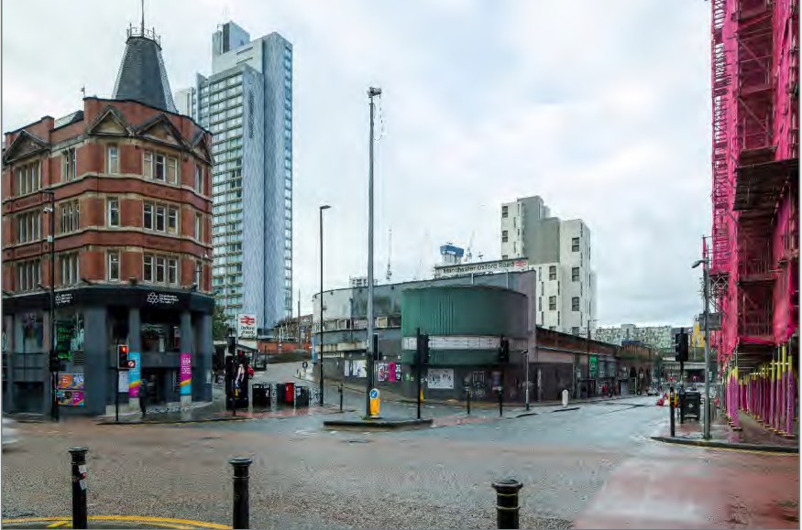

Viewpoint 4 Baseline
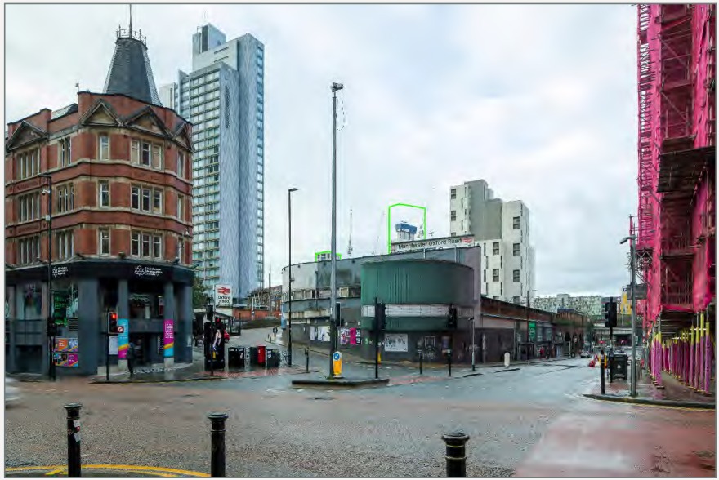
Viewpoint 4 Proposed

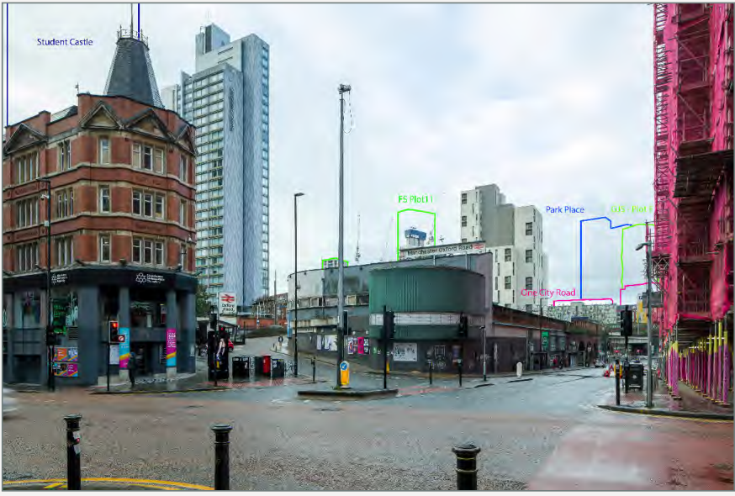

Viewpoint 4 Cumulative

Baseline: This streetscape contains a mix of historic red-brick Victorian and modern buildings. The foreground is vibrant, busy and heavily trafficked with vehicles and pedestrians. The view along Whitworth Street extends to the railway bridge. Beyond this the upper floors of Blocks B and D at First Street South, are apparent, with different façade colour and treatment.
The view is on the edge of the Whitworth Street Conservation Area. There are views of the evolving townscape with the more recent modern architectural styles and taller tower blocks.

Townscape Impacts: The proposal would not be visible.

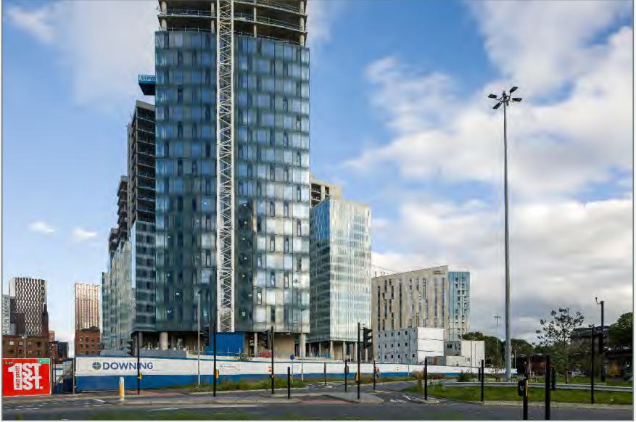
Viewpoint 5 Baseline
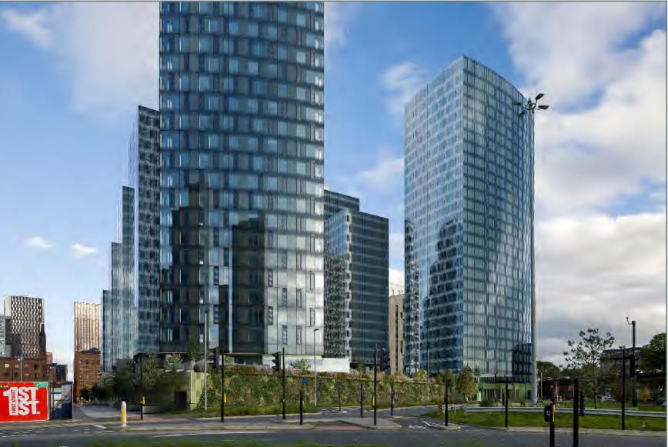
Viewpoint 5 Proposed

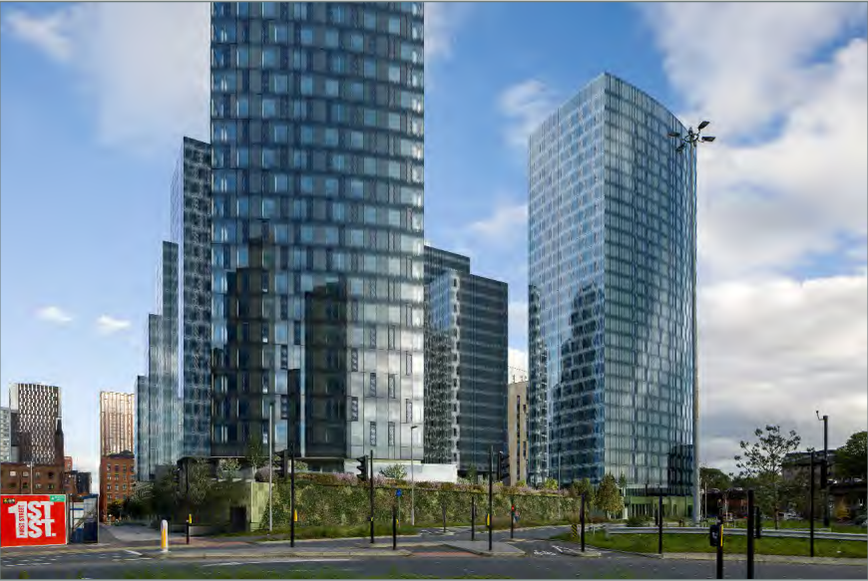
Viewpoint 5 Cumulative

Baseline: Blocks A, B and D of FSS are prominent with Block D particularly prominent. To the right are further modern development at Parkway Gate plus the Mancunian Way and mid-rise homes in Hulme. To the left are historic red-brick mill buildings with tall buildings beyond.
The townscape is evolving with a mixture of historic buildings and modern tall buildings. In particular, the FSS buildings now define the view to the east, and their associated design quality has contributed to the visual amenity of this area.

Townscape Impacts: The proposal would be seen to almost its full extent at close proximity, in the context of other tall buildings including all three at FSS. It would be seen adjacent to and would be smaller than Block D but would be taller than Block B beyond. It would bring development closer to the Mancunian Way. The proposal would continue the emerging pattern of tall buildings slightly closer to the smaller-scale development within Hulme, although its design and form will largely be in keeping with the existing development. The whole proposal including public realm would be visible. The effect would be significant (major-moderate)/ beneficial.

Cumulative Impacts: Student Castle would be a visible cumulative development. The proposal would be part of an increase in the scale of the surrounding buildings. The view would be contained in several directions, and greater influence from tall buildings in the immediate surroundings. The proposal would along with other cumulative developments, particularly One Medlock Street, contribute to this effect. The additional effect from the proposal is limited by its proximity to FSS which contains it. The additional contribution of the proposal to cumulative developments would be significant (moderate)/ neutral.
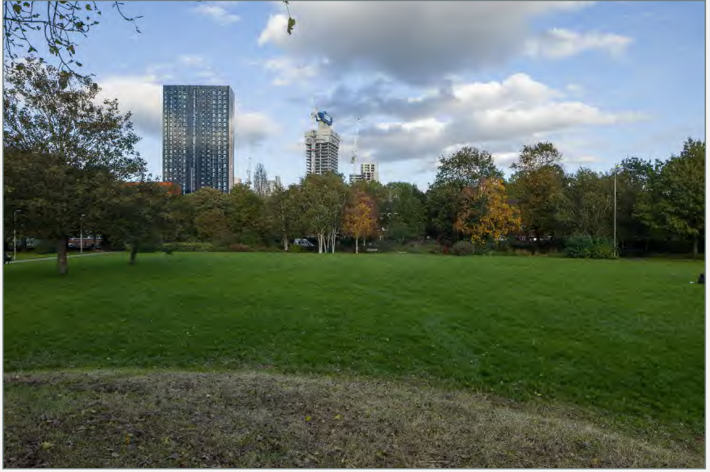
Viewpoint 6 Baseline
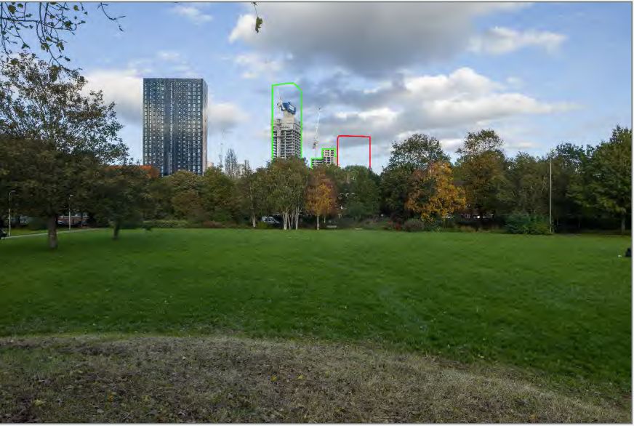
Viewpoint 6 Proposed.
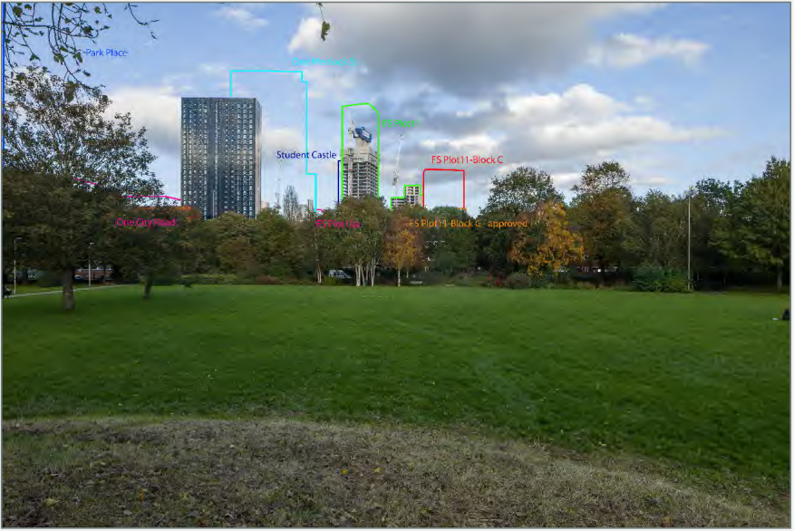
Viewpoint 6 Cumulative

Baseline: There would be filtered views to the River Street tower, FSS Blocks B and D and surrounding homes in Hulme. Tall buildings are beginning to influence the view to the east of the park.

From within a public park, the views of the greenspace and the experience it provides in contrast to the surrounding city, are likely to be locally valued and visited by a relatively large number of people.

Townscape Impacts: Upper parts of the proposal are visible beyond vegetation in the park and low-rise homes. The proposal would be seen in the context of Blocks B and D at FSS and River Street, which are tall features in the view. These buildings are taller than the proposal which would be in keeping with the emerging pattern of tall buildings to the east. However, this would extend this type of proposal and its effect on the view of people in Hulme Park would be significant (moderate)/neutral.

Cumulative Impacts: Several cumulative developments are visible including Student Castle, One Medlock St, One City Rd and Park Pl. Student Castle would be prominent to the east and appear taller than Block D. Other cumulative proposals would have less impact on the skyline from here. Other cumulative proposals may be visible to the north, including buildings at Great Jackson Street. The proposal would continue the effect of the cumulative schemes. Its scale would be smaller than One Medlock Street. Both One Medlock Street and Park Place would appear larger in scale than any existing buildings or the proposal. It would be located further south than other cumulative developments and extend the influence of tall buildings over a wider extent of the skyline. The additional contribution of the proposal to the cumulative effect would be not significant (minor)/ neutral.
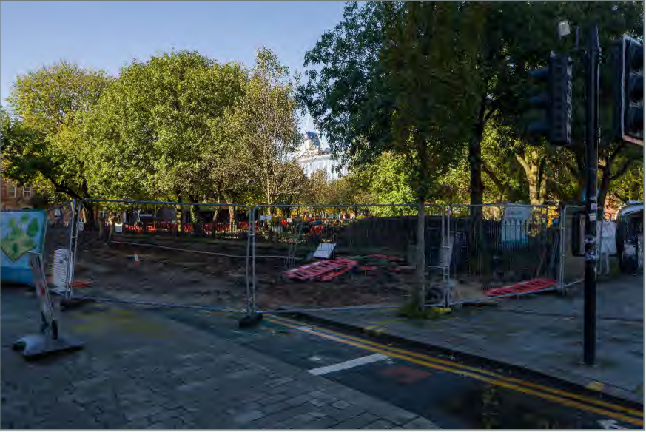
Viewpoint 7 Baseline

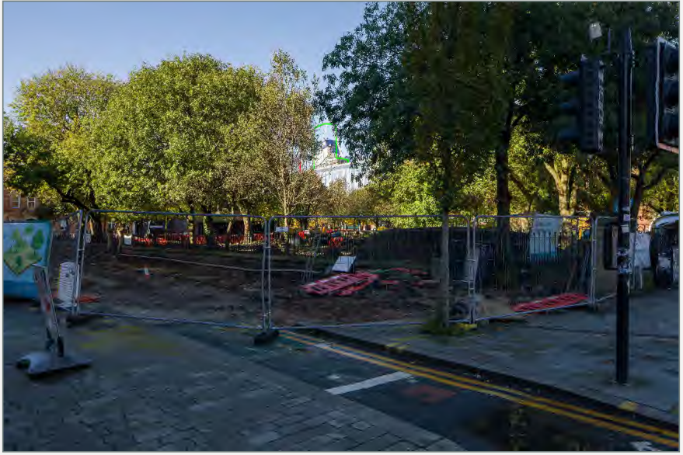
Viewpoint 7 Proposed

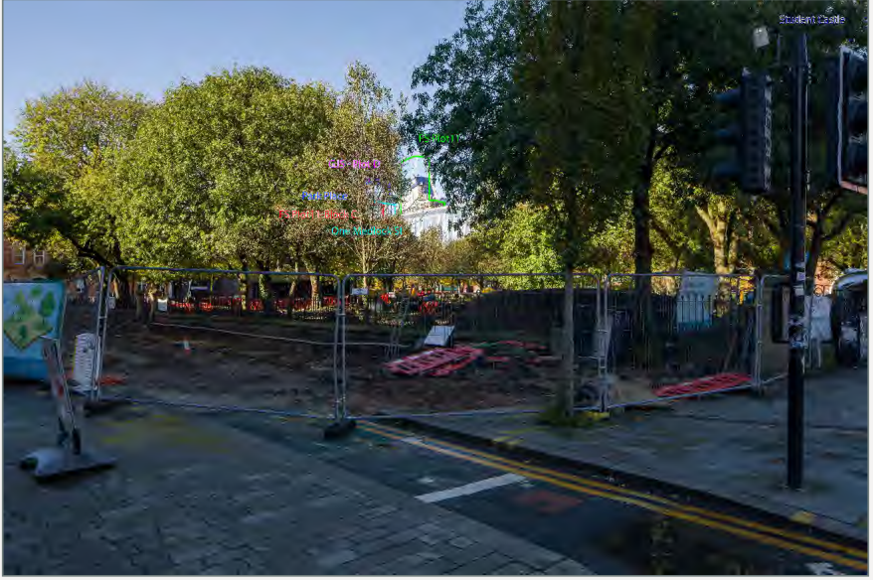
Viewpoint 7 Cumulative

Baseline: The foreground and middle ground is dominated by open greenspace, paths, trees and seating areas in the park. Moderately scaled educational buildings enclose the Park. Block D at FSS can be seen beyond the trees which surround the park. Further tall buildings can be seen from in the park such as the top of one of the Deansgate Square towers. The view is generally restricted and contained by the urban areas and the tree cover.

The view is from a public park, where views of the greenspace and the experience it provides as a contrast to the surrounding city are likely to be locally valued and visited by a relatively large number of people using the park. The view itself is not a specific view from the park but is incidental to its setting.

Townscape Impacts: Upper parts of the proposal would be seen beyond MMU. The view would be heavily filtered by vegetation in the park in summer, with views of the upper floors in winter. The proposal would be seen in the context of Block D and a tower at Deansgate Square beyond the university buildings. These are taller than that proposed, and the proposal would be in keeping with the tall buildings to the west. The effect of the proposal on the view experienced by those in All Saints Park would be not significant (minor - negligible)/and long-term.
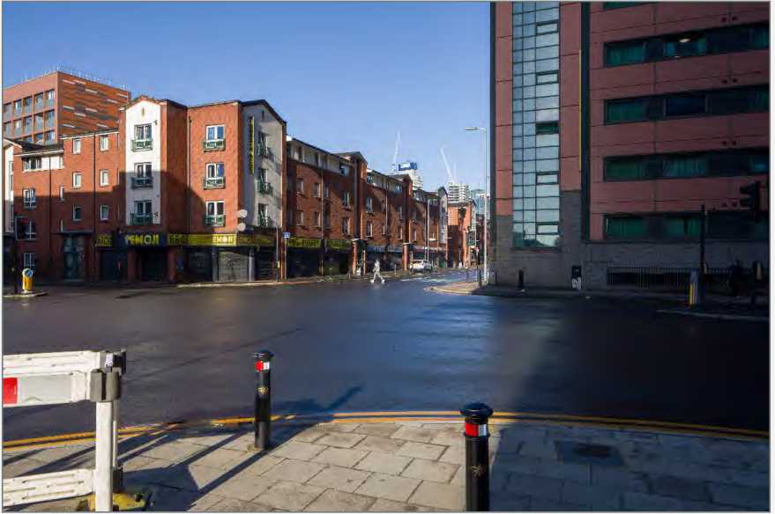
Viewpoint 8 Baseline

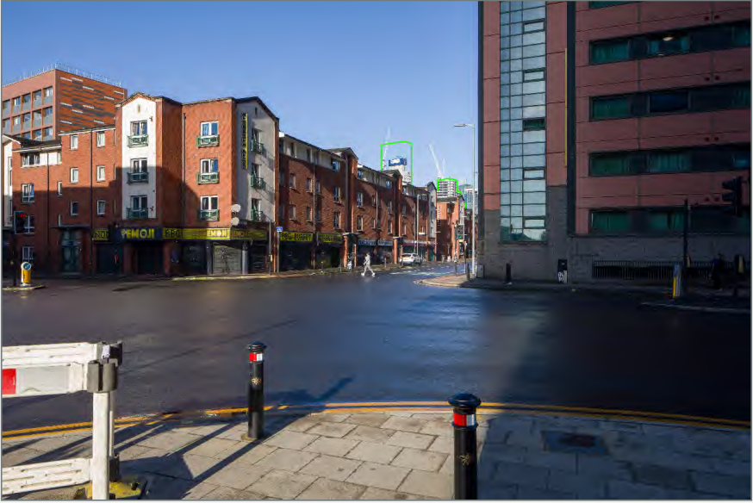
Viewpoint 8 Proposed
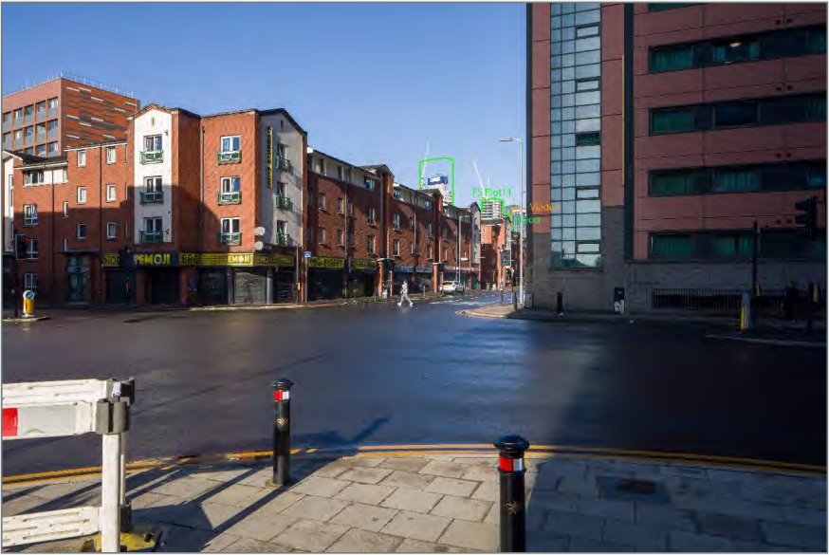
Viewpoint 8 Cumulative

Baseline: The view is of a junction enclosed by homes. Two blocks at FFS are visible beyond the lower-rise buildings on Higher Cambridge Street, and Beetham Tower and Viadux are beyond. To the left the city density starts to dissipate as storey heights decrease and the building levels are low into the distance. To the right is a seven storey PBSA building. Immediately behind is a tall hotel building which creates a more modern immediate streetscape, which is otherwise generally formed of lower-rise red brick and cladded buildings. This is a view of urban townscape with a range of modern building styles within a relatively hard environment.

Townscape Impacts: The proposal would be fully screened and the proposal would result in no change.

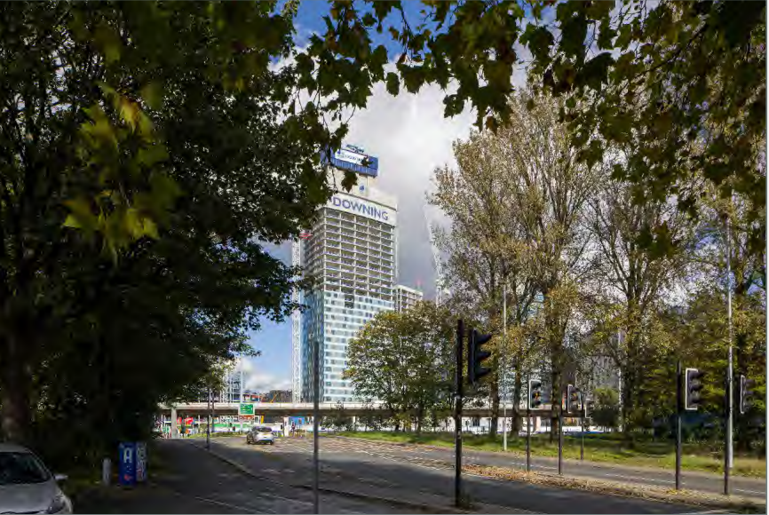
Viewpoint 9 Baseline

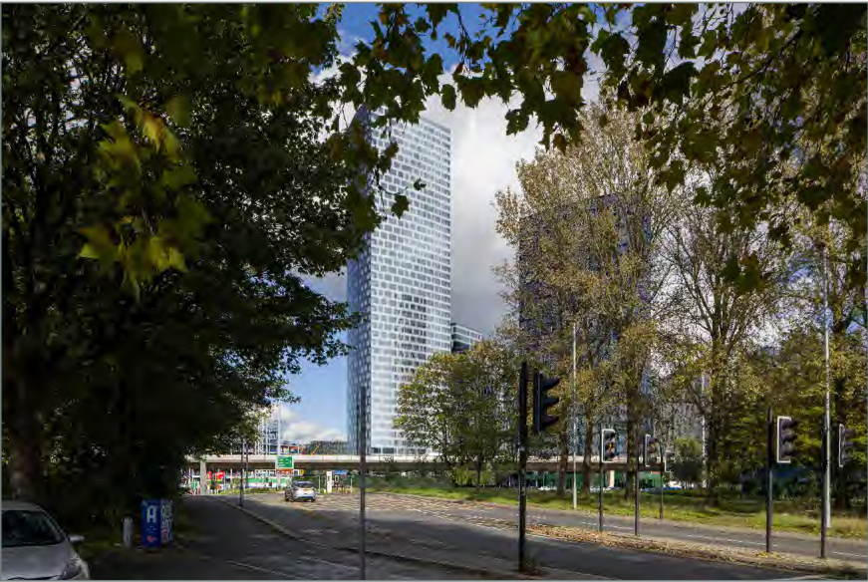
Viewpoint 9 Proposed

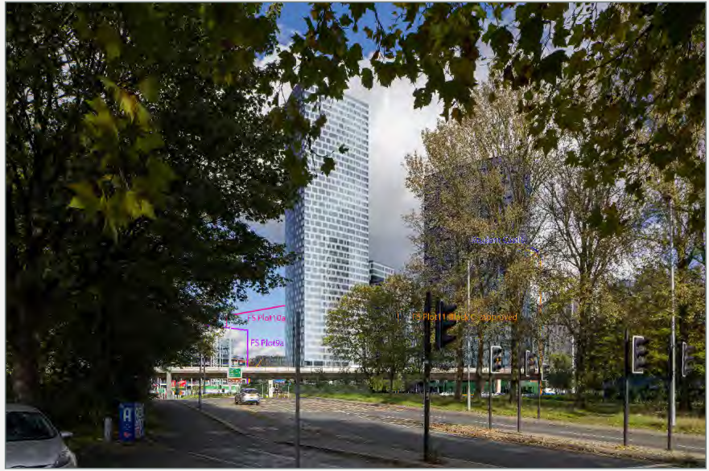
Viewpoint 9 Cumulative

Baseline: Views are channelled along Princess Street towards the Mancunian Way. There is a cluster of tall buildings north of the Mancunian Way including Blocks A, B and D at FSS and Plots 9a and 10a at First Street. The view contains a range of modern building styles, and the foreground is formed by the tree-lined Princess Street.

Townscape Impacts: The proposal would be seen to almost its full extent and close to existing tall buildings including Blocks A and D at FSS. The proposal would screen views towards Block B and would bring this development slightly closer in the view, but would be in keeping with the existing pattern and design. The vegetation on Princess Rd would filter the view. Views of lower parts would be screened by the Mancunian Way. Views from within homes would be restricted by surrounding vegetation, and views are therefore considered to be experienced by residents in the area surrounding their properties, as well as road users. The effect of the proposal would be not significant (moderate)/ neutral.

Cumulative Impacts: Student Castle could be visible in the distance. Part would be screened so only the edge of the tower would be seen. It is also likely to be difficult to discern due to distance and the filtering by trees. There is likely to be very limited association with Student Castle, and therefore a negligible additional cumulative effect. The additional contribution would be not significant (minor-negligible)/ neutral.

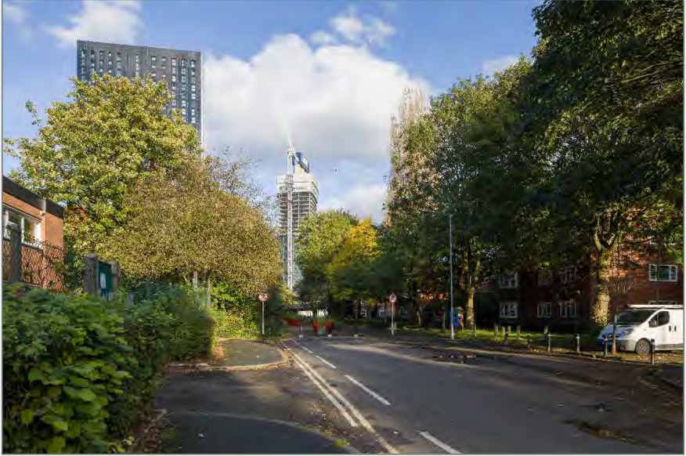
Viewpoint 10 Baseline

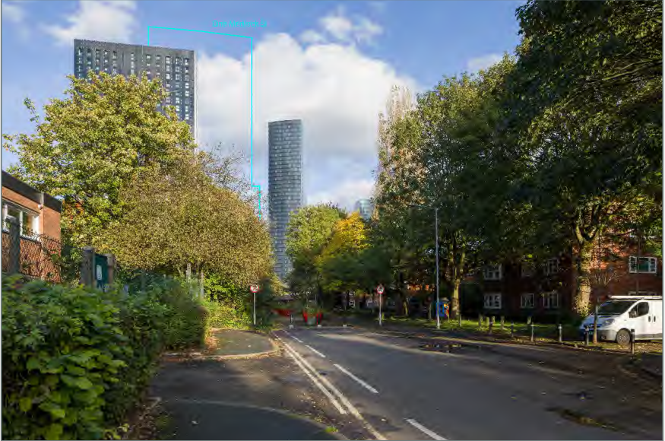
Viewpoint 10 Proposed
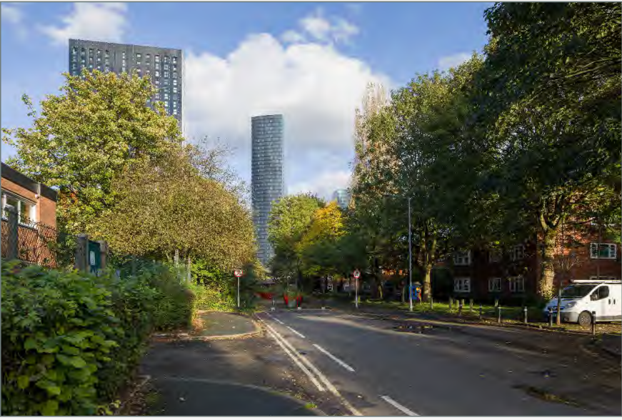
Viewpoint 10 Cumulative

Baseline: There are 3-storey red-brick homes in the foreground and trees which filter the view. There are tall buildings, including Block D at FSS, River Street, Deansgate Square and New Jackson. The view to the west over Hulme Park is more open. The view includes different architectural styles with red-brick low rise homes in the foreground with tall buildings beyond.

Townscape Impacts: Upper parts of the proposal would be seen beyond low-rise homes. Tree cover would heavily filter view. The proposal would be seen in the context of Block D at FSS and River Street. These buildings are taller than the proposal, which would align with tall buildings to the east, beyond the park, but would extend this type of development further south. The effect of the proposal on residents views on Hulme Street would be not significant (minor)/ neutral.

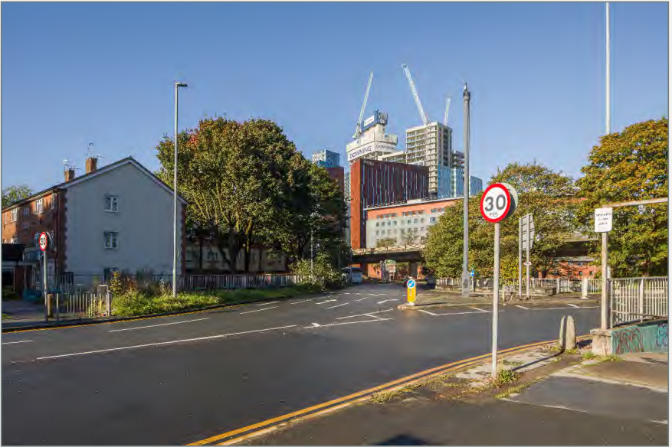
Viewpoint 11 Baseline

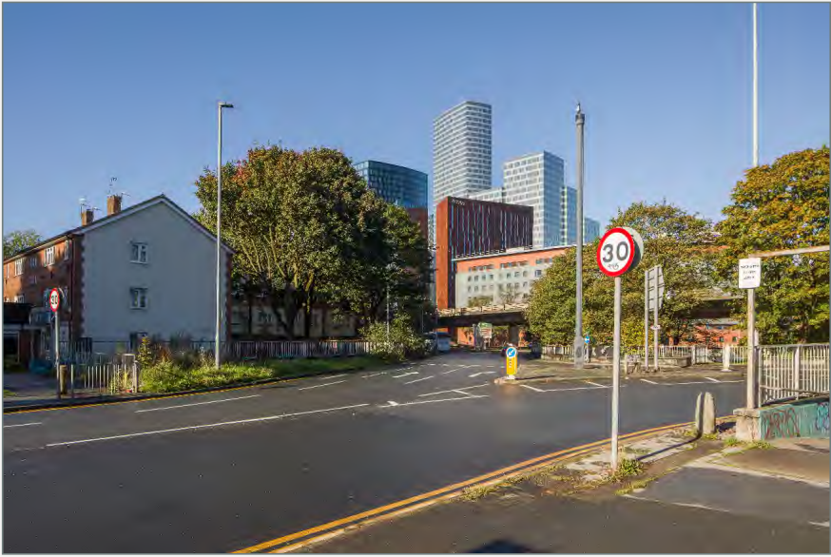
Viewpoint 11 Proposed

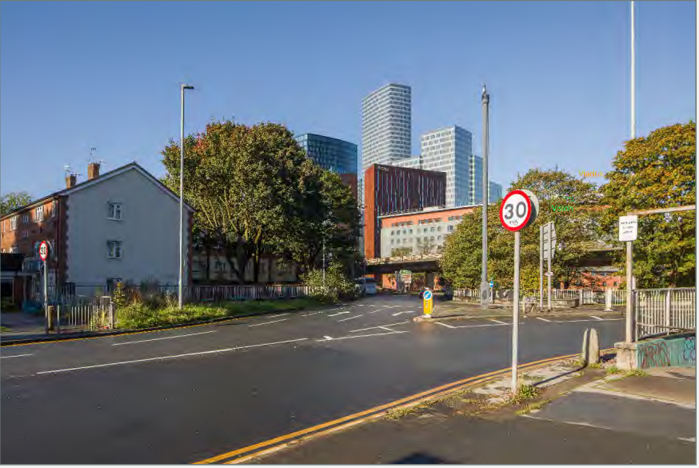
Viewpoint 11 Cumulative

Baseline: Higher Cambridge Street is in the foreground and the Mancunian Way is close to the north. Trees filter views towards the elevated road. Blocks B and D at FSS, Parkway Gate and Deansgate Square are beyond. There are three-storey red brick homes whose scale contrasts with the pattern of tall buildings beyond. Further to the south are apartment blocks. Some residents will value the view.

Townscape Impacts: Upper parts would be seen beyond Higher Cambridge Street. Its scale would contrast with low rise residential homes, but it would be in keeping with recent development at FSS which would appear taller. Lower parts would be screened by Parkway Gate. Tree cover would filter views. The proposal would relate to tall buildings to the north-west. Views towards the proposal from homes would be filtered by trees and it would be visible to residents, road users, and people in university buildings. The magnitude of change would be small and the effect would be not significant (negligible)/ neutral.
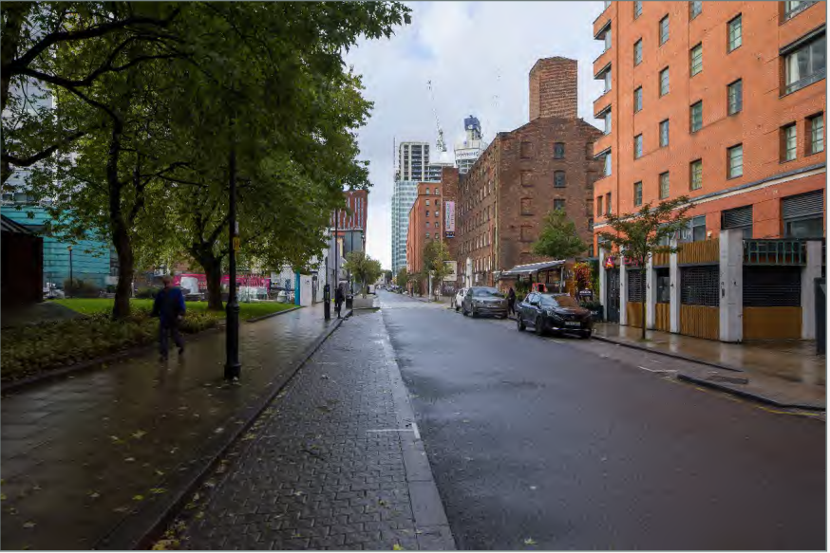
Viewpoint 12 Baseline

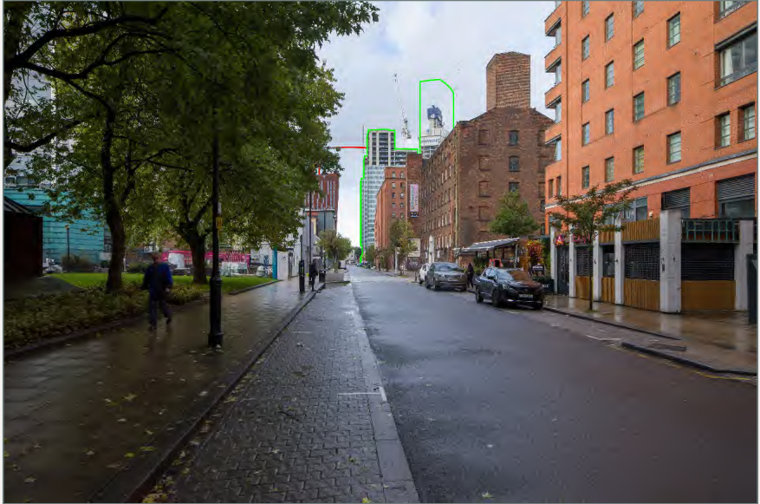
Viewpoint 12 Proposed
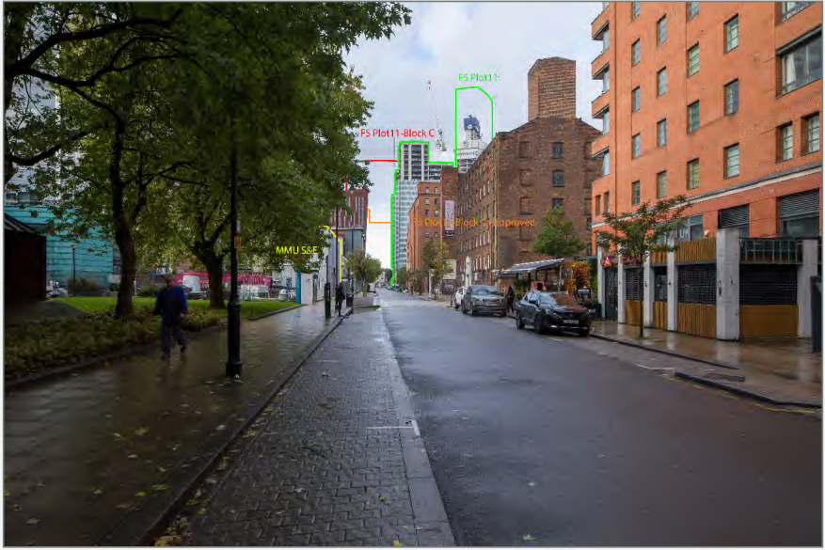
Viewpoint 12 Cumulative

Baseline: Chester Street is a narrow one-way route. A small garden is visible on the left, with MMU buildings beyond. A tower is filtered by trees. To the right are modern red-brick homes and converted warehouses. Parkway Gate and First Street South are visible along Chester Street. Views are likely to be valued by people living, working and at leisure in the area.

Townscape Impacts: The proposal would be seen to the west, would screen longer-distance views and would create a sense of enclosure. It would be partially screened by development on either side of Chester Street, although it would be visible. It would be seen in the context of Blocks B and D at FSS, although these are beyond built form on Chester Street. The proposal would be positioned further south. It would appear lower than Blocks B and D but taller than Parkway Gate. It would appear greater in width than the FSS buildings, and therefore would appear slightly out of proportion with surrounding development. Its effect would be significant (moderate)/ neutral.

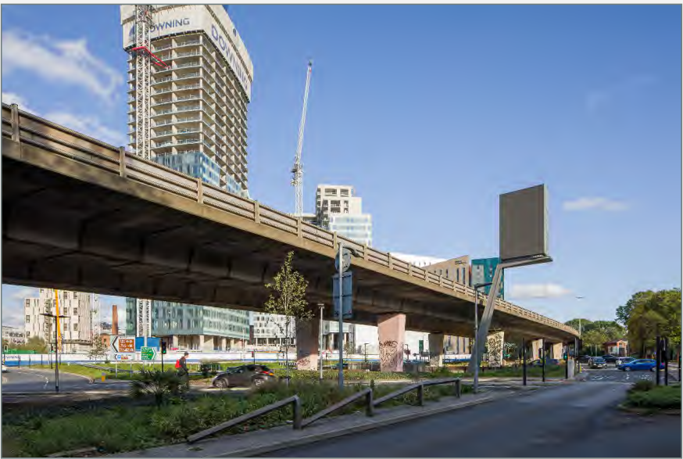
Viewpoint 13 Baseline

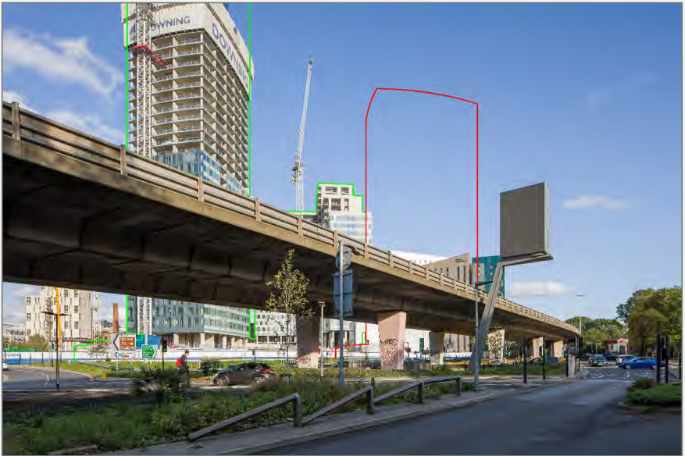
Viewpoint 13 Proposed

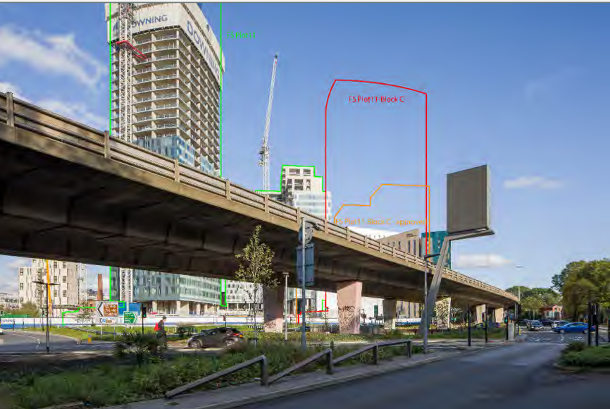
Viewpoint 13 Cumulative

Baseline: The Mancunian Way is a prominent feature. Homes on Hulme Street / Rockdove Avenue are partially filtered by trees on Medlock Street Junction. Beyond the Mancunian Way are modern tall buildings close to the lower-rise homes. In particular, there are views of Blocks B and D at FSS and buildings at Parkway Gate. Plot 10A, First Street is to the north of the FSSouth buildings. The view is likely to be of some value to local residents.

Townscape Impacts: Most of the proposal would be visible, at close proximity and in the context of other tall buildings including Blocks B and D at FSS. The proposal would at a similar distance as Block D and bring development into closer in the view than Block B. It would also bring development closer to the Mancunian Way and extend the pattern of tall buildings although its design and form would be in keeping with existing buildings. It would be seen from homes but would be partially filtered by trees in summer. Overall, the effect experienced by residents and road users on would be significant (major-moderate)/ beneficial.

Cumulative Impacts: One Medlock Street would be visible in a different sector of the view and further cumulative developments may be visible including Park Place. The proposal would contribute to an increase in the scale and contribute to the increasing containment of the view and the greater influence of tall buildings. The proposal would contribute to this effect. The cumulative magnitude of change would be medium as its contribution with One Medlock Street to the increasing influence of tall buildings. In particular, the proposal would contain views to the north-east, and will bring tall buildings closer to lower-rise homes to the south. However, the additional effect is limited by its proximity to the FS South blocks and its containment. The additional contribution would be significant (moderate)/ neutral.

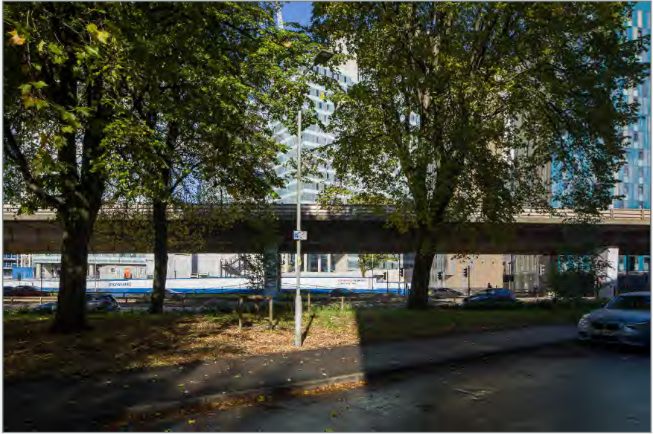
Viewpoint 14 Baseline

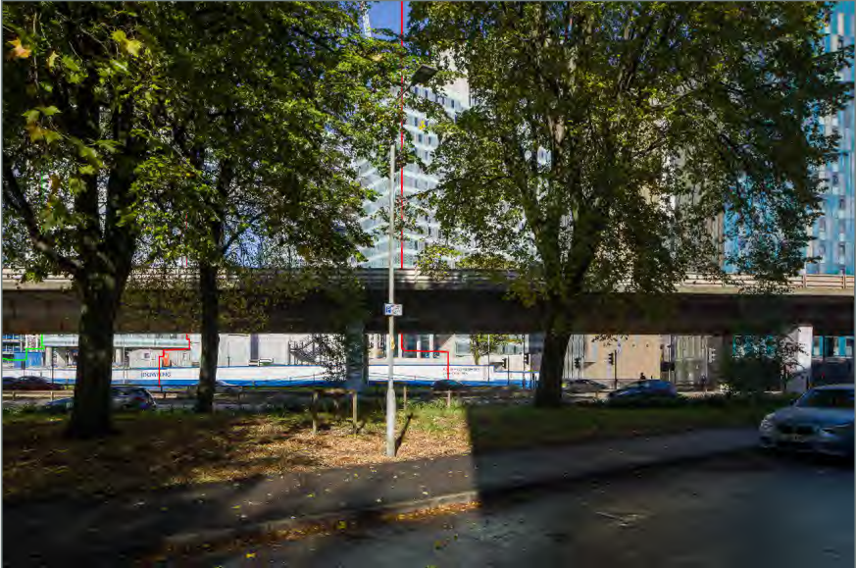
Viewpoint 14 Proposed
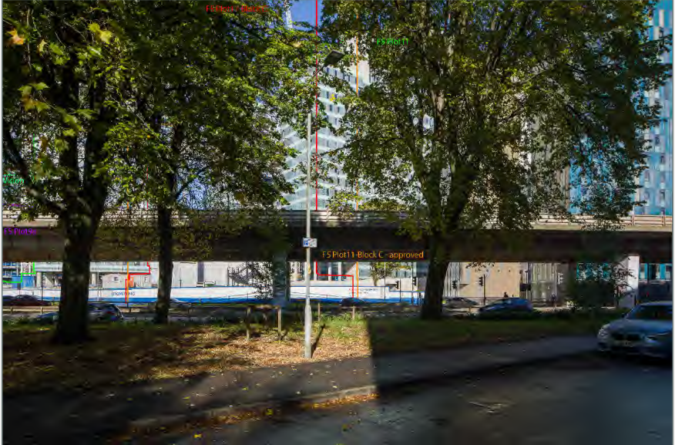
Viewpoint 14 Cumulative

Baseline: Mid-rise modern development has views to the site. The Mancunian Way is a prominent feature and beyond this development has brought the apparent edge of Manchester city centre closer. There are views of tall buildings at Parkway Gate, and Blocks B and D at FSS which are filtered by trees. The view is likely to be of some value to residents.

Townscape Impacts: The full extent of the proposal would be visible, at close proximity and in the context of tall buildings including es Blocks B and D at FSS and Parkway Gate. It would be lower than Block D but would appear similar in height. It would bring development closer to the Mancunian Way and extend the emerging pattern of tall buildings closer in the view, but its design and form would largely be similar. It would be seen from homes, although it would be partially filtered by trees. Overall, the magnitude of change would be medium.

Cumulative Impacts: One Medlock Street may be visible but there would be no further cumulative developments. Due to filtering by trees and the proximity of the proposal, there is likely to be very limited association to One Medlock Street, and therefore a negligible additional cumulative effect. The additional contribution of the proposal would be not significant (minor-negligible)/ neutral.

Impact on Heritage Assets

Former cotton mill on west side of junction with Cambridge Street (Macintosh Mill)– Grade II
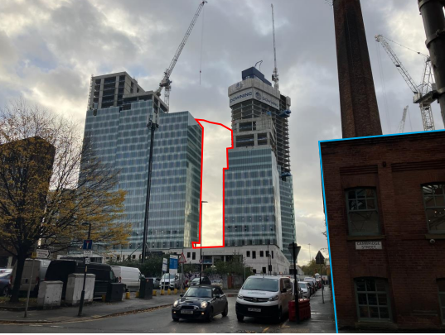
View of Macintosh Mill from Hulme Street looking west in conjunction with the Site denoted by red outline and heritage asset edged in blue

The proposal would be seen in conjunction with the heritage asset and slightly change to the way that the heritage asset is appreciated. The site is between the other three blocks which are being constructed at FSS. The proposal should blend into the emerging townscape rather than significantly altering it. The change would slightly alter, but not diminish the experience and appreciation of the building to any appreciable degree and, as such, it is considered therefore that the proposal would have no impact on the setting of the heritage asset.

Mill chimney stack on west side of junction with Cambridge Street – Grade II
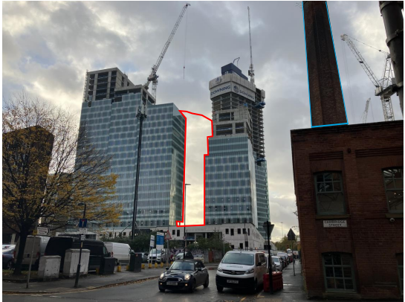
View of Macintosh Mill Chimney Stack from Hulme Street looking west in conjunction with the Site denoted by red outline and heritage asset edged in blue

The proposal would be close to this heritage asset and slightly change the way it is heritage asset appreciated. The site is surrounded by three blocks under construction, but the completed context of the scale, massing, and materiality cannot be fully understood. The proposal should blend into the emerging townscape of the surrounding area, rather than significantly altering it. The proposal would only slightly alter the experience and appreciation of the heritage asset, without diminishing its significance to any appreciable degree and it would have no impact on its setting.

Mill on north east corner of junction with Chester Street (Cambridge Mill)– Grade II
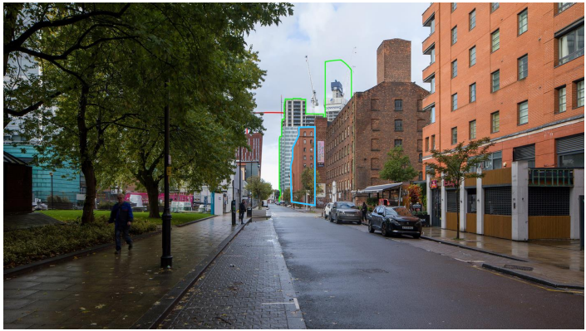
View of Cambridge Mill edged in blue from Chester Street in conjunction with Plot 11 edged in green and Block C in red.

The proposal is close to this heritage site and would be seen with it and change the way it is perceived. The proposal would be part of the group of buildings being built at FSS. It would mark the end of long views down Chester Street but would blend seamlessly with Plot 11 and not obstruct or dominate the appreciation of the heritage asset. The proposal would have no impact to the setting of the heritage asset.

Chatham Mill – Grade II
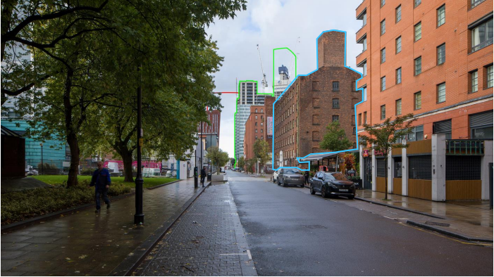
View of Chatham Mill edged in blue from Chester Street in conjunction with Plot 11 edged in green and Block C in red

The proposal would be slightly visible in conjunction with the heritage assets as they are close to each other. This would slightly change to the way that the heritage asset is appreciated. The proposal would add to the group of buildings under construction at Plot 11, FSS. The proposal would blend in with the emerging buildings at Plot 11 and would not obstruct nor dominate the viewing and appreciation of the heritage asset and would have no impact to the setting of the heritage asset.

Given the above the Proposed Development will not cause any harm identified heritage assets 1, 2, 5 and 6 and as such Paragraph 206, 207 and 208 of the NPPF are not triggered.

Effect on the Local Environment/ Amenity

This examines the impact that the scheme would have on nearby and adjoining occupiers and includes the consideration of issues such as impact on microclimate, daylight, sunlight and overshadowing, air quality, noise and vibration, construction operations and TV reception.

Daylight, Sunlight and Overshadowing

The nature of high density City Centre development means that amenity issues, such as daylight, sunlight and the proximity of buildings to one another have to be dealt with in a manner appropriate to their context.

An assessment of daylight, sunlight and overshadowing has used specialist computer software to measure the amount of daylight and sunlight available to windows in neighbouring buildings. The assessment references the BRE Guide to Good Practice – Site Layout Planning for Daylight and Sunlight Second Edition BRE Guide (2022).

This assessment is not mandatory but is generally accepted as the industry standard and helps local planning authorities consider these impacts. The guidance does not have ‘set’ targets and is intended to be interpreted flexibly. It acknowledges that there is a need to take account of locational circumstances, such as a site being within a town or city centre where higher density development is expected and obstruction of light can be inevitable. Major impacts occur when there is a reduction in excess of 40%, moderate between 30 and 40% and minor between 20 and 30%.

The daylight at 30-42 Rockdove Ave; 44-72 Rockdove Ave; Loxford Court; Block 1 Parkway Gate; Block 3 Parkway Gate; Block 2 Parkway Gate; Block B, Plot 11, First Street; Block A, Plot 11, First Street; and Block D, Plot 11, First Street could be affected. The PBSA at Parkway Gate is occupied on a temporary and short-term basis but given its proximity it has been considered. Sunlight Impacts have been modelled for sensitive windows i.e. living rooms or living kitchen diners facing within 90 degrees due south and sunlight levels within Block 1 Parkway Gate and Blocks A, B and D Plot 11, First Street could be affected.

The impact of a number of scenarios has been tested as follows:

Scenario 1: Existing baseline i.e. with committed developments schemes under construction in First Street including those set out in scenario 2 below but also including Plot 10a (136043) which is permitted but not under construction;

Scenario 2: Existing Site (baseline) with proposal including plot 11 (125573/FO/2019), 10b (136170/FO/2023) and 9a (132600/FO/2021) in First Street; and

Scenario 3: Existing Site (baseline) with proposal and cumulative development (i.e. those with planning permission, but not under construction including sites beyond First Street).

This report focuses on Scenario 2.

The assessment has scoped out other residential properties due to the distance and orientation from the site. The BRE Guidelines suggest that residential properties have the highest requirement for daylight and sunlight and states that the guidelines are intended for use for rooms where natural light is required, including living rooms, kitchens and bedrooms.

Para 129 (c) of section 11 of the NPPF states that when considering applications for housing, a flexible approach should be taken in terms of applying policies or guidance relating to daylight and sunlight, where they would otherwise inhibit making efficient use of a site; as long as the resulting scheme would provide acceptable living standards. The guidance suggests that hotels and student accommodation have a lower sensitivity to changes in daylight.

The Sunlight and Daylight Assessment has set out the current site condition VSC levels and how the proposal would perform against the BRE VSC targets.

It also considers the current site condition VSC levels (including impacts from adjacent approved schemes) and how the scheme would perform against BRE VSC and NSL targets

Daylight Impacts

The Guidelines provide methodologies for daylight assessment. The 2 tests set out in the Guidelines relevant to this development are VSC (vertical sky component) and NSL (no sky line).

VSC considers how much Daylight can be received at the face of a window by measuring the percentage that is visible from its centre. The less sky that can be seen means less daylight is available. Thus, the lower the VSC, the less well-lit the room would be. In order to achieve the daylight recommendations in the BRE, a window should attain a VSC of at least 27% but reductions or changes of 0.8 times the former value would not be appreciable by an occupant.

The guidance also states that internal daylight distribution is also measured as VSC does not take into account window size. This measurement NSL (or DD) assesses how light is cast into a room by examining the parts of the room where there would be a direct sky view. The NSL test assesses daylight levels within a whole room rather than just that reaching an individual window and more accurately reflects daylight loss. Daylight may be adversely affected if, after the development, the area in a room which can receive direct skylight is reduced to less than 0.8 times its former value. A resident would notice any reduction below this.

To assess whether the daylight amenity within a neighbouring room is likely to be adversely affected by a proposal, the BRE recommends an assessment of undertaken using the results of the above to assess the BRE and NSL targets in combination. This assessment has also been carried out to demonstrate the impacts of the proposal.

It is noted that VSC diminishes rapidly as building heights increase relative to the distance of separation. As such, the adoption of the ‘standard target values’ is not the norm in a city centre and the BRE Guide recognises that different targets may be appropriate. It acknowledges that if a building stands close to a common boundary, a higher degree of obstruction may be unavoidable and is common in urban locations.

The Guidance acknowledges that in a City Centre, or an area with modern high-rise buildings, a higher degree of obstruction may be unavoidable if new developments are to match the height and proportions of existing buildings.

Sunlight Impacts

For Sunlight, the BRE Guide should be applied to all main living rooms and conservatories which have a window which faces within 90 degrees of due south. The guide states that kitchens and bedrooms are less important, although care should be taken not to block too much sunlight. The BRE guide states that sunlight availability may be adversely affected if the centre of the window receives less than 25% of annual probable sunlight hours, or less than 5% of annual probable sunlight hours between 21 September and 21 March; receives less than 0.8 times its former sunlight hours during either period; and, has a reduction in sunlight received over the whole year greater than 4% of annual probable sunlight hours (APSH).

A scheme would be considered to comply with the advice if the base line values and those proposed are within 0.8 times of each other as an occupier would not be able to notice a reduction of this magnitude. The requirements for minimum levels of sunlight are only applicable to living areas.

Sunlight Impacts

For Sunlight, the BRE Guide explains that tests should be applied to all main living rooms and conservatories which have a window which faces within 90 degrees of due south. The guide states that kitchens and bedrooms are less important, although care should be taken not to block too much sunlight. The BRE guide states that sunlight availability may be adversely affected if the centre of the window receives less than 25% of annual probable sunlight hours, or less than 5% of annual probable sunlight hours between 21 September and 21 March; receives less than 0.8 times its former sunlight hours during either period; and, has a reduction in sunlight received over the whole year greater than 4% of annual probable sunlight hours (APSH).

A scheme would be considered to comply with the advice if the base line values and those proposed are within 0.8 times of each other as an occupier would not notice a reduction of this magnitude. The requirements for minimum levels of sunlight are only applicable to living areas.

BRE Targets

As set out above the Guidance states that a reduction of VSC to a window of more than 0.8 (20%) times or of NSL by 0.8 times (20%) does not necessarily mean that the room would be left inadequately lit, but there is a greater chance that the reduction in daylight would be more apparent. Under the Guidance, a scheme would comply, if figures achieved are within 0.8 times of baseline figures. Similarly, winter targets of APSH of 4% and an annual APSH of 0.8 times (20%) are considered to be acceptable levels of tolerance.

The BRE compliance targets referred to below are aligned with the above levels of reduction.

Daylight Impacts

With the development in place and the results weighted to make the allowance for the 20% reduction:

Scenario 2

30-42 Rockdove Ave: 20/20 windows (100%) would meet the BRE VSC Alternative Target. 20/20 rooms (100%) would meet the BRE NSL Alternative Target.

44-72 Rockdove Ave: 36/36 windows (100%) would meet the BRE VSC Alternative Target. 36/36 rooms (100%) would meet the BRE NSL Alternative Target.

Loxford Court: 74/74 windows (100%) would meet the BRE VSC Alternative Target. 62/62 rooms (100%) would meet the BRE NSL Alternative Target.

Block A Plot 11 First Street : 139/172 windows (81%) would meet the BRE VSC Alternative Target. 148/148 rooms (100%) would meet the BRE NSL Alternative Target.

Block 1 Parkway Gate: 226/253 windows (89%) would meet the BRE VSC Alternative Target. There would be a minor impact to 22 windows and a moderate impact to 2 windows. 174/186 rooms (94%) would meet the BRE NSL Alternative Target.There would be a minor impact on 11 rooms and moderate impact on 1 room.

In terms of daylight amenity (VSC & NSL) 167 (90%) of the 186 rooms would be fully compliant in terms of the BRE combined target. 15 of the remaining 19 rooms would experience changes in VSC and/or NSL which are minor. The effect upon the daylight amenity within these 15 rooms would be minor.

The windows serving 3 of the remaining 4 rooms would experience absolute changes in VSC of between 3.2% and 3.9% which is considered to be minor adverse.

The windows serving the remaining room would experience minor changes in VSC and a change in NSL of 31%. The effect of the proposal on the daylight amenity within these rooms would be minor adverse.

The overall effect of the proposal on daylight in this property would be minor adverse.

Block 3 Parkway Gate: 0/105 (0%) of windows would meet the BRE VSC Alternative Target. There would be a major impact to the 105 affected windows. 17/91 rooms (19%) would meet the BRE NSL Alternative Target. There would be a minor impact on 5 rooms, moderate impact on 19 rooms and major impact on 50 rooms.

105 windows to 91 rooms were assessed for daylight and the impact on all would be major. On the 10 lowest and thereby most sensitive floors, the retained VSC’s range from 8% to 16% with the average retained value being 12%. The reason for the large percentage of baseline changes is that the windows in this property derive light over a cleared site. Therefore the effect would be minor adverse, taking into account the lower sensitivity being transient rather than permanent residents.

Block 3 is more affected than the other Parkway Gate blocks as its main façade has an unobstructed view across the site. Whilst the other Blocks also have a view over the same site, their view is obstructed by Block B.

Block 2 Parkway Gate: 89/129 (69%) of windows would meet the BRE VSC Alternative Target. There would be a minor impact to 27 windows and a moderate. impact to 13 windows. 78/86 rooms (91%) would meet the BRE NSL Alternative Target. There would be a minor impact on 6 rooms and moderate impact on 1 room.

129 windows to 86 rooms were assessed for daylight. The changes in daylight amenity (VSC & NSL) to 101 (78%) rooms would be fully compliant in terms of the BRE combined target.

24 of the remaining 28 rooms experience VSC changes and/or NSL which are considered to be minor adverse. The windows serving 3 of the remaining 4 rooms will experience changes in VSC of between 3.2% and 3.9% which, whilst small, and impacts are considered to be moderate adverse in view of the low baseline values. In view of the small actual changes in VSC the effect would be minor adverse. The windows to the remaining room would experience minor changes in VSC and a change in NSL of 31%. The effect of the proposal on daylight in this rooms would be minor adverse. The overall effect on daylight amenity would be minor adverse.

Block B, Plot 11: 247/283 (87%) of windows would meet the BRE VSC Alternative Target. There would be a minor impact to 21 windows and a major impact to 15 windows. 264/264 rooms (100%) would meet the BRE NSL Alternative Target.

283 windows to 264 rooms were assessed for daylight. Changes to daylight amenity (VSC & NSL) to 235 (89%) of the 264 rooms would be fully compliant in terms of the BRE combined target. 14 of the remaining 29 rooms would experience changes in VSC and/or NSL which would be minor adverse.

The remaining 15 rooms have 2 windows, one of which would experience a major change in VSC. The other window would be affected to either a negligible or minor extent. The latter windows would be affected to a negligible to minor extant and retain VSC levels of between 18% and 32%. All of the windows affected to a major extent would retain VSC levels above 15%. These retained levels of VSC also mean that all of these 15 rooms would be compliant in NSL terms.

Overall and in consideration of the levels of retained daylight amenity, the effect of the proposal would be minor adverse.

Block D, Plot 11: 447/474 (94%) of windows would meet the BRE VSC Alternative Target. There would be a minor impact to the remaining 27 windows. 202/202 rooms (100%) would meet the BRE NSL Alternative Target.

A total of 474 windows serving 202 rooms were assessed for daylight within this property. Changes in daylight amenity (VSC & NSL) to 186 (92%) of the 202 rooms would be fully compliant in terms of the BRE combined target.

The remaining 16 rooms will experience changes in VSC and/or NSL which are minor. The effect upon the daylight amenity within these 16 rooms is therefore considered to be minor adverse.

The overall effect of the Proposed Development upon the daylight amenity within this property is considered to be Minor Adverse.

Sunlight

Block 1 Parkway Gate: 45/50 (90%) of windows would meet the BRE Alternative Target for annual APSH and 50/50 (100%) of windows would meet the BRE Alternative Target for winter APSH. There would be a minor impact to 1 window, moderate impact to 1 window and a major impact to 3 windows for annual APSH.

The overall effect of the Proposed Development upon the sunlight amenity within this property is considered to be minor adverse (not significant).

A total of 101 windows serving 50 rooms were assessed for sunlight within this property. Changes in sunlight amenity to 45 of the 50 rooms assessed will be fully BRE compliant. 1 of the remaining 5 rooms will experience APSH changes which are minor. The effect upon the sunlight amenity within this room is therefore considered to be minor adverse. The remaining 4 rooms all have low baseline values of total APSH and 0% baseline winter APSH values. The relatively small 6% to 9% absolute change in total APSH therefore present themselves as moderate to major adverse. In view of the isolated number of rooms affected and the low sensitivity of the property being student accommodation (i.e., transient residential rather than permanent), the overall effect of the Proposed Development upon the sunlight amenity within this property is considered to be minor adverse.

Block B Plot 11, First Street: 200/202 (99%) windows would meet the BRE Alternative Target for annual APSH and 201/202 (99.5%) would meet the Target for winter APSH. The impact on the window that does not meet that target would be moderate.

206 windows to 202 rooms were assessed for sunlight. Changes in sunlight amenity to 199 (99%) of the 202 rooms assessed will be fully BRE compliant.

The remaining 3 rooms would experience moderate to major changes in winter and/total sunlight amenity. They will, however, retain winter sunlight amenity levels of between 4% and 8% against the BRE recommended 5% and total sunlight amenity of between 24% and 30% against the BRE recommended 25%. In view of the very good levels of retained sunlight amenity, the effect upon theses rooms is considered to be Minor.

In view of the very isolated number of rooms affected and the reasonable in an urban context retained values to the affected rooms, the overall effect of the Proposed Development upon the sunlight amenity within this property is considered to be Minor Adverse.

Block A Plot 11, First Street: 18/19 (95%) windows would meet the BRE Alternative Target for annual APSH and 19/19 (100%) would meet the Alternative Target for winter APSH. There impact to the window that does not meet this target would be minor.

Block D Plot 11, First Street: 136/148 (92%) windows would meet the BRE Alternative Target for annual APSH and 136/148 (92%) would meet the alternative Target for winter APSH. There would be a minor impact to 4 windows, moderate impact to 3 and a major impact to 5 for annual APSH and a major impact to 12 for winter APSH.

339 windows to 148 rooms were assessed for sunlight. Changes in sunlight amenity to 136 (92%) of the 148 rooms assessed will be fully BRE compliant. 1

The remaining 12 rooms experience changes in annual sunlight amenity ranging from minor to major and retain total APSH levels of between 11% and 22% against the BRE recommended 25% and major changes in winter sunlight amenity and retain winter APSH levels of 3% against the BRE recommended 5%.

In view of the isolated number of rooms affected and the reasonable in an urban context retained values to the 12 affected rooms, the overall effect of the Proposed Development upon the sunlight amenity within this property is considered to be Minor Adverse.

A cumulative assessment (scenario 3) has also been carried out.

Daylight Impacts

30-42 Rockdove Ave: 20/20 windows (100%) would meet the BRE VSC Alternative Target. 20/20 rooms (100%) would meet the BRE NSL Alternative Target.

44-72 Rockdove Ave: 34/36 windows (94%) would meet the BRE VSC Alternative Target. 36/36 rooms (100%) would meet the BRE NSL Alternative Target. There would be a minor impact to 2 windows.

Loxford Court: 74/74 windows (100%) would meet the BRE VSC Alternative Target. 62/62 rooms (100%) would meet the BRE NSL Alternative Target

Block 1 Parkway Gate: 223/253 windows (98%) would meet the BRE VSC Alternative Target. There would be a minor impact to 25 windows and a moderate impact to 5 windows. 174/186 rooms (94%) would meet the BRE NSL Alternative Target. There would be a minor impact in 11 rooms and moderate impact in 1 room.

Block 3 Parkway Gate: 0/105 (0%) of windows would meet the BRE VSC Alternative Target. There would be a major impact to the 105 affected windows. 17/91 rooms (19%) would meet the BRE NSL Alternative Target. There would be a minor impact in 5 rooms, moderate impact in 61 rooms and major impact in 53 rooms.

Block 2 Parkway Gate: 89/129 (69%) of windows would meet the BRE VSC Alternative Target. There would be a minor impact to 27 windows and a moderate. impact to 13 windows. 78/86 rooms (91%) would meet the BRE NSL Alternative Target. There would be a minor impact in 6 rooms, moderate impact in 1 room and major impact in 1 room.

Block B, Plot 11 First Street: 247/283 (87%) of windows would meet the BRE VSC Alternative Target. There would be a minor impact to 21 windows and a major impact

Block A, Plot 11 First Street: 119/172 (69%) of windows would meet the BRE VSC Alternative Target. There would be a minor impact to 52 windows and a moderate. impact to 1 window. 129/148 rooms (87%) would meet the BRE NSL Alternative Target. There would be a minor impact in 11rooms, moderate impact in 7 rooms and major impact in 1 room.

Block D, Plot 11 First Street: 447/474 (94%) of windows would meet the BRE VSC Alternative Target. There would be a minor impact to 27 windows. 202/202 rooms (100%).

Sunlight Impacts

Block 1 Parkway Gate: 45/50 (90%) of windows would meet the BRE Alternative Target for annual APSH and 50/50 (100%) of windows would meet the BRE Alternative Target for winter APSH. There would be a minor impact to 1 window, moderate impact to 1 window and a major impact to 3 windows for annual APSH.

Block B Plot 11, First Street: 199/202 (98%) of windows would meet the BRE Alternative Target for annual APSH and 201/202 (99.5%) of windows would meet the BRE Alternative Target for winter APSH. The impact on the window that doe not meet that target would be moderate.

Block A Plot 11, First Street: 18/19 (95%) of windows would meet the BRE Alternative Target for annual APSH and 19/19 (100%) of windows would meet the BRE Alternative Target for winter APSH. There would be a minor impact to the 1 window that does not meet the alternative target.

Block D Plot 11, First Street: 136/148 (92%) of windows would meet the BRE Alternative Target for annual APSH and 136/148 (92%) of windows would meet the BRE Alternative Target for winter APSH. There would be a minor impact to 4 windows, moderate impact to 3 windows and a major impact to 5 windows for annual APSH and a major impact to 12 windows for winter APSH.

Overall, the impact on daylight and sunlight to affected properties would be negligible to minor adverse and the impact on sunlight would be negligible to minor adverse.

For Loxford court, the average VSC daylight level with the extant consent in place is 24.30%, whilst the average VSC daylight level with the proposal in place would be 23.69%.

Where windows receive a VSC daylight level in excess of 20% with the consented scheme in place, they will also do so with the proposed scheme in place. Where windows receive a VSC daylight level of less than 20% with the extant consent in place, there would be no additional impact from the proposal. There are marginal differences in VSC daylight to some windows, however this difference is around 1% or less in almost all cases, and the largest absolute difference is 1.4% to a fifth floor window, which is reduced from 24.2% VSC to 22.8% VSC.

Similarly, the average VSC daylight level of the properties on Rockdove Avenue would be 30.06% with the extant consent in place, whilst the average VSC daylight level with the proposal in place would be 29.18%.

The greatest difference in VSC daylight level is 1%, and crucially, all of the windows will continue to receive good levels of daylight. None of the windows are oriented within 90 degrees of due south so no assessment of APSH sunlight is necessary.

With the proposal in place, the VSC daylight levels of Loxford Court and Rockdove avenue are comparable to the extant permission. The difference in height and shape of the proposal mean there would be some marginal differences, these differences all comply with the BRE Targets, and occupants would not notice them.

There would be reductions against the baseline conditions for daylight and sunlight for some residents in Parkway Gate and Blocks A, B and D of Plot 11 First Street. Some impact is inevitable if the site is to be redeveloped to a scale appropriate to its city centre location and in First St.

The impact on the daylight and sunlight is important. However, some impact is inevitable if the site is to be redeveloped to a scale appropriate to its city centre location. The following are important considerations:

- Parkway Gate is a PBSA scheme and the residents are not permanent.

- Buildings that overlook the site have benefitted from conditions that are relatively unusual in a City Centre context;

- It is generally acknowledged that when buying/renting properties in the heart of a city centre, that there will be less natural daylight and sunlight in homes than could be expected in the suburbs;

- High density development is not unusual in the City Centre;

It is considered that the above impacts are acceptable in a City Centre context.

Solar Glare

There are two types of glare: disability glare, which is a safety issue; and discomfort glare, which includes solar reflections impacting adjacent buildings. Discomfort glare does not impair the ability to see but it can be important where work involves continuous viewing from a fixed vantage point. This would be typical of the site’s urban location and could occur with any redevelopment that includes glazing. It can generally be managed by using blinds or curtains. For these reasons, residential uses are classified as having low-sensitivity any impact on residential amenity is not expected to be significant and does not require assessment.

An assessment of disability glare has been prepared. A 3D computer model of the area, roads, train track, train station and signals has been created to calculate the glare levels in 8 selected viewpoints.

17 locations sensitive to road users have been identified and assessed. Due to distance no train or tram tracks are considered sensitive for this site.
The following nine road locations would be minor adverse and not significant. Mancunian Way Westbound (MW1, MW2 & MW3); Mancunian Way Slip Road/Medlock Street Junction (Slip3); Medlock Street (MS1); Cambridge Street junction with Mancunian Way on-ramp (CBS); Newcastle Street junction with Loxford Street (NS); Princess Street junction with Stretford Road (PR1); and Princess Street merging traffic (PR2). MW1, MW2 & MW3 are more dynamic viewpoints along a stretch of road which represents what a driver travelling eastbound would typically experience as they travel along the road and where no action is required by the drivers. It is for this reason the viewpoints are assessed together. This is the same approach used when assessing solar glare effects to train drivers.
6 road locations would experience minor to moderate adverse effects which are considered significant in terms of solar glare: Mancunian Way Eastbound (MW4-MW6); Mancunian Way Slip Road/Medlock Street Junction (Slip1); Medlock Street junction with Mancunian Way on ramp (MS2); Chester Street junction with Cambridge Street (CS1); and
2 road locations would experience moderate adverse effects which are significant, these are: Mancunian Way Slip Road/Medlock Street Junction (Slip2); and Chester Street junction with Wilmott Street (CS2).
The façade design includes measures to mitigate this including • the use of anodised aluminium ventilation panels to break up reflections; and • facetted facades so that large areas of flat glazing of the same angle are avoided and each panel is at an alternative angle from the panels reflecting sunlight at a different time to the adjacent panel.
The location and scale of the proposal mean that reflections are unavoidable. The assessment has assumed that the sun shines every day of the year to consider all potential circumstances. The probability of the sun shining during the times of the year when potential reflections are expected to occur ranges from 10% in the early mornings/mid-afternoons from the mid-seasons (mid-seasons typically considered mid-February to mid-April and mid-August to mid-October) through winter months, up to 40%-50% in the mid-seasons in the afternoon. The assessment does not include the sun itself also causes very intense glare to drivers at all of the affected viewpoints. In all of the views, the sun would be directly visible at other times of the day if the proposal was not present. In comparison, the reflections from the proposal would appear less intense and would not cause significantly worse effects when compared with a direct view of the sun.
To reduce these effects, a low reflectance glazing would reduce the intensity of any reflections. A glazing specification with a maximum Visible Light Reflectance (VLR) of 13% should be used. Prior to installation a detailed Solar Glare intensity assessed should be undertaken specification to confirm the glazing selected addresses the effects identified. This would be a condition.
Subject to mitigation the proposal would not significantly affect solar glare to drivers at surrounding road junctions above that currently experienced in terms of the site condition and with the proposal and mitigation in place the impacts would reduce.

Sunlight to Open Spaces

Open spaces should retain a reasonable amount of sunlight throughout the year and the Guidance recommends that to appear adequately sunlit throughout the year, at least 50% of a garden or amenity area should receive at least two hours of sunlight on the 21st March. If a detailed calculation cannot be carried out, it is recommended that the centre of the area should receive at least two hours of sunlight on the 21st March. Existing open spaces should receive at least two hours of sunlight on the 21st March on at least 50% of their area or at least 0.8 times the former area receiving two hours of sunlight.

The following five sensitive areas have been assessed to establish the effect of the proposal on the levels of sunlight on the ground:

Public Park, Plot 11, First Street; Block B Plot 11, First Street, Private; Block A Plot 11, First Street (Private); Block A Plot 11, First Street, (Private); and Block D Plot 11, First Street, (Private). Only Block A’s areas of amenity space would be adversely affected by the construction of the proposal in terms of whether it would receive adequate sunlight throughout the year. When the shadow that falls upon them during the summer months, when they are most likely to be frequented is assessed, there will, however, be an abundance of sunshine. The overall effect upon the sunlight amenity upon the above spaces is, therefore, considered to no greater than minor adverse.

Privacy and Overlooking

The proposal has been designed to minimise the potential for overlooking into surrounding properties. The closest residential building is Block B of Plot 11, under construction, which is adjacent to the proposal, directly facing Block C. Directly facing elevations are 12m apart, however this is a gable end and therefore there are no issues in terms of overlooking. Other buildings in close proximity include Block D (over 20m) and Parkway Gate (over 24m) which are in excess of the 20m suggested as a ‘norm’ between properties in Manchester’s Residential Quality Guidance..

Wind

Changes to the wind environment can impact on how comfortable and safe the public realm is. If changes cannot be designed out, they should be minimised by mitigation measures. A Wind Microclimate report focused on the impact on people using the site and surrounding area. This has been modelled using Computational Fluid Dynamics which simulates the effect of wind and is an acceptable industry standard alternative to wind tunnel testing, combined with adjusted meteorological data from Manchester Airport. The assessment used the Lawson Comfort Criteria, which seek to define the reaction of an average pedestrian to the wind. The potential impacts were modelled within a 450m radius which is consistent with the UK industry standard for an ES Assessment. The scenarios were 360deg full rotations, and gusts were accounted for using the standard gust-equivalent-mean method.

The sensitive receptors are people using the public realm and outdoor facilities including the seating area. This latter is highly sensitivity to strong winds, which can pose a risk to pedestrian safety. General thoroughfares are of medium sensitivity as people tend not to dwell for significant periods in specific regions. Bus stops, building entrances and amenity spaces are of high sensitivity to pedestrian comfort. Under construction consents within 400m radius were included, which is the UK industry standard for capturing local features which might be affected.

The assessment has considered a number of scenarios:

Existing baseline i.e., site with developments under construction;
Existing Site (baseline) with the proposal;
Existing Site (baseline) with the proposal and mitigation;
Existing Site (baseline) with the proposal, mitigation and cumulative development (i.e., those with planning permission).

In all scenarios, the Lawson criteria are met at the Site and surrounding area, while conditions are suitable for existing and planned uses. The effect is negligible and is not significant. Cumulative effects would be negligible.

Air quality

An air quality assessment (AQA) has considered changes to air quality during construction and in operation. The site is in an Air Quality Management Area (AQMA) where air quality is known to be poor because of surrounding roads. As such, occupiers could experience poor air quality and vehicles travelling to and from the site could increase pollution levels in this sensitive area.

Homes, businesses, educational facilities and recreational areas could be affected by construction traffic and from the proposal. A qualitative risk assessment based on the Institute of Air Quality Management’s (IAQM) ‘Guidance on the Assessment of Dust from Demolition and Construction’ document, published in 2014 has assessed the potential effects during construction of dust and particulate emissions from site activities and materials movement.

The assessment of the air quality impacts of the completed scheme has focused on the predicted impact of changes in ambient nitrogen dioxide (NO2) and particulate matter with an aerodynamic diameter of less than 10 μm (PM10) and less than 2.5 μm (PM2.5) at key local locations. The magnitude and significance of the changes have been referenced to non-statutory guidance issued by the IAQM and Environmental Protection UK (EPUK). The construction and operational impacts on air quality have been considered.

Window would be airtight and ventilation mechanical although residents could choose to open rapid vents. The impact on human health would be low and further minimised by dust suppression and other good practice which must be secured and implemented through the construction management plan condition. The AQA confirms that mitigation measures are required during construction to minimise dust impacts. Good on site practices would ensure dust and air quality impacts are not significant. This should remain in place for the duration of the construction period and should be the subject of a condition. Heating, cooling and hot water provision would be provided by air source heat pumps.

The impacts on air quality once complete would be negligible. Pollutant concentrations at the façades would be within the relevant health-based air quality objectives. Occupants would be exposed to acceptable air quality and the site is deemed suitable for its proposed future use.

There would be 116 cycle spaces in the building and a further 12 in the public realm. An Interim Travel Plan includes measures that promote the use of sustainable transport. These seek to reduce reliance on the private car and limit adverse impacts on air quality. Since all modelled NO2 values are below 60μg/m3, exceedance of national short-term NO2 objectives is unlikely at all floors Exceedances of fine particulate (PM10) and (PM2.5) objectives is unlikely. As there are no exceedances of annual mean NO2 concentrations at building facades, there will be no requirement for gaseous filtration.

Noise and Vibration

Whilst the principle of the proposal is acceptable, the impact of adjacent noise on occupiers needs to be considered. A Noise Report concludes that with appropriate acoustic design and mitigation, the internal noise levels would be acceptable.

The level of noise and mitigation measures required for any externally mounted plant and ventilation should be a condition.

Access for deliveries and service vehicles would be restricted to daytime hours to mitigate any impact on adjacent residential accommodation.

During the operational phase the proposal would not produce noise levels or vibration that would be significant. Disruption could arise during construction. The applicant and their contractors would work and engage with the local authority and local communities to minimise disruption. A Construction Management Plan should be a condition and would provide details of mitigation methods. Construction noise levels have been estimated based on worst case assumptions to be of moderate temporary adverse.

Following mitigation construction noise is not likely to be significant. Acceptable internal noise levels can be achieved with relatively standard thermal glazing.

TV and Radio reception and Broadband

A Baseline TV and Radio Impact Assessment has been prepared based on technical modelling in accordance with published guidance to determine the potential effects on the local reception of television and radio broadcast services.

The development is likely to cause reception issues for the reception of digital satellite television services in areas to the south west of the Site. If any interference does occur, the installation of a satellite dish or upgrading of aerials should restore reception. It is also possible that the television services could be supplied by an alternate transmitter in the surrounding area. Any interference arising from tower crane use is expected to be limited in duration (present only during operations i.e. working hours) and will cease completely when the cranes are removed.

The development is unlikely to adversely impact the reception of VHF(FM) radio broadcasts due to the existing good coverage in the survey area and the technology used to encode and decode radio signals.

It is recommended that any reported television or radio interference should be investigated by means of a post-construction reception measurement. Should there be any post construction impact a series of mitigation measures have been identified which could be controlled by a condition.

The location of the site is such that it is ‘high speed’ ready with the infrastructure is in place for the development to be connected into superfast broadband.

Architectural Quality

The key factors to evaluate are the buildings scale, form, massing, proportion and silhouette, materials and its relationship to other structures. Developments of this scale should be an exceptional and well considered design response. The quality of the detail, including window recesses and interfaces between the different components is key to creating a successful scheme.

The Core Strategy policy on tall buildings seeks to ensure that they complement the City's existing buildings and make a positive contribution to the creation of a unique, attractive and distinctive City. It identifies sites within and immediately adjacent to the City Centre as being suitable for tall buildings. The application proposes a high-quality building, with a clearly defined street edge.

The new proposal would have a smaller footprint and would be more slender and the amount of public realm has increased. The more slender tower on a stepped podium would help to reduce the overall massing. The appearance of the tower would be similar to Block D. The materials for the tower would be the same glazed curtain walling with the horizontal fritted banding as Blocks A,B & D.

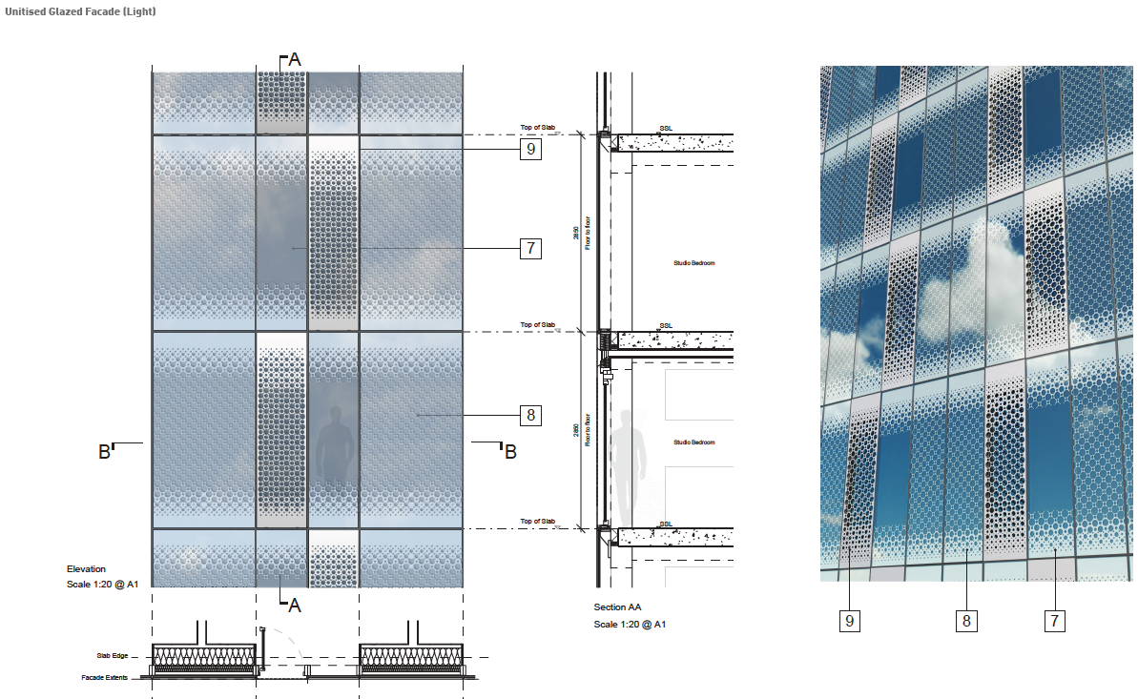
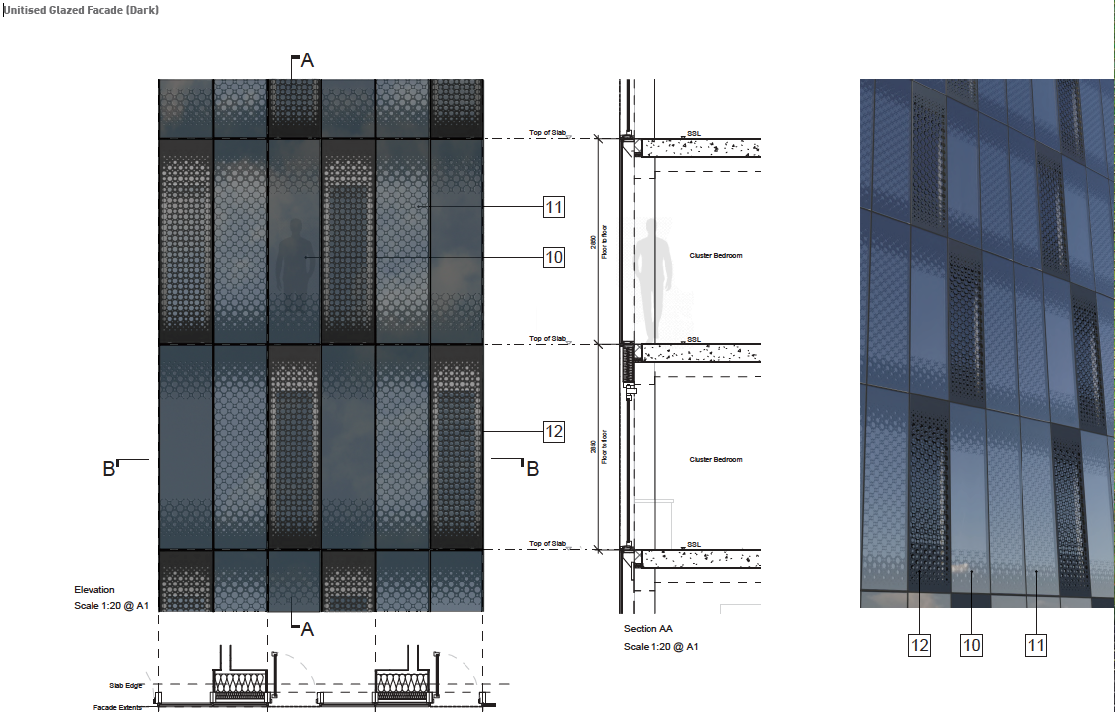

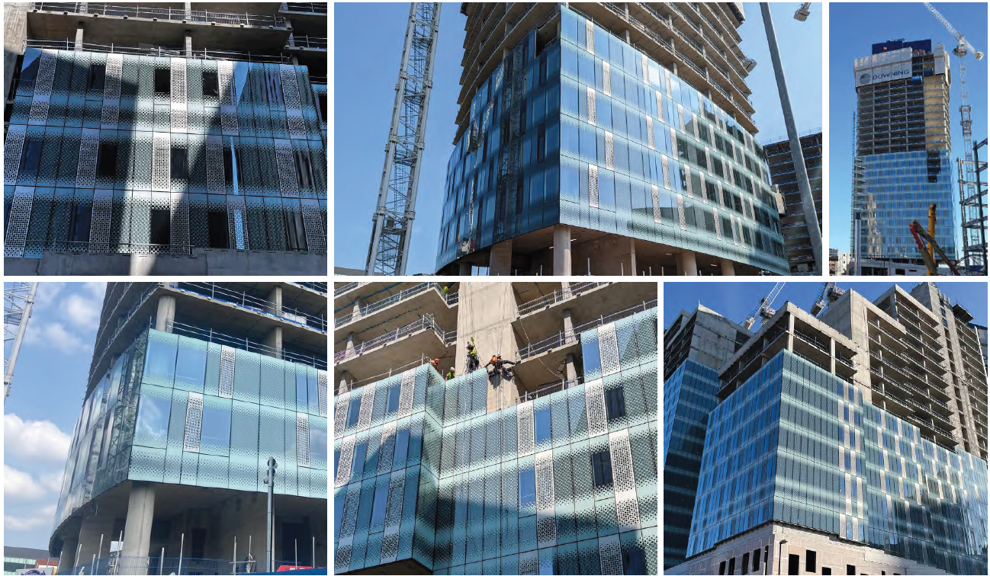

The above images show the facades of Blocks A,B & D under construction. The banding on the facades would give the tower a distinctive appearance. It would be a different architectural solution to the towers at Great Jackson Street. When viewed up close the fritted and perforated pattern provides texture. At ground level, the podium would relate to the public realm. A glazed brick would provide colour, texture and articulation to detailing of the podium.

A brick band at 3m would unify all the components of the podium and provide a datum for all openings.
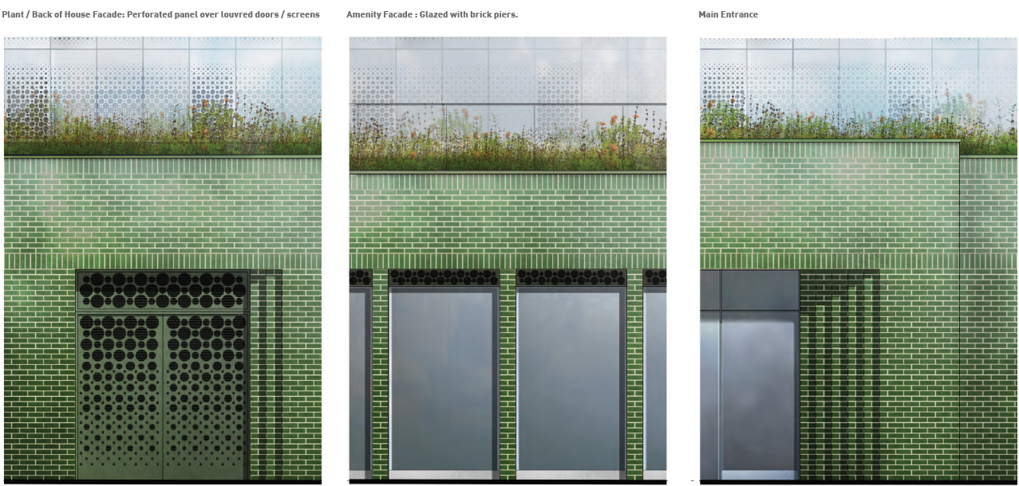

Openings in the podium would be articulated with brick set backs, and the main entrance would have much greater depth and more reveals. Active frontages and new public space would l help activate this emerging area.

All metal doors, louvred doors and louvred openings in the podium will have a decorative perforated screen to screen the functional weather louvres behind. This perforated screen would be colour matched to the green brick.

Overall, the building would be of a high architectural quality and would complement the surroundings and emerging developments at First Street.

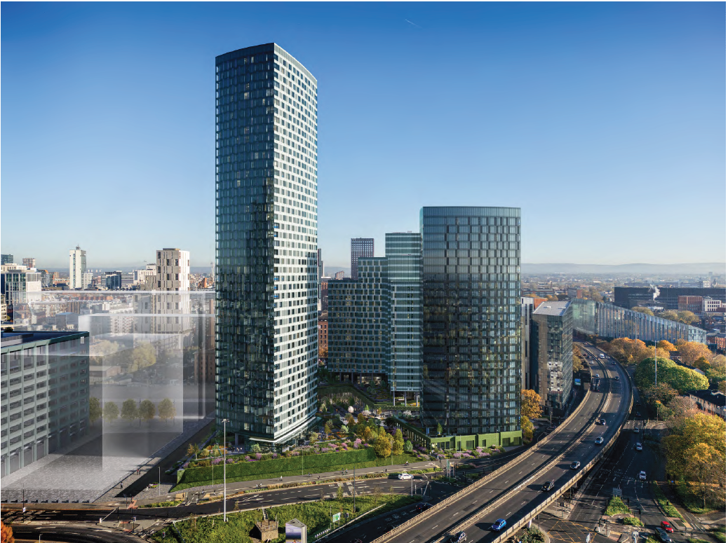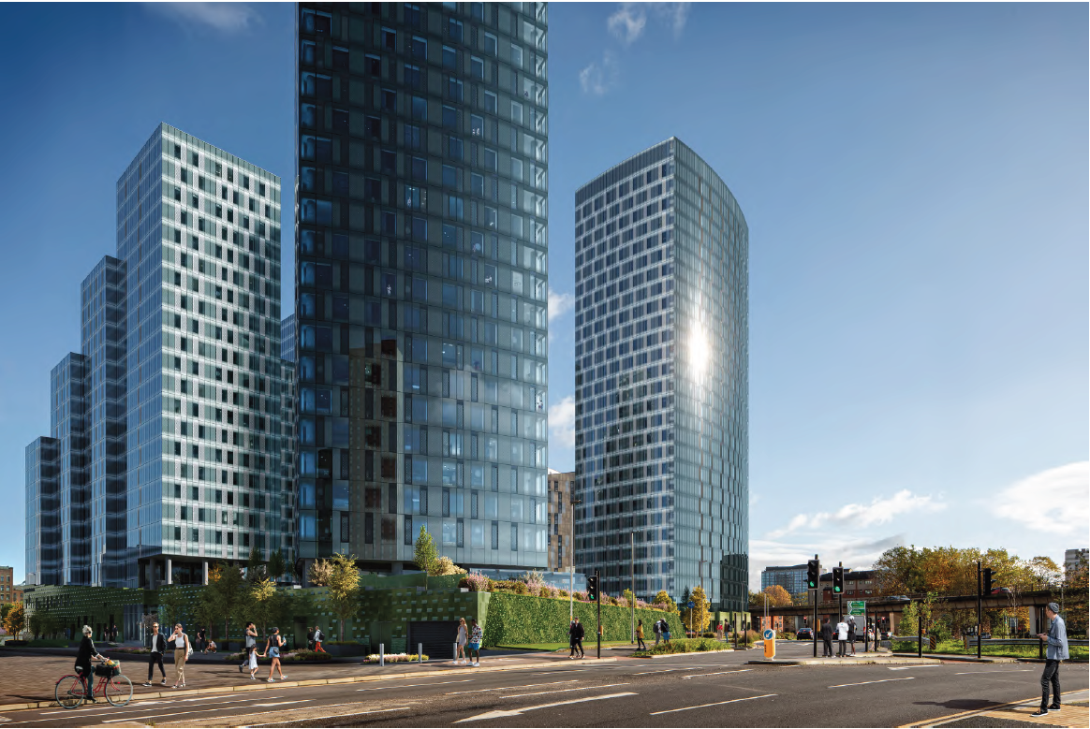

Conclusions in relation to CABE and English Heritage Guidance and Impacts on the Local Environment.

The application would meet the requirements of the CABE and EH guidance as well as the policy on Tall Buildings within the Core Strategy and as such the proposal would provide a building of a quality acceptable.

Crime and Disorder - The increased footfall, additional residents and improved lighting would improve security and surveillance. Greater Manchester Police have provided a crime impact assessment and the scheme should achieve Secured by Design accreditation. A condition is recommended.

Archaeological issues -.An archaeological excavation was undertaken at the site by Pre-Construct Archaeology (PCA) and an assessment report of the results (dated June 2017) was submitted as part of an application (CDN/18/0326) to discharge Condition 25 of application 111170/FO/2016/C1. Consequently, there are no significant archaeological remains that would be impacted upon by development of Block C. However following concerns raised that the wider archaeological investigations within First Street which include this site have not been adequately disseminated a condition will be attached to any consent granted requiring information on this to be provided within the public realm/

Biodiversity and Wildlife Issues/ Contribution to Blue and Green Infrastructure (BGIS) / Climate change adaptation and mitigation from Green Infrastructure - The site contains no statutory nature conservation sites, none are within 1km of the site and those situated further afield are considered unlikely to be impacted. The habitats and plant species recorded at the site are widespread and common throughout Greater Manchester and the UK. None of the plant species are either Nationally Scarce or Nationally Rare given the relative isolation of the site from larger areas of semi-natural habitat, and the lack of suitable refuge for protected species.

The site could provide a relatively limited foraging resource for local populations of birds. The has very limited foraging potential for black redstart and is unlikely, therefore, to form a key part of the foraging habitat for any local populations of black redstart. The on site tree could offer suitable for nesting birds.

The site provides a small area of low quality foraging habitat and is unlikely to be used by significant numbers of foraging bats. There is a known common pipistrelle bat roost in the River Medlock culvert which runs underneath First Street North however foraging behaviour is confined to the river corridor so it is unlikely bats would commute to or across the site to forage. An existing tree on the site would be incorporated into the landscaping.

There are opportunities to maintain and enhance the biodiversity on the site and improve connectivity to adjacent habitats by providing ‘ecological stepping stones’ to link to green/blue infrastructure. The proposal would include landscaping and tree cover. This could secure ecological enhancement for both flora and fauna. Measures to mitigate habitat loss and improve biodiversity are included in the Ecology Report.

Manchester Green & Blue Action Strategy highlights that Manchester needs to be a green city and a growing city. Urban greenery would be created in the proposed public realm. The tree planting and soft landscaping would improve biodiversity and form corridors which enable natural migration. This would increase opportunities for habitat expansion leading to greater ecological value.

Waste and Recycling - A waste management strategy details how waste would be managed. It has considered the potential refuse and recyclable waste volumes, including potential organic waste, and for all uses of the proposal in accordance with the Waste Storage and Collection Guidance for New Developments.

The refuse store would be on the ground floor with access to the service yard. Students would take their waste to a ground floor refuse drop lobby where there would be chutes into the bins. It is expected that PBSA waste would be collected via a private regime every 3 days. The management staff would move the bins out on collection days to the dedicated area before moving them back following collection.

Environmental Health consider the waste management arrangements to be acceptable subject to it being managed by a Commercial Waste Operator.

Flood Risk and Sustainable Urban Drainage Strategy (Suds) – The site, is in Flood Zone 1 and this is of a low risk of flooding.

The site is in the Core Critical Drainage Area in the Council Strategic Flood Risk Assessment and requires a 50% reduction in surface water run-off as part of brownfield development. Hydraulic modelling of the River Medlock indicates that with the above mitigation the site would not flood in a 1 in 100 year event, (with climate change taken into consideration), as the Site levels would be above the modelled flood levels.

The Flood Risk Assessment (FRA) has reviewed all sources of flood risk to the proposal and to existing adjacent properties and finds that the site is not at significant flood risk, nor does it increase flood risk off-site. Given the site is largely hard standing the proposal would not be likely to increase the impermeable area and is not likely to increase risk of surface water flooding. Discharge from the site would be restricted to a 50% betterment applied in accordance with planning policy.

The surface water drainage strategy has followed the hierarchy of drainage solutions. Sustainable Drainage Systems (Suds) would be implemented where possible to enable discharge, volume and water quality control of the surface water runoff and reduce flood risk on site. Sustainable drainage features and rain gardens would be incorporated into the public realm.

The drainage strategy is to install surface water attenuation. There is potential for small areas of permeable surfacing that will not infiltrate and SuDS enabled tree pit systems to capture low rainfall events which can be explored through a condition.

The initial SUDS assessment demonstrates that surface water run-off can be drained effectively in accordance with policy principles.

The foul and surface water drainage systems would be kept separate on the application site prior to discharge. The strategy would be to construct a separate foul drainage system which would either connect directly into the diverted public sewer system in River Street.

Contaminated Land - A review of site investigation and risk assessments carried out at the site The site investigation and risk assessment are considered appropriate for the site and consistent with recognised guidance and best practice.

Industrial activities have historically taken place over time. The site has been used for potentially contaminative land uses which includes a coal yard, engineering works and garage. Off-site potentially contaminative uses include the former Gaythorn gasworks and rubber works to the north. Some of the pre-commencement conditions on the previous residential consent were discharged and this included agreement of a detailed remediation strategy. The implementation of this would be a condition.

The site was affected by WW2 bomb damage. Although no UXO was encountered during previous investigations there is still a risk of UXO that would need to be mitigated prior to any ground investigation.

Further excavations are necessary to fully assess the site. Site mitigation measures may be required but with these in place, the site would present a low risk to people in the future. A condition would require a full site investigation and remediation measures to be submitted and agreed.

A requirement for this investigation can be secured via a condition. If ordinance is found, a specialist UXB team would be engaged to assess next steps and to draw up risk assessments for any continuing works which would be carried out in accordance with provide best practice guidance for the industry (CIRIA).

Accessibility/ Inclusive Access – The design has sought to avoid discrimination regardless of disability, age or gender by, wherever possible. This covers the access to and within the building and public realm.

The proposal would be accessible. There is level access into the building entrance lobby off Newcastle Street. All floors would be accessible by lift. There are 2 disabled parking spaces proposed as part of the development on Chester Street close to the building entrance.

27 (5%) of rooms would be capable of being fully accessible split equally between clusters and studios. 11 (2%) studios for those with accessibility needs would fitted out from the outset. The remainder would be M4 (2) adaptable to be tailored to specific needs when requested. Accessibility adaptations would be included within kitchen areas in the clusters with accessible rooms.

Fire safety - The HSE has not raised any concerns but has made a number of comments. Government advice is very clear that the review of fire safety at gateway one through the planning process should not duplicate matters that should be considered through building control. The issues raised in this instance are matters that should be addressed through building control and are not land use planning issues. The applicant has responded to these comments and the issues are being considered early in the design process as a result of the consultation at Gateway one. Fire Safety measures in relation to site layout, water supplies for firefighting purposes and access for fire appliances is addressed in the Fire Safety Report and subsequent supplementary information will be a condition.

On this basis it is considered that that there are no outstanding concerns which relate to the remit of planning as set out in the Fire safety and high-rise residential buildings guidance August 2021.

Local Labour – A condition would require the Council’s Work and Skills team to agree the detailed form of the Local Labour Agreement.

Construction Management – Measures would be put in place to minimise the impact on local residents such as dust suppression, minimising piling and use of screenings to cover materials. Plant would also be turned off when not needed and no waste or material would be burned on site. Provided appropriate management measures are put in place the impacts of construction management on surrounding residents and the highway network can be mitigated to be minimal.

Aerodrome Safeguarding

There are no safeguarding issues associated with the site.

CONCLUSION

The proposal conforms to the development plan taken as a whole as directed by s38 (6) of the Planning and Compulsory Purchase Act 2004 and there are no material considerations which would indicate otherwise.

Notwithstanding the objections received, this decision had been made under delegated powers as the proposals is in accordance with approved MCC policies. The principle of a taller building has been established and the impacts of this scheme on amenity would be very similar.

The proposal would develop an underused poor quality brownfield site. The high quality architecture and materials would make a positive contribution to the street scene, and it would achieve a high level of sustainability and reduce CO2 emissions.

The provision of PBSA meets policy H12 requirements and would contribute to the supply of student accommodation close to the universities.

It has been demonstrated that there would be no unduly harmful impacts on noise, traffic generation, air quality, water management, wind, contamination or loss of daylight and sunlight.
With the proposal in place, the VSC daylight levels of Loxford Court and Rockdove avenue are comparable to the extant consent and any differences meet the BRE targets and residents would not notice them.

Where harm does arise, it would not be unusual for this urban context, can be appropriately mitigated, and would not amount to a reason to refuse this planning application.

The proposal would develop a key site in First Street providing much needed high quality PBSA accommodation. It would develop an underused poor quality site on a key routes linking the City Centre with Hulme and Moss Side.

The new building would be sustainable with high quality materials and elevational treatment and addresses street frontages. Others benefits include job creation and public realm improvements.

The proposal would be fully accessible. The waste can be managed and recycled in line with the waste hierarchy. Construction impacts can be mitigated to minimise the effect on local residents and businesses.

There would be no harm to the setting of heritage assets and there would be beneficial impacts on the settings of adjacent listed buildings and the Whitworth Street Conservation Area. It meets with the requirements of S16 of the NPPF and has had the special regard to preservation and enhancing of heritage assets required by s66 and 72 of the Listed Buildings Act.

Other Legislative Requirements

Equality Act 2010
Section 149 (Public Sector Equality Duty) of the Equality Act 2010 requires due regard to the need to: Eliminate unlawful discrimination, harassment and victimisation and other conduct prohibited by the Act and; Advance equality of opportunity between persons who share a protected characteristic and persons who do not share it. The Equality Duty does not impose a legal requirement to conduct an Equality Impact Assessment. Compliance with the Equality Duty involves consciously thinking about the aims of the Equality Duty as part of the process of decision-making.

Human Rights Act 1998 considerations
This application needs to be considered against the provisions of the Human Rights Act 1998. Under Article 6, the applicants (and those third parties, including local residents, who have made representations) have a right to a fair hearing and to this end the local planning authority must give full consideration to their comments.

Protocol 1 Article 1, and Article 8 where appropriate, confer(s) a right of respect for a person’s home, other land and business assets. In taking account of all material considerations, including Council policy as set out in the Core Strategy and saved polices of the Unitary Development Plan, the Director of Planning, Building Control & Licensing has concluded that some rights conferred by these articles on the applicant(s)/objector(s)/resident(s) and other occupiers and owners of nearby land that might be affected may be interfered with but that that interference is in accordance with the law and justified by being in the public interest and on the basis of the planning merits of the development proposal. She believes that any restriction on these rights posed by the recommendation given is proportionate to the wider benefits of and that such a decision falls within the margin of discretion afforded to the Council under the Town and Country Planning Acts.

Recommendation: Minded to approve subject to the signing of a section 106 agreement to secure the provision of affordable rented accommodation, that private waste collections
would take place for the perpetuity of the development and secure the project architect.

Article 35 Declaration

Officers have worked with the applicant in a positive and pro-active manner to seek solutions to problems arising in relation to dealing with the planning application. This has included on going discussions about the form and design of the developments and pre application advice about the information required to be submitted to support the application.

Condition(s) to be attached to decision for approval OR Reasons for recommendation to refuse

1) The development must be begun not later than the expiration of three years beginning with the date of this permission.

Reason - Required to be imposed pursuant to Section 91 of the Town and Country Planning Act 1990.

2) The development hereby approved shall be carried out in accordance with the following drawings and documents:

(a) Dwgs 10474-SHP-Z0-A-B5D8-G100-XP-XX-001 P01 EXISTING SITE LOCATION PLAN and 10474-SHP-Z0-A-B5D8-G100-PL-XX-001 P01 SITE LOCATION PLAN;

(b) Dwgs 10474-SHP-Z0-A-B5D8-G000-EL-EE-001, 10474-SHP-Z0-A-B5D8-G000-EL-EE-002, 10474-SHP-Z0-A-B5D8-G000-EL-EN-001,
10474-SHP-Z0-A-B5D8-G000-EL-ES-001, 10474-SHP-Z0-A-B5D8-G000-EL-EW-001, 10474-SHP-Z0-A-B5D8-G000-VS-XX-001, 10474-SHP-Z0-A-B5D8-G000-VS-XX-002, 10474-SHP-Z0-A-B5D8-G000-VS-XX-003, 10474-SHP-Z0-A-B5D8-G000-VS-XX-004, 10474-SHP-Z0-A-B5D8-G100-PL-00-001, 10474-SHP-Z0-A-B5D8-G100-PL-TY-001, 10474-SHP-Z0-A-B5D8-G100-PL-XX-001, 10474-SHP-Z0-A-B5D8-G100-PL-XX-002, 10474-SHP-Z0-A-B5D8-G100-XP-XX-001, 10474-SHP-ZC-A-B5D8-F900-SC-XX-001, 10474-SHP-ZC-A-B5D8-G200-EL-EE-001, 10474-SHP-ZC-A-B5D8-G200-EL-EN-001, 10474-SHP-ZC-A-B5D8-G200-EL-ES-001, 10474-SHP-ZC-A-B5D8-G200-EL-EW-001, 10474-SHP-ZC-A-B5D8-G200-PL-00-001, 10474-SHP-ZC-A-B5D8-G200-PL-01-001, 10474-SHP-ZC-A-B5D8-G200-PL-28-001, 10474-SHP-ZC-A-B5D8-G200-PL-TY-001, 10474-SHP-ZC-A-B5D8-G200-SE-AA-001, 10474-SHP-ZC-A-B5D8-G200-SE-BB-001, 10474-SHP-ZC-A-B5D8-G251-DE-00-001
10474-SHP-ZC-A-B5D8-G251-DE-00-002, 10474-SHP-ZC-A-B5D8-G251-DE-00-003, 10474-SHP-ZC-A-B5D8-G251-DE-01-001, 10474-SHP-ZC-A-B5D8-G251-DE-TY-001, 10474-SHP-ZC-A-B5D8-G251-DE-TY-002, 10474-OPE-00-GF-DR-L-910001 REV 02, 10474-OPE-00-GF-DR-L-910301 REV 02, 10474-OPE-00-GF-DR-L-910401 REV 02 and 10474-OPE-00-PD-DR-L-910001 REV 02 all stamped as received on 14-12-2023

(c) Landscaping Strategy by Open and Dwgs 10474-OPE-00-GF-DR-L-910001 REV 02, 10474-OPE-00-GF-DR-L-910301 REV 02, 10474-OPE-00-GF-DR-L-910401 REV 02 and 10474-OPE-00-PD-DR-L-910001 REV 02 al stamped as received on 14-12-23;

(d) Section 5.0 of the First Street South - Building C, Manchester DESIGN & ACCESS STATEMENT | November 2023 10474-A-B5D8-RP-DAS | 01 by Simpson Haugh stamped as received on 14-12-23;

(e) Heritage Statement, by Deloitte stamped as received on 14-12-23;

(f) Site Appraisal Report, Block C, First Street, Manchester, GRM, Reference: GRM/P10418/SAR.1, November 2023 and. Remedial Strategy, Block C, First Street, Manchester, GRM, Reference: GRM/P10418/RS.1, Dated: November 2023 stamped as received on 14-12-23;

(g) Downing Student Management, Wellbeing and Tenure Plan Plot 11 (Block C) - First Street South, Manchester stamped as received on 14-12-23;

(h) Downing Living (Manchester South) , Limited Partnership Incorporated, Plot 11 - Block C, First Street South, Manchester, Travel Plan by Sanderson Associates stamped as received on 14-12-23;

(i) Television and Radio Baseline, Survey Report, Block C First Street, Manchester, Downing Living (Manchester South) Limited Partnership Incorporated November 2023 by Pager Power stamped as received on 14-12-23;

(j) BLOCK C - LEVELS 01-03 VENTILATION STRATEGY LAYOUTS and NITROSORB EQUINOX BROCHURE and Dwgs block c - level 03 Ventilation strategy layout,
block c - level 02 Ventilation strategy layout, block c - level 01 Ventilation strategy layout, by abacus all stamped as received on 31-01-24;

(k)Breeam Pre-assessment, by Ramboll November 2023 stamped as received on 14-12-23;

(l) Broadband Connectivity Assessment by Pager Power stamped as received on 14-12-23;

(m) First street south, Block C, plot 11, Manchester Circular Economy Statement November 2023 by Element Sustainability stamped as received on 14-12-23;

(n) Crime Impact Statement Version B 21 11 23 stamped as received on 14-12-23

(o) First Street Block C, Manchester, Drainage Strategy Report by AJP 24th November 2023 stamped as received on 14-12-23;

(p) Downing Student Management Strategy for Taxi, Food and Parcel Deliveries Plot 11 (Block C) - First Street South, Manchester stamped as received on 12-02-24;

(q) Student Move in Move Out Strategy within the Plot 11 - Block C, First Street South, Manchester Transport Statement by Sandersons stamped as received on th 18-01-24;

(r) EXTENDED PHASE 1 HABITAT SURVEY AND BIODIVERSITY NET GAIN ASSESSMENT by Penny Anderson Associates stamped as received on 14-12-23

(s) FIRST STREET SOUTH, BLOCK C, PLOT 11, MANCHESTER ENVIRONMENTAL STANDARDS STATEMENT NOVEMBER 2023 REF: 2023.208 stamped as received on 14-12-23

(t) Downing Living (Manchester South) Limited Partnership Incorporated Plot 11 - Block C, First Street South, Manchester Transport Statement and Road Safety Audit by Sanderson Associates stamped as received on 18-01-2024

(u) Swept path analysis of car into parking bays, prepared by Sanderson Associates (155345-001 REV B) stamped as received 14-02-24

(v) ES Volume 1 Main Text:

1. Introduction 2. EIA Methodology 3. Site, Surroundings and Description of Proposals 4. Alternatives and Design Evolution
5. Construction Phasing and Methodology , 6. Air Quality, 7. Climate Change, 8. Human Health,
9. Noise and Vibration, 10. Socio-Economics; 11.Daylight, Sunlight and Overshadowing, 12. Townscape and Visual Impact, 13. Wind Microclimate, 14. Ground Conditions, 15, Summary of Residual Impacts and 16. Type 1 Cumulative Effects

(w) ES Volume 2 List of Appendices
Chapter 1: Introduction
Appendix 1.1 - Site Location Plan
Chapter 2: Environmental Impact Assessment Methodology
Appendix 2.1 - ES Scoping Report
Appendix 2.2 - Committed Developments
Appendix 2.3 - EIA Scoping Opinion
Chapter 3: Alternatives and Design Evolution
No appendices
Chapter 4: Site, Surroundings and Description of Proposals
No appendices
Chapter 5: Construction Management and Phasing
Appendix 5.1 - Construction Management Plan and TMP
Appendix 5.2 - Tender Programme
Appendix 5.3 - Details of First Street Developer and Contractor Forum
Chapter 6: Air Quality
Appendix 6.1 - Air Quality Technical Appendix
Appendix 6.2 - Air Quality Figures
Appendix 6.3: Model Verification (Scenario 1)
Chapter 7: Climate Change
Appendix 7.1: Climate Change Resilience Assessment (Scenario 2 and 3)
Appendix 7.2: In-Combination Climate Change Impact Assessment (Scenario 3)
Appendix 7.3: Whole Life Carbon Assessment (Scenario 3)
Chapter 8: Human Health
No appendices.
Chapter 9: Noise and Vibration
Appendix 9.1: Noise Measurement Procedure and Noise Level Data
Chapter 10: Socio-Economic
No appendices.
Chapter 11: Sunlight, Daylight, Overshadowing and Solar Glare
Appendix 11.1: Drawings of the Baseline and Proposed Scenarios (Scenarios 1, 2 and 3)
Appendix 11.2: Daylight and Sunlight Analysis Results (Scenarios 1, 2 and 3)
Appendix 11.3: Overshadowing Analysis Results (Scenarios 1,2, 3 and 4)
Appendix 11.4: Solar Glare Assessment (Scenario 2)
Chapter 12: Townscape and Visual Impact
Appendix 12.1: TVIA Methodology
Appendix 12.2: Our Studio Accurate Visual Representation (AVR) Document (including Figures 12.7 - 12.21).
Chapter 13: Wind Microclimate
Appendix 13.1: Wind Microclimate Report (Scenarios 1 - 4)
Chapter 14: Ground Conditions
Appendix 14.1: Cundall Johnston and Partnerships LLP (Cundall), 'Geotechnical and Geoenvironmental
Assessment', dated June 2016 (Ref: 1011906.RPT.GL.004) (Scenario 2)
Appendix 14.2: Geotechnical Engineering Ltd, 'Factual Report on Ground Investigation', dated July 2016 (Ref:
31847) (Scenario 2)
Appendix 14.3: GRM, 'Site Appraisal Report' for Block C, First Street, Manchester, dated November 2023
(Ref: GRM/P10418/SAR.1) (Scenario 2)
Appendix 14.4: Groundsure Location Intelligence, Enviro and Geo Insight Report and Historic Ordnance
Survey (OS) maps, date obtained January 2024 (Ref: EMS_917745_1137632) (Scenario 1)
Appendix 14.5: GRM, 'Remedial Strategy' for Block C, First Street, Manchester, dated November 2023 (Ref:
GRM/P10418/RS.1) (Scenario 3)
Chapter 15: Residual Impacts
No appendices.
Chapter 16: Type 1 Cumulative Impacts
No appendices.

(x) ES Volume 3 -Non Technical Summary

all stamped as received on 24-01-23; and

Deloittes e-mail 16-01-24 point 2; and

PROJECT: BLOCK C, FIRST STREET, MANCHESTER SUBJECT: DAYLIGHT & SUNLIGHT Note DATE: 12 APRIL 2024 by GIA

Reason - To ensure that the development is carried out in accordance with the approved plans. Pursuant to Core Strategy SP1, CC3, H1, H8, CC5, CC6, CC7, CC9, CC10, T1, T2, EN1, EN2, EN3, EN6, EN8, EN9, EN11, EN14, EN15, EN16, EN17, EN18, EN19 and DM1 saved Unitary Development Plan polices DC19.1, DC20 and DC26.1.

3) (a) Notwithstanding the details submitted with the application, prior to the commencement of above ground development the following shall be submitted for approval in writing by the City Council, as Local Planning Authority:

*hand sized samples and specifications of all materials to be used on all external elevations;
*drawings to illustrate details of full sized sample panels that will be produced in line with an agreed programme: and
*a programme for the production of the full sized sample panels and strategy for quality control management; and

The panels to be produced shall include jointing and fixing details between all component materials and any component panels , details of external ventilation requirements, details of the drips to be used to prevent staining and details of the glazing and frames

and

( b) Prior to above ground development submission of a Construction Environmental Management Plan (CEMP)- Circular Economy Statement (Materials) to include details of the strategy for securing more efficient use of non-renewable material resources and to reducing the lifecycle impact of materials used in construction and how this would be achieved through the selection of materials with low environmental impact throughout their lifecycle in line with the Mitigation as set out in the Plot 11 C, First Street
Environmental Statement (Chapter 6) 24 January 2024 stamped as received on 24-03-24;

(c) The sample panels and quality control management strategy shall then be submitted and approved in writing by the City Council as local planning authority in accordance with the programme and dwgs as agreed above.

Reason - To ensure that the appearance of the development is acceptable to the City Council as local planning authority in the interests of the visual amenity of the area within which the site is located, as specified in policies SP1 and DM1 of the Core Strategy.

4) a) Notwithstanding the Site Appraisal Report, Block C, First Street, Manchester, GRM, Reference: GRM/P10418/SAR.1, November 2023 and.
Remedial Strategy, Block C, First Street, Manchester, GRM, Reference: GRM/P10418/RS.1, Dated: November 2023 the identified measures for investigating the site identified in the Site Investigation Proposal shall be carried out.

(b)Prior to the commencement of development a report outlining what measures, if any are required to remediate the land (a Site investigation Report and / or Remediation Strategy) (including confirmation of Environment Agency approval for the controlled waters) a risk assessment and conclusions shall be submitted to and approved in writing by the City Council as local planning authority.

In the event of the Preliminary Risk Assessment identifying risks which in the written opinion of the Local Planning Authority require further investigation, the development shall not commence in the identified areas until a scheme for the investigation of the site and the identification of remediation measures (the Site Investigation Proposal) has been submitted to and approved in writing by the City Council as local planning authority.

c) When the development commences, the development shall be carried out in accordance with the previously agreed Remediation Strategy and a Completion/Verification Report shall be submitted to and approved in writing by the City Council as local planning authority prior to the first occupation of the residential element of the scheme.

In the event that ground contamination, groundwater contamination and/or ground gas, not previously identified, are found to be present on the site at any time before the development is occupied, then development shall cease and/or the development shall not be occupied until, a report outlining what measures, if any, are required to remediate the land (the Revised Remediation Strategy) is submitted to and approved in writing by the City Council as local planning authority and the development shall be carried out in accordance with the Revised Remediation Strategy, which shall take precedence over any Remediation Strategy or earlier Revised Remediation Strategy.

Reason - To ensure that the presence of or the potential for any contaminated land and/or groundwater is detected and appropriate remedial action is taken in the interests of public safety, pursuant to policies DM1 and EN18 of the Core Strategy.

5) No development shall take place until a construction management plan or construction method statement has been submitted to and approved in writing by the Local Planning Authority

*Display of an emergency contact number;
*Details of Wheel Washing;
*Dust suppression measures;
*Compound locations where relevant;
*Location, removal and recycling of waste;
*Routing strategy and swept path analysis;
*Communication strategy with residents and businesses which shall include details of how there will be engagement, consult and notify residents during the works;
*Parking of construction vehicles and staff; and
* Sheeting over of construction vehicles.

Manchester City Council encourages all contractors to be 'considerate contractors' when working in the city by being aware of the needs of neighbours and the environment. Membership of the Considerate Constructors Scheme is highly recommended.

The development shall be carried out in accordance with the approved construction management plan.

Reason - To safeguard the amenities of nearby residents, highway safety and air quality, pursuant to policies SP1, EN15, EN16, EN19 and DM1 of the Manchester Core Strategy (July 2012).

6) Notwithstanding the documents detailed in condition 2, prior to the commencement of above ground works a programme for submission of final details of the public realm works as set out within dwgs 10474-OPE-00-GF-DR-L-910001 REV 02, 10474-OPE-00-GF-DR-L-910301 REV 02, 10474-OPE-00-GF-DR-L-910401 REV 02 and 10474-OPE-00-PD-DR-L-910001 REV 02 shall be submitted and approved in writing by the City Council as Local Planning Authority. The programme shall include an implementation timeframe and details of when the following details will be submitted.

For the avoidance of doubt the development should be delivered in accordance with the approved programme and should be completed within 3 months of occupation.

(a) Details of (a) all hard (to include use of natural stone or other high quality materials) and (b) all soft landscaping works (excluding tree planting) which demonstrably fully consider and promote inclusive access (including older and disabled people);

(b) Details of measures to create potential opportunities to enhance and create new biodiversity within the development to include, the choice of planting species within the public realm, where detailed design allows bat boxes and brick, bird boxes and areas of sensitively designed lighting provide opportunities areas within the site for use by bats and moths to include input from a qualified ecologist and which demonstrates Biodiversity Net gain across the site;

(c) Details of the proposed tree species within the public realm including proposed size, species and planting specification including tree pits and design and details of on going maintenance;

(d) Details of how surface water from the public realm would be managed within the public realm though Suds interventions such as infiltration, swales, soakways, rain gardens and permeable surfaces;

(e) Location and design of all street furniture including seating, lighting, bins, handrails, recycling bins, temporary gates, boundary treatments, planters all to include features which fully consider and promote inclusive access (which includes older and disabled people);

(f) Lighting around and within the site (which includes for consideration of older and disabled people and any biodiversity features installed for bats) and how it has been designed to increase opportunities for roosting bats;

(g) A management and maintenance strategy for the public realm and who would be responsible for the day to day management and maintenance of these areas including ensuring ongoing maintenance of provision of access for disabled people.;

(h) And details of interpretative materials to diseminate the findings of the archaeological investigations carried out within the wider First Street development site,

The detailed scheme shall demonstrate that it complies with Accessibility and Age Friendly principles.

and shall then be submitted and approved in writing by the City Council as local planning authority in accordance with the programme as agreed above.

All of the above shall be fully implemented prior to occupation of the development

If within a period of 5 years from the date of the planting of any tree or shrub, that tree or shrub or any tree or shrub planted in replacement for it, is removed, uprooted or destroyed or dies, or becomes, in the opinion of the local planning authority, seriously damaged or defective, another tree or shrub of the same species and size as that originally planted shall be planted at the same place,

Reason - To ensure a satisfactory development delivered in accordance with the above plans and in the interest of pedestrian and highway safety pursuant to Section 170 of the NPPF 2019, to ensure that a satisfactory landscaping scheme for the development is carried out that respects the character and visual amenities of the area, in accordance with policies R1.1, I3.1, T3.1, S1.1, E2.5, E3.7 and RC4 of the Unitary Development Plan for the City of Manchester and policies SP1, DM1, EN1, EN9 EN14 and EN15 of the Core Strategy.

7) The development hereby approved shall achieve a post-construction Building Research Establishment Environmental Assessment Method (BREEAM) rating of at least a 'Very Good' rating. Post construction review certificate(s) shall be submitted to, and approved in writing by the City Council as local planning authority, within six months of the buildings hereby approved being first occupied.

Reason - In order to minimise the environmental impact of the development, pursuant to policies SP1, T1-T3, EN4-EN7 and DM1 of the Core Strategy, and the principles contained within The Guide to Development in Manchester SPD (2007), and the National Planning Policy Framework.

8) Notwithstanding the details as set out within the First Street Block C, Manchester, Drainage Strategy Report by AJP 24th November 2023
no development shall take place until surface water drainage works in accordance with Non-Statutory Technical Standards for Sustainable Drainage Systems (March 2015) or any subsequent replacement national standards have been submitted to and approved in writing by the Local Planning Authority.

In order to avoid/discharge the above drainage condition the following additional information has to be provided:

o A finalised drainage layout showing all components, outfalls, levels and connectivity;

o Maximised integration of green SuDS components (utilising infiltration or attenuation) if practicable;

o A feasibility assessment and engineering details of the Green / Blue Roof (if achievable);

o Runoff volume in the 1 in 100 year, 6 hours rainfall shall be constrained to a value as close as is reasonable practicable to the greenfield runoff volume for the same event, but never to exceed the runoff volume from the development site prior to redevelopment;

o Evidence that the drainage system has been designed (unless an area is designated to hold and/or convey water as part of the design) so that flooding does not occur during a 1 in 100 year rainfall event with allowance for 45% climate change in any part of a building;

o Assessment of overland flow routes for extreme events that is diverted away from buildings (including basements). Overland flow routes need to be designed to convey the flood water in a safe manner in the event of a blockage or exceedance of the proposed drainage system capacity including inlet structures. A layout with overland flow routes needs to be presented with appreciation of these overland flow routes with regards to the properties on site and adjacent properties off site;

o Progression through the drainage hierarchy shall be evidence based and supported by site investigation. Results of ground investigation carried out under Building Research Establishment Digest 365. Site investigations should be undertaken in locations and at proposed depths of the proposed infiltration devices. Proposal of the attenuation that is achieving half emptying time within 24 hours. If no ground investigations are possible or infiltration is not feasible on site, evidence of alternative surface water disposal routes (as follows) is required;

o For surface water connections, evidence of agreement in principle from the relevant authority/service provider is required to ensure there is adequate spare capacity in the existing system taking future development requirements into account. An email of acceptance of proposed new connection will suffice.

o Where an application is part of a larger site which already has planning permission it is essential that the new proposal does not compromise the drainage scheme already approved.

o Hydraulic calculation of the proposed drainage system, including all engineering parameters;

o Construction details of flow control and SuDS elements.

Reason: To promote sustainable development, secure proper drainage and to manage the risk of flooding and pollution. This condition is imposed in light of national policies within the NPPF and NPPG and local policies EN08 and EN14

9) No development hereby permitted shall be occupied until details of the implementation, maintenance and management of the sustainable drainage scheme have been submitted to and approved by the local planning authority. The scheme shall be implemented and thereafter managed and maintained in accordance with the approved details. Those details shall include:

o Verification report providing photographic evidence of construction as per design drawings;
o As built construction drawings if different from design construction drawings;
o Management and maintenance plan for the lifetime of the development which shall include the arrangements for adoption by any public body or statutory undertaker, or any other arrangements to secure the operation of the sustainable drainage scheme throughout its lifetime.

Reason: To manage flooding and pollution and to ensure that a managing body is in place for the sustainable drainage system and there is funding and maintenance mechanism for the lifetime of the development.

10) Notwithstanding the details within the Plot 11 C, First Street Environmental Statement (Chapter 9) 24 January 2024 stamped as received on 24-01-24 before use of the gym, cinema room and private dining areas as shown in dwg 10474-SHP-ZC-A-B5D8-G200-PL-00-001 P01 commences a scheme for acoustically insulating the space to ensure that there is no unacceptable level of noise transfer from these aresa to the PBSA above or any unacceptable noise break out shall be submitted to and approved in writing by the City Council as local planning authority. Noise from gym activities such as impact machines and free weights areas will need to be included within the assessment and details of any acoustic insulation / acoustic floor build up recommendation for these areas.

Where entertainment noise is proposed the LAeq (entertainment noise) shall be controlled to 5dB below the LA90 (without entertainment noise) in each octave band at the facade of the nearest noise sensitive location.

The approved noise insulation scheme shall be completed before the use of the gym commences. The approved details shall be implemented and remain in place for as long as the unit is in use

Prior to the use commencing a post completion report to verify that all of the recommended mitigation measures have been installed and effectively mitigate any potential adverse noise impacts in adjacent residential accommodation arising directly from the proposed development shall be submitted and agreed in writing by the City Council as local planning authority. Prior to occupation any non compliance shall be suitably mitigated in accordance with an agreed scheme.

Reason - To secure a reduction in noise in order to protect future building occupiers from noise nuisance, pursuant to policies SP1 and DM1 of the Core Strategy and saved UDP Policy DC26.

11) The PBSA accommodation hereby approved shall be operated in accordance with the Downing Student Management, Wellbeing and Tenure Plan Plot 11 (Block C) - First Street South, Manchester stamped as received on 14-12-23

The details shall be implemented prior to the first use of the development and thereafter retained and maintained in situ.

Reason - To safeguard the amenities of nearby residential occupiers as the site is located in a residential area, pursuant to policies SP1, DM1 and C10 of the Manchester Core Strategy and to saved policy DC26 of the Unitary Development Plan for Manchester.

12) Notwithstanding the details within the Plot 11 C, First Street Environmental Statement (Chapter 9) 24 January 2024 stamped as received on 24-03-24 and BLOCK C - LEVELS 01-03 VENTILATION STRATEGY LAYOUTS and NITROSORB EQUINOX BROCHURE all stamped as received on 31-01-24

a) Prior to above ground works an Addendum Report to finalise the details of the scheme for acoustically insulating the proposed residential accommodation against noise from the nearby road network and any nearby commercial premises shall be submitted to and approved in writing by the City Council as local planning authority. There may be other actual or potential sources of noise which require consideration on or near the site.

The potential for overheating (level 2 assessment) shall also be assessed and the noise insulation scheme shall take this into account. The approved noise insulation and ventilation scheme shall be completed before any of the dwelling units are occupied.

Noise survey data shall include measurements taken during a rush-hour period and night time to determine the appropriate sound insulation measures necessary. The following noise criteria shall be required to be achieved with windows closed:

Bedrooms (night tme - 23.00 - 07.00) 30 dB LAeq (individual noise events shall not exceed 45 dB LAmax,F by more than 15 times)
Living Rooms (daytme - 07.00 - 23.00) 35 dB LAeq
Gardens and terraces (dayme) 55 dB LAeq

Additionally, where entertainment noise is a factor in the noise climate the sound insulation scheme shall be designed to achieve internal noise levels in the 63Hz and 125Hz octave centre frequency bands so as not to exceed (in habitable rooms) 47dB and 41dB (Leq,5min), respectively.

The approved noise insulation scheme and vibration mitigation measures shall be completed before any of the dwelling units are occupied.

b) Prior to first occupation of the PBSA bedspaces, a verification report shall be required to validate that the work undertaken throughout the development conforms to the recommendations and requirements in the approved acoustic consultant's report. The report shall also undertake post completion testing to confirm that the internal noise criteria have been met. Any instances of non-conformity with the recommendations in the report shall be detailed along with any measures required to ensure compliance with the internal
noise criteria.

Reason - To secure a reduction in noise in order to protect future residents from noise nuisance, and to reduce the potential for overheating pursuant to policies SP1, H1 and DM1 of the Core Strategy.

13) The development hereby approved shall be carried out in accordance with the Downing Living (Manchester South), Limited Partnership Incorporated W A S T E A N D SE R V I C I N G S T R A T E G Y Block C, First Street, Manchester , February 2024 by Vectos stamped as received on 14-02-24 (as agreed within the S106 agreement that accompanies this approval)

The details shall be implemented prior to the first use of the development and thereafter retained and maintained in situ.

The approved details shall be implemented and remain in place for as long as the unit is in use.

Reason - In order to ensure that adequate provision is made within the development for the storage and recycling of waste in accordance with policies DM1 and EN19 of the Core Strategy for the City of Manchester.

14) Piling or any other foundation designs using penetrative methods shall not be permitted other than with the express written consent of the Local Planning Authority, which may be given for those parts of the site where it has been demonstrated that there is no resultant unacceptable risk to groundwater. The development shall be carried out in accordance with the approved details.

Reason

To ensure a safe form of development that poses no unacceptable risk of contamination to controlled waters pursuant to section 10 of the National Planning Policy Framework Core Strategy policy EN14 and EN17.

15) Prior to commencement of development details of a Local Benefit Proposal, in order to demonstrate commitment to recruit local labour for the duration of the construction of the development, shall be submitted for approval in writing by the City Council, as Local Planning Authority. The document shall be implemented as part of the construction of the development and will be reviewed periodically

The Report will confirm the following:

i) the measures proposed to recruit local people including apprenticeships

ii) mechanisms for the implementation and delivery of the Local Benefit Proposal

iii) measures to monitor and review the effectiveness of the Local Benefit Proposal in achieving the objective of recruiting and supporting local labour objectives

(b) Within one month prior to construction work being completed, a detailed report which takes into account the information and outcomes about local labour recruitment pursuant to items (i) and (ii) above shall be submitted for approval in writing by the City Council as Local Planning Authority.

Reason - The applicant has demonstrated a commitment to recruiting local labour pursuant to policies SP1, EC1 and DM1 of the Manchester Core Strategy (2012).

16) Prior to occupation of the PBSA a scheme for the acoustic insulation of any plant including externally mounted ancillary equipment, lift equipment, substation and any emergency plant associated with the development to ensure that it achieves a background noise level of 5dB below the existing background (La90) at the nearest noise sensitive location shall be submitted to and approved in writing by the City Council as local planning authority in order to secure a reduction in the level of noise emanating from the equipment.

The approved scheme shall be completed before the premises is occupied and a verification report submitted for approval by the City Council as local planning authority for each of (a) and (b) and any non compliance suitably mitigated in accordance with an agreed scheme prior to occupation. The approved scheme shall remain operational thereafter.

The approved details shall be implemented and remain in place for as long as the above uses are operational

Reason - To secure a reduction in noise in order to protect future residents from noise nuisance, pursuant to policies SP1, H1 and DM1 of the Core Strategy.

17) The development hereby approved shall be carried out in accordance with the targets set out within the FIRST STREET SOUTH, BLOCK C, PLOT 11, MANCHESTER ENVIRONMENTAL STANDARDS STATEMENT NOVEMBER 2023 REF: 2023.208 stamped as received on 14-12-23

A post construction statement shall be submitted within 12 months of occupation of the development.

Reason - In order to minimise the environmental impact of the development, pursuant to policies SP1, DM1, EN4 and EN8 of Manchester's Core Strategy, and the principles contained within The Guide to Development in Manchester SPD (2007) and the National Planning Policy Framework.

18) Prior to implementation of any proposed lighting scheme (including on the terrace and external areas) details of the scheme including a report to demonstrate that the proposed lighting levels would not have any adverse impact on the amenity of residents within this and adjacent developments shall be submitted to and agreed in writing by the City Council as local planning authority:

Reason - In the interests of visual and residential amenity pursuant to Core Strategy policies SP1, CC9, EN3 and DM1 of the Core Strategy.

19) The development hereby approved shall be carried out in accordance with the Downing Living (Manchester South) , Limited Partnership Incorporated, Plot 11 - Block C, First Street South, Manchester, Travel Plan by Sanderson Associates stamped as received on 14-12-23
In this condition a travel plan means a document that includes the following:

i) the measures proposed to be taken to reduce dependency on the private car by building occupiers;
ii) a commitment to surveying the travel patterns of residents within the first six months of use of the development or when two thirds of the units are occupied (whichever is sooner) and thereafter from time to time;
iii) mechanisms for the implementation of the measures to reduce dependency on the private car;
iv) measures for the delivery of specified travel plan services;
v) measures to monitor and review the effectiveness of the Travel Plan in achieving the objective of reducing dependency on the private car;
vi) measures to identify and promote walking routes connecting First Street, The Civic Quarter, ID Manchester and the Corridor and the City Centre; and
vii) Details of how levels of cycle parking facilities are being monitored and can be enhanced if demand is exceeding supply up to a maximum of 25% provision on site.

Within 3 months of the completion of the travel survey, a revised Travel Plan which takes into account the information about travel patterns gathered pursuant to item (ii) above shall be submitted to and approved in writing by the City Council as local planning authority. Any Travel Plan which has been approved by the City Council as local planning authority shall be implemented in full at all times when the development hereby approved is in use.

Reason - To assist promoting the use of sustainable forms of travel and to secure a reduction in air pollution from traffic or other sources in order to protect existing and future residents from air pollution. , pursuant to policies SP1, T2 and DM1 of the Core Strategy, the Guide to Development in Manchester SPD (2007) and Greater Manchester Air Quality action plan 2016.

20) Notwithstanding the Television and Radio Baseline, Survey Report, Block C First Street, Manchester, Downing Living (Manchester South) Limited Partnership Incorporated November 2023 by Pager Power stamped as received on 14-12-23 if following commencement of construction of the hereby approved development, any interference complaint received by the Local Planning Authority shall be investigated to identify whether the reported television interference is caused by the Development hereby permitted. The Local Planning Authority will inform the developer of the television interference complaint received. Once notified, the developer shall instruct a suitably qualified person to investigate the interference complaint within 6 weeks and notify the Local Planning Authority of the results and the proposed mitigation solution. If the interference is deemed to have been caused by the Development, hereby permitted mitigation will be installed as soon as reasonably practicable but no later than 3 months from submission of the initial investigation to the Local Planning Authority. No action shall be required in relation to television interference complaints after the date 12 months from the completion of development.

Reason - To ensure terrestrial television services are maintained In the interest of residential amenity, as specified in Core Strategy Polices DM1 and SP1

21) Deliveries, servicing and collections, including waste collections shall not take place outside the following hours: 07:30 to 20:00, Monday to Saturday, Sunday/Bank Holiday the times shall be confined to 10:00 to 18:00

The approved details shall be implemented and remain in place for as long as the unit is in use (and any subsequent permitted changes of use)

Reason - In interests of residential amenity in order to reduce noise and general disturbance in accordance with saved policy DC26 of the Unitary Development Plan for the City of Manchester and policies SP1 and DM1 of the Core Strategy.

22) No infiltration of surface water drainage into the ground on land affected by contamination is permitted other than with the express written consent of the local planning authority, which may be given for those parts of the site where it has been demonstrated that there is no resultant unacceptable risk to controlled waters. The development shall be carried out in accordance with the approval details.

Reason - To prevent pollution of controlled waters from potential contamination on site. Infiltration methods on contaminated land carries groundwater pollution risks and may not work in areas with a high water table. Where the intention is to dispose to soakaway, these should be shown to work through an appropriate assessment carried out under Building Research Establishment (BRE) Digest 365.

23) No construction shall commence until details of the means of ensuring the water main that is laid within the site boundary is protected from damage as a result of the development have been submitted to and approved by the Local Planning Authority in writing. The details shall outline the potential impacts on the water main from construction activities and the impacts post completion of the development on the water main infrastructure that crosses the site and identify mitigation measures to protect and prevent any damage to the water main both during construction and post completion of the development. Any mitigation measures shall be implemented in full in accordance with the approved details.

Reason: In the interest of public health and to ensure protection of the public water supply pursuant to policies SP1, EN14 and DM1 of the Manchester Core Strategy (2012).

24) The development hereby approved shall include for full disabled access to be provided to all publicly accessible areas of public realm during the hours that it is open to the general public and via the main entrances.

Reason - To ensure that satisfactory disabled access is provided by reference to the provisions Core Strategy policy DM1

25) The window(s) at ground level, fronting onto the Mancunian Way, Newcastle Street and Medlock Street and fronting the public realm shall be retained as a clear glazed window opening at all times and views into the premises shall not be screened or obscured in any way.

Reason - The clear glazed window(s) is an integral and important element in design of the ground level elevations and are important in maintaining a visually interesting street-scene consistent with the use of such areas by members of the public, and so as to be consistent with saved policy DC14 of the Unitary Development Plan for the City of Manchester and policies SP1 and DM1 of the Core Strategy.

26) If any external lighting at the development hereby approved, when illuminated, causes glare or light spillage which in the opinion of the Council as local planning authority causes detriment to adjoining and nearby residential properties, within 14 days of a written request, a scheme for the elimination of such glare or light spillage shall be submitted to the Council as local planning authority and once approved shall thereafter be retained in accordance with details which have received prior written approval of the City Council as Local Planning Authority.

Reason - In order to minimise the impact of the illumination of the lights on the occupiers of nearby residential accommodation, pursuant to policies SP1 and DM1 of the Core Strategy

27) Notwithstanding the details contained within condition 2 above prior to the first occupation of the PBSA a scheme of highway works and footpaths reinstatement/public realm for that phase shall be submitted for approval in writing by the City Council, as Local Planning Authority.

This shall include the following:

(a) TRO's to prevent on road parking in the vicinity of the development;

(b) Any modifications / improvements to the public highway or footpath on Newcastle Street"

(c) Details of the service layby and disabled parking space as shown in dwgs 155345-001 revision A and 155345-002 revision A (contained at Appendix D of Transport Statement reference 155345-001-05);

(d) Details of the materials, including natural stone or other high quality materials to be used for the footpaths and for the areas between the back of pavement and the line of the proposed building on all site boundaries; and

(d) Evidence of the agreed amendments to TRO's associated with the above;

shall be implemented and be in place prior to the first occupation of the PBSA accommodation and thereafter retained and maintained in situ.

Reason - To ensure safe access to the development site in the interest of pedestrian and highway safety pursuant to policies SP1, EN1 and DM1 of the Manchester Core Strategy (2012).

28) The development shall be carried out in accordance with sections 3, 4, 5 and 6 of the Crime Impact Statement Version B 21 11 23 stamped as received on 14-12-23

The development shall only be carried out in accordance with these approved details and within 12 months of completion, the applicant will confirm in writing to the Council as local planning authority that the development has achieved Secure by Design accreditation

Reason - To reduce the risk of crime pursuant to policies SP1 and DM1 of the Core Strategy and to reflect the guidance contained in the National Planning Policy Framework

29) No doors (other than those designated as fire exits, access to the sub station, doors to plant rooms onto the maintenance access path around the back of the building and ground floor bin store shown on Dwg 10474-SHP-ZC-A-B5D8-G200-PL-00-001 P01 shall open outwards onto adjacent public routes or highway.

Reason - In the interest of pedestrian safety pursuant to policy DM1 of the Manchester Core Strategy (2012).

30) The 30 cycle parking spaces as shown in dwg 10474-SHP-ZC-A-B5D8-G200-PL-01-001 P01 along with the 86 'Free to Hire bikes and 12 short stay visitor spaces will be provided within the public realm as detailed within the Downing Living (Manchester South) Limited Partnership Incorporated Plot 11 - Block C, First Street South, Manchester Travel Plan by Sanderson Associates stamped as received on 14-12-23 shall be in place prior to occupation of the PBSA

The provision shall be retained so long as the use is in place and enhanced as required by Travel Plan monitoring

Reason - To ensure there is sufficient cycles stand provision at the development and the residents in order to support modal shift measures pursuant to policies SP1,T1, T2 and DM1 of the Manchester Core Strategy (2012).

31) Prior to the first use of the development hereby approved a external signage strategy for the entire building shall be submitted for approval in writing by the City Council, as Local Planning Authority. The approved strategy shall then be implemented and used to inform any future advertisement applications for the building.

Reason - In the interest of visual amenity pursuant to policies SP1 and DM1 of the Manchester Core Strategy (2012).

32) Prior to the first use of the development hereby approved, details of the siting, scale and appearance of the air source heat pumps to the buildings hereby approved. The air source heat pumps must also comply with the noise criteria as specified in condition 10. The approved details shall then be implemented prior to the first use of the development and thereafter retained and maintained in situ.

Reason - In the interest of ensuring the air source heat pumps are installed and to ensure that they are appropriate in terms of visual amenity pursuant to polices SP1, EN1, EN6 and DM1 of the Manchester Core Strategy (2012).

33) The proposed gym use hereby approved as shown in dwg 10474-SHP-ZC-A-B5D8-G200-PL-00-001 P01 shall be ancillary to the PBSA hereby approved and not operate as separate planning units or commercial uses for which a separate application for planning consent would be required.

Reason - For the avoidance of doubt and in order to secure a satisfactory form of development due to the particular circumstance of the application site, and in the interest of amenity, pursuant policy DM1 of the Core Strategy for Manchester.

34) The development shall be operated in accordance with the Block C, First Street, Manchester Waste Management Strategy Dated November 2023

The approved details shall be implemented and remain in place for as long as the above uses are operational

Reason - In interests of highway safety pursuant to Policy DM1 of the Core Strategy

35) Before development commences a scheme for dealing with the discharge of surface water and which demonstrates that the site will be drained on a separate system, shall be submitted to and approved in writing by the City Council as Local Planning Authority. The approved scheme shall be implemented in full before use of the use first commences.

Reason - Pursuant to National Planning Policy Framework policies (PPS 1 (22) and PPS 25 (F8)).

36) In relation to relation to site layout, water supplies for firefighting purposes and access for fire appliances the development shall be implemented in accordance with the Fire Statement - FS 001.2, Project: Block C, Plot 11, First Street South, Subject: The Town and Country Planning Order - Fire Statement Date: 22 November 2023 by Design Fire Consultants stamped as received on 14-12-23

To ensure a satisfactory development pursuant to Policy DM1 of the Core Strategy and in accordance with the Fire safety and high-rise residential buildings Guidance August 2021.

37) No externally mounted telecommunications equipment shall be mounted on any part of the building hereby approved, including the roofs other than with express written consent of the Local Planning Authority.

Reason - In the interest of visual amenity pursuant to Core Strategy Policies DM1 and SP1

38) Air quality mitigation shall be implemented in accordance with Chapter 6 of the Block C, Plot 11, First Street Environmental Statement: Volume 1, January 2024 stamped as received on 24-01-24

During the build phase of the development the specific construction mitigation measures listed in ES Chapter shall be implemented through the CEMP. Prior to commencement of development verification that the mitigation measures have been implemented shall be submitted to an agreed in writing by the City Council as local planning authority and shall remain in situ whilst the development is under construction'

Reason: To secure a reduction in air pollution from traffic or other sources in order to protect existing and future residents from air pollution, pursuant to policies EN16, SP1 and DM1 of the Core Strategy.

39) Prior to development commencing final details of the mitigation measures for solar glare and modelling to confirmation that these measures will be effective in the terms set out within section 5.167 of the submitted ES January 2024 shall be submitted and approved in writing by the City Council as Local Planning Authority.

Reason - In the interest of pedestrian and highway safety pursuant to policies SP1, EN1 and DM1 of the Manchester Core Strategy (2012).

40) The development shall be managed in accordance with the Management Strategy for Taxis and Deliveries stamped as received on 15-03-24.

The details shall be implemented prior to the first use of the development and thereafter retained and maintained in situ.

Reason - To safeguard the amenities of nearby residential occupiers as the site is located in a residential area, pursuant to policies SP1, DM1 and C10 of the Manchester Core Strategy and to saved policy DC26 of the Unitary Development Plan for Manchester.

41) The development shall operate in accordance with the Student Move in Move Out Strategy within the Plot 11 - Block C, First Street South,
Manchester Transport Statement by Sandersons stamped as received on the 18-01-24.

The details shall be implemented prior to the first use of the development and thereafter retained and maintained in situ.

Reason - To safeguard the amenities of nearby residential occupiers as the site is located in a residential area, pursuant to policies SP1, DM1 and C10 of the Manchester Core Strategy and to saved policy DC26 of the Unitary Development Plan for Manchester.

42) Prior to the installation of the proposed exterior façades, a detailed solar glare intensity assessment report shall be submitted for approval in writing by the City Council, as Local Planning Authority. The assessment shall detail any areas of mitigation in order to minimise solar glare and avoid safety concern to nearby road users. The approved assessment (and any associated mitigation) shall be implemented as part of the façade installation and thereafter retained and maintained in situ.

Reason - In the interest of minimising the effect of solar glare on the adjacent road infrastructure and road safety pursuant to policy DM1 of the Manchester Core Strategy (2012).

43) The student accommodation element of the development hereby approved shall be used as purpose built student accommodation (PBSA) (Sui Generis) and for no other purpose of The Town and Country Planning (Use Classes) Order 1987 (or any order revoking and re-enacting that Order with or without modification) (including serviced apartments/apart hotels or similar uses where
sleeping accommodation (with or without other services) is provided by way of trade for money or money's worth and occupied by the same person for less than ninety consecutive nights).

Reason - To ensure that the accommodation is used solely for the intended purpose - student accommodation and to safeguard the amenities of the neighbourhood by ensuring that other uses which could cause a loss of amenity such as serviced
apartments/apart hotels do not commence without prior approval; to safeguard the character of the area, and to maintain the sustainability of the local community through provision of accommodation that is suitable for people living as families pursuant to policies DM1 and H11 of the Core Strategy for Manchester and the guidance contained within the National Planning Policy Framework.

Informatives

1) The applicant's attention is drawn to the procedures for crane and tall equipment notifications,
please see: https://www.caa.co.uk/Commercial-industry/Airspace/Event-and-obstaclenotification/Crane-notificatio

2) Our Level 2 Hybrid Strategic Flood Risk Assessment (SFRA) indicates the proposed site is located within an area which is at risk from groundwater flooding. Groundwater should be appropriately considered at detailed design stage, and any monitoring reports should be submitted to Council.

The developer should also note, any temporary works for dewatering operations (if required) should be in place with the relevant Risk Management Authority (RMA) before proceeding.

3) Cadent Gas Ltd own and operate the gas infrastructure within the area of your development. Prior to carrying out works, please
register on www.linesearchbeforeudig.co.uk to submit details of the planned works for review, ensuring requirements are adhered
to.

4) It is expected that all modifications / improvements to the public highway are achieved with a maximum carbon footprint of 40%. Materials used during this process must also be a minimum of 40% recycled and fully recyclable. Developers will be expected to
demonstrate that these standards can be met prior to planning conditions being discharged. The developer is to agree the above with MCC's Statutory Approvals and Network Resilience Teams post planning approval and prior to construction taking place.
Commuted sums are required for any non-standard materials (and street trees) used on the adopted highway.

5) Any materials approved for planning purposes should be discussed in full with Building Control. This is to ensure they meet the guidance contained in the Building Regulations for fire safety. Should it be necessary to change the external facade treatment due to conflicts with the Building Regulations you should discuss these with the Planning Service as soon as possible as this could materially effect your permission.

6) Construction/demolition works shall be confined to the following hours unless otherwise agreed in writing by the City Council as local planning authority:

Monday - Friday: 7.30am - 6pm
Saturday: 8.30am - 2pm
Sunday / Bank holidays: No work

Workforce may arrive on site 30 minutes prior but no working outside these times, unless changed by prior agreement. Noise to be kept to a minimum in the first hour.
Reason - To safeguard the amenities of the occupiers of nearby residential accommodation during the construction phase.

7) As the proposal involves development over 11m in height (or alterations to increase the height of a building above 11m), developers are required to notify the Greater Manchester Fire & Rescue Service of the commencement of development via email to construction-started@manchesterfire.gov.uk

8) For this development proposals for good practice principles for both the design and operational phases are recommended. Reference should be made to IAQM/EPUK guidance: http://iaqm.co.uk/guidance

9) Should there be any basement excavations proposed adjacent to the highway structural drawings and calculations for the temporary and permanent support works must be submitted for checking (for a fee) to MCC Bridges/Structures Section. The applicant is advised to contact highways.structures@manchester.gov.uk.

10) All of the works required to achieve the new accesses / egresses and associated TROs should be included as part of a S278 agreement to be funded by the applicant

11) Nesting birds: No works to trees or shrubs shall occur between the 1 st March and 31 st August in any year unless a detailed bird nest survey by a suitably experienced ecologist has been carried out

12) INNS Management: It is an offence under the Wildlife & Countryside Act 1981, as amended to introduce, plant or cause to grow wild any plant listed in Schedule 9 part 2 of the Act. Species such as wall cotoneaster are included within this schedule. If any wall cotoneaster will be transported off site as a result of this development a suitably experienced consultant should be employed to advise on how to avoid an offence .

13) Generator: The routine maintenance and servicing of any emergency generator shall be confined to Monday to Friday 08:00 to 18:00 hours.

14) Detail should be sought from the applicant in relation to any proposed construction or fit out arrangements, where there is an impact on the highway. The applicant is advised that any requirements for licensing, hoarding / scaffolding and any associated temporary traffic management arrangements will need discussion and agreement with the council's Highways Applications and Network Resilience teams via Contact Manchester (Tel. 0161 234 5004).

15) Details of how the construction process will control of noise and vibration shall be agreed with MCC Environmental Protection Officers as a minimum, they will require details of machinery and equipment to be used and their expected noise levels, the identification of the noisiest activities and who these activities / work may impact, duration of these activities, site wide noise and vibration mitigation measures with reference to BPM to be adopted on site specifically for the noisier or more intrusive activities, the maximum site noise level and vibration levels at the site boundary particularly during the nosier activities, details of monitoring including how monitored (continual noise and vibration loggers) location of monitoring in relation to receptors, how the site supervisor is alerted if the noise /vibration limit is approached or exceeded and details of what action is taken where the maximum site noise and / or
vibration levels (once agreed) are approached or exceeded (such as work shall cease until the cause of the exceedance has been identified and where necessary, an alternative
method of work established).

Appendix 1 – List of consultees & neighbours notified

Planning Casework Unit
Sport England
City Centre Renegeration
Corporate Property
Environmental Health
MCC Flood Risk Management
Highway Services
Strategic Development Team
Neighbourhood Team Leader (Arboriculture)
Work & Skills Team
Greater Manchester Ecology Unit
Greater Manchester Pedestrians Society
Manchester Metropolitan University
University Of Manchester
Active Travel England
Civil Aviation Authority
Environment Agency
Greater Manchester Archaeological Advisory Service
Greater Manchester Police
Historic England (North West)
Health & Safety Executive (Fire Safety)
Manchester Airport Safeguarding Officer
National Air Traffic Safety (NATS)
Natural England
Transport For Greater Manchester
United Utilities Water PLC
Canal & River Trust
Corporate Property
Planning Casework Unit
Sport England
City Centre Renegeration
Environmental Health
MCC Flood Risk Management
Highway Services
Strategic Development Team
Neighbourhood Team Leader (Arboriculture)
Work & Skills Team
Greater Manchester Ecology Unit
Greater Manchester Pedestrians Society
Manchester Metropolitan University
University Of Manchester
Active Travel England
Civil Aviation Authority
Environment Agency
Greater Manchester Archaeological Advisory Service
Greater Manchester Police
Historic England (North West)
Health & Safety Executive (Fire Safety)
Manchester Airport Safeguarding Officer
National Air Traffic Safety (NATS)
Natural England
Transport For Greater Manchester
United Utilities Water PLC
Canal & River Trust
Corporate Property
MCC Flood Risk Management
Strategic Development Team
City Centre Renegeration
Work & Skills Team
Greater Manchester Police
United Utilities Water PLC
Historic England (North West)
Environment Agency
Transport For Greater Manchester
Canal & River Trust
Health & Safety Executive (Fire Safety)
Manchester Airport Safeguarding Officer
Greater Manchester Archaeological Advisory Service
Highway Services
Environmental Health
Neighbourhood Team Leader (Arboriculture)
Civil Aviation Authority
National Air Traffic Safety (NATS)
Natural England
Active Travel England
Greater Manchester Ecology Unit
Greater Manchester Pedestrians Society
Manchester Metropolitan University
University Of Manchester
Sport England
Planning Casework Unit

Flat 169, City South, 39 City Road East, Manchester, M15 4QE
Flat 173, City South, 39 City Road East, Manchester, M15 4QE
Flat 2, City South, 39 City Road East, Manchester, M15 4QA
Flat 5, City South, 39 City Road East, Manchester, M15 4QA
Flat 19, City South, 39 City Road East, Manchester, M15 4QA
Flat 22, City South, 39 City Road East, Manchester, M15 4QA
Flat 708, Vita House, 13 Jack Rosenthal Street, Manchester, M15 4RG
Flat 707, Vita House, 13 Jack Rosenthal Street, Manchester, M15 4RG
Flat 706, Vita House, 13 Jack Rosenthal Street, Manchester, M15 4RG
Flat 705, Vita House, 13 Jack Rosenthal Street, Manchester, M15 4RG
Flat 323, Vita House, 13 Jack Rosenthal Street, Manchester, M15 4RB
Flat 322, Vita House, 13 Jack Rosenthal Street, Manchester, M15 4RB
Flat 321, Vita House, 13 Jack Rosenthal Street, Manchester, M15 4RB
Flat 320, Vita House, 13 Jack Rosenthal Street, Manchester, M15 4RB
Flat 319, Vita House, 13 Jack Rosenthal Street, Manchester, M15 4RB
Flat 318, Vita House, 13 Jack Rosenthal Street, Manchester, M15 4RB
Flat 317, Vita House, 13 Jack Rosenthal Street, Manchester, M15 4RB
Flat 316, Vita House, 13 Jack Rosenthal Street, Manchester, M15 4RB
Flat 315, Vita House, 13 Jack Rosenthal Street, Manchester, M15 4RB
Flat 314, Vita House, 13 Jack Rosenthal Street, Manchester, M15 4RB
Flat 313, Vita House, 13 Jack Rosenthal Street, Manchester, M15 4RB
Flat 312, Vita House, 13 Jack Rosenthal Street, Manchester, M15 4RB
Flat 311, Vita House, 13 Jack Rosenthal Street, Manchester, M15 4RB
Flat 310, Vita House, 13 Jack Rosenthal Street, Manchester, M15 4RB
Flat 309, Vita House, 13 Jack Rosenthal Street, Manchester, M15 4RB
Flat 308, Vita House, 13 Jack Rosenthal Street, Manchester, M15 4RB
Flat 307, Vita House, 13 Jack Rosenthal Street, Manchester, M15 4RB
Flat 306, Vita House, 13 Jack Rosenthal Street, Manchester, M15 4RB
Flat 305, Vita House, 13 Jack Rosenthal Street, Manchester, M15 4RB
Flat 1021, Vita House, 13 Jack Rosenthal Street, Manchester, M15 4RH
Flat 1020, Vita House, 13 Jack Rosenthal Street, Manchester, M15 4RH
Flat 1019, Vita House, 13 Jack Rosenthal Street, Manchester, M15 4RH
Flat 1018, Vita House, 13 Jack Rosenthal Street, Manchester, M15 4RH
Flat 1017, Vita House, 13 Jack Rosenthal Street, Manchester, M15 4RH
Flat 609, Vita House, 13 Jack Rosenthal Street, Manchester, M15 4RF
Flat 608, Vita House, 13 Jack Rosenthal Street, Manchester, M15 4RF
Flat 607, Vita House, 13 Jack Rosenthal Street, Manchester, M15 4RF
Flat 606, Vita House, 13 Jack Rosenthal Street, Manchester, M15 4RF
Flat 605, Vita House, 13 Jack Rosenthal Street, Manchester, M15 4RF
Flat 604, Vita House, 13 Jack Rosenthal Street, Manchester, M15 4RF
Flat 603, Vita House, 13 Jack Rosenthal Street, Manchester, M15 4RF
Flat 602, Vita House, 13 Jack Rosenthal Street, Manchester, M15 4RF
Flat 601, Vita House, 13 Jack Rosenthal Street, Manchester, M15 4RF
Flat 801, Vita House, 13 Jack Rosenthal Street, Manchester, M15 4RG
Flat 528, Vita House, 13 Jack Rosenthal Street, Manchester, M15 4RF
Flat 328, Vita House, 13 Jack Rosenthal Street, Manchester, M15 4RB
Flat 327, Vita House, 13 Jack Rosenthal Street, Manchester, M15 4RB
Flat 326, Vita House, 13 Jack Rosenthal Street, Manchester, M15 4RB
Flat 325, Vita House, 13 Jack Rosenthal Street, Manchester, M15 4RB
Flat 324, Vita House, 13 Jack Rosenthal Street, Manchester, M15 4RB
Flat 304, Vita House, 13 Jack Rosenthal Street, Manchester, M15 4RB
Flat 303, Vita House, 13 Jack Rosenthal Street, Manchester, M15 4RB
Flat 302, Vita House, 13 Jack Rosenthal Street, Manchester, M15 4RB
Flat 301, Vita House, 13 Jack Rosenthal Street, Manchester, M15 4RB
Flat A14, New Medlock House, Chester Street, Manchester, M15 6JX
Flat A12, New Medlock House, Chester Street, Manchester, M15 6JX
Flat A11, New Medlock House, Chester Street, Manchester, M15 6JX
Flat A10, New Medlock House, Chester Street, Manchester, M15 6JX
Flat A9, New Medlock House, Chester Street, Manchester, M15 6JX
Flat A8, New Medlock House, Chester Street, Manchester, M15 6JX
Flat A7, New Medlock House, Chester Street, Manchester, M15 6JX
Flat A6, New Medlock House, Chester Street, Manchester, M15 6JX
Flat A5, New Medlock House, Chester Street, Manchester, M15 6JX
Flat A4, New Medlock House, Chester Street, Manchester, M15 6JX
Flat A3, New Medlock House, Chester Street, Manchester, M15 6JX
Flat A2, New Medlock House, Chester Street, Manchester, M15 6JX
Flat A1, New Medlock House, Chester Street, Manchester, M15 6JX
Flat B24, New Medlock House, Chester Street, Manchester, M15 6JY
Flat A21, New Medlock House, Chester Street, Manchester, M15 6JX
Flat A20, New Medlock House, Chester Street, Manchester, M15 6JX
Flat A23, New Medlock House, Chester Street, Manchester, M15 6JX
Flat A22, New Medlock House, Chester Street, Manchester, M15 6JX
23 Rockdove Avenue, Manchester, M15 5EH
Flat A17, New Medlock House, Chester Street, Manchester, M15 6JX
Flat A15, New Medlock House, Chester Street, Manchester, M15 6JX
Flat A16, New Medlock House, Chester Street, Manchester, M15 6JX
Flat A18, New Medlock House, Chester Street, Manchester, M15 6JX
Flat A19, New Medlock House, Chester Street, Manchester, M15 6JX
Flat 1, Cavendish Place, 20 Wilmott Street, Manchester, M15 6AS
Unit 1, New Medlock House, Chester Street, Manchester, M15 6DD
225 Hulme Street, Hulme, Manchester, M15 5EF
223 Hulme Street, Hulme, Manchester, M15 5EF
86 Stretford Road, Manchester, M15 5JH
84 Stretford Road, Manchester, M15 5JH
80 Stretford Road, Manchester, M15 5JH
78 Stretford Road, Manchester, M15 5JH
74 Stretford Road, Manchester, M15 5JH
40 Stretford Road, Manchester, M15 6HE
38 Stretford Road, Manchester, M15 6HE
36 Stretford Road, Manchester, M15 6HE
34 Stretford Road, Manchester, M15 6HE
32 Stretford Road, Manchester, M15 6HE
30 Stretford Road, Manchester, M15 6HE
28 Stretford Road, Manchester, M15 6HE
26 Stretford Road, Manchester, M15 6HE
28 Reilly Street, Manchester, M15 5NB
24 Reilly Street, Manchester, M15 5NB
30 Leaf Street, Manchester, M15 5LE
Flat 388, River Street Tower, 2 River Street, Hulme, Manchester, M15 5GU
Flat 387, River Street Tower, 2 River Street, Hulme, Manchester, M15 5GU
Flat 386, River Street Tower, 2 River Street, Hulme, Manchester, M15 5GU
Flat 385, River Street Tower, 2 River Street, Hulme, Manchester, M15 5GU
Flat 384, River Street Tower, 2 River Street, Hulme, Manchester, M15 5GU
Flat 144, River Street Tower, 2 River Street, Hulme, Manchester, M15 5GR
Flat 143, River Street Tower, 2 River Street, Hulme, Manchester, M15 5GR
Flat 142, River Street Tower, 2 River Street, Hulme, Manchester, M15 5GR
Flat 141, River Street Tower, 2 River Street, Hulme, Manchester, M15 5GR
Flat 113, River Street Tower, 2 River Street, Hulme, Manchester, M15 5GR
Flat 112, River Street Tower, 2 River Street, Hulme, Manchester, M15 5GR
Flat 383, River Street Tower, 2 River Street, Hulme, Manchester, M15 5GU
Flat 382, River Street Tower, 2 River Street, Hulme, Manchester, M15 5GU
Flat 381, River Street Tower, 2 River Street, Hulme, Manchester, M15 5GU
Flat 380, River Street Tower, 2 River Street, Hulme, Manchester, M15 5GU
Flat 379, River Street Tower, 2 River Street, Hulme, Manchester, M15 5GU
Flat 333, River Street Tower, 2 River Street, Hulme, Manchester, M15 5GT
Flat 332, River Street Tower, 2 River Street, Hulme, Manchester, M15 5GT
Flat 331, River Street Tower, 2 River Street, Hulme, Manchester, M15 5GT
Flat 261, River Street Tower, 2 River Street, Hulme, Manchester, M15 5GS
Flat 260, River Street Tower, 2 River Street, Hulme, Manchester, M15 5GS
Flat 330, River Street Tower, 2 River Street, Hulme, Manchester, M15 5GT
Flat 83, River Street Tower, 2 River Street, Hulme, Manchester, M15 5GQ
Flat 208, River Street Tower, 2 River Street, Hulme, Manchester, M15 5GS
Flat 207, River Street Tower, 2 River Street, Hulme, Manchester, M15 5GS
Flat 206, River Street Tower, 2 River Street, Hulme, Manchester, M15 5GS
Flat 43, City South, 39 City Road East, Manchester, M15 4QA
Flat 78, City South, 39 City Road East, Manchester, M15 4QD
Flat 79, City South, 39 City Road East, Manchester, M15 4QD
Flat 80, City South, 39 City Road East, Manchester, M15 4QD
Flat 87, City South, 39 City Road East, Manchester, M15 4QD
Flat 94, City South, 39 City Road East, Manchester, M15 4QD
Flat 88, City South, 39 City Road East, Manchester, M15 4QD
Flat 89, City South, 39 City Road East, Manchester, M15 4QD
Flat 119, City South, 39 City Road East, Manchester, M15 4QE
Flat 228, Vita House, 13 Jack Rosenthal Street, Manchester, M15 4RB
Flat 227, Vita House, 13 Jack Rosenthal Street, Manchester, M15 4RB
Flat 226, Vita House, 13 Jack Rosenthal Street, Manchester, M15 4RB
Flat 225, Vita House, 13 Jack Rosenthal Street, Manchester, M15 4RB
Flat 224, Vita House, 13 Jack Rosenthal Street, Manchester, M15 4RB
Flat 202, Vita House, 13 Jack Rosenthal Street, Manchester, M15 4RB
Flat 201, Vita House, 13 Jack Rosenthal Street, Manchester, M15 4RB
Flat 127, Vita House, 13 Jack Rosenthal Street, Manchester, M15 4RB
Flat 126, Vita House, 13 Jack Rosenthal Street, Manchester, M15 4RB
Flat 125, Vita House, 13 Jack Rosenthal Street, Manchester, M15 4RB
Flat 124, Vita House, 13 Jack Rosenthal Street, Manchester, M15 4RB
Flat 123, Vita House, 13 Jack Rosenthal Street, Manchester, M15 4RB
Flat 122, Vita House, 13 Jack Rosenthal Street, Manchester, M15 4RB
Flat 121, Vita House, 13 Jack Rosenthal Street, Manchester, M15 4RB
Flat 120, Vita House, 13 Jack Rosenthal Street, Manchester, M15 4RB
Flat 527, Vita House, 13 Jack Rosenthal Street, Manchester, M15 4RF
Flat 526, Vita House, 13 Jack Rosenthal Street, Manchester, M15 4RF
Flat 525, Vita House, 13 Jack Rosenthal Street, Manchester, M15 4RF
Flat 524, Vita House, 13 Jack Rosenthal Street, Manchester, M15 4RF
Flat 523, Vita House, 13 Jack Rosenthal Street, Manchester, M15 4RF
Flat 522, Vita House, 13 Jack Rosenthal Street, Manchester, M15 4RF
Flat 817, Vita House, 13 Jack Rosenthal Street, Manchester, M15 4RG
Flat 816, Vita House, 13 Jack Rosenthal Street, Manchester, M15 4RG
Flat 31, Cavendish Place, 20 Wilmott Street, Manchester, M15 6AS
Flat 30, Cavendish Place, 20 Wilmott Street, Manchester, M15 6AS
Flat 29, Cavendish Place, 20 Wilmott Street, Manchester, M15 6AS
Flat 28, Cavendish Place, 20 Wilmott Street, Manchester, M15 6AS
Flat 27, Cavendish Place, 20 Wilmott Street, Manchester, M15 6AS
Ground Floor Unit, 54 Stretford Road, Manchester, M15 5JH
Flat 26, Cavendish Place, 20 Wilmott Street, Manchester, M15 6AS
Flat 25, Cavendish Place, 20 Wilmott Street, Manchester, M15 6AS
Flat 24, Cavendish Place, 20 Wilmott Street, Manchester, M15 6AS
Flat 23, Cavendish Place, 20 Wilmott Street, Manchester, M15 6AS
Flat 22, Cavendish Place, 20 Wilmott Street, Manchester, M15 6AS
Flat 21, Cavendish Place, 20 Wilmott Street, Manchester, M15 6AS
Flat 20, Cavendish Place, 20 Wilmott Street, Manchester, M15 6AS
Flat 19, Cavendish Place, 20 Wilmott Street, Manchester, M15 6AS
Flat 18, Cavendish Place, 20 Wilmott Street, Manchester, M15 6AS
Flat 17, Cavendish Place, 20 Wilmott Street, Manchester, M15 6AS
Flat 16, Cavendish Place, 20 Wilmott Street, Manchester, M15 6AS
Flat 15, Cavendish Place, 20 Wilmott Street, Manchester, M15 6AS
Flat 14, Cavendish Place, 20 Wilmott Street, Manchester, M15 6AS
Flat 13, Cavendish Place, 20 Wilmott Street, Manchester, M15 6AS
Flat 12, Cavendish Place, 20 Wilmott Street, Manchester, M15 6AS
Flat 11, Cavendish Place, 20 Wilmott Street, Manchester, M15 6AS
Flat 10, Cavendish Place, 20 Wilmott Street, Manchester, M15 6AS
Flat 519, Vita House, 13 Jack Rosenthal Street, Manchester, M15 4RF
Flat 518, Vita House, 13 Jack Rosenthal Street, Manchester, M15 4RF
140 Stretford Road, Manchester, M15 5JH
136 Stretford Road, Manchester, M15 5JH
134 Stretford Road, Manchester, M15 5JH
132 Stretford Road, Manchester, M15 5JH
128 Stretford Road, Manchester, M15 5JH
126 Stretford Road, Manchester, M15 5JH
122 Stretford Road, Manchester, M15 5JH
120 Stretford Road, Manchester, M15 5JH
116 Stretford Road, Manchester, M15 5JH
114 Stretford Road, Manchester, M15 5JH
110 Stretford Road, Manchester, M15 5JH
108 Stretford Road, Manchester, M15 5JH
104 Stretford Road, Manchester, M15 5JH
102 Stretford Road, Manchester, M15 5JH
98 Stretford Road, Manchester, M15 5JH
96 Stretford Road, Manchester, M15 5JH
92 Stretford Road, Manchester, M15 5JH
90 Stretford Road, Manchester, M15 5JH
21 Newcastle Street, Manchester, M15 6AH
2J Newcastle Street, Manchester, M15 6AH
2H Newcastle Street, Manchester, M15 6AH
2G Newcastle Street, Manchester, M15 6AH
2L Newcastle Street, Manchester, M15 6AH
2M Newcastle Street, Manchester, M15 6AH
2E Newcastle Street, Manchester, M15 6AH
2D Newcastle Street, Manchester, M15 6AH
2P Newcastle Street, Manchester, M15 6AH
2B Newcastle Street, Manchester, M15 6AH
2C Newcastle Street, Manchester, M15 6AH
2A Newcastle Street, Manchester, M15 6AH
221 Hulme Street, Hulme, Manchester, M15 5EF
99 Newcastle Street, Manchester, M15 6HF
97 Newcastle Street, Manchester, M15 6HF
93 Newcastle Street, Manchester, M15 6HF
91 Newcastle Street, Manchester, M15 6HF
87 Newcastle Street, Manchester, M15 6HF
85 Newcastle Street, Manchester, M15 6HF
69 Newcastle Street, Manchester, M15 6HF
67 Newcastle Street, Manchester, M15 6HF
63 Newcastle Street, Manchester, M15 6HF
61 Newcastle Street, Manchester, M15 6HF
53 Newcastle Street, Manchester, M15 6HF
27 Newcastle Street, Manchester, M15 6AH
23 Newcastle Street, Manchester, M15 6AH
18 Loxford Street, Manchester, M15 6GH
12 Loxford Street, Manchester, M15 6GH
6 Loxford Street, Manchester, M15 6GH
2 Loxford Street, Manchester, M15 6GH
7 Loxford Street, Manchester, M15 6GH
54 Newbold Walk, Manchester, M15 6GP
52 Newbold Walk, Manchester, M15 6GP
70 Stretford Road, Manchester, M15 5JH
68 Stretford Road, Manchester, M15 5JH
64 Stretford Road, Manchester, M15 5JH
62 Stretford Road, Manchester, M15 5JH
58 Stretford Road, Manchester, M15 5JH
56 Stretford Road, Manchester, M15 5JH
Flat 278, River Street Tower, 2 River Street, Hulme, Manchester, M15 5GT
Flat 277, River Street Tower, 2 River Street, Hulme, Manchester, M15 5GT
Flat 276, River Street Tower, 2 River Street, Hulme, Manchester, M15 5GT
Flat 391, River Street Tower, 2 River Street, Hulme, Manchester, M15 5GU
Flat 390, River Street Tower, 2 River Street, Hulme, Manchester, M15 5GU
Flat 339, River Street Tower, 2 River Street, Hulme, Manchester, M15 5GT
Flat 338, River Street Tower, 2 River Street, Hulme, Manchester, M15 5GT
Flat 337, River Street Tower, 2 River Street, Hulme, Manchester, M15 5GT
Flat 336, River Street Tower, 2 River Street, Hulme, Manchester, M15 5GT
Flat 335, River Street Tower, 2 River Street, Hulme, Manchester, M15 5GT
Flat 334, River Street Tower, 2 River Street, Hulme, Manchester, M15 5GT
Flat 441, River Street Tower, 2 River Street, Hulme, Manchester, M15 5GW
Flat 440, River Street Tower, 2 River Street, Hulme, Manchester, M15 5GW
Flat 439, River Street Tower, 2 River Street, Hulme, Manchester, M15 5GW
Flat 438, River Street Tower, 2 River Street, Hulme, Manchester, M15 5GW
Flat 437, River Street Tower, 2 River Street, Hulme, Manchester, M15 5GW
Flat 436, River Street Tower, 2 River Street, Hulme, Manchester, M15 5GW
Flat 435, River Street Tower, 2 River Street, Hulme, Manchester, M15 5GW
Flat 399, River Street Tower, 2 River Street, Hulme, Manchester, M15 5GU
Flat 398, River Street Tower, 2 River Street, Hulme, Manchester, M15 5GU
Flat 397, River Street Tower, 2 River Street, Hulme, Manchester, M15 5GU
Flat 396, River Street Tower, 2 River Street, Hulme, Manchester, M15 5GU
Flat 395, River Street Tower, 2 River Street, Hulme, Manchester, M15 5GU
Flat 394, River Street Tower, 2 River Street, Hulme, Manchester, M15 5GU
Flat 393, River Street Tower, 2 River Street, Hulme, Manchester, M15 5GU
Flat 392, River Street Tower, 2 River Street, Hulme, Manchester, M15 5GU
Flat 120, City South, 39 City Road East, Manchester, M15 4QE
Flat 122, City South, 39 City Road East, Manchester, M15 4QE
Flat 125, City South, 39 City Road East, Manchester, M15 4QE
Flat 135, City South, 39 City Road East, Manchester, M15 4QE
Flat 136, City South, 39 City Road East, Manchester, M15 4QE
Flat 141, City South, 39 City Road East, Manchester, M15 4QE
Flat 156, City South, 39 City Road East, Manchester, M15 4QE
Flat 14, City South, 39 City Road East, Manchester, M15 4QA
Flat 27, City South, 39 City Road East, Manchester, M15 4QA
Flat 29, City South, 39 City Road East, Manchester, M15 4QA
Flat 38, City South, 39 City Road East, Manchester, M15 4QA
Flat 48, City South, 39 City Road East, Manchester, M15 4QA
Flat 50, City South, 39 City Road East, Manchester, M15 4QA
Flat 59, City South, 39 City Road East, Manchester, M15 4QA
Flat 61, City South, 39 City Road East, Manchester, M15 4QA
Flat 65, City South, 39 City Road East, Manchester, M15 4QD
Flat 67, City South, 39 City Road East, Manchester, M15 4QD
Flat 73, City South, 39 City Road East, Manchester, M15 4QD
Flat 81, City South, 39 City Road East, Manchester, M15 4QD
Flat 84, City South, 39 City Road East, Manchester, M15 4QD
Flat 90, City South, 39 City Road East, Manchester, M15 4QD
Flat 117, City South, 39 City Road East, Manchester, M15 4QE
Flat 131, City South, 39 City Road East, Manchester, M15 4QE
Flat 142, City South, 39 City Road East, Manchester, M15 4QE
Flat 130, City South, 39 City Road East, Manchester, M15 4QE
Flat 133, City South, 39 City Road East, Manchester, M15 4QE
Flat 149, City South, 39 City Road East, Manchester, M15 4QE
Flat 154, City South, 39 City Road East, Manchester, M15 4QE
Flat 158, City South, 39 City Road East, Manchester, M15 4QE
Flat 159, City South, 39 City Road East, Manchester, M15 4QE
Flat 160, City South, 39 City Road East, Manchester, M15 4QE
Flat 165, City South, 39 City Road East, Manchester, M15 4QE
Flat 166, City South, 39 City Road East, Manchester, M15 4QE
Flat 171, City South, 39 City Road East, Manchester, M15 4QE
Flat 178, City South, 39 City Road East, Manchester, M15 4QE
Flat 181, City South, 39 City Road East, Manchester, M15 4QE
Flat 9, City South, 39 City Road East, Manchester, M15 4QA
Flat 11, City South, 39 City Road East, Manchester, M15 4QA
Flat 155, City South, 39 City Road East, Manchester, M15 4QE
Flat 157, City South, 39 City Road East, Manchester, M15 4QE
Flat 168, City South, 39 City Road East, Manchester, M15 4QE
Flat 18, City South, 39 City Road East, Manchester, M15 4QA
Flat 32, City South, 39 City Road East, Manchester, M15 4QA
Flat 517, Vita House, 13 Jack Rosenthal Street, Manchester, M15 4RF
Flat 516, Vita House, 13 Jack Rosenthal Street, Manchester, M15 4RF
Flat 515, Vita House, 13 Jack Rosenthal Street, Manchester, M15 4RF
Flat 514, Vita House, 13 Jack Rosenthal Street, Manchester, M15 4RF
Flat 513, Vita House, 13 Jack Rosenthal Street, Manchester, M15 4RF
Flat 512, Vita House, 13 Jack Rosenthal Street, Manchester, M15 4RF
Flat 511, Vita House, 13 Jack Rosenthal Street, Manchester, M15 4RF
Flat 510, Vita House, 13 Jack Rosenthal Street, Manchester, M15 4RF
Flat 509, Vita House, 13 Jack Rosenthal Street, Manchester, M15 4RF
Flat 508, Vita House, 13 Jack Rosenthal Street, Manchester, M15 4RF
Flat 507, Vita House, 13 Jack Rosenthal Street, Manchester, M15 4RF
Flat 506, Vita House, 13 Jack Rosenthal Street, Manchester, M15 4RF
Flat 505, Vita House, 13 Jack Rosenthal Street, Manchester, M15 4RF
Flat 504, Vita House, 13 Jack Rosenthal Street, Manchester, M15 4RF
Flat 828, Vita House, 13 Jack Rosenthal Street, Manchester, M15 4RG
Flat 827, Vita House, 13 Jack Rosenthal Street, Manchester, M15 4RG
Flat 826, Vita House, 13 Jack Rosenthal Street, Manchester, M15 4RG
Flat 825, Vita House, 13 Jack Rosenthal Street, Manchester, M15 4RG
Flat 824, Vita House, 13 Jack Rosenthal Street, Manchester, M15 4RG
Flat 823, Vita House, 13 Jack Rosenthal Street, Manchester, M15 4RG
Flat 822, Vita House, 13 Jack Rosenthal Street, Manchester, M15 4RG
Flat 821, Vita House, 13 Jack Rosenthal Street, Manchester, M15 4RG
Flat 820, Vita House, 13 Jack Rosenthal Street, Manchester, M15 4RG
Flat 819, Vita House, 13 Jack Rosenthal Street, Manchester, M15 4RG
Flat 818, Vita House, 13 Jack Rosenthal Street, Manchester, M15 4RG
Flat 503, Vita House, 13 Jack Rosenthal Street, Manchester, M15 4RF
Flat 502, Vita House, 13 Jack Rosenthal Street, Manchester, M15 4RF
Flat 501, Vita House, 13 Jack Rosenthal Street, Manchester, M15 4RF
Flat 428, Vita House, 13 Jack Rosenthal Street, Manchester, M15 4RF
Flat 427, Vita House, 13 Jack Rosenthal Street, Manchester, M15 4RF
Flat 426, Vita House, 13 Jack Rosenthal Street, Manchester, M15 4RF
Flat 425, Vita House, 13 Jack Rosenthal Street, Manchester, M15 4RF
Flat 424, Vita House, 13 Jack Rosenthal Street, Manchester, M15 4RF
Flat 423, Vita House, 13 Jack Rosenthal Street, Manchester, M15 4RF
Flat 421, Vita House, 13 Jack Rosenthal Street, Manchester, M15 4RF
Flat 422, Vita House, 13 Jack Rosenthal Street, Manchester, M15 4RF
Flat 4, 52 Stretford Road, Manchester, M15 5GF
Flat 3, 52 Stretford Road, Manchester, M15 5GF
Flat 2, 52 Stretford Road, Manchester, M15 5GF
Flat 1, 52 Stretford Road, Manchester, M15 5GF
Flat 19, 27 Leaf Street, Manchester, M15 5GA
Flat 18, 27 Leaf Street, Manchester, M15 5GA
Flat 17, 27 Leaf Street, Manchester, M15 5GA
Flat 16, 27 Leaf Street, Manchester, M15 5GA
Flat 15, 27 Leaf Street, Manchester, M15 5GA
Flat 14, 27 Leaf Street, Manchester, M15 5GA
Flat 13, 27 Leaf Street, Manchester, M15 5GA
Flat 12, 27 Leaf Street, Manchester, M15 5GA
Flat 11, 27 Leaf Street, Manchester, M15 5GA
Flat 15, 25 Leaf Street, Manchester, M15 5GA
48 Stretford Road, Manchester, M15 6HE
46 Stretford Road, Manchester, M15 6HE
44 Stretford Road, Manchester, M15 6HE
42 Stretford Road, Manchester, M15 6HE
48 Newbold Walk, Manchester, M15 6GP
46 Newbold Walk, Manchester, M15 6GP
44 Newbold Walk, Manchester, M15 6GP
42 Newbold Walk, Manchester, M15 6GP
40 Newbold Walk, Manchester, M15 6GP
38 Newbold Walk, Manchester, M15 6GP
50 Newbold Walk, Manchester, M15 6GP
36 Newbold Walk, Manchester, M15 6GP
34 Newbold Walk, Manchester, M15 6GP
32 Newbold Walk, Manchester, M15 6GP
30 Newbold Walk, Manchester, M15 6GP
28 Newbold Walk, Manchester, M15 6GP
26 Newbold Walk, Manchester, M15 6GP
24 Newbold Walk, Manchester, M15 6GP
22 Newbold Walk, Manchester, M15 6GP
20 Newbold Walk, Manchester, M15 6GP
16 Newbold Walk, Manchester, M15 6GP
14A Newbold Walk, Manchester, M15 6GP
8 Newbold Walk, Manchester, M15 6GP
28 Leaf Street, Manchester, M15 5LE
24 Leaf Street, Manchester, M15 5LE
59 Newcastle Street, Manchester, M15 6HF
79 Newcastle Street, Manchester, M15 6HF
55 Newcastle Street, Manchester, M15 6HF
71 Newcastle Street, Manchester, M15 6HF
75 Newcastle Street, Manchester, M15 6HF
16 Leaf Street, Manchester, M15 5LE
8 Newcastle Street, Manchester, M15 6HF
6 Newcastle Street, Manchester, M15 6HF
27 Loxford Street, Manchester, M15 6GH
35 Loxford Street, Manchester, M15 6GH
31 Loxford Street, Manchester, M15 6GH
29 Loxford Street, Manchester, M15 6GH
11 Loxford Street, Manchester, M15 6GH
15 Loxford Street, Manchester, M15 6GH
19 Loxford Street, Manchester, M15 6GH
25 Loxford Street, Manchester, M15 6GH
37 Loxford Street, Manchester, M15 6GH
39 Loxford Street, Manchester, M15 6GH
41 Loxford Street, Manchester, M15 6GH
9 Loxford Street, Manchester, M15 6GH
5 Loxford Street, Manchester, M15 6GH
23 Loxford Street, Manchester, M15 6GH
21 Loxford Street, Manchester, M15 6GH
28 Loxford Street, Manchester, M15 6GH
24 Loxford Street, Manchester, M15 6GH
20 Loxford Street, Manchester, M15 6GH
22 Loxford Street, Manchester, M15 6GH
26 Loxford Street, Manchester, M15 6GH
Third Floor, 1 City Road East, Manchester, M15 4PN
Flat 5, River Street Tower, 2 River Street, Hulme, Manchester, M15 5GQ
Flat 85, River Street Tower, 2 River Street, Hulme, Manchester, M15 5GQ
Flat 84, River Street Tower, 2 River Street, Hulme, Manchester, M15 5GQ
Flat 235, River Street Tower, 2 River Street, Hulme, Manchester, M15 5GS
Flat 234, River Street Tower, 2 River Street, Hulme, Manchester, M15 5GS
Flat 77, River Street Tower, 2 River Street, Hulme, Manchester, M15 5GQ
Flat 76, River Street Tower, 2 River Street, Hulme, Manchester, M15 5GQ
Flat 300, River Street Tower, 2 River Street, Hulme, Manchester, M15 5GT
Flat 299, River Street Tower, 2 River Street, Hulme, Manchester, M15 5GT
Flat 298, River Street Tower, 2 River Street, Hulme, Manchester, M15 5GT
Flat 297, River Street Tower, 2 River Street, Hulme, Manchester, M15 5GT
Flat 66, River Street Tower, 2 River Street, Hulme, Manchester, M15 5GQ
Flat 262, River Street Tower, 2 River Street, Hulme, Manchester, M15 5GS
Flat 274, River Street Tower, 2 River Street, Hulme, Manchester, M15 5GT
Flat 273, River Street Tower, 2 River Street, Hulme, Manchester, M15 5GT
Flat 14, 25 Leaf Street, Manchester, M15 5GA
Flat 13, 25 Leaf Street, Manchester, M15 5GA
Flat 12, 25 Leaf Street, Manchester, M15 5GA
Flat 11, 25 Leaf Street, Manchester, M15 5GA
Flat 10, 25 Leaf Street, Manchester, M15 5GA
Flat 9, 25 Leaf Street, Manchester, M15 5GA
Flat 8, 25 Leaf Street, Manchester, M15 5GA
Flat 7, 25 Leaf Street, Manchester, M15 5GA
Flat 6, 25 Leaf Street, Manchester, M15 5GA
Flat 9, 52 Stretford Road, Manchester, M15 5GF
Flat 8, 52 Stretford Road, Manchester, M15 5GF
Flat 1, 27 Leaf Street, Manchester, M15 5GA
Flat 27, 25 Leaf Street, Manchester, M15 5GA
Flat 26, 25 Leaf Street, Manchester, M15 5GA
Flat 25, 25 Leaf Street, Manchester, M15 5GA
Flat 24, 25 Leaf Street, Manchester, M15 5GA
Flat 23, 25 Leaf Street, Manchester, M15 5GA
Flat 22, 25 Leaf Street, Manchester, M15 5GA
Flat 21, 25 Leaf Street, Manchester, M15 5GA
Flat 20, 25 Leaf Street, Manchester, M15 5GA
Flat 19, 25 Leaf Street, Manchester, M15 5GA
Flat 18, 25 Leaf Street, Manchester, M15 5GA
Flat 17, 25 Leaf Street, Manchester, M15 5GA
Flat 16, 25 Leaf Street, Manchester, M15 5GA
Flat 1, 23 Leaf Street, Manchester, M15 5LE
7 Leaf Street, Manchester, M15 5LE
Flat 3, Manchester House, 42 Cavendish Street, Manchester, M15 6BQ
Flat 2, Manchester House, 42 Cavendish Street, Manchester, M15 6BQ
Flat 1, Manchester House, 42 Cavendish Street, Manchester, M15 6BQ
Flat 10, Manchester House, 42 Cavendish Street, Manchester, M15 6BQ
Flat 9, Manchester House, 42 Cavendish Street, Manchester, M15 6BQ
Flat 8, Manchester House, 42 Cavendish Street, Manchester, M15 6BQ
Flat 7, Manchester House, 42 Cavendish Street, Manchester, M15 6BQ
Flat 6, Manchester House, 42 Cavendish Street, Manchester, M15 6BQ
Flat 5, Manchester House, 42 Cavendish Street, Manchester, M15 6BQ
Flat 4, Manchester House, 42 Cavendish Street, Manchester, M15 6BQ
Flat 7, 52 Stretford Road, Manchester, M15 5GF
Flat 6, 52 Stretford Road, Manchester, M15 5GF
Flat 5, 52 Stretford Road, Manchester, M15 5GF
Flat 711, Vita House, 13 Jack Rosenthal Street, Manchester, M15 4RG
Flat 813, Vita House, 13 Jack Rosenthal Street, Manchester, M15 4RG
Flat 812, Vita House, 13 Jack Rosenthal Street, Manchester, M15 4RG
Flat 811, Vita House, 13 Jack Rosenthal Street, Manchester, M15 4RG
Flat 810, Vita House, 13 Jack Rosenthal Street, Manchester, M15 4RG
Flat 809, Vita House, 13 Jack Rosenthal Street, Manchester, M15 4RG
Flat 808, Vita House, 13 Jack Rosenthal Street, Manchester, M15 4RG
Flat 807, Vita House, 13 Jack Rosenthal Street, Manchester, M15 4RG
Flat 806, Vita House, 13 Jack Rosenthal Street, Manchester, M15 4RG
Flat 805, Vita House, 13 Jack Rosenthal Street, Manchester, M15 4RG
Flat 804, Vita House, 13 Jack Rosenthal Street, Manchester, M15 4RG
Flat 803, Vita House, 13 Jack Rosenthal Street, Manchester, M15 4RG
Flat 802, Vita House, 13 Jack Rosenthal Street, Manchester, M15 4RG
Flat 42, River Street Tower, 2 River Street, Hulme, Manchester, M15 5GQ
Flat 41, River Street Tower, 2 River Street, Hulme, Manchester, M15 5GQ
Flat 40, River Street Tower, 2 River Street, Hulme, Manchester, M15 5GQ
Flat 39, River Street Tower, 2 River Street, Hulme, Manchester, M15 5GQ
Flat 38, River Street Tower, 2 River Street, Hulme, Manchester, M15 5GQ
Flat 30, River Street Tower, 2 River Street, Hulme, Manchester, M15 5GQ
Flat 11, River Street Tower, 2 River Street, Hulme, Manchester, M15 5GQ
Flat 10, River Street Tower, 2 River Street, Hulme, Manchester, M15 5GQ
Flat 9, River Street Tower, 2 River Street, Hulme, Manchester, M15 5GQ
Flat 8, River Street Tower, 2 River Street, Hulme, Manchester, M15 5GQ
Flat 7, River Street Tower, 2 River Street, Hulme, Manchester, M15 5GQ
Flat 6, River Street Tower, 2 River Street, Hulme, Manchester, M15 5GQ
16 Loxford Street, Manchester, M15 6GH
10 Loxford Street, Manchester, M15 6GH
14 Newbold Walk, Manchester, M15 6GP
10 Newbold Walk, Manchester, M15 6GP
4 Newbold Walk, Manchester, M15 6GP
Flat 35, River Street Tower, 2 River Street, Hulme, Manchester, M15 5GQ
Flat 20, River Street Tower, 2 River Street, Hulme, Manchester, M15 5GQ
Flat 51, River Street Tower, 2 River Street, Hulme, Manchester, M15 5GQ
Flat 245, River Street Tower, 2 River Street, Hulme, Manchester, M15 5GS
Flat 415, River Street Tower, 2 River Street, Hulme, Manchester, M15 5GU
Flat 252, River Street Tower, 2 River Street, Hulme, Manchester, M15 5GS
Flat 191, River Street Tower, 2 River Street, Hulme, Manchester, M15 5GS
Flat 190, River Street Tower, 2 River Street, Hulme, Manchester, M15 5GS
Flat 189, River Street Tower, 2 River Street, Hulme, Manchester, M15 5GS
Flat 188, River Street Tower, 2 River Street, Hulme, Manchester, M15 5GS
Flat 251, River Street Tower, 2 River Street, Hulme, Manchester, M15 5GS
Flat 250, River Street Tower, 2 River Street, Hulme, Manchester, M15 5GS
Flat 249, River Street Tower, 2 River Street, Hulme, Manchester, M15 5GS
Flat 404, River Street Tower, 2 River Street, Hulme, Manchester, M15 5GU
Flat 287, River Street Tower, 2 River Street, Hulme, Manchester, M15 5GT
Flat 286, River Street Tower, 2 River Street, Hulme, Manchester, M15 5GT
Flat 285, River Street Tower, 2 River Street, Hulme, Manchester, M15 5GT
Flat 403, River Street Tower, 2 River Street, Hulme, Manchester, M15 5GU
Flat 284, River Street Tower, 2 River Street, Hulme, Manchester, M15 5GT
Flat 270, River Street Tower, 2 River Street, Hulme, Manchester, M15 5GS
Flat 269, River Street Tower, 2 River Street, Hulme, Manchester, M15 5GS
Flat 268, River Street Tower, 2 River Street, Hulme, Manchester, M15 5GS
Flat 267, River Street Tower, 2 River Street, Hulme, Manchester, M15 5GS
Flat 266, River Street Tower, 2 River Street, Hulme, Manchester, M15 5GS
Flat 312, River Street Tower, 2 River Street, Hulme, Manchester, M15 5GT
Flat 239, River Street Tower, 2 River Street, Hulme, Manchester, M15 5GS
Flat 728, Vita House, 13 Jack Rosenthal Street, Manchester, M15 4RG
Flat 727, Vita House, 13 Jack Rosenthal Street, Manchester, M15 4RG
Flat 726, Vita House, 13 Jack Rosenthal Street, Manchester, M15 4RG
Flat 725, Vita House, 13 Jack Rosenthal Street, Manchester, M15 4RG
Flat 724, Vita House, 13 Jack Rosenthal Street, Manchester, M15 4RG
Flat 723, Vita House, 13 Jack Rosenthal Street, Manchester, M15 4RG
Flat 722, Vita House, 13 Jack Rosenthal Street, Manchester, M15 4RG
Flat 721, Vita House, 13 Jack Rosenthal Street, Manchester, M15 4RG
Flat 720, Vita House, 13 Jack Rosenthal Street, Manchester, M15 4RG
Flat 719, Vita House, 13 Jack Rosenthal Street, Manchester, M15 4RG
Flat 718, Vita House, 13 Jack Rosenthal Street, Manchester, M15 4RG
Flat 717, Vita House, 13 Jack Rosenthal Street, Manchester, M15 4RG
Flat 716, Vita House, 13 Jack Rosenthal Street, Manchester, M15 4RG
Flat 715, Vita House, 13 Jack Rosenthal Street, Manchester, M15 4RG
Flat 714, Vita House, 13 Jack Rosenthal Street, Manchester, M15 4RG
Flat 713, Vita House, 13 Jack Rosenthal Street, Manchester, M15 4RG
Flat 712, Vita House, 13 Jack Rosenthal Street, Manchester, M15 4RG
Flat 704, Vita House, 13 Jack Rosenthal Street, Manchester, M15 4RG
Flat 703, Vita House, 13 Jack Rosenthal Street, Manchester, M15 4RG
Flat 702, Vita House, 13 Jack Rosenthal Street, Manchester, M15 4RG
Flat 701, Vita House, 13 Jack Rosenthal Street, Manchester, M15 4RG
Flat 628, Vita House, 13 Jack Rosenthal Street, Manchester, M15 4RF
Flat 627, Vita House, 13 Jack Rosenthal Street, Manchester, M15 4RF
Flat 626, Vita House, 13 Jack Rosenthal Street, Manchester, M15 4RF
Flat 625, Vita House, 13 Jack Rosenthal Street, Manchester, M15 4RF
Flat 624, Vita House, 13 Jack Rosenthal Street, Manchester, M15 4RF
Flat 623, Vita House, 13 Jack Rosenthal Street, Manchester, M15 4RF
Flat 622, Vita House, 13 Jack Rosenthal Street, Manchester, M15 4RF
Flat 621, Vita House, 13 Jack Rosenthal Street, Manchester, M15 4RF
Flat 620, Vita House, 13 Jack Rosenthal Street, Manchester, M15 4RF
Flat 619, Vita House, 13 Jack Rosenthal Street, Manchester, M15 4RF
Flat 618, Vita House, 13 Jack Rosenthal Street, Manchester, M15 4RF
Flat 617, Vita House, 13 Jack Rosenthal Street, Manchester, M15 4RF
Flat 616, Vita House, 13 Jack Rosenthal Street, Manchester, M15 4RF
Flat 615, Vita House, 13 Jack Rosenthal Street, Manchester, M15 4RF
Flat 614, Vita House, 13 Jack Rosenthal Street, Manchester, M15 4RF
Flat 613, Vita House, 13 Jack Rosenthal Street, Manchester, M15 4RF
Flat 612, Vita House, 13 Jack Rosenthal Street, Manchester, M15 4RF
Flat 611, Vita House, 13 Jack Rosenthal Street, Manchester, M15 4RF
Flat 610, Vita House, 13 Jack Rosenthal Street, Manchester, M15 4RF
Flat F154, New Medlock House, Chester Street, Manchester, M15 6JX
Flat F153, New Medlock House, Chester Street, Manchester, M15 6JX
Flat F152, New Medlock House, Chester Street, Manchester, M15 6JX
Flat F151, New Medlock House, Chester Street, Manchester, M15 6JX
Flat F150, New Medlock House, Chester Street, Manchester, M15 6JX
Flat F149, New Medlock House, Chester Street, Manchester, M15 6JX
Flat F148, New Medlock House, Chester Street, Manchester, M15 6JX
Flat F147, New Medlock House, Chester Street, Manchester, M15 6JX
Flat 19, River Street Tower, 2 River Street, Hulme, Manchester, M15 5GQ
Flat 18, River Street Tower, 2 River Street, Hulme, Manchester, M15 5GQ
Flat 17, River Street Tower, 2 River Street, Hulme, Manchester, M15 5GQ
Flat 16, River Street Tower, 2 River Street, Hulme, Manchester, M15 5GQ
Flat 15, River Street Tower, 2 River Street, Hulme, Manchester, M15 5GQ
Flat 14, River Street Tower, 2 River Street, Hulme, Manchester, M15 5GQ
Flat 13, River Street Tower, 2 River Street, Hulme, Manchester, M15 5GQ
Flat 12, River Street Tower, 2 River Street, Hulme, Manchester, M15 5GQ
81 Newcastle Street, Manchester, M15 6HF
Flat 28, River Street Tower, 2 River Street, Hulme, Manchester, M15 5GQ
Flat 27, River Street Tower, 2 River Street, Hulme, Manchester, M15 5GQ
Flat 26, River Street Tower, 2 River Street, Hulme, Manchester, M15 5GQ
Flat 25, River Street Tower, 2 River Street, Hulme, Manchester, M15 5GQ
Flat 24, River Street Tower, 2 River Street, Hulme, Manchester, M15 5GQ
Flat 23, River Street Tower, 2 River Street, Hulme, Manchester, M15 5GQ
Flat 22, River Street Tower, 2 River Street, Hulme, Manchester, M15 5GQ
Flat 21, River Street Tower, 2 River Street, Hulme, Manchester, M15 5GQ
Flat 29, River Street Tower, 2 River Street, Hulme, Manchester, M15 5GQ
Flat 2, River Street Tower, 2 River Street, Hulme, Manchester, M15 5GQ
Flat 1, River Street Tower, 2 River Street, Hulme, Manchester, M15 5GQ
Flat 4, River Street Tower, 2 River Street, Hulme, Manchester, M15 5GQ
Flat 238, River Street Tower, 2 River Street, Hulme, Manchester, M15 5GS
Flat 237, River Street Tower, 2 River Street, Hulme, Manchester, M15 5GS
Flat 236, River Street Tower, 2 River Street, Hulme, Manchester, M15 5GS
Flat 417, River Street Tower, 2 River Street, Hulme, Manchester, M15 5GU
Flat 416, River Street Tower, 2 River Street, Hulme, Manchester, M15 5GU
Flat 344, River Street Tower, 2 River Street, Hulme, Manchester, M15 5GT
Flat 343, River Street Tower, 2 River Street, Hulme, Manchester, M15 5GT
Flat 342, River Street Tower, 2 River Street, Hulme, Manchester, M15 5GT
Flat 341, River Street Tower, 2 River Street, Hulme, Manchester, M15 5GT
Flat 340, River Street Tower, 2 River Street, Hulme, Manchester, M15 5GT
Flat 265, River Street Tower, 2 River Street, Hulme, Manchester, M15 5GS
Flat 209, River Street Tower, 2 River Street, Hulme, Manchester, M15 5GS
Flat 194, River Street Tower, 2 River Street, Hulme, Manchester, M15 5GS
Flat 193, River Street Tower, 2 River Street, Hulme, Manchester, M15 5GS
Flat 192, River Street Tower, 2 River Street, Hulme, Manchester, M15 5GS
Flat 264, River Street Tower, 2 River Street, Hulme, Manchester, M15 5GS
Flat 263, River Street Tower, 2 River Street, Hulme, Manchester, M15 5GS
Flat 456, River Street Tower, 2 River Street, Hulme, Manchester, M15 5GW
Flat 455, River Street Tower, 2 River Street, Hulme, Manchester, M15 5GW
Flat 454, River Street Tower, 2 River Street, Hulme, Manchester, M15 5GW
Flat 453, River Street Tower, 2 River Street, Hulme, Manchester, M15 5GW
Flat 143, Parkway Gate, 50 Chester Street, Manchester, M15 6JE
Flat 142, Parkway Gate, 50 Chester Street, Manchester, M15 6JE
Flat 141, Parkway Gate, 50 Chester Street, Manchester, M15 6JE
Flat 140, Parkway Gate, 50 Chester Street, Manchester, M15 6JE
Flat 139, Parkway Gate, 50 Chester Street, Manchester, M15 6JE
Flat 138, Parkway Gate, 50 Chester Street, Manchester, M15 6JE
Flat 137, Parkway Gate, 50 Chester Street, Manchester, M15 6JE
Flat 136, Parkway Gate, 50 Chester Street, Manchester, M15 6JE
Flat 135, Parkway Gate, 50 Chester Street, Manchester, M15 6JE
Flat F146, New Medlock House, Chester Street, Manchester, M15 6JX
Flat F145, New Medlock House, Chester Street, Manchester, M15 6JX
Flat 1027, Vita House, 13 Jack Rosenthal Street, Manchester, M15 4RH
Flat 1026, Vita House, 13 Jack Rosenthal Street, Manchester, M15 4RH
Flat 1025, Vita House, 13 Jack Rosenthal Street, Manchester, M15 4RH
Flat 1024, Vita House, 13 Jack Rosenthal Street, Manchester, M15 4RH
Flat 1023, Vita House, 13 Jack Rosenthal Street, Manchester, M15 4RH
Flat 1022, Vita House, 13 Jack Rosenthal Street, Manchester, M15 4RH
Flat E123, New Medlock House, Chester Street, Manchester, M15 6JZ
Flat E122, New Medlock House, Chester Street, Manchester, M15 6JZ
Flat E121, New Medlock House, Chester Street, Manchester, M15 6JZ
Flat E120, New Medlock House, Chester Street, Manchester, M15 6JZ
Flat 223, Vita House, 13 Jack Rosenthal Street, Manchester, M15 4RB
Flat 222, Vita House, 13 Jack Rosenthal Street, Manchester, M15 4RB
Flat 221, Vita House, 13 Jack Rosenthal Street, Manchester, M15 4RB
Flat 220, Vita House, 13 Jack Rosenthal Street, Manchester, M15 4RB
Flat 219, Vita House, 13 Jack Rosenthal Street, Manchester, M15 4RB
Flat 218, Vita House, 13 Jack Rosenthal Street, Manchester, M15 4RB
Flat 217, Vita House, 13 Jack Rosenthal Street, Manchester, M15 4RB
Flat 216, Vita House, 13 Jack Rosenthal Street, Manchester, M15 4RB
Flat 215, Vita House, 13 Jack Rosenthal Street, Manchester, M15 4RB
Flat 214, Vita House, 13 Jack Rosenthal Street, Manchester, M15 4RB
Flat 213, Vita House, 13 Jack Rosenthal Street, Manchester, M15 4RB
Flat 212, Vita House, 13 Jack Rosenthal Street, Manchester, M15 4RB
Flat 211, Vita House, 13 Jack Rosenthal Street, Manchester, M15 4RB
Flat 210, Vita House, 13 Jack Rosenthal Street, Manchester, M15 4RB
Flat 209, Vita House, 13 Jack Rosenthal Street, Manchester, M15 4RB
Flat 208, Vita House, 13 Jack Rosenthal Street, Manchester, M15 4RB
Flat 207, Vita House, 13 Jack Rosenthal Street, Manchester, M15 4RB
Flat 206, Vita House, 13 Jack Rosenthal Street, Manchester, M15 4RB
Flat 205, Vita House, 13 Jack Rosenthal Street, Manchester, M15 4RB
Flat 204, Vita House, 13 Jack Rosenthal Street, Manchester, M15 4RB
Flat 203, Vita House, 13 Jack Rosenthal Street, Manchester, M15 4RB
Flat 119, Vita House, 13 Jack Rosenthal Street, Manchester, M15 4RB
Flat 118, Vita House, 13 Jack Rosenthal Street, Manchester, M15 4RB
Flat 117, Vita House, 13 Jack Rosenthal Street, Manchester, M15 4RB
Flat 116, Vita House, 13 Jack Rosenthal Street, Manchester, M15 4RB
Flat 115, Vita House, 13 Jack Rosenthal Street, Manchester, M15 4RB
Flat 114, Vita House, 13 Jack Rosenthal Street, Manchester, M15 4RB
Flat 113, Vita House, 13 Jack Rosenthal Street, Manchester, M15 4RB
Flat 112, Vita House, 13 Jack Rosenthal Street, Manchester, M15 4RB
Flat 111, Vita House, 13 Jack Rosenthal Street, Manchester, M15 4RB
Flat 110, Vita House, 13 Jack Rosenthal Street, Manchester, M15 4RB
Flat 109, Vita House, 13 Jack Rosenthal Street, Manchester, M15 4RB
Flat 108, Vita House, 13 Jack Rosenthal Street, Manchester, M15 4RB
Flat 107, Vita House, 13 Jack Rosenthal Street, Manchester, M15 4RB
Flat 106, Vita House, 13 Jack Rosenthal Street, Manchester, M15 4RB
Flat 105, Vita House, 13 Jack Rosenthal Street, Manchester, M15 4RB
Flat 3, River Street Tower, 2 River Street, Hulme, Manchester, M15 5GQ
30 Reilly Street, Manchester, M15 5NB
26 Reilly Street, Manchester, M15 5NB
18 Reilly Street, Manchester, M15 5NB
16 Reilly Street, Manchester, M15 5NB
22 Leaf Street, Manchester, M15 5LE
20 Leaf Street, Manchester, M15 5LE
38 Reilly Street, Manchester, M15 5NB
36 Reilly Street, Manchester, M15 5NB
34 Reilly Street, Manchester, M15 5NB
18 Leaf Street, Manchester, M15 5LE
Flat 36, River Street Tower, 2 River Street, Hulme, Manchester, M15 5GQ
Flat 34, River Street Tower, 2 River Street, Hulme, Manchester, M15 5GQ
Flat 33, River Street Tower, 2 River Street, Hulme, Manchester, M15 5GQ
Flat 32, River Street Tower, 2 River Street, Hulme, Manchester, M15 5GQ
Flat 31, River Street Tower, 2 River Street, Hulme, Manchester, M15 5GQ
Flat 37, River Street Tower, 2 River Street, Hulme, Manchester, M15 5GQ
Flat 452, River Street Tower, 2 River Street, Hulme, Manchester, M15 5GW
Flat 305, River Street Tower, 2 River Street, Hulme, Manchester, M15 5GT
Flat 304, River Street Tower, 2 River Street, Hulme, Manchester, M15 5GT
Flat 303, River Street Tower, 2 River Street, Hulme, Manchester, M15 5GT
Flat 302, River Street Tower, 2 River Street, Hulme, Manchester, M15 5GT
Flat 301, River Street Tower, 2 River Street, Hulme, Manchester, M15 5GT
Flat 451, River Street Tower, 2 River Street, Hulme, Manchester, M15 5GW
Flat 450, River Street Tower, 2 River Street, Hulme, Manchester, M15 5GW
Flat 449, River Street Tower, 2 River Street, Hulme, Manchester, M15 5GW
Flat 421, River Street Tower, 2 River Street, Hulme, Manchester, M15 5GU
Flat 420, River Street Tower, 2 River Street, Hulme, Manchester, M15 5GU
Flat 419, River Street Tower, 2 River Street, Hulme, Manchester, M15 5GU
Flat 418, River Street Tower, 2 River Street, Hulme, Manchester, M15 5GU
Flat 283, River Street Tower, 2 River Street, Hulme, Manchester, M15 5GT
Flat 282, River Street Tower, 2 River Street, Hulme, Manchester, M15 5GT
Flat 281, River Street Tower, 2 River Street, Hulme, Manchester, M15 5GT
Flat 280, River Street Tower, 2 River Street, Hulme, Manchester, M15 5GT
Flat 279, River Street Tower, 2 River Street, Hulme, Manchester, M15 5GT
Flat 407, River Street Tower, 2 River Street, Hulme, Manchester, M15 5GU
Flat 406, River Street Tower, 2 River Street, Hulme, Manchester, M15 5GU
Flat 405, River Street Tower, 2 River Street, Hulme, Manchester, M15 5GU
Flat 352, River Street Tower, 2 River Street, Hulme, Manchester, M15 5GT
Flat 351, River Street Tower, 2 River Street, Hulme, Manchester, M15 5GT
Flat 350, River Street Tower, 2 River Street, Hulme, Manchester, M15 5GT
Flat 349, River Street Tower, 2 River Street, Hulme, Manchester, M15 5GT
Flat 348, River Street Tower, 2 River Street, Hulme, Manchester, M15 5GT
Flat 347, River Street Tower, 2 River Street, Hulme, Manchester, M15 5GT
Flat 134, Parkway Gate, 50 Chester Street, Manchester, M15 6JE
Flat 68, City South, 39 City Road East, Manchester, M15 4QD
Flat 71, City South, 39 City Road East, Manchester, M15 4QD
Flat 72, City South, 39 City Road East, Manchester, M15 4QD
Flat 74, City South, 39 City Road East, Manchester, M15 4QD
Flat 76, City South, 39 City Road East, Manchester, M15 4QD
Flat 77, City South, 39 City Road East, Manchester, M15 4QD
Flat 82, City South, 39 City Road East, Manchester, M15 4QD
Flat 83, City South, 39 City Road East, Manchester, M15 4QD
Flat 85, City South, 39 City Road East, Manchester, M15 4QD
Flat 86, City South, 39 City Road East, Manchester, M15 4QD
Flat 90, Parkway Gate, 50 Chester Street, Manchester, M15 6JE
Flat 89, Parkway Gate, 50 Chester Street, Manchester, M15 6JE
Flat 88, Parkway Gate, 50 Chester Street, Manchester, M15 6JE
Flat 87, Parkway Gate, 50 Chester Street, Manchester, M15 6JE
Flat 86, Parkway Gate, 50 Chester Street, Manchester, M15 6JE
Flat 85, Parkway Gate, 50 Chester Street, Manchester, M15 6JE
Flat 84, Parkway Gate, 50 Chester Street, Manchester, M15 6JE
Flat 59, Parkway Gate, 50 Chester Street, Manchester, M15 6JE
Flat 58, Parkway Gate, 50 Chester Street, Manchester, M15 6JE
Flat 104, Parkway Gate, 50 Chester Street, Manchester, M15 6JE
Flat 103, Parkway Gate, 50 Chester Street, Manchester, M15 6JE
Flat 102, Parkway Gate, 50 Chester Street, Manchester, M15 6JE
Flat 101, Parkway Gate, 50 Chester Street, Manchester, M15 6JE
Flat 100, Parkway Gate, 50 Chester Street, Manchester, M15 6JE
Flat 99, Parkway Gate, 50 Chester Street, Manchester, M15 6JE
Flat 98, Parkway Gate, 50 Chester Street, Manchester, M15 6JE
Flat 97, Parkway Gate, 50 Chester Street, Manchester, M15 6JE
Flat 96, Parkway Gate, 50 Chester Street, Manchester, M15 6JE
Flat 95, Parkway Gate, 50 Chester Street, Manchester, M15 6JE
Flat 94, Parkway Gate, 50 Chester Street, Manchester, M15 6JE
Flat 93, Parkway Gate, 50 Chester Street, Manchester, M15 6JE
Flat 83, Parkway Gate, 50 Chester Street, Manchester, M15 6JE
Flat 82, Parkway Gate, 50 Chester Street, Manchester, M15 6JE
Flat 81, Parkway Gate, 50 Chester Street, Manchester, M15 6JE
Flat 80, Parkway Gate, 50 Chester Street, Manchester, M15 6JE
Flat 79, Parkway Gate, 50 Chester Street, Manchester, M15 6JE
Flat 78, Parkway Gate, 50 Chester Street, Manchester, M15 6JE
Flat 77, Parkway Gate, 50 Chester Street, Manchester, M15 6JE
Flat 76, Parkway Gate, 50 Chester Street, Manchester, M15 6JE
Flat 75, Parkway Gate, 50 Chester Street, Manchester, M15 6JE
Flat 74, Parkway Gate, 50 Chester Street, Manchester, M15 6JE
Flat 73, Parkway Gate, 50 Chester Street, Manchester, M15 6JE
Flat 72, Parkway Gate, 50 Chester Street, Manchester, M15 6JE
Flat 71, Parkway Gate, 50 Chester Street, Manchester, M15 6JE
Flat 70, Parkway Gate, 50 Chester Street, Manchester, M15 6JE
Flat 69, Parkway Gate, 50 Chester Street, Manchester, M15 6JE
Flat 68, Parkway Gate, 50 Chester Street, Manchester, M15 6JE
Flat 67, Parkway Gate, 50 Chester Street, Manchester, M15 6JE
Flat 33, City South, 39 City Road East, Manchester, M15 4QA
Flat 35, City South, 39 City Road East, Manchester, M15 4QA
Flat 36, City South, 39 City Road East, Manchester, M15 4QA
Flat 63, City South, 39 City Road East, Manchester, M15 4QA
Flat 69, City South, 39 City Road East, Manchester, M15 4QD
Flat 75, City South, 39 City Road East, Manchester, M15 4QD
Flat 93, City South, 39 City Road East, Manchester, M15 4QD
Flat 99, City South, 39 City Road East, Manchester, M15 4QE
Flat 100, City South, 39 City Road East, Manchester, M15 4QE
Flat 101, City South, 39 City Road East, Manchester, M15 4QE
Flat 102, City South, 39 City Road East, Manchester, M15 4QE
Flat 106, City South, 39 City Road East, Manchester, M15 4QE
Flat 118, City South, 39 City Road East, Manchester, M15 4QE
Flat 123, City South, 39 City Road East, Manchester, M15 4QE
Flat 134, City South, 39 City Road East, Manchester, M15 4QE
Flat 137, City South, 39 City Road East, Manchester, M15 4QE
Flat 143, City South, 39 City Road East, Manchester, M15 4QE
Flat 104, Vita House, 13 Jack Rosenthal Street, Manchester, M15 4RB
Flat 103, Vita House, 13 Jack Rosenthal Street, Manchester, M15 4RB
Flat 102, Vita House, 13 Jack Rosenthal Street, Manchester, M15 4RB
Flat 101, Vita House, 13 Jack Rosenthal Street, Manchester, M15 4RB
Flat 9, Cavendish Place, 20 Wilmott Street, Manchester, M15 6AS
Flat 8, Cavendish Place, 20 Wilmott Street, Manchester, M15 6AS
Flat 7, Cavendish Place, 20 Wilmott Street, Manchester, M15 6AS
Flat 6, Cavendish Place, 20 Wilmott Street, Manchester, M15 6AS
Flat 5, Cavendish Place, 20 Wilmott Street, Manchester, M15 6AS
Flat 4, Cavendish Place, 20 Wilmott Street, Manchester, M15 6AS
Flat 3, Cavendish Place, 20 Wilmott Street, Manchester, M15 6AS
Flat 2, Cavendish Place, 20 Wilmott Street, Manchester, M15 6AS
Flat 901, Vita House, 13 Jack Rosenthal Street, Manchester, M15 4RG
Flat 1016, Vita House, 13 Jack Rosenthal Street, Manchester, M15 4RH
Flat 1015, Vita House, 13 Jack Rosenthal Street, Manchester, M15 4RH
Flat 1014, Vita House, 13 Jack Rosenthal Street, Manchester, M15 4RH
Flat 1013, Vita House, 13 Jack Rosenthal Street, Manchester, M15 4RH
Flat 1012, Vita House, 13 Jack Rosenthal Street, Manchester, M15 4RH
Flat 1011, Vita House, 13 Jack Rosenthal Street, Manchester, M15 4RH
Flat 1010, Vita House, 13 Jack Rosenthal Street, Manchester, M15 4RH
Flat 1009, Vita House, 13 Jack Rosenthal Street, Manchester, M15 4RH
Flat 1008, Vita House, 13 Jack Rosenthal Street, Manchester, M15 4RH
Flat 1007, Vita House, 13 Jack Rosenthal Street, Manchester, M15 4RH
Flat 1006, Vita House, 13 Jack Rosenthal Street, Manchester, M15 4RH
Flat 1005, Vita House, 13 Jack Rosenthal Street, Manchester, M15 4RH
Flat 1004, Vita House, 13 Jack Rosenthal Street, Manchester, M15 4RH
Flat 1003, Vita House, 13 Jack Rosenthal Street, Manchester, M15 4RH
Flat 1001, Vita House, 13 Jack Rosenthal Street, Manchester, M15 4RH
Flat 920, Vita House, 13 Jack Rosenthal Street, Manchester, M15 4RG
Flat 420, Vita House, 13 Jack Rosenthal Street, Manchester, M15 4RF
Flat 419, Vita House, 13 Jack Rosenthal Street, Manchester, M15 4RF
Flat 418, Vita House, 13 Jack Rosenthal Street, Manchester, M15 4RF
Flat 417, Vita House, 13 Jack Rosenthal Street, Manchester, M15 4RF
Flat 416, Vita House, 13 Jack Rosenthal Street, Manchester, M15 4RF
Flat 415, Vita House, 13 Jack Rosenthal Street, Manchester, M15 4RF
Flat 919, Vita House, 13 Jack Rosenthal Street, Manchester, M15 4RG
Flat 918, Vita House, 13 Jack Rosenthal Street, Manchester, M15 4RG
Flat 917, Vita House, 13 Jack Rosenthal Street, Manchester, M15 4RG
Flat 916, Vita House, 13 Jack Rosenthal Street, Manchester, M15 4RG
Flat 915, Vita House, 13 Jack Rosenthal Street, Manchester, M15 4RG
Flat 914, Vita House, 13 Jack Rosenthal Street, Manchester, M15 4RG
Flat 913, Vita House, 13 Jack Rosenthal Street, Manchester, M15 4RG
Flat 912, Vita House, 13 Jack Rosenthal Street, Manchester, M15 4RG
Flat 911, Vita House, 13 Jack Rosenthal Street, Manchester, M15 4RG
Flat 910, Vita House, 13 Jack Rosenthal Street, Manchester, M15 4RG
Flat 909, Vita House, 13 Jack Rosenthal Street, Manchester, M15 4RG
Flat 908, Vita House, 13 Jack Rosenthal Street, Manchester, M15 4RG
Flat 907, Vita House, 13 Jack Rosenthal Street, Manchester, M15 4RG
77 Newcastle Street, Manchester, M15 6HF
39 Conmere Square, Manchester, M15 6DE
37 Conmere Square, Manchester, M15 6DE
8 Matham Walk, Manchester, M15 6BZ
6 Matham Walk, Manchester, M15 6BZ
4 Matham Walk, Manchester, M15 6BZ
2 Matham Walk, Manchester, M15 6BZ
12 Matham Walk, Manchester, M15 6BZ
10 Matham Walk, Manchester, M15 6BZ
49 Conmere Square, Manchester, M15 6DE
45 Conmere Square, Manchester, M15 6DE
43 Conmere Square, Manchester, M15 6DE
41 Conmere Square, Manchester, M15 6DE
12 Elmdale Walk, Manchester, M15 6BJ
18 Knowles Place, Manchester, M15 6DA
16 Knowles Place, Manchester, M15 6DA
14 Knowles Place, Manchester, M15 6DA
12 Knowles Place, Manchester, M15 6DA
10 Knowles Place, Manchester, M15 6DA
24 Matham Walk, Manchester, M15 6BZ
20 Matham Walk, Manchester, M15 6BZ
18 Matham Walk, Manchester, M15 6BZ
14 Matham Walk, Manchester, M15 6BZ
8 Dalesman Walk, Manchester, M15 6BU
2 Dalesman Walk, Manchester, M15 6BU
18 Dalesman Walk, Manchester, M15 6BU
14 Dalesman Walk, Manchester, M15 6BU
12 Dalesman Walk, Manchester, M15 6BU
10 Dalesman Walk, Manchester, M15 6BU
4 Dalesman Walk, Manchester, M15 6BU
28 Dalesman Walk, Manchester, M15 6BU
24 Dalesman Walk, Manchester, M15 6BU
8 Elmdale Walk, Manchester, M15 6BJ
6 Elmdale Walk, Manchester, M15 6BJ
2 Elmdale Walk, Manchester, M15 6BJ
12 Broomwood Walk, Manchester, M15 6BF
8 Broomwood Walk, Manchester, M15 6BF
6 Broomwood Walk, Manchester, M15 6BF
8 Knowles Place, Manchester, M15 6DA
6 Knowles Place, Manchester, M15 6DA
4 Knowles Place, Manchester, M15 6DA
24 Knowles Place, Manchester, M15 6DA
22 Knowles Place, Manchester, M15 6DA
20 Knowles Place, Manchester, M15 6DA
2 Knowles Place, Manchester, M15 6DA
70 Loxford Street, Manchester, M15 6DF
68 Loxford Street, Manchester, M15 6DF
66 Loxford Street, Manchester, M15 6DF
64 Loxford Street, Manchester, M15 6DF
62 Loxford Street, Manchester, M15 6DF
22 Dalesman Walk, Manchester, M15 6BU
32 Reilly Street, Manchester, M15 5NB
22 Reilly Street, Manchester, M15 5NB
60 Loxford Street, Manchester, M15 6DF
55 Conmere Square, Manchester, M15 6DE
51 Conmere Square, Manchester, M15 6DE
2 Broomwood Walk, Manchester, M15 6BF
48 Hunmanby Avenue, Manchester, M15 5FE
Flat 346, River Street Tower, 2 River Street, Hulme, Manchester, M15 5GT
Flat 345, River Street Tower, 2 River Street, Hulme, Manchester, M15 5GT
Flat 248, River Street Tower, 2 River Street, Hulme, Manchester, M15 5GS
Flat 247, River Street Tower, 2 River Street, Hulme, Manchester, M15 5GS
Flat 246, River Street Tower, 2 River Street, Hulme, Manchester, M15 5GS
Flat 448, River Street Tower, 2 River Street, Hulme, Manchester, M15 5GW
Flat 447, River Street Tower, 2 River Street, Hulme, Manchester, M15 5GW
Flat 446, River Street Tower, 2 River Street, Hulme, Manchester, M15 5GW
Flat 445, River Street Tower, 2 River Street, Hulme, Manchester, M15 5GW
Flat 444, River Street Tower, 2 River Street, Hulme, Manchester, M15 5GW
Flat 402, River Street Tower, 2 River Street, Hulme, Manchester, M15 5GU
Flat 401, River Street Tower, 2 River Street, Hulme, Manchester, M15 5GU
Flat 400, River Street Tower, 2 River Street, Hulme, Manchester, M15 5GU
Flat 460, River Street Tower, 2 River Street, Hulme, Manchester, M15 5GW
Flat 459, River Street Tower, 2 River Street, Hulme, Manchester, M15 5GW
Flat 458, River Street Tower, 2 River Street, Hulme, Manchester, M15 5GW
Flat 457, River Street Tower, 2 River Street, Hulme, Manchester, M15 5GW
Flat 124, River Street Tower, 2 River Street, Hulme, Manchester, M15 5GR
Flat 123, River Street Tower, 2 River Street, Hulme, Manchester, M15 5GR
Flat 108, River Street Tower, 2 River Street, Hulme, Manchester, M15 5GR
Flat 107, River Street Tower, 2 River Street, Hulme, Manchester, M15 5GR
Flat 106, River Street Tower, 2 River Street, Hulme, Manchester, M15 5GR
Flat 122, River Street Tower, 2 River Street, Hulme, Manchester, M15 5GR
Flat 121, River Street Tower, 2 River Street, Hulme, Manchester, M15 5GR
Flat 66, Parkway Gate, 50 Chester Street, Manchester, M15 6JE
Flat 65, Parkway Gate, 50 Chester Street, Manchester, M15 6JE
Flat 64, Parkway Gate, 50 Chester Street, Manchester, M15 6JE
Flat 63, Parkway Gate, 50 Chester Street, Manchester, M15 6JE
Flat 62, Parkway Gate, 50 Chester Street, Manchester, M15 6JE
Flat 61, Parkway Gate, 50 Chester Street, Manchester, M15 6JE
Flat 60, Parkway Gate, 50 Chester Street, Manchester, M15 6JE
Flat 57, Parkway Gate, 50 Chester Street, Manchester, M15 6JE
Flat 56, Parkway Gate, 50 Chester Street, Manchester, M15 6JE
Flat 55, Parkway Gate, 50 Chester Street, Manchester, M15 6JE
Flat 54, Parkway Gate, 50 Chester Street, Manchester, M15 6JE
Flat 53, Parkway Gate, 50 Chester Street, Manchester, M15 6JE
Flat 52, Parkway Gate, 50 Chester Street, Manchester, M15 6JE
Flat 51, Parkway Gate, 50 Chester Street, Manchester, M15 6JE
Flat 50, Parkway Gate, 50 Chester Street, Manchester, M15 6JE
Flat 49, Parkway Gate, 50 Chester Street, Manchester, M15 6JE
Flat 48, Parkway Gate, 50 Chester Street, Manchester, M15 6JE
Flat 47, Parkway Gate, 50 Chester Street, Manchester, M15 6JE
Flat 46, Parkway Gate, 50 Chester Street, Manchester, M15 6JE
Flat 45, Parkway Gate, 50 Chester Street, Manchester, M15 6JE
Flat 44, Parkway Gate, 50 Chester Street, Manchester, M15 6JE
Flat 43, Parkway Gate, 50 Chester Street, Manchester, M15 6JE
Flat 42, Parkway Gate, 50 Chester Street, Manchester, M15 6JE
Flat 41, Parkway Gate, 50 Chester Street, Manchester, M15 6JE
Flat 40, Parkway Gate, 50 Chester Street, Manchester, M15 6JE
Flat 39, Parkway Gate, 50 Chester Street, Manchester, M15 6JE
Flat 38, Parkway Gate, 50 Chester Street, Manchester, M15 6JE
Flat 37, Parkway Gate, 50 Chester Street, Manchester, M15 6JE
Flat 36, Parkway Gate, 50 Chester Street, Manchester, M15 6JE
Flat 35, Parkway Gate, 50 Chester Street, Manchester, M15 6JE
Flat 34, Parkway Gate, 50 Chester Street, Manchester, M15 6JE
Flat 33, Parkway Gate, 50 Chester Street, Manchester, M15 6JE
Flat 32, Parkway Gate, 50 Chester Street, Manchester, M15 6JE
Flat 31, Parkway Gate, 50 Chester Street, Manchester, M15 6JE
Flat 30, Parkway Gate, 50 Chester Street, Manchester, M15 6JE
Flat 29, Parkway Gate, 50 Chester Street, Manchester, M15 6JE
Flat 28, Parkway Gate, 50 Chester Street, Manchester, M15 6JE
Flat 27, Parkway Gate, 50 Chester Street, Manchester, M15 6JE
Flat 26, Parkway Gate, 50 Chester Street, Manchester, M15 6JE
Flat 25, Parkway Gate, 50 Chester Street, Manchester, M15 6JE
Flat 24, Parkway Gate, 50 Chester Street, Manchester, M15 6JE
Flat 23, Parkway Gate, 50 Chester Street, Manchester, M15 6JE
Flat 22, Parkway Gate, 50 Chester Street, Manchester, M15 6JE
Flat 21, Parkway Gate, 50 Chester Street, Manchester, M15 6JE
Flat 20, Parkway Gate, 50 Chester Street, Manchester, M15 6JE
Flat 19, Parkway Gate, 50 Chester Street, Manchester, M15 6JE
Flat 18, Parkway Gate, 50 Chester Street, Manchester, M15 6JE
Flat 17, Parkway Gate, 50 Chester Street, Manchester, M15 6JE
Flat 16, Parkway Gate, 50 Chester Street, Manchester, M15 6JE
Flat 15, Parkway Gate, 50 Chester Street, Manchester, M15 6JE
Flat 162, City South, 39 City Road East, Manchester, M15 4QE
Flat 177, City South, 39 City Road East, Manchester, M15 4QE
Flat 182, City South, 39 City Road East, Manchester, M15 4QE
Flat 1, City South, 39 City Road East, Manchester, M15 4QA
Flat 3, City South, 39 City Road East, Manchester, M15 4QA
Flat 7, City South, 39 City Road East, Manchester, M15 4QA
Flat 17, City South, 39 City Road East, Manchester, M15 4QA
Flat 42, City South, 39 City Road East, Manchester, M15 4QA
Flat 46, City South, 39 City Road East, Manchester, M15 4QA
Flat 56, City South, 39 City Road East, Manchester, M15 4QA
Flat 57, City South, 39 City Road East, Manchester, M15 4QA
Flat 62, City South, 39 City Road East, Manchester, M15 4QA
Flat 70, City South, 39 City Road East, Manchester, M15 4QD
Flat 906, Vita House, 13 Jack Rosenthal Street, Manchester, M15 4RG
Flat 905, Vita House, 13 Jack Rosenthal Street, Manchester, M15 4RG
Flat 904, Vita House, 13 Jack Rosenthal Street, Manchester, M15 4RG
Flat 903, Vita House, 13 Jack Rosenthal Street, Manchester, M15 4RG
Flat 902, Vita House, 13 Jack Rosenthal Street, Manchester, M15 4RG
Flat G158, New Medlock House, Chester Street, Manchester, M15 6JX
Flat F157, New Medlock House, Chester Street, Manchester, M15 6JX
Flat F156, New Medlock House, Chester Street, Manchester, M15 6JX
Flat F155, New Medlock House, Chester Street, Manchester, M15 6JX
Flat F144, New Medlock House, Chester Street, Manchester, M15 6JX
Flat F143, New Medlock House, Chester Street, Manchester, M15 6JX
Flat F142, New Medlock House, Chester Street, Manchester, M15 6JX
Flat F141, New Medlock House, Chester Street, Manchester, M15 6JX
Flat F140, New Medlock House, Chester Street, Manchester, M15 6JX
Flat F139, New Medlock House, Chester Street, Manchester, M15 6JX
Flat F138, New Medlock House, Chester Street, Manchester, M15 6JX
Flat F137, New Medlock House, Chester Street, Manchester, M15 6JX
Flat F136, New Medlock House, Chester Street, Manchester, M15 6JX
Flat F135, New Medlock House, Chester Street, Manchester, M15 6JX
Flat F134, New Medlock House, Chester Street, Manchester, M15 6JX
Flat F133, New Medlock House, Chester Street, Manchester, M15 6JX
Flat F132, New Medlock House, Chester Street, Manchester, M15 6JX
Flat E131, New Medlock House, Chester Street, Manchester, M15 6JZ
Flat E130, New Medlock House, Chester Street, Manchester, M15 6JZ
Flat E129, New Medlock House, Chester Street, Manchester, M15 6JZ
Flat E128, New Medlock House, Chester Street, Manchester, M15 6JZ
Flat E127, New Medlock House, Chester Street, Manchester, M15 6JZ
Flat E126, New Medlock House, Chester Street, Manchester, M15 6JZ
Flat E125, New Medlock House, Chester Street, Manchester, M15 6JZ
Flat E124, New Medlock House, Chester Street, Manchester, M15 6JZ
Flat E115, New Medlock House, Chester Street, Manchester, M15 6JZ
Flat E114, New Medlock House, Chester Street, Manchester, M15 6JZ
Flat E113, New Medlock House, Chester Street, Manchester, M15 6JZ
Flat E112, New Medlock House, Chester Street, Manchester, M15 6JZ
Flat E111, New Medlock House, Chester Street, Manchester, M15 6JZ
Flat E110, New Medlock House, Chester Street, Manchester, M15 6JZ
Flat E109, New Medlock House, Chester Street, Manchester, M15 6JZ
Flat E108, New Medlock House, Chester Street, Manchester, M15 6JZ
Flat E107, New Medlock House, Chester Street, Manchester, M15 6JZ
Flat E106, New Medlock House, Chester Street, Manchester, M15 6JZ
Flat E105, New Medlock House, Chester Street, Manchester, M15 6JZ
Flat E104, New Medlock House, Chester Street, Manchester, M15 6JZ
Flat E103, New Medlock House, Chester Street, Manchester, M15 6JZ
Flat E102, New Medlock House, Chester Street, Manchester, M15 6JZ
Flat E101, New Medlock House, Chester Street, Manchester, M15 6JZ
Flat D100, New Medlock House, Chester Street, Manchester, M15 6JZ
Flat D99, New Medlock House, Chester Street, Manchester, M15 6JZ
Flat D98, New Medlock House, Chester Street, Manchester, M15 6JZ
Flat D97, New Medlock House, Chester Street, Manchester, M15 6JZ
46 Hunmanby Avenue, Manchester, M15 5FE
44 Hunmanby Avenue, Manchester, M15 5FE
42 Hunmanby Avenue, Manchester, M15 5FE
23 Loxford Court, Manchester, M15 6AF
2 Loxford Court, Manchester, M15 6AF
6 Rockdove Avenue, Manchester, M15 5FH
2 Rockdove Avenue, Manchester, M15 5FH
83 Hunmanby Avenue, Manchester, M15 5FF
79 Hunmanby Avenue, Manchester, M15 5FF
77 Hunmanby Avenue, Manchester, M15 5FF
73 Hunmanby Avenue, Manchester, M15 5FF
71 Hunmanby Avenue, Manchester, M15 5FF
67 Hunmanby Avenue, Manchester, M15 5FF
65 Hunmanby Avenue, Manchester, M15 5FF
61 Hunmanby Avenue, Manchester, M15 5FF
74 Hunmanby Avenue, Manchester, M15 5FE
70 Hunmanby Avenue, Manchester, M15 5FE
68 Hunmanby Avenue, Manchester, M15 5FE
64 Hunmanby Avenue, Manchester, M15 5FE
62 Hunmanby Avenue, Manchester, M15 5FE
58 Hunmanby Avenue, Manchester, M15 5FE
56 Hunmanby Avenue, Manchester, M15 5FE
54 Hunmanby Avenue, Manchester, M15 5FE
52 Hunmanby Avenue, Manchester, M15 5FE
50 Hunmanby Avenue, Manchester, M15 5FE
54 Stretford Road, Manchester, M15 5JH
8 Loxford Street, Manchester, M15 6GH
12 Newbold Walk, Manchester, M15 6GP
2 Newbold Walk, Manchester, M15 6GP
11 Hunmanby Avenue, Manchester, M15 5FF
1 Hunmanby Avenue, Manchester, M15 5FF
8 Loxford Court, Manchester, M15 6AF
6 Loxford Court, Manchester, M15 6AF
5 Loxford Court, Manchester, M15 6AF
4 Loxford Court, Manchester, M15 6AF
3 Loxford Court, Manchester, M15 6AF
40 Hunmanby Avenue, Manchester, M15 5FE
38 Hunmanby Avenue, Manchester, M15 5FE
36 Hunmanby Avenue, Manchester, M15 5FE
32 Hunmanby Avenue, Manchester, M15 5FE
30 Hunmanby Avenue, Manchester, M15 5FE
26 Hunmanby Avenue, Manchester, M15 5FE
24 Hunmanby Avenue, Manchester, M15 5FE
20 Hunmanby Avenue, Manchester, M15 5FE
16 Hunmanby Avenue, Manchester, M15 5FE
14 Hunmanby Avenue, Manchester, M15 5FE
95 Rockdove Avenue, Manchester, M15 5EH
93 Rockdove Avenue, Manchester, M15 5EH
13 Conmere Square, Manchester, M15 6DE
1 Conmere Square, Manchester, M15 6DE
9 Valerie Walk, Manchester, M15 6DB
Flat 120, River Street Tower, 2 River Street, Hulme, Manchester, M15 5GR
Flat 101, River Street Tower, 2 River Street, Hulme, Manchester, M15 5GR
Flat 100, River Street Tower, 2 River Street, Hulme, Manchester, M15 5GR
Flat 99, River Street Tower, 2 River Street, Hulme, Manchester, M15 5GR
Flat 98, River Street Tower, 2 River Street, Hulme, Manchester, M15 5GR
Flat 105, River Street Tower, 2 River Street, Hulme, Manchester, M15 5GR
Flat 211, River Street Tower, 2 River Street, Hulme, Manchester, M15 5GS
Flat 210, River Street Tower, 2 River Street, Hulme, Manchester, M15 5GS
Flat 97, River Street Tower, 2 River Street, Hulme, Manchester, M15 5GR
Flat 96, River Street Tower, 2 River Street, Hulme, Manchester, M15 5GR
Flat 68, River Street Tower, 2 River Street, Hulme, Manchester, M15 5GQ
Flat 54, River Street Tower, 2 River Street, Hulme, Manchester, M15 5GQ
Flat 67, River Street Tower, 2 River Street, Hulme, Manchester, M15 5GQ
Flat 53, River Street Tower, 2 River Street, Hulme, Manchester, M15 5GQ
Flat 52, River Street Tower, 2 River Street, Hulme, Manchester, M15 5GQ
Flat 159, River Street Tower, 2 River Street, Hulme, Manchester, M15 5GR
Flat 158, River Street Tower, 2 River Street, Hulme, Manchester, M15 5GR
Flat 14, Parkway Gate, 50 Chester Street, Manchester, M15 6JE
Flat 13, Parkway Gate, 50 Chester Street, Manchester, M15 6JE
Flat 12, Parkway Gate, 50 Chester Street, Manchester, M15 6JE
Flat 11, Parkway Gate, 50 Chester Street, Manchester, M15 6JE
Flat 10, Parkway Gate, 50 Chester Street, Manchester, M15 6JE
Flat 9, Parkway Gate, 50 Chester Street, Manchester, M15 6JE
Flat 8, Parkway Gate, 50 Chester Street, Manchester, M15 6JE
Flat 7, Parkway Gate, 50 Chester Street, Manchester, M15 6JE
Flat 6, Parkway Gate, 50 Chester Street, Manchester, M15 6JE
Flat 5, Parkway Gate, 50 Chester Street, Manchester, M15 6JE
Flat 4, Parkway Gate, 50 Chester Street, Manchester, M15 6JE
Flat 3, Parkway Gate, 50 Chester Street, Manchester, M15 6JE
Flat 2, Parkway Gate, 50 Chester Street, Manchester, M15 6JE
Flat 305, 84 Cambridge Street, Manchester, M15 6BS
Flat 304, 84 Cambridge Street, Manchester, M15 6BS
Flat 303, 84 Cambridge Street, Manchester, M15 6BS
Flat 302, 84 Cambridge Street, Manchester, M15 6BS
Flat 301, 84 Cambridge Street, Manchester, M15 6BS
Flat 208, 84 Cambridge Street, Manchester, M15 6BS
Flat 207, 84 Cambridge Street, Manchester, M15 6BS
Flat 206, 84 Cambridge Street, Manchester, M15 6BS
Flat 205, 84 Cambridge Street, Manchester, M15 6BS
Flat 204, 84 Cambridge Street, Manchester, M15 6BS
Flat 203, 84 Cambridge Street, Manchester, M15 6BS
Flat 202, 84 Cambridge Street, Manchester, M15 6BS
Flat 201, 84 Cambridge Street, Manchester, M15 6BS
Flat 108, 84 Cambridge Street, Manchester, M15 6BS
Flat 107, 84 Cambridge Street, Manchester, M15 6BS
Flat 106, 84 Cambridge Street, Manchester, M15 6BS
Flat 105, 84 Cambridge Street, Manchester, M15 6BS
Flat 104, 84 Cambridge Street, Manchester, M15 6BS
Flat 103, 84 Cambridge Street, Manchester, M15 6BS
Flat 102, 84 Cambridge Street, Manchester, M15 6BS
Flat 101, 84 Cambridge Street, Manchester, M15 6BS
2 Coleman Street, Manchester, M15 4GD
Flat 808, 84 Cambridge Street, Manchester, M15 6BS
Flat 807, 84 Cambridge Street, Manchester, M15 6BS
Flat D96, New Medlock House, Chester Street, Manchester, M15 6JZ
Flat D95, New Medlock House, Chester Street, Manchester, M15 6JZ
Flat D89, New Medlock House, Chester Street, Manchester, M15 6JZ
Flat D88, New Medlock House, Chester Street, Manchester, M15 6JZ
Flat D87, New Medlock House, Chester Street, Manchester, M15 6JZ
Flat D86, New Medlock House, Chester Street, Manchester, M15 6JZ
Flat D85, New Medlock House, Chester Street, Manchester, M15 6JZ
Flat D80, New Medlock House, Chester Street, Manchester, M15 6JZ
Unit 2, New Medlock House, Chester Street, Manchester, M2 5WA
Flat D84, New Medlock House, Chester Street, Manchester, M15 6JZ
Flat D83, New Medlock House, Chester Street, Manchester, M15 6JZ
Flat D82, New Medlock House, Chester Street, Manchester, M15 6JZ
Flat D81, New Medlock House, Chester Street, Manchester, M15 6JZ
Flat E119, New Medlock House, Chester Street, Manchester, M15 6JZ
Flat E118, New Medlock House, Chester Street, Manchester, M15 6JZ
Flat E117, New Medlock House, Chester Street, Manchester, M15 6JZ
Flat E116, New Medlock House, Chester Street, Manchester, M15 6JZ
Flat D94, New Medlock House, Chester Street, Manchester, M15 6JZ
Flat D93, New Medlock House, Chester Street, Manchester, M15 6JZ
Flat D92, New Medlock House, Chester Street, Manchester, M15 6JZ
Flat D91, New Medlock House, Chester Street, Manchester, M15 6JZ
Flat D90, New Medlock House, Chester Street, Manchester, M15 6JZ
Flat D79, New Medlock House, Chester Street, Manchester, M15 6JZ
Flat C78, New Medlock House, Chester Street, Manchester, M15 6JY
Flat C77, New Medlock House, Chester Street, Manchester, M15 6JY
Flat C76, New Medlock House, Chester Street, Manchester, M15 6JY
Flat C75, New Medlock House, Chester Street, Manchester, M15 6JY
Flat C74, New Medlock House, Chester Street, Manchester, M15 6JY
Flat C73, New Medlock House, Chester Street, Manchester, M15 6JY
Flat C72, New Medlock House, Chester Street, Manchester, M15 6JY
Flat C71, New Medlock House, Chester Street, Manchester, M15 6JY
Flat C70, New Medlock House, Chester Street, Manchester, M15 6JY
Flat C69, New Medlock House, Chester Street, Manchester, M15 6JY
Flat C68, New Medlock House, Chester Street, Manchester, M15 6JY
Flat C67, New Medlock House, Chester Street, Manchester, M15 6JY
Flat C66, New Medlock House, Chester Street, Manchester, M15 6JY
Flat C65, New Medlock House, Chester Street, Manchester, M15 6JY
Flat C64, New Medlock House, Chester Street, Manchester, M15 6JY
Flat C63, New Medlock House, Chester Street, Manchester, M15 6JY
Flat C62, New Medlock House, Chester Street, Manchester, M15 6JY
Flat C61, New Medlock House, Chester Street, Manchester, M15 6JY
Flat C60, New Medlock House, Chester Street, Manchester, M15 6JY
Flat C59, New Medlock House, Chester Street, Manchester, M15 6JY
Flat C58, New Medlock House, Chester Street, Manchester, M15 6JY
Flat C57, New Medlock House, Chester Street, Manchester, M15 6JY
10 Loxford Court, Manchester, M15 6AF
Flat 1002, Vita House, 13 Jack Rosenthal Street, Manchester, M15 4RH
Flat 928, Vita House, 13 Jack Rosenthal Street, Manchester, M15 4RG
Flat 927, Vita House, 13 Jack Rosenthal Street, Manchester, M15 4RG
5 Valerie Walk, Manchester, M15 6DB
3 Valerie Walk, Manchester, M15 6DB
23 Valerie Walk, Manchester, M15 6DB
19 Valerie Walk, Manchester, M15 6DB
17 Valerie Walk, Manchester, M15 6DB
13 Valerie Walk, Manchester, M15 6DB
11 Valerie Walk, Manchester, M15 6DB
51 Newcastle Street, Manchester, M15 6AH
49 Newcastle Street, Manchester, M15 6AH
45 Newcastle Street, Manchester, M15 6AH
43 Newcastle Street, Manchester, M15 6AH
41 Newcastle Street, Manchester, M15 6AH
39 Newcastle Street, Manchester, M15 6AH
37 Newcastle Street, Manchester, M15 6AH
35 Newcastle Street, Manchester, M15 6AH
33 Newcastle Street, Manchester, M15 6AH
19 Conmere Square, Manchester, M15 6DE
15 Conmere Square, Manchester, M15 6DE
31 Newcastle Street, Manchester, M15 6AH
29 Newcastle Street, Manchester, M15 6AH
9 Loxford Court, Manchester, M15 6AF
15 Hunmanby Avenue, Manchester, M15 5FF
3 Knowles Place, Manchester, M15 6DA
23 Knowles Place, Manchester, M15 6DA
19 Knowles Place, Manchester, M15 6DA
17 Knowles Place, Manchester, M15 6DA
13 Knowles Place, Manchester, M15 6DA
11 Knowles Place, Manchester, M15 6DA
9 Conmere Square, Manchester, M15 6DE
5 Conmere Square, Manchester, M15 6DE
35 Conmere Square, Manchester, M15 6DE
31 Conmere Square, Manchester, M15 6DE
3 Conmere Square, Manchester, M15 6DE
27 Conmere Square, Manchester, M15 6DE
25 Conmere Square, Manchester, M15 6DE
21 Conmere Square, Manchester, M15 6DE
28 Rockdove Avenue, Manchester, M15 5FH
26 Rockdove Avenue, Manchester, M15 5FH
24 Rockdove Avenue, Manchester, M15 5FH
22 Rockdove Avenue, Manchester, M15 5FH
20 Rockdove Avenue, Manchester, M15 5FH
18 Rockdove Avenue, Manchester, M15 5FH
16 Rockdove Avenue, Manchester, M15 5FH
14 Rockdove Avenue, Manchester, M15 5FH
12 Rockdove Avenue, Manchester, M15 5FH
10 Rockdove Avenue, Manchester, M15 5FH
9 Hunmanby Avenue, Manchester, M15 5FF
7 Hunmanby Avenue, Manchester, M15 5FF
57 Hunmanby Avenue, Manchester, M15 5FF
55 Hunmanby Avenue, Manchester, M15 5FF
51 Hunmanby Avenue, Manchester, M15 5FF
5 Hunmanby Avenue, Manchester, M15 5FF
47 Hunmanby Avenue, Manchester, M15 5FF
45 Hunmanby Avenue, Manchester, M15 5FF
41 Hunmanby Avenue, Manchester, M15 5FF
39 Hunmanby Avenue, Manchester, M15 5FF
35 Hunmanby Avenue, Manchester, M15 5FF
33 Hunmanby Avenue, Manchester, M15 5FF
Flat 104, River Street Tower, 2 River Street, Hulme, Manchester, M15 5GR
Flat 119, River Street Tower, 2 River Street, Hulme, Manchester, M15 5GR
Flat 111, River Street Tower, 2 River Street, Hulme, Manchester, M15 5GR
Flat 110, River Street Tower, 2 River Street, Hulme, Manchester, M15 5GR
Flat 103, River Street Tower, 2 River Street, Hulme, Manchester, M15 5GR
Flat 102, River Street Tower, 2 River Street, Hulme, Manchester, M15 5GR
Flat 109, River Street Tower, 2 River Street, Hulme, Manchester, M15 5GR
Flat 79, River Street Tower, 2 River Street, Hulme, Manchester, M15 5GQ
Flat 78, River Street Tower, 2 River Street, Hulme, Manchester, M15 5GQ
Flat 70, River Street Tower, 2 River Street, Hulme, Manchester, M15 5GQ
Flat 69, River Street Tower, 2 River Street, Hulme, Manchester, M15 5GQ
Flat 61, River Street Tower, 2 River Street, Hulme, Manchester, M15 5GQ
Flat 60, River Street Tower, 2 River Street, Hulme, Manchester, M15 5GQ
Flat 44, River Street Tower, 2 River Street, Hulme, Manchester, M15 5GQ
Flat 59, River Street Tower, 2 River Street, Hulme, Manchester, M15 5GQ
Flat 58, River Street Tower, 2 River Street, Hulme, Manchester, M15 5GQ
Flat 57, River Street Tower, 2 River Street, Hulme, Manchester, M15 5GQ
Flat 56, River Street Tower, 2 River Street, Hulme, Manchester, M15 5GQ
Flat 55, River Street Tower, 2 River Street, Hulme, Manchester, M15 5GQ
Flat 43, River Street Tower, 2 River Street, Hulme, Manchester, M15 5GQ
Flat 95, City South, 39 City Road East, Manchester, M15 4QD
Flat 96, City South, 39 City Road East, Manchester, M15 4QE
Flat 97, City South, 39 City Road East, Manchester, M15 4QE
Flat 103, City South, 39 City Road East, Manchester, M15 4QE
Flat 104, City South, 39 City Road East, Manchester, M15 4QE
Flat 105, City South, 39 City Road East, Manchester, M15 4QE
Flat 109, City South, 39 City Road East, Manchester, M15 4QE
Flat 110, City South, 39 City Road East, Manchester, M15 4QE
Flat 40, City South, 39 City Road East, Manchester, M15 4QA
Flat 41, City South, 39 City Road East, Manchester, M15 4QA
Flat 44, City South, 39 City Road East, Manchester, M15 4QA
Flat 45, City South, 39 City Road East, Manchester, M15 4QA
Flat 60, City South, 39 City Road East, Manchester, M15 4QA
Flat 113, City South, 39 City Road East, Manchester, M15 4QE
Flat 115, City South, 39 City Road East, Manchester, M15 4QE
Flat 116, City South, 39 City Road East, Manchester, M15 4QE
Flat 121, City South, 39 City Road East, Manchester, M15 4QE
Flat 126, City South, 39 City Road East, Manchester, M15 4QE
Flat 127, City South, 39 City Road East, Manchester, M15 4QE
Flat 129, City South, 39 City Road East, Manchester, M15 4QE
Flat 132, City South, 39 City Road East, Manchester, M15 4QE
Flat 138, City South, 39 City Road East, Manchester, M15 4QE
Flat 140, City South, 39 City Road East, Manchester, M15 4QE
Flat 146, City South, 39 City Road East, Manchester, M15 4QE
Flat 147, City South, 39 City Road East, Manchester, M15 4QE
Flat 148, City South, 39 City Road East, Manchester, M15 4QE
Flat 150, City South, 39 City Road East, Manchester, M15 4QE
Flat 4, City South, 39 City Road East, Manchester, M15 4QA
Flat 6, City South, 39 City Road East, Manchester, M15 4QA
Flat 8, City South, 39 City Road East, Manchester, M15 4QA
Flat 10, City South, 39 City Road East, Manchester, M15 4QA
Flat 12, City South, 39 City Road East, Manchester, M15 4QA
Flat 13, City South, 39 City Road East, Manchester, M15 4QA
Flat 15, City South, 39 City Road East, Manchester, M15 4QA
Flat 20, City South, 39 City Road East, Manchester, M15 4QA
Flat 23, City South, 39 City Road East, Manchester, M15 4QA
Flat 806, 84 Cambridge Street, Manchester, M15 6BS
Flat 805, 84 Cambridge Street, Manchester, M15 6BS
Flat 804, 84 Cambridge Street, Manchester, M15 6BS
Flat 803, 84 Cambridge Street, Manchester, M15 6BS
Flat 802, 84 Cambridge Street, Manchester, M15 6BS
Flat 801, 84 Cambridge Street, Manchester, M15 6BS
Flat 708, 84 Cambridge Street, Manchester, M15 6BS
Flat 926, Vita House, 13 Jack Rosenthal Street, Manchester, M15 4RG
Flat 925, Vita House, 13 Jack Rosenthal Street, Manchester, M15 4RG
Flat 924, Vita House, 13 Jack Rosenthal Street, Manchester, M15 4RG
Flat 923, Vita House, 13 Jack Rosenthal Street, Manchester, M15 4RG
Flat 922, Vita House, 13 Jack Rosenthal Street, Manchester, M15 4RG
Flat 921, Vita House, 13 Jack Rosenthal Street, Manchester, M15 4RG
Flat 414, Vita House, 13 Jack Rosenthal Street, Manchester, M15 4RF
Flat 413, Vita House, 13 Jack Rosenthal Street, Manchester, M15 4RF
Flat 412, Vita House, 13 Jack Rosenthal Street, Manchester, M15 4RF
Flat 411, Vita House, 13 Jack Rosenthal Street, Manchester, M15 4RF
Flat 410, Vita House, 13 Jack Rosenthal Street, Manchester, M15 4RF
Flat 409, Vita House, 13 Jack Rosenthal Street, Manchester, M15 4RF
Flat 408, Vita House, 13 Jack Rosenthal Street, Manchester, M15 4RF
Flat 407, Vita House, 13 Jack Rosenthal Street, Manchester, M15 4RF
Flat 406, Vita House, 13 Jack Rosenthal Street, Manchester, M15 4RF
Flat 405, Vita House, 13 Jack Rosenthal Street, Manchester, M15 4RF
Flat 404, Vita House, 13 Jack Rosenthal Street, Manchester, M15 4RF
Flat 403, Vita House, 13 Jack Rosenthal Street, Manchester, M15 4RF
Flat 402, Vita House, 13 Jack Rosenthal Street, Manchester, M15 4RF
Flat 401, Vita House, 13 Jack Rosenthal Street, Manchester, M15 4RF
Flat 815, Vita House, 13 Jack Rosenthal Street, Manchester, M15 4RG
Flat 814, Vita House, 13 Jack Rosenthal Street, Manchester, M15 4RG
Flat 10, 27 Leaf Street, Manchester, M15 5GA
Flat 9, 27 Leaf Street, Manchester, M15 5GA
Flat 8, 27 Leaf Street, Manchester, M15 5GA
Flat 7, 27 Leaf Street, Manchester, M15 5GA
Flat 6, 27 Leaf Street, Manchester, M15 5GA
Flat 5, 27 Leaf Street, Manchester, M15 5GA
Flat 4, 27 Leaf Street, Manchester, M15 5GA
Flat 2, 27 Leaf Street, Manchester, M15 5GA
Flat 3, 27 Leaf Street, Manchester, M15 5GA
Flat 6, 23 Leaf Street, Manchester, M15 5LE
Flat 5, 23 Leaf Street, Manchester, M15 5LE
Flat 4, 23 Leaf Street, Manchester, M15 5LE
Flat 3, 23 Leaf Street, Manchester, M15 5LE
Flat 2, 23 Leaf Street, Manchester, M15 5LE
Union Hall Evangelical Church, Stretford Road, Manchester, M15 6DY
Flat 5, 25 Leaf Street, Manchester, M15 5GA
Flat 4, 25 Leaf Street, Manchester, M15 5GA
Flat 3, 25 Leaf Street, Manchester, M15 5GA
Flat 2, 25 Leaf Street, Manchester, M15 5GA
Flat 1, 25 Leaf Street, Manchester, M15 5GA
Flat 11, 23 Leaf Street, Manchester, M15 5LE
Flat 10, 23 Leaf Street, Manchester, M15 5LE
Flat 9, 23 Leaf Street, Manchester, M15 5LE
Flat 7, 23 Leaf Street, Manchester, M15 5LE
Flat 8, 23 Leaf Street, Manchester, M15 5LE
Admo Coffee Shop, 22 Stretford Road, Manchester, M15 6HE
24 Stretford Road, Manchester, M15 6HE
2N Newcastle Street, Manchester, M15 6AH
2R Newcastle Street, Manchester, M15 6AH
Flat C56, New Medlock House, Chester Street, Manchester, M15 6JY
3 Hunmanby Avenue, Manchester, M15 5FF
29 Hunmanby Avenue, Manchester, M15 5FF
25 Hunmanby Avenue, Manchester, M15 5FF
23 Hunmanby Avenue, Manchester, M15 5FF
19 Hunmanby Avenue, Manchester, M15 5FF
17 Hunmanby Avenue, Manchester, M15 5FF
9 Knowles Place, Manchester, M15 6DA
5 Knowles Place, Manchester, M15 6DA
72 Rockdove Avenue, Manchester, M15 5FH
70 Rockdove Avenue, Manchester, M15 5FH
68 Rockdove Avenue, Manchester, M15 5FH
229 Clarendon Street, Manchester, M15 5AW
227 Clarendon Street, Manchester, M15 5AW
225 Clarendon Street, Manchester, M15 5AW
223 Clarendon Street, Manchester, M15 5AW
221 Clarendon Street, Manchester, M15 5AW
66 Rockdove Avenue, Manchester, M15 5FH
64 Rockdove Avenue, Manchester, M15 5FH
62 Rockdove Avenue, Manchester, M15 5FH
60 Rockdove Avenue, Manchester, M15 5FH
58 Rockdove Avenue, Manchester, M15 5FH
56 Rockdove Avenue, Manchester, M15 5FH
54 Rockdove Avenue, Manchester, M15 5FH
52 Rockdove Avenue, Manchester, M15 5FH
50 Rockdove Avenue, Manchester, M15 5FH
48 Rockdove Avenue, Manchester, M15 5FH
46 Rockdove Avenue, Manchester, M15 5FH
44 Rockdove Avenue, Manchester, M15 5FH
42 Rockdove Avenue, Manchester, M15 5FH
40 Rockdove Avenue, Manchester, M15 5FH
11 Rockdove Avenue, Manchester, M15 5EH
1 Rockdove Avenue, Manchester, M15 5EH
89 Rockdove Avenue, Manchester, M15 5EH
87 Rockdove Avenue, Manchester, M15 5EH
85 Rockdove Avenue, Manchester, M15 5EH
83 Rockdove Avenue, Manchester, M15 5EH
81 Rockdove Avenue, Manchester, M15 5EH
79 Rockdove Avenue, Manchester, M15 5EH
77 Rockdove Avenue, Manchester, M15 5EH
75 Rockdove Avenue, Manchester, M15 5EH
71 Rockdove Avenue, Manchester, M15 5EH
69 Rockdove Avenue, Manchester, M15 5EH
37 Clarendon Street, Manchester, M15 5ED
33 Clarendon Street, Manchester, M15 5ED
31 Clarendon Street, Manchester, M15 5ED
29 Clarendon Street, Manchester, M15 5ED
27 Clarendon Street, Manchester, M15 5ED
25 Clarendon Street, Manchester, M15 5ED
23 Clarendon Street, Manchester, M15 5ED
17 Clarendon Street, Manchester, M15 5ED
15 Clarendon Street, Manchester, M15 5ED
11 Clarendon Street, Manchester, M15 5ED
9 Clarendon Street, Manchester, M15 5ED
5 Clarendon Street, Manchester, M15 5ED
3 Clarendon Street, Manchester, M15 5ED
33 Reilly Street, Manchester, M15 5NB
31 Reilly Street, Manchester, M15 5NB
27 Reilly Street, Manchester, M15 5NB
Flat 130, River Street Tower, 2 River Street, Hulme, Manchester, M15 5GR
Flat 129, River Street Tower, 2 River Street, Hulme, Manchester, M15 5GR
Flat 128, River Street Tower, 2 River Street, Hulme, Manchester, M15 5GR
Flat 127, River Street Tower, 2 River Street, Hulme, Manchester, M15 5GR
Flat 126, River Street Tower, 2 River Street, Hulme, Manchester, M15 5GR
Flat 125, River Street Tower, 2 River Street, Hulme, Manchester, M15 5GR
Flat 162, River Street Tower, 2 River Street, Hulme, Manchester, M15 5GR
Flat 161, River Street Tower, 2 River Street, Hulme, Manchester, M15 5GR
Flat 160, River Street Tower, 2 River Street, Hulme, Manchester, M15 5GR
Flat 133, River Street Tower, 2 River Street, Hulme, Manchester, M15 5GR
Flat 132, River Street Tower, 2 River Street, Hulme, Manchester, M15 5GR
Flat 131, River Street Tower, 2 River Street, Hulme, Manchester, M15 5GR
Flat 81, River Street Tower, 2 River Street, Hulme, Manchester, M15 5GQ
Flat 80, River Street Tower, 2 River Street, Hulme, Manchester, M15 5GQ
Flat 170, River Street Tower, 2 River Street, Hulme, Manchester, M15 5GR
Flat 169, River Street Tower, 2 River Street, Hulme, Manchester, M15 5GR
Flat 140, River Street Tower, 2 River Street, Hulme, Manchester, M15 5GR
Flat 26, City South, 39 City Road East, Manchester, M15 4QA
Flat 28, City South, 39 City Road East, Manchester, M15 4QA
Flat 30, City South, 39 City Road East, Manchester, M15 4QA
Flat 37, City South, 39 City Road East, Manchester, M15 4QA
Flat 39, City South, 39 City Road East, Manchester, M15 4QA
Flat 34, City South, 39 City Road East, Manchester, M15 4QA
Flat 47, City South, 39 City Road East, Manchester, M15 4QA
Flat 51, City South, 39 City Road East, Manchester, M15 4QA
Flat 52, City South, 39 City Road East, Manchester, M15 4QA
Flat 53, City South, 39 City Road East, Manchester, M15 4QA
Flat 55, City South, 39 City Road East, Manchester, M15 4QA
Flat 64, City South, 39 City Road East, Manchester, M15 4QD
Flat 58, City South, 39 City Road East, Manchester, M15 4QA
Flat 92, City South, 39 City Road East, Manchester, M15 4QD
Flat 192, Parkway Gate, 50 Chester Street, Manchester, M15 6JE
Flat 191, Parkway Gate, 50 Chester Street, Manchester, M15 6JE
Flat 190, Parkway Gate, 50 Chester Street, Manchester, M15 6JE
Flat 189, Parkway Gate, 50 Chester Street, Manchester, M15 6JE
Flat 188, Parkway Gate, 50 Chester Street, Manchester, M15 6JE
Flat 187, Parkway Gate, 50 Chester Street, Manchester, M15 6JE
Flat 186, Parkway Gate, 50 Chester Street, Manchester, M15 6JE
Flat 185, Parkway Gate, 50 Chester Street, Manchester, M15 6JE
Flat 184, Parkway Gate, 50 Chester Street, Manchester, M15 6JE
Flat 183, Parkway Gate, 50 Chester Street, Manchester, M15 6JE
Flat 182, Parkway Gate, 50 Chester Street, Manchester, M15 6JE
Flat 181, Parkway Gate, 50 Chester Street, Manchester, M15 6JE
Flat 180, Parkway Gate, 50 Chester Street, Manchester, M15 6JE
Flat 179, Parkway Gate, 50 Chester Street, Manchester, M15 6JE
Flat 178, Parkway Gate, 50 Chester Street, Manchester, M15 6JE
Flat 177, Parkway Gate, 50 Chester Street, Manchester, M15 6JE
Flat 176, Parkway Gate, 50 Chester Street, Manchester, M15 6JE
Flat 175, Parkway Gate, 50 Chester Street, Manchester, M15 6JE
Flat 174, Parkway Gate, 50 Chester Street, Manchester, M15 6JE
Flat 173, Parkway Gate, 50 Chester Street, Manchester, M15 6JE
Flat 707, 84 Cambridge Street, Manchester, M15 6BS
Flat 706, 84 Cambridge Street, Manchester, M15 6BS
Flat 705, 84 Cambridge Street, Manchester, M15 6BS
Flat 704, 84 Cambridge Street, Manchester, M15 6BS
Flat 703, 84 Cambridge Street, Manchester, M15 6BS
Flat 702, 84 Cambridge Street, Manchester, M15 6BS
Flat 701, 84 Cambridge Street, Manchester, M15 6BS
Flat 608, 84 Cambridge Street, Manchester, M15 6BS
Flat 607, 84 Cambridge Street, Manchester, M15 6BS
Flat 606, 84 Cambridge Street, Manchester, M15 6BS
Flat 605, 84 Cambridge Street, Manchester, M15 6BS
Flat 604, 84 Cambridge Street, Manchester, M15 6BS
Flat 603, 84 Cambridge Street, Manchester, M15 6BS
Flat 602, 84 Cambridge Street, Manchester, M15 6BS
Flat 601, 84 Cambridge Street, Manchester, M15 6BS
Flat 507, 84 Cambridge Street, Manchester, M15 6BS
Flat 506, 84 Cambridge Street, Manchester, M15 6BS
Flat 505, 84 Cambridge Street, Manchester, M15 6BS
Flat 504, 84 Cambridge Street, Manchester, M15 6BS
Flat 503, 84 Cambridge Street, Manchester, M15 6BS
Flat 502, 84 Cambridge Street, Manchester, M15 6BS
Flat 501, 84 Cambridge Street, Manchester, M15 6BS
Flat C55, New Medlock House, Chester Street, Manchester, M15 6JY
Flat C54, New Medlock House, Chester Street, Manchester, M15 6JY
Flat C53, New Medlock House, Chester Street, Manchester, M15 6JY
Flat C52, New Medlock House, Chester Street, Manchester, M15 6JY
Flat B51, New Medlock House, Chester Street, Manchester, M15 6JY
Flat B50, New Medlock House, Chester Street, Manchester, M15 6JY
Flat B32, New Medlock House, Chester Street, Manchester, M15 6JY
Flat B31, New Medlock House, Chester Street, Manchester, M15 6JY
Flat B30, New Medlock House, Chester Street, Manchester, M15 6JY
Flat B29, New Medlock House, Chester Street, Manchester, M15 6JY
Flat B28, New Medlock House, Chester Street, Manchester, M15 6JY
Flat B27, New Medlock House, Chester Street, Manchester, M15 6JY
Flat B26, New Medlock House, Chester Street, Manchester, M15 6JY
Flat B25, New Medlock House, Chester Street, Manchester, M15 6JY
101 Newcastle Street, Manchester, M15 6HF
95 Newcastle Street, Manchester, M15 6HF
89 Newcastle Street, Manchester, M15 6HF
83 Newcastle Street, Manchester, M15 6HF
65 Newcastle Street, Manchester, M15 6HF
57 Newcastle Street, Manchester, M15 6HF
25 Newcastle Street, Manchester, M15 6AH
12 Newcastle Street, Manchester, M15 6HF
2K Newcastle Street, Manchester, M15 6AH
2F Newcastle Street, Manchester, M15 6AH
Flat B49, New Medlock House, Chester Street, Manchester, M15 6JY
Flat B48, New Medlock House, Chester Street, Manchester, M15 6JY
Flat B47, New Medlock House, Chester Street, Manchester, M15 6JY
Flat B46, New Medlock House, Chester Street, Manchester, M15 6JY
Flat B45, New Medlock House, Chester Street, Manchester, M15 6JY
Flat B44, New Medlock House, Chester Street, Manchester, M15 6JY
Flat B43, New Medlock House, Chester Street, Manchester, M15 6JY
Flat B42, New Medlock House, Chester Street, Manchester, M15 6JY
Flat B41, New Medlock House, Chester Street, Manchester, M15 6JY
Flat B40, New Medlock House, Chester Street, Manchester, M15 6JY
Flat B39, New Medlock House, Chester Street, Manchester, M15 6JY
Flat B38, New Medlock House, Chester Street, Manchester, M15 6JY
Flat B37, New Medlock House, Chester Street, Manchester, M15 6JY
Flat B36, New Medlock House, Chester Street, Manchester, M15 6JY
Flat B35, New Medlock House, Chester Street, Manchester, M15 6JY
Flat B34, New Medlock House, Chester Street, Manchester, M15 6JY
Flat B33, New Medlock House, Chester Street, Manchester, M15 6JY
Flat 3, 44A Cavendish Street, Manchester, M15 6BQ
Flat 2, 44A Cavendish Street, Manchester, M15 6BQ
Flat 1, 44A Cavendish Street, Manchester, M15 6BQ
4 Loxford Street, Manchester, M15 6GH
18 Newbold Walk, Manchester, M15 6GP
6 Newbold Walk, Manchester, M15 6GP
138 Stretford Road, Manchester, M15 5JH
130 Stretford Road, Manchester, M15 5JH
124 Stretford Road, Manchester, M15 5JH
118 Stretford Road, Manchester, M15 5JH
112 Stretford Road, Manchester, M15 5JH
14 Leaf Street, Manchester, M15 5LE
10 Leaf Street, Manchester, M15 5LE
8 Leaf Street, Manchester, M15 5LE
4 Leaf Street, Manchester, M15 5LE
2 Leaf Street, Manchester, M15 5LE
Flat 227, River Street Tower, 2 River Street, Hulme, Manchester, M15 5GS
Flat 360, River Street Tower, 2 River Street, Hulme, Manchester, M15 5GT
Flat 359, River Street Tower, 2 River Street, Hulme, Manchester, M15 5GT
Flat 358, River Street Tower, 2 River Street, Hulme, Manchester, M15 5GT
Flat 311, River Street Tower, 2 River Street, Hulme, Manchester, M15 5GT
Flat 226, River Street Tower, 2 River Street, Hulme, Manchester, M15 5GS
Flat 225, River Street Tower, 2 River Street, Hulme, Manchester, M15 5GS
Flat 218, River Street Tower, 2 River Street, Hulme, Manchester, M15 5GS
Flat 217, River Street Tower, 2 River Street, Hulme, Manchester, M15 5GS
Flat 216, River Street Tower, 2 River Street, Hulme, Manchester, M15 5GS
Flat 215, River Street Tower, 2 River Street, Hulme, Manchester, M15 5GS
Flat 214, River Street Tower, 2 River Street, Hulme, Manchester, M15 5GS
Flat 213, River Street Tower, 2 River Street, Hulme, Manchester, M15 5GS
Flat 310, River Street Tower, 2 River Street, Hulme, Manchester, M15 5GT
Flat 309, River Street Tower, 2 River Street, Hulme, Manchester, M15 5GT
Flat 308, River Street Tower, 2 River Street, Hulme, Manchester, M15 5GT
Flat 307, River Street Tower, 2 River Street, Hulme, Manchester, M15 5GT
Flat 306, River Street Tower, 2 River Street, Hulme, Manchester, M15 5GT
Flat 212, River Street Tower, 2 River Street, Hulme, Manchester, M15 5GS
Flat 196, River Street Tower, 2 River Street, Hulme, Manchester, M15 5GS
Flat 195, River Street Tower, 2 River Street, Hulme, Manchester, M15 5GS
Flat 272, River Street Tower, 2 River Street, Hulme, Manchester, M15 5GS
Flat 271, River Street Tower, 2 River Street, Hulme, Manchester, M15 5GS
Flat 408, River Street Tower, 2 River Street, Hulme, Manchester, M15 5GU
Flat 222, River Street Tower, 2 River Street, Hulme, Manchester, M15 5GS
Flat 221, River Street Tower, 2 River Street, Hulme, Manchester, M15 5GS
Flat 220, River Street Tower, 2 River Street, Hulme, Manchester, M15 5GS
Flat 139, River Street Tower, 2 River Street, Hulme, Manchester, M15 5GR
Flat 138, River Street Tower, 2 River Street, Hulme, Manchester, M15 5GR
Flat 137, River Street Tower, 2 River Street, Hulme, Manchester, M15 5GR
Flat 136, River Street Tower, 2 River Street, Hulme, Manchester, M15 5GR
Flat 135, River Street Tower, 2 River Street, Hulme, Manchester, M15 5GR
Flat 134, River Street Tower, 2 River Street, Hulme, Manchester, M15 5GR
Flat 82, River Street Tower, 2 River Street, Hulme, Manchester, M15 5GQ
Flat 75, River Street Tower, 2 River Street, Hulme, Manchester, M15 5GQ
Flat 74, River Street Tower, 2 River Street, Hulme, Manchester, M15 5GQ
Flat 73, River Street Tower, 2 River Street, Hulme, Manchester, M15 5GQ
Flat 50, River Street Tower, 2 River Street, Hulme, Manchester, M15 5GQ
Flat 168, River Street Tower, 2 River Street, Hulme, Manchester, M15 5GR
Flat 167, River Street Tower, 2 River Street, Hulme, Manchester, M15 5GR
Flat 166, River Street Tower, 2 River Street, Hulme, Manchester, M15 5GR
Flat 165, River Street Tower, 2 River Street, Hulme, Manchester, M15 5GR
Flat 164, River Street Tower, 2 River Street, Hulme, Manchester, M15 5GR
Flat 163, River Street Tower, 2 River Street, Hulme, Manchester, M15 5GR
Flat 49, River Street Tower, 2 River Street, Hulme, Manchester, M15 5GQ
Flat 48, River Street Tower, 2 River Street, Hulme, Manchester, M15 5GQ
Flat 47, River Street Tower, 2 River Street, Hulme, Manchester, M15 5GQ
Flat 46, River Street Tower, 2 River Street, Hulme, Manchester, M15 5GQ
Flat 45, River Street Tower, 2 River Street, Hulme, Manchester, M15 5GQ
Flat 179, River Street Tower, 2 River Street, Hulme, Manchester, M15 5GR
Flat 72, River Street Tower, 2 River Street, Hulme, Manchester, M15 5GQ
Flat 71, River Street Tower, 2 River Street, Hulme, Manchester, M15 5GQ
Flat 1, Parkway Gate, 50 Chester Street, Manchester, M15 6JE
Flat 194, Parkway Gate, 50 Chester Street, Manchester, M15 6JE
Flat 193, Parkway Gate, 50 Chester Street, Manchester, M15 6JE
Flat 407, 84 Cambridge Street, Manchester, M15 6BS
Flat 406, 84 Cambridge Street, Manchester, M15 6BS
Flat 405, 84 Cambridge Street, Manchester, M15 6BS
Flat 404, 84 Cambridge Street, Manchester, M15 6BS
Flat 108, City South, 39 City Road East, Manchester, M15 4QE
Flat 111, City South, 39 City Road East, Manchester, M15 4QE
Flat 112, City South, 39 City Road East, Manchester, M15 4QE
Flat 114, City South, 39 City Road East, Manchester, M15 4QE
Flat 124, City South, 39 City Road East, Manchester, M15 4QE
Flat 128, City South, 39 City Road East, Manchester, M15 4QE
Flat 139, City South, 39 City Road East, Manchester, M15 4QE
Flat 144, City South, 39 City Road East, Manchester, M15 4QE
Flat 403, 84 Cambridge Street, Manchester, M15 6BS
Flat 402, 84 Cambridge Street, Manchester, M15 6BS
Flat 401, 84 Cambridge Street, Manchester, M15 6BS
Flat 308, 84 Cambridge Street, Manchester, M15 6BS
Flat 307, 84 Cambridge Street, Manchester, M15 6BS
Flat 306, 84 Cambridge Street, Manchester, M15 6BS
Flat 145, City South, 39 City Road East, Manchester, M15 4QE
Flat 163, City South, 39 City Road East, Manchester, M15 4QE
Flat 172, City South, 39 City Road East, Manchester, M15 4QE
Flat 174, City South, 39 City Road East, Manchester, M15 4QE
Flat 164, City South, 39 City Road East, Manchester, M15 4QE
Flat 175, City South, 39 City Road East, Manchester, M15 4QE
Flat 176, City South, 39 City Road East, Manchester, M15 4QE
Flat 16, City South, 39 City Road East, Manchester, M15 4QA
Flat 21, City South, 39 City Road East, Manchester, M15 4QA
Flat 24, City South, 39 City Road East, Manchester, M15 4QA
Flat 25, City South, 39 City Road East, Manchester, M15 4QA
Flat 31, City South, 39 City Road East, Manchester, M15 4QA
Flat 49, City South, 39 City Road East, Manchester, M15 4QA
Flat 54, City South, 39 City Road East, Manchester, M15 4QA
Flat 66, City South, 39 City Road East, Manchester, M15 4QD
Flat 91, City South, 39 City Road East, Manchester, M15 4QD
Flat 98, City South, 39 City Road East, Manchester, M15 4QE
Flat 107, City South, 39 City Road East, Manchester, M15 4QE
106 Stretford Road, Manchester, M15 5JH
76 Stretford Road, Manchester, M15 5JH
72 Stretford Road, Manchester, M15 5JH
66 Stretford Road, Manchester, M15 5JH
60 Stretford Road, Manchester, M15 5JH
14 Reilly Street, Manchester, M15 5NB
26 Leaf Street, Manchester, M15 5LE
Premier Lodge, River Street, Hulme, Manchester, M15 5FJ
100 Stretford Road, Manchester, M15 5JH
94 Stretford Road, Manchester, M15 5JH
88 Stretford Road, Manchester, M15 5JH
82 Stretford Road, Manchester, M15 5JH
St Philips CE Primary School, Loxford Street, Manchester, M15 6BT
Flat 103, MacIntosh Mills, 4 Cambridge Street, Manchester, M1 5GH
Flat 100, MacIntosh Mills, 4 Cambridge Street, Manchester, M1 5GH
Flat 99, MacIntosh Mills, 4 Cambridge Street, Manchester, M1 5GH
Flat 98, MacIntosh Mills, 4 Cambridge Street, Manchester, M1 5GH
Flat 97, MacIntosh Mills, 4 Cambridge Street, Manchester, M1 5GH
Flat 96, MacIntosh Mills, 4 Cambridge Street, Manchester, M1 5GH
Flat 95, MacIntosh Mills, 4 Cambridge Street, Manchester, M1 5GH
Flat 94, MacIntosh Mills, 4 Cambridge Street, Manchester, M1 5GH
Flat 91, MacIntosh Mills, 4 Cambridge Street, Manchester, M1 5GH
Flat 90, MacIntosh Mills, 4 Cambridge Street, Manchester, M1 5GH
Flat 89, MacIntosh Mills, 4 Cambridge Street, Manchester, M1 5GH
Flat 88, MacIntosh Mills, 4 Cambridge Street, Manchester, M1 5GH
Flat 87, MacIntosh Mills, 4 Cambridge Street, Manchester, M1 5GH
Flat 86, MacIntosh Mills, 4 Cambridge Street, Manchester, M1 5GH
Flat 85, MacIntosh Mills, 4 Cambridge Street, Manchester, M1 5GH
Flat 84, MacIntosh Mills, 4 Cambridge Street, Manchester, M1 5GH
Flat 83, MacIntosh Mills, 4 Cambridge Street, Manchester, M1 5GH
Flat 82, MacIntosh Mills, 4 Cambridge Street, Manchester, M1 5GH
Flat 81, MacIntosh Mills, 4 Cambridge Street, Manchester, M1 5GH
Flat 80, MacIntosh Mills, 4 Cambridge Street, Manchester, M1 5GH
Flat 79, MacIntosh Mills, 4 Cambridge Street, Manchester, M1 5GH
2I Newcastle Street, Manchester, M15 6AH
Flat 102, MacIntosh Mills, 4 Cambridge Street, Manchester, M1 5GH
Flat 101, MacIntosh Mills, 4 Cambridge Street, Manchester, M1 5GH
Flat 93, MacIntosh Mills, 4 Cambridge Street, Manchester, M1 5GH
Flat 92, MacIntosh Mills, 4 Cambridge Street, Manchester, M1 5GH
Flat 74, MacIntosh Mills, 4 Cambridge Street, Manchester, M1 5GH
Flat 65, MacIntosh Mills, 4 Cambridge Street, Manchester, M1 5GH
Flat 64, MacIntosh Mills, 4 Cambridge Street, Manchester, M1 5GH
Flat 56, MacIntosh Mills, 4 Cambridge Street, Manchester, M1 5GH
Flat 55, MacIntosh Mills, 4 Cambridge Street, Manchester, M1 5GH
Flat 37, MacIntosh Mills, 4 Cambridge Street, Manchester, M1 5GH
Flat 29, MacIntosh Mills, 4 Cambridge Street, Manchester, M1 5GH
Flat 28, MacIntosh Mills, 4 Cambridge Street, Manchester, M1 5GH
Flat 19, MacIntosh Mills, 4 Cambridge Street, Manchester, M1 5GH
Flat 18, MacIntosh Mills, 4 Cambridge Street, Manchester, M1 5GH
Flat 40, MacIntosh Mills, 4 Cambridge Street, Manchester, M1 5GH
Flat 39, MacIntosh Mills, 4 Cambridge Street, Manchester, M1 5GH
Flat 219, River Street Tower, 2 River Street, Hulme, Manchester, M15 5GS
Flat 205, River Street Tower, 2 River Street, Hulme, Manchester, M15 5GS
Flat 204, River Street Tower, 2 River Street, Hulme, Manchester, M15 5GS
Flat 203, River Street Tower, 2 River Street, Hulme, Manchester, M15 5GS
Flat 202, River Street Tower, 2 River Street, Hulme, Manchester, M15 5GS
Flat 201, River Street Tower, 2 River Street, Hulme, Manchester, M15 5GS
Flat 200, River Street Tower, 2 River Street, Hulme, Manchester, M15 5GS
Flat 199, River Street Tower, 2 River Street, Hulme, Manchester, M15 5GS
Flat 198, River Street Tower, 2 River Street, Hulme, Manchester, M15 5GS
Flat 197, River Street Tower, 2 River Street, Hulme, Manchester, M15 5GS
Flat 313, River Street Tower, 2 River Street, Hulme, Manchester, M15 5GT
Flat 463, River Street Tower, 2 River Street, Hulme, Manchester, M15 5GW
Flat 462, River Street Tower, 2 River Street, Hulme, Manchester, M15 5GW
Flat 461, River Street Tower, 2 River Street, Hulme, Manchester, M15 5GW
Flat 255, River Street Tower, 2 River Street, Hulme, Manchester, M15 5GS
Flat 254, River Street Tower, 2 River Street, Hulme, Manchester, M15 5GS
Flat 253, River Street Tower, 2 River Street, Hulme, Manchester, M15 5GS
Flat 233, River Street Tower, 2 River Street, Hulme, Manchester, M15 5GS
Flat 232, River Street Tower, 2 River Street, Hulme, Manchester, M15 5GS
Flat 231, River Street Tower, 2 River Street, Hulme, Manchester, M15 5GS
Flat 230, River Street Tower, 2 River Street, Hulme, Manchester, M15 5GS
Flat 229, River Street Tower, 2 River Street, Hulme, Manchester, M15 5GS
Flat 228, River Street Tower, 2 River Street, Hulme, Manchester, M15 5GS
Flat 357, River Street Tower, 2 River Street, Hulme, Manchester, M15 5GT
Flat 356, River Street Tower, 2 River Street, Hulme, Manchester, M15 5GT
Flat 355, River Street Tower, 2 River Street, Hulme, Manchester, M15 5GT
Flat 354, River Street Tower, 2 River Street, Hulme, Manchester, M15 5GT
Flat 353, River Street Tower, 2 River Street, Hulme, Manchester, M15 5GT
Flat 65, River Street Tower, 2 River Street, Hulme, Manchester, M15 5GQ
Flat 64, River Street Tower, 2 River Street, Hulme, Manchester, M15 5GQ
Flat 63, River Street Tower, 2 River Street, Hulme, Manchester, M15 5GQ
Flat 62, River Street Tower, 2 River Street, Hulme, Manchester, M15 5GQ
Flat 178, River Street Tower, 2 River Street, Hulme, Manchester, M15 5GR
Flat 177, River Street Tower, 2 River Street, Hulme, Manchester, M15 5GR
Flat 176, River Street Tower, 2 River Street, Hulme, Manchester, M15 5GR
Flat 175, River Street Tower, 2 River Street, Hulme, Manchester, M15 5GR
Flat 174, River Street Tower, 2 River Street, Hulme, Manchester, M15 5GR
Flat 173, River Street Tower, 2 River Street, Hulme, Manchester, M15 5GR
Flat 172, River Street Tower, 2 River Street, Hulme, Manchester, M15 5GR
Flat 171, River Street Tower, 2 River Street, Hulme, Manchester, M15 5GR
Flat 187, River Street Tower, 2 River Street, Hulme, Manchester, M15 5GS
Flat 186, River Street Tower, 2 River Street, Hulme, Manchester, M15 5GS
Flat 185, River Street Tower, 2 River Street, Hulme, Manchester, M15 5GS
Flat 184, River Street Tower, 2 River Street, Hulme, Manchester, M15 5GS
Flat 183, River Street Tower, 2 River Street, Hulme, Manchester, M15 5GS
Flat 86, River Street Tower, 2 River Street, Hulme, Manchester, M15 5GQ
Flat 182, River Street Tower, 2 River Street, Hulme, Manchester, M15 5GS
Flat 181, River Street Tower, 2 River Street, Hulme, Manchester, M15 5GR
Flat 180, River Street Tower, 2 River Street, Hulme, Manchester, M15 5GR
Flat 155, River Street Tower, 2 River Street, Hulme, Manchester, M15 5GR
Flat 154, River Street Tower, 2 River Street, Hulme, Manchester, M15 5GR
Flat 153, River Street Tower, 2 River Street, Hulme, Manchester, M15 5GR
Flat 152, River Street Tower, 2 River Street, Hulme, Manchester, M15 5GR
Flat 151, River Street Tower, 2 River Street, Hulme, Manchester, M15 5GR
Flat 150, River Street Tower, 2 River Street, Hulme, Manchester, M15 5GR
Flat 149, River Street Tower, 2 River Street, Hulme, Manchester, M15 5GR
Flat 148, River Street Tower, 2 River Street, Hulme, Manchester, M15 5GR
Flat 163, Parkway Gate, 50 Chester Street, Manchester, M15 6JE
Flat 162, Parkway Gate, 50 Chester Street, Manchester, M15 6JE
Flat 161, Parkway Gate, 50 Chester Street, Manchester, M15 6JE
Flat 160, Parkway Gate, 50 Chester Street, Manchester, M15 6JE
Flat 159, Parkway Gate, 50 Chester Street, Manchester, M15 6JE
Flat 158, Parkway Gate, 50 Chester Street, Manchester, M15 6JE
Flat 157, Parkway Gate, 50 Chester Street, Manchester, M15 6JE
Flat 156, Parkway Gate, 50 Chester Street, Manchester, M15 6JE
Flat 155, Parkway Gate, 50 Chester Street, Manchester, M15 6JE
Flat 154, Parkway Gate, 50 Chester Street, Manchester, M15 6JE
Flat 153, Parkway Gate, 50 Chester Street, Manchester, M15 6JE
Flat 152, Parkway Gate, 50 Chester Street, Manchester, M15 6JE
Flat 151, Parkway Gate, 50 Chester Street, Manchester, M15 6JE
Flat 150, Parkway Gate, 50 Chester Street, Manchester, M15 6JE
Flat 149, Parkway Gate, 50 Chester Street, Manchester, M15 6JE
Flat 148, Parkway Gate, 50 Chester Street, Manchester, M15 6JE
Flat 147, Parkway Gate, 50 Chester Street, Manchester, M15 6JE
Flat 146, Parkway Gate, 50 Chester Street, Manchester, M15 6JE
Flat 145, Parkway Gate, 50 Chester Street, Manchester, M15 6JE
Flat 144, Parkway Gate, 50 Chester Street, Manchester, M15 6JE
Flat 38, MacIntosh Mills, 4 Cambridge Street, Manchester, M1 5GH
Flat 36, MacIntosh Mills, 4 Cambridge Street, Manchester, M1 5GH
Flat 35, MacIntosh Mills, 4 Cambridge Street, Manchester, M1 5GH
Flat 34, MacIntosh Mills, 4 Cambridge Street, Manchester, M1 5GH
Flat 33, MacIntosh Mills, 4 Cambridge Street, Manchester, M1 5GH
Flat 32, MacIntosh Mills, 4 Cambridge Street, Manchester, M1 5GH
Flat 31, MacIntosh Mills, 4 Cambridge Street, Manchester, M1 5GH
Flat 15, MacIntosh Mills, 4 Cambridge Street, Manchester, M1 5GH
Flat 14, MacIntosh Mills, 4 Cambridge Street, Manchester, M1 5GG
Flat 12, MacIntosh Mills, 4 Cambridge Street, Manchester, M1 5GG
Flat 11, MacIntosh Mills, 4 Cambridge Street, Manchester, M1 5GG
Flat 10, MacIntosh Mills, 4 Cambridge Street, Manchester, M1 5GG
Flat 9, MacIntosh Mills, 4 Cambridge Street, Manchester, M1 5GG
Flat 8, MacIntosh Mills, 4 Cambridge Street, Manchester, M1 5GG
Flat 7, MacIntosh Mills, 4 Cambridge Street, Manchester, M1 5GG
Flat 6, MacIntosh Mills, 4 Cambridge Street, Manchester, M1 5GG
Flat 5, MacIntosh Mills, 4 Cambridge Street, Manchester, M1 5GG
Flat 4, MacIntosh Mills, 4 Cambridge Street, Manchester, M1 5GG
Flat 3, MacIntosh Mills, 4 Cambridge Street, Manchester, M1 5GG
Flat 2, MacIntosh Mills, 4 Cambridge Street, Manchester, M1 5GG
Flat 1, MacIntosh Mills, 4 Cambridge Street, Manchester, M1 5GG
Flat 78, MacIntosh Mills, 4 Cambridge Street, Manchester, M1 5GH
Flat 77, MacIntosh Mills, 4 Cambridge Street, Manchester, M1 5GH
Flat 76, MacIntosh Mills, 4 Cambridge Street, Manchester, M1 5GH
Flat 75, MacIntosh Mills, 4 Cambridge Street, Manchester, M1 5GH
Flat 72, MacIntosh Mills, 4 Cambridge Street, Manchester, M1 5GH
Flat 71, MacIntosh Mills, 4 Cambridge Street, Manchester, M1 5GH
Flat 70, MacIntosh Mills, 4 Cambridge Street, Manchester, M1 5GH
Flat 69, MacIntosh Mills, 4 Cambridge Street, Manchester, M1 5GH
Flat 68, MacIntosh Mills, 4 Cambridge Street, Manchester, M1 5GH
Flat 67, MacIntosh Mills, 4 Cambridge Street, Manchester, M1 5GH
Flat 66, MacIntosh Mills, 4 Cambridge Street, Manchester, M1 5GH
Flat 63, MacIntosh Mills, 4 Cambridge Street, Manchester, M1 5GH
Flat 62, MacIntosh Mills, 4 Cambridge Street, Manchester, M1 5GH
Flat 61, MacIntosh Mills, 4 Cambridge Street, Manchester, M1 5GH
Flat 60, MacIntosh Mills, 4 Cambridge Street, Manchester, M1 5GH
Flat 21, MacIntosh Mills, 4 Cambridge Street, Manchester, M1 5GH
Flat 20, MacIntosh Mills, 4 Cambridge Street, Manchester, M1 5GH
Flat 17, MacIntosh Mills, 4 Cambridge Street, Manchester, M1 5GH
Flat 16, MacIntosh Mills, 4 Cambridge Street, Manchester, M1 5GH
Flat 59, MacIntosh Mills, 4 Cambridge Street, Manchester, M1 5GH
Flat 58, MacIntosh Mills, 4 Cambridge Street, Manchester, M1 5GH
Flat 57, MacIntosh Mills, 4 Cambridge Street, Manchester, M1 5GH
Flat 54, MacIntosh Mills, 4 Cambridge Street, Manchester, M1 5GH
Flat 53, MacIntosh Mills, 4 Cambridge Street, Manchester, M1 5GH
Flat 52, MacIntosh Mills, 4 Cambridge Street, Manchester, M1 5GH
Flat 51, MacIntosh Mills, 4 Cambridge Street, Manchester, M1 5GH
Flat 50, MacIntosh Mills, 4 Cambridge Street, Manchester, M1 5GH
Flat 49, MacIntosh Mills, 4 Cambridge Street, Manchester, M1 5GH
Flat 316, River Street Tower, 2 River Street, Hulme, Manchester, M15 5GT
Flat 224, River Street Tower, 2 River Street, Hulme, Manchester, M15 5GS
Flat 223, River Street Tower, 2 River Street, Hulme, Manchester, M15 5GS
Flat 244, River Street Tower, 2 River Street, Hulme, Manchester, M15 5GS
Flat 243, River Street Tower, 2 River Street, Hulme, Manchester, M15 5GS
Flat 242, River Street Tower, 2 River Street, Hulme, Manchester, M15 5GS
Flat 241, River Street Tower, 2 River Street, Hulme, Manchester, M15 5GS
Flat 240, River Street Tower, 2 River Street, Hulme, Manchester, M15 5GS
Flat 315, River Street Tower, 2 River Street, Hulme, Manchester, M15 5GT
Flat 314, River Street Tower, 2 River Street, Hulme, Manchester, M15 5GT
Flat 467, River Street Tower, 2 River Street, Hulme, Manchester, M15 5GW
Flat 466, River Street Tower, 2 River Street, Hulme, Manchester, M15 5GW
Flat 465, River Street Tower, 2 River Street, Hulme, Manchester, M15 5GW
Flat 464, River Street Tower, 2 River Street, Hulme, Manchester, M15 5GW
Flat 429, River Street Tower, 2 River Street, Hulme, Manchester, M15 5GW
Flat 296, River Street Tower, 2 River Street, Hulme, Manchester, M15 5GT
Flat 295, River Street Tower, 2 River Street, Hulme, Manchester, M15 5GT
Flat 294, River Street Tower, 2 River Street, Hulme, Manchester, M15 5GT
Flat 293, River Street Tower, 2 River Street, Hulme, Manchester, M15 5GT
Flat 292, River Street Tower, 2 River Street, Hulme, Manchester, M15 5GT
Flat 291, River Street Tower, 2 River Street, Hulme, Manchester, M15 5GT
Flat 290, River Street Tower, 2 River Street, Hulme, Manchester, M15 5GT
Flat 289, River Street Tower, 2 River Street, Hulme, Manchester, M15 5GT
Flat 430, River Street Tower, 2 River Street, Hulme, Manchester, M15 5GW
Flat 411, River Street Tower, 2 River Street, Hulme, Manchester, M15 5GU
Flat 410, River Street Tower, 2 River Street, Hulme, Manchester, M15 5GU
Flat 428, River Street Tower, 2 River Street, Hulme, Manchester, M15 5GU
Flat 427, River Street Tower, 2 River Street, Hulme, Manchester, M15 5GU
Flat 426, River Street Tower, 2 River Street, Hulme, Manchester, M15 5GU
Flat 425, River Street Tower, 2 River Street, Hulme, Manchester, M15 5GU
Flat 424, River Street Tower, 2 River Street, Hulme, Manchester, M15 5GU
Flat 423, River Street Tower, 2 River Street, Hulme, Manchester, M15 5GU
Flat 147, River Street Tower, 2 River Street, Hulme, Manchester, M15 5GR
Flat 146, River Street Tower, 2 River Street, Hulme, Manchester, M15 5GR
Flat 145, River Street Tower, 2 River Street, Hulme, Manchester, M15 5GR
Flat 88, River Street Tower, 2 River Street, Hulme, Manchester, M15 5GQ
Flat 87, River Street Tower, 2 River Street, Hulme, Manchester, M15 5GQ
Flat 157, River Street Tower, 2 River Street, Hulme, Manchester, M15 5GR
Flat 95, River Street Tower, 2 River Street, Hulme, Manchester, M15 5GR
Flat 94, River Street Tower, 2 River Street, Hulme, Manchester, M15 5GR
Flat 93, River Street Tower, 2 River Street, Hulme, Manchester, M15 5GR
Flat 92, River Street Tower, 2 River Street, Hulme, Manchester, M15 5GR
Flat 156, River Street Tower, 2 River Street, Hulme, Manchester, M15 5GR
Flat 118, River Street Tower, 2 River Street, Hulme, Manchester, M15 5GR
Flat 117, River Street Tower, 2 River Street, Hulme, Manchester, M15 5GR
Flat 116, River Street Tower, 2 River Street, Hulme, Manchester, M15 5GR
Flat 115, River Street Tower, 2 River Street, Hulme, Manchester, M15 5GR
Flat 114, River Street Tower, 2 River Street, Hulme, Manchester, M15 5GR
Flat 91, River Street Tower, 2 River Street, Hulme, Manchester, M15 5GR
Flat 90, River Street Tower, 2 River Street, Hulme, Manchester, M15 5GR
Flat 89, River Street Tower, 2 River Street, Hulme, Manchester, M15 5GR
Flat 59A, River Street Tower, 2 River Street, Hulme, Manchester, M15 5GQ
Flat 172, Parkway Gate, 50 Chester Street, Manchester, M15 6JE
Flat 171, Parkway Gate, 50 Chester Street, Manchester, M15 6JE
Flat 48, MacIntosh Mills, 4 Cambridge Street, Manchester, M1 5GH
Flat 47, MacIntosh Mills, 4 Cambridge Street, Manchester, M1 5GH
Flat 46, MacIntosh Mills, 4 Cambridge Street, Manchester, M1 5GH
Flat 45, MacIntosh Mills, 4 Cambridge Street, Manchester, M1 5GH
Flat 44, MacIntosh Mills, 4 Cambridge Street, Manchester, M1 5GH
Flat 43, MacIntosh Mills, 4 Cambridge Street, Manchester, M1 5GH
Flat 42, MacIntosh Mills, 4 Cambridge Street, Manchester, M1 5GH
Flat 41, MacIntosh Mills, 4 Cambridge Street, Manchester, M1 5GH
Flat 30, MacIntosh Mills, 4 Cambridge Street, Manchester, M1 5GH
Flat 27, MacIntosh Mills, 4 Cambridge Street, Manchester, M1 5GH
Flat 26, MacIntosh Mills, 4 Cambridge Street, Manchester, M1 5GH
Flat 25, MacIntosh Mills, 4 Cambridge Street, Manchester, M1 5GH
Flat 24, MacIntosh Mills, 4 Cambridge Street, Manchester, M1 5GH
Flat 23, MacIntosh Mills, 4 Cambridge Street, Manchester, M1 5GH
Flat 22, MacIntosh Mills, 4 Cambridge Street, Manchester, M1 5GH
Flat 9, Cambridge House, Cambridge Street, Manchester, M15 6BP
Flat 8, Cambridge House, Cambridge Street, Manchester, M15 6BP
Flat 7, Cambridge House, Cambridge Street, Manchester, M15 6BP
Flat 6, Cambridge House, Cambridge Street, Manchester, M15 6BP
Flat 5, Cambridge House, Cambridge Street, Manchester, M15 6BP
Flat 4, Cambridge House, Cambridge Street, Manchester, M15 6BP
Flat 3, Cambridge House, Cambridge Street, Manchester, M15 6BP
Flat 2, Cambridge House, Cambridge Street, Manchester, M15 6BP
Flat 10, Cambridge House, Cambridge Street, Manchester, M15 6BP
Flat 1, Cambridge House, Cambridge Street, Manchester, M15 6BP
1 City Road East, Manchester, M15 4PN
1 Loxford Street, Manchester, M15 6GH
3 Loxford Street, Manchester, M15 6GH
17 Loxford Street, Manchester, M15 6GH
33 Loxford Street, Manchester, M15 6GH
Ground Floor, 1 City Road East, Manchester, M15 4PN
73 Newcastle Street, Manchester, M15 6HF
10 Newcastle Street, Manchester, M15 6HF
22 Matham Walk, Manchester, M15 6BZ
16 Matham Walk, Manchester, M15 6BZ
6 Dalesman Walk, Manchester, M15 6BU
26 Dalesman Walk, Manchester, M15 6BU
4 Newcastle Street, Manchester, M15 6HF
44 Cavendish Street, Manchester, M15 6BQ
12 Leaf Street, Manchester, M15 5LE
20 Dalesman Walk, Manchester, M15 6BU
16 Dalesman Walk, Manchester, M15 6BU
19 Clarendon Street, Manchester, M15 5ED
7 Clarendon Street, Manchester, M15 5ED
Flat 422, River Street Tower, 2 River Street, Hulme, Manchester, M15 5GU
Flat 288, River Street Tower, 2 River Street, Hulme, Manchester, M15 5GT
Flat 409, River Street Tower, 2 River Street, Hulme, Manchester, M15 5GU
Flat 369, River Street Tower, 2 River Street, Hulme, Manchester, M15 5GU
Flat 368, River Street Tower, 2 River Street, Hulme, Manchester, M15 5GU
Flat 367, River Street Tower, 2 River Street, Hulme, Manchester, M15 5GU
Flat 366, River Street Tower, 2 River Street, Hulme, Manchester, M15 5GU
Flat 365, River Street Tower, 2 River Street, Hulme, Manchester, M15 5GU
Flat 364, River Street Tower, 2 River Street, Hulme, Manchester, M15 5GU
Flat 363, River Street Tower, 2 River Street, Hulme, Manchester, M15 5GT
Flat 362, River Street Tower, 2 River Street, Hulme, Manchester, M15 5GT
Flat 361, River Street Tower, 2 River Street, Hulme, Manchester, M15 5GT
Flat 319, River Street Tower, 2 River Street, Hulme, Manchester, M15 5GT
Flat 318, River Street Tower, 2 River Street, Hulme, Manchester, M15 5GT
Flat 317, River Street Tower, 2 River Street, Hulme, Manchester, M15 5GT
13 Loxford Court, Manchester, M15 6AF
13 Clarendon Street, Manchester, M15 5ED
19 Loxford Court, Manchester, M15 6AF
18 Loxford Court, Manchester, M15 6AF
16 Loxford Court, Manchester, M15 6AF
15 Loxford Court, Manchester, M15 6AF
Flat 434, River Street Tower, 2 River Street, Hulme, Manchester, M15 5GW
Flat 433, River Street Tower, 2 River Street, Hulme, Manchester, M15 5GW
Flat 432, River Street Tower, 2 River Street, Hulme, Manchester, M15 5GW
Flat 431, River Street Tower, 2 River Street, Hulme, Manchester, M15 5GW
20 Reilly Street, Manchester, M15 5NB
Flat 170, Parkway Gate, 50 Chester Street, Manchester, M15 6JE
Flat 169, Parkway Gate, 50 Chester Street, Manchester, M15 6JE
Flat 168, Parkway Gate, 50 Chester Street, Manchester, M15 6JE
Flat 167, Parkway Gate, 50 Chester Street, Manchester, M15 6JE
Flat 166, Parkway Gate, 50 Chester Street, Manchester, M15 6JE
Flat 165, Parkway Gate, 50 Chester Street, Manchester, M15 6JE
Flat 164, Parkway Gate, 50 Chester Street, Manchester, M15 6JE
Flat 133, Parkway Gate, 50 Chester Street, Manchester, M15 6JE
Flat 132, Parkway Gate, 50 Chester Street, Manchester, M15 6JE
Flat 131, Parkway Gate, 50 Chester Street, Manchester, M15 6JE
Flat 130, Parkway Gate, 50 Chester Street, Manchester, M15 6JE
Flat 129, Parkway Gate, 50 Chester Street, Manchester, M15 6JE
Flat 128, Parkway Gate, 50 Chester Street, Manchester, M15 6JE
Flat 127, Parkway Gate, 50 Chester Street, Manchester, M15 6JE
Flat 126, Parkway Gate, 50 Chester Street, Manchester, M15 6JE
Flat 125, Parkway Gate, 50 Chester Street, Manchester, M15 6JE
Flat 124, Parkway Gate, 50 Chester Street, Manchester, M15 6JE
Flat 123, Parkway Gate, 50 Chester Street, Manchester, M15 6JE
Flat 122, Parkway Gate, 50 Chester Street, Manchester, M15 6JE
Flat 121, Parkway Gate, 50 Chester Street, Manchester, M15 6JE
Flat 120, Parkway Gate, 50 Chester Street, Manchester, M15 6JE
Flat 119, Parkway Gate, 50 Chester Street, Manchester, M15 6JE
Flat 118, Parkway Gate, 50 Chester Street, Manchester, M15 6JE
Flat 117, Parkway Gate, 50 Chester Street, Manchester, M15 6JE
Flat 116, Parkway Gate, 50 Chester Street, Manchester, M15 6JE
Flat 115, Parkway Gate, 50 Chester Street, Manchester, M15 6JE
Flat 114, Parkway Gate, 50 Chester Street, Manchester, M15 6JE
Flat 113, Parkway Gate, 50 Chester Street, Manchester, M15 6JE
Flat 112, Parkway Gate, 50 Chester Street, Manchester, M15 6JE
Flat 111, Parkway Gate, 50 Chester Street, Manchester, M15 6JE
Flat 110, Parkway Gate, 50 Chester Street, Manchester, M15 6JE
Flat 109, Parkway Gate, 50 Chester Street, Manchester, M15 6JE
Flat 108, Parkway Gate, 50 Chester Street, Manchester, M15 6JE
Flat 107, Parkway Gate, 50 Chester Street, Manchester, M15 6JE
Flat 106, Parkway Gate, 50 Chester Street, Manchester, M15 6JE
Flat 105, Parkway Gate, 50 Chester Street, Manchester, M15 6JE
Flat 92, Parkway Gate, 50 Chester Street, Manchester, M15 6JE
Flat 91, Parkway Gate, 50 Chester Street, Manchester, M15 6JE
35 Clarendon Street, Manchester, M15 5ED
17 Loxford Court, Manchester, M15 6AF
10 First Street, Manchester, M15 4GU
12 First Street, Manchester, M15 4GU
Flat 151, City South, 39 City Road East, Manchester, M15 4QE
Flat 152, City South, 39 City Road East, Manchester, M15 4QE
Flat 153, City South, 39 City Road East, Manchester, M15 4QE
Flat 161, City South, 39 City Road East, Manchester, M15 4QE
Flat 167, City South, 39 City Road East, Manchester, M15 4QE
Flat 170, City South, 39 City Road East, Manchester, M15 4QE
35 Reilly Street, Manchester, M15 5NB
29 Reilly Street, Manchester, M15 5NB
10 Elmdale Walk, Manchester, M15 6BJ
4 Elmdale Walk, Manchester, M15 6BJ
10 Broomwood Walk, Manchester, M15 6BF
4 Broomwood Walk, Manchester, M15 6BF
53 Conmere Square, Manchester, M15 6DE
47 Conmere Square, Manchester, M15 6DE
7 Knowles Place, Manchester, M15 6DA
21 Knowles Place, Manchester, M15 6DA
15 Knowles Place, Manchester, M15 6DA
1 Knowles Place, Manchester, M15 6DA
59 Hunmanby Avenue, Manchester, M15 5FF
53 Hunmanby Avenue, Manchester, M15 5FF
49 Hunmanby Avenue, Manchester, M15 5FF
43 Hunmanby Avenue, Manchester, M15 5FF
37 Hunmanby Avenue, Manchester, M15 5FF
31 Hunmanby Avenue, Manchester, M15 5FF
27 Hunmanby Avenue, Manchester, M15 5FF
21 Hunmanby Avenue, Manchester, M15 5FF
13 Hunmanby Avenue, Manchester, M15 5FF
34 Hunmanby Avenue, Manchester, M15 5FE
28 Hunmanby Avenue, Manchester, M15 5FE
22 Hunmanby Avenue, Manchester, M15 5FE
18 Hunmanby Avenue, Manchester, M15 5FE
73 Rockdove Avenue, Manchester, M15 5EH
Flat 378, River Street Tower, 2 River Street, Hulme, Manchester, M15 5GU
Flat 377, River Street Tower, 2 River Street, Hulme, Manchester, M15 5GU
Flat 376, River Street Tower, 2 River Street, Hulme, Manchester, M15 5GU
Flat 375, River Street Tower, 2 River Street, Hulme, Manchester, M15 5GU
Flat 374, River Street Tower, 2 River Street, Hulme, Manchester, M15 5GU
Flat 373, River Street Tower, 2 River Street, Hulme, Manchester, M15 5GU
Flat 372, River Street Tower, 2 River Street, Hulme, Manchester, M15 5GU
Flat 371, River Street Tower, 2 River Street, Hulme, Manchester, M15 5GU
Flat 370, River Street Tower, 2 River Street, Hulme, Manchester, M15 5GU
10 New Vine Street, Manchester, M15 5ND
Flat 326, River Street Tower, 2 River Street, Hulme, Manchester, M15 5GT
Flat 325, River Street Tower, 2 River Street, Hulme, Manchester, M15 5GT
Flat 324, River Street Tower, 2 River Street, Hulme, Manchester, M15 5GT
Flat 323, River Street Tower, 2 River Street, Hulme, Manchester, M15 5GT
Flat 322, River Street Tower, 2 River Street, Hulme, Manchester, M15 5GT
Flat 321, River Street Tower, 2 River Street, Hulme, Manchester, M15 5GT
Flat 320, River Street Tower, 2 River Street, Hulme, Manchester, M15 5GT
57 Rockdove Avenue, Manchester, M15 5EH
8 New Vine Street, Manchester, M15 5ND
4 New Vine Street, Manchester, M15 5ND
2 New Vine Street, Manchester, M15 5ND
11 New Vine Street, Manchester, M15 5ND
9 New Vine Street, Manchester, M15 5ND
5 New Vine Street, Manchester, M15 5ND
3 New Vine Street, Manchester, M15 5ND
55 Rockdove Avenue, Manchester, M15 5EH
53 Rockdove Avenue, Manchester, M15 5EH
51 Rockdove Avenue, Manchester, M15 5EH
49 Rockdove Avenue, Manchester, M15 5EH
47 Rockdove Avenue, Manchester, M15 5EH
43 Rockdove Avenue, Manchester, M15 5EH
41 Rockdove Avenue, Manchester, M15 5EH
37 Rockdove Avenue, Manchester, M15 5EH
35 Rockdove Avenue, Manchester, M15 5EH
31 Rockdove Avenue, Manchester, M15 5EH
29 Rockdove Avenue, Manchester, M15 5EH
27 Rockdove Avenue, Manchester, M15 5EH
21 Rockdove Avenue, Manchester, M15 5EH
19 Rockdove Avenue, Manchester, M15 5EH
Flat 179, City South, 39 City Road East, Manchester, M15 4QE
Flat 180, City South, 39 City Road East, Manchester, M15 4QE
Flat 183, City South, 39 City Road East, Manchester, M15 4QE
Flat 28, 52 Stretford Road, Manchester, M15 5GF
Flat 27, 52 Stretford Road, Manchester, M15 5GF
Flat 26, 52 Stretford Road, Manchester, M15 5GF
Flat 25, 52 Stretford Road, Manchester, M15 5GF
Flat 24, 52 Stretford Road, Manchester, M15 5GF
Flat 23, 52 Stretford Road, Manchester, M15 5GF
Flat 22, 52 Stretford Road, Manchester, M15 5GF
Flat 21, 52 Stretford Road, Manchester, M15 5GF
Flat 20, 52 Stretford Road, Manchester, M15 5GF
Flat 19, 52 Stretford Road, Manchester, M15 5GF
Flat 18, 52 Stretford Road, Manchester, M15 5GF
Flat 17, 52 Stretford Road, Manchester, M15 5GF
Flat 16, 52 Stretford Road, Manchester, M15 5GF
21 Clarendon Street, Manchester, M15 5ED
39 Clarendon Street, Manchester, M15 5ED
1 Loxford Court, Manchester, M15 6AF
21 Loxford Court, Manchester, M15 6AF
Flat 73, MacIntosh Mills, 4 Cambridge Street, Manchester, M1 5GH
GAZPROM MARKETING, First Floor, 1 City Road East, Manchester, M15 4PN
Second Floor, 1 City Road East, Manchester, M15 4PN
Flat 1028, Vita House, 13 Jack Rosenthal Street, Manchester, M15 4RH
15 Jack Rosenthal Street, Manchester, M15 4RA
17 Jack Rosenthal Street, Manchester, M15 4RA
Flat 15, 52 Stretford Road, Manchester, M15 5GF
Flat 14, 52 Stretford Road, Manchester, M15 5GF
Flat 13, 52 Stretford Road, Manchester, M15 5GF
Flat 12, 52 Stretford Road, Manchester, M15 5GF
Flat 11, 52 Stretford Road, Manchester, M15 5GF
Flat 10, 52 Stretford Road, Manchester, M15 5GF
213 Clarendon Street, Manchester, M15 5AW
211 Clarendon Street, Manchester, M15 5AW
209 Clarendon Street, Manchester, M15 5AW
207 Clarendon Street, Manchester, M15 5AW
205 Clarendon Street, Manchester, M15 5AW
203 Clarendon Street, Manchester, M15 5AW
219 Clarendon Street, Manchester, M15 5AW
217 Clarendon Street, Manchester, M15 5AW
215 Clarendon Street, Manchester, M15 5AW
1 Leaf Street, Manchester, M15 5LE
5 Leaf Street, Manchester, M15 5LE
3 Leaf Street, Manchester, M15 5LE
11 Leaf Street, Manchester, M15 5LE
9 Leaf Street, Manchester, M15 5LE
13 Leaf Street, Manchester, M15 5LE
15 Leaf Street, Manchester, M15 5LE
17 Leaf Street, Manchester, M15 5LE
19 Leaf Street, Manchester, M15 5LE
21 Leaf Street, Manchester, M15 5LE
Flat 521, Vita House, 13 Jack Rosenthal Street, Manchester, M15 4RF
Flat 520, Vita House, 13 Jack Rosenthal Street, Manchester, M15 4RF
Flat 710, Vita House, 13 Jack Rosenthal Street, Manchester, M15 4RG
Flat 709, Vita House, 13 Jack Rosenthal Street, Manchester, M15 4RG
12 New Vine Street, Manchester, M15 5ND
6 New Vine Street, Manchester, M15 5ND
13 New Vine Street, Manchester, M15 5ND
7 New Vine Street, Manchester, M15 5ND
1 New Vine Street, Manchester, M15 5ND
45 Rockdove Avenue, Manchester, M15 5EH
39 Rockdove Avenue, Manchester, M15 5EH
33 Rockdove Avenue, Manchester, M15 5EH
25 Rockdove Avenue, Manchester, M15 5EH
7 Conmere Square, Manchester, M15 6DE
33 Conmere Square, Manchester, M15 6DE
29 Conmere Square, Manchester, M15 6DE
23 Conmere Square, Manchester, M15 6DE
17 Conmere Square, Manchester, M15 6DE
11 Conmere Square, Manchester, M15 6DE
7 Valerie Walk, Manchester, M15 6DB
21 Valerie Walk, Manchester, M15 6DB
15 Valerie Walk, Manchester, M15 6DB
1 Valerie Walk, Manchester, M15 6DB
47 Newcastle Street, Manchester, M15 6AH
4 Rockdove Avenue, Manchester, M15 5FH
81 Hunmanby Avenue, Manchester, M15 5FF
75 Hunmanby Avenue, Manchester, M15 5FF
69 Hunmanby Avenue, Manchester, M15 5FF
63 Hunmanby Avenue, Manchester, M15 5FF
72 Hunmanby Avenue, Manchester, M15 5FE
66 Hunmanby Avenue, Manchester, M15 5FE
60 Hunmanby Avenue, Manchester, M15 5FE
8 Rockdove Avenue, Manchester, M15 5FH
6 Leaf Street, Manchester, M15 5LE
7 Rockdove Avenue, Manchester, M15 5EH
32 Rockdove Avenue, Manchester, M15 5FH
17 Rockdove Avenue, Manchester, M15 5EH
9 Rockdove Avenue, Manchester, M15 5EH
5 Rockdove Avenue, Manchester, M15 5EH
3 Rockdove Avenue, Manchester, M15 5EH
15 Rockdove Avenue, Manchester, M15 5EH
13 Rockdove Avenue, Manchester, M15 5EH
67 Rockdove Avenue, Manchester, M15 5EH
65 Rockdove Avenue, Manchester, M15 5EH
63 Rockdove Avenue, Manchester, M15 5EH
61 Rockdove Avenue, Manchester, M15 5EH
59 Rockdove Avenue, Manchester, M15 5EH
14 Loxford Court, Manchester, M15 6AF
91 Rockdove Avenue, Manchester, M15 5EH
226 Clarendon Street, Manchester, M15 5AB
224 Clarendon Street, Manchester, M15 5AB
222 Clarendon Street, Manchester, M15 5AB
12 Loxford Court, Manchester, M15 6AF
11 Loxford Court, Manchester, M15 6AF
38 Rockdove Avenue, Manchester, M15 5FH
36 Rockdove Avenue, Manchester, M15 5FH
34 Rockdove Avenue, Manchester, M15 5FH
30 Rockdove Avenue, Manchester, M15 5FH
Flat 414, River Street Tower, 2 River Street, Hulme, Manchester, M15 5GU
Flat 413, River Street Tower, 2 River Street, Hulme, Manchester, M15 5GU
Flat 412, River Street Tower, 2 River Street, Hulme, Manchester, M15 5GU
Flat 259, River Street Tower, 2 River Street, Hulme, Manchester, M15 5GS
Flat 258, River Street Tower, 2 River Street, Hulme, Manchester, M15 5GS
Flat 257, River Street Tower, 2 River Street, Hulme, Manchester, M15 5GS
Flat 256, River Street Tower, 2 River Street, Hulme, Manchester, M15 5GS
Flat 329, River Street Tower, 2 River Street, Hulme, Manchester, M15 5GT
Flat 328, River Street Tower, 2 River Street, Hulme, Manchester, M15 5GT
Flat 327, River Street Tower, 2 River Street, Hulme, Manchester, M15 5GT
Flat 443, River Street Tower, 2 River Street, Hulme, Manchester, M15 5GW
Flat 442, River Street Tower, 2 River Street, Hulme, Manchester, M15 5GW
Flat 275, River Street Tower, 2 River Street, Hulme, Manchester, M15 5GT
Flat 389, River Street Tower, 2 River Street, Hulme, Manchester, M15 5GU
7 Loxford Court, Manchester, M15 6AF
14 Loxford Street, Manchester, M15 6GH

Appendix 2 – Planning constraints

Article 4 Direction - Removal Of PD Rights Change Of Use From Class C3 To Class C4
Article 4 Direction - City Centre PD Restriction - Class B1(a) To C3
Aircraft Safeguarding Zone - Aircraft Safeguarding Zone - All Exceeding 90M
Coal Authority - Development Low Risk - Name: DEVELOPMENT_LOW_RISK_AREA
Susceptible to Surf Water Flood (Less) -
Area Team Boundary - Name: CENTRAL

