

Planning

Delegated Officer Report

Summary of application details
Application reference: | PLA-2026-000530
Application type: | Consent to display an advertisement
Proposal: | Installation of 1no internally illuminated projecting sign.
Site address: | Unit 2 80 Port Street Manchester M1 2FH
Ward(s): | Piccadilly
Date application valid: | 29 May 2026
Applicant name: | Mr Dan Hope
Agent (if any): | Ms Heather Allen
Case officer: | Lea Joseph
Recommendation: | Approve
Date of recommendation: | 22 July 2026

Description of site, building and area

The application pertains to a retail unit at the ground floor of 80 Port Street. 80 Port Street is a mixed-use building, near completion. When completed 80 Port Street will be a multi storey structure with ground floor commercial space. The buildings would consist of a large glass tower, and smaller red brick buildings.

Unit 2 is a ground floor unit with double height glazing and decorative louvres; the unit forms part of the shorter towers within the 80 Port Street development, finished in red brick.

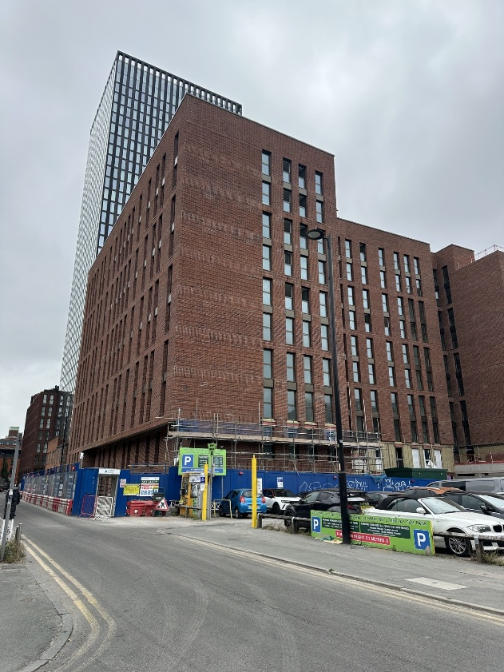
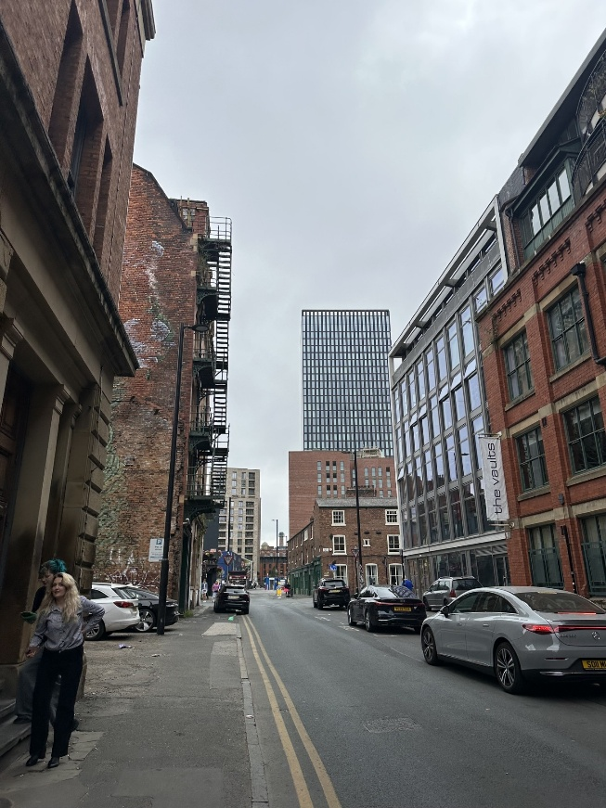

The site is located at the fringe of the Northern Quarter, in walking distance of the Ancoats neighbourhood. The area has an active and vibrant character, characterised by bars, restaurants, cafes and live music venues. Large areas of pedestrianisation on Dale Street, Hare Street and Edge Street, are filled with street furniture, further defining the area's character.

Description of development

Advertisement consent is sought for the installation of 1no. internally illuminated projecting sign.

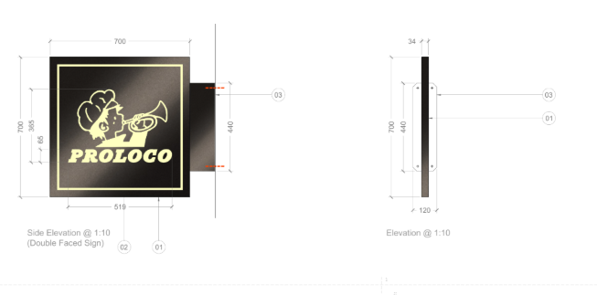

Relevant planning history
Applications pertaining to 80 Port Street:

132489/FO/2021 | Erection of a part-33, part-11, part 9 part 7 storey residential building above semi-basement level, with associated residents' amenity space including gym (Use Class C3) (comprising 481 dwellings), commercial space (Use Class E), basement car parking (47 spaces), cycle parking (481 spaces) landscaping, and other associated works (Approved October 2022)

CDN/25/0785 | Discharge of conditions 6(b) Contaminated Land and 39 (Signage Strategy) pursuant to planning permission 132489/FO/2021 (as amended by 135938/NMC/2023 138008/NMC/2023, 140874/NMC/2024 and 142363/NMC/2025. (Approved October 2025)

Applications pertaining to Unit 2:

OTH-2026-000590 | Discharge of conditions 15b (Plant Noise Verification), 17 (Commercial Noise), 18 (Commercial Hours), 19 (Fumes), 20 (Commercial Waste) and 37 (Management Plan) attached to planning permission 132489/FO/2021 (Under consideration)

Consultation, notification and publicity responses

Consultations

Highway Services – No objections. Should the projecting sign extend more than 350mm over the adopted Highway a projection over license will be required.

Environmental Health – No objections. The proposed luminance level of 300cd/m2 is acceptable.

Notifications and publicity

Letters were sent to surrounding businesses and neighbours, no representations have been received.

Relevant policies
Town and Country Planning (Control of Advertisements) Regulations 2007

The Local planning authority shall exercise its powers under these Regulations in the interests of amenity and public safety, taking into account—

(a)the provisions of the development plan, so far as they are material; and

(b)any other relevant factors.

(2) Without prejudice to the generality of paragraph (1)(b)—

(a)factors relevant to amenity include the general characteristics of the locality, including the presence of any feature of historic, architectural, cultural or similar interest;

(b)factors relevant to public safety include—

(i)the safety of persons using any highway, railway, waterway, dock, harbour or aerodrome (civil or military);

(ii)whether the display of the advertisement in question is likely to obscure, or hinder the ready interpretation of, any traffic sign, railway signal or aid to navigation by water or air;

(iii)whether the display of the advertisement in question is likely to hinder the operation of any device used for the purpose of security or surveillance or for measuring the speed of any vehicle.

(3) In taking account of factors relevant to amenity, the local planning authority may, if it thinks fit, disregard any advertisement that is being displayed.

(4) Unless it appears to the local planning authority to be required in the interests of amenity or public safety, an express consent for the display of advertisements shall not contain any limitation or restriction relating to the subject matter, content or design of what is to be displayed.

The following policies are relevant to consideration of this application within the development plan:

Manchester Core Strategy (2012-2027)

SP1 Spatial Principles

EN1 Design Principles and Strategic Character Areas

DM1 Development Management

Saved Unitary Development Plan (UDP) Policies
DC14 Shopfronts and Related Signs

Other Material Considerations:

Shopfront and Signage Design Guide (2024)

National Planning Policy Framework
Chapter 12 Achieving well-designed places

Paragraph 141 states:
The quality and character of places can suffer when advertisements are poorly sited and
designed. A separate consent process within the planning system controls the display of
advertisements, which should be operated in a way which is simple, efficient and effective.
Advertisements should be subject to control only in the interests of amenity and public safety,
taking account of cumulative impacts.

Assessment

Visual Amenity
Policy DM1 requires consideration of siting, scale, materials and appearance in all development applications. The Shopfront and Signage Design Guide requires that proposals install only 'the minimum' signage required to identify their building. The Shopfront and Signage Design Guide Section 4 require that when an up-to-date signage strategy is available, occupants adhere to its principles in their advert proposals. Policy DC14.1 requires that projecting signage is aligned with any fascia signage.

The proposed 1no. projecting sign would be composed of aluminium box with a fret cut logo design. The sign would be 34mm in depth, and 700mm by 700mm in width and length. The sign proposed is consistent with the provisions of the Shopfront and Signage Design Guide and the approved signage strategy for the commercial units at 80 Port Street (CDN/25/0785).

Chapter 12 of the National Planning Policy Framework requires that when assessing design quality Local Planning Authorities consider ‘will function well and add to the overall quality of the area’, ‘are visually attractive’ and ‘are sympathetic to local character and history, including the surrounding built environment and landscape setting’.

The colouration, and finish of the signage was selected to complement the wider building. All commercial units will install external signage with identical materials, colours and finishes. As such the projecting sign is considered to be in keeping with the high-quality frontages of 80 Port Street, and complementary to the wider street scene.

Public Safety

The proposed illuminance level of 300cd/m2 has been deemed acceptable by the Environmental Protection and Highways Services. Thus, there are no further public safety concerns associated with the proposal.

Other Legislative Requirements

Equality Act 2010
Section 149 (Public Sector Equality Duty) of the Equality Act 2010 requires due regard to the need to: Eliminate unlawful discrimination, harassment and victimisation and other conduct prohibited by the Act and; Advance equality of opportunity between persons who share a protected characteristic and persons who do not share it. The Equality Duty does not impose a legal requirement to conduct an Equality Impact Assessment. Compliance with the Equality Duty involves consciously thinking about the aims of the Equality Duty as part of the process of decision-making.

Human Rights Act 1998 considerations
This application needs to be considered against the provisions of the Human Rights Act 1998. Under Article 6, the applicants (and those third parties, including local residents, who have made representations) have a right to a fair hearing and to this end the local planning authority must give full consideration to their comments.

Protocol 1 Article 1, and Article 8 where appropriate, confer(s) a right of respect for a person’s home, other land and business assets. In taking account of all material considerations, including Council policy as set out in the Core Strategy and saved polices of the Unitary Development Plan, the Director of Planning, Building Control & Licensing has concluded that some rights conferred by these articles on the applicant(s)/objector(s)/resident(s) and other occupiers and owners of nearby land that might be affected may be interfered with but that that interference is in accordance with the law and justified by being in the public interest and on the basis of the planning merits of the development proposal. She believes that any restriction on these rights posed by the recommendation given is proportionate to the wider benefits of and that such a decision falls within the margin of discretion afforded to the Council under the Town and Country Planning Acts.

Conclusion
In totality, the proposed 1no. projecting sign is considered to be an appropriate advertisement for the application. It’s scale, materials and siting are consistent with the requirements of Core Strategy policy DM1, EN1, Saved Unitary Development Plan policy DC14. The sign is considered to be a quality addition to the application site that while remaining subservient to the wider building; given these details the proposal would be acceptable pursuant to the Town and Country Planning (Control of Advertisements) Regulations 2007, the National Planning Policy Framework Chapter 12 and the Shopfront and Signage Design Guide (2024).

Recommendation: Approve

Conditions attached to this decision
- (a) No advertisement is to be displayed without the permission of the owner of the site or any other person with an interest in the site entitled to grant permission.

(b) No advertisement shall be sited or displayed so as to:

i. endanger persons using any highway, railway, waterway, dock, harbour or aerodrome (civil or military);

ii. obscure, or hinder the ready interpretation of, any traffic sign, railway signal or aid to navigation by water or air; or

iii. hinder the operation of any device used for the purpose of security or surveillance or for measuring the speed of any vehicle.

(c) Any advertisement displayed, and any site used for the display of advertisements, shall be maintained in a condition that does not impair the visual amenity of the site.

(d) Any structure or hoarding erected or used principally for the purpose of displaying

advertisements shall be maintained in a condition that does not endanger the public.

(e) Where an advertisement is required under these Regulations to be removed, the site shall be left in a condition that does not endanger the public or impair visual amenity.

- The development hereby approved shall be carried out in accordance with the following drawings and documents:

Drawing: Location Plan
Drawing: PH0263-D-002
Drawing: PH0262-002.2 REV F

All received the 29th May 2026.

Reason - To ensure that the development is carried out in accordance with the approved plans pursuant to policies SP1 and DM1 of the Core Strategy.

- Lighting from illuminated signage shall be designed and installed so as not to exceed 300cd/m2 in illumination.

Reason - In the interest of amenity and to prevent glare and excessive illumination pursuant to policy DM1 of the Manchester Core Strategy (2012),

Informatives

- The applicant is advised that any requirements for licensing, hoarding / scaffolding and any associated temporary traffic management arrangements will need discussion and agreement with the Council's Highways Applications and Network Resilience teams via Contact Manchester (Tel. 0161 234 5004) Email -highwaylicences@manchester.gov.uk.

- The projecting sign will extend over the adopted highway, it will therefore require a projection over license to be funded at the applicant's expense. Inforamtion is available at the following link: https://www.manchester.gov.uk/directory_record/451898/projecting_over_the_highway

- The applicant is required to discuss and agree any requirements for temporary pedestrian and traffic management with the Council's Event and Traffic Management Team via Email to highwaynetworkmanagement@manchester.gov.uk

