

Planning

Delegated Officer Report

Summary of application details
Application reference: | PLA-2026-000071
Application type: | Full planning permission
Proposal: | Part retrospective planning application for the erection of a single storey bin store, following demolition of existing structure.
Site address: | Cambrian House 60 Wood Road Manchester M16 8BL
Ward(s): | Whalley Range
Date application valid: | 29 May 2026
Applicant name: | Mr Anthony Espiga-Ventura
Agent (if any): | Mr Sunil Nandha
Case officer: | David Lawless
Recommendation: | Approve with Conditions
Date of recommendation: | 16 July 2026

Description of site, building and/or area

Cambrian House is a substantial Victorian villa dating from 1898, located at the junction of Wood Road and College Road within the Whalley Range Conservation Area. The property was originally constructed as a single dwellinghouse and has been in use as 10 self-contained flats since 1999. Historically, the building was set within extensive grounds; however, the site was subsequently subdivided, with the western portion now occupied by a large detached multi-occupancy residential property.

The surrounding area is predominantly residential in character. Notwithstanding this, the British Muslim Heritage Centre is situated opposite the site on College Road, occupying the Grade II* listed former GMB National College building.

Pedestrian and vehicular access to the site is taken from Wood Road. The site's frontages to both Wood Road and College Road benefit from mature landscaping.

Cambrian House and the proposed structure which is the subject of this planning application is shown below:

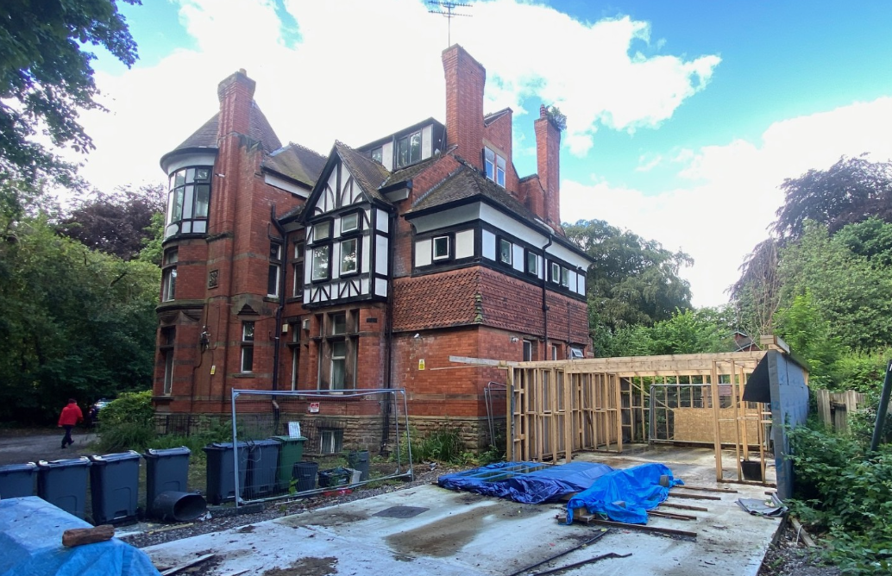
Description of development

The application seeks part retrospective planning permission for the erection of a bin store located to the side of the property for use by the occupants of the self-contained flats. The application was submitted following the receipt of an enforcement complaint which identified that the structure had been erected without the benefit of planning permission.

The bin store as originally constructed occupied the full extent of the foundations shown on the submitted plans and highlighted in yellow below. However, following site investigations and discussions with the applicant, the structure was reduced in length. The application therefore relates to the amended bin store as currently proposed and in situ, rather than the larger structure originally erected.
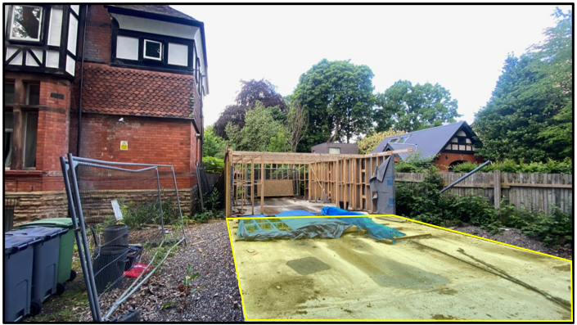

The bin store would be constructed from timber cladding over a timber frame and would be topped by a green roof, with complementary green screens to the side to form a barrier to the rear garden area. The proposed front elevation is shown below:

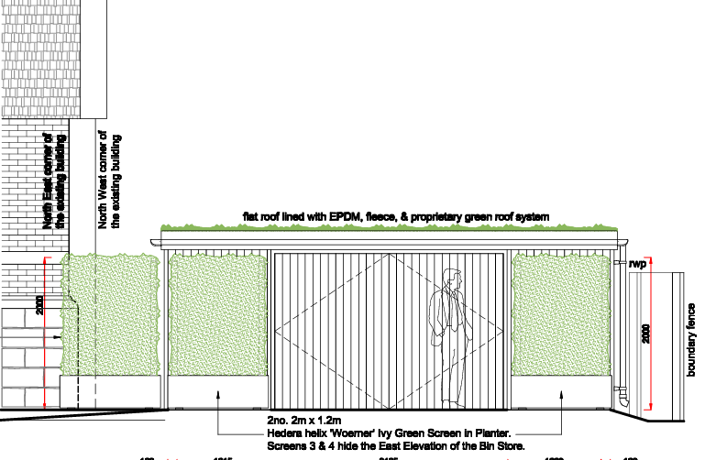

Consultation, notification and publicity responses

Local Residents – No comments received.

Whalley Range Forum – No comments received.

Flood Risk Management – No objections to the proposal.

Environmental Health – No objections to the proposal.

Relevant policies

Draft National Planning Policy Framework (December 2025) - The National Planning Policy Framework (NPPF) sets out the Government’s planning policies for England and how these should be applied. A draft revised NPPF was published for consultation on 16 December 2025. The consultation period ran for 12 weeks and closed on 10 March 2026.

The draft NPPF proposes significant changes to the structure and content of national policy. These include a move to Local Plan-style policy sections, a clearer distinction between plan-making and decision-making policies, and the reintroduction of strategic planning through Spatial Development Strategies. Other notable changes include an expanded presumption in favour of sustainable development, policies promoting higher densities around transport hubs, and support for small and medium-scale housing schemes through a new “medium development” category. The draft also integrates National Development Management Policies, strengthens climate change and biodiversity policies, and introduces measures to encourage clean energy and critical minerals development.

Once adopted, the revised NPPF will replace the current framework and form a key part of national planning policy. At this stage, as the document is subject to consultation and has not yet been finalised, while still a material consideration, it can only be afforded limited weight in the determination of planning applications. In this instance, the relevant sections are outlined below:

Policy DM3 (Determining development proposals) – When considering development proposals, local planning authorities should:

- Work with the applicant in a positive and proactive manner, where necessary seeking solutions to problems arising from initial proposals, to enable a timely decision;
- Take a proportionate approach to the consideration of the planning matters raised by the proposals, in a way that reflects their scale, complexity and potential impact;
- Take account of planning matters raised during any pre-application engagement, including any positive responses to this engagement, as well as representations on the proposals;
- Consult statutory or internal consultees only where it is necessary to do so. Decisions on development proposals should not be delayed in order to secure advice from a statutory or internal consultee beyond their statutory deadlines unless there is insufficient information to make the decision or more detailed advice may enable an approval rather than a refusal;
- Consider whether otherwise unacceptable development proposals could be made acceptable through the use of planning conditions or planning obligations; and
- Not refuse applications for development which should clearly be approved, having regard to its accordance with the development plan, the policies in this Framework and any other material considerations.

Policy DP3 (Key principles for well-designed places) – To respond to their context and create well-designed places development proposals should:

- Context: respond to the history, character and features of the site and its setting, so that it integrates into and enhances its surroundings (such as through the arrangement of development plots and buildings, the use of materials and architectural features, and the restoration, reuse and integration of heritage assets).
- Liveability: support healthy, mixed, vibrant and integrated communities, which will function well over the lifetime of the development, by incorporating a range of uses and tenures, employing features which promote social interaction, and which are robust, durable and easy to look after.
- Climate: contribute to climate change mitigation and adaptation and the transition to net zero, by using building layouts, building orientation, massing, landscaping and materials which conserve energy and other resources, and which minimise risks from the impacts of climate change including overheating.
- Movement: provide transport infrastructure and choices which support the design vision for the site, provide good connections to the wider settlement (or those nearby), and prioritise walking, wheeling, cycling and public transport.
- Built Form: use the pattern of buildings to define the arrangement of streets, squares and other spaces, promote compact forms of development to optimise the site’s potential, distinguish between public and private areas, create focal points and, where appropriate, enhance views into and out of the scheme.
- Identity: create visually attractive, distinctive and characterful development to establish or maintain a strong sense of place and pride, including through the use of a coherent palette of materials, design features and planting.

It states further that development proposals that are not well designed should be refused, when assessed against this policy and local design policies, guides, codes and masterplans set out in the development plan. Substantial weight should be given to compliance with these policies when assessing the design quality of proposals.

The National Planning Policy Framework (December 2024) – The National Planning Policy Framework sets out the Government’s planning policies for England and how these should be applied. It provides a framework within which locally prepared plans for housing and other development can be produced. Planning law requires that applications for planning permission be determined in accordance with the development plan, i.e. the Core Strategy Development Plan Document and accompanying policies, unless material considerations indicate otherwise. The National Planning Policy Framework is a material consideration in planning decisions.

Paragraph 11 states that plans and decisions should apply a presumption in favour of sustainable development, which for decision-taking means:

- approving development proposals that accord with an up-to-date development plan without delay; or
- where there are no relevant development plan policies, or the policies which are most important for determining the application are out-of-date, granting permission unless:

i. the application of policies in this Framework that protect areas or assets of particular importance provides a clear strong reason for refusing the development proposed; or
ii. any adverse impacts of doing so would significantly and demonstrably outweigh the benefits, when assessed against the policies in this Framework taken as a whole, having particular regard to key policies for directing development to sustainable locations, making effective use of land, securing well-designed places and providing affordable homes, individually or in combination.

Paragraph 12 states that the presumption in favour of sustainable development does not change the statutory status of the development plan as the starting point for decision-making. Where a planning application conflicts with an up-to-date development plan (including any neighbourhood plans that form part of the development plan), permission should not usually be granted. Local planning authorities may take decisions that depart from an up-to-date development plan, but only if material considerations in a particular case indicate that the plan should not be followed.

In addition to the above, Section 16 (Conserving and enhancing the historic environment) is of relevance:

Paragraph 210 in Section 16 states that in determining planning applications, local planning authorities should take account of:

- the desirability of sustaining and enhancing the significance of heritage assets and putting them to viable uses consistent with their conservation;
- the positive contribution that conservation of heritage assets can make to sustainable communities including their economic vitality; and
- the desirability of new development making a positive contribution to local character and distinctiveness.

Paragraph 212 states that when considering the impact of a proposed development on the significance of a designated heritage asset, great weight should be given to the asset’s conservation (and the more important the asset, the greater the weight should be). This is irrespective of whether any potential harm amounts to substantial harm, total loss or less than substantial harm to its significance.

Paragraph 213 states that any harm to, or loss of, the significance of a designated heritage asset (from its alteration or destruction, or from development within its setting), should require clear and convincing justification.

Paragraph 214 states that where a proposed development will lead to substantial harm to (or total loss of significance of) a designated heritage asset, local planning authorities should refuse consent, unless it can be demonstrated that the substantial harm or total loss is necessary to achieve substantial public benefits that outweigh that harm or loss, or all of the following apply:

- the nature of the heritage asset prevents all reasonable uses of the site; and
- no viable use of the heritage asset itself can be found in the medium term through appropriate marketing that will enable its conservation; and
- conservation by grant-funding or some form of not for profit, charitable or public ownership is demonstrably not possible; and
- the harm or loss is outweighed by the benefit of bringing the site back into use.

Paragraph 215 states that where a development proposal will lead to less than substantial harm to the significance of a designated heritage asset, this harm should be weighed against the public benefits of the proposal including, where appropriate, securing its optimum viable use.

The Places for Everyone Plan – This plan was adopted on 21 March 2024, as such the Plan and its policies are now a material planning consideration in the determination of planning applications. The Plan and its policies must therefore be given significant weight in the planning balance. The relevant policy is set out below:

Policy JP-Strat9 (Southern Areas) – This policy states that the economic competitiveness, distinctive local neighbourhood character and environmental attractiveness of the southern areas will be protected and enhanced. There will be a strong emphasis on making as much use as possible of suitable previously developed (brownfield) land and promoting the roles of the areas’ town centres and its other key assets.

Policy JP-P2: Heritage (Heritage) – This policy states that the member authorities will proactively manage and work with partners to positively conserve, sustain and enhance their respective historic environments, heritage assets and their settings.

Policy JP-G7: Trees and Woodland – This policy states that the member authorities will work to deliver the aims and objectives of the Greater Manchester Tree and Woodland Strategy, aiming to significantly increase tree cover, protect and enhance woodland, and connect people to the trees and woodland around them. This will be done through local planning and a number of associated activities, but in the case of development as follows:

- Where development would result in the loss of existing trees, requiring replacement on the basis of two new trees for each tree lost, or other measures that would also result in a net enhancement in the character and quality of the treescape and biodiversity value in the local area, with a preference for on-site provision; and
- Protecting trees and woodland during the construction phase of development.
Policy JP-G8: A Net Enhancement of Biodiversity and Geodiversity – This policy states that through local planning and associated activities a net enhancement of biodiversity resources will be sought. It states further than in relation to development, proposals would be expected to:

- Follow the mitigation hierarchy of:
  - Avoiding significant harm to biodiversity, particularly where it is irreplaceable, through consideration of alternative sites with less harmful impacts, then
  - Adequately mitigating any harm to biodiversity, then
  - Adequately compensating for any remaining harm to biodiversity
- Avoid fragmenting or severing connectivity between habitats;
- Achieve a measurable net gain in biodiversity of no less than 10%
- Make appropriate provision for long-term management of habitats and geological features connected to the development;
- Where appropriate, development should: mitigate air pollution impacts on Manchester Mosses SAC; mitigate urban edge, functionally linked land and recreation disturbance impacts on the South Pennine Moors SAC/SPAs; and assess and potentially mitigate boat movement, water pollution, and light spillage and shading impacts on the Rochdale Canal SAC; and
- Development proposals should be informed by the findings and recommendations of the appropriate biodiversity/ecological assessment(s) in the PfE evidence base and/or any updated or appropriate biodiversity/ecological assessments submitted as part of the planning application process.
Core Strategy Development Plan Document – The Core Strategy Development Plan Document 2012 -2027 ("the Core Strategy") was adopted by the City Council on 11th July 2012. It is the key document in Manchester's Local Development Framework. The Core Strategy replaces significant elements of the Unitary Development Plan (UDP) as the document that sets out the long term strategic planning policies for Manchester's future development.

A number of UDP policies have been saved until replaced by further development plan documents to accompany the Core Strategy. Planning applications in Manchester must be decided in accordance with the Core Strategy, saved UDP policies and other Local Development Documents. Relevant policies in the Core Strategy are detailed below

Policy SP1, Spatial Principles, - Development in all parts of the City should make a positive contribution to neighbourhoods of choice including creating well designed places that enhance or create character and protect and enhance the built and natural environment.

Policy DM1, Development Management – This policy states that all development should have regard to a number of specific issues, of which the following are of most relevance:-

- Appropriate siting, layout, scale, form, massing, materials and detail.
- Impact on the surrounding areas in terms of the design, scale and appearance of the proposed development. Development should have regard to the character of the surrounding area.
- Effects on amenity, including privacy, light, noise, vibration, air quality, odours, litter, vermin, birds, road safety and traffic generation. This could also include proposals which would be sensitive to existing environmental conditions, such as noise.
- Community safety and crime prevention.
- Design for health.
- Vehicular access and car parking.
- Effects relating to biodiversity, landscape, archaeological or built heritage.
- Flood risk and drainage.

Policy EN3, Heritage – Throughout the City, the Council will encourage development that complements and takes advantage of the distinct historic and heritage features of its districts and neighbourhoods, including those of the City Centre.

Proposals which enable the re-use of heritage assets will be encouraged where they are considered consistent with the significance of the heritage asset.

Policy EN 9, Green Infrastructure – New development will be expected to maintain existing green infrastructure in terms of its quantity, quality and multiple function. Where the opportunity arises and in accordance with current Green Infrastructure Strategies the Council will encourage developers to enhance the quality and quantity of green infrastructure, improve the performance of its functions and create and improve linkages to and between areas of green infrastructure. Where the benefits of a proposed development are considered to outweigh the loss of an existing element of green infrastructure, the developer will be required to demonstrate how this loss will be mitigated in terms of quantity, quality, function and future management.

Policy EN 15, Biodiversity and Geological Conservation – The Council will seek to maintain or enhance sites of biodiversity and geological value throughout the City.

Saved UDP Policy DC18, Conservation Areas – Policy DC18.1 states that the Council will give particularly careful consideration to development proposals within Conservation Areas by taking into consideration the following:

- a) The Council will seek to preserve and enhance the character of its designated conservation areas by carefully considering the following issues:

- the relationship of new structures to neighbouring buildings and spaces;
- the effect of major changes to the appearance of existing buildings;
- the desirability of retaining existing features, such as boundary walls, gardens, trees, (including street trees);
- the effect of signs and advertisements;
- any further guidance on specific areas which has been approved by the Council.

b) The Council will not normally grant outline planning permission for development within Conservation Areas.
c) Consent to demolish a building in a conservation area will be granted only where it can be shown that it is wholly beyond repair, incapable of reasonably beneficial use, or where its removal or replacement would benefit the appearance of character of the area.
d) Where demolition is to be followed by redevelopment, demolition will be permitted only where there are approved detailed plans for that redevelopment and where the Council has been furnished with evidence that the development will be undertaken.
e) Development proposals adjacent to Conservation Areas will be granted only where it can be shown that they will not harm the appearance or character of the area. This will include the protection of views into and out of Conservation Areas.

Assessment

Principle of the Proposal – It is recognised that multi-occupancy residential buildings can generate a substantial amount of waste and recycling. Consequently, developments of this nature are often required to accommodate multiple refuse and recycling bins serving individual flats. Whilst such bins are frequently stored in the open, which can result in visual clutter and increase the potential for issues relating to vermin, the provision of a purpose-built and secure bin store is welcomed and represents a more satisfactory arrangement.

Notwithstanding this, the acceptability of the proposal must be assessed having regard to its impact on residential amenity, visual amenity, pedestrian and highway safety, ecological interests and the character and appearance of the Whalley Range Conservation Area. These matters are considered below.

Design – The proposed bin store would be constructed from timber cladding stained black to minimise its visual impact. In addition, a green roof and green screening would be incorporated to soften its appearance and help integrate the structure into its surroundings. Taking into account the reduction in its size and the use of these materials and landscaping measures, the overall design and appearance of the proposed bin store are considered acceptable.
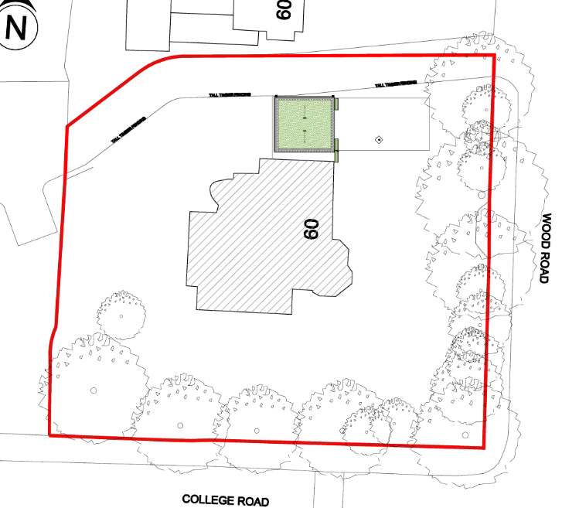
Siting – The bin store is to be sited to the north of Cambrian House and would line up with the front elevation, as such the siting is considered appropriate in this instance.

Residential Amenity – The proposed bin store would be located to the side of the property and is of a modest scale, designed primarily to accommodate the refuse and recycling needs of the existing self-contained flats. Given its siting, size and purpose, it is not considered that the structure would result in any undue loss of outlook, light, privacy or overbearing impact for neighbouring occupiers.

The provision of a dedicated and secure bin storage facility is also likely to improve the management of waste on the site by reducing the visual clutter associated with bins being stored in the open and helping to minimise the potential for odour and vermin-related issues. Accordingly, the proposal is not considered to have an unacceptable impact on the residential amenity of either the occupiers of Cambrian House or neighbouring residential properties.

Visual Amenity – Owing to the scale and design of the proposed bin store, its position to the side of the property and the presence of mature landscaping along the Wood Road frontage, the structure would have limited visibility from the public realm (location circled in red below). Consequently, it is not considered that the development would result in any undue harm to visual amenity or materially detract from the character and appearance of Wood Road.

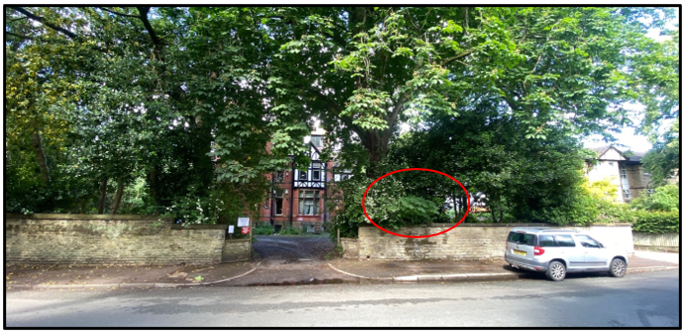

Impact on the Whalley Range Conservation Area – The application site is located within the Whalley Range Conservation Area. The area's special architectural and historic interest is derived from the scale, appearance and form of development, together with its verdant character, which results from the presence of mature trees, extensive landscaping and generous open spaces, predominantly within private grounds.

The conservation area is characterised by large Victorian and Edwardian houses set along tree-lined avenues. Whilst many of these properties remain in residential use, others have been converted into apartments or institutional uses. In addition, a number of larger buildings and complexes were established within the area prior to the designation of the conservation area, including St Bede's College, the British Muslim Heritage Centre and several purpose-built apartment developments.

The proposed bin store is modest in scale and has been designed to minimise its visual impact. The inclusion of a green roof and green wall panels will assist in integrating the structure into its landscaped surroundings. As such, it is considered that the proposal would not detract from the appearance of the host Victorian building or the wider character and appearance of the Whalley Range Conservation Area.

Paragraph 208 of the National Planning Policy Framework states that where a development proposal would lead to less than substantial harm to the significance of a designated heritage asset, that harm should be weighed against the public benefits of the proposal.
In this case, having regard to the design, scale and siting of the bin store, any harm to the significance, character or appearance of the conservation area would be at the very lowest end of less than substantial harm. This limited harm is outweighed by the public benefits arising from the provision of secure and dedicated refuse storage, together with the associated improvements to visual amenity and residential amenity within the site and its surroundings. Accordingly, the proposal is considered acceptable in heritage terms and complies with relevant local and national planning policies.

Pedestrian and Highway Safety – The proposed development would not result in the loss of any existing off-street parking provision and would therefore be unlikely to generate additional demand for on-street parking within the surrounding area. Consequently, the proposal is not considered to have a detrimental impact on pedestrian or highway safety conditions along Wood Road or College Road.

Trees – The proposal would not result in the loss of any of the existing trees located around the perimeter of the site.

Ecology – The proposal would not result in the loss of any identified habitats, protected species, or other ecological features of value within the site. Furthermore, the development incorporates a green roof and green screening, both of which would provide biodiversity benefits and contribute positively to the site's ecological value.

Landscaping – A condition is proposed which will require the submission and approval of a more detailed landscaping scheme for the green roof and associated screens. In addition, the condition will require the removal of the hardstanding that remains in-situ following the reduction in the size of the bin store.

Other Legislative Requirements

Equality Act 2010 – Section 149 (Public Sector Equality Duty) of the Equality Act 2010 requires due regard to the need to: Eliminate unlawful discrimination, harassment and victimisation and other conduct prohibited by the Act and; Advance equality of opportunity between persons who share a protected characteristic and persons who do not share it. The Equality Duty does not impose a legal requirement to conduct an Equality Impact Assessment. Compliance with the Equality Duty involves consciously thinking about the aims of the Equality Duty as part of the process of decision-making.

Human Rights Act 1998 considerations – This application needs to be considered against the provisions of the Human Rights Act 1998. Under Article 6, the applicants (and those third parties, including local residents, who have made representations) have a right to a fair hearing and to this end the local planning authority must give full consideration to their comments.

Protocol 1 Article 1, and Article 8 where appropriate, confer(s) a right of respect for a person’s home, other land and business assets. In taking account of all material considerations, including Council policy as set out in the Core Strategy and saved polices of the Unitary Development Plan, the Director of Planning, Building Control & Licensing has concluded that some rights conferred by these articles on the applicant(s)/objector(s)/resident(s) and other occupiers and owners of nearby land that might be affected may be interfered with but that that interference is in accordance with the law and justified by being in the public interest and on the basis of the planning merits of the development proposal. She believes that any restriction on these rights posed by the recommendation given is proportionate to the wider benefits of and that such a decision falls within the margin of discretion afforded to the Council under the Town and Country Planning Acts.

Conclusion

Owing to its modest scale, appropriate siting and high-quality design incorporating timber cladding, green screening and a green roof, the development would not result in any unacceptable impacts on residential amenity, visual amenity, highway safety, trees or ecological interests. Furthermore, any harm to the character and appearance of the Whalley Range Conservation Area would be at the very lowest end of less than substantial harm and would be outweighed by the public benefits arising from improved waste management and visual amenity. Subject to appropriate landscaping conditions, the proposal is considered to comply with relevant local and national planning policies and is recommended for approval.

Article 35 Declaration

Officers have worked with the applicant in a positive and proactive manner based on seeking solutions to issues arising from the consideration of this application.

Recommendation: Approve with Conditions

Conditions attached to this decision

1) The development must be begun not later than three years beginning with the date of this permission.
Reason - Required to be imposed by Section 91 of the Town and Country Planning Act 1990 (as amended).

2) The development hereby approved shall be carried out in accordance with the following drawings and documents:

a) Drawing no. 2502 004 P2 Proposed Site Plan A2, received on 27 April 2026.
b) Drawing no. 2502 005 P2 Proposed Plans A2, received on 27 April 2026.
c) Drawing no. 2502 006 P2 Proposed Elevations A1, received on 27 April 2026.
d) Drawing no. 2502 007 P2 Proposed Elevations with Green Screening A1, received on 27 April 2026.
e) Heritage Statement Submission, received on 29 May 2026.

Reason - To ensure that the development is carried out in accordance with the approved plans. Pursuant to Policies SP1 and DM1 of the Manchester Core Strategy.

3) The bin store hereby approved shall be erected and completed using the materials detailed on the approved plans and drawings. The bin store shall thereafter be retained and maintained in accordance with the approved materials.

Reason - In order to ensure a satisfactory appearance in the interests of visual amenity in accordance with Policies SP1 and DM1 of the Manchester Core Strategy and the requirements of the National Planning Policy Framework.

4) Prior to the first use of the development hereby approved, a detailed landscaping scheme for the “green roof” and associated “green screen”, based on approved drawing no. 2502 007 P2 (Proposed Elevations with Green Screening A1), received on 27 April 2026, together with a long term maintenance and management plan, a timescale for its implementation and a timescale for the removal of the redundant foundation pad and its remediation, shall be submitted to and approved in writing by the City Council as Local Planning Authority. The submitted details shall be installed within the previously agreed timescale and maintained and managed in accordance with the agreed details thereafter.

Reason - To ensure that biodiversity and sustainability measures proposed are installed and maintained thereafter in the interests of increasing biodiversity at the site and adapt to climate change pursuant to Policies EN8 and EN15 of the Manchester Core Strategy.

