

Planning

Delegated Officer Report

Summary of application details
Application reference: | 143763/FO/2025
Application type: | Full planning permission
Proposal: | Erection of replacement car wash and vehicle tyre fitting building with ancillary accommodation, formation of ground floor office and first floor stockroom to retained shop unit (Class E) and alterations to existing canopy
Site address: | 351 Central Car Wash Stockport Road Manchester M13 0LF
Ward(s): | Ardwick
Date application valid: | 02 April 2026
Applicant name: | Mr Abdul Ghani
Agent (if any): | Mr Muneeb Lokasher
Case officer: | Carl Glennon
Recommendation: | Approve
Date of recommendation: | 21 July 2026

Description of site, building and/or area
The application site is located at the north-west junction of Stockport Road and Richmond Grove East. The application site comprises of a variety of commercial and retail uses operating within single storey buildings. The primary use of the site is as a car wash that operates from a single storey building a beneath a canopy retained from the former use as a petrol filling station. The area immediately to the north of the site comprises of car sale and vehicle repair businesses with the Jamala Masjid Mosque and academy beyond. GMP Longsight has its station opposite the site on the western side of Stockport Road. The area to the south of the site is predominantly residential. The adjacent section of highway comprises of a bus lane with a single yellow line TRO and left turn only restriction into Richmond Grove East. The junction of Stockport Road and Richmond Grove East incorporates a light controlled pedestrian crossing.
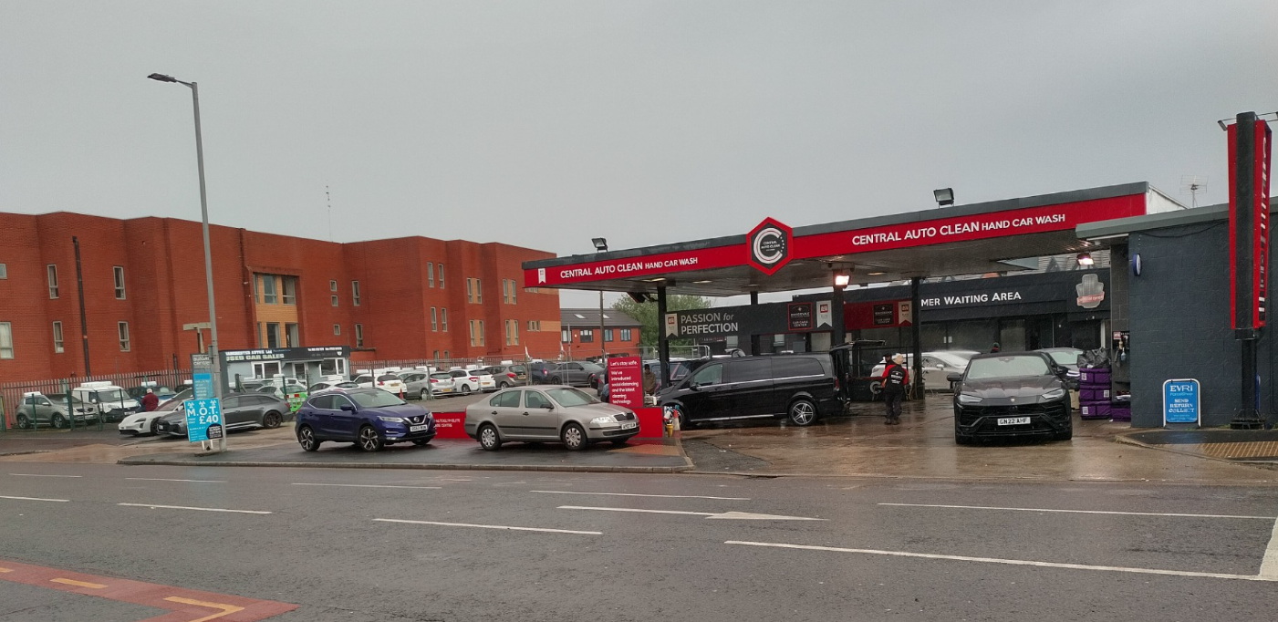
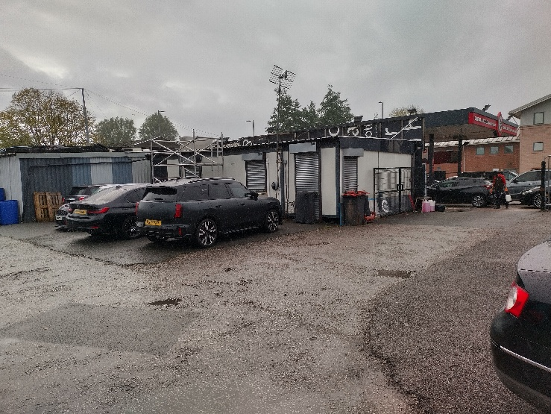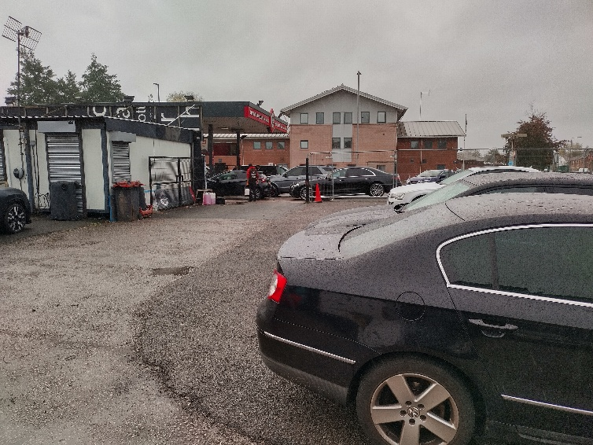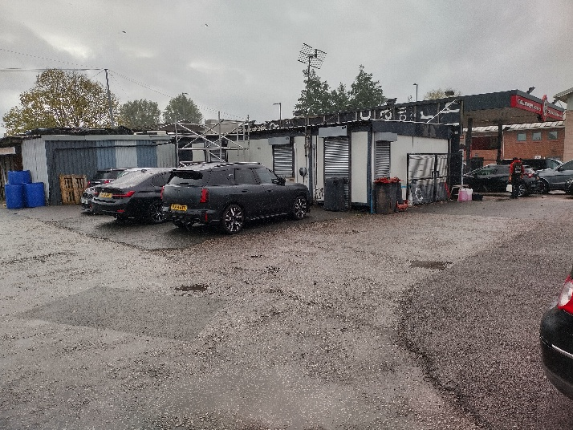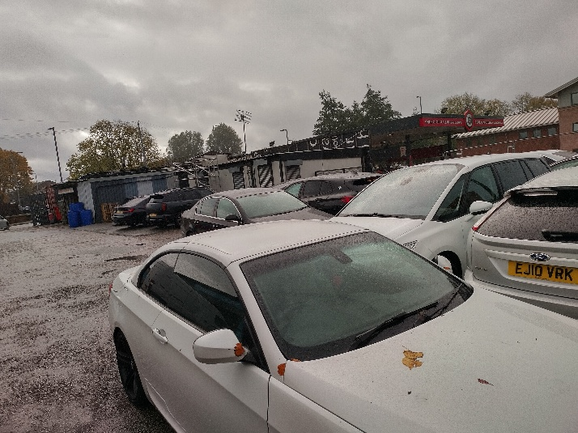

Fig.1 – Views of the application site.

Description of development
The development would involve the enlargement of the canopy to a position adjacent to the site boundary thereby extending the covered area of the undertaking of external car washing. The canopy would have height of 4.9 metres and width of 34 metres. The car washing area would continue to utilise the in and out vehicular access and egress arrangements to and from Stockport Road. The proposed two storey building would have a significant set back from the edge of the canopy and would incorporate a mono pitched roof with a maximum height of 8.5 metres. The elevation would comprise of metal cladding relieved by expansive glazing to windows. Internally, the development would comprise:

i. Ground floor – The formation of three valeting bays and one tyre fitting bay. Ancillary storage and customer waiting areas would be formed along with a new office to the retained adjoining shop unit.
ii. First (mezzanine) floor – Ancillary office space and a store room to be used by the retained shop unit.

A 17 space car parking area to would be formed to the east of the site. An existing secondary vehicular access and egress point from Richmond Grove East would serve the car parking area and valeting and tyre fitting bays.

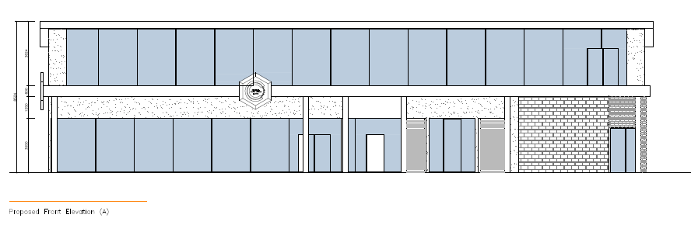
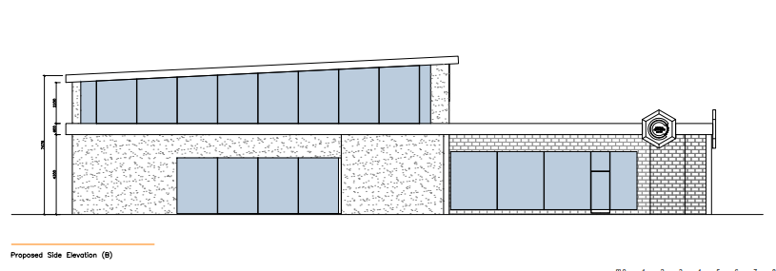

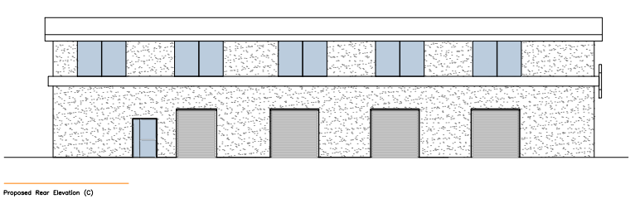
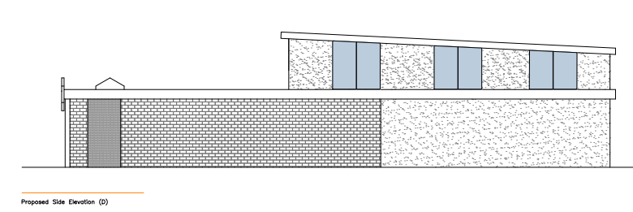
Fig.2 – Proposed elevations

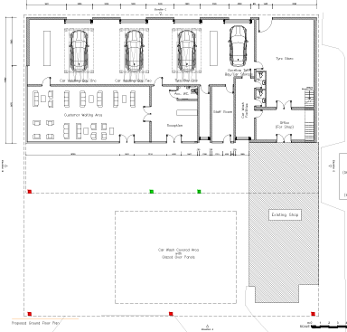

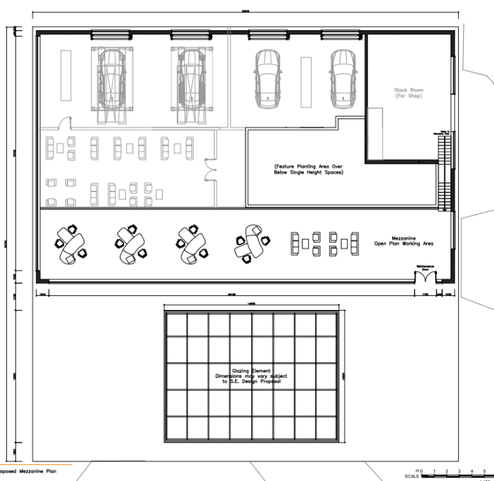

Fig.3 – Proposed layout

Relevant planning history

i. 133940/FO/2022: Approved - 19.01.2023
Central Car Wash , Stockport Road, Manchester, M13 0LF
Removal of existing temporary structures at existing car wash to erect a new purpose built building to enhance existing car wash and vehicle tyre facilities whilst retaining existing convenience store and upgrading existing canopy. No change to existing established use.

ii. 090622/FO/2009/N2: Approved - 09.10.2009
351 Stockport Road, Longsight, Manchester, M13 0LF
Erection of a single storey portal frame building to form car repairs and servicing garage in association with existing business

iii. 092234/FO/2010/N2: Approved - 16.09.2010
351 Stockport Road, Ardwick, Manchester, M13 0LF
Erection of a new single storey office and sales building and canopy in association with existing car wash and car hire business, and formation of associated storage compound with gates and alterations to existing vehicular access following demolition of existing buildings

iv. 109423/AOH/2015/N2: Approved - 09.09.2015
351 Stockport Road, Longsight, Manchester, M13 0LF.
Installation of free-standing illuminated digital advertisement board to replace existing free-standing vinyl internally illuminated advertisement board

v. 096330/FO/2011/N2: Permitted Development - 11.07.2011
351 Stockport Road, Longsight, Manchester, M13 0LF Formation of 9 car parking spaces and relocation of bin store in association with the use of existing buildings for MOT testing, car servicing and car repairs

vi. 057516/FO/NORTH2/99: Approved - 30.11.1999
351/363, Stockport Road, Longsight.
Construction of 2m. high palisade fencing to side and rear boundaries, and powder coated 2m high Paladin Axis Fencing to front boundary.

vii. 052722/AO/CENTL2/97: Approved - 06.10.1997
Mercury Filling Station, Stockport Road, Longsight.
Replacement forecourt signage including new pole and fascia signs

viii. 041712: Approved - 17.07.1992
351, Stockport Road, Longsight.
Extension at front of existing vehicle repair workshop to accommodate M.O.T testing equipment and new office

ix. 035845: Refused - 19.04.1990
Vacant site, corner of, Richmond Grove East/South, Street, Longsight, LONGSIGHT, Erection of new vehicle repair workshop and M.O.T. testing station

x. F/AD03370: Approved - 30.07.1981
Mercury Filling Station, Stockport Road/Richmond, Grove East, Longsight.
A) Illuminated identification pole sign in forecourt of petrol filling station. B) Illuminated totem pole sign in forecourt. C) Illuminated fascia box sign on canopy. D) Illuminated circular box sign mounted on kiosk wall

xi. F15449: Approved - 25.06.1981
351 Stockport Road, Longsight.
RESERVED MATTERS Detailed plans and elevations of a building for the repair and preparation of vans and light commercial vehicles for sale, arising out of the outline planning permission (Ref: F10693) granted on 4.7.79.

xii. F13279: Approved - 02.07.1980
Mercury Filling Station, Stockport Road, Ardwick.
Redevelopment of existing petrol filling station.

xiii. F10693 Approved - 04.07.1979
351 Stockport Road, Longsight.
Erection of a building to be used for the repair and preparation of commercial vehicles for sale.

Consultation, notification and publicity responses

Consultations

Local residents and businesses – No comments received.

Highways – The following comments have been received:

i. A condition is requested to ensure the submission of supplementary details relating to submitted construction management plan, including:
- Arrangements to accommodate construction vehicles accessing, egressing and / or visiting the site each day alongside details of loading and unloading arrangements
- The details of on-site offices and welfare facilities during construction.
- Perimeter hoarding and measures to ensure pedestrian safety during construction.
- Measures to control dust and debris on the highway.

ii. The submission has demonstrated a reduction in access width on Richmond Grove East and the reinstatement of the redundant access. These works will be subject to the approval of the local highway authority as part of s278 agreement.
iii. Revised swept path analysis and vehicle tracking information has been provided, demonstrating that vehicles can safely enter and exit the site and all on-site parking bays, including those located within the building. Visibility splays at the Richmond Grove East access are also shown on the submitted drawings. These details are acceptable in principle.
iv. Details relating to signage and surface markings, the revised site management plan, and operational controls for the secure gate to the on-site car park to be conditioned.
v. Car parking provision has been clarified with confirmation of standard bay dimensions of 2.5 metres x 5.0 metres. These arrangements are acceptable.
vi. A condition should be included requiring the demarcation of car parking spaces and provision of directional signage within the site.
vi. Details of the proposed provision of cycle storage should be conditioned.
vii. Further information has been provided regarding the operational management of parking between staff and customers. Continual monitoring of parking demands to assess future impact on the operation of the highway network is recommended.

Environmental Health - The following comments have been received:
i. Opening hours should be confirmed and conditioned.
ii. Servicing and deliveries should not take place outside the hours of 07:30 to 20:00, Monday to Saturday with no deliveries / waste collections on Sundays / bank holidays.
iii. A condition is requested the control glare from any external lighting installed as part of the development.
iv. Conditions are requested relation the acoustic attenuation / insulation of the application building and any externally mounted equipment.
v. The development should be related to e a comprehensive scheme for the storage of waste and recyclable material.
v. A condition requiring the provision of electric vehicle charging points is recommended.
v. A condition to assess and remediate potential ground contamination is required.
3. Flood Risk Management Team – A pre-commencement condition to ensure appropriate surface water drainage is required.
pursuant to policy EN14 and EN17 of the Core Strategy for the City of Manchester.

GM Ecology Unit – The following comments have been received:

i. The site appears to entirely comprise hardstanding with no vegetation and will therefore be exempt from mandatory BNG under the de minimis exemption.
ii. Based on the submitted details it is highly unlikely that the existing buildings within the site would support roosting bats. However, as precautionary measure, an informative should be included to ensure that the applicant is aware that ecological advice should be sought if they find or suspect that the proposal will impact on protected species.
iii. Wherever possible measures to enhance the site for biodiversity should be secured as part of this planning application.

United Utilities (UU) – Have requested that the development is related to a SUDS condition (which has been included). The informative provided by UU has also been forwarded to the applicant.

Greater Manchester Police Design for Security -
i. The existing shop and the proposed car wash should be self-contained.
ii. A CCTV and alarm system should be installed.
• All high value equipment (e.g. computers, projectors, flat screen monitors / televisions, tools etc.) should be property marked and securely fixed or stored to deter damage / theft. An accurate record should be maintained which logs all such items.
• Staff should be provided with a secure area to store personal belongings (i.e. lockers) within a secure area of the building, which is restricted to staff, such as the staff room.
• Lighting of the car park should be to a high standard.
• The development should be built to the Secured by Design standards.

Notifications and publicity

There was no requirement for a press or a site notice.

Relevant policies
National Planning Policy Framework Plan-making and national decision-making policies
December 2025 (Draft document)

The following chapters are relevant to the proposed development:

i. Chapter 12 - Making effective use of land
Policy L2: Making effective use of land – States that substantial weight should be given to the benefits of development proposals, which make better use of vacant and under utilised land and buildings. The development would relate appropriately to these objectives through the siting of the development on previously developed land.

ii. Chapter 14 - Achieving well-designed places
Policy DP3: Key principles for well-designed places – States that, in order to respond to their context and create well-designed places, development should:

- Context - The development would secure a contemporary design response that would relate appropriately to the constraints of the site and its context. The submitted drawings indicate that an appropriate elevational treatment would be achieved with final details approved by condition.

- Liveability - The operation of the development would be consistent with the existing operation of the site. The attached conditions would improve the management of the site to the benefit of residential amenity.

- Climate - The development would be constructed using contemporary construction techniques thereby securing proportionate carbon reductions.

- Built Form – The development would secure and appropriate design that would related satisfactorily to neighbouring built from.

- Identity – The development would positively respond to the objective of forming visually attractive, distinctive and characterful development.

Chapter 15 - Promoting sustainable transport

Policy TR3: Locating development in sustainable locations – In this case, the development relates to existing uses undertaken within the site with improved site management arrangements. Policy TR3 would thereby be positively responded to.

Policy TR4: Street design, access and parking – States that to contribute to creating well-designed places, transport considerations should be integral to the design of development.

Policy TR6: Assessing transport impacts - Sets out the requirements for assessing such impacts.

The development relates to and existing use and the submitted details have allowed the appropriate assessment of the development Policies TR5 and TR6 would thereby be positively responded to.

Chapter 17 - Pollution, public protection and security

Policy P2: Ground Conditions – Requires consideration of ground conditions. Potential issues have been identified in the submitted ground condition report. Appropriate mitigation measures would be addressed through the attached contaminated land condition.

Policy P3: Living conditions and pollution - The development relates to activities that are currently undertaken within the site. The development would thereby represent a continuation of the existing circumstances with improvements to the operation of the site delivered through the included conditions.

Chapter 18 - Managing flood risk and coastal change – Sets out the requirements for assessing flood risk. The local lead flood authority has provided comments, and the requested drainage condition has been included. Chapter 18 would thereby be appropriately responded to.

The following chapters of the NPPF, adopted December 2024, are also relevant:
i. Chapter 8 - Promoting healthy and safe communities
ii. Chapter 11 - Making effective use of land
iii. Chapter 12 - Achieving well-designed places
iv. Chapter 14 - Meeting the challenge of climate change, flooding and coastal change
v. Chapter 15 - Conserving and enhancing the natural environment.

Sustainable Development Joint Development Plan Document - Places for Everyone (2022-2039)

Policy JP-P6 - Health - States that development should maximise its positive contribution to health and wellbeing, whilst avoiding any potential negative impacts of new development. The development would be appropriately related to its context and harm from related impacts could be appropriately mitigated against through condition. Policy JP-P6 would not thereby be accorded with.

Policy JP-S1 - Sustainable development - States that, to address climate change, development should aim to maximise its economic, social and environmental benefits simultaneously, minimise its adverse impacts, utilise sustainable construction techniques and actively seek opportunities to secure net gains across each of the different objectives. The development would achieve a quality of the accommodation that would encourage the sustained use of the site. Policy JP-S1 would, therefore, be accorded with.

JP-S2 – Carbon and Energy – States that development should be consistent with Part L of the Building Regulations (2022).The development has been submitted with an environmental statement that demonstrates and exceedance of the building regulations in relation to carbon reduction. The development would therefore respond positively to policy JP-S2.

Policy JP-S4 - Flood risk and the water environment - States that in locating and designing development to minimise the impacts of current and future flood risk. The site is in Flood Zone 1 with low risk of surface water flooding. The proposed extension would be related to the first floor and car parking related to existing hard standing areas. There would not be any apparent change to the existing circumstances regarding flood risk.

Manchester's Local Development Framework: Core Strategy

Policy SP 1 (Spatial Principles) -
The development relates to a use, which is within a commercial setting. It is not apparent the development, in itself, would significantly change the existing circumstances with regard to the operation of the site and its relationship to the surrounding area, including nearby housing. Moreover, the proposal presents opportunities for improved site management through the included operational conditions. The development thereby accords with policy SP1.

Policy EC1 (Employment and Economic Growth in Manchester) - The development would provide a contribution to the local economy, supply of commercial floorspace and employment provision within an established warehousing area. The development would thereby be positively related to policy EC1.

Policy EN1 (Design Principles and Strategic Character Areas) - It is therefore considered that the development would deliver satisfactorily designed development that would accord with policy EN1.

Policy EN 14 (Flood Risk) - Requires an assessment of flood risk and drainage. In this case the development has been assessed by the Flood Risk Management Team and the requested drainage condition has been included to secure compliance with policy EN14 would be positively responded to.

Policy EN 16 (Air Quality) - States that developers will be expected to take measures to minimise and mitigate the local impact of emissions from traffic generated by the development, as well as emissions created by the new built form. The development would be related to an existing site operation and an appreciable change to vehicle movement is not envisaged.

Policy EN 18 (Contaminated Land and Ground Stability) - Sets out the requirements for addressing issues relating to land contamination issues. Compliance with policy EN18 would be secured through the attached condition.

Policy EN19 (Waste) -. A condition has been included to ensure the submission and approval of a waste management plan to secure compliance with policy EN19.

Policy T1 (Sustainable transport) - Relates to the delivery of sustainable, high quality, integrated transport system, which encourages a modal shift away from car travel to public transport, cycling and walking and prepare for carbon free modes of transport. Given the nature of the proposed use there would be localised traffic generation, but this has been assessed and considered to be predictable and capable of being absorbed into the highway network. The operation of the site would be managed through conditions, including a condition requiring the implementation of a site management plan. The operation of the site would be aided through the opening hours and the operational arrangements. Provision has been made for cycle storage. The application site is accessible via public transport that could be utilised by staff. On this basis, it is considered that policy T1 would be positively responded to.

Policy T2 (Accessible areas of opportunity and need) – It is considered that the development presents an opportunity to improve the operation of the site without significant increase in traffic flows to and from the site. The submitted highways details have been assessed, and it is considered that policy T2 would be positively accorded with.

Policy DM1 (Development Management) - It is considered that the continued use of the premises and its external areas would be related to a local environment dominated by traffic noise from Stockport Road, in addition to noise from the application site and neighbouring commercial uses. Additional impacts would be addressed through conditions to safeguard the amenity of residents of Richmond Grove East and South Street. It is considered that the development would be consistent with the existing use of the site and there would not be a significant change to the existing circumstance. The proposed operational conditions would improve site management with improved built form and site configuration. On balance, policy DM1 would be accorded with.

Unitary Development Plan (UDP) saved policies

Policy DC26.1 – Requires consideration of, amongst other things, the effect of new development proposals which are likely to be generators of noise.

In this case, Environmental Health has assessed the proposal with regard to its location and the nature of its operation as set out in the site management plan. Notwithstanding the context of the site, it is considered conditions should be put in place to ensure the appropriate acoustic insulation of the building and equipment to safeguard the amenities of local residents. On this basis, it is considered that policy DC26 would be accorded with.

Assessment
Principle of the development – The proposal is consistent with the existing activities that take place within the application site. The development presents the opportunity to improve the quality of built form within the site to the benefit of the streetscene and the amenities of the area. The development would provide management arrangements for car parking and the future operation the respective elements of the business operation. This includes a condition that limits the use of the development to the undertaking of car washing and valeting and tyre fitting with ancillary offices and storage. It also requires that the ancillary space associated with the retained shop operates as part of the established retail unit. A separate condition prevents the sub-division and / or the occupation operation of these ancillary offices as separate business enterprises. The development has the capability of being managed through the recommended conditions and the principle of the development is therefore considered to be acceptable.

Siting – The proposed canopy would increase the width of the proposed canopy but would replicate the relationship of the canopy to the Stockport Road boundary previously considered to be acceptable as part of the consideration of planning permission Ref: 133940/FO/2022. This aspect of the development would secure an appropriate relationship to Stockport Road and Richmond Grove East junction. The proposed building would set back from the Stockport Road boundary thereby maintain characteristic space above the roof of the canopy. The main building has been informed by the previous planning permission thereby securing an appropriate relationship to Richmond Grove East. The application site has the capacity to accommodate the increased width of the building whilst maintaining appropriate vehicular circulation space. The proposed siting of the development would thereby be acceptable.

Height, scale and massing – The main building would incorporate a mono-pitched roof would have a maximum height of 8.5 metres falling to 7.4 metres. This arrangement would lead to the formation of angled glazing that would relieve the solidity and massing of the upper floor elevations. The arrangement of glazing at ground floor level would have the same effect. The height of the proposed canopy has been suitably informed by the existing canopy and its characteristic arrangements to the streetscene. It is considered that the arrangement of the roofscape and the maximum height of the building would be appropriate at a junction location.

Design – The proposed elevations would comprise of a mix of render punctuated with glazed panels at ground and first floor level. It is considered that the existing blue brickwork to the retained shop unit would contribute positively composition of the building. The development would incorporate a flat roof canopy that would project from the principal at ground and first floor level. The first floor element would comprise of a mono-pitched roof in profiled metal. The setting back of the first floor elevation would facilitate glazing to the canopy roof. Definition would be added to the elevations through the inclusion of fascia detailing at ground and first floor level. The development would secure a cohesive design response. The design would be acceptable subject to the conditioned approval of materials.

Residential amenity – The development would increase activity in the site, but this would be consistent with the existing operation of the site. materially affect the relationship of the site to neighbouring houses as the existing operations would continue to be undertaken. Moreover, the continuation of the existing operations in accordance with the submitted schedule of condition would potentially improve these circumstances through the delivery of more structured site management. The appearance of the proposed building would be beneficial to the streetscene and would contribute positively to the quality of the local built environment. It is not considered, therefore, that the development would unduly harm residential amenity.

Security and crime reduction – The application site benefits from natural surveillance due to is prominent location at the junction of Stockport Road and Richmond Grove East. The site is positioned within a wider site that has existing robust its northern, eastern and southern boundary treatments. The applicant has indicated the formation of paladin fencing to prior to site boundary. However, as discussed below it is considered that these details need to appropriate address site security for Stockport Road. The recommendations of GMP Secured by Design are related to the development as an informative. It is considered that appropriate security measures can be delivered as part of the development.

Highways issues – As the development relates to an existing use the comprises, car washing and tyre fitting and the operation of a shop unit. The development would introduce dedicated valeting bays. The existing access and egress arrangements to Stockport Road would be maintained. The development has been accompanied with a site management plan and highways details that demonstrate that separate access and egress arrangement would be formed from Richmond Grove East that would appropriately manage the movement of vehicles with the site thereby avoiding undue the disruption of the flow of traffic on the adjacent highway. The proposed arrangements of car parking would be appropriate manoeuvring space would be provided to allow vehicles to egress the site from Richmond Grove East. The proposed car parking area would service the tyre fitting and valeting facilities.

Car parking -The development would be supported with 17 car parking spaces (one accessible) The valeting and tyre fitting operations would utilises 16 spaces with one space allocated for staff use. The provision of car parking would aid the operation of the site. A condition has been included to ensure that provision of a signage strategy to manage access to the car parking, valeting and tyre fitting areas. This condition is included in the interests of pedestrian and highways safety.

Electric vehicle (charging points – Consideration has been given to the provision of electric vehicle charging points. However, there were concerns that drivers may specifically visit the site to charge their vehicles thereby reducing car parking for vehicles visiting the valeting and tyre fitting business. In this instance the benefits of providing EV charging points would be outweighed by the potential harm caused to site management.

Cycle storage – The development would include cycle storage adjacent to the car parking area. A condition has been included to ensure the approval of details of the appearance of the cycle store (with a capacity for four cycles as indicated on the attached drawings). The provision of appropriate cycle storage would thereby be delivered.

Waste and recycling management – The applicant has not submitted a waste and recycling management plan as part of the development. However, the submitted drawings have indicated the provision of a tyre store that appears to have the capacity to accommodate waste storage, including use tyre pending disposal. The attached condition requires the submission and approval of these arrangements alongside details of the siting and appearance of bin enclosures.

Opening hours – The retail use is and existing business operation that would be retained on site. In these circumstances, it would be unreasonable to seek any alteration of the current opening hours of Monday to Saturday: 7.00 am to 10.00 pm and Sunday 8.00 am to 10.00 pm.
A condition has been included to restrict the opening hours for the undertaking of vehicle washing and valeting and the undertaking of tyre fitting shall not be open outside the following hours: Monday to Saturday (including bank holidays): 9.30 and to 6.00pm, Closed Sunday. The opening hours condition also applies to the related office accommodation in the mezzanine floor.

Servicing – The undertaking of loading or unloading, servicing and / or deliveries, including waste collections, has been related to the following conditioned hours: Monday to Saturday: 7:30 am to 8:00 pm with no deliveries/waste collections on Sundays/Bank Holidays.

Demolition and construction management – The development would involve limited demolition, which is capable of being manged within the constraints of the site. The development has been submitted with a construction management plan that has indicated how related works would be undertaken. However, the following supplementary details are required and would be delivered as part of a condition:

• Arrangements to accommodate construction vehicles accessing, egressing and / or visiting the site each day alongside details of loading and unloading arrangements
• The details of on-site offices and welfare facilities during construction.
• Perimeter hoarding and measures to ensure pedestrian safety during construction.
• Measures to control dust and debris on the highway.

The approved measures would provide the necessary safeguard residential amenity and the operation of the highway during the related phase of the development.

Air quality – The development relates to activities that are currently undertaken at the site and the existing circumstances regarding air quality would be maintained.

External lighting – A condition has been included to manage glare from any lighting that may be installed as part of the development. This condition is included in the interests of residential amenity.

Ground conditions – A condition to address potential land contamination issues has been included. This is significant given previous uses undertaken and the site, including the operation of a petrol filling station.

Noise – The operation of the car wash facility would be consistent with the existing use and would be subsumed into the noise environment to Stockport Road. The proposed building has been related to a condition to secure appropriate noise attenuation of the building including the operation of valeting and tyre fitting facilities.

Boundary treatment – A condition has been included to ensure the appropriate demarcation of the site with suitable boundary treatments.

Other Legislative Requirements

Equality Act 2010
Section 149 (Public Sector Equality Duty) of the Equality Act 2010 requires due regard to the need to: Eliminate unlawful discrimination, harassment and victimisation and other conduct prohibited by the Act and; Advance equality of opportunity between persons who share a protected characteristic and persons who do not share it. The Equality Duty does not impose a legal requirement to conduct an Equality Impact Assessment. Compliance with the Equality Duty involves consciously thinking about the aims of the Equality Duty as part of the process of decision-making.

Human Rights Act 1998 considerations
This application needs to be considered against the provisions of the Human Rights Act 1998. Under Article 6, the applicants (and those third parties, including local residents, who have made representations) have a right to a fair hearing and to this end the local planning authority must give full consideration to their comments.

Protocol 1 Article 1, and Article 8 where appropriate, confer(s) a right of respect for a person’s home, other land and business assets. In taking account of all material considerations, including Council policy as set out in the Core Strategy and saved polices of the Unitary Development Plan, the Director of Planning, Building Control & Licensing has concluded that some rights conferred by these articles on the applicant(s)/objector(s)/resident(s) and other occupiers and owners of nearby land that might be affected may be interfered with but that that interference is in accordance with the law and justified by being in the public interest and on the basis of the planning merits of the development proposal. She believes that any restriction on these rights posed by the recommendation given is proportionate to the wider benefits of and that such a decision falls within the margin of discretion afforded to the Council under the Town and Country Planning Acts.

Conclusion
The development would result in an expansion of the existing operation of the site. The development has been informed by the principles established by the planning permission Ref: 133940/FO/2022. The submission has demonstrated that the proposed development can be appropriately undertaken subject to the conditioned site management and operational conditions. On balance, the development is in It is considered that the development would be acceptable.

Article 35 Declaration
In this case, officers have worked with the applicant in a positive and proactive manner based on seeking solutions to problems arising in relation to dealing with the planning application. This involved negotiations to secure the submission of revised details relating to site management and arrangement for vehicular access and egress. The development is acceptable based on the assessment of the submitted details.

Recommendation: Approve

Conditions attached to this decision

1 | The development must be begun not later than the expiration of three years beginning with the date of this permission.  Reason - Required to be imposed pursuant to Section 91 of the Town and Country Planning Act 1990.
2 | The development hereby approved shall be carried out in accordance with the following drawings and documents stamped as received by the City Council as local planning authority on the specified date:  Proposed ground floor plan Ref: 1147/0200 Rev L received 2 April 2026  Proposed mezzanine floor Plan Ref: 1147/0210 Rev K received 17 July 2026  Proposed roof plan Ref: 1147/ 0220 Rev I received 2 April 2026  Proposed elevation drawing Ref: 1147/0300 Rev F received 17 July 2026  Proposed elevations drawings Ref: 1147/0310 Rev F received 17 July 2026  Proposed block / site plan Ref: 1147/ 0400 Rev E received 17 July 2026  Proposed local site plan Ref: 1147/0405 Rev E received 2 April 2026  Reason - To ensure that the development is carried out in accordance with the approved plans. Pursuant to policies SP1 and DM1 of the Core Strategy for the City of Manchester.
3 | Before the commencement of above ground construction work, samples and specifications of all materials to be used on all external elevations of the development shall be submitted to and approved in writing by the City Council as local planning authority. The development shall be implemented in accordance with the approved details, which shall be maintained in situ at thereafter.  Reason - To ensure that the appearance of the development is acceptable to the City Council as local planning authority in the interests of the visual amenity of the area within which the site is located, as specified in policies SP1 and DM1 of the Core Strategy for the City of Manchester.
4 | Prior to the commencement of the development hereby approved, a detailed demolition and construction management plan outlining working practices during development shall be submitted to and approved in writing by the local planning authority, which for the avoidance of doubt should include:  i. Display of an emergency contact number;  ii. Details of wheel washing;  iii. Dust suppression;  iv. A site set up plan highlighting location of welfare facilities, material and plant storage, waste storage and loading/unloading areas  v. Arrangements for the location, removal of waste and recyclable materials;  vi. Routing strategy and swept path analysis;  vii. Parking of construction vehicles and staff;  viii. Sheeting over of construction vehicles;  ix. Parking of construction vehicles and staff;  x. Sheeting over of construction vehicles.  Development shall be carried out in accordance with the approved construction management plan upon commencement of authorised works.  Reason - To safeguard the amenities of nearby residents and highway safety, pursuant to policies SP1, EN19 and DM1 of the Core Strategy for the City of Manchester and policy JP-P6 of Places for Everyone Joint Development Plan and the National Planning Policy Framework.
5 | The development hereby approved relates:  i. To the operation of a car wash, valeting service and tyre fitting business with ancillary waiting and storage areas and first floor (mezzanine) office area;  ii. Ground floor office and first floor storage area to be used in conjunction with adjoining shop unit (Class E).  Reason – For the avoidance of doubt and to safeguard the amenities of nearby residents, pursuant to policies SP1, EN19 and DM1 of the Core Strategy for the City of Manchester and policies JP-P6 and JP-S1 of Places for Everyone Joint Development Plan and the National Planning Policy Framework.  6 Notwithstanding the provisions of the Town and Country Planning (General Permitted Development) (England) Order 2015 (as amended) (or any order revoking and re-enacting that Order with or without modification) office space within the mezzanine floor shall only be used in conjunction with the operation of the authorised car wash, valeting service and tyre fitting business. The first floor office space shall not be sub-divided, separately occupied or used for any other purpose within Class E of the Schedule to the Town and Country Planning (Use Classes) Order 1987 (as amended) (or in any provision equivalent to that Class in any statutory instrument revoking and re-enacting that Order with or without modification).  Reason – For the avoidance of doubt and to safeguard the amenities of nearby residents, pursuant to policies SP1, EN19 and DM1 of the Core Strategy for the City of Manchester and policies JP-P6 and JP-S1 of Places for Everyone Joint Development Plan and the National Planning Policy Framework.
7 | The operation of the premises relating to the undertaking of vehicle washing and valeting and the undertaking of tyre fitting, including the associated use of its ancillary offices, shall not be open outside the following hours:  Monday to Saturday (including bank holidays): 9.30 am and to 6.00 pm, Closed Sunday.  Reason - In order to protect the amenity of local residents and in accordance with policies SP1 and DM1 of the Core Strategy for the City of Manchester and saved policy DC26 of the Unitary Development Plan.
8 | No loading or unloading, servicing and / or deliveries, including waste collections, shall be carried out on the site outside the hours of:  Monday to Saturday: 7:30 am to 8:00 pm with no deliveries/waste collections on Sundays/Bank Holidays.  Reason - In order to protect the amenity of local residents and in accordance with policies SP1 and DM1 of the Core Strategy for the City of Manchester and saved policy DC26 of the Unitary Development Plan.
9 | Before the occupation of the development, a scheme shall be submitted to and approved in writing by the City Council as local planning authority relating to authority relating to the number, siting and specification of cycle storage enclosures. The approved scheme shall be fully implemented upon occupation of the development and maintained in situ at all times thereafter.  Reason - In the interests of residential amenity and to secure appropriate arrangements for the storage of cycles, pursuant to policies SP1, T1 and DM1 of the Core Strategy for the City of Manchester.
10 | The development shall be implemented in accordance with the Site Management Plan document Rev B dated February 2026 and drawings referenced and the vehicle management, access and egress arrangements detailed on drawings referenced Highway 278 drawing and Vehicular swept path analysis drawings Rev.1 received by the City Council as local planning authority on 2 March 2026 and 29 April 2026. The implemented measures shall be maintained in situ at all times thereafter.  Reason - In the interest of pedestrian and highways safety and to ensure the provision of appropriate car parking pursuit to policies SP1, T1 and DM1 of the Core Strategy for the City of Manchester.
11 | The car parking, servicing and other vehicular access arrangements shown on the approved plans to serve the development hereby permitted shall be laid out, demarcated and made fully available for use prior to the development being first brought into use and shall be retained thereafter for their intended purpose.  Reason - In the interest of pedestrian and highways safety and to ensure the provision of appropriate car parking pursuant to policies SP1, T1 and DM1 of the Core Strategy for the City of Manchester.
12 | No development shall take place until details of any required off-site highways works to Stockport Road and Richmond Grove East have been approved in writing by the City Council as local planning authority. The development shall not be occupied until the works have been constructed in accordance with the approved details.  Reason - In the interest of pedestrian and highway safety and in the interests of local amenity, as specified in policies SP1, T2 and DM1 of the Core Strategy for the City of Manchester and guidance contained within the National Planning Policy Framework.
13 | a) Prior to commencement of the development hereby approved, a report (the Preliminary Risk Assessment) to identify and evaluate all potential sources and impacts of any ground contamination, groundwater contamination and/or ground gas relevant to the site shall be submitted to and approved in writing by the Local Planning Authority. The Preliminary Risk Assessment shall conform to the City Council’s current guidance document (Planning Guidance in Relation to Ground Contamination).  In the event of the Preliminary Risk Assessment identifying risks which in the written opinion of the Local Planning Authority require further investigation, the development shall not commence until a scheme for the investigation of the site and the identification of remediation measures (the Site Investigation Proposal) has been submitted to and approved in writing by the Local Planning Authority.  The measures for investigating the site identified in the Site Investigation Proposal shall be carried out before development commences and a report prepared outlining what measures, if any, are required to remediate the land (the Site Investigation Report and/or Remediation Strategy) which shall be submitted to and approved in writing by the Local Planning Authority. The development shall then be carried out in accordance with the approved Site Investigation Report and/or Remediation Strategy.  b) Prior to the first use/occupation of the development, a Completion/Verification Report shall be submitted to and approved in writing by the Local Planning Authority, to validate that the development conforms with the approved Site Investigation Report and/or Remediation Strategy.  c) In the event of any non-conformity with the approved Site Investigation Report and/or Remediation Strategy, then any further measures that are required to remediate the land shall be carried out. Any required measures/remediation and validation shall continue until conformity has been achieved and agreed in writing by the Local Planning Authority, prior to first use/occupation of the development.  Reason - To ensure that the presence of or the potential for any contaminated land and/or groundwater is detected and appropriate remedial action is taken in the interests of public safety, pursuant to policies DM1 and EN18 of the Core Strategy for the City of Manchester, policies JP-S1 and JP-P6 of the Sustainable Joint Plan Document – Places for Everyone and the guidance with the National Planning Policy Framework.
14 | Prior to the commencement of the development hereby approved, a surface water drainage layout for the development site shall be submitted for approval in writing by the City Council, as Local Planning Authority. This shall include the following:  i. Evidence of drainage hierarchy adherence.  ii. Finalised surface water drainage layout including all components, levels and connectivity.  iii. Evidence of connection approval in principle.  iv. Maintenance and management plan including responsible party and a schedule of tasks/frequencies for the components.  The development shall be constructed and completed in accordance with the approved details prior to the first occupation/use of the development.  Reason: To prevent the increased risk of flooding, to improve and protect water quality and ensure future maintenance of the surface water drainage system pursuant to policy EN14 and EN17 of the Core Strategy for the City of Manchester and policies JP-P6 and JP-S4 of Places for Everyone Joint Development Plan document.
15 | Prior to the commencement of development, details of a sustainable surface water drainage scheme and a foul water drainage scheme shall be submitted to and approved in writing by the Local Planning Authority. The drainage schemes must include:  i. An investigation of the hierarchy of drainage options in the National Standards for Sustainable Drainage Systems (or any subsequent amendment thereof). This investigation shall include evidence of an assessment of ground conditions and the potential for infiltration of surface water;  ii. A restricted rate of discharge of surface water agreed with the local planning authority (if it is agreed that infiltration is discounted by the investigations);  iii. Levels of the proposed drainage systems including proposed ground and finished floor levels in AOD;  iv. Incorporate mitigation measures to manage the risk of sewer surcharge where applicable; and  v. Foul and surface water shall drain on separate systems. The approved schemes shall be in accordance with the National Standards for Sustainable Drainage Systems (2025) or any subsequent replacement national standards.  Prior to occupation of the proposed development, the drainage schemes shall be completed in accordance with the approved details and retained thereafter for the lifetime of the development.  Reason: To promote sustainable development, secure proper drainage and to manage the risk of flooding and pollution pursuant to policy EN14 and EN17 of the Core Strategy for the City of Manchester and policies JP-P6 and JP-S4 of Places for Everyone Joint Development Plan document.
16 | a) Before the commencement of above ground construction work, either a scheme that demonstrates that any plant equipment will achieve a rating level of 5dB (LAeq) below the typical background (LA90) level in each octave band at the nearest noise sensitive location, or a scheme showing a method to acoustically treat/insulate any plant equipment so as to achieve a rating level of 5dB (LAeq) below the typical background (LA90) level in each octave band at the nearest noise sensitive location, shall be submitted to and approved in writing by the Local Planning Authority. The development shall then be carried out in accordance with the approved details.  b) Prior to the first of the development, a verification report, which will include post-completion testing, shall be submitted to and approved in writing by the Local Planning Authority to validate that the plant equipment achieves a rating level of 5dB (LAeq) below the typical background (LA90) level in each octave band at the nearest noise sensitive location.  c) In the event of non-conformity with a rating level of 5dB (LAeq) below the typical background (LA90) level in each octave band, then any measures/changes required to achieve conformity shall be carried out. Any required measures/changes and verification shall continue until conformity has been achieved and agreed in writing by the Local Planning Authority, before the use can commence.  Reason – In the interest of residential amenity and to minimise the impact of the development and to prevent a general increase in pre-existing background noise levels around the site. Pursuant to policies SP1 and DM1 of the Core Strategy for the City of Manchester, saved policy DC26 of the Unitary Development Plan and policies JP-P6 and JP-S1 of Places for Everyone Joint Development Plan document.
17 | a) Before the commencement of above ground construction work, a scheme shall be submitted to and approved in writing by the City Council as local planning authority relating to acoustic insulation and treatment of the development to limit the break out of noise in accordance with a noise study of the premises.  b) Prior to occupation of the development a verification report shall be required to validate that the work undertaken throughout the development conforms to the recommendations and requirements in the approved acoustic consultant's report. The report shall also undertake post completion testing to confirm that acceptable criteria have been met. Any instances of non-conformity with the recommendations in the verification report shall be detailed along with any measures required to be undertaken prior to occupation of the development to ensure compliance with the internal noise criteria.  Reason – In the interest of residential amenity and to minimise the impact of the development and to prevent a general increase in pre-existing background noise levels around the site. Pursuant to policies SP1 and DM1 of the Core Strategy for the City of Manchester, saved policy DC26 of the Unitary Development Plan and policies JP-P6 and JP-S1 of Places for Everyone Joint Development Plan document.
18 | Before the occupation of the development, a scheme shall be submitted to and approved in writing by the City Council as local planning authority detailing, the arrangements to demarcate the site boundary to Stockport Road and the enclosure of the car parking and servicing areas as shown on drawing referenced: Proposed local site plan Ref: 1147/0405 Rev E and Proposed block / site plan Ref: 1147/ 0400 Rev E. These details shall include specification of any walls, railings, fencing and gates to be installed as part of the development. The approved scheme shall be implemented in accordance with the approved details upon occupation of the development and maintained in situ at all times thereafter.  Reason – In the interests of the residential and visual amenities of the area pursuant to policies SP1 and DM1 of the Core Strategy for the City of Manchester.
19 | Before occupation the development, a scheme for the storage and disposal of refuse and recycling, shall be submitted to and approved in writing by the City Council as local planning authority, including the details of the appearance and siting of bin enclosures and the internal storage and removal of waste tyres. The approved scheme shall be implemented as part of the development and shall be maintained in situ at all times thereafter.  Reason - In the interests of amenity and to secure appropriate arrangements for the storage and collection of segregated waste and recycling, pursuant to policies SP1, EN19 and DM1 of the Core Strategy for the City of Manchester and policies JP-P6 and JP-S1 of Places for Everyone Joint Development Plan document.
20 | If any lighting installed as part of the development hereby approved, when illuminated, causes glare or light spillage which in the opinion of the Council as local planning authority causes detriment to nearby residential properties, a scheme for the elimination of such glare or light spillage shall be submitted to the Council as local planning authority within 14 days of its written notification. The approved scheme shall be implemented in accordance with an agreed timescale and retained in situ at all times thereafter.  Reason - To minimise the impact of the illumination on the occupiers of nearby residential accommodation, pursuant to policies SP1 and DM1 of the Core Strategy for the City of Manchester.
21 | Before the occupation of the development, a scheme shall be submitted to and approved in writing by the City Council relating to measures to reduce the risk of crime and improve site security. The scheme should include details of new locks , fittings, doors, frames and glazing, lighting and CCTV cameras, which should meet Secured by Design standards. The scheme should be implemented in accordance with the approve scheme and maintained in situ at all times thereafter.  Reason - To reduce the risk of crime, pursuant to policies SP1, EN1 and DM1 of the Core Strategy for Manchester and to reflect the guidance contained in the National Planning Policy Framework.
22 | Before the occupation of the development, a scheme shall be submitted to and approved in writing by the City Council relating to the design, specification and colour treatment of roller shutters to be installed as part of the development, including the position of related housing boxes. The development shall be implemented in accordance with the approved details at all times thereafter.  Reason – In the interests of visual amenity and to reduce the risk of crime, pursuant to policies SP1, EN1 and DM1 of the Core Strategy for Manchester and to reflect the guidance contained in the National Planning Policy Framework.
23 | Before the occupation of the development, a hard and soft landscaping treatment scheme shall be summitted to and approved in writing by the City Council as local planning authority. The approved scheme shall include arrangements for future maintenance of landscaped areas and be implemented not later than 12 months from the date the buildings are first occupied. If within a period of 5 years from the date of the planting of any tree or shrub, that tree or shrub or any tree or shrub planted in replacement for it, is removed, uprooted or destroyed or dies, or becomes, in the opinion of the local planning authority, seriously damaged or defective, another tree or shrub of the same species and size as that originally planted shall be planted at the same place.  Reason - To ensure that a satisfactory landscaping scheme for the development is carried out that respects the character and visual amenities of the area, in accordance with policies SP1, EN9 and DM1 of the Core Strategy for the City of Manchester.  24 Before the occupation of the development, a scheme shall be submitted to and approved in writing by the City Councils local planning authority relating to the demarcation of directional signage around the site and hardstanding area as detailed routes to and from the car parking, valeting and tyre fitting areas. The approved scheme shall be implemented upon occupation of the development and maintained in situ thereafter.  Reason – In the interests of pedestrian and highway safety and the aid the operation of the site pursuant to policies SP1, T1 and DM1 of the Core Strategy for the City of Manchester.  25 The planning permission hereby granted does not confer advertisement consent to the display of advertisement the buildings comprising the development and its external areas.  Reason - For the avoidance of doubt and in the interests of the amenities of the area and the character of the streetscene pursuant to policies SP1 and DM1 of the Core Strategy for the City of Manchester.  26 The roof to the canopy hereby approved shall not be used as an external terrace and shall only be accessed for maintenance purposes or if required for emergency access and /or egress.  Reason – In the interests of residential amenity pursuant to policies SP1 and DM1 of the Core Strategy for the City of Manchester.

Informatives

1) | Information for Developers guidance documents can be downloaded using the following link:  http://www.manchester.gov.uk/info/500207/planning_and_regeneration/1962/additional_planning_guidance/3
2) | The applicant is required to discuss and agree any requirements for licensing, hoarding / scaffolding, skips and temporary points of access (Section 50) with MCC's Highways Licensing Team via Email to: highwaynetworkmanagement@manchester.gov.uk
3) | The applicant is required to discuss and agree any requirements for temporary pedestrian and traffic management with MCC’s Event and Traffic Management Team via Email to highwaynetworkmanagement@manchester.gov.uk.
4) | Applications for off-site highways works condition discharge may only be submitted following securement of cash bond or surety provision of the total costs of the associated highways works as provided by the statutory approvals team. Evidence of this should be provided with the condition discharge documents. The process for permission to work on the highway can be found using the following link:https://www.manchester.gov.uk/directory_record/451887/permission_to_work_on_the_highways_-_section_278_agreements/category/355/highways_and_pavements
5) | The following additional details are required in relation to demolition and construction management plan:  i. Arrangements to accommodate estimated numbers of construction vehicles accessing, egressing and / or visiting the site each day. Details of loading and unloading arrangements should be provided.  ii. The details of on-site offices and welfare facilities during construction.  iii. Perimeter hoarding and measures to ensure pedestrian safety during construction.  iv. Measures to control dust and debris on the highway.

6) The applicant is reminded that under the Habitat Regulations it is an offence to disturb, harm or kill bats. If a bat is found all work should cease immediately and a suitably licensed bat worker employed to assess how best to safeguard the bat(s). Natural England should also be informed. The applicant should also seek ecological advice should they find or suspect that the proposal will impact on any other protected species.

