

Planning

Delegated Officer Report

Summary of application details
Application reference: | PLA-2026-000457
Application type: | Full planning permission
Proposal: | Installation of 2no rooftop condenser units.
Site address: | Westminster House 11 Portland Street Manchester
Ward(s): | Piccadilly
Date application valid: | 22 May 2026
Applicant name: | Franck Rosello
Agent (if any): | David Briggs
Case officer: | Lea Joseph
Recommendation: | Approve
Date of recommendation: | 14 July 2026

Description of site, building and/or area

The application site pertains to the roof top of 11 Portland Streer, also known as Westminster House.

The former offices of Manchester City Council, the building has a modernist design inspiration. The façade is composed of glass, concrete and metal. At first floor windows are differentiated by their recessed location. Across the remaining upper storeys, small bands of red brick sit between each floor. The site has an active ground floor with a corner frontage. An internal courtyard functions as carpark. First floor features recessed windows and a cement terrace wrapping around the length of the building. The application site is bounded by Portland Street, Aytoun Street and Major Street.

The site sits between the busy, commercial and service-oriented Piccadilly Gardens area and, which is dominated by Class E and C1 uses and the Gay Village, an area with residential and bar uses. The area has a vibrant atmosphere with a number of mixed-use buildings with active ground floor frontages and high levels of pedestrian and vehicle traffic.

Description of development

Full planning permission is sought for the installation of 2no. Air condensers to be sited on the roof. Condensers would be wall mounted.

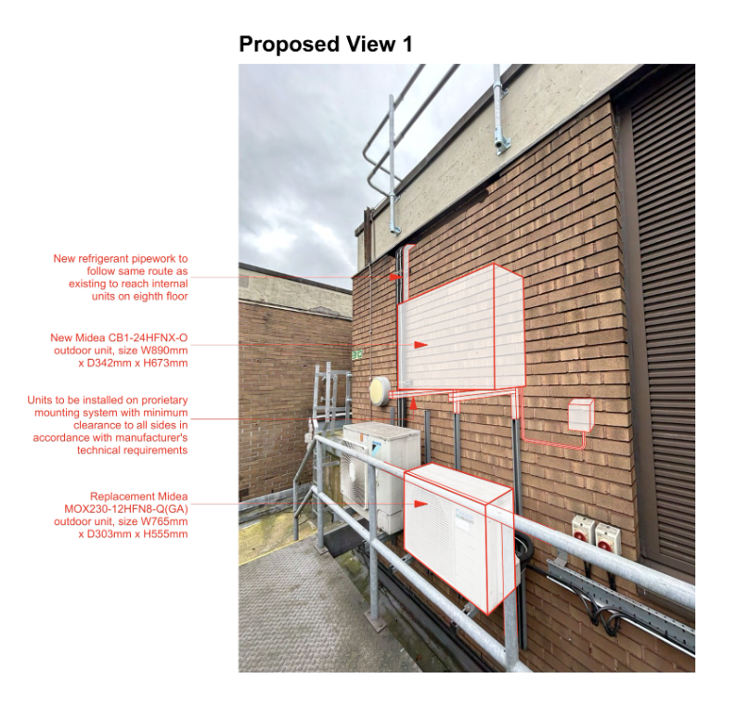

Relevant planning history

142049/FO/2025 | Installation of 4 no. air-conditioning condenser units to roof. (Approved March 2025)

139383/FO/2024 | Replacement of 5no existing AC units and the installation of 18no additional roof mounted AC Units within existing dedicated roof plant area. (Approved April 2024)

137739/FO/2023 | Installation of 3 no. louvered sections within existing glazed facade to the rear courtyard. Replacement of 14 no. air conditioning units and installation of 20 no. air conditioning units at roof level within the designated plant area. (Approved January 2024)

122741/FO/2019 | Installation of 2No roof mounted Air Conditioning units within existing Roof mounted Plant area. (Approved June 2019)

117369/FO/2017 | Installation of 1no air conditioning unit at roof level. (Approved November 2017).

Consultation, notification and publicity responses

Consultations

Environmental Health – No objections. The submitted acoustic assessment is considered acceptable. Further verification testing is required in the event of an approval, to ensure the noise limits are maintained after installation of the condenser units.

Notifications and publicity

A site notice has been posted. Letters were sent to surrounding businesses and the development was advertised is the press. No representations have been received.

Relevant policies

Places for Everyone Joint Development Plan (2024-2037)

JP-Strat1 Core Growth Area

JP-Strat2 City Centre

JP-P1 Sustainable Places

Manchester Core Strategy (2012-2027)

SP1 Spatial Principles

EC1 Employment and Economic Growth in Manchester

CC1 Primary Economic Development Focus: City Centre and Fringe

C1 Centre Hierarchy

DM1 Development Management

Saved Unitary Development Plan Policies

DC26 Development and Noise

Other Material Considerations:

National Planning Policy Framework (2024)

Chapter 2 Achieving sustainable development

Chapter 6 Building a strong, competitive economy

Chapter 12 Achieving well designed places

Assessment
Principle of Development

New air condensers are proposed to meet the operational needs of the applicant. The condensers proposed would service the eight floor occupant of the application site. The kitchen, pantry, and food preparation areas within the floor cater and service the meetings, conferences and training that takes place within the application site. These rooms frequently overheat. The development therefore supports the economic goals for the City Centre set out in JP-Strat1, JP-Strat2, EC1 and CC1.

The principle of the development is therefore acceptable under policies SP1, EC1, CC1, C1, JP-Strat1, and JP-Strat2.

Visual Amenity

Policy DM1 requires consideration of siting, scale and amenity in development considerations.

Proposed air condenser units would be sited within the existing plant area, which would continue the arrangement that has been consented for occupants of other floors of the application site. The application site has a large parapet, as such views of the roof level beyond the parapet are not possible from street level. This roof siting would therefore minimise obtrusiveness of the units.

Given this no requirement for any screening was considered necessary. The appearance and colouration of the units would not contrast the existing utilitarian appearance of the site’s roof area.

Given these details any potential visual intrusiveness would be effectively mitigated by the site’s existing height and massing the visual amenity impact of the development is therefore acceptable pursuant to policies DM1, SP1 and JP-P1.

Residential Amenity

Policies DM1 and DC26 require consideration of the impact of developments on the existing noise environment, particularly when in close proximity to noise sensitive uses such as hotels.

An acoustic report was submitted that demonstrated that the 2no. condensers proposed would produce an acceptable level of noise and would not cause an undue disturbance to the nearest sensitive receptors which are the hotel rooms on the building’s top floor.

A requirement for a verification report would be attached to an approval decision to ensure that acoustic assessment targets are adhered to.

Given these details the proposal is expected to adhere to the requirements of policies DM1 and DC26.

Other Legislative Requirements

Equality Act 2010
Section 149 (Public Sector Equality Duty) of the Equality Act 2010 requires due regard to the need to: Eliminate unlawful discrimination, harassment and victimisation and other conduct prohibited by the Act and; Advance equality of opportunity between persons who share a protected characteristic and persons who do not share it. The Equality Duty does not impose a legal requirement to conduct an Equality Impact Assessment. Compliance with the Equality Duty involves consciously thinking about the aims of the Equality Duty as part of the process of decision-making.

Human Rights Act 1998 considerations
This application needs to be considered against the provisions of the Human Rights Act 1998. Under Article 6, the applicants (and those third parties, including local residents, who have made representations) have a right to a fair hearing and to this end the local planning authority must give full consideration to their comments.

Protocol 1 Article 1, and Article 8 where appropriate, confer(s) a right of respect for a person’s home, other land and business assets. In taking account of all material considerations, including Council policy as set out in the Core Strategy and saved polices of the Unitary Development Plan, the Director of Planning, Building Control & Licensing has concluded that some rights conferred by these articles on the applicant(s)/objector(s)/resident(s) and other occupiers and owners of nearby land that might be affected may be interfered with but that that interference is in accordance with the law and justified by being in the public interest and on the basis of the planning merits of the development proposal. She believes that any restriction on these rights posed by the recommendation given is proportionate to the wider benefits of and that such a decision falls within the margin of discretion afforded to the Council under the Town and Country Planning Acts.

Conclusion

In totality, 2no. units are proposed to support an occupant within the application site. All condensers would be sited in an a location with a long precedent of plant equipment. The noise levels expected from the 2no. units would not cause an unacceptable level of impact on amenity within the site or area. For these reasons the development is considered acceptable pursuant to Core Strategy policies DM1 and SP1, Places for Everyone Policy JP-P1 and Saved Unitary Development Plan policy DC26.

Article 35 Declaration
In assessing the merits of a planning application, officers will seek to work with the applicant in a positive and proactive manner to seek solutions to problems arising in relation to dealing with the planning application. All such issues have been resolved due to the discussions within the applicant and the conditions.

Recommendation: Approve

Conditions attached to this decision

- The development must be begun not later than three years beginning with the date of this permission.

Reason - Required to be imposed by Section 91 of the Town and Country Planning Act 1990 (as amended).

- The development hereby approved shall be carried out in accordance with the following drawings and documents:

Drawing (Location Plan): 001
Document: Rooftop Plant Design Statement
Document: Breezeless+ Product Specification
Document: Acoustic Planning Report, prepared by Sandy Brown Acoustics

Reason - To ensure that the development is carried out in accordance with the approved plans pursuant to policies SP1 and DM1 of the Core Strategy.

3) a) Externally mounted ancillary plant, equipment and servicing shall carried out in accordance with 'Acoustic planning report - Convene 11 Portland Street, Manchester 026953-R01-A' produced by Sandy Brown dated 20 February 2026, received by the City Council as the Local Planning Authority on 22 May 2026.

b) Prior to the operation of the scheme a verification report shall be submitted to and approved in writing by the City Council as local planning authority to validate that the work undertaken throughout the development conforms to the recommendations and requirements in the approved acoustic report. The report shall also undertake post completion testing to confirm that the noise criteria have been met. Any instances of non-conformity with the recommendations in the report shall be detailed along with any measures required to ensure compliance with the agreed noise criteria.

Reason - To safeguard residential amenity by minimising the impact of the development and to prevent a general increase in pre-existing background noise levels around the site, pursuant to policies SP1, H1 and DM1 of the Core Strategy for the City of Manchester and Unitary Development Plan saved policy DC26

