Peter House, Manchester – Discounted Options
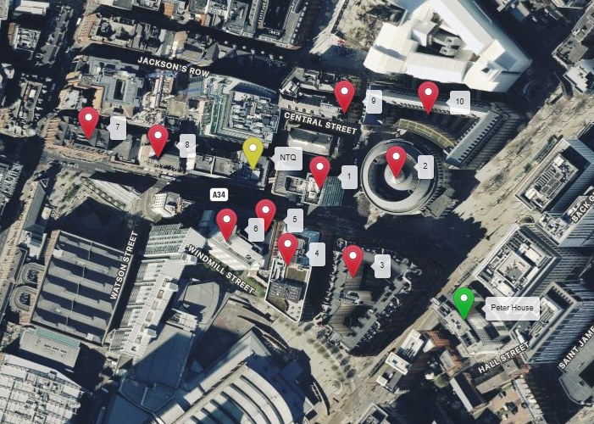
NGR Link: NGR Link

Discounted Options
1) The Lexicon – NGR: 383779 , 397953. This is NOT a discounted option – a proposal on this building is being progressed.
2) Manchester Central Library – NGR: 383844 , 397961. Discounted for obvious reasons – rooftop unsuitable. Grade II* listed.
3) The Midland Hotel – NGR: 383807 , 397878. Prominent Hotel building discounted due to the rooftop being unsuitable to house equipment. The building is also noted to be Grade II* Listed.
4) St Georges House – NGR: 383752 , 397888. Relatively low building compared to the surrounding properties. A site in this location would be partial blocked by the Midland Hotel, and potentially create ICNIRP issues. Unable to progress.
5) Theatre Royal – NGR: 383734 , 397916. Similar to the above. One of the lowest buildings in the area. Unable to consider due to taller buildings either side, potentially blocking coverage and creating ICNIRP issues.
6) The Edwardian Hotel – NGR: 383701 , 397909. We have surveyed this rooftop previously and found it difficult to design due to parapet wall around the rooftop, together with limited space for equipment without blocking accesses. Building is also noted to be Grade II* listed.
7) South Central – NGR: 383585 , 397995. Rooftop design unsuitable to house telecoms equipment.
8) 27 Peter Street – NGR: 383644 , 397980. Grade II listed building unsuitable to house equipment on the rooftop. The ‘former’ clock tower is also unsuitable.
9) 4 Mount Street – NGR: 383800 , 398016. Another tall building which could potentially provide the height required, however the rooftop is unsuitable to house equipment so unable to consider. Grade II* Listed also.
10) Town Hall – NGR: 383871 , 398015. Town Hall extension. Grade II* listed and unsuitable rooftop. Therefore discounted.

