

Planning

Delegated Officer Report

Summary of application details
Application reference: | 145539/FO/2026
Application type: | Full planning permission
Proposal: | Change of use of an existing industrial unit to an indoor sport and wellness facility (Use Class E(d)) with an ancillary cafe
Site address: | 11 Sherborne Street Manchester M3 1JS
Ward(s): | Cheetham
Date application valid: | 06 May 2026
Applicant name: | Veloura Padel Ltd
Agent (if any): | Mr Ikraam Ibrahim
Case officer: | Steven Mccoombe
Recommendation: | Refuse
Date of recommendation: | 20 July 2026

Description of site, building and/or area

The application site comprises a large, vacant, part single, part two storey industrial warehouse building bounded by Sherborne Street to the south, Irwell Street to the north, the rear of commercial properties fronting Bury New Road to the east, and Overbridge Road to the west, which forms the boundary with Salford City Council.

The application site contains a large industrial warehouse building, predominantly constructed in red brick with sections of external metal cladding. The principal warehouse structure is rectangular in form and occupies a substantial footprint. Adjoining the front elevation is a two-storey office element, which is built in matching brickwork.

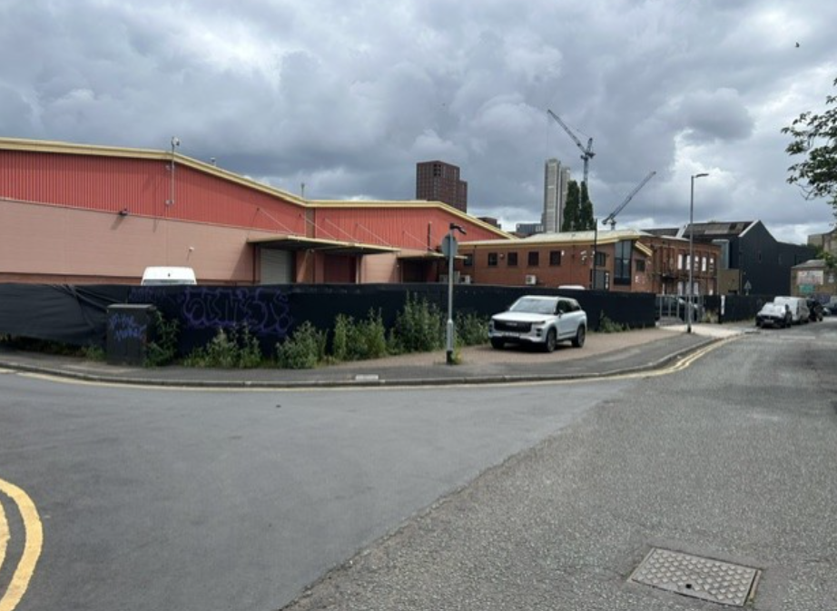

The site includes an area of car parking accessed from Overbridge Road which presently appears to be used by a nearby Sikh temple situated a short distance to south.

The site is located within Flood Zone 3 and within an area characterised by a dense mix of industrial and commercial uses, including warehousing, cash and carry operation, distribution, industrial premises, and surface car parks.

The site falls within the Overbridge area identified in the recently published Strangeways and Cambridge Strategic Regeneration Framework (SRF). The SRF highlights the area's potential for significant redevelopment, including city-centre uses within development blocks, subject to the proposed expansion of the city centre boundary through the Manchester Local Plan adoption process, a residential-led development strategy focused around the proposed new park, providing natural surveillance and supporting the activation of the surrounding neighbourhood and ground-floor commercial uses that respond to climate change and flood risk considerations, while creating opportunities for new business activity in close proximity to the city centre through a range of flexible workspace typologies. These aspirations reflect the Council's long-term vision for the regeneration and transformation of the wider Strangeways and Cambridge area.

Description of development

Planning permission is sought for a change of use of the existing warehouse building to indoor sport, recreation and fitness uses (Class E(d)). The intention is for the building to be used for padel courts and wellness facility with an ancillary café to operate on a 24-hour basis.

In addition, alterations to the car parking are proposed. Namely, an increase from 23 on-site parking to 31, including 3 accessible bays.

Relevant planning history
058710/FO/NORTH1/00

Extension to existing warehouse and creation of 8 additional parking spaces. Approved 25 April 2000.

052774/FO/NORTH1/97

Erection of a two-storey building for use as warehouse. Approved 14 January 1998.

022863

Use of part of vacant engineering works, formerly used for tyre fitting, as garage premises and workshop. Approved 27 November 1984.

F04910

Change of use from industrial works and warehouse to wholesale warehouse and distribution. Approved 2 August 1976.

Consultation, notification and publicity responses
Local Residents/Occupiers – No representations received.

Environment Agency - No objection but ‘informatives’ are advised in relation to flooding evacuation arrangements, emergency arrangements, insurance and building stability.

Flood Risk Management – No objection. The submitted information states that the proposal relates to the change of use of an existing industrial/storage unit to a commercial leisure use within an existing building, with no extension, increase in footprint or significant physical alterations proposed. The applicant argues that the development represents the sustainable reuse of a brownfield site and aligns with national planning objectives promoting the optimisation of existing urban assets.

It is further stated that the proposal would not introduce additional impermeable surfaces, alter external building dimensions, lower floor levels or create basement accommodation. As a result, the applicant considers that the development would not increase flood risk on-site or elsewhere, notwithstanding the site's location within Flood Zone 3. The proposal is presented as a low-impact form of development that reuses the existing building while providing social, economic and regeneration benefits.

‘Informatives’ are advised in relation to Environment Agency Flood Warnings, the existing surface water drainage system, flood resilience measures and the proximity of the River Irwell.

Salford City Council – No objection. The site is located within an established industrial area on the Manchester–Salford boundary, with the nearest residential properties approximately 240 metres away and separated from the site by the River Irwell. As a result, it is not considered that the proposed use would give rise to unacceptable impacts on residential amenity or the character of the area.

The Council also notes that the proposal includes an increase in on-site parking from 23 to 31 spaces, together with covered cycle parking for 10 bicycles. Given the site's sustainable location and the operational characteristics of the proposed use, it is considered unlikely that the development would result in a significant impact on the surrounding highway network. It is further acknowledged that any necessary controls over deliveries or operational matters could be secured through planning conditions imposed by Manchester City Council.

The response also highlights the aspirations of the Strangeways and Cambridge Strategic Regeneration Framework, which identifies Sherborne Street as a future active travel route connecting to Copper Park.

Manchester Active - Insufficient information has been submitted to enable a full assessment of the proposal against the objectives of Manchester's Sport Strategy and therefore offers no substantive support at this stage. They note that matters relating to the loss of employment space and the acceptability of the change of use fall outside its remit and should be considered by other statutory consultees.

Manchester Active has requested further information to justify the proposal, including evidence of the strategic need for padel courts in this location, details of the community benefits arising from the development, particularly how it would serve underrepresented groups within a highly deprived area and technical specifications demonstrating that the courts would be designed in accordance with the Sports and Play Construction Association (SAPCA) Code of Practice.

In addition, Manchester Active advises that commercial padel operators are expected to enter into a Community Use Agreement with Manchester City Council, Manchester Active and the Lawn Tennis Association to ensure opportunities are available for local residents and unmet demand is addressed. It is noted that such an agreement could potentially be secured through a planning condition, subject to sufficient evidence being provided to demonstrate a strategic need for the facility.

Highway Services – No fundamental objection to the proposal. The transport impacts are considered likely to be less intensive than the extant B2/B8 industrial use. The proposed 31 parking spaces are considered sufficient to accommodate visitor and staff demand, although a copy of the operational/travel strategy is requested, including measures to manage parking and prevent overspill parking on surrounding streets.

The site is considered accessible by sustainable transport, but further evidence is requested to support the claim that there is no existing road safety issue or collision pattern.

The proposed parking layout is acceptable in principle, but EV charging provision should be included in accordance with Manchester City Council standards. Clarification is also sought on pedestrian access arrangements.

Footway improvements around the site are requested, including reinstatement of existing dropped kerbs on Sherbourne Street and Irwell Street, which would require a Section 278 agreement.

The proposed cycle parking is welcomed, although additional secure and covered staff cycle parking is requested.

The submitted Waste Management Strategy is accepted in principle, but further details are required regarding servicing and delivery arrangements, together with a Service Management Strategy along with a Construction Management Plan should planning permission be granted.

Relevant policies

Local Development Framework

The Development Plan consists of:

- The Manchester Core Strategy (2012);
- Saved policies of the Unitary Development Plan for the City of Manchester (1995); and
- Places for Everyone Joint Development Plan.

The principal document within the framework is the Manchester Core Strategy which sets out the spatial vision for the City and includes strategic policies for development during the period 2012 – 2027.

'The Core Strategy Development Plan Document 2012 -2027 ("the Core Strategy") was adopted by the City Council on 11th July 2012. It is the key document in Manchester's Local Development Framework. The Core Strategy replaces significant elements of the Unitary Development Plan (UDP) as the document that sets out the long term strategic planning policies for Manchester's future development.

A number of UDP policies have been saved until replaced by further development plan documents to accompany the Core Strategy. Planning applications in Manchester must be decided in accordance with the Core Strategy, saved UDP policies and other Local Development Documents.'

The following policies contained within the Core Strategy are considered relevant:

Policy SP1 refers to the key spatial principles which will guide the strategic development of Manchester together with core development principles. It is stated that developments in all parts of the city should create well designed places which enhance or create character, make a positive contribution to the health, safety and well-being of residents, consider the needs of all members of the community and protect and enhance the built environment. Further, development should seek to minimise emissions, ensure the efficient use of natural resources, reuse previously developed land wherever possible, improve access to jobs, services and open space and provide good access to sustainable transport provision.

Policy DM1 states that new development should have regard to more specific issues for which more detailed guidance may be given within supplementary planning documents. Issues include: the appropriate siting and appearance of development, the impact upon the surrounding area, the effects on amenity, accessibility, community safety and crime prevention, health, the adequacy of internal accommodation and amenity space and refuse storage/collection.

Policy EC1 looks to ensure priorities for economic growth. The Council will support significant contributors to economic growth and productivity including health, education, retailing, cultural and tourism facilities, and other employment generating uses.

Policy EC2 states that the Council will seek to retain and enhance existing employment space and sites. Alternative uses will only be supported on sites allocated accordingly, or if it can be demonstrated that:

- The existing use is un-viable in terms of business operations, building age and format;
- The existing use is incompatible with adjacent uses;
- The existing use is unsuitable for employment having had regard to the Manchester-Salford - Trafford SFRA; or
- On balance, proposals are able to offer greater benefits in terms of the Core Strategy’s vision and spatial objectives than the existing use.

Policy EC4 states that North Manchester is expected to provide approximately 14ha of employment land. The key development opportunity in the area is:

1. City Centre Fringe suitable for office (B1a) led mixed use development:
-Strangeways;

-Collyhurst.

2. Significant existing employment and economic development is found in:

- Strangeways Employment Area north of the City Centre fringe, suitable for retention and growth of general industry, warehousing and distribution;

- Collyhurst;

-North of City Centre Fringe, an area with a number of major employers;

-Cheetham offering cultural facilities, such as museums;

-Manchester Fort Retail Park;

-North Manchester Business Park.

The Council will promote development which has had regard to:

-The key transport infrastructure such as the arterial roads Bury New Road, Cheetham Hill, Rochdale Road and other public transport networks such as bus routes;

-Metrolink and proposed extension and new stops;

-Connecting major employment opportunities to residential neighbourhoods within North Manchester and Lower Broughton and Salford;

-The importance of waterways and particularly the Irwell River in creating a sense of place and attracting investment.

Policy T2 – sets out strategy for managing the pattern of development to improve accessibility in the city, stating that car parking standards are maximums and cycle and disabled car parking standards are minimums, with account for circumstances at the council’s discretion.

Unitary Development Plan for the City of Manchester

Saved policy CC10 encourages the continued high level of economic activity in Strangeways and lower Cheetham Hill Rd areas, recognising particularly the needs of the wholesale trades which dominate these areas. The Council recognises the regional role played by this locality and will pursue policies designed to improve the efficiency of existing businesses by environmental improvements and better parking and servicing.

Permission will only be granted where proposals incorporate sufficient parking and servicing for their own needs, subject to a proper balance of other planning requirements.

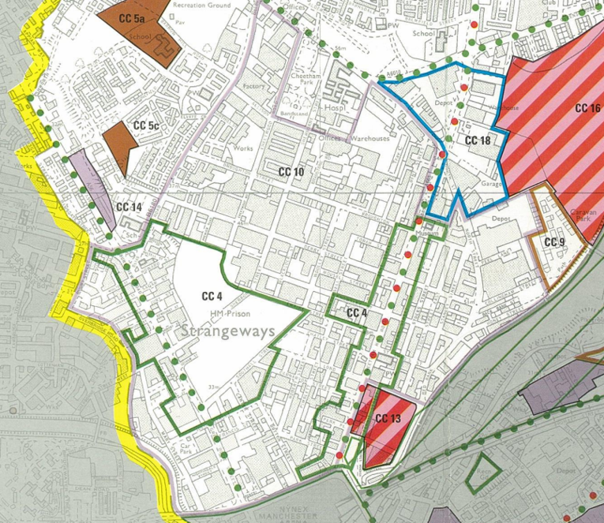
Saved policy CC10 of the UDP area allocated policy indicated by pink outline with the
application site indicated by arrow

Places for Everyone Greater Manchester Joint Development Plan (March 2024)

Places for Everyone Joint Development Plan was published in March 2024 and has been produced by Greater Manchester Combined Authority to provide a long-term plan for jobs, new homes, and sustainable growth for nine of Greater Manchester’s districts.

The Plan forms part of the Development Plan and its policies are now a material planning consideration in the determination of planning applications. The Plan and its policies must therefore be given significant weight in the planning balance.

The Plan identifies the essential aspect of the efficient and effective use of land with the preference to be given to making as much use as possible of suitable previously developed brownfield land and vacant buildings when meeting development needs. The following policies are considered relevant:

JP-J2 – (Employment Sites and Premises) - Existing employment areas that are important to maintain a strong and diverse supply of sites and premises in our boroughs will be protected from redevelopment to other uses, nurtured to ensure they remain competitive and their accessibility improved where necessary. This will include local employment areas as well as key growth locations.

JP-J4 (Industry and Warehousing Development) – ‘The need to provide the level of industrial and warehousing land within the Plan reflects the need for Greater Manchester to compete internationally for investment and provide sufficient choice and flexibility to respond to the varied needs of different businesses. This will help Greater Manchester to maximise its ability to attract and retain businesses and hence support its long-term economic growth prospects and the availability of local jobs.’

The policy goes on to state:

‘The existing supply of potential industrial and warehousing sites identified in the districts' strategic employment land availability assessments are insufficient to meet the overall identified need’.

The Strangeways and Cambridge Strategic Regeneration Framework (SRF) (2025)

This Strangeways and Cambridge Strategic Regeneration Framework (‘the SRF’) has been produced in partnership between Manchester City Council (‘MCC’) and Salford City Council

It is an important document that will be used to guide development and investment in this key area of the city over a 20-30-year period. Historically considered as ‘city fringe’, the Strangeways and Cambridge area will have a fundamental role in the growth and evolution of the city centre and the wider Greater Manchester economy.

The two councils have come together to prepare the SRF in response to the considerable changing context of the area, including:

– The ongoing growth of the Manchester and Salford ‘city core’, which has seen rapid expansion ‘upwards and outwards’ in areas such as Greengate and along Trinity Way, but where there remains an identified need for a larger city centre to help deliver continued economic growth;

– The desire of both councils to progress long-standing strategic challenges: in the case of the MCC, its desire to see the relocation of HMP Manchester, for SCC the need to address the impact of climate change on flooding from the River Irwell;

– The need to follow up the success of the recent Operation Vulcan – the GMP-led drive to purge the counterfeit goods trade and associated criminality – with a long-term plan for the area’s regeneration;

– A recognised opportunity to make more of the heritage assets across the area; and

– The requirement to provide a long-term vision for the area for residents, businesses and landowners, given this changing context, and the need to establish confidence in the future as a basis for investment and development.

This SRF provides guidance to support a holistic and coordinated approach to development in the area, which supports both City Councils objectives, and the inclusive growth of the
area.

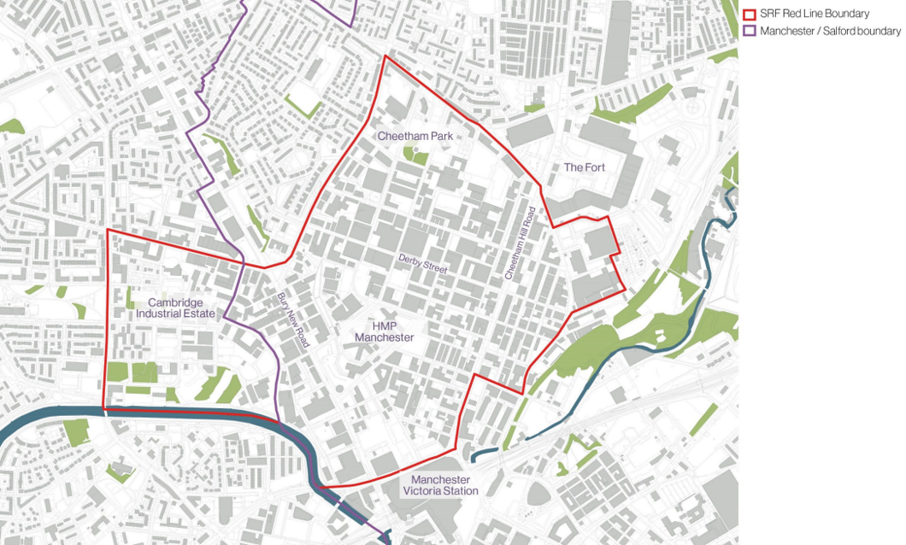
The Strangeways and Cambridge Strategic Regeneration Framework (SRF) boundary – arrow indicating location of application site

National Planning Policy Framework - The central theme to the revised NPPF is to achieve sustainable development. The Government states that there are three dimensions to sustainable development: an economic role, a social role and an environmental role.

The Framework underlines a “presumption in favour of sustainable development”. This means approving development, without delay, where it accords with the development plan and where the development is absent or relevant policies are out-of-date, to grant planning permission unless any adverse impacts of doing so would significantly and demonstrably outweigh the benefits when assessed against the NPPF.

Draft National Planning Policy Framework (December 2025)

A draft revised NPPF was published for consultation on 16 December 2025 and proposes significant changes to the structure and content of national policy.

The draft NPPF represents a fundamental shift toward a more rules based, nationally led and pro‑development planning system, whilst retaining the core objective of achieving sustainable development. It restructures the framework entirely into a policy format and separates plan‑making from decision‑making policies, with national decision‑making policies expected to carry significant weight where local plans are out of date or inconsistent.
A strengthened and more explicit presumption in favour of development sits at the heart of the draft.

The reforms place strong emphasis on boosting housing delivery, including support for small sites, higher densities in sustainable locations, and continued pressure on authorities to meet housing need, alongside earlier reforms such as mandatory targets and five‑year supply expectations.

There is a marked focus on transport‑led development for sites near well‑connected public transport hubs, alongside encouragement of urban densification.

The draft also strengthens support for economic growth, infrastructure delivery, climate action and design quality; while seeking to streamline local plans so they focus only on local issues.

Overall, the direction of travel is toward a faster, more certain and delivery‑focused system, with reduced local discretion where it conflicts with national policy and a stronger emphasis on housing, sustainable locations and growth.

Assessment
Loss of Employment

Section 38(6) of the Planning and Compulsory Purchase Act 2004 requires that planning decisions are made in accordance with the development plan unless other material considerations indicate otherwise.

The National Planning Policy Framework (NPPF), at paragraphs 2 and 47, reinforces this principle. Paragraph 12 further clarifies that the presumption in favour of sustainable development does not alter the statutory status of the development plan as the starting point for decision-making. Where a proposal conflicts with an up-to-date development plan, planning permission should normally be refused.

In this case, the proposed development is considered unacceptable in principle as it conflicts with policies designed to protect the character and function of the area for employment generating uses and activities with a high level of economic output.

The application site lies within an area covered by a site-specific policy (Policy CC10 of the UDP) which emphasises the need to maintain high levels of economic activity, particularly supporting the wholesale trades that dominate the locality.

This approach is reinforced by Policies EC1, EC2, and EC4 of the UDP, which highlight the area’s significant contribution to employment and economic activity within the regional centre.

Policy JP-J2 of Places for Everyone stresses that existing employment areas are vital for maintaining a strong and diverse supply of sites and premises across Greater Manchester and should be safeguarded from redevelopment for alternative uses. Similarly, Policy JP-J4 underlines the need to provide sufficient industrial and warehousing land to remain competitive internationally, attract investment, and offer flexibility to meet varied business needs supporting long-term economic growth and local job availability.

The recently published Strangeways and Cambridge Strategic Regeneration Framework (SRF) 2025 further confirms the area’s role as a key employment hub, hosting the highest concentration of businesses outside Manchester city centre. This is supported by an economic study demonstrating Strangeways’ ongoing and future importance as an employment location.

It is considered that the proposed leisure use would harm the area’s established character and function, undermining policies aimed at retaining its employment role and the significant economic activity generated by wholesale, warehousing, and distribution trades. The proposal is therefore contrary to saved Policy CC10 of the UDP, Policies SP1, EC1, EC2, EC4, DM1 and SP1 of the Manchester Core Strategy, Policies JP-J2 and JP-J4 of the Places for Everyone Joint Development Plan, the Strangeways and Cambridge SRF, and the NPPF.

From a regeneration perspective, the proposed change of use from an employment premises to indoor padel courts is not supported.

The application site is located within an established industrial estate comprising a range of active businesses and forms part of a recognised and strategically important employment area. Whilst it is acknowledged that the proposed development would provide a recreational facility capable of contributing positively towards health and wellbeing objectives, increasing sporting participation and generating a modest level of employment, these benefits are not considered sufficient to outweigh the significant policy support afforded to the retention of employment land and premises in this location.

The site falls within the Inner Areas designation identified by Places for Everyone (PfE) 2024, where regeneration objectives are intrinsically linked with the maintenance of a robust and diverse portfolio of employment land. Policy JP-J2 (Employment Sites and Premises) establishes a clear presumption in favour of protecting existing employment areas from encroachment by non-employment uses, recognising the critical role such sites play in supporting economic growth, facilitating business investment and expansion, and providing accessible employment opportunities. The policy seeks to ensure that employment locations remain competitive and capable of meeting the needs of existing and future businesses.

In addition, Policy JP-J4 (Industry and Warehousing Development) highlights the strategic requirement to retain and enhance the supply of industrial and warehousing floorspace across Greater Manchester. The policy identifies a need for substantial levels of industrial and logistics development throughout the plan period and recognises the importance of safeguarding existing employment stock in order to meet future economic demands. The proposed conversion of an industrial unit to a leisure use would result in the permanent loss of employment floorspace, thereby reducing the availability of premises capable of accommodating industrial, storage, distribution or other employment-generating uses. As such, the proposal would not support the objectives of the PfE employment policies.

The application site is also located within the Strangeways Employment Area, identified under Core Strategy Policy EC4 (North Manchester) as a key location for the retention and growth of general industrial, warehousing and distribution activities. The area performs an important economic function within the city and has a long-established role as a mixed industrial and commercial location. Furthermore, the site is designated for industrial and commercial uses within the Unitary Development Plan, reflecting its continued strategic significance as an employment area.

Given that the proposal would result in the permanent loss of an established employment unit within the Strangeways Employment Area, it falls to be assessed against the requirements of Core Strategy Policy EC2 (Existing Employment Space). Policy EC2 makes clear that proposals for alternative uses will only be supported where it can be robustly demonstrated that the existing employment use is no longer viable, is incompatible with surrounding land uses, or that the benefits of the proposed development demonstrably outweigh those associated with retaining the site for employment purposes.

In this case, the Council is not satisfied that sufficient evidence has been provided to demonstrate that the existing employment use is no longer viable. Whilst the applicant has sought to explain the circumstances surrounding the departure of the previous occupier, this merely establishes that the former business no longer required premises of this scale and does not demonstrate that the building itself is unsuitable for continued employment use. Significantly, no robust market evidence has been submitted to establish a lack of demand for the premises and neither has a comprehensive and independently verifiable marketing exercise been undertaken over a reasonable period to demonstrate that the property has been actively marketed for employment purposes without success. In the absence of such evidence, there is no compelling basis upon which to conclude that the building is incapable of attracting a future industrial, storage, distribution or other employment-generating occupier.

Further, there is little evidence to suggest that the building suffers from physical, operational or locational constraints that would prevent its continued use for employment purposes. The premises remain substantially intact and appear capable of accommodating a range of industrial and commercial activities. Indeed, the Council is currently in receipt of a proposal seeking to subdivide the building into a number of smaller Class B8 units, albeit that application has not yet been registered. This is a material indication that the site retains potential for continued employment use and that alternative commercial models may exist which could secure its ongoing occupation.

The applicant's contention that the proportion of office accommodation reduces the building's attractiveness to modern occupiers is afforded limited weight. Many businesses operating within established employment areas require a mix of warehouse, industrial and office space and no substantive evidence has been provided to demonstrate that the configuration of the building renders it obsolete or incapable of adaptation. Across Manchester, older industrial buildings continue to be refurbished, reconfigured and successfully reoccupied for a wide variety of employment uses. The Council has not been presented with any evidence to demonstrate why this building should be regarded differently.

Whilst it is acknowledged that the proposal would deliver certain benefits, including the provision of indoor sporting and recreational facilities, the promotion of health and wellbeing objectives, investment in an existing building and the creation of a number of jobs, these benefits are not considered sufficient to outweigh the strong policy presumption in favour of safeguarding employment land and premises within a designated employment location. The proposal would facilitate the loss of a substantial warehouse and employment unit from the city's employment land portfolio and would diminish the stock of premises available to support industrial, storage and distribution activities. Such a loss would undermine the established economic function of the area and conflict with the strategic objective of maintaining an adequate supply of employment land to meet future business needs.

The applicant's reliance on the low employment density associated with the site's previous occupier is not considered sufficient. The planning assessment must have regard to the lawful use and future potential of the site rather than the operational characteristics of a single former business. The building is capable of accommodating a range of employment generating activities and there is insufficient evidence to conclude that its future contribution to employment would be limited to the level previously experienced.

As such, the Council considers that the loss of the existing employment unit has not been adequately justified. Insufficient evidence has been submitted to demonstrate that continued employment use is no longer viable, that the site is unsuitable for employment purposes, or that the wider benefits of the proposal are of such significance as to outweigh the loss of employment floorspace. The proposal therefore represents an unjustified erosion of employment capacity within the Strangeways Employment Area and is contrary to the aims and objectives of Policies JP-J2 and JP-J4 of Places for Everyone 2024, together with Core Strategy Policies EC2 and EC4, which seek to protect, retain and enhance employment land and premises for continued economic use.

Whilst the proposal may provide recreation, health and wellbeing benefits, these benefits do not outweigh the harm arising from the unjustified loss of a sizeable and potentially marketable employment premises. The loss of the warehouse and employment floorspace is therefore considered unacceptable.

Other Legislative Requirements

Equality Act 2010
Section 149 (Public Sector Equality Duty) of the Equality Act 2010 requires due regard to the need to: Eliminate unlawful discrimination, harassment and victimisation and other conduct prohibited by the Act and; Advance equality of opportunity between persons who share a protected characteristic and persons who do not share it. The Equality Duty does not impose a legal requirement to conduct an Equality Impact Assessment. Compliance with the Equality Duty involves consciously thinking about the aims of the Equality Duty as part of the process of decision-making.

Human Rights Act 1998 considerations
This application needs to be considered against the provisions of the Human Rights Act 1998. Under Article 6, the applicants (and those third parties, including local residents, who have made representations) have a right to a fair hearing and to this end the local planning authority must give full consideration to their comments.

Protocol 1 Article 1, and Article 8 where appropriate, confer(s) a right of respect for a person’s home, other land and business assets. In taking account of all material considerations, including Council policy as set out in the Core Strategy and saved polices of the Unitary Development Plan, the Director of Planning, Building Control & Licensing has concluded that some rights conferred by these articles on the applicant(s)/objector(s)/resident(s) and other occupiers and owners of nearby land that might be affected may be interfered with but that that interference is in accordance with the law and justified by being in the public interest and on the basis of the planning merits of the development proposal. She believes that any restriction on these rights posed by the recommendation given is proportionate to the wider benefits of and that such a decision falls within the margin of discretion afforded to the Council under the Town and Country Planning Acts.

Article 35 Declaration
Officers have communicated their concerns about this proposal to the applicant during the course of the planning application, but these concerns have not been overcome. The proposal is considered to be contrary to the development plan and therefore refused in a timely manner.

Recommendation: Refuse

Reasons for refusal

1) | The proposed change of use would result in the unjustified loss of employment floorspace within the Strangeways Employment Area. Insufficient evidence has been provided to demonstrate that the premises are no longer viable or suitable for continued employment use, including through appropriate marketing evidence. The loss of an industrial/warehouse unit to a leisure use would undermine the strategic objective of maintaining and enhancing the supply of employment land and premises in this designated employment location. The proposal is therefore contrary to saved Policy CC10 of the Manchester Unitary Development Plan (1995), Policies DM1, EC1, EC2 and EC4 of the Manchester Core Strategy (2012), Policies JP-J2 and JP-J4 of the Places for Everyone Joint Development Plan (2024), the Strangeways and Cambridge Strategic Regeneration Framework (2025), and the National Planning Policy Framework.

