CONSTRUCTION PHASE PLAN FOR
Stack Manchester -Full Planning permission for the erection of one and two storey structures with flexible commercial uses )Use classes E(a) , E(b) , E(c) at ground and first floor ,with associated access arrangements , landscaping , lighting and other associated works including external seating areas and courtyard space .

AT
Stack Manchester

BY
Abbey Construction Services Limited,
Sunniside Lane,
Cleadon,
South Shields,
England,
NE34 8DY

OFFICE TELEPHONE NUMBER | 0191 5194477
EMAIL-ADDRESS | Info@theabbeygroup.co.uk

PREPARED BY | Richard Nellis / Abbey Construction

POSITION | Director

SIGNATURE | R.A Nelis

DATE | 13/07/2026
Revision | REV 1

Revision Log
This plan will be reviewed against the construction works and at least monthly to ensure its relevance.
Amendments to the contents of this Construction Phase Plan are to be recorded below with rows added to the table as required. Examples include changes to site management personnel, changes or additions to significant risks.
Regular amendments such as completion or Register of Risk Assessments should not be recorded.

Revision number | Date | Section Amended | Details of Amendment | Amended By
00 | As front cover | Original Document | N/A | N/A
01 | As front cover |  |  | R.Nellis
02
03
04
05
06

Issue Register
The register below to be used to record which parties are issued this document, all revisions to this plan are then to be issued those named below.
Issue To | Date | Revision Number | Issued By
PW – For Review | 20/02/2024 | 00 | Abbey
JK – For Review | 15/09/2025 | 01 | Abbey

Contents
- Pre-Construction Information and Exchange of Design Information.
- Distribution of Design Information.
- F10 Notification by Principal Designer
- Scope of Works.
- Summary of project specific constraints and restrictions affecting the works at various phases.
- Principal Parties.
- Location Map.
- Description of existing environment.
- Outline site plans, elevations and layout drawings for descriptive purposes
- Noise
- Dust
- Vibration
- Fire safety
- Sequence of works and programmes
- Further information and sources or information available
- Health safety, environmental management and welfare management structure
- Assessment of Risks
- Subcontractor risk assessment and any method statement, COSHH assessment etc
- SHE responsibilities on site
- Security and protection of the project
- Welfare arrangement and site set up
- Site Transport
- Storage of materials (including hazardous) and removal of debris
- Emergency procedures (fire and first aid)
- The notifications and investigation of reportable accidents and dangerous occurrences
- Site rules
- Induction
- Consultation with people on site
- Evaluation of subcontractors and discipline procedures
- Communication and coordination
- Tool box talk
- SHE monitoring
- Records of inspection and register
- Permits
- Temporary works
- NEXUS Tyne & Wear Metro and St James Park Stadium
- The Health and Safety File
- Appendix

01 Pre-Construction Information and Exchange of Design Information
All information in the form of drawings, specification and instructions will be registered by the company’s contract manager. Originals will be retained at the company’s office and a copy kept within the site office.

The company will disseminate this information to its subcontractors formally and record such distributions on the registers. The Contracts Manager will be responsible for ensuring current information is issued to the relevant contractors prior to all works commencing on site and for communicating any feedback or queriers back to the design team.

Any design information in the form of material samples will be resourced from the relevant contractor and formally issued to the design team by the Project Manager.

The Pre-Construction Information Document reviewed by Mr Paul Wright

02 Distribution of Changes in Design Information
No design changes will be made unless instruction has been made from Paul wright .

When changes in the design are made, these will be passed on to the relevant contractor as soon as possible. The information will be issued to the Principal Designer Adept to ensure a CDM review of changes has been undertaken. This will trigger a procedure of review between Abbey Construction management and subcontractor. The implications of the design change are to be fully considered. This will be an agenda item at weekly subcontract co-ordination meetings.

Existing risk assessments and method statements will be reviewed following changes to ensure these documents are still suitable and sufficient. This process will determine if any further mitigation measures are required.

03 F10 Notification
An F10 Notification will be made to the Health and Safety Executive by the Principal Designer Adept prior to works commencing. A copy of the F10 will be posted at the works area e.g Site office / Welfare facilities.

04 Scope of Works
The scope of works include;
Hatch Manchester - Erection of mixed use temporary structures comprising uses within use Class E ‘Commercial, Business and service ‘and Sui Generis ‘Drinking Establishments and Venue for live Music Performances with ancillary facilities, external seating and associated facilities and Events.

Works are scheduled to commence on site TBC and complete by TBC

05 Summary of Project Specific Constraints and Restrictions Affecting the Works at Various Phases.
The existing site area is located within land owned by TBC.

Working areas are to be segregated at all times with suitable barriers/ hoarding and signage highlighting on-going construction works being undertaken.

Abbey Construction will ensure that the site area is secure at all times with ongoing communications carried out with surrounding premises. Skips will be of a lockable type and will remain locked at all times, skips will be stored within the site boundary lines at all times.

Hours of operation comprising 0800 hours to 1600 hours Monday to Friday and 0800 to 1300 hours on a Saturdays only with no works on a Sunday or Bank Holiday, unless otherwise agreed in writing by the local planning authority. No construction works or deliveries to the site should take place on High Risk Days, unless otherwise agreed in writing by the local planning authority.

Crane company to ensure that details of the TTRO application are provided and in place when cranes are tracking into and around the construction site boundary.

06 Principal Parties
Client
Stack Manchester
Tel: 07772594759
Email: javaad@consultnorth.co.uk
Contact: Javaad
Principal Contractor
Abbey Construction Services Limited,
Sunniside Lane,
Cleadon,
South Shields,
NE34 8DY Tel: 0191 5194477
Email: richard@abbeyelectricalengineering.co.uk
Contact: Richard Nelis

Principal Designer
Adept Tel:074761294647
Email: info@adpetbc.co.uk
Contact:
Project Manager
TBC
Tel:
Email:
Contact:

Architect
Dunwoodie Swift Architects
i6Charlotte Square
Newcastle Upon Tyne
NE1 4XF
Tel: 01913758838
Email: C.ferguson@dunwoodieswift.co.uk
Contact: Chris Ferguson
07 Location Map
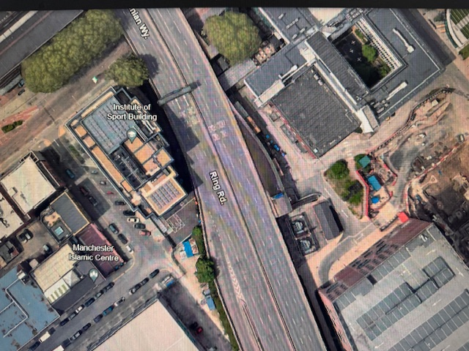



8 Description of Existing Environment
8.1 | Use of surrounding Land  Sports , Office blocks and current building projects
8.2 | Overlap with clients undertakings  TBC
8.3 | Existing services  Prior to works commencing Abbey Construction will ensure that suitable and sufficient method statement, risk assessment and COSHH assessments, five days prior to commencing on site. No works will be carried out until RAMS have been accepted by the client.  A permit system will be implemented by Abbey Construction for any isolation works that are required.
8.4 | Existing Ground Management  TBC
8.5 | Existing Traffic Systems  TBC  Any signs proposed to be installed on the public highway will require consent from the Highway Authority prior to installation. Applicant is required to submit a Traffic Management Plan detailing the proposed sign facing, where proposed located and if affixed to street furniture confirm type for fixing. This will be submitted to (Streetworks@Manchester.gov.uk) for the Area Traffic Management Engineer to assess and approve. The signs will be DfT approved – no branding will be used.  Material deliveries and all construction vehicle movements to site will require strict control by the Contractor’s Logistics Manager. These movements will also be closely monitored by the wider site management team. During pre-contract negotiations with sub-contractors and suppliers, it will be highlighted that the site restrictions / rules that are to be observed, specifically those times to avoid.  All formal sub contracts will reflect these matters and will be further communicated during the site specific inductions. All specialist sub contractors Risk Assessments and Method Statements are required a minimum of 2-weeks prior to their commencement on site to ensure these rules have been incorporated and will therefore be communicated to their staff prior to commencement on the contract.  The implementation of pre-agreed delivery schedules and programmes ensures that all deliveries arrive at the right time; materials are efficiently off loaded and despatched to the  correct storage zone as quickly as possible.  The Logistics Manager will co-ordinate and assist subcontractors with the booking process  and act as a liaison between contractors, to assess priorities and resolve booking conflicts,  this will be undertaken using an online booking system, with intervention by the logistics  manager to ensure that critical deliveries and delivery times can be made more efficient for  the project and surrounding roads.  The site plan will indicate a loading area where construction vehicles such as material  deliveries will pull in to be unloaded. Stacking’ vehicles on the existing road network will  not be permitted. We will schedule the arrival of vehicles via a booking system allowing  each delivery sufficient time to carry out their loading/unloading prior to the next vehicle  arriving. There will be no vehicles queuing onto the highway.  Delivery scheduling will be fully co-ordinated with all materials, waste and plant and  equipment leaving site. Hard copies of daily delivery schedules will be displayed at  prominent locations e.g. provided at the site offices, the delivery gate & offloading points  and also issued to site plant operators.  Any deliveries which are made during peak times (07:30-09:00, 16:00-18:00) will require  prior notification to Manchester Traffic Management and approval before taking place.  Vehicles will be required to pull into the nearest Government registered location for  abnormal loads . From there the delivery driver is to call ahead to site to  notify that they are approaching site and seek approval prior to setting off. This will allow approximately 30 minutes notice to site to ensure it is clear and ready for the delivery. All  abnormal loads will be required to provide notification to Manchester Highways and Manchester  Council.  The delivery procedure is appended to this document which will be issued to all subcontractors and suppliers.  A wheel wash will be in place from the start of the works, and used for any vehicles likely to generate debris transfer onto the highway, including excavation works. The traffic marshal will check each vehicle for cleanliness before allowing the vehicle to leave site. A mobile jet wash and clean water bowser will be used on a compacted stone/solid surface to limit further contamination onto the public highway.  A road sweeper will be deployed frequently to ensure there is no accidental contamination  on the roads, public highways and hoardings around the site. The areas will be regularly  inspected by Site Management and maintained and cleaned as required.  A crane will be in use throughout the site, at all times the surrounding areas will be restricted to public access and it is anticipated that road closures will be in agreement with The Highways Agency. A lifting plan must be agreed in advance highlighting lifting routes to ensure that over sailing of surrounding structures and public access routes is not carried out, as the site is located within Manchester City Centre.  See further details within appendix:  - Site Logistics Plan  - Crane Lifting Plan & Information
  Vehicle route to site.
  Vehicle route from site.
8.6 | Planning Restrictions  This document seeks to ensure all planning requirements for the construction phase of these works are planned, managed and monitored; continual communication with Manchester City Council is ongoing.  Planning permission has been granted for the development in accordance with the information contained in the applications subject to the conditions laid out in the decision notice:  - Planning application REF 140907/FO/2024

09 Outline Site Plans
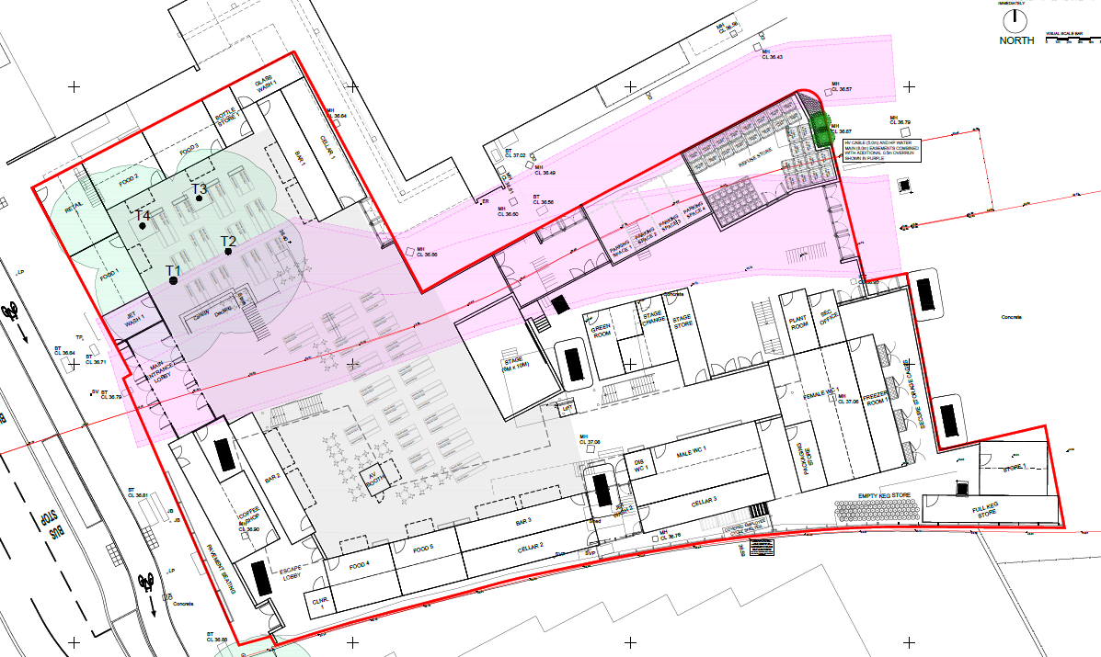

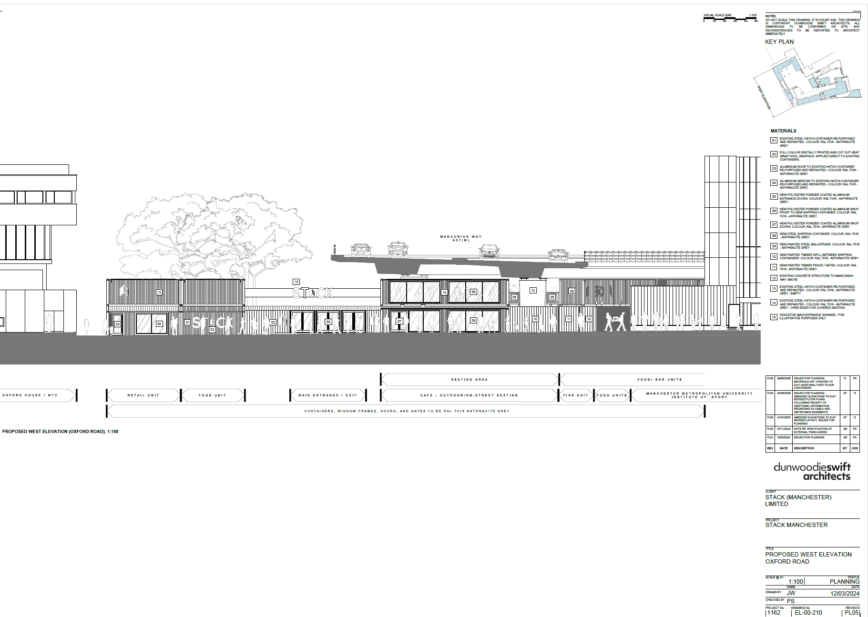

10 Noise
Noise is to be controlled on site ensuring that noise levels of plant and equipment are taken into consideration, working hours are Monday – Friday 08:00am – 08.00am and Saturday 08:00am – 08.00am. A risk assessment for noise will be located within the site office onsite. Hearing protection zones for operatives will be put in place as and when required.

A noise assessment is being undertaken, in relation to any adjacent hotels and residential properties , copies are to be provided to Abbey Construction to ensure adequate control measures can be implemented to reduce nuisance on surrounding businesses.

11 Dust
Dust suppression equipment (on tool extraction/ water suppression) will be mandatory on site where activities will create airborne debris, therefore limiting the amount of dust being released by the construction activities. A risk assessment for dust will be located within the site office.

Exposed ground and materials stockpiled on site, such as soils, hardcore and sand, can pollute water and air with silt and dust. The substructure and superstructure phases pose the most significant risk to dust contaminating the atmosphere.

Any stockpiles will be situated away from drains and water courses and measures will be
taken to prevent stockpiles and exposed ground from generating pollution as water run-off or dust.
If any material is to be stockpiled a damping down measures will be in place during dry and windy periods (i.e. proprietary perforated water supply) will be maintained to prevent the escape of dust into the atmosphere. Water suppression via jet wash will be utilised during excessive windy periods to ensure materials & dust are kept to a minimum.
Additional cleaning to surrounding facilities may be required.

Where applicable subcontractors will require evidence of Face Fit Testing for FFP3/P3 masks, where they will be generating dust.

12 Vibration
Vibration on site will be minimal, however consideration is to be taken for the surrounding environment as this will be operational throughout the construction phase. Where relevant a suitable and sufficient risk assessment will be carried out to ensure that higher risk vibratory operation will not affect the surrounding area. A risk assessment for vibration will be located within the site office onsite. Operatives will not be exposed to vibration which reaches the exposure action value (2.5 m/s2) A(8) or the exposure limit value (5 m/s2) (A8) vibrations will be logged for users of vibratory equipment.

13 Fire Safety on Site
A fire plan is attached to this Construction Phase Plan, however site management team will ensure that the fire plan is reviewed on a regular basis to ensure that the plan remains up to date throughout the construction phase.

Abbey Construction will ensure that fire alarm points are placed around the site and fire safety measures are highlighted during the site induction. This will include how to raise the alarm in the event of a fire and relevant muster points. Fire Fighting equipment will be provided throughout the site and have in date inspection carried out.

The fire assembly point will be identified during the site induction process and details are to be communicated to all operatives during the induction process.

In addition to a fire assembly point an additional evacuation point will be noted in the event of a suspected terror attack and details will be provided during the induction process.

Note: additional information is being required from the police and crowd safety/counter termism to highlight considerations within the licensing arrangements.

Operatives are required to sign in and out of site on a daily basis to ensure that a record of all persons is maintained at all times.

Hot works permits will be in place and managed by the site manager when operatives are undertaking any hot works.

14 Sequence of Works and Programmes
A full programme of works will be available for review within the site health and safety file and located within the site office.

Accident / incident reporting procedures will be highlighted to all operatives within the site induction carried out by the site management team.

Health and safety goals for the project include;
- Achieve Zero fatalities or specified injuries
- Comply with all current Health and Safety Legislation, Approved Codes of Practice and Industry Guidance and Good Practice.
- Maintain safe access and egress for the surrounding residents and site users.
- Identify and address all risks in accordance with Regulation 3 of The Management of Health and Safety at Work Regulations 1999.
- Maintain adequate levels of welfare facilities for the workforce.
- Avoid any significant disruption to the surround areas (including minimisation of dust/noise/vibration)

15 Further Information and Sources of Information Available
Pre-Construction Information Document | YES | Provided 01/11/23.
Design Information | YES | Design Team
Asbestos Survey | No | To be provided by Principal Designer / Client
Stats Drawing | No | To be provided by Principal Designer / Client
Structural Survey | No | To be provided by Principal Designer / Client
M&E Survey | No | To be provided by Principal Designer / Client
Soil Survey | No | To be provided by Principal Designer / Client
Layout drawings and elevations Schedule. | No | To be provided by Principal Designer / Client

16 Health Safety, Environmental Management and Welfare Management Structure
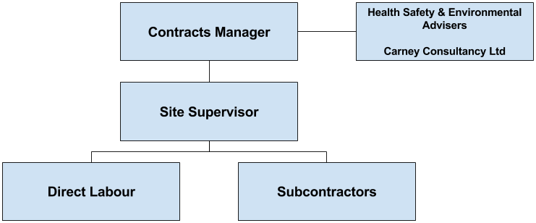

17 Assessments of Risks
To be completed by the company management before the start of the contract, significant risks will be identified and where necessary suitable risk assessments and method statements will be produced and or control measures to be adopted and outlined.
Hazard | Significant Risk to Project | Information Received from the Pre-Construction Information
Topography | Yes | Further information required
Access to Site | Yes | Further information required/ site specific information.
Overhead Services | Yes | Further information required/ site specific information.
Traffic Restrictions | Yes | Further information required/ site specific information.
Existing Plant or Work | Yes | Further information required/ site specific information.
Residential Buildings | Yes | Further information required/ site specific information.
Industrial Buildings | Yes | Further information required/ site specific information.
Scaffolding | Yes | Further information required/ site specific information.
Working at Height | Yes | Further information required/ site specific information.
Temporary Works | Yes | Further information required/ site specific information.
Concreting | Yes | Further information required/ site specific information.
Roofing | Yes | Further information required/ site specific information.
M&E | Yes | Further information required/ site specific information.
Asbestos | Yes | Further information required/ site specific information.
Site Fencing | Yes | Further information required/ site specific information.
Site Traffic Management | Yes | Further information required/ site specific information.
Excavations | Yes | Further information required/ site specific information.
Lifting | Yes | Further information required/ site specific information.
Waste Disposal | Yes | Further information required/ site specific information.
Arc Welding | Yes | Further information required/ site specific information.
Hole Ducts through Floors | Yes | Further information required/ site specific information.
Site Security | Yes | Further information required/ site specific information.
Cutting and Burning | Yes | Further information required/ site specific information.
Cartridge Tools | Yes | Further information required/ site specific information.
Fragile Material | Yes | Further information required/ site specific information.
Fire | Yes | Further information required/ site specific information.
Welfare | Yes | Further information required/ site specific information.
Risks to The General Public
Security / Fencing | Yes | Further information required/ site specific information.
Pedestrian Access to Site | Yes | Further information required/ site specific information.
Movement of Plant | Yes | Further information required/ site specific information.
Noise from Works | Yes | Further information required/ site specific information.
Dust from Works | Yes | Further information required/ site specific information.
Vibration from Works | Yes | Further information required/ site specific information.
Fire | Yes | Further information required/ site specific information.
Storage/ Delivery of Materials | Yes | Further information required/ site specific information.
Risks to Occupational Health
Dusts (Wood and Silica) | Yes | Site Specific RA to be produced
Asbestos | Yes | Site Specific RA to be produced
COSHH | Yes | Site Specific RA to be produced
Manual Handling | Yes | Site Specific RA to be produced
Vibration | Yes | Site Specific RA to be produced
Noise | Yes | Site Specific RA to be produced
Weils Disease | Yes | Site Specific RA to be produced
Welding fumes | Yes | Site Specific RA to be produced
Arc Eye | Yes | Site Specific RA to be produced
Sharps (Needlestick Injuries) | Yes | Site Specific RA to be produced
Temporary Accommodation
Office Installation | Yes | Site Specific RA to be produced
Electrical Installation | Yes | Site Specific RA to be produced
Drainage | Yes | Site Specific RA to be produced
Fire | Yes | Site Specific RA to be produced
Signage | Yes | Site Specific RA to be produced
Cleaning | Yes | Site Specific RA to be produced
Fencing | Yes | Site Specific RA to be produced
Security | Yes | Site Specific RA to be produced
Materials Storage | Yes | Site Specific RA to be produced

18 Subcontractor Risk Assessments and any required Method Statements, COSHH assessments etc
Subcontractor Risk Assessments, Method Statements and COSHH Assessments etc will be kept in the site file.

Contractor / Supplier Name | Task / Operation | Date Risk Assessment / Method Statement and COSHH Assessment required | Date Complete
TBC | Building Works | To be provided | To be provided
TBC | M&E | To be provided | To be provided
TBC | Groundworks | To be provided | To be provided
TBC | Decorating | To be provided | To be provided
TBC | Plumbing | To be provided | To be provided
TBC | Dry lining / plastering | To be provided | To be provided
TBC | Joinery Package | To be provided | To be provided
TBC | Container delivery | To be provided | To be provided
TBC | Container Siting | To be provided | To be provided

19 SHE Responsibilities on Site
Site manager/ Supervisor who has the overall responsibility for health, safety, welfare and environment and shall assume the role of Principal Contractor Representative.
Roles may be developed to other staff members from the Principal Contractor. This could include personnel off site.
Site Safety Appointments
Site Manager / Site Supervisor | TBC
Lifting Co-ordinator | TBC
Logistics | TBC
Site electricity Co-ordinator | TBC
Temporary Works Co-ordinator | TBC
COSHH Co-ordinator | TBC
First Aider | TBC
Mental Health First Aider | TBC
The TWC must be appointed in writing and manage the Temporary Works Schedule - openings are being made in the floor structure for this project and TW will be required to be designed.

20 Security and Protection of the public
Abbey Construction Services will operate a signing in procedure with all contractors and visitors on a daily basis. Inductions are to be carried out by the Site Manager before operatives commence works.

Access and egress points will be agreed away from public areas as far as is reasonably practicable and these points will remain secure at all times to prevent unauthorised access by the public, signage will be posted warning of restricted or prohibited access.

Prior to works commencing our project team will liaise with the surrounding businesses and Manchester City Council Highways Department to ensure that there is a coordinated approach to project delivery methods.

Monthly stakeholder meetings will be arranged by TBC which are proposed to be between Abbey Construction, TBC ,Manchester City Council Highways to ensure the most up to date information is circulated and can be addressed within this forum. Weekly logistics plans to be issued to all parties detailing the current phase of construction and its associated logistics.

Hoardings will be installed with ‘heras style’ fencing within to segregate the works area. All fencing will be designed by a temporary works designer and the designs will be checked by an independent temporary works checking designer.

The site management team will carry out weekly inspections on the fencing / hoardings to review its integrity, any alterations / modifications will be subject to the sites temporary works procedures which will include design, installation and maintenance checks.

Applications for hoardings licence will be secured via Manchester City Council online application form, as necessary.

Cranes
Any proposed crane use whether MEWP, mobile crane or tower crane will require a licence from Highways where the crane is operating on, or over-sails public highway. Licence of their use are available via the Council Website. No vehicles will be parked on the highway for materials to be lifted to or from site.

At no point will materials be permitted to be offloaded on any public roads. This will be clearly stated within the associated lifting plans as well as briefed to operatives during site induction.

All mobile cranes attending site will be required to inform Manchester Council when accessing site via public roads. This will be done via abnormalloads@Manchester.gov.uk for deliveries accessing Manchester Council Highways. abnormalloads@manchester.gov.uk.

Crane information including the lifting plan is appended to this document.

21 Welfare Arrangements and Site Set Up
Site Welfare accommodation will be constructed in line with requirements of the CDM Regulations 2015 Health and Safety at Work Act 1974. This will comprise of an onsite contractor village, site offices for both the client and principal contractor. No parking will be permitted on the road or footway for delivery drivers using the welfare facilities.

The contractor welfare facilities will incorporate the requirements for food storage, preparation and general heating up of food to promote the site personnel to remain on site and mitigate unnecessary vehicle movement during the break periods.

Welfare facilities will be cleaned and maintained on a daily basis and preventative pest control measures will also be put in place i.e. appropriate storage and regular collection and disposal of waste. Inspections will be carried out to ensure that food housekeeping measures are maintained at all times.

Temporary services connections will be maintained to the site office accommodation and welfare facilities will include:
- Electricity
- Water Supply
- Drainage
- Broadband & Wi-Fi

These connections are to be taken from existing supplies within the adjacent highway and public network. Abbey Construction will be required to apply for the appropriate notices including s50 via
the Manchester Council website .

There will be no on site car-parking spaces available to Construction personnel during the main construction phase; Operative’s will be encouraged to use public transport networks to travel to site where possible.

Any operatives who are unable to use public transport effectively will be advised during their induction to use public transport, or public car park in pay and display public car parks within the city centre.

Public car parks within walking distance of the site include NCP Circle Square Oxford Road

23 Storage of Materials (Including Hazardous) and Removal of Debris
Storage areas will be defined at all stages of the project; during the initial stages of the project storage areas will be confined to the site footprint for plant, fuel and materials for the groundworks.

Storage areas will be allocated to specialist contractors and these will be identified on a site plan and controlled daily.

Pedestrian and vehicular access routes will also be clearly defined on the plan and the limits of the pedestrian and vehicle access routes will be clearly signposted to ensure no migration between pedestrians and vehicular movements.

No storage or unloading of any materials will be permitted on the identified Nexus access route to the station

Materials will be stored in designated areas to prevent damage and cross contamination.

The storage of any liquids will be sited away from drains and un-surfaced areas. Storage containers will be regularly inspected and maintained, and will have secondary containment where applicable to contain any leaks or spills.

Bunded tanks will be sited away from accommodation / welfare facilities and will incorporate emergency spill kits, these will be made available adjacent to the storage areas.

Daily inspections will ensure that storage areas are kept clean and tidy at all times.

Storage will not be allowed to ‘spread’ in an uncontrolled manner onto footpaths and other walkways. It will not be permitted to store materials where they could obstruct access routes or where they could interfere with emergency escape.

A detailed Site Waste Management Plan will be developed in conjunction with our subcontractors detailing all monitoring, recording of disposal and recycling from site waste and vehicle tracking data.

All deliveries will be placed and delivered within the site boundary to ensure of control. This will however be in various locations depending on the nature of the delivery and if it is loading or unloading of a vehicle.

24 Emergency Procedures (Fire, First Aid, Flood, Power Outage, Environmental Incident)
Suitable emergency procedures will be prepared and posted in a prominent position on site. All foreseeable emergencies will be identified and the arrangements must be communicated to all site personnel through regular briefings and inductions.

Nominated induvial with specific duties that need to be carried out as part of the emergency incident prevention or control will be formally appointed and their names will be displayed on the emergency action noticed that have been made available for the first aid and fire.

All such notices must be regularly reviewed and kept up to date by the person in control of the site and the methods of achieving that are described below.

The emergency procedures for the site will be reviewed as the works progress to reflect changing layouts and will be reviewed as part of all internal and external safety inspections undertaken on the project.

The following items will (as a minimum) be included in any emergency plan that is prepared for the site. Please note that additional information will be provided where specific high-risk operations are being carried out (i.e confined space entry, Crane operations and electrical work)

- A fully completed fire action notice – Details of fire evacuation procedure from site. When an alarm is sounded on site all operatives on site should go immediately to their designated muster point which will be identified by the client.
- A site layout plan shows the following. Fire Points, Fire alarm points and call points, Assembly points, Emergency access routes, Access arrangements for emergency services, location of first aid equipment, Location of the emergency spill response kit, Site accommodation layout, Site storage areas, Waste disposal locations, Site perimeters and boundaries, specific hazard areas.
- A comprehensive site induction that covers the above points, the site rules in place on the site and any restrictions that are in place on the site.

Emergency Services
Fire | 999
Police | 999
Ambulance | 999
Hospital A&E | Manchester Royal Infirmary  Manchester  England  M13 9NZ  Tel 01612761234
Statutory Authorities
Electricity | ENWL 08001954141
Telecom | British Telecom: 0800 800 152
Water | United Utilities 03456723723
Gas | British Gas: 0800 111 999
Enforcing Authorities
HSE Contact | 0151 922 1221
EA / SEPA Contact | 0370 850 6506
Principal Contractor
Out of hours contact | Richard Nellis – 07860939627

25 The Notification ad Investigation or Reportable Accidents and Dangerous Occurrences
Details of all accidents are recorded in the site accident book.
It is the responsibility of the employer to report any RIDDOR accidents and dangerous occurrences of the HSE and to ensure an appropriate investigation is undertaken with a view to preventing recurrence.
Accidents to direct employees, single person labour only subcontractors should be notified by using form F2508 and within ten days of the accident occurring.
In the case of death or specified injury, initial notification must be made by telephone to the HSE as soon as practicable after the accident has occurred. (HSE may be notified by telephone either via the local HSE office or via their incident contact centre 0345 300 9923)
As an employer it is the subcontractor’s responsibility to report any accidents sustained by those working for them. Copies of the subcontractors completed F2508 notification form must be retained by the Principal Contractor for company records. If the subcontractor is unwilling or unable to complete form F2508, the Principal Contractor’s manager or their equivalent must notify the HSE.
Following any reportable accident or dangerous occurrence, the relevant risk assessments and any relevant method statement should be reviewed to determine whether they need changing in the light of the incident.

26 Site Rules
Site rules will be communicated to all site personnel and visitors at induction and posted on the site notice board.

Site rules (Not definitive) have been provided as a minimum from the Estate Management team.
The following rules apply to all persons entering the site
- Do not smoke anywhere on site
- Only use predefined rest areas agreed by the site manager
- Wear suitable and sufficient protective clothing (no not work bare chested)
- Keep your work area clean and tidy at all times
- Try and avoid disturbing site occupants and visitors (keep noise down and do not play music)
- Do not block fire exits and other access/ egress routes.
- Do not use environmentally hazardous materials without site approval.
- Appropriate bunding to be made accessible for spillage prevention.
- Do not work or interfere with anything which has not been authorised by the site manager.
- Do not discharge any substances to site drainage without site authorisation and consent from the regulator where required.
- Do not access any areas where you have not been authorised to do so.
- Comply with all site health, safety and environmental signage and instructions.
- When you finish working, leave your work area safe and secure and tidy.
- Take all waste away with you and ensure the legal duty of care and hazardous waste regulations are followed. Do not use site bins/ skips without authorisation.
 

27 Induction
All persons prior to commencing operations on site shall receive induction training from the site supervisor/ site manager
Records of all inductions will be maintained on site
Visitors to site, after signing in will receive a visitor’s induction unless accompanied at all times by a previously inducted person who will take responsibility for their health and safety. Copies of the site induction available in site safety file.

28 Consultation with people on site
Any H&S or Environmental matters that arise can be discussed with the site supervisor at any time, As a company there is an open door policy for anyone with concerns / issues regarding H&S or Environment. This will be stated and actively promoted at site induction.

29 Evaluation of Subcontractors and Discipline Procedures
All subcontractors working on the project will be required to satisfactorily complete to the company H&S prequalification questionnaire prior to commencing works.
A pre start meeting will be held with each subcontractor to allow method statement and risk assessments to be issued by the subcontractor and evaluated by the company prior to works commencing on site. All sub-contractors personnel will be required to undertake the site induction and will be subject to the sanctions described therein for breach of site rules / H&S regulations.

30 Communication and Co-ordination
Communications with the project team and subcontractors shall be carried out through regular site meetings.

It is essential that there is a constant liaison between the PC and subcontractors, the client, PD and project team. Regular meetings will be held to discuss design and construction matters

Duration and Frequency to be confirmed

31 Toolbox Talks
These will be undertaken as appropriate to the needs of the site. A register of tool box talks undertaken will be maintained onsite.

32 SHE Monitoring
The ongoing monitoring of SHE on site is a line management and supervisory responsibility. In addition, external consultants will carry out safety inspections and audits on a regular basis with written reports being submitted to relevant levels of management for review and action.
Site management and supervision will be responsible for carrying out regular site SHE inspections including formal documented weekly inspections.

33 Records of Inspections and Registers
All relevant forms and statutory registers will be completed as required by the specific nature of the contract and will form part of this plan and kept available for inspection.

34 Permits
The company will operate a permit system for the following activities (Delete as necessary).
- Hot Works
- Working at Height
- Confined Spaces
- Roof Works
- Excavation Works
- Use of Step Ladders
- Mechanical Isolation
- Electrical Isolation

35 Temporary Works
The appointed Temporary Works Coordinator (TWC) is responsible for identifying areas that need temporary works consideration and for a register of such work.
Where design is necessary the TWC will liaise with the appropriate designer ensuring they are provided with the necessary information.

36
Access along the agreed access route will be maintained at all times for passengers, emergency vehicles .

Crane Tracking plans detailed within the appendix

37 The Health and Safety File
The company will collect and collate information on aspects of the design, the materials and the construction processes and forward information to Principal Designer or the client if the Principal Designers appointment has ended before the construction phase is complete.

Construction Phase
Fire Prevention Strategy

General Information
Name and Relevant Details of the Person Responsible for Implementing the Plan | Site Manager/Responsible Person:
Contact Details Normal Hours  Contact Details out of Hours | TBC
Name of Fire Warden(s) | TBC
Fire Safety Awareness Training – how often, what is covered? | To be arranged before site induction and before the start of the relevant operations and during any additional changes to the contract
Date of Assessment: | TBC
General Objective of The Fire Prevention Plan | - To meet our legal obligations under the Construction (Design & Management) Regulations 2015.  - To meet our legal obligations under the Regulatory Reform (Fire Safety) Order 2005 (the Fire Safety Order).  - To provide an effective fire prevention strategy and exercise good management of fire safety to ensure that fires are unlikely to occur.  - To ensure if they do occur, that they are controlled or contained quickly, effectively and safely.  - To ensure that all relevant persons are able to escape to a place of safety easily and quickly.  - To ensure the fire safety of people in and around all areas under our control during the construction phase.  - To ensure as far as reasonably practicable, the protection of property and the environment and to minimise business disruption in case of fire.
Contract Status (e.g. Demolition/New Build/Refurbishment etc.) | Installation at newly formed unit.
Brief Description of Site Conditions (or Premises if Refurbishment) | Hatch Craft Bar
Existing or Previous Use of Premises (if demolition/refurbishment) | Mixed Leisure / Retail
Number of Floors | 2
Number of Client/Other Occupied Areas | TBC
Times the Premises Are In Use: | 06:00 – 23:00
Occupancy Type (N/B If Residential Obtain Client FRA for Premises) | Leisure Unit
Client Liaison Details (if Premises Occupied) | TBC

Foreseeable Fire Hazards
Ignition Sources: | smoking materials, electrical installations (existing and temporary),  plant and equipment, petrol cut off saws, task lighting, temporary heating units  Hot works (cutting / grinding/ burning/welding during construction phase).  spontaneous combustion of paint scrapings /oily rags etc.  static charges, friction, lightening, refracted sunlight  heating to site or temporary accommodation etc.
Additional Controls Required | PAT Testing , Hot works permits, Good housekeeping, Isolation permits / safe systems of works / no smoking
Sources of Fuel (inc Highly Flammables) | paper, wood, soft furnishings, construction materials & waste materials  existing structure e.g. composite panels, timber frames  Highly flammables such as paints, thinners, petrol/acetylene LPG etc.  protective coverings e.g. visqueen or scaffold sheeting etc.
Additional Controls Required | analysis of existing FRA’s of premises, good housekeeping
Oxygen (or Oxidising Agents) | natural ventilation, forced ventilation in existing premises, oxy-acetylene welding sets chimney stack effect
Additional Controls Required | fabrication off site etc., checking existing dampers etc.
Work Process | removal of compartmentation structural fire integrity, disabling part or fully the existing fire alarm system during refurbishment
Additional Controls Required | Programming of works to incorporate compartmentation and fire stopping as work progresses  This may also include temporary fire doors as required

Means of Escape for Relevant Persons
Total Number of Relevant Persons Requiring Evacuation at any Given Time: | TBC
Number of Escape Routes per Floor/Storey Exits Available | TBC
Number & Length of Any Escape Routes Containing Dead Ends | TBC
Width of Escape Staircase & maximum permissible Numbers | not less than 750mm for normal evacuation or 900mm for disabled evacuation
Number of Final Exits Available | daily/weekly checks made throughout the construction period
Maintenance of Escape Routes Inc Storey & Final Exit Doors. | daily visual inspection to ensure they are kept free from obstruction.
Provision of Emergency Escape Signage | provision and quantity of signage to be developed as work progresses throughout the term of the contract.
Location of Assembly Point | TBC

Means of Providing Warning & Emergency Lighting Provision
Type of Alarm System/Means of Providing Warning Proposed | Fire horn at signing in point plus rear escape door
Name of Company/Person Responsible for Maintenance & Functional Testing | Abbey Construction – Subcontractor
Contact Details | TBC
Emergency Lighting | Emergency units to be included in temporary provisions
Name of Company/Person Responsible for Maintenance & Functional Testing | Abbey Construction
Contact Details | Richard Nellis - 07860939627

Means of Containing or Fighting a Fire
Types of Fire Outbreak Likely | Class A
Maximum Floor Areas | N/B you should have a minimum of Two ‘Class A’ extinguishers on every storey of the building. (e.g., 6lt Foam or 9lt Water etc.).  Where there is 415 volt rated equipment, e.g. temporary supplies are used then 5kg not 2kg CO2 extinguishers are required  To be reviewed prior to commencement on site.
Number of Extinguishers Provide or Required | (BS5306) and states that you should be no more than 30 metres from the appropriate extinguisher on any given level of your premises.  To be reviewed prior to commencement on site.
Maintenance & Inspection Frequencies | annual servicing & /weekly checks made throughout the construction period
Existing Fixed Arrangements e.g. Dry or Wet Risers, Gas Suppression, Hose reels etc. | None
Maintenance & Inspection Frequencies | N/A
Access Routes for Fire & Rescue Service | N/B if normal routes are restricted or altered Local Fire & Rescue Service Should be notified of the changes
Existing Hydrants/ Water Pressure Issues | N/B if normal provision is restricted or altered Local Fire & Rescue Service Should be notified

Describe the anticipated fire in terms of size and location indicating the likely growth and spread in terms of time assuming all controls are implemented:
Low

Record of Additional Significant Findings, Control Measures including Deficiency Rectification:
Compartmentation to be maintained throughout the Construction Phase
There is an existing fire escape door that must be kept clear at all times, it is noted that one exits onto the car park at the rear

Fire extinguishers to be positioned in suitable locations.
Site Manager to act as fire warden
Temporary alarm system to be installed.
Method for calling the Fire Service.
- Immediately on hearing, the alarm the Site Manager/Fire Warden (Name) will summon the Emergency Services, giving clear and precise information relevant to the situation.
- Site Manager/Fire Warden (Name) will inform the client/existing occupied building of a Fire on site.
- When the call to the Emergency Services is complete, The Site Manager will take the signing in book, and proceed to the assembly point and account for all operative signed in for the day.

Emergency Action Plan.
In the event of a fire,
- The alarm is to be raised immediately,
- All buildings are to be immediately evacuated and emergency services contacted.
- All staff / operatives are to assemble at the assembly point.
- NO PERSONNEL are to re-enter the site unless authorised by the Fire and Rescue Service

