

Planning

Delegated Officer Report

Summary of application details
Application reference: | PLA-2026-000439
Application type: | Listed building consent (Alt/Ext)
Proposal: | Listed Building Consent for the installation of internal partitions and other internal fit-out works.
Site address: | Eighth Floor Bridgewater House 58-60 Whitworth Street Manchester M1 6LT
Ward(s): | Piccadilly
Date application valid: | 21 May 2026
Applicant name: | Gary Thomson
Agent (if any): | Mr Don Murphy
Case officer: | James Bridgman
Recommendation: | Approve
Date of recommendation: | 15 July 2026

Description of site, building and/or area
The site relates to the Grade II Listed Bridgewater House, which is an office building. The building is bounded by the Palace Theatre, Whitworth Street, a multi storey car park and the Rochdale Canal. It is located in an area of Manchester City Centre that accommodates a large number of Grade II and Grade II* former warehouses that are now used as hotels, offices and residential accommodation.
The building was built in 1912 as a shipping warehouse by Harry S. Fairhurst. It is ten storeys in height including a ground floor. It has a steel frame and is cladded with Sandstone Ashlar and White Glazed Terracotta with a concealed roof and is in keeping with the typical construction techniques of the Georgian Period.
The main frontage to the building faces out on to Whitworth Street, in an area historically known as Gaythorn, in the South-West of the City Centre. The character of the area comprises many different uses, including the Palace Theatre, shops, restaurants, hotels, residential accommodation, offices, takeaways and cafés.
The site is located within the Whitworth Street Conservation Area.

Description of development
Listed Building Consent for the installation of internal partitions and other internal fit-out works to an area on the Eighth Floor of the building.

The primary impact of these works will be the installation of solid and glazed partitions and suspended acoustic ceiling rafts.

Consultation, notification and publicity responses

Consultations
N/A

Notifications and publicity
Publicity - Neighbour notification letters were sent to surrounding properties. A site notice and local press advert were also produced. At the time of writing this report, no representations have been received due to this publicity.

Relevant policies
The effect of the proposal on the affected heritage asset has been considered under the following:
The Places for Everyone Plan - Joint Development Plan Document, for nine of the 10 boroughs which make up Greater Manchester adopted on 21st of March 2024:
- Policy JP-Strat2 - City Centre
- Policy JP-P2 - Heritage
The Manchester Core Strategy - Development Plan Document 2012-2027 ("the Core Strategy") was adopted by the City Council on the 11th of July 2012:
- Policy SP1 - Spatial Principles
- Policy CC9 - Design and Heritage
- Policy EN3 - Heritage
- Policy DM1 - Development Management
Saved Unitary Development Plan for Manchester - The following saved UDP Policies are of relevance to this application:
- Policy DC19 - Listed Buildings
National Planning Policy Framework (NPPF) (2024)
- Chapter 12 - Achieving well-designed places
- Chapter 16 - Conserving and enhancing the historic environment
Draft National Planning Policy Framework (NPPF) (2025)
The government has published a consultation National Planning Policy Framework which is intended to improve housebuilding rates through a clearer, more predictable and faster policy basis for decision and plan making. Whilst this is a draft NPPF for consultation it is considered that the development proposals are in accordance with the general thrust of policy contained within it. As set out in the printed report no adverse impacts have been identified through consideration of the application proposals that would outweigh a positive decision in this instance.
﻿Planning (Listed Buildings and Conservation Areas) Act 1990.

Assessment
In determining whether the proposed works are acceptable, the main issue to consider is the impact these proposed works will have on the historic character and fabric of the listed building itself and to establish as necessary whether the public benefits, including heritage benefits, of the proposal will outweigh any harm to the significance of the heritage asset.
Impact on the listed building
Listed Building Consent 141985/LO/2025 was granted for the internal refurbishment of the eighth floor. This application refers to the tenant fit out of the eighth floor of Bridgewater House.
The proposal includes the installation of partitions as shown below in Figure 2. These partitions would be limited to create meeting rooms to serve the office occupier. The partitions would be glazed to retain the permeability across the floor plan and minimise the impacts of the subdivision. Additionally, the fixing details show there would be a shadow gap when abutting historic fabric.
The partitions by virtue of the siting and impact on the openness of the floor plan would result in a low level of less than substantial harm.
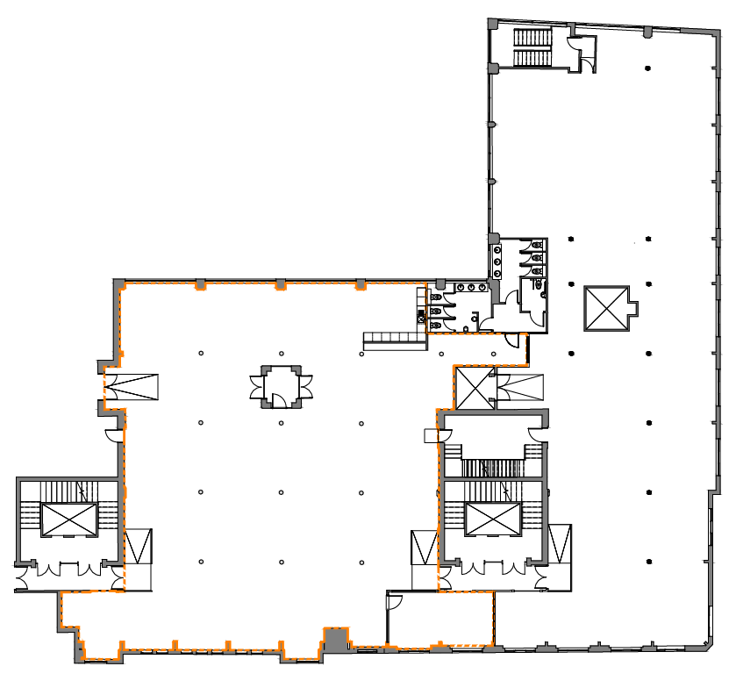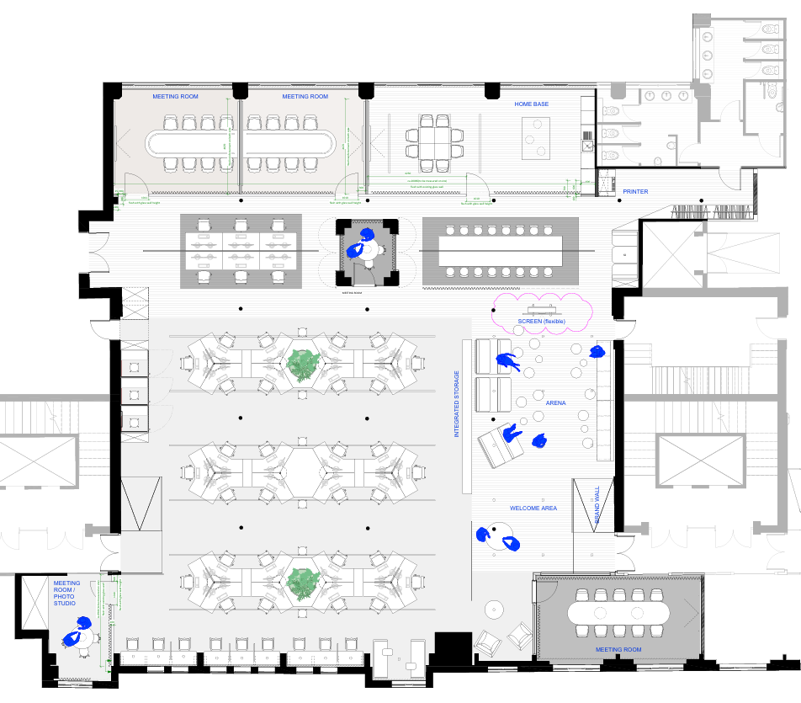
Figure 1 – Existing Floor Plan Figure 2 – Proposed Floor Plan

The installation of acoustic ceiling panels would restrict visibility of the original ceiling of the listed building. The panels have been significantly reduced by approximately 40% since the original submission as there were concerns, they appeared similar to a suspended ceiling.
The breaks between the panels would allow for visibility of the ceiling and reduces the prominence of the panels within the space. The panels would sit above the M&E
The LPA advise the colour of the suspended ceiling rafts preferably should be colour matched to the ceiling so they do not detract and it minimises any visual impact. Given the existing ceiling is painted black, the applicant is to explore the final colour with the landlord. The exact details including the appearance and finish is to be submitted for approval through condition.
The lighting design would be minimal as the linear lighting is an acceptable design solution.
All curtain rails would be fixed to the ceiling where possible to avoid any fixings into historic brickwork.
The original proposal included the installation of a large tv screen. The LPA expressed concerns with the fixings into historic brickwork. This element has been removed until the applicant can demonstrate fixings can be installed into mortar joints. Alternatively, a free standing TV unit would be better solution to avoid direct fixings into historic fabric.
The curtain finishes plan shows there would be rail system for the blinds along the windows. No fixing details have been provided and therefore prior to installation, exact details are to be submitted through condition.
Heritage Assessment
The partitions and acoustic ceiling panels would result in a low level of less than substantial harm to the listed building.
In line with the requirements of paragraph 215 of the NPPF where less than substantial harm occurs this must be set against the public benefits of the scheme.
The glazed partitions are necessary to provide meeting rooms, and the suspended acoustic rafts are to ensure the occupier’s office can operate to meet their businesses demands. The occupation of the listed building is a public benefit, and it is considered these alterations are necessary.
As set out above overall it is considered that the works have resulted in a low level of less than substantial harm to the listed building. Section 215 of the NPPF requires these to be outweighed by public benefits.
Conclusion
It is considered that the works are in accordance with Places for Everyone Plan policies JP Strat2 and JP-P2, Manchester Core Strategy policies CC9, EN1, EN3, DM1 and SP1, and Saved Unitary Development Plan for Manchester policy DC19, section 16 of the NPPF, and Planning (Listed Buildings and Conservation Areas) Act 1990.

Other Legislative Requirements

Equality Act 2010
Section 149 (Public Sector Equality Duty) of the Equality Act 2010 requires due regard to the need to: Eliminate unlawful discrimination, harassment and victimisation and other conduct prohibited by the Act and; Advance equality of opportunity between persons who share a protected characteristic and persons who do not share it. The Equality Duty does not impose a legal requirement to conduct an Equality Impact Assessment. Compliance with the Equality Duty involves consciously thinking about the aims of the Equality Duty as part of the process of decision-making.

Human Rights Act 1998 considerations
This application needs to be considered against the provisions of the Human Rights Act 1998. Under Article 6, the applicants (and those third parties, including local residents, who have made representations) have a right to a fair hearing and to this end the local planning authority must give full consideration to their comments.

Protocol 1 Article 1, and Article 8 where appropriate, confer(s) a right of respect for a person’s home, other land and business assets. In taking account of all material considerations, including Council policy as set out in the Core Strategy and saved polices of the Unitary Development Plan, the Director of Planning, Building Control & Licensing has concluded that some rights conferred by these articles on the applicant(s)/objector(s)/resident(s) and other occupiers and owners of nearby land that might be affected may be interfered with but that that interference is in accordance with the law and justified by being in the public interest and on the basis of the planning merits of the development proposal. She believes that any restriction on these rights posed by the recommendation given is proportionate to the wider benefits of and that such a decision falls within the margin of discretion afforded to the Council under the Town and Country Planning Acts.

Recommendation: Approve

- The works must be begun not later than the expiration of three years beginning with the date of this consent.

Reason - Required to be imposed pursuant to Section 18 of the Planning (Listed Buildings and Conservation Areas) Act 1990 (as amended).

2) The development hereby approved shall be carried out in accordance with the following drawings and documents:

- Proposed Floor Plan: 1893-AUS-OG08-GR-010 Rev C
- Proposed Sections: 1893-AUS-OG08-SEC-090 Rev C
- Proposed Sections: 1893-AUS-OG08-SEC-092- Rev B
- Demolition Sections: 1893-AUS-OG08-GR-081 Rev A
- Proposed Ceiling Plan: 1893-AUS-OG08-DS-020 Rev B
- Flooring Plan: 1893-AUS-OG08-BP-030 Rev C
- Curtain Plan: 1893-AUS-OG08-VP-061 Rev B
- Lighting Relocation Plan: 1893-AUS-OG08-GR-082 Rev B
- Carpentry Position Plan: 1893-AUS-OG08-GR-070 Rev B
- Furniture Position Plan: 1893-AUS-OG08-GR-071-Rev B
- Wall Surface Plan: 1893-AUS-OG08-WP-051 Rev B

All received by the City Council as Local Planning Authority on 15 July 2026

- Partition Spec and Fixing Details (100mm Offset Single Glazed Screen with 54x77mm Double Glaze Hinged Door, No Deflection) (Received 10 July 2026)

Reason - To ensure that the development is carried out in accordance with the approved plans. Pursuant to policies CC9, EN1, EN3, SP1 and DM1 of the Core Strategy, saved policy DC19.1 and Sections 12 and 16 of the National Planning Policy Framework.

- Prior to the installation of the acoustic ceiling panels hereby approved, final details of the fixings, design and finish including the colour of each panel shall be submitted to and approved in writing by the Local Planning Authority.

The panels shall then be installed in accordance with approved details and the siting/layout as shown on Ceiling Plan: 1893-AUS-OG08-DS-020 Rev B (Received 15 July 2026)

Reason - The proposed works affect a building which is included in the Statutory List of Buildings of Special Architectural or Historic Interest so careful attention to building work is required to protect the character and appearance of this building in accordance with saved policy DC19.1 of the Unitary Development Plan for the City of Manchester and policies SP1, EN3 and DM1 of the Core Strategy.

- Prior to the installation of the Blinds and Rail System annotated as TEX-05 on drawing No.1893-AUS-OG08-VP-061 Rev B (Received 15 July 2026), a final detailed design including fixings details shall be submitted to and approved in writing by the Local Planning Authority.

The approved rail system and blinds shall then be implemented as part of the development.

Reason - The proposed works affect a building which is included in the Statutory List of Buildings of Special Architectural or Historic Interest so careful attention to building work is required to protect the character and appearance of this building in accordance with saved policy DC19.1 of the Unitary Development Plan for the City of Manchester and policies SP1, EN3 and DM1 of the Core Strategy.

- The partitions hereby approved shall be installed in accordance with the Floor Plan (Drawing 1893-AUS-OG08-GR-010 Rev C - Received 15 July 2026) and Drawing (100mm Offset Single Glazed Screen with 54x77mm Double Glaze Hinged Door, No Deflection), prepared by JM Glazing (Received 10 July 2026).

Reason: The proposed works affect a building which is included in the Statutory List of Buildings of Special Architectural or Historic Interest so careful attention to building work is required to protect the character and appearance of this building in accordance with saved policy DC19.1 of the Unitary Development Plan for the City of Manchester and policies SP1, EN3 and DM1 of the Core Strategy.

