

Planning

Delegated Officer Report

Summary of application details
Application reference: | PLA-2026-000163
Application type: | Householder planning permission
Proposal: | Retention of a single storey outbuilding and canopy, to rear of dwellinghouse.
Site address: | 12 Crescent Range, Manchester, M14 5RW
Ward(s): | Rusholme
Date application valid: | 02 June 2026
Applicant name: | Mr Hamed Elanazi
Agent (if any): | Mr Barry Cullen
Case officer: | Joshua Lee
Recommendation: | Approve
Date of recommendation: | 16 July 2026

Description of site, building and/or area
The proposal is related to a two-storey semidetached dwellinghouse on Crescent Range. The property has an existing single storey rear extension. The property features hardstanding to the front for off street vehicle parking and garden to the rear.
The property is in a mixed-use part of the Rusholme ward. The property is in a high-risk surface water risk area. The property is in Victoria Park Conservation Area. Xaverian College sits opposite with part of the building and attached archway Grade II listed. The Rusholme district centre sits to the west.

Description of development
The applicant is proposing the retention of a single storey outbuilding and canopy, to rear of dwellinghouse.
The outbuilding measures 5430mm wide and runs 12700mm and is finished in brick with a flat roof at a maximum height of 2550mm. New glazing is featured to the front and side elevation.
A new canopy is also proposed which runs most of the length of the outbuilding and connects the eaves of the outbuilding to the boundary fence. The canopy is constructed of timber and finished with plastic roof panels.
The proposed outbuilding is noted as a ‘granny annexe’ which suggests a ancillary residential use.
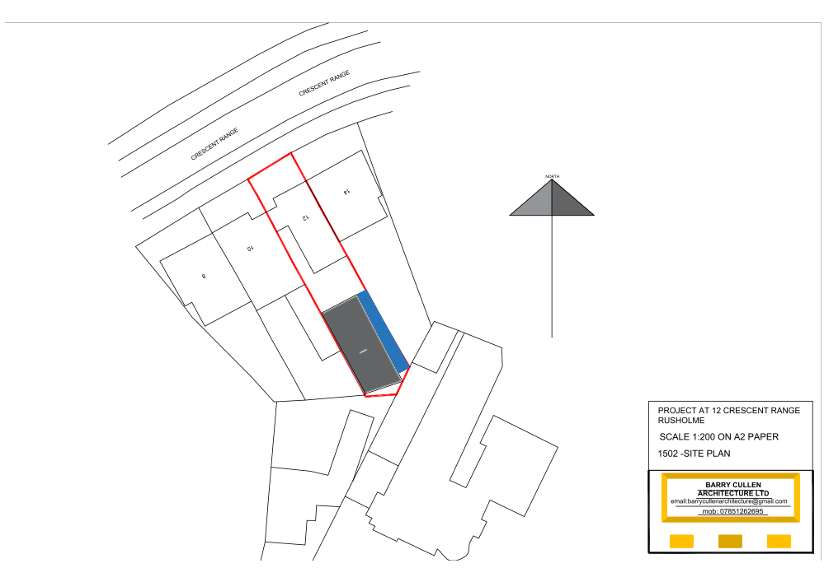
Figure 1. Site plan

Relevant planning history

Enforcement Case - ENF/16071/25
Unauthorised erection of a single storey rear extension
Under Investigation, Rec'd: 2025-08-29

Planning Application - 059362/FH/SOUTH1/00
Single storey rear lounge extension and first floor rear bathroom
Approve - 2000-07-07

Planning Application - 057669/FH/SOUTH1/99
Single and two storey side and rear extensions to form kitchen/dining room with bedroom/bathroom over.
Refuse – 1999-11-19

Consultation, notification and publicity responses

Consultations

Flood Risk Management
No objection however a United Utilities public sewer is onsite. The LLFA recommends that the LPA should consult UU on an approvable master plan before determining the planning application.

United Utilities (Planning)
No response received.

Notifications and publicity
No responses received.

Negotiations
Issues have arisen in the consultation phase which required negotiations in positive and proactive manner.
- The roof appears to break the boundary line on the rear angled corner. The applicant has signed Certificate A which would suggest this is within his ownership.
The applicant provided updated plans with a revised drawing.

Relevant policies
In accordance with Section 38(6) of the Planning and Compulsory Purchase Act 2004, decisions on planning applications must be made in line with the statutory development plan, unless material considerations indicate otherwise.
For Manchester, the development plan comprises:

- The Core Strategy (2012–2027)
- Saved policies of the Unitary Development Plan (UDP)
- The Places for Everyone Joint Development Plan Document (2022–2039)

These documents are considered up to date and carry substantial weight in decision-making. Supplementary Planning Documents (SPDs) and other local guidance may also be relevant.
National planning policy, including the National Planning Policy Framework (NPPF), is a material consideration and provides overarching guidance.
The Government has published a consultation draft of the NPPF, intended to improve housebuilding rates through a clearer, more predictable and faster policy basis for decision and plan making. While this draft is not yet adopted, it is a material consideration.
Where applicable, the Council must give special regard to preserving the character of conservation areas and the setting of listed buildings, in line with statutory duties under the Planning (Listed Buildings and Conservation Areas) Act 1990.
The policies referenced in this report are those considered most relevant to the nature, scale and location of the proposed development as follows:

- The Manchester Core Strategy Development Plan Document 2012-2027
  - Development Management and Planning Obligations
    - DM 1 - Development Management
  - Objective 1 - Spatial Principles
    - SP 1 - Spatial Principles (Partially replaced by PfE Policy JP-S 1)
  - Objective 6 Environment
    - EN 1 - Design Principles and Strategic Character Areas
    - EN 3 – Heritage (Deletions replaced with PfE Policy JP-P2)
    - EN 14 – Flood Risk (partially replaced by PfE Policy JP-S 4)
    - EN 19 – Waste
- Guide to development in Manchester - supplementary planning document and planning guidance, April 2007
- Extant Unitary Development Plan (UDP) –
  - Citywide Development Control Policies
    - DC1 - Residential extensions
    - DC18 - Conservation Areas
    - DC26 - Development and Noise
- Places for Everyone Plan Joint Development Plan Document 2022-2039-
  - Strategy
    - JP-Strat9: Southern Areas
  - Sustainable and Resilient Places
    - JP-S1: Sustainable Development
    - JP-S4: Flood Risk and the Water Environment
  - Places for People
    - JP-P1 Sustainable Places
    - JP-P2: Heritage
- National Planning Policy Framework (NPPF) December 2024–
  - Section 2 - Achieving sustainable development
  - Section 4 – Decision-making
  - Section 12 – Achieving well-designed places
  - Section 14 - Meeting the challenge of climate change, flooding and coastal change
  - Section 16 - Conserving and enhancing the historic environment
- National Planning Policy Framework Draft for Consultation December 2025 - National decision-making policies
  - Chapter 3 – Decision-making policies
    - DM1: Preparing development proposals
    - DM2: Information requirements
    - DM3: Determining development proposals
    - DM6: Use of planning conditions and obligations
    - DM7: Relationship with other regulatory regimes
    - DM8: Unauthorised development and enforcement
  - Chapter 4 - Achieving sustainable development
    - S3: Presumption in favour of sustainable development
    - S4: Principle of development within settlements
  - Chapter 12 - Making effective use of land
    - L4: Residential extensions
  - Chapter 14 - Achieving well-designed places
    - DP3: Key principles for well-designed places
    - DP4: The Design process
  - Chapter 18 - Managing flood risk and coastal change
    - F4: Assessing flood risk for decision-making
    - F7: Ensuring development is safe from flooding
    - F8: Sustainable drainage systems and watercourses
  - Chapter 20 - Conserving and enhancing the historic environment
    - HE9: Conservation areas

Assessment

Principle of Development
The application seeks retrospective planning permission under Section 73A of the Town and Country Planning Act 1990 for the retention of a domestic outbuilding within the curtilage of an existing dwellinghouse. Development of this nature is acceptable in principle where it is clearly subordinate to and used for purposes ancillary to the main dwelling. In this case, the applicant has confirmed that the outbuilding is used for purposes ancillary to the host property and remains subordinate in scale and function to the dwellinghouse. As such, the proposal accords with Core Strategy policy DM1, saved UDP policy DC1 and the National Planning Policy Framework.
A fallback position under permitted development is also a material consideration. Class E of the Town and Country Planning (General Permitted Development) (England) Order 2015 (as amended) permits the erection of outbuildings within the curtilage of a dwellinghouse, subject to limitations and restrictions, including that they are used for purposes incidental to the enjoyment of the dwellinghouse. The scale and siting of the retained outbuilding are such that a broadly comparable structure could reasonably be erected under permitted development rights. This fallback position attracts moderate weight in favour of the proposal.
Overall, the retention of the outbuilding is considered acceptable in principle, subject to the detailed assessment set out below.

Appropriate siting, layout, scale, form, massing, materials, and detail
The proposed outbuilding would be constructed using materials to match the existing dwellinghouse, which would ensure a satisfactory visual relationship with the host property.
The development is appropriately sited to the rear of the property and is limited to single-storey height, ensuring that it remains clearly subordinate to the main dwelling in terms of scale, form and massing.
The design and form of the outbuilding are typical of domestic garden structures and would not appear incongruous within the residential context. Whilst the proposal slightly exceeds what may be achievable under permitted development (by a marginal height difference), it broadly reflects the type and scale of development that could reasonably be expected within a residential curtilage.
In terms of layout and relationship to neighbouring properties, the outbuilding is positioned at the rear of the garden, in a location where similar outbuildings are commonly found. Given its scale, siting, and proximity to boundary treatments and neighbouring structures, the proposal would not result in an overbearing or dominant feature when viewed from adjoining properties.
Overall, the proposal demonstrates an appropriate siting, layout, scale and design, and would sit comfortably within the established pattern of development, in accordance with Core Strategy policy DM1 and saved UDP policy DC1.

Impact on the surrounding areas in terms of the design, scale and appearance of the proposed development. Development should have regard to the character of the surrounding area.
Only minimal views of the main proposed works are capable of being seen from the street. Given the position of the extension and the limited massing, together with the use of proposed materials, the character of the street would not be unduly affected.
The proposal is similar in size and scale to other outbuildings closeby and would not therefore disrupt the area's existing features.

Effects on amenity

Privacy
The proposal includes adding glazing facing back into the host garden. As these are at ground level they present no more harm than windows in the main dwelling and would likely be accepted under permitted development.

Light
Given the proposal is entirely at ground floor level at the rear of the site, the impact to light from the added massing is acceptable.

Noise
The proposed extension is not expected to generate any noise beyond what would be reasonably expected of a residential dwelling.

Accessibility: buildings and neighbourhoods fully accessible to disabled people, access to new development by sustainable transport modes.
The proposal does not change how people can get in and out of the building and would not present further accessibility issues into the property.

Adequacy of internal accommodation and external amenity space.
The proposal adds space inside the property with minimal effect to the outdoor area and maintains a good level of external amenity space post development.

Refuse storage and collection.
The proposal itself has little impact on waste from the site. It uses the current domestic storage and collection methods on site and maintains external access to the rear of the property.

Vehicular access and car parking
The proposal doesn't change how vehicles access and park at the property.

Effects relating to biodiversity, landscape, archaeological or built heritage

Built heritage
The application relates to a semi‑detached dwelling within the Victoria Park Conservation Area. Whilst located opposite elements of Xaverian College, including the Grade II listed archway, intervening development and separation mean the proposal would not affect its setting. The conservation area is therefore the primary heritage asset for assessment.
The significance of the Victoria Park Conservation Area is derived in part from its spacious plots, mature landscaping, and the sense of openness around dwellings.
The proposal comprises a single-storey outbuilding and canopy to the rear. By virtue of its modest height, domestic function, and siting, the outbuilding would appear clearly subordinate to the host dwelling and would be largely screened from public views. Subject to appropriate matching materials, it would integrate acceptably within its immediate context and would not harm key views or the wider townscape.
However, the combined footprint of the outbuilding and canopy would reduce the amount of undeveloped garden space. This would result in a limited erosion of the spaciousness and openness that contribute to the character and appearance of the conservation area.
This harm is considered to be low level and less than substantial in NPPF terms. In applying the balancing exercise, it is relevant that elements of the proposal, particularly the canopy, are of a scale and form that could reasonably be constructed under permitted development rights. This fallback position attracts some weight and reduces the extent to which harm can be attributed to the proposal as a whole.
Taking this into account, along with the modest scale of the development and its ancillary residential benefits, the proposal would, on balance, preserve the character and appearance of the conservation area, in accordance with Section 72(1) of the Planning (Listed Buildings and Conservation Areas) Act 1990.

Green Infrastructure including open space, both public and private
The rear garden of the property is entirely hardstanding which has been completed under permitted development. The proposed structure would have limited affect to green infrastructure.

Flood risk and drainage.
The site lies within an area identified as being susceptible to surface water flooding. However, given that the proposal relates to an outbuilding and would be constructed at the same finished floor level as the existing surrounding land, it would be unreasonable to require the submission of a full Flood Risk Assessment in this instance. Notwithstanding this, the applicant is advised to incorporate Property Flood Resilience (PFR) measures within the design. Such measures should provide protection to a minimum of 150mm above the predicted surface water flood level, or 600mm above the predicted fluvial flood level where applicable.
United Utilities were consulted on the application but no response was received. The applicant should nevertheless be aware of the potential presence of public sewers within the site. Given that the outbuilding is existing and any sewer infrastructure would likely have been identified at the time of the original development, there is no evidence before the Local Planning Authority to indicate that the proposal would adversely affect any public sewer.

Other Legislative Requirements

Equality Act 2010
Section 149 (Public Sector Equality Duty) of the Equality Act 2010 requires due regard to the need to: Eliminate unlawful discrimination, harassment and victimisation and other conduct prohibited by the Act and; Advance equality of opportunity between persons who share a protected characteristic and persons who do not share it. The Equality Duty does not impose a legal requirement to conduct an Equality Impact Assessment. Compliance with the Equality Duty involves consciously thinking about the aims of the Equality Duty as part of the process of decision-making.

Human Rights Act 1998 considerations
This application needs to be considered against the provisions of the Human Rights Act 1998. Under Article 6, the applicants (and those third parties, including local residents, who have made representations) have a right to a fair hearing and to this end the local planning authority must give full consideration to their comments.

Protocol 1 Article 1, and Article 8 where appropriate, confer(s) a right of respect for a person’s home, other land and business assets. In taking account of all material considerations, including Council policy as set out in the Core Strategy and saved polices of the Unitary Development Plan, the Director of Planning, Building Control & Licensing has concluded that some rights conferred by these articles on the applicant(s)/objector(s)/resident(s) and other occupiers and owners of nearby land that might be affected may be interfered with but that that interference is in accordance with the law and justified by being in the public interest and on the basis of the planning merits of the development proposal. She believes that any restriction on these rights posed by the recommendation given is proportionate to the wider benefits of and that such a decision falls within the margin of discretion afforded to the Council under the Town and Country Planning Acts.

Conclusion
The retention of the outbuilding and canopy is considered acceptable in principle and would not result in unacceptable harm to the character and appearance of the host property, the surrounding area, neighbouring residential amenity, or the significance of the Victoria Park Conservation Area. Whilst the development results in a minor reduction in garden openness, any resulting heritage impact is low level and is outweighed by the limited scale of the works, their ancillary residential function, and the fallback position under permitted development rights. Subject to the recommended conditions, the proposal accords with the Development Plan and the National Planning Policy Framework. Accordingly, planning permission is recommended for approval

Recommendation: Approve

Article 35 Declaration
Officers have worked with the applicant in a positive and proactive manner based on seeking solutions to problems arising in relation to dealing with the planning application. There were minor changes required to meet the requirements for approval and the officer and applicant worked together to find an amicable solution.

Conditions

Specified plans
The development hereby approved shall be carried out in accordance with the following drawings and documents:
  - MAP.pdf - The location plan - 1 May 2026
  - SITE PLAN.pdf - Site Plan – 1502 - 10 Jun 2026
  - PLANS AND ELEVATIONS.pdf – Plan - Plans and Elevations - 16 Jun 2026
Reason - To ensure that the development is carried out in accordance with the approved plans, pursuant to policies DM 1, SP 1 and EN 1 of the Core Strategy and JP-P1 & of Places for Everyone.

Materials - to match
The materials used in the external surfaces of the development hereby approved shall be similar in appearance to the existing building in terms of type, size, colour and texture.
Reason - In order to ensure a satisfactory appearance in the interests of visual amenity in accordance with policies SP1 and DM1 of the Core Strategy and the requirements of the National Planning Policy Framework.

Ancillary living accommodation
The development herby approved is for ancillary living accommodation for the main dwellinghouse. The proposed outbuilding is not to be used as an additional dwelling at the location or for short term lettings and is explicitly for the private enjoyment of the occupants of the main dwellinghouse unless otherwise agreed in writing by the City Council as local planning authority.
Reason - In the exceptional circumstances of a proliferation of HMOs and short term lets restricting housing choice and adversely affecting sustainability and in the interests of residential amenity, to safeguard the character of the area and to maintain the sustainability of the local community through the provision of accommodation that is suitable for people living as families pursuant to paragraph 7.4 of the Guide to Development in Manchester: Supplementary Planning Document and Planning Guidance, the National Planning Policy Framework and policies SP1 and DM1 of the Core Strategy for the City of Manchester.

Flat roof restriction
The flat roof of the outbuilding shall not be used for any other purpose other than for maintenance of the building.

Reason - To safeguard the amenities of the adjoining premises for overlooking or perceived overlooking and in accordance with policies SP1 and DM1 of the Core Strategy.

Informatives

Flood risk
The applicant is advised that the site lies within an area identified as being susceptible to surface water flooding. Whilst a Flood Risk Assessment was not considered necessary in support of this application, it is recommended that Property Flood Resilience (PFR) measures are incorporated into the development. Such measures should be designed to provide protection to a minimum of 150mm above the predicted surface water flood level, or 600mm above the predicted fluvial flood level where applicable.

