

Planning

Delegated Officer Report

Summary of application details
Application reference: | PLA-2026-000661
Application type: | Listed building consent (Alt/Ext)
Proposal: | Listed Building Consent for ceiling removal works due to asbestos contamination.
Site address: | Ward 90 Old St. Mary's Hospital Oxford Road Manchester M13 9WL
Ward(s): | Ardwick
Date application valid: | 11 June 2026
Applicant name: | Manchester University NHS Foundation Trust
Agent (if any): | Mr Joshua Wyatt-Smith
Case officer: | James Bridgman
Recommendation: | Approve
Date of recommendation: | 15 July 2026

Description of site, building and/or area
This application relates to works to Ward 90 in Old St Mary's Hospital.
St. Mary’s Hospital is orientated with the front (main) entrance facing east towards Oxford Road. It is to the far southwest corner of the Manchester Royal Infirmary campus and is bound by York Place Street to the north, Citylabs 2.0 office/research building to the east, Hathersage Road to the south and Oxford Road to the west, beyond which is Whitworth Park.

Description of development
Listed Building Consent is sought for ceiling removal works due to asbestos contamination.

Consultation, notification and publicity responses

Consultations

N/A

Notifications and publicity
Publicity - The proposal has been advertised, by way of site notice and press advertisement, as affecting the setting of a listed building. Letters have also been sent out to nearby occupiers. No comments have been as part of that process.

Relevant policies
The Places for Everyone Plan – Joint Development Plan Document, for nine of the 10 boroughs which make up Greater Manchester adopted on 21st of March 2024:
• Policy JP-Strat2 – City Centre
• Policy JP-P1 - Sustainable Places
• Policy JP-P2 – Heritage
The Manchester Core Strategy – Development Plan Document 2012-2027 (“the Core Strategy”) was adopted by the City Council on the 11th of July 2012:
• Policy CC9 – Design and Heritage
• Policy CC10 - A Place for Everyone
• Policy EN1 – Design Principles and Strategic Character Areas
• Policy EN3 – Heritage
Saved Unitary Development Plan for Manchester - The following saved UDP Policies are of relevance to this application:
• Policy DC19 – Listed Buildings
National Planning Policy Framework (NPPF)
• Chapter 6 – Building a strong, competitive economy
• Chapter 7 – Ensuring the vitality of town centres
• Chapter 9 – Promoting Sustainable Transport
• Chapter 12 – Achieving well-designed places
• Chapter 16 – Conserving and enhancing the historic environment
Draft National Planning Policy Framework (2025)
The government has published a consultation National Planning Policy Framework which is intended to improve housebuilding rates through a clearer, more predictable and faster policy basis for decision and plan making. Whilst this is a draft NPPF for consultation it is considered that the development proposals are in accordance with the general thrust of policy contained within it.
As set out in the printed report no adverse impacts have been identified through consideration of the application proposals that would outweigh a positive decision in this instance.

Assessment
Impacts on the listed building

The proposal refers to the removal of the first-floor ceiling to the ward 90 within the south wing of the Grade II listed Old St Mary's Hospital because of asbestos contamination.
The ceiling is constructed of expanding metal lath and plaster and has a utilitarian appearance in the space. The Heritage Statement identifies the ceiling as low to medium significance as the construction is typical of its time and not rare. The structural form of the roof and projecting beams however make a positive contribution to the character of the internal space and will remain in situ.
The removal of the ceiling is supported in principle given the level of asbestos contamination as evidenced in the supporting documents. Following the removal of the contamination, the ceiling would be made good with a modern plasterboard ceiling.
Although the existing ceiling is identified as low to medium significance, there would be a low level of less than substantial harm associated with the removal of the asbestos.
Heritage Assessment
Through discussions it is understood that the installation of the existing metal lath and plaster consists of a very hard gypsum plaster which is more similar to a modern product rather than a traditional method of a lime-based product, in terms of breathability and performance.
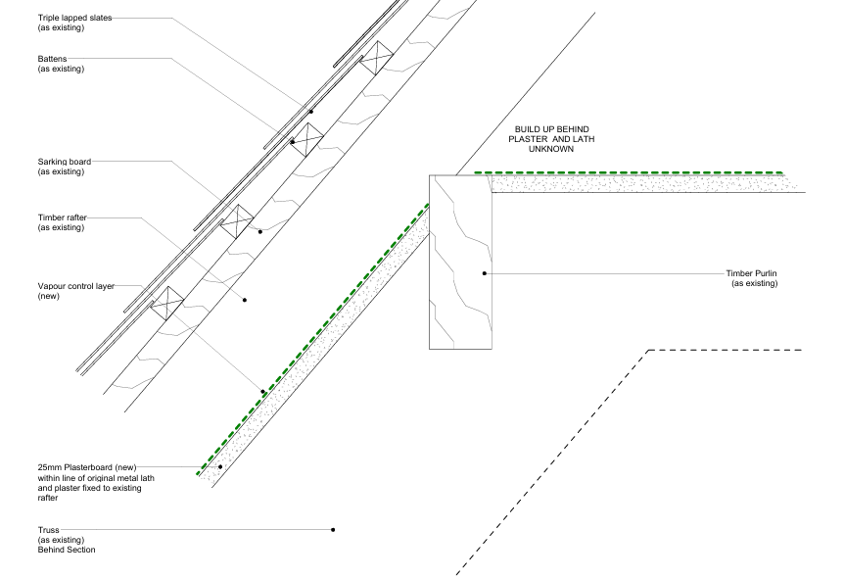
Proposed section detail of new plasterboard

In line with paragraph 215 of the NPPF, where less than substantial harm has been identified, this must be outweighed by the public benefits of the proposal.
A low level of less than substantial harm was identified through works associated with the removal of the asbestos.
The works are necessary in order to remove the contamination from the site and ensure the safe operation of the hospital ward. The Local Planning Authority are therefore satisfied that in the interests of public safety and the heritage benefit of repairing any damage to the listed building, the low level of less than substantial harm has been outweighed.
The replacement ceiling details are acceptable and shall be conditioned as part of the consent.
The applicant has stated the details of internal wall finishes is to be submitted under a separate listed building consent.
It is therefore considered that subject to the recommended compliance condition with the approved documents, the low level of less than substantial harm to the listed building is considered to be outweighed by the public benefits. The proposal therefore is considered to comply with policies SP1, CC9, EN1, EN3 and DM1 of the Manchester Core Strategy, saved UDP policy DC19, Places for Everyone Plan policy JP-P2, and guidance within the National Planning Policy Framework and the Planning (Listed Buildings and Conservation Areas) Act 1990

Other Legislative Requirements

Equality Act 2010
Section 149 (Public Sector Equality Duty) of the Equality Act 2010 requires due regard to the need to: Eliminate unlawful discrimination, harassment and victimisation and other conduct prohibited by the Act and; Advance equality of opportunity between persons who share a protected characteristic and persons who do not share it. The Equality Duty does not impose a legal requirement to conduct an Equality Impact Assessment. Compliance with the Equality Duty involves consciously thinking about the aims of the Equality Duty as part of the process of decision-making.

Human Rights Act 1998 considerations
This application needs to be considered against the provisions of the Human Rights Act 1998. Under Article 6, the applicants (and those third parties, including local residents, who have made representations) have a right to a fair hearing and to this end the local planning authority must give full consideration to their comments.

Protocol 1 Article 1, and Article 8 where appropriate, confer(s) a right of respect for a person’s home, other land and business assets. In taking account of all material considerations, including Council policy as set out in the Core Strategy and saved polices of the Unitary Development Plan, the Director of Planning, Building Control & Licensing has concluded that some rights conferred by these articles on the applicant(s)/objector(s)/resident(s) and other occupiers and owners of nearby land that might be affected may be interfered with but that that interference is in accordance with the law and justified by being in the public interest and on the basis of the planning merits of the development proposal. She believes that any restriction on these rights posed by the recommendation given is proportionate to the wider benefits of and that such a decision falls within the margin of discretion afforded to the Council under the Town and Country Planning Acts.

Recommendation: Approve

Conditions attached to this decision

- The works must be begun not later than the expiration of three years beginning with the date of this consent.
Reason - Required to be imposed pursuant to Section 18 of the Planning (Listed Buildings and Conservation Areas) Act 1990 (as amended).
2) The development hereby approved shall be carried out in accordance with the following drawings and documents:
- Proposed First Floor RCP and Roof Section: 25178-SRA-ZZ-ZZ-DR-A-80202 Rev P03
- Demolition First Floor RCP and Roof Section: 25178-SRA-ZZ-ZZ-DR-A-80201 Rev P02
- Proposed Lining Detail Asbestos Removal: 25178-SRA-ORC39-03-DR-A-80601 Rev P02
All received by the City Council as Local Planning Authority on 3 July 2026
- Design and Access Statement: 10236-SRA-ZZ-ZZ-RP-A-80901
- Covering Letter, prepared by Deloitte
- Site Specific Plan of Works, prepared by Reddish Vale
- Heritage Statement, prepared by SLHA
- Asbestos Scope of Work
- Asbestos Removal Scope Part 1: 10236-SRA-ZZ-ZZ-RP-A-80900
- Asbestos Removal Scope Part 2: 10236-SRA-ZZ-ZZ-RP-A-80900
- Asbestos Removal Scope Part 3: 10236-SRA-ZZ-ZZ-RP-A-80900
- Proposed Site Plan Asbestos Removal: 10236-SRA-ZZ-00-DR-A-80101
All received by the City Council as Local Planning Authority on 11 June 2026
Reason - To ensure that the development is carried out in accordance with the approved plans pursuant to policies SP1 and DM1 of the Core Strategy.

