ETEC CONTRACT SERVICES LTD
Traffic Management Plan
Wythenshawe Park Sports Hub – Building & Enabling Works

Contract Name | Wythenshawe Park Sports Hub – Building & Enabling Works
Contract No. | J2976 / TBC – WSP Package
Site Address | Wythenshawe Park, Wythenshawe Road, Manchester, M23 0PH
Client | Manchester City Council – Louise Harding | Tel: 07931 471403
Employers Agent / Principal Designer | Abacus, 4th Floor Cotton House, Queen Street, Manchester, M2 5HS | Robert Ogden: 0845 365 1350
Principal Contractor | Etec Contract Services Ltd, Suite 7, Elmhurst, 98/106 High Rd, South Woodford, London E18 2QH | Russell Parsons: 07766 224 489
Contracts Manager | Lee Jones
What3Words (Site Entrance) | TBC – to be confirmed at mobilisation
Date Created | June 2026
Traffic Coordinator | TBC – Site Manager
Deputy Traffic Coordinator | TBC
Working Hours | Monday–Friday 07:30–17:30 | Saturday 08:00–13:00 (no Sunday / Bank Holiday working without written Client consent)
Next Review Date | 3 months from issue / following any traffic-related incident or significant site change
Distribution | Site H&S File / All Contractors & Suppliers / Site Notice Boards / Welfare Cabin

Rev | Description | Completed By | Approved By | Date
01 | Original Issue – Traffic Management Plan for Park Building & Enabling Works | L Jones | S Tariq | Jun 2026

Purpose of this Plan

This Traffic Management Plan (TMP) sets out the arrangements for managing all vehicles, mobile plant and pedestrians throughout the construction of the Wythenshawe Park Sports Hub building and associated enabling works. The site is located within Wythenshawe Park, a busy public open space managed by Manchester City Council, and particular care must be taken to protect park users – including children, elderly visitors and vulnerable persons – at all times.

This TMP must be:
- Displayed prominently on all site notice boards
- Used during site inductions for all new personnel
- Issued to all sub-contractors and suppliers before their first site visit
- Reviewed every 3 months, after any traffic-related incident or near miss, and whenever there is a significant change to site conditions, work activities or the programme

Note: The Artificial Grass Pitches (AGPs), MUGA and Skatepark external sporting infrastructure are not part of the current package and are excluded from the scope of this plan. This TMP will be updated when those works are programmed to commence.

Scope of Works

The works covered by this TMP comprise the construction of the new Wythenshawe Park Sports Hub building and all associated enabling, demolition and infrastructure works. The key elements include:

Enabling & Demolition Works:
- Asbestos survey, reporting and removal from existing buildings on site
- Isolation and diversion of existing services
- Demolition of existing weightlifting gym
- Demolition and removal of existing athletics changing block
- Removal of existing fencelines, long jump sandpit and lighting columns
- Tree works: felling of trees T2, T3, T4, T5, T6, T26 and T29 (stump removal) in accordance with Arbtech AMS 01
- Relocation of existing shipping containers and associated enabling works
- Remediation of ground and installation of compacted Type 1 MOT sub-base

Building Construction:
- Formation of pad foundations and below-ground blockwork
- Below-ground drainage installation
- Structural steel frame erection
- Roofing and external envelope (SFS, cladding, windows and external doors)
- Mechanical, electrical and public health services installation (HRUs, heating/cooling, ventilation, drainage, small power, lighting, fire alarm, security, PA systems)
- Internal fit-out comprising: reception, café/servery, community room, treatment rooms, clinical rooms (GP suite), changing areas (wet and dry), bike workshop, WC facilities, staff areas, IT server room and plant room
- Substation installation and LV cabling; power upgrade works

Site Establishment & Infrastructure:
- Site hoarding, Heras fencing, security gates and CCTV
- Site welfare cabins, signage, wheel wash
- Temporary services connections (power, water, drainage)
- Access road works associated with the building construction
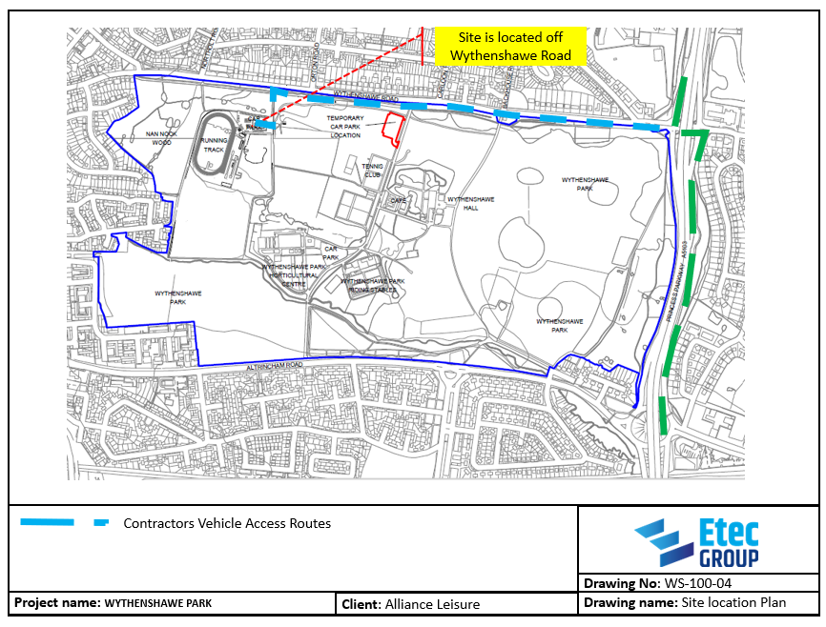

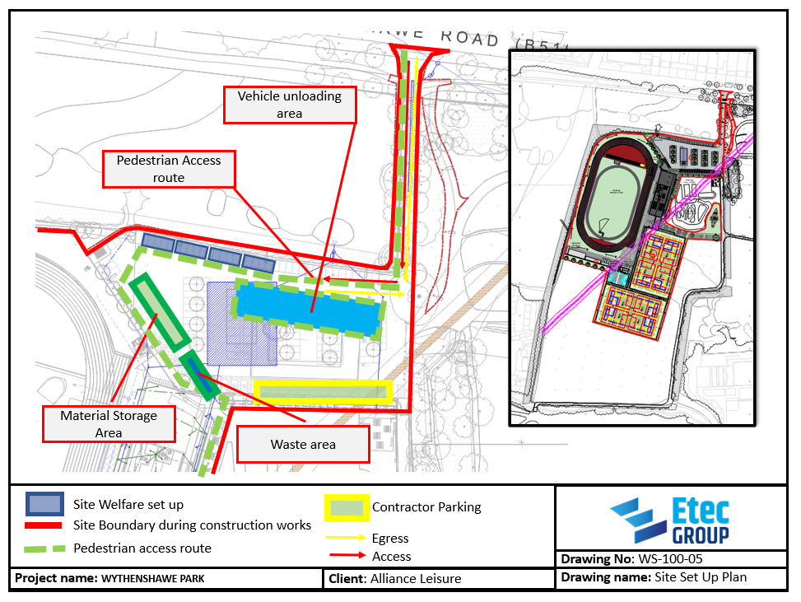

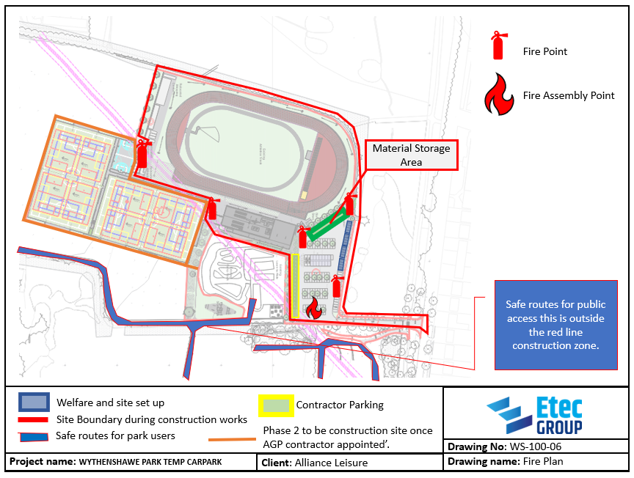

Traffic Management Plan – Sections 1 to 9

No. | Category | Detail
1 | TRAFFIC RESTRICTIONS
 | Restricted Delivery Routes | All vehicles making deliveries to the site must approach via Wythenshawe Road and enter via the existing park access road. Vehicles must NOT use residential side streets or queue on Wythenshawe Road at any time. Delivery drivers to be provided with clear written instructions and a site location map (including What3Words reference) prior to their first visit.
 | Restricted Delivery Times | Deliveries are restricted to: Monday–Friday 07:30–17:30 and Saturday 08:00–13:00. No deliveries on Sundays or Bank Holidays without the prior written approval of Manchester City Council. All deliveries to be pre-booked with the Site Manager at least 24 hours in advance. No HGV to be left waiting on Wythenshawe Road.
 | Scheduling Site Deliveries | All deliveries to be pre-booked with the Site Manager. No more than one HGV on the internal access road at any time unless the Site Manager confirms adequate space and marshalling is in place. Heavy deliveries (structural steel, groundworks materials, roof plant) to be pre-planned to avoid conflicts with other site activities. Delivery schedule to be communicated to all sub-contractors weekly.
 | Storage Space Restrictions | On-site material storage limited to the designated compound area only. No materials, plant or skips to be stored on public footpaths, park access tracks, or within Tree Protection Zones. Compound location confirmed with Manchester City Council prior to mobilisation. 2 no. site containers provided for tools and equipment storage.
 | Control of Unauthorised Entry of Vehicles and Personnel | Site perimeter to be secured with Heras fencing and timber hoarding with padlocked vehicular gates. Gates to be locked when the site is not in operation. All vehicles and visitors to report to the Banksman/Site Manager on arrival. Delivery vehicles to be met at the site entrance and escorted to unloading area. No unauthorised vehicles or personnel permitted within the construction zone at any time.
 | Temporary Road Markings and Signage | Temporary road markings, cones and delineators to define vehicle routes along the access road and within the compound. All markings to be clearly visible and maintained throughout the works. Temporary 'Construction Traffic' and '5 MPH' signs on approach from Wythenshawe Road. 'Banksman in Operation', 'Pedestrians Keep Clear' and 'No Unauthorised Access' signs at site boundary. All signage to be removed on completion.
 | Barrier and Hoarding Requirements | Temporary Heras fencing panels to define the construction zone perimeter throughout. Timber hoarding (minimum 2 m high) where the site boundary is adjacent to public footpaths or park areas. All barriers to be inspected daily and secured against displacement. Water-filled or concrete block barriers at the site access points. Hoarding to display Etec contact details and out-of-hours emergency number.
 | Road and Footpath Cleaning & Maintenance | Daily inspection: Site Manager to check the park access road and Wythenshawe Road frontage for mud, debris or damage caused by site vehicles. Any mud or debris on the public highway to be removed immediately. Wheel wash to be used by all vehicles leaving the construction zone. Weekly mechanical sweep of the site access road. Road sweeper to be available on call during wet or muddy conditions.
 | Sensitive Issues | Wythenshawe Park is a busy public open space used by all sections of the community including children, elderly visitors and vulnerable persons. No unnecessary sounding of vehicle horns. Dust suppression measures to be used during dry conditions. All complaints to be recorded and responded to promptly. Manchester City Council Park Management to be kept informed of the programme and any planned activities that may affect park access. Construction activities to be coordinated around known park events.
2 | SITE PEDESTRIAN ACCESS AND EGRESS
 | Main Site Pedestrian Entrance | The main pedestrian entrance to the construction zone is via the existing park access road off Wythenshawe Road. Pedestrians to use a clearly defined, signed and segregated walkway adjacent to – but physically separated from – the vehicle route. The pedestrian access gate is separate from the vehicle access point and is secured via a digital padlock. All visitors to sign in at the site office on arrival.
 | Pedestrian Emergency Exit | In the event of an emergency, all personnel to evacuate via the nearest site boundary gate to the open park area and proceed to the assembly point (to be confirmed at mobilisation and displayed prominently on site). Emergency exit routes to be kept clear at all times, clearly signed, and inspected at the start of each working day. Emergency exit gates to open outwards and must never be padlocked during working hours.
 | Public Footpath Management | Any existing public footpaths crossing or adjacent to the construction zone to be assessed prior to commencement. Where footpaths must be temporarily closed, diversion routes to be agreed with Manchester City Council, signed, lit and maintained for the duration of the closure. Temporary closures to be notified to MCC Parks Management in advance. No footpath closure to be implemented without an agreed and signed diversion in place.
3 | SITE VEHICULAR TRAFFIC ROUTES
 | Vehicle/Plant and Pedestrian Route Segregation | Pedestrian and vehicle routes to be physically segregated using Heras fencing, water-filled barriers and cones throughout the construction zone. No pedestrian to cross a vehicle route without a clearly marked, signed and managed crossing point. Banksman to be present at all times when plant or delivery vehicles are manoeuvring on site. Exclusion zones of minimum 3 m to be maintained around all operating plant at all times.
 | Emergency Access Route for Emergency Services | The primary emergency access route is the existing park access road off Wythenshawe Road. This route must remain free from obstruction at all times – no plant, materials, delivery vehicles or skips to be placed within or across this route. The route has been confirmed as suitable for fire tender and ambulance access per swept path analysis (Drawing No. QPM-DR-C-912 Rev T03). Emergency services access to be maintained 24 hours a day, 7 days a week.
 | Plant and HGV Movement Management | All HGV and plant movements on the internal site road to be supervised by a Banksman at all times. One-way system to be implemented on the internal access road where practicable. No reversing without a Banksman present. During particularly heavy delivery phases (e.g. structural steel erection, concrete pours), a dedicated Traffic Marshal to be stationed at the site entrance for the duration of the activity.
 | Arboricultural Constraints on Vehicle Routes | No vehicles or plant to be driven, parked or manoeuvred within Tree Protection Zones (TPZs) at any time. Vehicle routes near trees T17, T21 and T39 (access road widening area) require direct supervision by the appointed arboricultural consultant (Arbtech – 72 hours' notice required). Ground protection matting to be used within RPAs as directed by the arborist. Tree protection fencing to be erected prior to any works commencing and inspected daily.
4 | SITE SPEED LIMIT | 5 mph maximum at all times throughout the site and on the park internal access road. Speed limit signs to be erected at the site entrance and at all appropriate intervals along the internal route. All sub-contractors and suppliers to be informed of the speed limit as part of their site induction.
5 | PARKING RESTRICTIONS | No parking on Wythenshawe Road by site operatives or delivery vehicles at any time. Operative parking to be agreed with Manchester City Council prior to mobilisation and must not impact on public park parking. HGV waiting arrangements to be agreed to prevent vehicles holding on the public highway. Procedures for removal of unauthorised vehicles: contact Site Manager immediately.
6 | VEHICLE CLEANING | All vehicles to be inspected by the Traffic Marshal/Banksman prior to leaving site. Wheel wash to be used by all vehicles. Stones lodged in tyres to be removed with hand tools before the vehicle exits to the highway. This check to be carried out for every vehicle during wet or muddy conditions. Daily road sweeping of the site access route. Photographic evidence of vehicle cleaning checks to be retained in the site file during adverse weather periods.
7 | COMPLIANCE
 | Enforcement Measures | Etec site management are responsible for overseeing and enforcing this TMP at all times. The Site Manager has the authority to issue verbal and written warnings to any person or organisation that fails to comply with this plan. Persistent non-compliance will result in exclusion from site. Regular inspection of compliance records to be carried out by the visiting SHE Advisor as part of the routine site audit programme.
 | Driver/Sub-Contractor/Supplier Sign-Off | All sub-contractors and suppliers to receive a copy of this TMP and the Driver Rules sheet in advance of their first visit to site, to be included within their contract/order documentation. All drivers must sign the Driver Rules sheet on their first visit – signed copies to be retained in the site H&S file. Site inductions to include a walk-through of all traffic management arrangements.
 | Personnel Responsible for Enforcement | Overall TMP responsibility: Contracts Manager (Lee Jones). On-site delivery: Site Manager / Traffic Coordinator (TBC). Day-to-day supervision: Traffic Marshal / Banksman (TBC). All three persons are given authority to stop any vehicle or activity that does not comply with this plan.
8 | MONITORING AND REVIEW | This plan will be monitored by the visiting SHE Advisor as part of the regular site audit programme. The Contracts Manager / Site Manager is responsible for reviewing, updating and distributing the plan. The plan must be reviewed: (a) every 3 months; (b) after any traffic-related incident or near miss; (c) when significant changes are made to the site layout, access arrangements or programme. All revisions to be recorded in the revision history and re-issued to all holders.
9 | APPENDICES | The following appendices are to be completed and attached prior to commencement of works: Appendix A – Site layout plan showing vehicle traffic routes, delivery route, plant operating areas and compound layout. Appendix B – Site layout plan showing pedestrian routes, crossing points, segregation measures and assembly point location. Appendix C – Signage schedule – list and positions of all traffic management signage. Appendix D – Loading and unloading area locations and procedures. Appendix E – Driver Rules sheet (to be signed by all drivers on first visit). Appendix F – Tree Protection Plan (Arbtech TPP 01) showing TPZs and exclusion zones for all vehicles and plant.

Site-Specific Traffic Risk Summary

The following risks have been identified as specific to this project and have been addressed within the body of this plan:

Risk | Control Measure | Responsible
Public park – members of the public (including children) in close proximity to construction vehicles and plant | Strict physical segregation of construction zone from public areas using hoarding and Heras fencing. Banksman on duty at all times when vehicles are manoeuvring. Clearly signed pedestrian routes directing park users away from site vehicles. | Site Manager / Banksman
HGV deliveries – large loads including structural steel, concrete, roofing and M&E plant | All deliveries pre-booked. Single HGV on internal access road at a time. Banksman to escort and guide all HGVs. Unloading area clearly designated. No reversing without a Banksman. One-way system implemented where practicable. | Site Manager / Banksman
Heavy plant operation (excavators, piling rig, telehandler, crane) within confined site | Exclusion zone minimum 3 m maintained at all times. Banksman present during all plant movements. Plant routes pre-agreed and marked. Lift plans required for any crane operations. | Site Manager / Plant Operator
Demolition phase – demolition plant and skip lorries alongside active park areas | Full hoarding perimeter in place before demolition commences. Banksman at site entrance during all skip and demolition vehicle movements. No demolition debris to be left accessible to the public. | Site Manager / Banksman
Tree works near access road – vehicles within RPAs of trees T17, T21 & T39 | Arboricultural consultant to supervise all works within RPAs (72 hours notice required). Ground protection matting as directed. No vehicle movements within TPZs without arborist sign-off. | Site Manager / Arborist
Shared park access road – risk of conflict with park users, cyclists and maintenance vehicles | Temporary traffic management on access road during construction (cones, signs). Banksman at junction during HGV movements. Liaison with MCC regarding park activity calendar to avoid major deliveries during high-footfall events. | Site Manager / Traffic Marshal
Mud and debris tracking onto Wythenshawe Road (public highway) | Wheel wash at site exit. Traffic Marshal inspection of all vehicles leaving site. Daily road sweeping of access route. Road sweeper available on call during wet conditions. | Traffic Marshal / Site Manager
Emergency vehicle access being obstructed | Emergency access route via park access road to remain clear 24/7. No plant or materials to be placed across this route. Route confirmed suitable for fire tender and ambulance per swept path analysis. | Site Manager
Substation delivery and installation – abnormal load movement | Abnormal load route to be pre-agreed with Manchester City Council and notified to relevant parties. Traffic management to be in place during the delivery. Works to be coordinated with MCC Parks Management. | Contracts Manager / Site Manager

Driver Rules – Wythenshawe Park Sports Hub

All drivers visiting this site must read, understand and comply with the following rules. A signed copy must be retained in the site H&S file.

APPROACHING THE SITE
- Approach via Wythenshawe Road only. Do not use residential side streets.
- Do not queue or park on Wythenshawe Road. If the site is not ready, wait in an agreed holding area away from the highway and contact the Site Manager.
- Report to the Banksman/Site Manager at the site entrance on arrival. Do not enter the site until directed.

ON SITE
- Maximum speed 5 mph at all times. Drive with extreme care – members of the public may be present nearby.
- Follow only the designated vehicle route as directed by the Banksman.
- Do not reverse without a Banksman in attendance.
- Do not drive, park or manoeuvre within Tree Protection Zones. Observe all exclusion zone fencing.
- Do not use your horn unnecessarily.
- Switch off engine when stationary for more than 2 minutes (unless operational requirement).
- No unauthorised persons to travel in your vehicle on site.

LEAVING THE SITE
- Stop at the wheel wash before leaving the construction zone. Clean wheels and undercarriage thoroughly.
- Allow the Traffic Marshal to inspect your vehicle for stones in tyres and loose debris before you depart.
- Exit only via the designated exit point.

NON-COMPLIANCE
- Failure to comply with these rules may result in your vehicle being refused entry or asked to leave immediately.
- Persistent non-compliance will be reported to your employer and may result in permanent exclusion from site.

I confirm I have read and understood the above Driver Rules:

Signed: ……………………………………………………………… Date: ………………………………

Print Name: …………………………………………………………… Company: ……………………………………

Vehicle Registration: …………………………………………………………… Vehicle Type: ……………………………………

