

Planning

Delegated Officer Report

Summary of application details
Application reference: | PLA-2026-000399
Application type: | Full planning permission
Proposal: | Change of Use from residential dwellinghouse (Use Class C3) to Children’s Residential Care Home (Use Class C2).
Site address: | 7 Badminton Road Manchester M21 0UQ
Ward(s): | Chorlton Park
Date application valid: | 19 May 2026
Applicant name: | Mr Hardave Singh
Agent (if any): | Mr Vikas Alyas
Case officer: | Ellie Knowles
Recommendation: | Refuse
Date of recommendation: | 13 July 2026

Description of site/building/area

The property that is the subject of this application is a two-storey semi-detached property in the Chorlton Park ward of Manchester. The application property features a two-storey bay to the front with rendered first floor design. The property has been previously extended through the addition of a part single storey, part two storey rear extension, rear dormer window extension, alongside the erection of a detached single garage.

The authorised use of the property is a single family dwellinghouse (Use Class C3). Access to the rear of the property and garden is either through the house, or down the side of the property. There is dedicated parking for 2 vehicles within the site curtilage to the front. The site frontage is bound by unauthorised heavy boundary treatment in the form of metal gates and fencing atop a brick boundary wall.

The existing accommodation comprises of living room, lounge, home office, dining room, kitchen and WC to the ground floor with 4 bedrooms and bathroom at first floor and 5th bedroom and shower room at second floor level.

The area is predominantly residential along Badminton Road, comprising semi-detached family dwellinghouses of a similar character and scale.

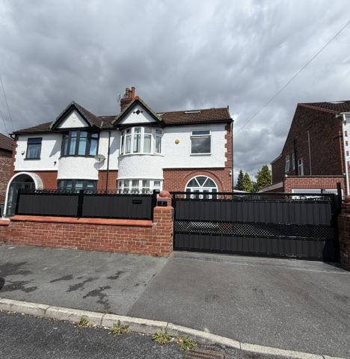
Front view of the application site

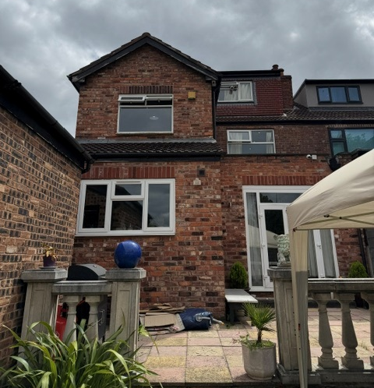
Rear elevation of the application property

Listed building: Not applicable

Conservation area: Not applicable

Tree Preservation Order: Not applicable

Description of development

The authorised use for the property is a C3 dwellinghouse. The applicant wishes to secure planning permission to change from a dwellinghouse to Use Class C2 (Supported housing) Children’s Care Home for up to 3 children (aged between 8-18 years).

The accommodation would comprise of a kitchen, dining room, 2.no lounges and WC to the ground floor. To the first floor are 3 children’s bedrooms, shared bathroom and carer’s office. To the second floor is a carer’s bedroom/rest area and shower room.

The submitted plans and elevations do not include the detached garage within the application site.

There would be a maximum of two members of staff of which would operate either a 12-hour or 24-hour shift pattern. One member of staff would sleep overnight.

There are no proposed physical changes to the property to facilitate the change of use.

Consultations & Notification Responses

Local responses

14 letters of representation were received from 9 local residents raising the following concerns:

- Badminton Road is an established, quiet residential street consisting entirely of family homes there are no care homes or institutional uses anywhere on this road. This proposal fundamentally alters the residential character.
- A 24-hour facility will generate 2/3 x more vehicle movements: staff shifts, visitors, medical deliveries, and inspections. This will cause congestion, blocked access, and road safety risks for residents and emergency services.
- It will also bring noise, lighting, and activity at all hours, seriously harming privacy and quiet enjoyment. The plot size, drainage, utilities, and waste capacity are designed only for a single household, not higher occupancy.
- Parking on Badminton Road is already a major issue. The introduction of a residential care home will increase demand for parking due to staff, visitors and service providers, placing further strain on an already congested road.
- The property currently operates as a single residential dwelling, whereas a care home would involve staff shift changes, visitor arrivals, deliveries and additional vehicle movements throughout the day and potentially during evenings. This would inevitably result in greater noise and disturbance for neighbouring properties.
- The proposed use represents a significantly more intensive use of the property than a family home. This may negatively affect the enjoyment of neighbouring homes and reduce residents' quality of life.
- The proposed change of use would also have a direct impact on the privacy of neighbouring residents.
- Even if no external changes are shown, extensive internal upgrades will almost certainly be required: new fire separation, alarm systems, modified door locks, improved lighting, and compliance with care regulations.
- Pattern of activity: A family has fixed routines. A care home operates 24 hours a day, 365 days a year, with staff shift changes, emergency call-outs, professional visits, and regulatory inspections including evenings, weekends, and public holidays.
- Staffing model: Even with one staff member, shift changes mean regular arrivals/departures at different times; the Registered Manager, social workers, therapists, and maintenance staff add further movements. The application underestimates the true frequency of visits and activity.
- The Operational Management Plan is too vague: it offers no clear limits on visiting hours, no complaints procedure for neighbours, and no enforceable rules to prevent disturbance.
- There are registered children’s residential care homes and C2 care facilities located approximately 180 metres and 350 metres from this site well within the standard 500-metre assessment distance used by the Council for cumulative impact.
- This is a large 5-bedroom, 257 sqm dwelling – exactly the type of much-needed family home Manchester seeks to retain.
- An absence of information and engagement in the submission
- Provision for more than 3 children will create a crowded, frenetic and unpleasant environment not conducive to a person’s growth to responsibility and maturity.

Consultee responses

Highway Services – The change of use is not expected to generate any significant changes in vehicle trips and therefore no unacceptable traffic impact on the adopted highway is envisaged. The area is well served by alternative modes of transport to the car. Two off-street parking spaces will be retained within the site curtilage. The waste management provision is to remain as is and is considered acceptable. Highways request secure & sheltered cycle parking provision is secured via condition.

Environmental Health – No objections to the proposal.

Flood Risk Management – United Utilities public sewer onsite. The LPA should consult UU on an approvable master plan before determining the planning application.

MCC Supported Housing Monitoring Group – We already have an oversupply of homes in the city. Moreover, Ofsted guidance is clear that providers ought to have an understanding of local need before registering a new service. This provider hasn't engaged with us to understand whether we have a need for the home. I am also concerned by the information contained in their planning application regarding appropriate staffing levels for a 3-bed children's home - this suggests a clear lack of knowledge and experience.

In terms of whether the location is suitable, there are four existing children's homes all within a 10-minute walk of 7 Badminton Road. We would not support further homes opening in this part of the city, as we need to avoid an overconcentration of provision.

Relevant Planning History

At the application site –

059797/FH/SOUTH1/00 – Construction of new dormer roof at rear elevation. Approved 26.10.2000.

052731/FH/CENTL1/97 – Part single, part two storey rear extension to form Lounge & Kitchen with Bedroom over and erection of a detached garage. Approved 25.11.1997.

History of negotiations

No negotiations were entered into with the agent, given that the proposal was considered unacceptable in principle, even in the event of significant revisions.

Policy

Places for Everyone (2022-2039) – Places for Everyone is a long-term plan of nine Greater Manchester districts for jobs, new homes, and sustainable growth. It has been published by the GMCA on behalf of the nine districts and took effect and became part of the statutory development plan on March 21, 2024.

The PfE Plan and its policies are now a material planning consideration in the determination of planning applications. The PfE Plan and its policies must therefore be given full weight in the planning balance.

Manchester Core Strategy Development Plan Document (2012-2027) - The Core Strategy was adopted on the 11 July 2012 and replaces a large number of policies in Manchester’s Unitary Development Plan. Parts of the policies have been superseded by the Places for Everyone Plan.

The Unitary Development Plan (UDP) for the City of Manchester (1995) - The Unitary Development Plan for the City of Manchester was adopted in 1995 and has largely been replaced with the policies contained within the Core Strategy. However, there are a number of policies that are extant.

The relevant Places for Everyone policies for this application are as follows:

JP-Strat9 – Southern Areas
JP-H3 – Type, Size and Design of New Housing

The relevant Core Strategy policies for this application are as follows:

DM 1 – Development Management
SP 1 – Spatial Principles (partially superseded by PfE)
H 6 – South Manchester
H 10 – Housing for people with additional support needs
T 2 – Accessible areas of opportunity and need
EN 19 – Waste

The relevant saved UDP policies for this application are:

DC2 – Rest homes and nursing homes (Class 2)
DC26 – Development and Noise

The relevant supplementary planning guidance documents for this application are:
- The Special Needs and Supported Housing Policy (1998)

National Planning Policy Framework

The National Planning Policy Framework (December 2024) – The NPPF sets out broad national policies on themes such as housing, historic environment, town centres, design, climate change and the Green Belt. Central to the broad policy direction contained within the NPPF is the notion of sustainable development; development which effectively balances economic, social and environmental factors. The Local Planning Authority consider the following sections relevant to this proposal.
- Section 2 – Achieving sustainable development
- Section 4 – Decision-making
- Section 5 – Delivering a sufficient supply of homes
- Section 8 – Promoting healthy and safe communities

The Draft National Planning Policy Framework (December 2025) - The National Planning Policy Framework (NPPF) sets out the Government’s planning policies for England and how these should be applied. A draft revised NPPF was published for consultation on 16 December 2025. The consultation period runs for 12 weeks and will close on 10 March 2026.

The draft NPPF proposes significant changes to the structure and content of national policy. These include a move to Local Plan-style policy sections, a clearer distinction between plan-making and decision-making policies, and the reintroduction of strategic planning through Spatial Development Strategies. Other notable changes include an expanded presumption in favour of sustainable development, policies promoting higher densities around transport hubs, and support for small and medium-scale housing schemes through a new “medium development” category. The draft also integrates National Development Management Policies, strengthens climate change and biodiversity policies, and introduces measures to encourage clean energy and critical minerals development.

Once adopted, the revised NPPF will replace the current framework and form a key part of national planning policy. At this stage, as the document is subject to consultation and has not yet been finalised, while still a material consideration, it can only be afforded limited weight in the determination of planning applications. In this instance, the relevant sections are outlined below:

Issues

Principle of development:

Section 38(6) Planning and Compulsory Purchase Act 2004 requires that decisions are to be made in accordance with the development plan, unless material considerations indicate otherwise.

The NPPF (2024) at paragraphs 2 and 48 reinforces this requirement and at paragraph 12 states that the presumption in favour of sustainable development does not change the statutory status of the development plan as a starting point for decision making, and that where a planning application conflicts with an up-to-date development plan, permission should not normally be granted.

In the case of this application, the principle of the proposed development is not considered acceptable and is in conflict with the aforementioned development plan policy and associated guidance.

It is considered that the proposed conversion of the property to supported accommodation (Class C2) would result in the loss of family sized accommodation, in an area where it is desirable to retain such properties, in order to contribute to the Council's housing supply. The nature of the majority of the immediately surrounding area is historically that of family dwellings, and it is considered that the conversion of the house into a unit for supported housing would result in an intensification of such properties within the local area and as such, would further erode the character of the immediate surroundings.

In addition, the proposed development would result in an over concentration of this particular type of care within this area of the city. It is considered that further provision would lead to clustering of such accommodation in this particular part of the city, which would be to the detriment of the character of this immediate area and the balance of uses as part of creating sustainable neighbourhoods.

Impact on character of the area:

Overarching policy and guidance relating to supported living provision is contained within saved policy DC2.1 of the Unitary Development Plan, policy H10 of the Manchester Core Strategy and Supplementary Planning Guidance contained within The Special Needs and Supported Housing Policy (1998).

A principal thread running these documents is the need to seek to avoid an over-concentration of such provision in any one area and to ensure a more even spread of ‘special need’ accommodation within local areas and across the city as a whole.

There is a further need to ensure the protection of residential character and amenity, to avoid the unnecessary loss of the bigger dwelling houses available for larger and extended families and to ensure supported needs accommodation is provided within the right areas.

In this case, the proposed development would result in over concentration of this particular type of care within this area of the city. It is considered that further provision for the care of children would lead to the clustering and accumulation of such accommodation in the immediate area which would be harmful to the character of this immediate area and the local balance of uses, as part of creating sustainable, cohesive neighbourhoods.

The consultation response from the Council’s Supported Needs and Monitoring Group (SNMG) indicates that within the Council’s administrative area there already is an oversupply of this accommodation type in the city. Therefore, the need for the type of accommodation is questioned.

In assessing the need for the type of accommodation proposed, SNMG consider whether a proposed site meets strategic commissioning aims and principles and whether it is in a suitable location.

In this case, details provided indicate that there is already 4.no registered children's home located within a 10-minute walk of the application property, 7 Badminton Road. The Council do not support children's homes being so close to one another and the addition of the home being proposed as part of this application would clearly lead to a cluster of such uses.

On the basis of the lack of support provided by SNMG and the information on the nature and location of similar accommodation situated locally, it is believed that the introduction of the proposed use would lead to an over concentration of such uses in the immediate area, which in turn would adversely affect the character of the area, upsetting the balance of uses within a key residential neighbourhood.

Housing Balance and the loss of family accommodation:

Policy H6 of the Core Strategy set out requirements for new housing development in south Manchester, giving priority to family housing and other high value quality development. There is huge demand across the city for larger homes, demonstrated by the waiting list for social housing, highlighting that demand significantly outstrips supply.

The Manchester Move website provides advice on available properties in Manchester and is used by the City Council's Housing and Residential Growth service as a data source, reflecting the Manchester Housing Register. The latest figures extracted from the website shows an extremely high demand for social housing in Manchester with over 20,000 live applications on the Manchester Housing Register.

The table below highlights the number of households on the Manchester Housing Register, by their band and the size of property applicants need.

For example, without internal modifications and extensions to the floorplan, the application property was originally built as a 3-bedroom 1 lounge property. Figures show that for this type of property 3923 applicants were waiting for a 3-bedroom property as of 13 July 2026.

The current extended floor plan offers a 5-bedroom 2-lounge property. Figures show that for this type of property 240 applicants were waiting for a 5-bedroom property as of 13 July 2026. The application property (considering both the original & extended floorplate) is therefore a dwellinghouse suitable for a family and the proposal in this case would see the loss of such.

The table below shows the current demand for properties by bedroom need:
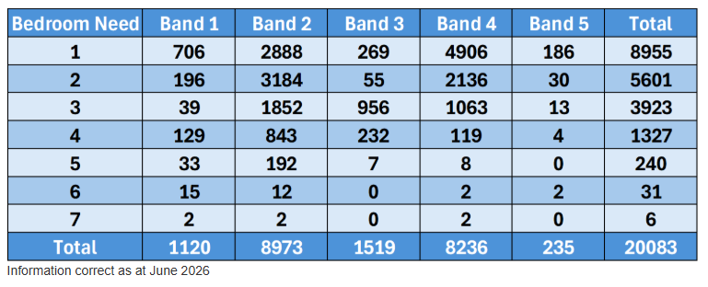
Extract taken from Manchester Move website (Data from June 2026)

Whilst these figures are based on the supply of social housing, there is inevitably an intrinsic relationship between the availability of family homes for sale or rent in the private sector, and the demand for housing.

An important policy objective of the City Council is to improve the quality of housing stock in the city and to deliver a more sustainable housing market. This can be achieved by increasing the amount of family housing stock on offer and by providing for choice though a range of accommodation. This would allow for more balanced and cohesive neighbourhoods that provide for stronger and safer communities.

The loss of a further family house in this area would conflict with this aspiration, undermine the policy objectives for the area and increase the threat of existing families being driven out of the area, or from being attracted to the area, due to a shortage of appropriate accommodation. Whilst the effect of the loss of a single home on the overall mix and balance of housing in the area would be limited, it would nevertheless contribute to the short fall.

In light of the above, the proposed development would result in the loss of a family dwellinghouse, further eroding the balance of housing provision in the locality. The proposed change of use therefore conflicts with the development plan when considered as a whole with respect to delivering a sufficient supply of homes. It is not therefore believed there are any other considerations, either individually or in combination that outweigh the harm and associated conflict with the development plan.

Residential amenity:

The proposed development seeks to provide accommodation for up to three children under the age of 18 years, supported by a maximum of 2 staff present on-site at any one time. The scale and intensity of the proposed use are considered to increase the activity levels at the application property. There would be an increase in comings and goings to the property which would give rise to increased levels of disamenity to local residents. The proposed change of use signals a modification in the degree to which the site is visibly active. Whereas it is reasonable to assert that a single C3 dwellinghouse will make fewer entrances and exits to and from the site over the course of a day or week, a supporting housing unit (C2 Use Class), has the potential to exert a much greater impact on the amenity of local residents from comings and goings.

In addition, an increase in vehicular activity at the property would be likely to take place by staff and visitors. However, it is acknowledged that the application site would retain 2 off-street vehicle parking spaces. As such, it is not anticipated that the proposal would lead to a significant increase demand for on-street car-parking.

As such this would be contrary to saved policy DC2 of the Manchester Unitary Development Plan.

The application site affords a deep rear garden and a separate area for storage of waste bins.

Visual amenity:

There are no proposed external changes to the property, and as such it is not considered that the proposed change of use would result in a detrimental impact upon the visual amenity of the neighbouring properties.

Privacy:

It is not considered that the proposed use of the property as a children's care home would result in any unacceptable loss of privacy for adjoining residents.

Waste:

The existing domestic waste storage arrangements would be sufficient for a use of this scale.

Other Legislative Requirements

Equality Act 2010
Section 149 (Public Sector Equality Duty) of the Equality Act 2010 requires due regard to the need to: Eliminate unlawful discrimination, harassment and victimisation and other conduct prohibited by the Act and; Advance equality of opportunity between persons who share a protected characteristic and persons who do not share it. The Equality Duty does not impose a legal requirement to conduct an Equality Impact Assessment. Compliance with the Equality Duty involves consciously thinking about the aims of the Equality Duty as part of the process of decision-making.

Human Rights Act 1998 considerations
This application needs to be considered against the provisions of the Human Rights Act 1998. Under Article 6, the applicants (and those third parties, including local residents, who have made representations) have a right to a fair hearing and to this end the local planning authority must give full consideration to their comments.

Protocol 1 Article 1, and Article 8 where appropriate, confer(s) a right of respect for a person’s home, other land and business assets. In taking account of all material considerations, including Council policy as set out in the Core Strategy and saved polices of the Unitary Development Plan, the Director of Planning, Building Control & Licensing has concluded that some rights conferred by these articles on the applicant(s)/objector(s)/resident(s) and other occupiers and owners of nearby land that might be affected may be interfered with but that that interference is in accordance with the law and justified by being in the public interest and on the basis of the planning merits of the development proposal. She believes that any restriction on these rights posed by the recommendation given is proportionate to the wider benefits of and that such a decision falls within the margin of discretion afforded to the Council under the Town and Country Planning Acts.

Recommendation: Refuse

Article 35 Declaration

Officers have informed the agent that the proposal is fundamentally unacceptable, and therefore no negotiations in this instance would resolve the problems arising in relation to dealing with the planning application. The proposal is considered to be contrary to the development plan and therefore refused in a timely manner.

Reasons for recommendation to refuse

- The proposed conversion of the host property into a supported living accommodation (Class C2), would result in the loss of a family sized dwellinghouse, which would reduce the standard and availability of such housing in the area, undermining the provisions of policies H6, DM1 and SP1 of the Manchester Core Strategy, which seek to provide an appropriate mix and balance of housing provision in the locality, in order to maintain a sustainable neighbourhood and cohesive housing market.

- The proposal would have a detrimental impact upon the current levels of residential amenity enjoyed by the occupants of neighbouring residential accommodation, by reason of the increased noise and movements associated with the comings and goings of patrons to the premises, contrary to policy DM1 of the Core Strategy and saved policy DC26 in the Unitary Development Plan for the City of Manchester.

