Proposed Fencing Scheme
Ashkirk Car Park, Gorton, Manchester, M18 8LS.

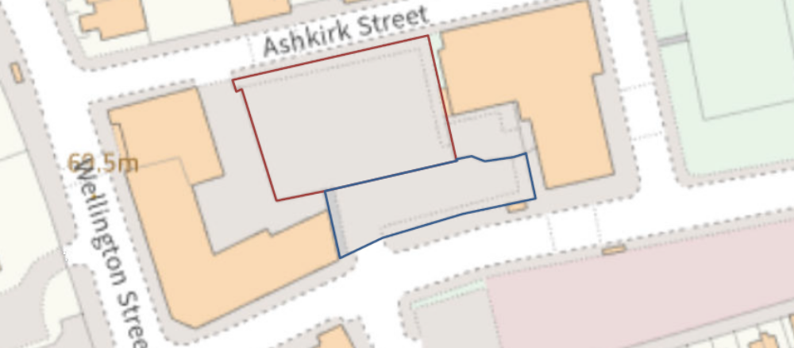

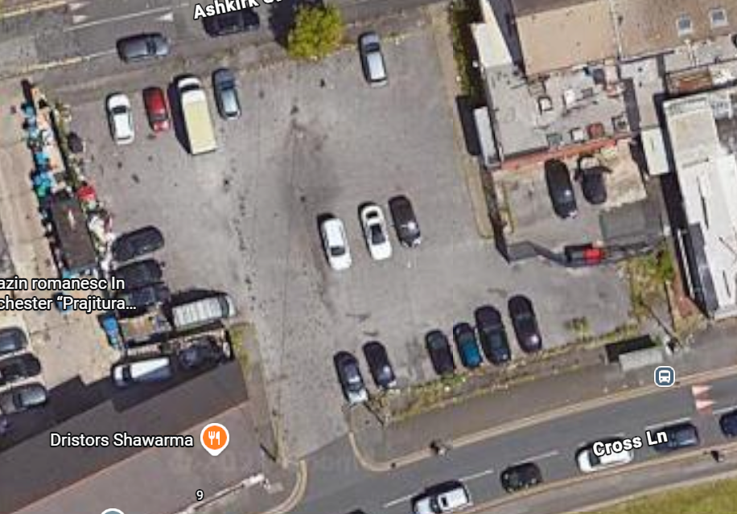
5m
27m
11.5m
21m
35m

Scope of Works
Provide all labour, materials, plant and equipment necessary for the removal of existing vegetation and the installation of new 2.0m high Paladin security fencing at the locations as highlighted in red on the aforementioned Plan.
The works shall include the provision and installation of a new 5.0m wide double-leaf vehicular access gate, complete with all posts, foundations, hinges, locking mechanisms and associated ironmongery.
Remove all shrubs, hedging, self-seeded vegetation and other planted material along the proposed fence lines as deemed necessary.
The works shall include:
- Removal of all shrubbery and vegetation necessary to facilitate the fence installation.
- Grubbing out of roots and root systems.
- Removal of all arisings from site.
- Disposal of waste at a licensed facility.
- Reinstatement and levelling of disturbed ground to provide a suitable formation for the fencing works.

Security Fencing
Supply and install 2.0m high steel welded mesh security fencing as detailed in NBS Q40 to the locations as highlighted with the red line on the Plan provided.

Fence Specification
- Height: 2.0 metres above finished ground level.
- Type: As Q40 or similar approved.
- Finish: Galvanised and polyester powder coated.
- Colour: Black.
- Posts: Steel hollow section posts with tamper-resistant fixings.
- Installation: In accordance with the manufacturer's recommendations.

Double Vehicular Gate
Provide and install one new 5.0m wide double-leaf gate to the location indicated as highlighted with the red line on the Plan provided.

Gate Specification
- Overall clear opening width: 5.0 metres.
- Height: 2.0 metres to match adjacent fencing.
- Infill: Matching Paladin welded mesh panels.
- Finish: Galvanised and polyester powder coated to match fencing.
- Support posts: Heavy-duty steel gate posts set in concrete foundations.
- Hinges: Adjustable heavy-duty hinges.
- Locking: Centre gate lock with facility for padlock by the Client.
- Ground restraint: Drop bolts to both leaves with suitable ground sockets.
- Opening: To open inwards unless otherwise indicated on the drawings.
- All gate furniture to be vandal-resistant and suitable for external use.

Completion
Upon completion, the Contractor shall:
- Remove all waste, spoil and surplus materials from site.
- Reinstate all disturbed surfaces.
- Ensure gates operate freely and securely.
- Leave the site clean and fit for use.
Drawing Reference: The proposed location of fencing and gate installations shall be as shown on the Plan provided. Any discrepancies between drawings and site conditions shall be reported to the Contract Administrator prior to commencement of works.

Q40
New Fencing

Fencing systems

126 Open mesh steel panel security fencing
- Description: Car Park Security Fencing
- Manufacturer: CLD Lockmaster S1 or similar approved
  - Product reference: 358 Mesh or similar approved
- Performance: Security performance
- Standard: To BS 1722-14, Category 2.
- Height: 2.0m
- Mesh and wire: 358 Mesh - Powder Coated - Black
- Posts: As per Manufacturer's design details
- Maximum centres of posts: As per Manufacturer's design details
- Method of setting posts: In concrete foundations to comply with the design loading requirements specified by BS 1722-14 for this category of fence.
- Bottom of fencing: 25mm from ground level
- Accessories: Double -leaf entrance gate at vehicle entrance

Execution

710 Installation generally
- Set out and erect
  - Alignment: As per Manufacturer's design details
  - Tops of posts: As per Manufacturer's design details
  - Setting posts: Rigid, plumb and to specified depth, or greater where necessary to ensure adequate support
  - Fixings: All components securely fixed

715 Competence
- Operatives: Contractors must employ competent operatives
- Qualifications: Submit certification of training
  - NHSS 'Sector Scheme 2A' subcategories: (c)
  - NHSS 'Sector Scheme 2C' subcategories:

720 Setting posts in concrete
- Standard: To BS 8500-2.
- Mix: Designated concrete not less than GEN1 or standard prescribed concrete not less than ST2
- Alternative mix for small quantities: 50 kg Portland cement to 150 kg fine aggregate to 250 kg 20 mm nominal maximum size coarse aggregate, medium workability.
- Admixtures:
- Holes: Excavate neatly and with vertical sides
- Filling: Position post/ strut and fill hole with concrete to not less than the specified depth, well-rammed as filling proceeds and consolidated
- Backfilling of holes not completely filled with concrete: Excavated material, well-rammed and consolidated

Completion

930 Gates
- Hinges, latches and closers: Adjust to provide smooth operation. Lubricate where necessary.
  - Timing: Before handover.

995 Verification on completion
- Requirement: Check completed system and provide assurance of compliance with specified performance.
- Method: Manufacturer's performance declarations
- Submittals:
  - Format:
  - Timing: At completion of installation.

