

Planning

Delegated Officer Report

Summary of application details
Application reference: | PLA-2026-000034
Application type: | Lawful development: Proposed use
Proposal: | Internal structural work, changes to window and door openings, new raised patio and associated fence.
Site address: | 6 Limley Grove Manchester M21 8UB
Ward(s): | Chorlton Park
Date application valid: | 08 May 2026
Applicant name: | Ms L Bradley & Mr D Yankson
Agent (if any): | Ms Claire Bandy
Case officer: | Robert Tyrer
Recommendation: | Split
Date of recommendation: | 06/07/2026

Description of site, building and/or area
Application site relates to a two-storey mid-terraced dwellinghouse, located within a predominantly residential area.

Description of development
The applicant is seeking a certificate of proposed lawful development for internal structural work, changes to window and door openings, new raised patio and associated fence.

Relevant planning history

No previous planning applications at this address.

Consultation, notification and publicity responses
None Required - There is no statutory requirement to consult third parties including neighbours; views expressed by third parties on the planning merits of the case, or on whether the applicant has any private rights to carry out the operation, use or activity in question, are irrelevant when determining the application.

Legislative Issues

Sections 191 and 192 of the Town and Country Planning Act 1990 provide for anyone (not just a person with a legal interest in the land) to apply to the local planning authority (LPA) for a lawful development certificate (LDC). A certificate is a statutory document certifying:

(1) in the case of an application under section 191, the lawfulness, for planning purposes, of existing operations on, or use of land, or some activity being carried out in breach of a planning condition; or

(2) in the case of an application under section 192, the lawfulness of proposed operations on, or use of land.

The onus of proof in regard to (1) is firmly on the applicant and the issue of a certificate will depend on the on factual evidence provided about the history and planning status of the building or other land and the interpretation of any relevant planning law or judicial authority. The relevant test of the evidence in this matter is “the balance of probability” and the applicants own evidence does not need to be corroborated by independent evidence. If the LPA have no evidence to contradict the applicants version of events or make them less then probable, there is no good reason to refuse the issue of a certificate.

In regard to (2), this provides that, if the LPA are supplied with information satisfying them that the use or operations described in the application would be lawful, if instituted or begun at the time of the application, they shall issue a certificate to that effect; and, in any other case, they shall refuse the application.

In short, the purpose section 192 is to enable any person who wishes to find out whether any proposed use or operations would be lawful to apply to the LPA for that purpose

The application needs to describe the proposal with sufficient clarity and precision to enable the LPA to understand (from a written description and plans) exactly what is involved in the proposal; and to submit whatever supporting information or legal submission that are to be relied upon in order to satisfy the LPA that a certificate should be granted for the proposal.

In making their decision on an application under section 192, the LPA ask themselves the hypothetical question - "If this proposed change of use had already occurred, or if this proposed operation had commenced, on the application date, would it have been lawful for planning purposes?" In doing so, the LPA will not only consider whether the proposal would involve "development" requiring an application for planning permission, but whether it would involve a breach of any existing condition or limitation imposed on a grant of planning permission which has been acted upon, and which therefore constrains what can be done on the land. The LPA will not make a proposal fit a scenario; the only question is whether the proposal made by the applicant is lawful at the time of submission.

Assessment
This application is pursued under subsection (1) of section 192, which provides for an application to determine whether any proposed use of buildings or other land (s192(1)(a) or operations proposed to be carried out in, on, over or under land, (s192(1)(b) would be lawful for planning purposes.
The applicant states that the existing use falls under: “C3 - Dwellinghouses” and in response to the question “Why do you consider that a Lawful Development Certificate should be granted for this proposal?”, the applicant has responded with; " The application seeks a Certificate of Lawfulness for proposed works to an existing single dwellinghouse. The proposed works comprise internal alterations and minor external changes. No material change of use is proposed. The works fall within permitted development rights. ".
The applicant is seeking a certificate of proposed lawful development for internal structural work, changes to window and door openings, new raised patio and associated fence.
As the proposal is comprised of multiple elements these will be assessed against the relevant classes of Schedule 2, Parts 1 and 2 of Town and Country (General Permitted Development) Order 2015 (as amended), (GPDO).
Internal Works

Section 55 of the Town and Country Planning Act 1990 (The Act) set out the meaning of development and new development.

Section 55(2)(a) states that the “following operations or uses of land shall not be taken for the purposes of this Act to involve development of the land —

(a)the carrying out for the maintenance, improvement or other alteration of any building of works which

(i)affect only the interior of the building, or

(ii)do not materially affect the external appearance of the building,”

In this case, the proposed floor plan shows changes to the first-floor bathroom internal walls and changes to the ground floor internal walls between the existing kitchen, hallway and dining room and the removal of a chimney stack. The works also include the creation of internal walls to form an open plan kitchen and dining room and a ground floor WC. These changes relate to the “improvement or other alteration” of the dwellinghouse and affect only the interior of the building and do not materially affect the external appearance, these elements of the proposal would not constitute development requiring planning permission.

The external changes are considered in detail below.

Window Changes and Door Openings
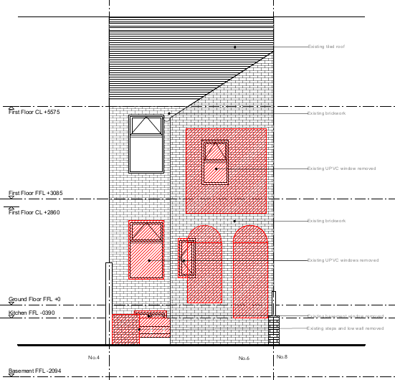
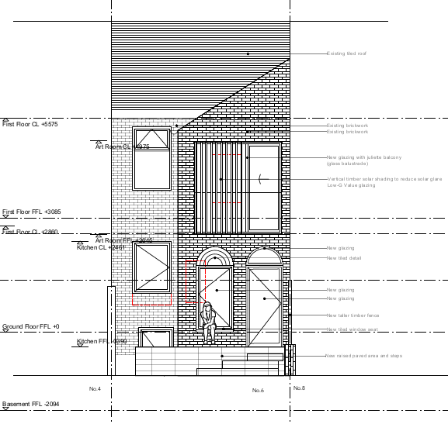

Image 1 Comparison between the existing rear elevation and proposed rear elevation.
The proposed drawings (image 1) indicate changes to the windows and doors on the rear elevation which includes a vertical timber solar shading on the first floor and new glazing for Juliet balcony. A new rear door and window on the ground floor that would lead to the proposed dining room following the removal of a small rear window. There is also a new door being created that would allow access to the basement and the ground floor window is to be reduced in size.

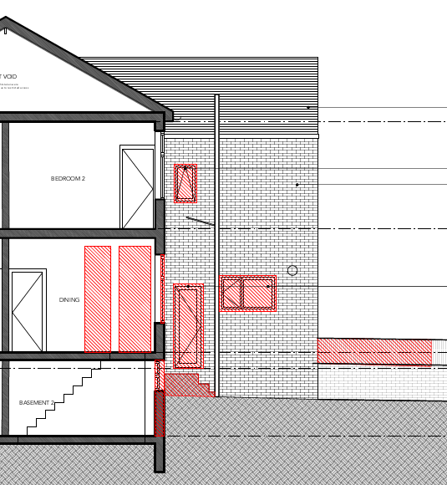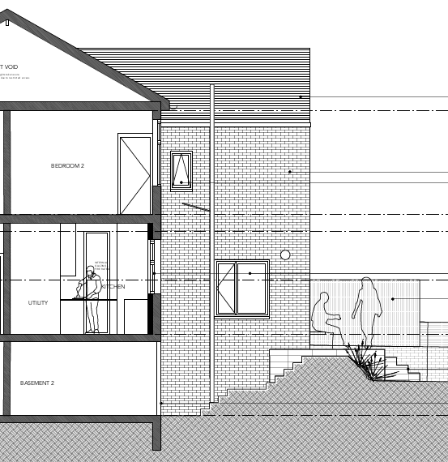
Image 2 Comparison between the existing side and proposed side elevations
As the proposed windows and doors would relate to the improvement, or other alterations to dwellinghouses, they would fall within Schedule 2, Part 1, Class A of the Town and Country (General Permitted Development) Order 2015 (as amended)

Condition A.3(a) requires that “the materials used in any exterior work (other than materials used in the construction of a conservatory) shall be of a similar appearance to those used in the construction of the exterior of the existing dwellinghouse”. Furthermore, the Permitted development rights for householders technical guidance September 2019 document in relation to windows states that “What is important is that they give a similar visual appearance to those in the existing house, for example in terms of their overall shape, and the colour and size of the frames”.

In this case, the proposal fails to meet this requirement as the proposed first floor rear windows, the ground floor rear and side windows, ground floor and basement doors on the rear elevation are larger, differ in shape and style when compared to the existing openings.

However, the first-floor side window to the bathroom as indicated by the blue box on image 2 appears to be only new glazing with the window opening remaining the same size and the same style. This change can be considered as an act of maintenance, improvement or other alteration as defined by Section 55(2)(a)(ii) that would not materially affect the external appearance of the building.

Raised Patio and Associated Fence

Raised Patio

The proposal shows changes to the rear of the dwellinghouse, these include the removal of side/rear door and steps into the existing kitchen, the changes to the windows and doors have been addressed within the section above. In its place the drawings show steps leading to a new door within the basement and up to a new patio and steps that would also provide access to the dining room and garden.

Sub-paragraph A.1(k)(i) of the GPDO states that development is not permitted if it would consist of or include the construction or provision of a verandah, balcony or raised platform.

The Permitted development rights for householder – Technical Guidance, September 2019, provides further clarification that a raised platform is any platform with a height greater than 0.3 metres. In this case the proposed patio would have a proposed varying height of between 0.785 metres and 0.86 metres, which for the purposes of the GPDO would be a raised platform that would require planning permission

The raised patio area and steps to the proposed basement door will require the excavation of significant amounts of material. Class A of the GPDO can be reasonably interpreted to mean that permission granted for "the enlargement, improvement or other alteration of a dwellinghouse" would normally include such excavation as is required for footings for walls. But in this instance, the required excavation works

Section 55 of the Act (as amended) defines development as “…the carrying out of building, engineering, mining or other operations in, on, over or under land, or the making of any material change in the use of any buildings or other land.” Whilst there is a lack of a description of what constitutes an “engineering operation” in Section 55 of the Act, in practice it applies to activities altering the profile of land by excavation, embanking or tipping, or alternatively those which change the character of the surface of land. It has been held in the Courts that that the term engineering operation should be given its ordinary meaning in the English language. It must mean operations of the kind usually undertaken by engineers, i.e., operations calling for the skills of an engineer. This does not mean that an engineer must actually be engaged on the project, simply that it is the kind of operation on which an engineer could be employed.

There is no class of the GPDO that permits the carrying out of an engineering operation within the curtilage of a dwellinghouse and, as such, the proposed development requires planning permission.

Fence

Schedule 2, Part 2, Class A of GPDO is the relevant section when considering proposals relating to the erection, construction, maintenance, improvement or alteration of a gate, fence, wall or other means of enclosure

Specifically, A.1(b) states that development is not permitted by Class A if the height of any other gate, fence, wall or means of enclosure erected or constructed would exceed 2 metres above ground level.

In this case a new timber fence is shown next to the patio and steps which when measured from the ground level would have a total height of 2.576 metres and thus would fail to comply with A.1(b) of the GPDO as its height exceeds the maximum permitted height.

Conclusion
Based on the assessment above, the internal structural works would not constitute development and therefore do not require planning permission. However, the alterations to the window and door openings, with the exception of the first-floor side bathroom window, would not comply with the provisions of the GPDO and would require planning permission. Furthermore, the proposed raised patio and associated fencing would also require planning permission, as they fail to meet the relevant GPDO criteria and require excavation works.

Other Legislative Requirements

Equality Act 2010
Section 149 (Public Sector Equality Duty) of the Equality Act 2010 requires due regard to the need to: Eliminate unlawful discrimination, harassment and victimisation and other conduct prohibited by the Act and; Advance equality of opportunity between persons who share a protected characteristic and persons who do not share it. The Equality Duty does not impose a legal requirement to conduct an Equality Impact Assessment. Compliance with the Equality Duty involves consciously thinking about the aims of the Equality Duty as part of the process of decision-making.

Human Rights Act 1998 considerations
This application needs to be considered against the provisions of the Human Rights Act 1998. Under Article 6, the applicants (and those third parties, including local residents, who have made representations) have a right to a fair hearing and to this end the local planning authority must give full consideration to their comments.

Protocol 1 Article 1, and Article 8 where appropriate, confer(s) a right of respect for a person’s home, other land and business assets. In taking account of all material considerations, including Council policy as set out in the Core Strategy and saved polices of the Unitary Development Plan, the Director of Planning, Building Control & Licensing has concluded that some rights conferred by these articles on the applicant(s)/objector(s)/resident(s) and other occupiers and owners of nearby land that might be affected may be interfered with but that that interference is in accordance with the law and justified by being in the public interest and on the basis of the planning merits of the development proposal. She believes that any restriction on these rights posed by the recommendation given is proportionate to the wider benefits of and that such a decision falls within the margin of discretion afforded to the Council under the Town and Country Planning Acts.

Recommendation: Split

Reasons for approval
1 | Maintenance, improvement or other alteration works that do not materially affect the external appearance of a building are not development under Section 55(2)(a)(ii) of the Town and Country Planning Act 1990. The first-floor side window is shown on drawings 201 and 230 as new glazing of the same size and opening style as the existing window. On that basis, this element of the proposal would not constitute development and would not require planning permission.
2 | Alterations that affect "only the interior of the building" are not development as set out in Section 55(2)(a) of the Town and Country Planning Act 1990; as the changes to the internal walls and removal of the chimney stack relates to the interior, this element of the proposal would not constitute development and would not require planning permission.

Reasons for refusal
1 | The proposed first floor rear windows including the vertical timber solar shading, the ground floor rear and side windows, the ground floor and basement doors as shown on drawings 199, 200, 201, 230 Rev C, 231 Rev A and 232 does not constitute permitted development. It fails to meet the conditions of Class A within Part 1 of Schedule 2; specifically, condition A.3(a) of the Town and Country Planning (General Permitted Development) (England) Order 2015 (as amended). The proposed windows and doors are larger, differ in shape and style when compared to the existing openings.
2 | The proposed raised patio area as shown on drawings 199, 200,230 Rev C, 231 Rev A and 232 does not constitute permitted development. It fails to meet the requirements of sub-paragraph A.1(k)(i) of Part 1, Class A of Schedule 2 of the Town and Country Planning (General Permitted Development) (England) Order 2015 (as amended). The proposal would include a raised platform with a height greater than 0.3 metres.
3 | Section 55 of the Town and Country Planning Act 1990 (as amended) defines development as "the carrying out of building, engineering, mining or other operations in, on, over or under land, or the making of any material change in the use of any buildings or other land." Whilst there is a lack of a description of what constitutes an "engineering operation" in Section 55 of the Act, in practice it applies to activities altering the profile of land by excavation, embanking or tipping, or alternatively those which change the character of the surface of land. In this instance, the raised patio area and steps to the proposed basement door will require the excavation of significant amounts of material as part of the development, significant volumes of material will need to be excavated from the rear garden, before the construction of raised patio area and steps can be built. There is no class of the Town and Country Planning (General Permitted Development) (England) Order 2015 (as amended), that permits the carrying out of an engineering operation within the curtilage of a dwellinghouse and, as such, the proposed development requires planning permission.
4 | The proposed timber fence as shown on drawings 199, 200,230 Rev C, 231 Rev A and 232 does not constitute permitted development. It fails to meet the requirements of sub-paragraph A.1(b), of Part 2, Class A of Schedule 2 of the Town and Country Planning (General Permitted Development) (England) Order 2015 (as amended). The proposal would result in a fence with a height greater than 2 metres above ground level.

