TECHNICAL SPECIFICATION
Proposed External Air Conditioning Condensing Unit – Appearance, Plans and Elevations
1 William Lunt Gardens, Manchester, M21 9PB
Planning Portal reference | PP-15022881
Applicant | Mr Andrew Booker
Manufacturer / model | Daikin 3MXM-M Series – Multi Outdoor Unit, model 3MXM52M2V1B
Document date | 3 July 2026

1. Introduction
This document sets out the technical specification and appearance of the external air conditioning condensing unit proposed at 1 William Lunt Gardens, Manchester, and includes a site location plan, a photograph of the proposed installation location, and dimensioned elevation drawings of the unit, as requested by the Local Planning Authority.

2. Description of Works
Installation of a single external air conditioning condensing unit (Daikin 3MXM52N R32 Multi Outdoor Unit) to the side of the property at ground floor level. The unit will be sited within the private patio area of the property and will not be visible from the public highway or any public vantage points outside the property boundary. Associated refrigerant pipework will be enclosed in dark grey/black trunking to match the existing external cablework on this elevation.

3. Equipment Technical Specification
Model | 3MXM52M2V1B
Unit type | Hermetically sealed swing compressor, single-fan outdoor condensing unit
Dimensions (H x W x D) | 734 mm x 868 mm x 320 mm
Weight | 57 kg
Casing colour / finish | Neutral off-white / light grey powder-coated steel casing (Daikin standard finish)
Refrigerant | R-32, 1.80 kg charge (GWP 675, 1.2 tCO2Eq)
Sound pressure level | 46 dBA (cooling, nominal) / 47 dBA (heating, nominal)
Power supply | Single phase, 220–240V, 50Hz
Operating range | Cooling: -10°C to 46°C · Heating: -15°C to 18°C
Max. pipe run (outdoor–indoor) | 25 m (max. level difference 15 m)

Full manufacturer's technical data is included in the accompanying Daikin 3MXM-M product datasheet submitted with this application.

4. Appearance
The unit has a simple rectangular profile with a neutral off-white/light grey powder-coated casing and a circular fan grille to the front face, typical of modern domestic air source condensing units. It will be mounted at low level on the patio floor slab (or a low plinth/anti-vibration feet), with no wall-mounted brackets required. Refrigerant pipework will run in dark grey/black PVC trunking fixed tight to the wall face, matching the colour of existing surface-mounted cables and rainwater goods on this elevation, so as to minimise visual clutter.

5. Site Location
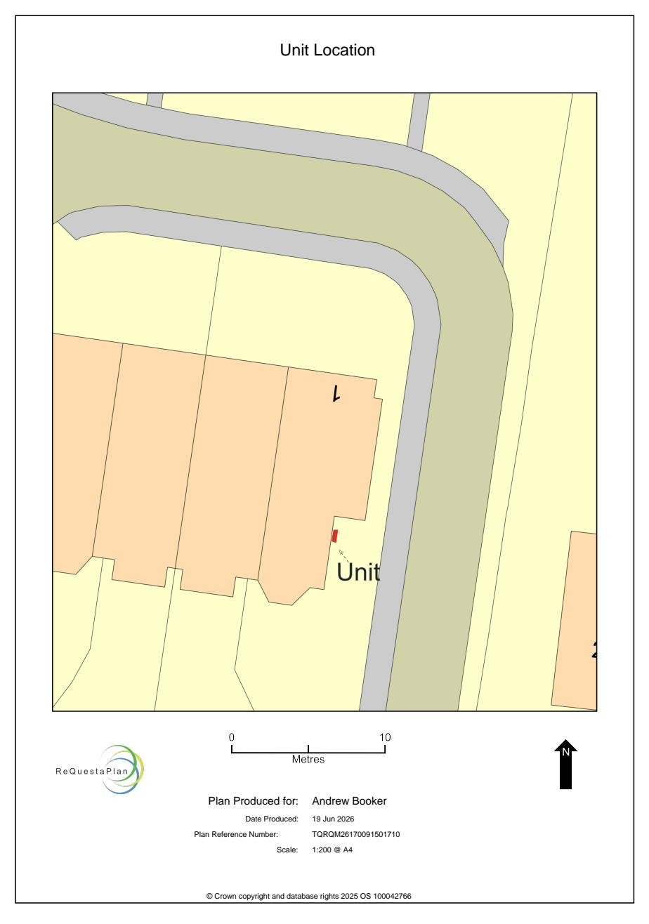
Figure 1: Site location plan (Ref: TQRQM26170091501710), submitted as part of the planning application, showing the site at 1 William Lunt Gardens.

6. Proposed Installation Location
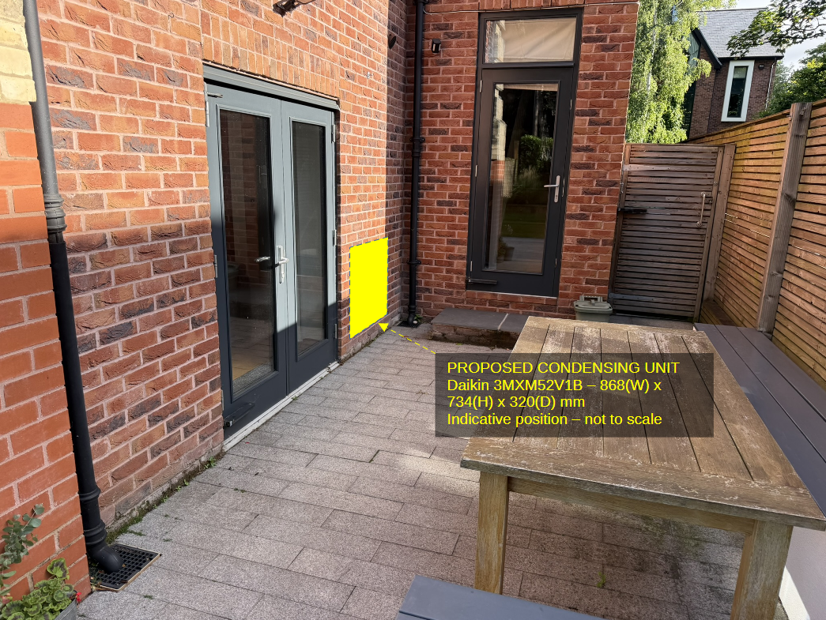
Figure 2: Annotated photograph of the private patio, showing the indicative position of the proposed condensing unit on the brick pier between the French doors and the side door. Position shown is indicative and not to scale – see dimensioned elevations below for accurate unit dimensions.

7. Dimensioned Elevations
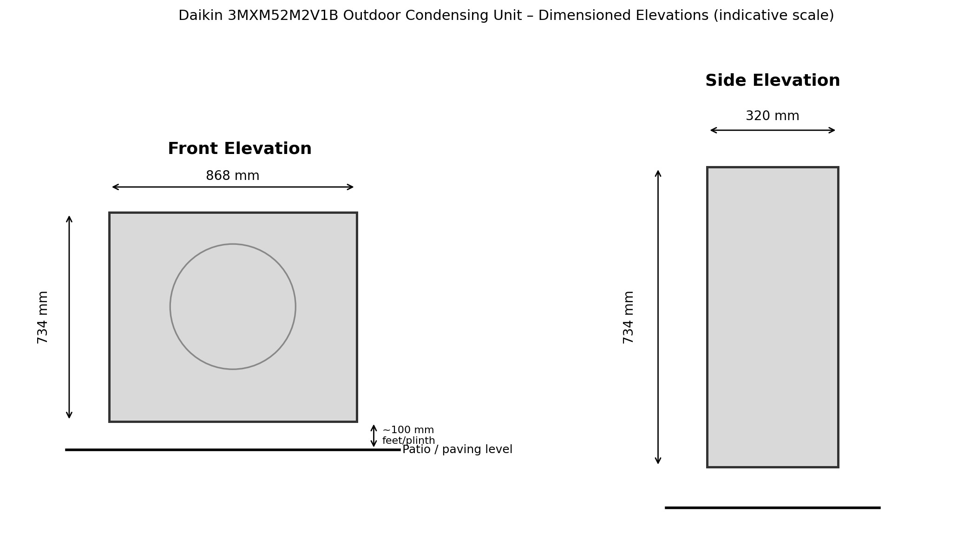
Figure 3: Front and side elevations of the Daikin 3MXM52M2V1B outdoor unit, dimensioned in millimetres, drawn to indicative scale from manufacturer's data.

8. Summary
The proposed condensing unit is a small-scale, neutrally-finished piece of domestic plant, to be installed at ground level within a fully enclosed private patio not visible from any public vantage point. Full manufacturer specification, site location plan and dimensioned elevations are provided above and in the accompanying manufacturer's datasheet to support the Local Planning Authority's assessment.

