HERITAGE STATEMENT
Installation of an External Air Conditioning Condensing Unit
1 William Lunt Gardens, Manchester, M21 9PB
Planning Portal reference | PP-15022881
Site address | 1 William Lunt Gardens, Manchester, M21 9PB
Applicant | Mr Andrew Booker
Conservation area | Wilbraham Road / Edge Lane Conservation Area
Document date | 3 July 2026

1. Introduction and Purpose
This Heritage Statement has been prepared in support of a householder planning application for the installation of an external air conditioning condensing unit at 1 William Lunt Gardens, Manchester, M21 9PB. The application site lies within the Wilbraham Road / Edge Lane Conservation Area, and this statement has been requested by the Local Planning Authority to accompany the application.
The purpose of this statement is to describe the proposed development, to summarise the significance of the conservation area and the contribution (if any) made by the application site, and to assess the effect of the proposed works on that significance, in accordance with Section 72 of the Planning (Listed Buildings and Conservation Areas) Act 1990 and the National Planning Policy Framework (NPPF).

2. The Site and its Surroundings
1 William Lunt Gardens is a modern dwelling forming part of a small residential development accessed off the wider Wilbraham Road / Edge Lane area of Chorlton-cum-Hardy. The property has an enclosed rear/side patio, bounded by brick walls to the dwelling and neighbouring boundary treatments and a close-boarded timber fence, which is fully private and not accessible to, or visible from, the public highway or any public vantage point.
The wider conservation area is characterised predominantly by substantial Victorian and Edwardian villas, semi-detached houses and terraces in Manchester red/orange brick with sandstone dressings, set within mature planted gardens along Wilbraham Road, Edge Lane, St Clements Road and Whitelow Road. The character appraisal for the area also identifies later twentieth and twenty-first century infill development – including apartment buildings and residential closes such as William Lunt Gardens – as making, at most, a neutral contribution to the character of the conservation area, being of a different scale, form and material palette to the historic buildings that define its special interest.
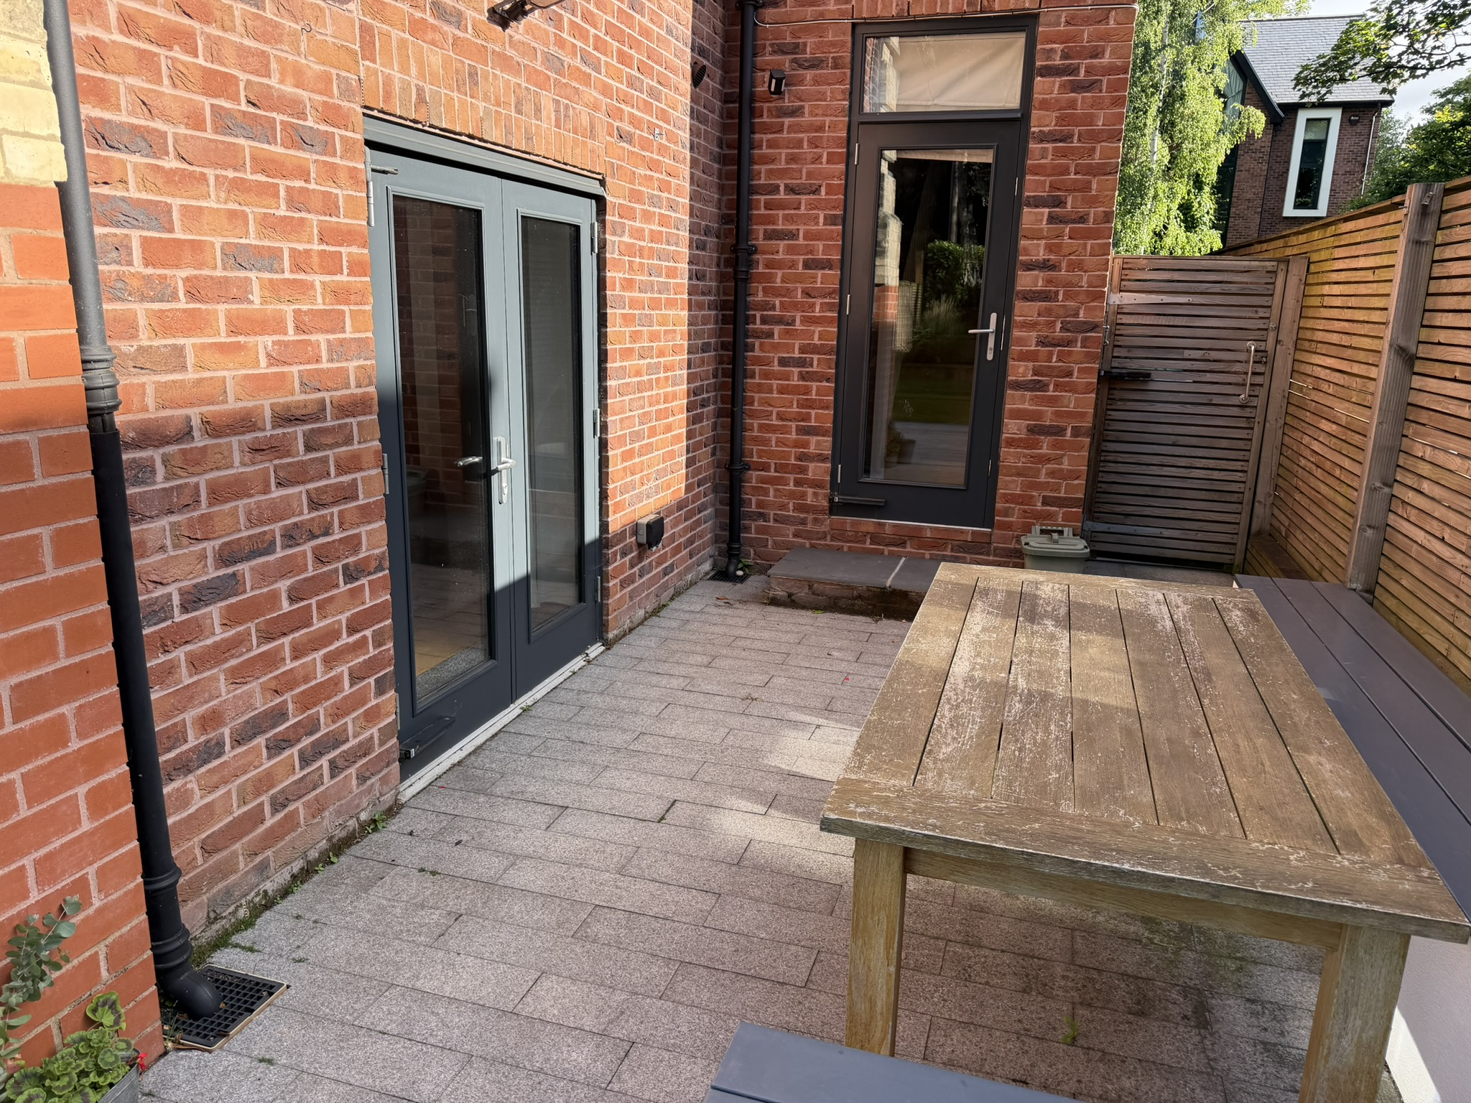
Figure 1: The enclosed private patio at the rear/side of the property, showing the fully screened nature of the area in which the unit is to be sited.

3. Description of the Proposed Development
It is proposed to install a single external air conditioning condensing unit (Daikin 3MXM52N R32 Multi Outdoor Unit) at ground floor level within the private patio area to the side of the dwelling. The unit will be wall/floor-mounted on a low plinth or bracket in the position shown on the accompanying technical specification and elevation drawings, adjacent to the existing rear door.
Associated refrigerant pipework linking the outdoor unit to the internal system will be surface-mounted and enclosed within dark grey/black PVC trunking, chosen to match the colour of the existing external cables and fittings already present on this elevation, minimising its visual impact.
No alterations are proposed to any historic fabric, windows, doors, boundary walls or roofscape. No trees or hedges are affected, and no works are proposed to any part of the property visible from the public highway.

4. Legislative and Policy Framework
Section 72(1) of the Planning (Listed Buildings and Conservation Areas) Act 1990 requires that, in exercising planning functions in respect of any buildings or land in a conservation area, special attention shall be paid to the desirability of preserving or enhancing the character or appearance of that area.
The NPPF requires that great weight be given to the conservation of designated heritage assets, including conservation areas, with the level of weight relating to the asset's significance. Local planning policy similarly requires development within conservation areas to preserve or enhance the character and appearance of the area, having regard to the relevant conservation area appraisal.

5. Significance of the Conservation Area and Contribution of the Site
The special interest of the Wilbraham Road / Edge Lane Conservation Area derives principally from its well-preserved late-nineteenth and early-twentieth century residential character: substantial individual villas, semi-detached houses and terraces in Manchester red/orange brick with sandstone dressings, blue/black Welsh slate roofs, timber sash windows and mature garden settings enclosed by brick or stone boundary walls. Only two buildings in the area are statutorily listed (Lloyd's Hotel and St Clement's Church), and the significance of the area otherwise derives from the collective quality and relationship of these buildings, their plots, boundary treatments and street trees, as experienced from the public realm – principally Wilbraham Road, Edge Lane and the connecting residential streets.
The character appraisal expressly identifies later infill development of the type at William Lunt Gardens as having a neutral effect on the character of the area, in contrast to the eras of villa and terrace development that define its special interest. The application site itself – a fully enclosed private patio to the side of a modern dwelling, screened from all public viewpoints by brick walls and close-boarded fencing – makes no contribution to the significance of the conservation area and forms no part of any of the public views, garden settings or street-facing elevations identified in the appraisal as important to its character.

6. Assessment of Impact
- Visibility: The condensing unit will be sited entirely within a private, enclosed patio and will not be visible from Wilbraham Road, Edge Lane, St Clements Road or any other public highway, footpath or public vantage point identified in the conservation area appraisal as significant to its character.
- Scale and prominence: At 868mm (W) x 734mm (H) x 320mm (D), the unit is a small, domestic-scale piece of plant, typical of equipment increasingly found to the rear and side of dwellings throughout the conservation area and comparable suburban areas, and will not be visually prominent even within the private curtilage.
- Materials and finish: The unit has a neutral light grey/off-white powder-coated casing, and associated pipework will be enclosed in trunking coloured to match existing services on the elevation, reducing visual clutter.
- Historic fabric: No historic walls, windows, doors, boundary treatments, or garden features are affected. The proposal does not require the removal of any trees or hedges.
- Cumulative effect: Given the site's location within an already neutral, late-development part of the conservation area, and its complete enclosure from public view, the proposal does not erode any of the qualities – architectural detailing, materials, garden settings, or public views – identified as contributing positively to the area's special interest.
On this basis, the proposed installation would have no discernible effect, whether individually or cumulatively, on the character or appearance of the Wilbraham Road / Edge Lane Conservation Area, or on the setting of any nearby listed building (the nearest listed buildings, Lloyd's Hotel and St Clement's Church, being well separated from the site and with no intervisibility with the enclosed patio).

7. Conclusion
This Heritage Statement has assessed the proposed installation of a domestic air conditioning condensing unit at 1 William Lunt Gardens against the significance of the Wilbraham Road / Edge Lane Conservation Area. The proposal is small in scale, sited within a fully enclosed and publicly invisible private patio, uses a neutral and unobtrusive finish, and affects no historic fabric, boundary treatment, tree or public view of significance to the conservation area.
The proposal therefore preserves the character and appearance of the conservation area in accordance with Section 72 of the Planning (Listed Buildings and Conservation Areas) Act 1990 and relevant national and local heritage policy, and no heritage objection is raised to the scheme.

