

Planning

Delegated Officer Report

Summary of application details
Application reference: | PLA-2026-000188
Application type: | Listed building consent (Alt/Ext)
Proposal: | Listed Building Consent for internal reconfiguration to allow the merging of apartments PM101 and PM102 including demolition and rebuilding of non-original internal fabric; removal and installation of non-original fixtures and fittings; and other associated works.
Site address: | Apartment PM 102 Paragon Mill 4 Cotton Street Manchester M4 5AX
Ward(s): | Ancoats & Beswick
Date application valid: | 04 May 2026
Applicant name: | Katie Wray

Agent (if any):
Case officer: | Lea Joseph
Recommendation: | Approve
Date of recommendation: | 24 June 2026

Description of site, building and/or area
The proposal relates to Paragon Mill a Grade II* former cotton mill. The mill has a large footprint of size storeys and ten bays. Red brick, white stone and terracotta dressing form the façade. Nine flats are currently present in the application site.

The building forms part of a complex of converted mills with Royal Mill. The site is situated within the Ancoats Conservation Area which has a distinct industrial identity and has slowly emerged as a ‘neighbourhood of choice’ in Manchester since regeneration of the area.

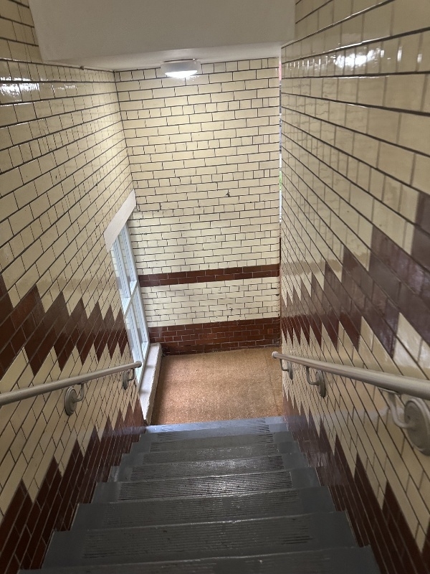
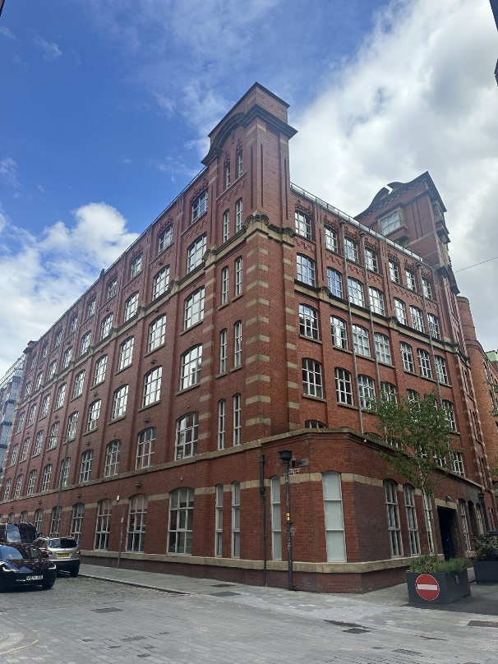

Application site when viewed from Jersey Street. Internal image of communal stairwell with historic glazed brick.

The application site derives its significance from its historic value, the former mill acts as an example of how early industries mill practices, how people and labour were managed for the mass production of cotton in Manchester. For example, the ‘larder’ or former toilets present within the units, meant to increase industrial productivity by reducing the time taken by workers to leave the mill to relieve themselves. The well-preserved façade, the site’s physical grandeur with brick decoration at corners, evenly spaced bays and period accurate window mullions contribute to its high aesthetic value, in addition the preservation of historic brick and tile decoration within the interior. The ongoing social value of the site comes from it’s ongoing use as a mixed-use site; it’s indoor-outdoor layout creates opportunity for pedestrians to engage with historic details; thus, the site has a moderate social value. Together these features establish the building’s high level of importance as a placemaking feature within the area and the site’s historic significance as a Grade II* building.

Description of development
Listed building consent is sought for internal alterations to allow for the merging of 2no. apartments. Alterations proposed include:
- the removal of partition walls
- installation of new flooring
- installation of modern render walls to facilitate master bedroom with ensuite, walk in closet, and utility room
- installation of pocket doors

Relevant planning history
104925/LO/2014/N1 | LISTED BUILDING CONSENT for use of part of first floor of both Paragon and Royal Mills to create an additional 18 apartments ( 9 in Paragon Mill and 9 in Royal Mill ) including internal works and associated parking spaces. (Approved December 2015).

126171/LO/2020 | Listed Building Consent for elevational alterations including the installation of new glazed fire escape door, new glazed canopy and door together with new louvres and plant equipment together with internal refurbishment of the ground floor including the installation of the meeting pods. (Approved July 2020).

OTH-2026-000247 | Non-material amendment to planning permission 104923/FO/2014/N1 to alter description of development to allow the merging of apartments PM101 and PM102 in Paragon Mill together to create 1no. residential apartment. (Approved 5 June 2026).

Consultation, notification and publicity responses

Consultations

Heritage England (North West) – No comment.

Notifications and publicity
A site notice was posted, a press notice was published, and letters were sent to surrounding neighbours; no representations have been received.

Relevant policies
Places for Everyone Joint Development Plan (2024-2037)
JP-P2 Heritage

Manchester Core Strategy (2012-2027)
SP1 Spatial Principles
CC9 Design and Heritage
H1 Overall Housing Provision
EN1 Design Principles and Strategic Character Areas
EN3 Heritage
DM1 Development Management

Saved Unitary Development Plan Policies
DC18 Conservation Areas
DC19 Listed Buildings

Other Material Considerations:

National Planning Policy Framework (2024)
Chapter 16 Conserving and enhancing the historic environment

Draft National Planning Policy Framework (NPPF) (2025)

The government has published a consultation National Planning Policy Framework which is intended to improve housebuilding rates through a clearer, more predictable and faster policy basis for decision and plan making.

Whilst this is a draft NPPF for consultation it is considered that the development proposals are in accordance with the general thrust of policy contained within it. As set out in the printed report no adverse impacts have been identified through consideration of the application proposals that would outweigh a positive decision in this instance.

Other Legislative Requirements
Planning (Listed Buildings and Conservation Areas) Act 1990
Sections 16, and 66

Assessment
Impact of the development on the significance of the Listed Building

The application relates to alterations proposed to two apartments on the first floor of the north facing elevation of Paragon Mill. At present both sites contain a medley of historic and modern fabric and elements. In flat PM101, original brick is present on walls sited to the north; flat PM102 includes historic brick in the kitchen and salon, and an original toilet, with a unique form and an original glazed brick finish. Original columns are present in both flats.

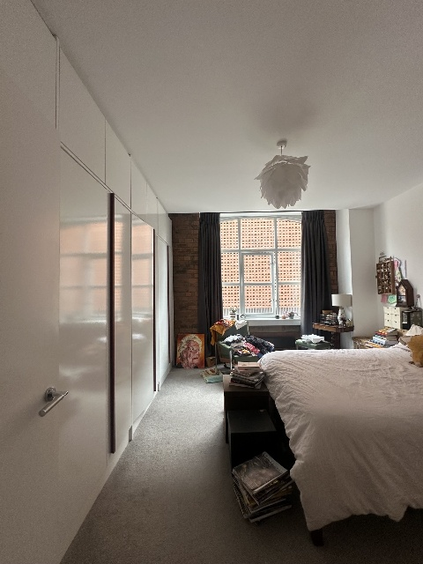
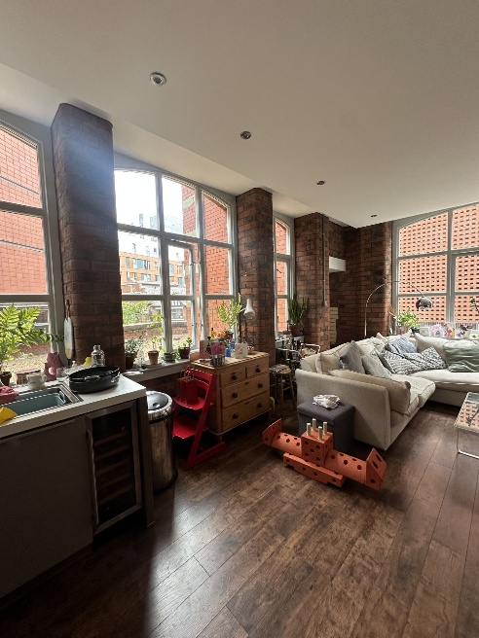
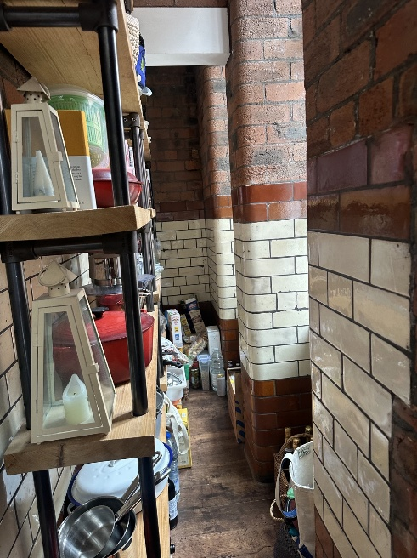

Original brick and larder in flat PM102.

The approach is ‘light touch’, modern partition walls are being removed in PM102 to create a larger communal space where the salon, kitchen and bathroom are currently. In the flat PM102 communal kitchen living area, a strip out would take place with white plaster partitions being inserted to facilitate the creation of a master bedroom with ensuite.

1no. partition selected for removal in flat PM102 abuts an original brick wall. These partitions are modern and not considered to contribute or preserve the significance of the site. A method statement for the removal of these sensitive partitions was submitted as part of this application. Hand tools would be used for removal whenever possible, during wider works within the site areas of historic significance would be protected from damage; all works would also be monitored by the applicant to ensure adherence to the method statement. This methodology was reviewed and considered to acceptable pursuant to policies DC19, EN3 and DM1.

Partition removal is considered to be an enhancement to the heritage significance of the site. The creation of larger open space more closely reflects the historic layout of the site, and the open expanse of the industrial workspace. As such these alterations are considered to be an acceptable improvement on the existing historic significance of the site pursuant to policies DC19, EN3, EN1 and JP-P2.

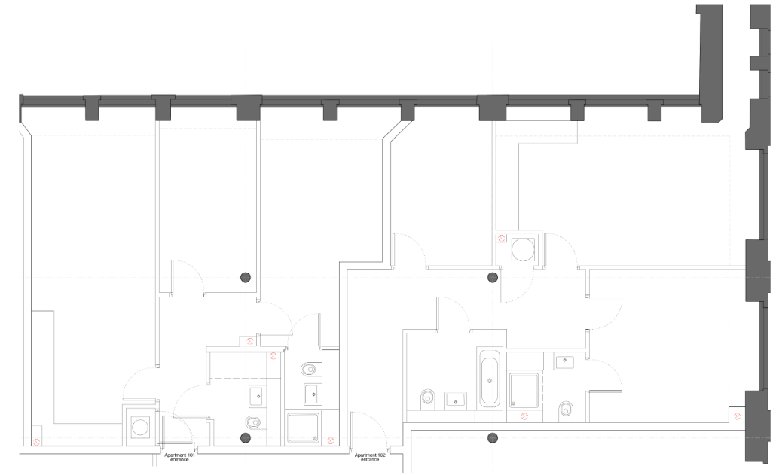
Existing floor plans

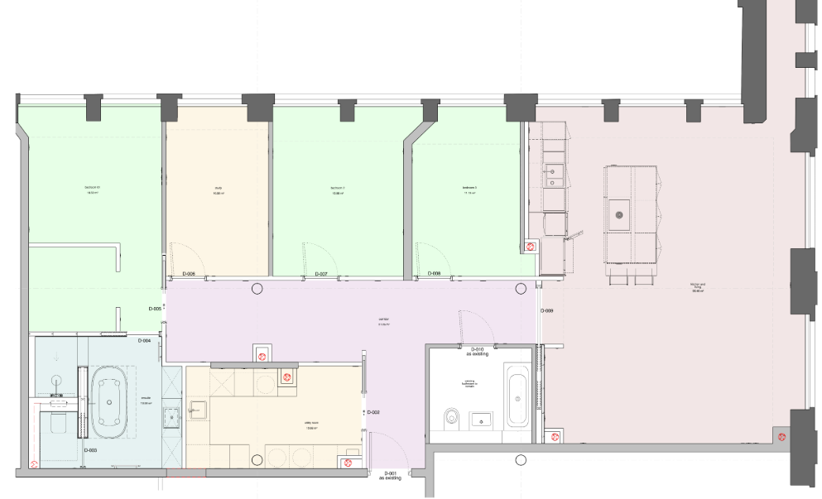
Proposed floor plan

A small number of electrical sockets and switches are proposed for installation on original brick; all sockets to be installed on historic fabric will match the materials and fixings employed in the original fit out (104925/LO/2014/N1). This industrial, utilitarian appearance of sockets and switches is considered to be in keeping with the industrial character of the application site and acceptable pursuant to policies SP1, DM1, CC9 and EN1.

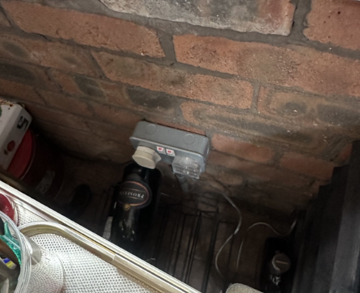
Socket treatment would be replicated on a like for like basis.

A small number of new partitions and pocket doors are proposed to segment the proposed bedrooms, study and utility room. None of these new partitions would interface with historic fabric. All furniture will be freestanding. Wall and floor finishes were selected to be in keeping with the original fit out and to be subservient to the historic features within the space.

In consideration of the above details, the proposed renovations are limited and sympathetic in their approach. The continued use of plaster partitions, and introduction of additional modern floors would result in a low level of less than substantial harm. Original brick and columns would remain unaffected. Conversely the removal of the partitions on the eastern side of the structure would result in an enhancement to the asset, as the site’s original design would have been open plan.

In accordance with paragraph 215 of the National Planning Policy Framework, less than substantial harm to an asset’s significance must be weighed against its public benefits.

The proposal supports the social benefits of the scheme by allowing for the ongoing occupation and maintenance of this Grade II* asset; the C3 use proposed is considered to be an acceptable long-term use that positively contributes to the asset’s conservation; further the creation of new family-sized accommodation within Manchester would meet an evidenced housing need.

The proposal is therefore considered to be acceptable pursuant to the National Planning Policy Framework, Core Strategy policies EN3, DM1, and CC9, Saved Unitary Development Plan policy DC19 and, Places for Everyone Policy JP-P2.

Conclusion

The development would employ a light touch approach to allow for the extension of an apartment to create a larger family home. The use is considered compatible with the long-term conservation of the site, and alterations to remove partitions on the x side of the application would result in an enhancement of the site’s significance. Thus, the proposed development is considered to be acceptable pursuant to the National Planning Policy Framework, Core Strategy policies EN3, DM1, and CC9, Saved Unitary Development Plan policy DC19 and, Places for Everyone Policy JP-P2.

Other Legislative Requirements
Equality Act 2010
Section 149 (Public Sector Equality Duty) of the Equality Act 2010 requires due regard to the
need to: Eliminate unlawful discrimination, harassment and victimisation and other conduct
prohibited by the Act and; Advance equality of opportunity between persons who share a
protected characteristic and persons who do not share it. The Equality Duty does not impose a
legal requirement to conduct an Equality Impact Assessment. Compliance with the Equality
Duty involves consciously thinking about the aims of the Equality Duty as part of the process of
decision-making.

Human Rights Act 1998 considerations
This application needs to be considered against the provisions of the Human Rights Act 1998.
Under Article 6, the applicants (and those third parties, including local residents, who have
made representations) have a right to a fair hearing and to this end the local planning authority
must give full consideration to their comments.

Protocol 1 Article 1, and Article 8 where appropriate, confer(s) a right of respect for a person’s
home, other land and business assets. In taking account of all material considerations, including
Council policy as set out in the Core Strategy and saved polices of the Unitary Development
Plan, the Director of Planning, Building Control & Licensing has concluded that some rights
conferred by these articles on the applicant(s)/objector(s)/resident(s) and other occupiers and
owners of nearby land that might be affected may be interfered with but that that interference is
in accordance with the law and justified by being in the public interest and on the basis of the
planning merits of the development proposal. She believes that any restriction on these rights
posed by the recommendation given is proportionate to the wider benefits of and that such a
decision falls within the margin of discretion afforded to the Council under the Town and
Country Planning Acts.

Recommendation: Approve

Article 35 Declaration
In assessing the merits of a planning application, officers will seek to work with the applicant in a positive and proactive manner to seek solutions to problems arising in relation to dealing with the planning application. All such issues have been resolved due to the discussions within the applicant and the conditions.

Conditions attached to this decision

- The works must be begun not later than the expiration of three years beginning with the date of this consent.

Reason - Required to be imposed pursuant to Section 18 of the Planning (Listed Buildings and Conservation Areas) Act 1990 (as amended).

- The development hereby approved shall be carried out in accordance with the following drawings and documents:

Drawing: 7710-al(46)0001-P03
Drawing: 7710-al(62)0002-P02
Drawing: 7710-al(45)0001-P04
Drawing: 7710-al(04)0003-P03
Drawing: 7710-al(22)0002-P03
Drawing: 7710-al(03)0001
Drawing: 7710-al(74)0003
Drawing: 7710-al(32)0001

Drawing: 7710-al(04)0001
Drawing: 7710-al-(73)0001
Drawing: 7710-al(22)0001
Drawing: 7710-al(74)001
Drawing: 7710-al(74)0002
Drawing: 7710-al(73)0003
Drawing: 7710-al(73)0002
Drawing: 7710-al(74)0004

(All received 7 May 2026)

Drawing: 7710-al(62)0001 (Received 22 May 2026)

Document: Task Method Statement for Removal of Partitions and Making Good of PM101 and PM102, Paragon Mill (Received 8 June 2026)

Reason - To ensure that the development is carried out in accordance with the approved plans pursuant to policies SP1 and DM1 of the Core Strategy.

- In areas of the application site where demolition interacts with historic fabric, removal of partitions shall be done in accordance with 'Task Method Statement for Removal of Partitions and Making Good of PM101 and PM102', dated June 2026, stamped as received by the City Council as Local Planning Authority the 8th of June 2026.

Reason - In the interests of visual amenity and because the proposed works affect a building which is included in the Statutory List of Buildings of Special Architectural or Historic Interest and careful attention to building work is required to protect the character and appearance of this building and to ensure consistency in accordance with policy and EN3 of the Core Strategy and saved policy DC19.1 of the Unitary Development Plan for the City of Manchester.

