PROPOSED BAT & BIRD BOX SPECIFICATION
342 SLADE LANE, MANCHESTER, M10 2BX
18 JUNE 2026

This specification is submitted in line with the accompanying drawing identifying locations of bat and bird boxes to the development at 342 Slade Lane, Manchester, M19 2BX

The specification for the bat and bird boxes is set out below. They will be installed to a height of approximately 4 metres near to the eaves on southern elevations where possible.

Bat box

Features:-

- Grooved interior design helps bats find a secure place to roost
- Painted black which helps retain heat for hibernation
- Measurements 370mm x 185mm x 65mm

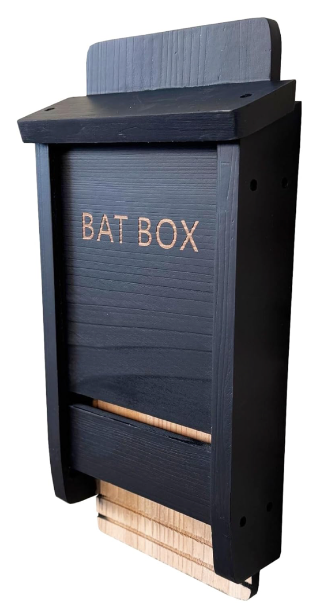
Bird box

Features:-

- Suitable for many species of wild birds such as Robins, Pied Wagtail, Spotted Flycatcher, Great Tit, Blue Tit, Nuthatch and Tree Sparrows and more
- Small gap in base so birds can easily clean the box out
- Dimensions 165mm(l) x 180mm(w) x 260mm(h)

