

342 SLADE LANE, MANCHESTER, M19 2BX

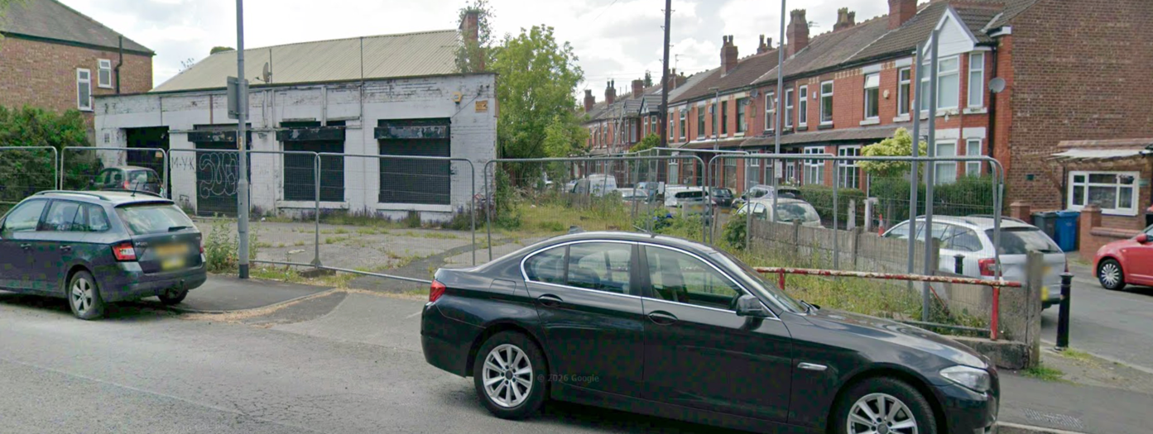

DESIGN AND ACCESS STATEMENT
18 JUNE 2026
1. BACKGROUND

This statement is prepared to form a resubmission of a planning application on the subject site. Planning permission was granted on 30 June 2023 under reference 136026/FO/2023 for ‘Erection of 5no. 3 bed residential dwellinghouses, associated boundary treatment, and car parking following demolition of existing garage/workshop’.

The developer, D Woodman Developments Limited purchased this vacant site in April 2026 with the sole aim to deliver 5 new dwellings given the nature of their business as a residential property developer.

Throughout the conveyancing process, the developer had instructed a variety of consultants to work through planning conditions imposed, with an application submitted on 29th April 2026 for the discharge of pre-commencement and other conditions under reference OTH-2026-000140. There was a delay in the validation of the planning application due to Manchester City Council migrating over to a new computer system, which resulted in a delay in the commencement of consultation. When consultation comments were received from the Lead Local Flood Authority, there were amendments required to the submitted drainage scheme which could not have been addressed by the developer, resubmitted for consultation with responses to be returned in a timely manner prior to the expiry date of the planning permission on 30th June. Due to insufficient timescales for the discharge of pre-commencement conditions 14 (Contamination) and 18 (Drainage) and therefore the developer requested a partial discharge of this application which was granted by the planning officer.

As a result, the developer is resubmitting a fresh application in the same manner and the same scheme as was previously granted and is not seeking any amendments to the proposal which had previously been granted planning permission under reference 136026/FO/2023.

2. PRE APPLICATION

We understand that the former site owner, Mr Javed Shah, and his agent, NADA Architects, sought pre-application advice from Planning Officer Carl Glennon. Given the site’s history, it appears that Manchester City Council supports the redevelopment of this brownfield site for residential use.

The plans prepared by NADA Architects which were previously approved form part of this planning application which consist of 5 x 3-bedroom residential dwelling houses ranging from 91m2 to 111m2.

3. ACCESS

For compliance with Part M of the Building Regulations, the developer is obliged to ensure each dwelling provides level access. From the public highway to the dwelling the scheme incorporates a gradient of less than 1:40. The car parking arrangement to each dwelling provides for level access from the exit from a vehicle to the dwelling which is also a requirement and compliant with Part M of the Building Regulations. Each dwelling threshold will have a level access of less than 1:20 and minimum width of 900mm with no change in level to the ground floor and accommodating a WC.

4. APPEARANCE

The scheme drawn up as replicated by the previous planning permission is made up of 2 separate structures being a pair of semi-detached and a terraced row of 3 houses. The accommodation will span into the loft area containing 1 bedroom and over 3 storeys within all 5 dwellings. It is proposed and identified from the site layout drawing for provision of 1 car parking space per dwelling along with provision for an electric vehicle charging point. Details of the proposed EV charging points location and specification are submitted with the application. For privacy, the 3 dwellings along the frontage of Slade Lane Each dwelling will have a private rear garden with separate accesses. Each property will accommodate either a bat or bird box to be located on a southern elevation near the eaves. A plan identifying the locations of the bat and bird boxes is submitted with this application.

There is a schedule of external materials submitted with this planning application which provides a computer generated image as a visual of how the external façade will appear. The materials have been carefully considered by the developer with a view to incorporating materials in keeping with neighbouring properties along Slade Lane and Monica Grove. This schedule of external materials was submitted with the discharge of conditions OTH-2026-000140 and discharged by the planning department on 18 June 2026.

5. REFUSE

The proposed bin storage locations are indicated on drawing 22-1110 (03)002 PL1 with specified details of the stores on drawing 22-1110 (08)001 PL2 and submitted with this application. The siting and specification arrangement referred to on these drawings was approved by way of condition 13 of planning permission 136026/FO/2023.

6. SECURITY

Submitted with this application is a Crime Impact Statement reference 2014/0829/CIS/01 prepared by Design For Security dated 22 June 2026. Within this statement recommended measures are detailed for boundary treatments and security provision as crime deterrents. The developer will undertake to provide for the following:-

- The proposed boundary treatments to be in line with the recommendations along the rear garden of unit 5 on Monica Grove adjacent to the alley between 17 Monica Grove, and a section of visually permeable boundary treatment along the rear boundary of unit 3 fronting Slade Lane and adjacent to Monica Grove.

- The gate into the rear garden of unit 1 to be positioned close to the front elevation of the dwelling.

- Units 4 and 5 to have dusk till dawn lighting along the gables for illumination of the driveways.

- Photo cell motion sensor PIR lighting to front and rear of dwellings positioned away from boundary treatments.

- External meter boxes located outside of private areas.

Given it is a requirement of Part Q of the Building Regulations for accessible windows and doors to meet PAS24 standard, the developer will ensure compliance with the installation of these.

7. SUMMARY

This site has previously been granted planning permission and the developer therefore seeks Manchester City Council approval for the resubmission of the same scheme given that:-

- the existing building utilised as a garage workshop has been vacant for many years and a vulnerable target for anti-social behaviour;
- the development will aesthetically enhance the local area;
- it will welcome 5 new much needed homes to the borough;
- provide economic benefits generating income streams for Manchester City Council and the local economy.

