ENVIRONMENTAL
STANDARDS
STATEMENT

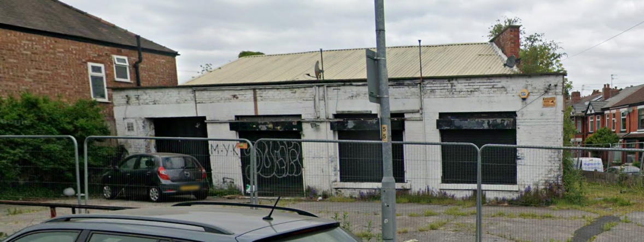

342 SLADE LANE, MANCHESTER, M19 2BX

18 June 2026



SCHEDULE OF CONTENTS

Page Nos

PART 1 Developer requirements 3

PART 2 About the development 4 - 5

PART 3 Part L Building Regulations requirements 6

PART 4 Compliance 7 - 12

PART 1
DEVELOPER REQUIREMENTS

The site of 342 Slade Lane, Manchester, M19 2BX was previously granted planning permission on 30th June 2023 by Manchester City Council under planning number 136026/FO/2023 entitled “Erection of 5no. 3 bed residential dwellinghouses, associated boundary treatment and car parking following demolition of existing garage/workshop”.

Due to the imminent expiry of the planning permission, the developer D Woodman Developments are re-submitting a new application in the same manner and scheme as the previous application.

An application to discharge conditions was submitted on 29th April 2026 under reference OTH-2026-000140 which included a request for an Environmental Standards Statement for discharge of condition 23 of planning permission 136026/FO/2023. This statement is therefore submitted with the new application in the same terms as the previous statement dated 10 April 2026 and amended 11 June 2026 which was approved and discharged by the planning department subject to the following:-

Within 3 months of the completion of the construction of the authorised development, a verification statement shall be submitted to and approved in writing, by the City Council as local planning authority, confirming the incorporation of the specified measures at each phase of the construction of the development, including dated photographic documentary evidence of the implementation and completion of required works

Set out within this statement are details of how the development has incorporated sustainable measures regarding a reduction in carbon emissions and environmental efficiency which therefore satisfies compliance with Part L of the Building Regulations.

The developer requests the planning department accepts that by way of verification they will accept the as built BREL (Building Regulations England Part L) report along with EPC (Energy Performance Certificate) which is issued on completion of the dwelling. The developer is required to provide photographic evidence throughout the construction phase identifying requirements have been met and adhered to which are provided to the SAP assessor prior to issue of these documents. The BREL report will detail the following have also been incorporated within the 5 dwellings on the development. In accordance with the Partial approval of discharge of conditions issued 18th June 2026 the developer will provide the information requested by Manchester City Council within 3 months of the construction of the development.

PART 2
ABOUT THE DEVELOPMENT

The development comprises:-

- Plot 1 – Erection of a new end terraced 3 bedroom dwelling
- Plot 2 – Erection of a new mid terraced 3 bedroom dwelling
- Plot 3 – Erection of a new end terraced 3 bedroom dwelling
- Plot 4 – Erection of a new semi detached 3 bedroom dwelling
- Plot 5 – Erection of a new semi detached 3 bedroom dwelling

SITE LAYOUT
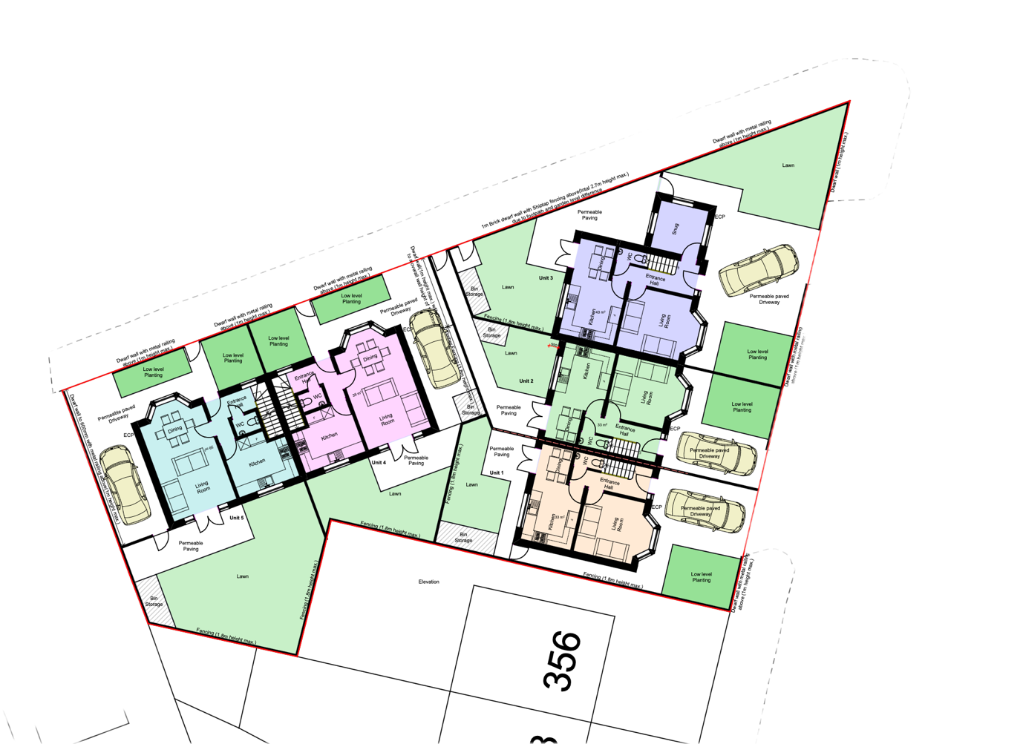

The total floor area for each plot is detailed below:-

PLOT | GIA M2 | GIA SQ FT
1 | 88 | 947
2 | 88 | 947
3 | 110 | 1184
4 | 105 | 1130
5 | 105 | 1130

PART 3
BUILDING REGULATIONS REQUIREMENTS

The developer is required to demonstrate how the development will meet Part L of the Building Regulations in England (2021 edition, amended 2023) for Conservation of Fuel and Power and for the purposes of setting standards for the energy performance of new build dwellings. This development will be classified as Part L1A given they are new build homes.

A Standard Assessment Procedure (SAP) is required to be carried out at design stage to assess key factors that the dwelling is compliant with Part L which are:-

- Target Emission Rate (TER)

- Target Primary Energy Rate (TPER)

- Target Fabric Energy Efficiency (TFEE)

The TER is a calculation of the annual predicted CO2 emissions per m2 of the dwelling.

The TPER is a measure of the dwelling energy demand for heating and hot water provision, ventilation and lighting.

The TFEE measures the energy demand for heating and cooling based on the fabric makeup of the dwelling. They are concentrated on air tightness, insulation and thermal bridges.

A fabric first approach is required for SAP calculations to provide incorporation of quality materials and ensuring dwellings are sufficiently insulated. This is a fundamental requirement for dwelling heat loss and the specification of the heating provision.

A specification is provided for the developer based on u value calculations carried out for the walls, floor and roof aspects which detail the fabric makeup required to ensure compliance. These include the quality and type of insulation introduced along with other materials such as doors and windows which make up the dwelling envelope.

The SAP calculation also incorporates a maximum required air permeability rate which the developer needs to meet to ensure air tightness. This test is required to be carried out by a competent member of an accredited scheme and a certificate issued to confirm compliance.

In order to achieve building regulations sign off the developer must demonstrate by providing a portfolio for the dwelling of photographic evidence and statements confirming they have conformed to requirements and compliance has been met.

PART 4
COMPLIANCE

The developer has appointed an On Construction Domestic Energy Assessor to provide design stage SAP calculations to ensure the new dwellings on the site of 342 Slade Lane, Manchester, M19 2BX comply with the current requirements under Part L of the Building Regulations.

The as designed Building Regulations England Part L (BREL) Compliance Report prepared by Chris Law dated 4th May 2026 is attached to this Statement. This report provides the developer with a methodology for required U values for the fabric makeup of the dwelling, proposed heating and ventilation systems to be installed, lighting efficacy and air permeability target to ensure the as built dwelling is within the compliance parameters.

It can be demonstrated from the Compliance Report that the dwelling emission, primary energy and fabric energy efficiency rates fall well below the target rates and as such are well within the statutory requirements. This is shown against each box on the Report namely 1a, 1b and 1c as ‘OK’. If the targets had not been met this would read ‘FAIL’.

The Report also includes on page 2 the space heating and hot water provision to be provided by air source heat pump and accompanying hot water cylinder. A typical gas boiler may provide for an efficiency rating of up to 94%, whereas the Vaillant air source heat pump specified shows an efficiency rating of 247.3%.

One of the main contributory factors that the inclusion of an air source heat pump has achieved a pass on the dwelling emission rate is it relies on a lower flow temperature than a gas boiler, thus reducing the dwelling’s carbon output. The installation of underfloor heating to the ground floor also reduces the heat demand as this is run at a lower temperature given it is an even distribution of heat as opposed to ‘warmer spot’s next to a wall mounted radiator. The radiators to other floors are specified to have an increased capacity than a standard radiator which would be installed with a gas boiler to enable these to run at lower temperatures. Along with the specified low U values and air permeability target the heat loss and air leakage is significantly reduced and allows for the dwelling to retain the heat so demand on the heating system is much less, therefore resulting in a reduction of CO2 emissions.

The elimination of reliance on a gas boiler using a fossil fuel and inclusion of an air source heat pump for the heating and hot water provision and required U value and air permeability targets has significantly lowered the dwelling CO2 emissions. The below are taken from the Energy Report within the attached which shows the dwelling achieving an Energy Efficiency Rating of 83B and Carbon Dioxide (CO2) Emissions Rating of 97A. This therefore identifies that the development complies with Part L of Building Regulations in England (2021 edition, amended 2023) for Conservation of Fuel and Power for energy efficiency and carbon reduction.
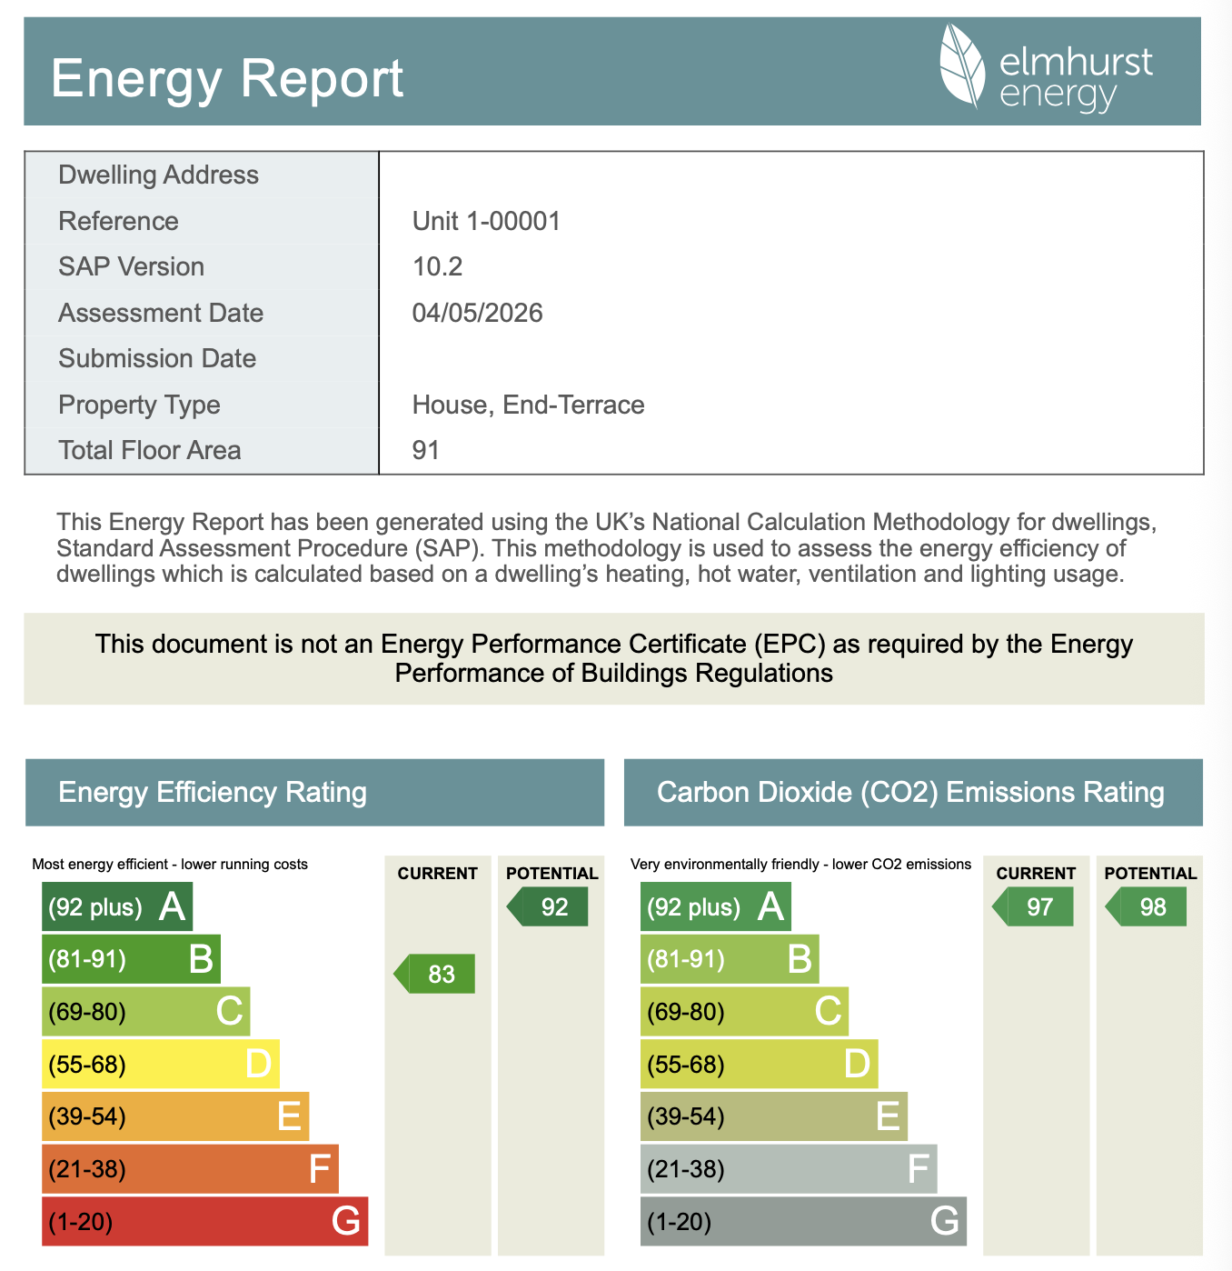

HEATING & HOT WATER

As a form of renewable energy, the developer will be installing a Vaillant aroTHERM plus heat pump system for both heating and hot water elements of the property. This is a system D Woodman Developments have installed in 13 new homes on our 2 of our previous developments.

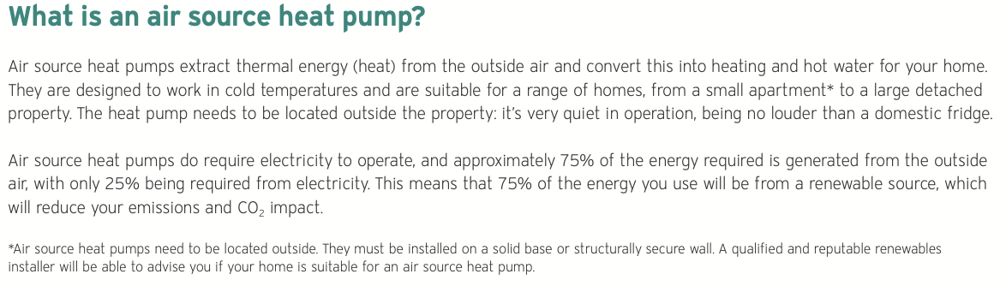

Accompanied with the aroTHERM plus heat pump will be the Vaillant uniSTOR cylinder for the hot water supply. This system will provide the dwellings with a low carbon heating and hot water solution. Vaillant provide a warranted design to ensure each property has the correct specification of equipment required to ensure full capacity for heating and hot water provision and demands for the dwelling are met.

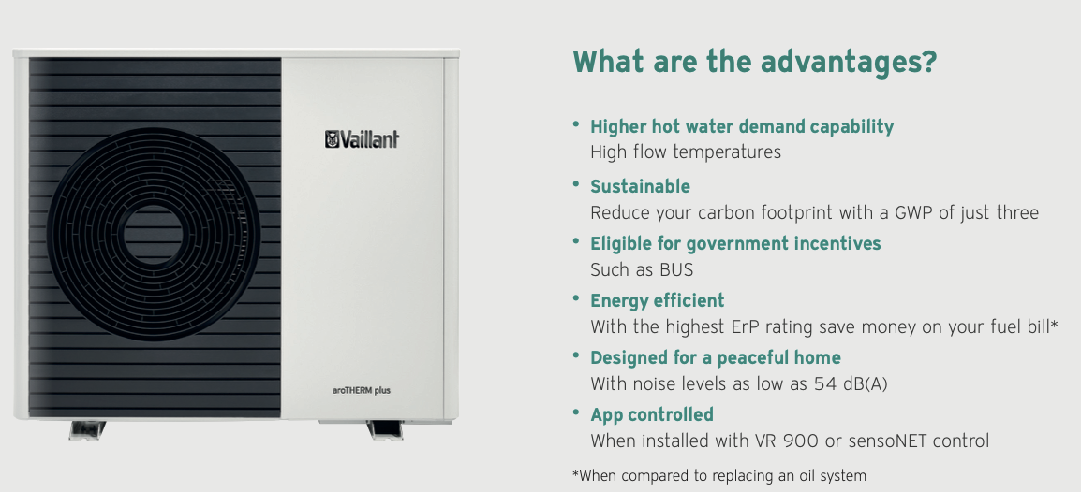

With an energy class of A+++, The Vaillant aroTHERM air to water heat pump is a high-performance eco-friendly system designed to operate for heating flow temperatures of between 35-55 degrees Celsius. The unit uses monobloc technology with a hermetically sealed natural refrigerant R290 to deliver one of the lowest Global Warming Potential (GWP) ratings of just 3, and zero Ozone Depletion Potential (ODP). With a Seasonal Coefficiency of Performance (SCOP) of up to 5.03 the heat pump offers excellent efficiency with energy savings against fossil fuel. The aroTHERM plus has operational capabilities for temperatures as low as -25 degrees celsius.

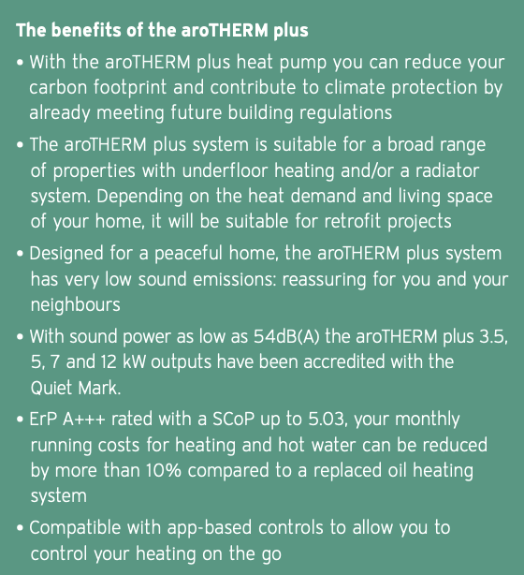
The Vaillant uniSTOR hot water cylinder have superior insulation and efficiency as they contain thermally injected polyurethane insulation with vacuum panels. With a GWP of less than 5 and, as with the aroTHERM plus, an ODP of 0. Due to the excellent thermal qualities, the uniSTOR can retain unused hot water for over 24 hours given the low standing heat loss qualities of roughly 1.22kw/24 hours. The cylinder also offers excellent recovery of approximately 45 minutes from an empty to full tank.

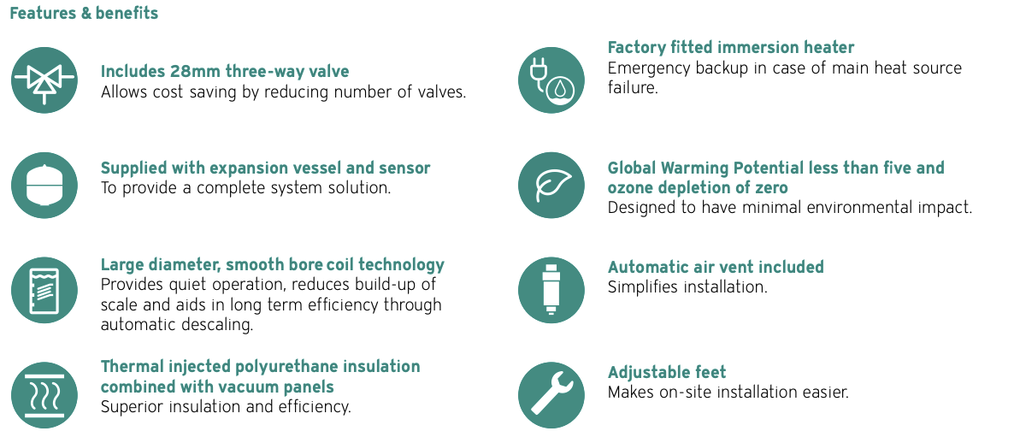

With the factory fitted immersion heater within the uniSTOR unit, this eliminates the need for direct electric immersion. It also contains a legionella control function which periodically triggers a hot water boost above 60 degrees celsius to sterilise the water.

VENTILATION

D Woodman Developments have been installing Mechanical Ventilation & Heat Recovery (MVHR) units in all our new build homes for the last 5 years. Due to the low air permeability at less than 3.0 m3 of air escape per hour the introduction of a ventilation system is vital for the extraction of moist air from wet rooms to avoid mould and also provides for a healthier living environment.

The developer will be installing a Mechanical Ventilation and Heat Recovery system into all 9 properties on the development. This will be in the form of a Titon HRV 1.6 Q Plus which has an energy rating of A.

A design drawing will be provided by Titon in respect of location of the inlet and extract in each room in order to maximise the efficiency of the system. It should also be noted that no trickle vents will be installed to any of the windows as this would have a counter effect on the performance of the system.

The specific fan power for mechanical ventilation systems should not exceed 1.5W/litres per second for continuous mechanical supply and extract ventilation systems. On the specific fan power on the Titon HTV 1.6 Q Plus we will be achieving between 0.49-0.53w/l/s SFP which is over a 50% improvement on the 1.5w/l/s required in accordance with the table below.

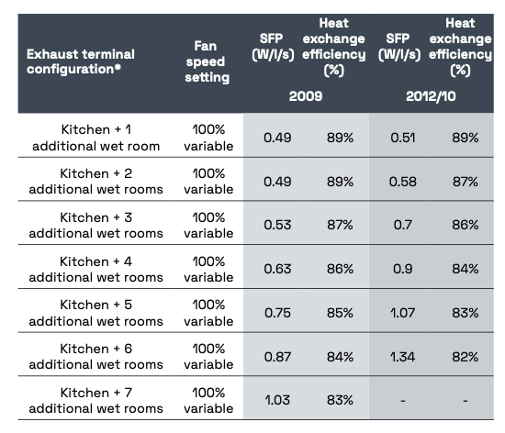

All ventilation systems which provide both supply and extract ventilation within the same unit should be fitted with the following:-

- A heat recovery system with a minimum efficiency of 73%
- A summer bypass facility (giving the ability to bypass the heat exchanger or to control its heat recovery performance).
- A variable speed controller

This system complies with all the above as:-

- the heat recovery system efficiency is achieving between 86%-89%
- a 100% automatic summer bypass as standard
- it has a Summer boost facility which enhances the unit's ability to cool the home during summer, often by automatically bypassing the heat exchanger to bring in cooler air.
- all units are supplied with an Aura-T LCD 4 speed controller

With the features of the 100% automatic summer bypass as standard and Summer boost facility, The Titon 1.6 HRV Q Plus will also play a fundamental part under Part O of the Building Regulations which covers Overheating specifically for the removal of excess heat within the dwelling.

The other key features of this unit include-

- An internal humidity sensor
- Frost protection programme
- Low acoustic levels

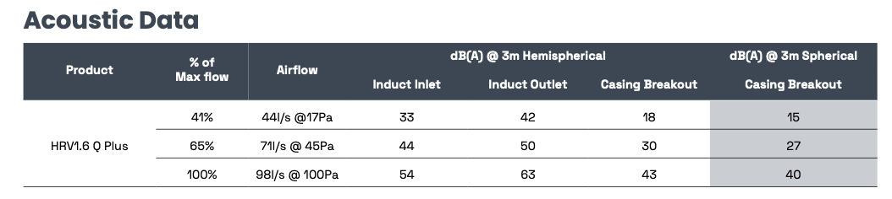

Another key feature of the Titon 1.6 HRV Q Plus is that it offers a high efficiency filtration to improve indoor air quality. The unit includes an automatic filter change alert. There are various filter grades available:-

- G3 – standard filters which also protect the heat exchanger

- G4 – 5-10% enhanced superior air filtration from the standard G3 filters

- Anti allergy – offers advanced protection against pollen and allergy causing pollutants

