

Planning

Delegated Officer Report

Summary of application details
Application reference: | PLA-2026-000186
Application type: | Householder planning permission
Proposal: | Erection of single-storey granny annex in the rear garden.
Site address: | 10 Thoresway Road Manchester M13 0XN
Ward(s): | Rusholme
Date application valid: | 04 May 2026
Applicant name: | Mr Shahjan Ali
Agent (if any): | Mr Rashid Mehmood
Case officer: | Holly Wright
Recommendation: | Approve
Date of recommendation: | 22nd June 2026

Description of site, building and/or area
The application relates to a two-storey semi-detached dwellinghouse of redbrick (painted cream at ground-floor level and red at first-floor level to the front) with a grey/brown hipped roof. The property features white uPVC-framed windows, a single storey front extension and canopy overhang, a paved driveway space bordered by timber fencing, a part-single / part-two storey rear extension and a detached shed structure situated within a spacious rear garden.

Located in the Rusholme ward of Manchester, the surrounding area is predominantly residential in terms of its character, consisting of terraced and semi-detached dwellinghouses, and benefits from its proximity to public outdoor amenity and green spaces, such as Birchfields Park.

The property is not listed, nor is it sited within a conservation area.

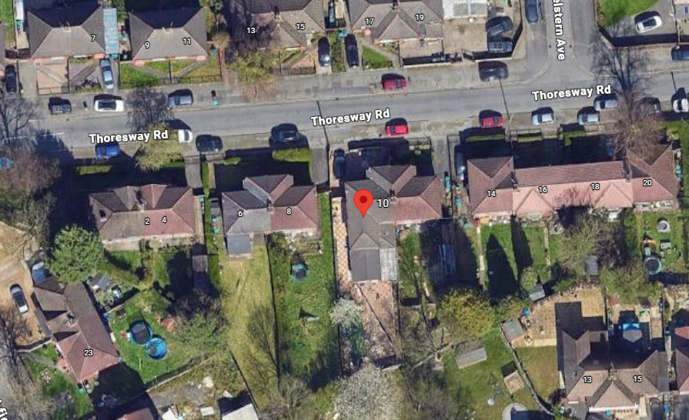

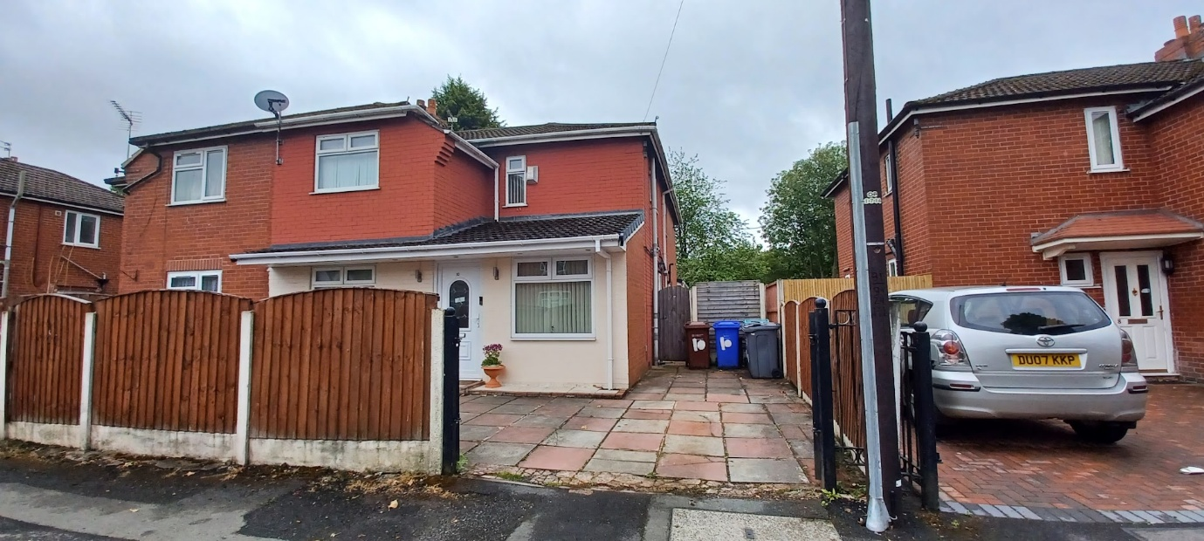
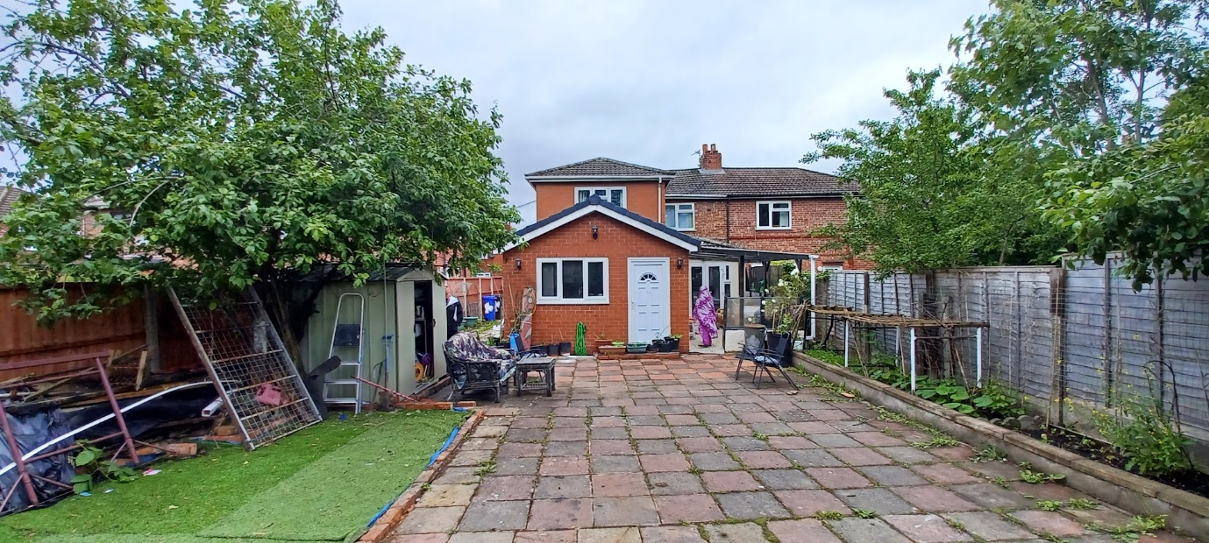
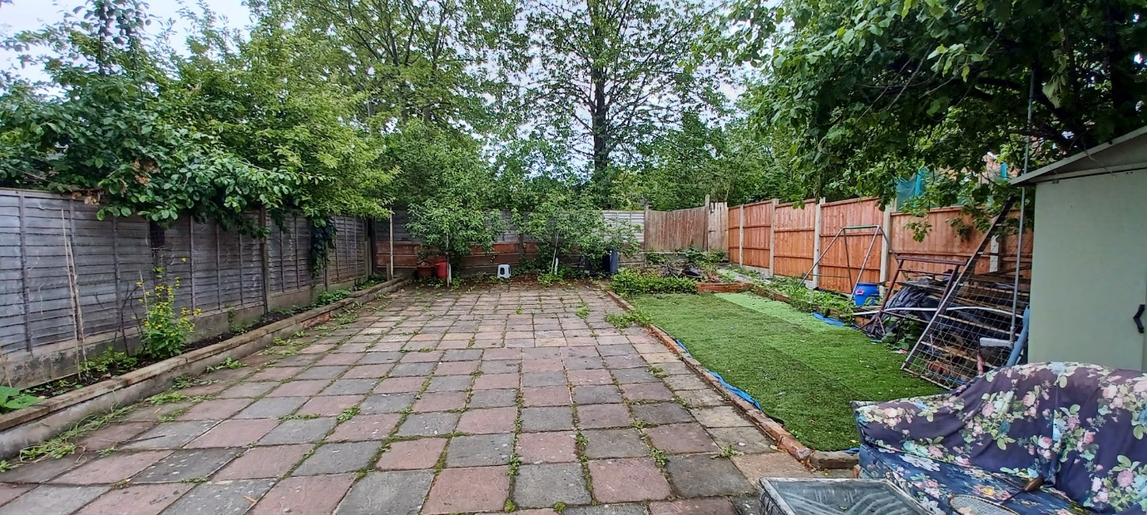

Description of development
The applicant is seeking planning permission for the erection of a single-storey granny annex in the rear garden.

Relevant planning history
Planning Application - 092226/FH/2010/S1 - Erection of part single, part two storey rear extension together with single storey front extension and elevational alterations to form additional living accommodation – Refused (2010).

Planning Application - 093226/FH/2010/S1 - Erection of single storey front extension and part single storey, part two storey rear extension to form additional living accommodation – Approved (2010).

Planning Application - 127185/FH/2020 - Erection of a single-storey rear extension to form additional living accommodation – Approved (2020).

Consultation, notification and publicity responses

Consultations

Environment Agency made the following comments in response to the application:

• We have no objection in principle to the proposed development, but we take this opportunity to make the following comments.
• The proposed development falls within Flood Zone 2, which is land identified as being at risk of flooding from rivers and sea, now or in the future. We have produced a series of standard comments for local planning authorities and planning applicants to refer to on ‘lower risk’ development proposals. These comments replace direct case-by-case consultation with us. This proposal falls within this category.
• These standard comments are known as Flood Risk Standing Advice (FRSA). They can be viewed at https://www.gov.uk/guidance/flood-risk-assessment-for-planning-applications#when-to-follow-standing-advice.
• The Building Regulations 2010 and Government Guidance contained within the PPG for Water Supply, Wastewater and Water Quality (paragraph 020 ID: 34-020-20140306) sets out a hierarchy of drainage options that must be considered and discounted in the following order:
o Connection to the public sewer
o Connection to a private sewer that drains to a public sewer
o Package sewage treatment plant or septic tank
o Cesspool
• Foul drainage should be connected to the main sewer whenever it is feasible to do so. Where this is not possible, under the Environmental Permitting (England and Wales) Regulations 2016 any discharge of sewage or trade effluent made to either surface water or groundwater will need to either comply with General Binding Rules for Small Sewage Discharges or comply with a permit issued by the Environment Agency, additional to any planning permission that may be required. This applies to any discharge to ground, inland freshwaters, coastal waters or relevant territorial waters.

MCC Flood Risk Management Team - indicated that the site lies within the Environment Agency’s consultation zone for main rivers. As such, it is the responsibility of the Environment Agency to provide comments on the proposed development.

Notifications and publicity

One letter of objection was received from a local resident in response to the application; the comments are summarised as follows:

• The proposal would contribute to an intensification of residential use on the site, resulting in increased activity and associated disturbance.
• Approval of this development could encourage similar proposals throughout the area, leading to a cumulative pattern of overbuilding and erosion of garden space.
• The proposal would have a detrimental impact on the residential amenity of neighbouring properties. The annex would introduce additional residential activity immediately adjacent to neighbouring properties, resulting in increased noise, disturbance, visitor activity and general comings and goings. This would negatively affect the peaceful enjoyment of neighbouring properties and gardens.
• The proposed annex would have an unacceptable impact on daylight and sunlight available to neighbouring properties. Due to its size, height and proximity to the boundary, the development would result in increased overshadowing and a reduction in natural light to neighbouring dwellinghouses and gardens. This would adversely affect both the enjoyment and usability of neighbouring outdoor spaces and living accommodation.
• Neighbouring residents have lived in the area for a long time and value the peace, privacy, and enjoyment it provides.
• Neighbouring residents have indicated that they live alone and have experienced recent personal and health-related challenges.
• Neighbouring residents have indicated that, after a very difficult period of their life, they have recently resumed spending time in their garden, which is an important part of their day-to-day wellbeing.
• The proposed annex at the rear of the neighbouring property feels like a significant invasion of privacy and would have a serious impact on the ability of neighbouring residents to enjoy their gardens and outdoor space.
• Concerns regarding increased activity, presence of additional occupants, and overlooking associated with the development which would make neighbouring residents feel uncomfortable in what is currently a private and peaceful environment.
• Concerned about the cumulative impact of the continued development of this property. The property already has an extension and there appears to have been ongoing building work within the property for a considerable length of time.
• The addition of a separate annex would represent a further intensification of the use of the site and would amount to overdevelopment.
• Parking is another significant concern. It is already difficult to park on the street because of the number of vehicles associated with this property. Parking in the area is already limited, and the proposed annex is likely to increase the number of occupants, visitors, and vehicles, placing even greater pressure on available parking spaces.

Negotiations
Concerns were raised in relation to the intended use of the outbuilding as well as its impact upon residential amenity, in terms of introducing an overbearing feature.

In response to this, the applicant’s agent confirmed that the outbuilding is purely for household use with the space needed to accommodate family members. Additionally, to reduce its impact, the height of the outbuilding was reduced to 3m in height.

Relevant policies
Unitary Development Plan (UDP) – The UDP has been superseded by the Core Strategy Development Plan, but certain policies are still considered of relevance:
- Policy DC1 – Residential Extensions

The Manchester Core Strategy – Development Plan Document 2012-2027 (“the Core Strategy”) was adopted by the City Council on the 11th of July 2012:
- Policy DM1 – Development Management
- Policy SP1 – Spatial Principles
- Policy EN14 – Flood Risk

Places for Everyone - is a long-term plan of nine Greater Manchester districts for jobs, new homes, and sustainable growth. It has been published by the GMCA on behalf of the nine districts and took effect and became part of the statutory development plan on March 21, 2024.
- Policy JP-P1 – Sustainable Places

The National Planning Policy Framework (NPPF, 2024)
- Chapter 12 – Achieving Well-Designed Places

Draft National Planning Policy Framework (NPPF, 2025)
The Government has published a consultation draft of the NPPF, intended to improve housebuilding rates through a clearer, more predictable and faster policy basis for decision and plan making. While this draft is not yet adopted, it is a material consideration.
- Chapter 12 – Making Effective Use of Land
- Policy L4: Residential extensions
- Chapter 14 – Achieving Well-Designed Places
- Policy DP3: Key principles for well-designed places

Assessment

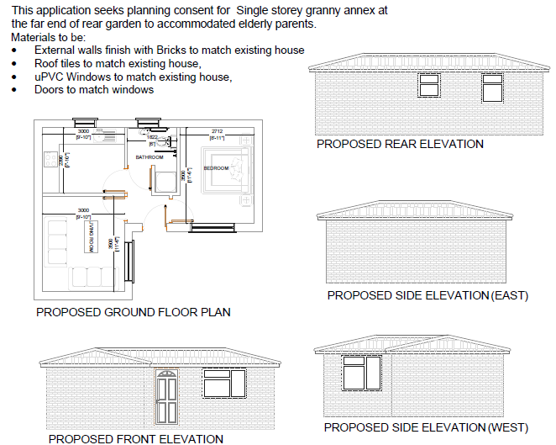
Submitted amended proposed plans and elevations

Principle – the principle of erecting a single storey outbuilding within the rear garden of a
residential dwellinghouse (to be used for ancillary purposes to the main dwelling) is acceptable given that many individuals prefer to extend and alter their homes to meet changing household needs rather than move. However, consideration must be given to the proposal’s siting, scale and massing, appearance and impact upon visual amenity, residential amenity, waste storage, parking, flood risk implications as well as its intended use.

Siting, scale, and massing - the single storey outbuilding would be situated within the rear garden of the residential dwellinghouse known as No.10 Thoresway Road. It would be L-shaped in plan, measuring to 6.599m in length along its eastern edge, 4.097m in length along its western edge, 3.598m in width to the front, and 8.352m in width to the rear, with a hipped roof height of 3m and an eaves height of 2.298m. A gap of approximately 1m would be maintained to the plot’s eastern, southern, and western shared boundaries, with a gap of approximately 7.2m maintained to the main dwellinghouse.

It is acknowledged that concerns were raised in regard to the size, height, and proximity of the outbuilding to the plot’s shared boundaries as well as the overdevelopment of the application site. However, in this instance, the overall siting, scale, and massing of the proposal is considered to be acceptable as the footprint of the outbuilding would not exceed that which could be erected under permitted development rights, as it would avoid more than half the area of land around the original dwellinghouse being covered by additions and other buildings and would not reduce the property’s private amenity space to an unacceptable degree.

Further to this, as the outbuilding would feature a hipped roof with a maximum height of
3m, would be sited at the rear end of the application property’s garden space (away from neighbouring dwellinghouses) with adequate gaps retained to the plot’s shared boundaries (at least 1m), it is considered that it would not cause undue harm to the residential amenity of neighbouring occupiers in terms of introducing an overbearing feature into the area.

The proposal therefore accords with saved policy DC1 of the Unitary Development Plan for the City of Manchester and policies DM1 and SP1 of the Manchester Core Strategy.

Appearance and visual amenity – the submitted application form and plans indicate that the outbuilding would feature brickwork, roof tiles, and uPVC windows
and doors to match the main dwellinghouse. Its northern elevation (facing the main dwellinghouse) would feature an inward-opening door and 1no. window, whilst its rear elevation would feature 2no. windows (conditioned to be obscurely glazed due to their proximity to the plot’s shared boundary). Its eastern and western side elevations would be blank, as would its roof slopes.

The proposal is relatively standard in terms of its design and scale for developments of this type and would be in-keeping with the existing precedent of residential extensions and outbuildings in this locale, with large outbuildings evident at No.25 Birchfields Road, No.17 and No.35 Thoresway Road, No.7 , No.17, and No.29 Kelstern Square, amongst others. Sited at the rear of the property, the proposal would not be highly visible from the public highway or associated footpath. Moreover, its use of matching/similar materials to the main dwellinghouse should ensure that it does not form an overly prominent visual feature within the locale.

The design and appearance of the outbuilding therefore accords with saved policy DC1 of the Unitary Development Plan for the City of Manchester, policies DM1 and SP1 of the Manchester Core Strategy and chapter 12 of the National Planning Policy Framework

Residential amenity – it is acknowledged that concerns have been raised regarding the potential for the proposed outbuilding to adversely impact the residential amenity of the surrounding area, including through overshadowing, noise, activity and disturbance, loss of light, loss of outlook, and the introduction of an overbearing feature. However, it should be noted that the outbuilding would be single storey in scale, with a modest maximum height of approximately 3m, and would be positioned at the rear end of the garden away from surrounding dwellinghouses, with adequate gaps maintained to the plot’s shared boundaries. As such, in this context, it is considered that the proposal would not result in unacceptable overshadowing, loss of light, or loss of outlook, nor would it appear unduly dominant or overbearing when viewed from neighbouring properties.

Concerns have also been raised in relation to overlooking and loss of privacy. In response, the proposed windows within the rear elevation and it proposed that these be conditioned to be obscurely glazed, thereby preventing direct views into neighbouring plots and safeguarding the existing levels of privacy enjoyed by neighbouring occupiers. Further to this, no openings are proposed within the east and west elevations of the outbuilding, which sit 1m away from the plot’s shared boundaries. Additionally, the windows within the northern elevation would be set at a sufficient distance (approximately 7.2m) away from the main dwellinghouse and approximately 16m away from neighbouring properties and are oriented such that they would not give rise to significant or unduly harmful overlooking/loss of privacy.

With regard to the potential impact upon the quiet enjoyment of neighbouring properties and their associated garden areas, it is noted that the use of the outbuilding would remain ancillary to the main dwellinghouse, as confirmed by the applicant’s agent and secured by condition. As such, it would not be expected to result in levels of activity, noise, or disturbance beyond those typically associated with a residential setting. Having regard to its siting, scale, and separation from boundaries, as such it is considered that the proposal would not significantly harm the use or enjoyment of neighbouring gardens/properties to warrant refusal of the proposals.

The proposal therefore accords with saved policy DC1 of the Unitary Development Plan for the City of Manchester and policies DM1 and SP1 of the Manchester Core Strategy.

Waste storage – the current waste storage arrangements would be unaffected by the proposal.

Parking and highways implications - concerns have been raised regarding the potential for the proposal to exacerbate existing parking pressures and traffic conditions in the area. However, it is noted that the proposal would not result in any loss of existing off-street parking provision, as the property’s driveway would be retained and remain available for use.

Further to this, the outbuilding would remain ancillary to the main dwellinghouse and would not result in the creation of a separate residential unit. As such, the proposed outbuilding is not expected to generate significant additional vehicular trips or significantly increase parking demand beyond that of the existing residential use of the main dwellinghouse. Given the scale and nature of the proposal, it is therefore considered that it would not give rise to a significant intensification of use or have a detrimental impact upon highway safety or the operation of the surrounding highway network.

Use – the applicant’s agent has confirmed that the outbuilding would provide additional living accommodation for family members of the dwellinghouse’s main household. This is considered acceptable, so long as the outbuilding is used for purposes ancillary to the main dwellinghouse in perpetuity. For the avoidance of doubt, the outbuilding is not to be used as an additional dwelling at the location or for short-term lettings and is explicitly for the private enjoyment of the occupants of the main dwellinghouse. This has been conditioned accordingly.

Flood risk implications – the site lies within Flood Zone 2 (medium flood risk). The Environment Agency has raised no objection in principle and advises that the proposal falls under its Flood Risk Standing Advice for lower-risk development. Given the small scale and ancillary nature of the outbuilding, it is not considered to increase flood risk on site or elsewhere. Foul drainage should follow the established hierarchy, with connection to the public sewer where feasible, and comply with relevant regulations. Overall, the proposal is acceptable in flood risk and drainage terms.

Conclusion
Given the above issues, it is considered that the proposal is acceptable in terms of its principle, siting, scale and massing, appearance, impact upon visual and residential amenity, waste storage and parking as it broadly complies with saved policy DC1 of the Unitary Development Plan for the City of Manchester, policies DM1 and SP1 of the Manchester Core Strategy and chapter 12 of the National Planning Policy Framework.

Other Legislative Requirements

Equality Act 2010
Section 149 (Public Sector Equality Duty) of the Equality Act 2010 requires due regard to the need to: Eliminate unlawful discrimination, harassment and victimisation and other conduct prohibited by the Act and; Advance equality of opportunity between persons who share a protected characteristic and persons who do not share it. The Equality Duty does not impose a legal requirement to conduct an Equality Impact Assessment. Compliance with the Equality Duty involves consciously thinking about the aims of the Equality Duty as part of the process of decision-making.

Human Rights Act 1998 considerations
This application needs to be considered against the provisions of the Human Rights Act 1998. Under Article 6, the applicants (and those third parties, including local residents, who have made representations) have a right to a fair hearing and to this end the local planning authority must give full consideration to their comments.

Protocol 1 Article 1, and Article 8 where appropriate, confer(s) a right of respect for a person’s home, other land and business assets. In taking account of all material considerations, including Council policy as set out in the Core Strategy and saved polices of the Unitary Development Plan, the Director of Planning, Building Control & Licensing has concluded that some rights conferred by these articles on the applicant(s)/objector(s)/resident(s) and other occupiers and owners of nearby land that might be affected may be interfered with but that that interference is in accordance with the law and justified by being in the public interest and on the basis of the planning merits of the development proposal. She believes that any restriction on these rights posed by the recommendation given is proportionate to the wider benefits of and that such a decision falls within the margin of discretion afforded to the Council under the Town and Country Planning Acts.

Recommendation: Approve

Article 35 Statement
Officers have worked with the applicant in a positive and proactive manner based on seeking solutions to problems arising in relation to dealing with the planning application. Minor issues have arisen during the consideration of this application and the officer negotiated with the agent to reach a satisfactory resolution.

Condition(s) to be attached to decision for approval OR Reasons for recommendation to refuse

1) 3-year time limit:
The development must be begun not later than the expiration of three years beginning with the date of permission.

Reason - Required to be imposed pursuant to Section 91 of the Town and Country Act Planning Act 1990.

2) Specified plans:
The development hereby approved shall be carried out in accordance with the following drawings and documents:

‘Proposed Floor plans and Elevations’, received by the City Council as Local Planning Authority on the 4th June 2026.

Reason - To ensure that the development is carried out in accordance with the approved plans, pursuant to saved policy DC1 of the Unitary Development Plan for the City of Manchester and policies SP1 and DM1 of the Manchester Core Strategy.

3) Materials:
The materials used in the external surfaces of the development hereby approved shall be those as specified on the following approved plan/drawing:

‘Proposed Floor plans and Elevations’, received by the City Council as Local Planning Authority on the 4th June 2026.

Reason - In order to ensure a satisfactory appearance in the interests of visual amenity in accordance with policies SP1 and DM1 of the Core Strategy and the requirements of the National Planning Policy Framework.

4) Obscure glazing:
The windows in the southern elevation of the development hereby approved shall be obscure glazed to a specification of no less than level 5 of the Pilkington Glass Scale or such other alternative equivalent and shall be retained as such thereafter whilst the building is in use.

Reason - In order to protect the amenity of neighbouring residents and in accordance with policies SP1 and DM1 of the Core Strategy.

5) PD restriction - additional openings:
Notwithstanding the provisions of Schedule 2, Part 1 of the Town and Country Planning (General Permitted Development) Order 2015 (as amended) (or any order revoking and re-enacting that Order with or without modification), no additional windows, doors or other openings shall be inserted into the elevations of the development hereby approved, without planning permission being granted by the Local Planning Authority.

Reason - In the interests of residential amenity, pursuant to policies DM1 and SP1 of the Manchester Core Strategy.

6) Ancillary use:
The outbuilding hereby permitted shall not be occupied at any time other than for purposes ancillary to the residential use of the dwelling known as No.10 Thoresway Road, Manchester, M13 0XN. The proposed outbuilding is not to be used as an additional dwelling at the location or for short-term lettings and is explicitly for the private enjoyment of the occupants of the main dwellinghouse.

Reason - To ensure the proposed use remains ancillary to the principle use on the site. In the interest of residential amenity, in accordance with policies DM1 and SP1 of the Manchester Core Strategy.

Informatives

1) The proposed development falls within Flood Zone 2, which is land identified as being at risk of flooding from rivers and sea, now or in the future. We have produced a series of standard comments for local planning authorities and planning applicants to refer to on ‘lower risk’ development proposals. These comments replace direct case-by-case consultation with us. This proposal falls within this category. These standard comments are known as Flood Risk Standing Advice (FRSA). They can be viewed at https://www.gov.uk/guidance/flood-risk-assessment-for-planning-applications#when-to-follow-standing-advice.

2) The Building Regulations 2010 and Government Guidance contained within the PPG for Water Supply, Wastewater and Water Quality (paragraph 020 ID: 34-020-20140306) sets out a hierarchy of drainage options that must be considered and discounted in the following order:

1.Connection to the public sewer
2.Connection to a private sewer that drains to a public sewer
3.Package sewage treatment plant or septic tank
4.Cesspool

Foul drainage should be connected to the main sewer whenever it is feasible to do so. Where this is not possible, under the Environmental Permitting (England and Wales) Regulations 2016 any discharge of sewage or trade effluent made to either surface water or groundwater will need to either comply with General Binding Rules for Small Sewage Discharges or comply with a permit issued by the Environment Agency, additional to any planning permission that may be required. This applies to any discharge to ground, inland freshwaters, coastal waters or relevant territorial waters. Further information about the permitting process can be found at Septic tanks and sewage treatment plants: what you need to do.

