KEEPMOAT CONSTRUCTION MANAGEMENT PLAN
Land off Crabtree Lane, Manchester

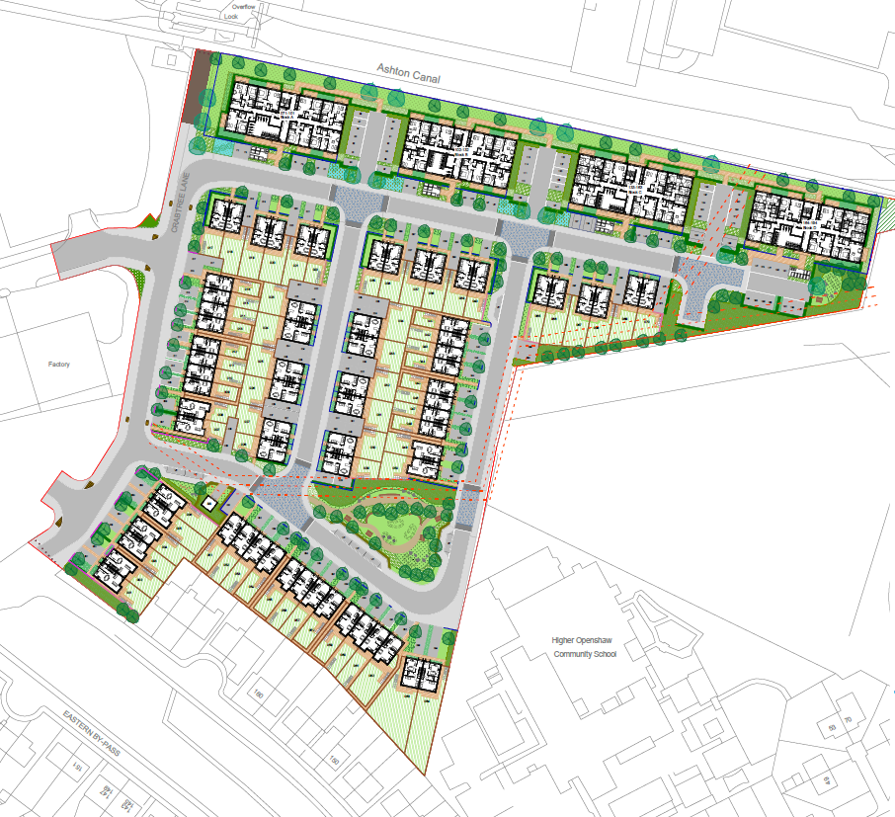

CONTENTS

1.1 Site Information 2
1.2 Background 2
1.3 Objectives of the CMP 2
1.4 Health and Safety 2
1.5 Client Contact & Appointments 3
1.6 Responsibilities & Reporting 4
2 Construction Environmental Management Plan 5
2.1 Construction Management Protection Measures 5
2.2 Construction Routes and Traffic Management 6
2.3 Parking of vehicles deliveries, site personnel, operatives and visitors 9
2.4 Construction Working Hours 10
2.5 Precautions Against Mud & Substances on the Public Highway Including Wheel Wash 11
2.6 Dust Suppression Measures 11
2.7 Noise Emission Suppression Measures 12
2.8 Water Environment Mitigation 13
2.9 Dilapidation Survey 16
2.10 Site Water Run Off 17
3 Conclusions 17
3.1 Objective 17
4 Keepmoat Environmental Policy 18
5 Associated Keepmoat Environmental Standards 20

Introduction

Site Information
This Construction Management plan (CMP) has been produced to support the delivery of 194 dwellings (Class C3) with new vehicular accesses from Crabtree Lane and associated parking, landscaping and open space as approved by Manchester City Council (application reference 142609/FO/2025).
The Site is bound by the Ashton Canal to the north, scrubland to the east, Openshaw Community School to the southeast, residential properties to the south, and Crabtree Lane to the east, beyond which is an industrial estate.
The Site is currently accessed off Crabtree Lane, to the east of the Site and also via an access road to the north, immediately alongside the Canal.
Adjacent/Surrounding Land Uses
North – Ashton canal, commercial / industrial units with residential beyond.
East – Open waste land and possible materials processing / recycling site.
South – Residential development
West – Commercial / Industrial properties
There is an existing culverted watercourse on the development which is to be retained and maintained.

Background
This Construction Management Plan (CMP) has been prepared by Keepmoat Developments Ltd (Keepmoat) to address the requirements of Planning Condition No.3 which stipulates the following;
Notwithstanding the content of the Construction Management Plan and prior to the commencement of the development, a detailed construction management plan outlining working practices during development shall be submitted to and approved in writing by the local planning authority, which for the avoidance of doubt should include;
o The routing of construction traffic;
o Detail the vehicular activity associated with the construction including appropriate swept path assessment;
o Details of the location and arrangements for contractor parking;
o The identification of the vehicular access points into the site.
o Identify measures to control dust and mud, including on the surrounding public highway including details of how the wheels of contractor's vehicles are to be cleaned during the construction period;
o The details of an emergency telephone contact number for the site contractor to be displayed in a publicly accessible location;
o A highway dilapidation survey including photographs and commentary on the condition of carriageway/footways on construction vehicle routes surrounding the site.
o Identify measures to reduce noise emissions;

Development shall be carried out in accordance with the approved construction management plan.
The management of construction activities that can have significant environmental impacts is required as part of the proposed development. The CMP provides a framework for planning and implementing demolition and construction activities in a way which prevents, minimises or controls their potential environmental impacts.
The document also highlights responsibility and accountability for the management of the Plan. The purpose of this plan is to outline how Keepmoat and its employed contractors will control and mitigate environmental issues onsite and during the construction works to minimise as much as possible the impact of the development activities on local community and environment
Through this plan, Keepmoat ISO 14001:2015 certified Environmental Management System and the sites Construction Phase Plan, Keepmoat and its contractors will ensure that throughout the duration of the development best practice environmental controls will be adhered to alleviating any potential issues.

Objectives of the CMP
This CMP provides the details of the measures that will be implemented to minimise and mitigate the construction impacts on the environment at the development site and the surrounding area. The primary objective of this CMP is to ensure that the relevant provisions set out by Manchester City Council under conditions of the planning permission are met.
Keepmoat is committed to ensuring measures are in place to minimise and mitigate any potential impacts on the environment during the construction phase of development.
The CMP has been developed considering the overall environmental objectives of Keepmoat set out in existing company Environmental Policies and will comply with relevant legislation.

Health and Safety
Keepmoat is committed to promoting a positive safety culture. The enforcing authority for Health and Safety on construction sites is the Health and Safety Executive who will be notified of all construction works prior to their commencement on site.
The main contractor will maintain a register of accidents, incidents, near misses and complaints all in line with Data Protection Act 2018 (GDPR Regulations). Contractors failing to maintain the required safety standards will be excluded from the approved tender list for future works.

Client Contact & Appointments
Name and address | Contact name | Telephone number | E-mail
Client | Keepmoat Homes NW | Peter Barlow | peter.barlow@keepmoat.com
Principal Designer | Mark Dawson | 0151 966 8400 | Mark.Dawson@keepmoat.com
Designer | Manor Architecture Ltd for the Apartments  Banners Gate Ltd (Consultants) for the Houses  Betts – Civils | Manor – 01565 740520  Betts - 01244 288178  Banners Gate - 0121 687 1500 | office@manorarchitects.com  mail@bannersgate.com  admin@betts-associates.co.uk
Principal Contractor | Keepmoat Homes NW
Keepmoat Regional Managing Director | Peter Barlow | 0151 966 8400 | peter.barlow@keepmoat.com
Keepmoat Technical Director | Mark Dawson | 0151 966 8400 | Mark.Dawson@keepmoat.com
Keepmoat Engineering Manager | Chris Leighton | 0151 966 8400 | chris.leighton@keepmoat.com
Keepmoat Construction Director | Simon Ward | 0151 966 8400 | simon.ward@keepmoat.com
Keepmoat Contract Manager | Steve Green | 0151 966 8400 | steve.green@keepmoat.com
Keepmoat Site Manager | Adam Labno | 0151 966 8400 | adam.labno@keepmoat.com
Temporary Works Engineer | TBC
Keepmoat Regional Health & Safety Business Partner | Gareth Mayers | 0151 966 8400 | gareth.mayers@keepmoat.com
Keepmoat Sustainability Director | John Bowden | 0151 966 8400 | John.Bowden@Keepmoat.com
Keepmoat Environmental Advisor | Sian Helmkay | 0151 966 8400 | Sian.Helmkay@Keepmoat.com
Keepmoat Ecology Advisor | Charlotte Gray | 0151 966 8400 | Charlotte.Gray@keepmoat.com
Keepmoat Quality Business Partner | Jo Dunford | 0151 966 8400 | Jo.dunford@keepmoat.com

Responsibilities & Reporting
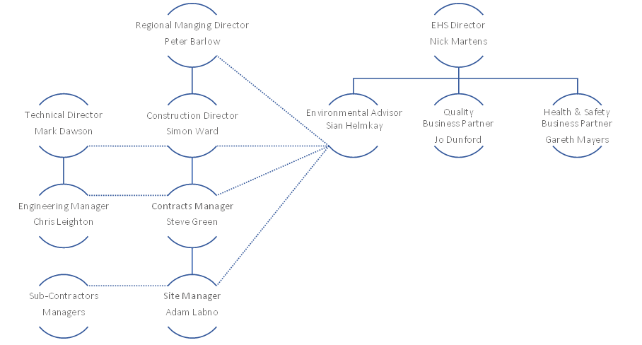

Communication  Method | Frequency | Attendees | Environmental Points for  Discussion | How it is Recorded
Contracts Managers  Meetings | Monthly | Contract Managers & Site Managers | Waste Management,  Nuisance, Environmental  Incidents etc. | System Templates
Contractor/Sub-Contractor  Meetings | Monthly | Head of Contractor, Contracts Manager, Site Manager, Quantity Surveyor | Waste Management,  Nuisance, Environmental  Incidents etc. | Action Log
Toolbox Talks | As required | All site personnel,  including  sub-contractors | Toolbox Talks will be used to inform all site personnel of key information concerning.  the management of the site, procedures to be followed and expected conduct when working on the project. The  toolbox talks will cover a broad range of topics  including those related to best practise | System Templates
Site Induction | As Required | Employees or Contractors new to site. | Health and Safety procedures and specific site rules. | System Templates
Site Manager Daily Diary | Daily | Site Manager/Assistant Site Manager | Monitors and registers daily upkeep of site and covers general duties. | System Templates

Construction Environmental Management Plan

Construction Management Protection Measures
This section of the report addresses the key elements relating to construction management protection measures, including the following:
Notwithstanding the Construction Management Plan, and prior to the commencement of the development , a detailed construction management plan outlining working practices during development shall be submitted to and approved in writing by the local planning authority, which for the avoidance of doubt should include;
- The routing of construction traffic;
Please refer to section 2.2 of this document
- Detail the vehicular activity associated with the construction including appropriate swept path assessment;
Please refer to section 2.2 of this document
- Details of the location and arrangements for contractor parking;
Please refer to section 2.3 of this document
- The identification of the vehicular access points into the site;
Please refer to section 2.2 of this document
- Identify measures to control dust and mud, including on the surrounding public highway including details of how the wheels of contractor's vehicles are to be cleaned during the construction period;
Please refer to section 2.5 & 2.6 of this document
- The details of an emergency telephone contact number for the site contractor to be displayed in a publicly accessible location;
Please refer to section 2.6 & 2.7 of this document
- A highway dilapidation survey including photographs and commentary on the condition of carriageway/footways on construction vehicle routes surrounding the site.
Please refer to section 2.9 of this document & also the Photographic Record of Condition Survey dated 3rd September 2025 issued with this CMP

- Identify measures to reduce noise emissions;
Please refer to section 2.7 of this document

Construction Routes and Traffic Management
The site will be accessed via the entrance roads off Crabtree Lane.
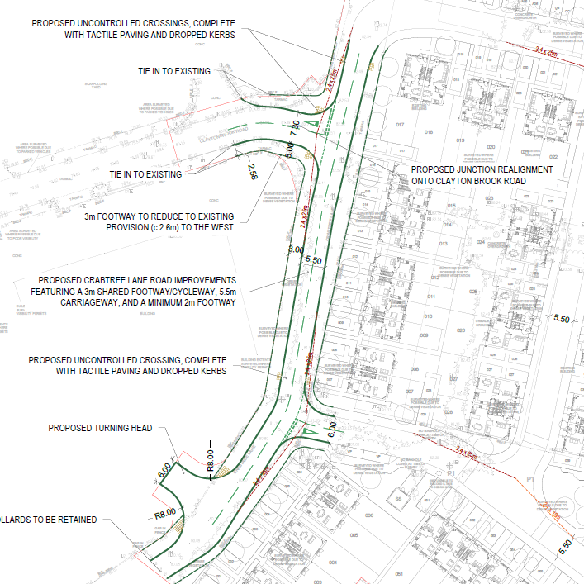
Good relations with people living and working in the vicinity of the site are of paramount importance to Keepmoat. Therefore, businesses and residences located within proximity to the site shall be notified of the works by the Keepmoat Construction Team, including a summary of the proposed phasing and details of the proposed operating hours two weeks in advance of starting works on site. In addition, a contact telephone number will be provided in the event of complaints from the public and a procedure adopted to respond to such complaints.
Keepmoat shall provide clear and prominent signage at the main access points to the site and at other appropriate locations around the site perimeter warning that construction works are in progress and that the site is hazardous. Signs shall identify the potential hazards associated with the proposed construction works. Signs shall include emergency telephone numbers and other relevant contact details.
- The contractor must agree the principles and routes for material haulage to and from the Site with the Local Highways Authority and Highways Agency as appropriate. Both newly formed site entrances will be used for material haulage and plant.
- A Traffic Management Plan will be put in place for all s278 works, identifying protection of pedestrian routes to be maintained during the course of the partial road closure.
- Prior to closures to allow S278 works to be implemented, letters will be issued to residents affected by the closure, notifying them of the start and end date of the closure and measures to be put in place to allow pedestrian access.
- Keepmoat will operate a traffic management system across the site, which is relayed to all personnel during induction. This will include:
- Deliveries will report to the site office, and all delivery drivers will sign in and out on completion of delivery.
- Banksmen will be present during reversing operations, where operator's view is obscured.
- Flashing beacons will be fitted to all on site vehicles and plant.
- Plant is to be fitted with traverse alarms to ensure safe manoeuvring.
- The general site speed limit across the site will be limited to 5mph, although alternative limits may be applicable in certain areas.
- The provision of temporary signalling will be considered where vehicle access to the site is likely to cause congestion or the potential for access.
- The movement of construction vehicles will be limited to non-peak hours where possible to limit any disruption to the local highway network.
- All construction traffic entering and leaving the site will be closely controlled and HGVs making deliveries to the site or removing construction material etc, shall avoid prohibited routes.
Sufficient signs for the size and complexity of the project will be erected both on and off site prior to the commencement of the project. All signage will comply with Chapter 8 of the Traffic Signs Manual and will be adequately checked and supervised by personnel with NRSWA Accreditation (Supervisory level). A record of daily inspections will be maintained and included within the Construction Phase Plan.
Construction traffic will be directed through the safest route with all contractors and deliveries being made aware of this routing before travel. The access to the development will be signposted and clearly visible. The Site Manager will ensure vehicular movements will be restricted during peak travel times for local residents leaving for work and students arriving and leaving local schools and colleges.
Construction traffic will follow the build sequence, which has been arranged as shown on drawing CRL-CMP-001 Rev B, with the sequence to build the development.
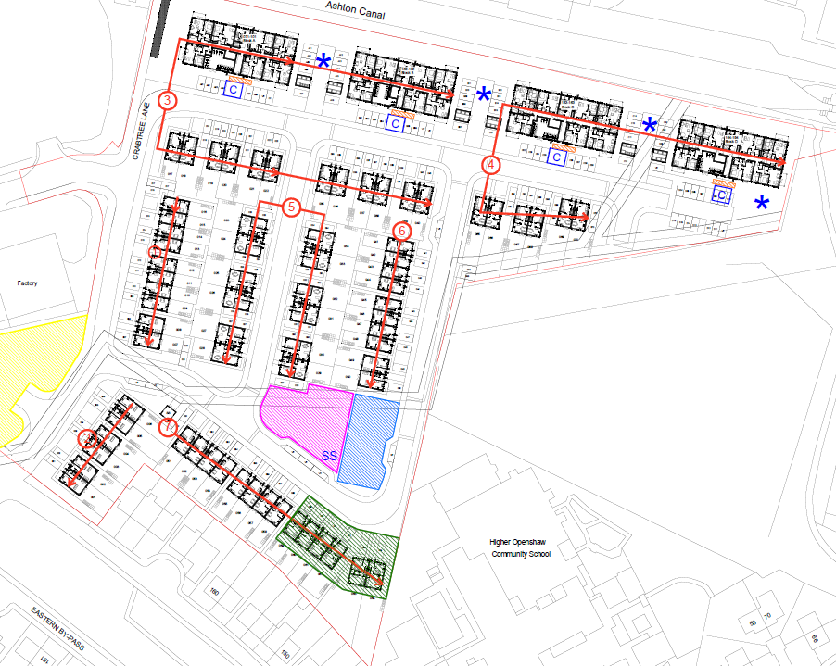

Where it is not possible to implement or adhere to a one-way traffic system trained banksmen will be always on site and will direct all vehicular movements. All companies supplying materials, vehicles and plant will be contacted prior to the commencement of works and instructed that no goods vehicle is to arrive on site without prior appointment, drivers will be required to attend the Keepmoat Homes site induction prior to entering the construction area. Should any driver disregard the traffic management plan, they will be required to re-attend the site induction, further transgression will result in the operator being removed from site.
Heavy plant, equipment, and aggregate deliveries, craneage etc will be required to be adequately planned and co-ordinated to reduce disruption on the highway / internal access roads and ensure suitable safe systems (Traffic / pedestrian management) of work are adopted to reduce risk to public utilising the footpath. Exception to the above stated delivery times and loading/unloading requirements will determine obtaining Local Authority approval where necessary and liaison with residents/neighbouring businesses.
Separate vehicular and pedestrian access will exist on site. The vehicular access will be set out to ensure adequate lines of sight in each direction. As the project progresses, the lines of sight may become more restricted in which case the use of visual aids (fixed mirrors) and a banksman will be utilised. The pedestrian access will be into the site compound/welfare area of the site.
Loading and unloading of plant and materials will be restricted to the access/egress arrangements indicated on the plan. Delivery drivers will be instructed as to the restrictions within the local highway network. Reversing onto local highways will not be allowed. A one way system will be employed on the site to ensure vehicles exit the site going forward with full visibility onto the local highways.
The number of HGV’s will be organised so that there will be sufficient distance to enable HGV’s to enter directly on to the haul road as they arrive and not impact on the immediate highways.
Our communication process will ensure we have on and off site hold points for over burden and to best facilitate “Just in time deliveries” this will involve a process where advanced comms are provided to site so that volumes around time of year, stage of project and climatic conditions can be assessed / managed.
Typical Swept Path Analysis for construction traffic Typical wagon size shown.
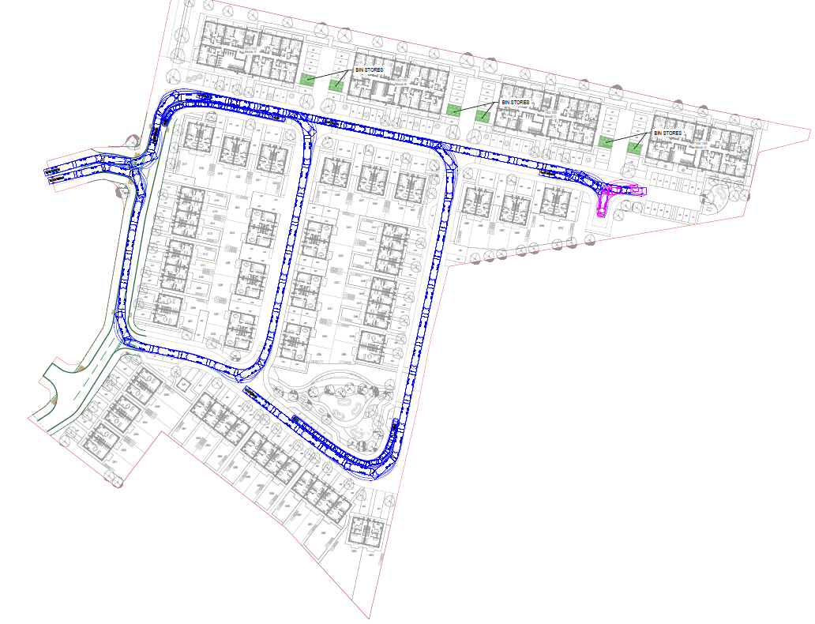

Parking of vehicles deliveries, site personnel, operatives and visitors
Parking will be in a designated area adjacent to the compound/welfare area and this will be sufficient to hold all necessary vehicles. If vehicles need to park off site, then it must be done only in a proper and suitable place without obstructing local dwellings and/or businesses.
Construction traffic, deliveries and site personnel will be directed through the safest route with all parties being made aware of this routing before travel. The access to the development will be signposted and clearly visible.
Loading and unloading of plant and materials will be restricted to the access/egress arrangements on to the site.
Storage on site will be in the designated compound and will include temporary containers. This will be secured by 2m high Heras fencing temporary works designed with lockable gates. The gates will remain closed when the compound is not in use and the gates locked at the end of each working day. Off- loading of materials will be carried out as close to the compound as practicable in order to reduce the need for double handling.
The Construction Management Plan ref. CRL-CMP-001 Rev B identifies the location (within the area hatched and outlined).
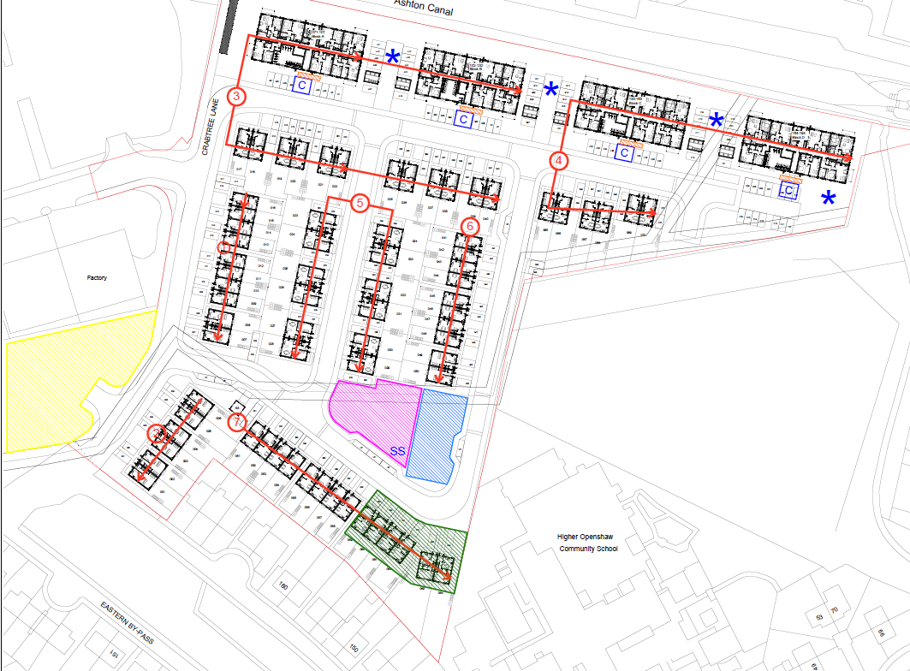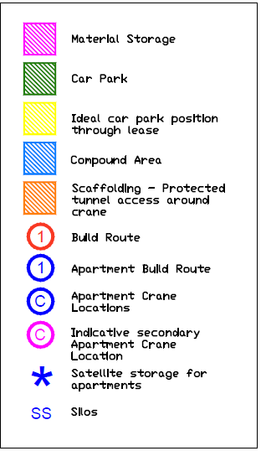

The storage of plant will be within the construction area which will be fenced off from the public.
Parking will be in a designated area adjacent to the compound area and this will be sufficient to hold all necessary vehicles.
In accordance with Regulations 27 and 28 of CDM 2015 this plan endeavours as far as is reasonably practical to ensure that pedestrians and vehicles are adequately separated by establishing:
- Pedestrian-only areas from which vehicles are completely excluded (Constraints during works & shutdown periods to also be considered),
- Safe pedestrian routes to work locations,

Construction Working Hours

No operations (including the repair of Plant machinery and the movement of such machinery) shall be carried out on the site outside the following hours:
- Monday – Friday 07:30 – 18:00 hours
- Saturday – 08:30 – 14.00 hours
- No working permitted on Sundays or Public Holidays. In order to avoid disruption to local traffic, contractors will aim to be on site by 07:30.
Exceptions to this may arise due to abnormal loads or to conduct specialist services. In the event that exceptions to the standard working hours are required, Manchester City Council approval will be sought, and residents will be notified via letter drop.
Loading and unloading of Plant and materials will be restricted to the access / egress arrangements indicated on the Compound Plan and also noted below.
- Deliveries will be arranged by the site manager so as to avoid peak traffic times in the area i.e. school start and end, rush hour etc. Peak times will be monitored to ensure deliveries do not hinder or obstruct local traffic.
Outside the above periods the following working is permitted:
- pre-planned construction works to highway infrastructure requiring possessions where first notified to the relevant planning authority and local residents;
- emergency works; and
- works which do not cause noise that is audible at the boundary of the Order limits
Any emergency works carried out must be notified to the relevant planning authority within 72 hours of their commencement.

Precautions Against Mud & Substances on the Public Highway Including Wheel Wash
A water-assisted dust sweeper will be used on the access and local roads as necessary to remove any material tracked out of the site.
Vehicles entering and leaving the sites will be covered to prevent escape of materials during transport.
All vehicles leaving site will have visual inspection prior to leaving the site, at the location/provisions to be established.
Any vehicle found to be holding excessive dirt will have its wheels cleaned and the dirt removed using a jet wash, once the vehicle is deemed suitably cleaned it will be allowed to leave the site. This process will be adhered to throughout the duration of the project, with additional attention to be paid during the winter period to help minimise the effects of adverse weather conditions.
Any vehicle transporting material in loads that could be spread or blown onto highway networks or adjacent properties will be sheeted over before leaving site.
All inspections of haul routes and any subsequent action will be recorded in a site log book.
All deliveries to site and construction traffic will aim to utilise hard standing areas.
Road Sweeps are to be booked as and when required.
Monitoring of weather conditions particularly during cold weather for gritting on construction sites involve site-specific risk assessments to cover the construction site and any works on the public highways.

Dust Suppression Measures
In order to control construction dust and prevent escape beyond the site boundary Keepmoat will develop a Dust Management Plan (DMP), aligned to the IAQM guidance on the assessment of dust from demolition and construction. This plan will be included in the Construction Phase Plan and be specific to the scale and type of activities on site and the surrounding sensitive receptors.
The following measures will be taken to control dust during construction:
- The name and contact details of person(s) accountable for air quality and dust issues will be displayed on the site boundary/construction main access. The head office contact information will also be displayed at the site boundary.
- Solid screens or barriers will be erected around particularly dusty activities. Site runoff of water or mud to be avoided.
- Cutting, grinding or sawing equipment will only be used if fitted or in conjunction with suitable dust suppression techniques such as water sprays or local extraction.
- An adequate supply of water will be provided to the site for the effective dust/particle suppression/mitigation, using non-potable water where possible and appropriate.
- In order to prevent sediment/silt entering the surface water system, gullies will be cleaned out and lined with straw bales/gully bags. All waste will be stored in designated areas which are isolated from surface drains.
- All vehicles to switch off engines when stationary – no idling vehicles.
- Ensure vehicles entering and leaving sites are covered to prevent escape of materials during transport
- Planning vehicle movements and deliveries around the site avoid sensitive receptors, either through route or timing (e.g., rush hour / schools)
- Road sweeping on the public highway where track-out is identified during inspections.
- Water suppression to be used during demolition operations.
- Cement bags to be sealed after use and stored appropriately to prevent dust. Sand and other aggregates to be stored in bunded areas and will not be allowed to dry out.
- If on-site concrete batching is used, bulk cement and other fine powder materials will be delivered in enclosed tankers and stored in silos with suitable emission control systems to prevent escape of material or overfilling during delivery.
- Regular visual inspections to be carried out to ensure dust mitigation measures are effective. The frequency of inspections will increase when activities with high potential to produce dust are carried out or during prolonged periods of dry or windy conditions.
- All dust and air quality complaints will be recorded, and appropriate measures will be taken to reduce emissions in a timely manner and regular site inspections will be carried out to monitor compliance with the CMP.

Noise Emission Suppression Measures
Operational hours generating noise and vibration will be restricted to:
Monday – Friday 07:30 – 18:00 hours
Saturday – 08:30 – 14.00 hours
No working permitted on Sundays or Public Holidays. In order to avoid disruption to local traffic, contractors will aim to be on site by 07:30.
The name and contact details of person(s) accountable for air quality and dust issues will be displayed on the site boundary/construction main access. The head office contact information will also be displayed at the site boundary.
In accordance with the requirements of the Control of Pollution Act 1974 (CoPA), noise and vibration will be controlled and limited so far as reasonably practicable so that sensitive receptors are protected from excessive noise and vibration arising from construction.
The site boundaries will be fenced off and secured, and any permanent boundary fencing will be established as soon as possible with suitable hoarding / Heras fencing. The height of this will be approximately 2mtr. Contractors to assess the need for noise barriers around generators continually operating in welfare area where noise transfer has environmental impact potential (neighbours).
Further to this, the following practises will also be adhered to throughout the duration of the development in line with the recommendations of BS 5228-1:2009+A1:2014.
- Operatives will be toolbox trained to employ appropriate techniques to keep site noise to a minimum and should be supervised to ensure that best working practice in respect of noise reduction is followed.
All employees should be advised regularly of the following, as part of their training:
- The proper use and maintenance of tools and equipment;
- The positioning of machinery on site to reduce the emission of noise to the neighbourhood and to site personnel;
- The avoidance of unnecessary noise when carrying out manual operations and when operating plant and equipment;
- The protection of persons against noise;
- The operation of sound measuring equipment (selected personnel).
- A programme of monitoring will be implemented to ensure that condition limits are not exceeded and that all the relevant recommendations are met.
- Managers and supervisors can help by recognising the need for employees to make proper use of equipment so that noise emission will be minimised, and to make proper use of ear protectors when required.
- Where driven piles are required, a ‘soft start’ approach which includes a number of initial ‘lighter, quieter blows’ to reduce the startle effect, encouraging birds to move away from the works site but not due to stress.
- All Plant will be maintained in good working condition.
- Throughout the duration of any driven piling works on site, vibration monitoring will be utilised to record and monitor the relevant levels.
- Avoid unnecessary revving of engines and switch off equipment when not required and all internal haul routes will be well maintained and avoid steep gradients.
- Machinery to be turned off when not in use to prevent idling.
- Handling all materials in a manner which minimises noise, such as minimising drop heights;
- Switching all audible warning systems to the minimum setting (or white noise function) required by the Health and Safety Executive
- Inductions and refresher Toolbox talks (TBT’s) to be provided to the site team regarding the need to minimize the need for reversing on site through use of best practice in use of heavy machinery and plant traversing the site
- Where processes could give rise to significant levels of noise for extended periods of time, noise levels should be monitored regularly by a suitably qualified person with the survey results kept on file
- In terms of on-site employees, appropriate actions should be undertaken with regard to the Noise at Work Regulations including the requirement for the use of ear defenders and appropriate warning notices.

Water Environment Mitigation
The appropriate management of site activities is required by Keepmoat and its contractors in order to prevent pollution of the site and the surrounding area. The controls employed follow the Source-Pathway-Receptor model and are aimed at preventing spills at source (e.g., a leaking fuel tank) therefore ultimately protecting the potential receptor (e.g., bare soils, surface water feature). In general terms, the following good practice measures will be adopted.
During the construction phase there will be a number of activities which could disturb and mobilise physical contaminants, including:
- Materials handling, storage, stockpiling, spillage and disposal;
- Earthworks involving manipulation of ground levels and re-engineering of existing made ground;
- Excavation and foundation construction within the site and site preparation;
- Installation of temporary and permanent infrastructure and roads;
- Installation of temporary site accommodation and sanitary facilities;
- Construction of proposed dwellings;
- Construction of drainage runs and utilities duct runs;
- Formation of public spaces, public realm and associated restoration and landscaping; and
- And movement and use of static and mobile plant/construction vehicles.
These activities may result in sediments directly or indirectly entering surface and ground water features, thereby affecting the physical, chemical and biological quality of surface and ground water receptors in the surrounding area.
Potential effects of the water environment through the construction phase will be managed by a range of operation, control and monitoring measures as set out below:
- All construction works to be carried out in accordance with the latest relevant guidance.
- Method statements would be agreed with the Environment Agency to ensure compliance with PPG prior to the commencement of construction works to ensure that surface runoff quality is managed during the construction process.
- Contractors undertaking earthworks will develop risk assessments and method statements covering all aspects of their work that have the potential to cause physical damage to structures (e.g. water supply and sewerage infrastructure), mobilise large quantities of soil/sediments or block open watercourses. Earth moving operations will be undertaken in accordance with BS 6031:2009 Code of Practice for Earthworks.
- Works affecting soils will follow MAFF’s Good Practice Guide for Handling Soils (2000) which provides comprehensive advice on soil handling including stripping, soil stockpiling and reinstatement.
- Work will comply with DEFRA guidance in the Construction Code of Practice for the Sustainable Use of Soils on Construction Sites (2009) which provides guidance on the use, management and movement of soil on site.
- Good practice guidance on erosion and pollution will be followed.
- The principal contractor will avoid the storage of plant, machinery fuel or materials (including soil stockpiles) alongside watercourses unless unavoidable.
- The refuelling of plant, storage of fuels and chemicals and overnight storage of mobile plant will be within the designated contractor’s compound areas. The compounds will contain appropriate facilities for the storage of fuels and chemicals.
- Surface water runoff during the construction phase will be carefully controlled with temporary infrastructure established to allow it to drain as existing.
- Connections to the public sewer from welfare facilities should be made where possible. Where this is not possible hygienic potable facilities will be used.
- The principal contractor will avoid the storage of plant, machinery or materials in areas at risk of flooding wherever possible.
Surface water runoff will be disposed of according to the following hierarchy: into the ground (infiltration); To a surface water body; To a surface water sewer, highway drain, or another drainage system; To a combined sewer.
Across the site, the following minimum standards will be employed
- Drip trays will be utilised to collect leaks from diesel pumps or from standing plant (such as generators)
- Oil/fuel interceptors will be fitted to all temporary discharge points from the compounds and from any temporary oil storage or refuelling areas; and
- Within the construction compound there will be the provision of spill containment equipment such as absorbent material
- Vehicles and plant will be subject to regular inspections to check for possible leaks and/or damage and maintained in a good working condition
- Concrete / mortar storage will only be permitted where this is in line with the relevant Keepmoat Standard detail (ref: 2012SD (095)) with sufficient bunding, hard standing and contained wash run-off facilities
- Storage of waste materials in dedicated and weatherproof containers
- Security fencing to surround the site with this to be locked and monitored to avoid potential trespass and arson
- Storage of hazardous materials / liquids within locked and weatherproof containers when not in use.
Spill Kits:
- Be the appropriate absorbent for the activity being carried out (all spill kits for diesel must be oil spill kits)
- Be located next to all diesel tanks on site, visible and easily accessible
- Be at least 90L and stored in a yellow wheelie bin
- Remain closed to prevent rainwater ingress
- Always remain stocked and not be used for litter
- Be referred to on the site’s EHS-FO-001-Spill-Spill Response Poster
- Once the equipment is used, including any unmade ground that has been spilled on, material to be disposed of as hazardous waste by a licensed waste contractor.
Fuel Tanks:
- Be 110% internally bunded
- Pressure tested and externally inspected every 2 years and internally inspected every 5 years (with records of such checks kept on site)
- Accompanied by a drip tray (used for all fuelling operations).
- Sited with an oil spill kit – either 90 or 120 litres (with yellow bin for external storage)
- Visually inspected weekly to identify any leaks, damage, or spills
- If on unmade ground or permeable hard standing the tank/bowser will be placed on the Diesel Tank Standard Detail (2008/SD/126)
- If located on impermeable hard standing the location must be at least 10m from any down slope drain
- No vehicle refuelling at any other locations on site.

Dilapidation Survey
It is recommended that a minimum 10 m “no development” buffer be implemented from the northern boundary of the site to protect the SBI. The buffer should be suitably signed and fenced during site clearance and construction to ensure no works or storage are undertaken in this area.
See also Photographic Record of Condition Survey dated 3rd September 2025 issued with this CMP

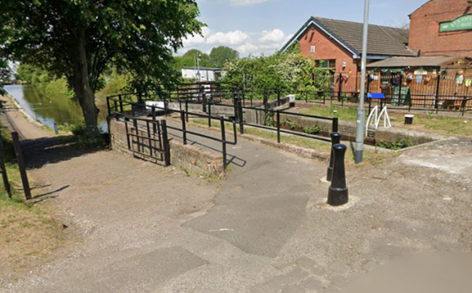

Existing Public Footpath over the canal, evidence of rework.
Canal Tow Path to the East

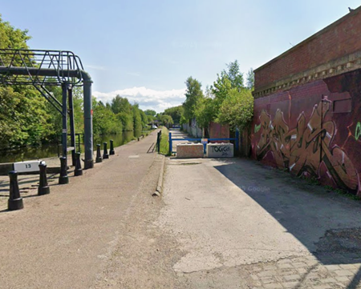
Forner Access road, concrete surface with some potholes, cobles showing.
Canal Tow Path

Site Water Run Off
See also the Site Surface water Management Plan (HSS-PL-001-Water) issued with this CMP.
During construction, any water from dewatering activities should be discharged via a settlement tank in combination with a filter bag, before entering the surface water drainage system. Where possible, discharge should be over a vegetated or soft landscaped area to minimise erosion and prevent mobilisation of silt. Dewatering measures should be frequently monitored and maintained to prevent silt-laden water entering the drainage network or leaving the site.
The use of silt fencing to ensure silty runoff does not impact adjacent site areas, in particular the residential developments to the south, school site to the southeast and vegetated area/allotments to the east.
Silt fencing will also be considered as part of the SWMP mitigation measures when construction starts in areas adjacent to residential properties being built. Stockpiles of excavated spoil that will remain on site for extended periods of time should also have silt fencing placed around the base and be set back from the drainage system to prevent silty run-off entering it.
Any silt collected within the surface water drainage network during construction of the site should be jetted and removed via tanker by the groundworker to prevent accidental discharge into the sewage system. Regular monitoring of this is required (suggested monthly) and cleaning as necessary.
Use of filter (dirt) bags to filter water pumped from excavations prior to discharge to surface or drainage should be used in conjunction with sediment tanks if dewatering of excavations is required.
All road gullies to be fitted with gully protection (gully bags, MuckStoppers or similar) to prevent blocking and limit reactive maintenance (sucking/jetting) – regular cleaning is required, to be determined at site level during periodic inspections (maximum 1 month between cleaning). Cleaning to become more frequent in wetter months of the year or during periods of significant earthworks. A written record of gully inspection and subsequent maintenance should be maintained by the site construction team.
If dewatering of excavations pumps water to surface, then silt mats should be installed downstream of where the water is being pumped to. This, along with having filter bags, should help prevent significant quantities of silty water entering the drainage system or leaving site. Silt mats to be suitably positioned and weighed down and replaced when spoiled.

Conclusions

Objective
The overall objective of this Construction Environmental Management Plan has been developed to ensure that throughout the construction process, the following fundamental goals are all met so far as practicable.
- Exemplary Environmental Practise
- Protection of the Interests of Local residents
- Efficient, Economic and Timely Construction Practises

Keepmoat Environmental Policy

Environmental Policy
Keepmoat recognise that its activities have a significant impact on the environment and are committed to minimising that impact by:-
Efficient protection of the Environment
Efficient use of resources
- Direct Impact is caused through the physical process of building muck shifting, noise, dust, excavation, noise and destruction of habitat.
- Indirect Impact is caused by the use of large amounts of raw materials either as fill material (aggregates) or for the use of the manufacture of building materials, such as bricks, cement or plasterboard.
‘Hierarchy of waste management’:-
- Re-use: There are many examples of using salvaged bricks, slates, timber etc
- Prevention: ordering components of the correct dimensions to avoid trimming or wastage.
- Re-cycle
- Incineration for the recovery of Energy
- Design Review: Aimed at encouraging designers and Site teams to consider material selection and working methods. Opportunity to influence material selection and working methods.
- Use of materials: 95% of the timber used from a sustainable forest
- Landfill
Keepmoat are committed to:-
- Strict compliance with all relevant legal and other requirements, codes of practise and regulations.
- Organisation of our operations in order to minimise pollution and disturbance to our neighbours and the general public.
- Efficient use of materials and resources with particular regard to the long-term sustainability of consumable items.
We aim to:-
- Ensure the effective management of resourcing thus reducing our impact on the natural environment.
- Influence design and consideration processes to ensure environmentally effective selection of materials and working methods.
- Foster employees’ environmental awareness and concern.
- Encourage the participation of our subcontractors, suppliers and clients in our environmental goals.
- Make our environmental policy freely available to the public
The following list indicates some of the key issues that will be considered: -
- Seek to prevent pollution
- Seek to minimise waste
- Identify and manage environmental risks and hazards
- Seek to influence the choice of construction materials and working methods efficient of resources.

‘The Directors and Staff of Keepmoat are fully committed to protecting the environment and we are continually looking for ways to improve the environment performance, objectives and targets of the company’s activities, which are set and reviewed within a period not exceeding 12 months.’
‘Our aim is to prevent pollution, reduce carbon emissions, cut down on waste and the use of sustainable materials from well managed sources’

Signed: Simon Ward
(Construction Director)

Associated Keepmoat Environmental Standards
(copies available upon request)
The following table lists all supporting policies, standards, plans and reports that provide the framework for the site activities being undertaken and management controls to be applied:
Keepmoat Policy, Standard, Plan or Report Reference | Applicable Section of CMP | Location (TBC)
General Keepmoat Policies:
HSS-PO-002-Policy – Environmental Policy | All | KM Intranet
SUS-PO-001-Policy – Sustainability Policy | All | KM Intranet
Keepmoat Standards:
HSS-ST-001-Archaeology – Archaeology & Heritage Standard | 2 | KM Intranet
HSS-ST-001-Energy – Carbon & Energy Management | 3 | KM Intranet
HSS-ST-002-Dust – Construction & Demolition Dust Controls | 4 | KM Intranet
HSS-ST-001-Nuisance – Nuisance Standard | 4 & 6 | KM Intranet
HSS-ST-001-Ecology – Ecology & Biodiversity | 5 | KM Intranet
HSS-ST-001-Spill – Pollution Incident Response Standard | 7 | KM Intranet
HSS-ST-001-Land – Contaminated Land | 8 | KM Intranet
HSS-ST-001-Soil – Soil Management | 8 | KM Intranet
HSS-ST-001-Waste – Waste Materials Management | 10 | KM Intranet
HSS-ST-002-Waste – Materials Management Plan | 8 | KM Intranet
HSS-ST-001-Water – Surface Water Management | 9 | KM Intranet
EHS-ST-001-MSS – Minimum Site Health, Safety & Environmental Standards | All | KM Intranet
2008SD(122) – Tree Protection Details | 5 | KM Intranet
2008SD(126) – B – Diesel Tank Details | 7 | KM Intranet
2012SD(083) – C – Mortar Silo Foundation | 7 | KM Intranet
2012SD(094) – Material Stockpile (Granular Soils) | 7 & 8 | KM Intranet
2012SD(095) – Material Stockpile (Wet or Plastic Soils) | 7 & 8 | KM Intranet
Trade Specifications – Sub-Contractor General Obligations | All | KM Intranet
Supporting Site Specific Plans
EHS-PL-001-CDM – Construction Phase Plan | All | Site File
EHS-PL-002 – Dust - Dust Management Plan | 4 & 6 | Site File
EHS-PL-001 – Water – Surface Water Management Plan | 9 | Site File
EHS-PL-001 – Waste – CLAIRE Materials Management Plan | 8 | Site File
EHS-PL-002 – Waste – Waste Management Plan | 10 | Site File
Ecological Survey & Constraints Management Plan | 5 | Site File
Arboricultural Survey & Management Plan | 5 | Site File
Ground Investigation Report | 8 | Site File

