Echo Street
Local Benefit / Social Value Plan
Planning Permission Ref No: 136874/FO/2023

At Bowmer and Kirkland (B+K), creating social value means making a positive impact on peoples’ lives and local communities. For the Echo Street development, we will strive to and Manchester City Council’s expectations and comply with the Public Services (Social Value) Act 2012 by:
- Creating a social value plan, setting project specific KPIs and monitoring progress.
- Understanding community needs and collaborating with the Council and local community groups to address these.
- Employing local and spending local.
- Quantifying social value and documenting impact through case studies.
- Having a dedicated social value resource.
Social value KPIs

Social Value Targets | Delivered Social Value
Spend £25m with local suppliers, within 20 miles of Manchester | £26,011,188.21 spent with local suppliers, including SMEs and social enterprises within 20 miles of Manchester
Employ 50% local labour, within 20 miles of Manchester, including:  - 20% from Manchester City Council district postcodes  - 6 people from a long-term unemployed background | The project has employed 60% local labour within 20 miles of Manchester, including:  - 17% from Manchester City Council district postcodes  - 3 people from a long-term unemployed background
Engage 30 apprentices (or 780 apprentice week equivalent) on the project, either as sustained apprentices or new start opportunities as a result of the project. | 51 apprentices engaged (or 799 apprentice week equivalent)
Offer 3 T-level work experience placements (or 27 weeks equivalent) on the project in addition to facilitating work experience placements equivalent to 21 weeks. | 3 T-level work experience placements facilitated (or 21 weeks equivalent) on the project.  1 additional industry work experience placement facilitated (equivalent to 48 weeks)
Participate in 38 activities with local schools, colleges and universities (or 76 hours equivalent) | Participated in 30 activities with local schools, colleges and universities (or 128 hours equivalent)
Participate in 8 career activities to support unemployed people e.g. via Manchester Adult Education and Skills Construction Centre | Participated in 8 career activities to support unemployed people
Organise 19 local community or fundraising activities (or 38 hours equivalent) | 5 local community or fundraising activities organised (or 106 hours equivalent)
Divert at least 95% of site waste from landfill | Diverted 99.99% of site waste from landfill

Measuring and reporting
B+K is a member of the Social Value Portal and used the TOMs (Themes Outcomes and Measures) methodology to calculate the social value contribution (in £) on this project to track progress against its economic, social and environmental measures. Using the above social value KPIs, the project was targeted to deliver £32,314,242 in social and local economic value, equating to 25% Social Value Add. The project has exceeded the target and delivered £41,970,538 in social and local economic value, equating to 32% Social Value Add (exceeding best practice). The project’s social value data will be submitted to the Social Value Portal for validation in July 2026.

The site was registered with the Considerate Constructors Scheme to ensure compliance with industry standards and work towards best practice, all monitored by independent industry experts. The project delivered the following scores exceeding industry best practice:

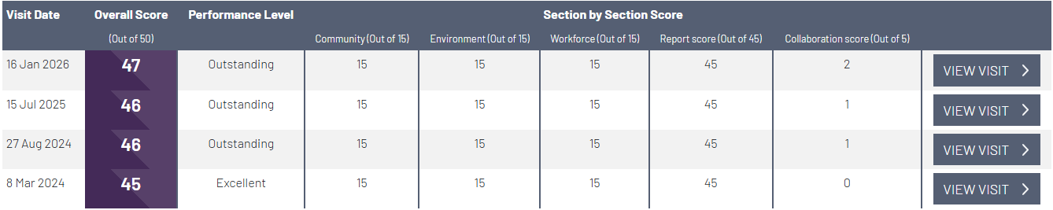

The project has also been the recipient of 2 Silver CCS National Site Awards.

Social value contact
Mona Baig, B+K Social Value Coordinator 0161 493 1880 or m.baig@bandk.co.uk, will be the local labour officer for the scheme and will be based on the project. She will be responsible for all contact with stakeholders affected by the development and will submit an end of project social value report to iQ Student Accommodation and Manchester City Council.


