RYEBANK FIELDS COMMUNITY GROUP
Planning Application ref: 143413/FO/2025
TRANSPORT NOTE
Introduction:
To understand the impact on traffic and highways for the change of use of Ryebank Fields, Chorlton, Manchester M21 9WW, to a Community Woodland and Meadow, it is important to note that events would make up less than 5% of the use of the site. The primary intention of this planning application is to conserve the land for the preservation of existing wildlife and ecology and maintain the site for community use for recreation, leisure and wellbeing. Please see document: ‘A Working Research Report on Ryebank Fields: Its uses and impacts’ by Dr. Jenna Ashton, University of Manchester, for a full overview of community/individual usage, submitted with our planning application. There is no intention to increase the number of events planned or numbers attending as this would undermine the primary intention to preserve the land as it is.
The primary focus is wildlife conservation and preservation of the ecological value of the site.
Overview:
The existing trip generation for events is minimal.
The majority of attendees are from the local community and walk or cycle to Ryebank Fields.
There is an average of 30 attendees per event.
In addition, there are two or three large events per year generating approximately 200 attendees.
Attendees often stay for part of the event rather than the whole duration, which means that arrival and departure times are staggered.
Elderly/disabled people are picked up and dropped off by local residents.
We promote the use of public transport and car pooling for groups travelling from further afield.
Post events we encourage attendees to utilise the cafes and toilet facilities in Longford Park to promote the use of the adjacent parking facilities.
Mini buses are advised to drop off and collect groups at the Longford Road entrance and use the car parking facilities at Longford Park.
Cyclists generally take their bikes with them into Ryebank Fields during events so as not to block access or pavements.
As requested, please see the following mode survey compiled for the recent Wassail event which took place on Saturday 10th of January 2026 from 15:30-17:30. The total number of attendees has been estimated as it was a non-ticketed event.

Number of Attendees | 200
Number of Responses | 71
Walking | 55
Cycling | 5
Bus | 2
Tram | 2
Car Individual Use | 1
Car Share | 5
Other | 1
Stayed for the whole event | 60
Stayed for part of the event | 11

Based on the outcomes of this survey, it is clear that the implications of any events taking place at the fields on the local highways network are likely to be minimal, with only 8.45% of attendees using a private motor vehicle.

EXISTING/PROPOSED VEHICLE PARKING
- There are two existing off-street entrances to Ryebank fields:
- Longford Road M21 9WW (Chorlton side) where there are approximately 20 on-street vehicle parking spaces
- Rye Bank Road cul-de-sac M16 0HB (Trafford side) we will not promote car parking on this cul-de-sac; this entrance is suitable for pedestrian and cycle access only.

- There are 3 car parks situated in Longford Park within a three-minute walk of Ryebank Fields, plus a drop off point and a disabled parking area. All car parks also have disabled bays and the main car park has EV charging points. The main car park is accessed from the Chorlton side, off Ryebank Road and the other two car parks are accessed from Trafford, one from Cromwell Road and the other from the Quadrant roundabout.

EXISTING/PROPOSED CYCLE PARKING
- There is an existing Sheffield cycle stand adjacent to the Longford Road M21 9WW entrance to Ryebank Fields.
There is currently no formal cycle parking provision at the Trafford side entrance M16 0HB. Should our planning application be succesful we will approach TMBC regarding the provision of a Sheffield cycle stand to be sited at this entrance, adjacent to the TRRA Community Garden.

- There are several existing cycle stands in Longford Park both in the car parks and other areas, including two large covered stands one in the main car park and one in the car park adjacent to the Quadrant roundabout.
Conclusion:
The above provisions offer adequate car and cycle parking for all planned events we therefore do not propose that any additional parking facilities are required however, for added convenience we would recommend provision of an additional cycle stand at the Trafford side entrance to Ryebank Fields as mentioned above. We envisage little or no increase to the number of events or attendees and are confident that the majority of people who attend will do so sustainably.
Going forward we will monitor travel modes for all future events in accordance with our Event Management Strategy document. All social media posts and advertising for future events in Ryebank Fields will include travel instructions or the link to our Travel Advice website page shown below.
https://ryebankfieldscommunity.co.uk/travel-advice

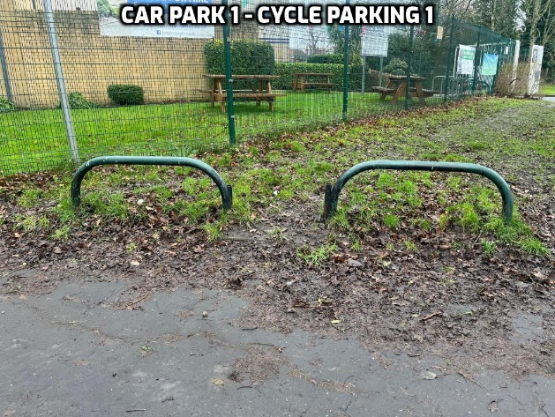
Appendix - Drop off point, car and cycle parking; maps and locations of bins
