0045 – The Park Pub, Wythenshawe

Condition 2: Materials Schedule

Element | Product | Image
Facing Brick (Main) & Soldiers | AG – Woodward Tullamore Antique  Mortar to be natural | 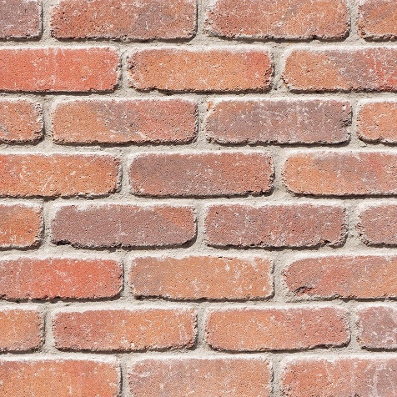
Facing Brick (Feature Brick) | AG – Woodward Clarendon Antique blue  Dark grey mortar (greys) | 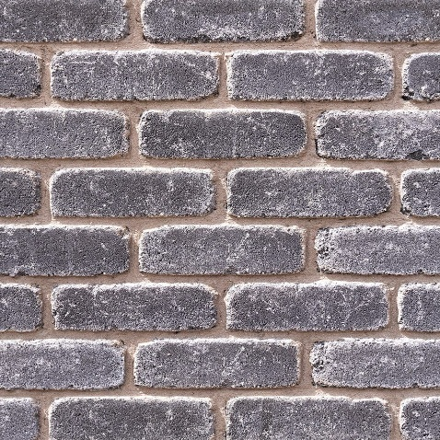
Projecting Brick | AG - Woodward Tullamore Smooth  Mortar to be natural | 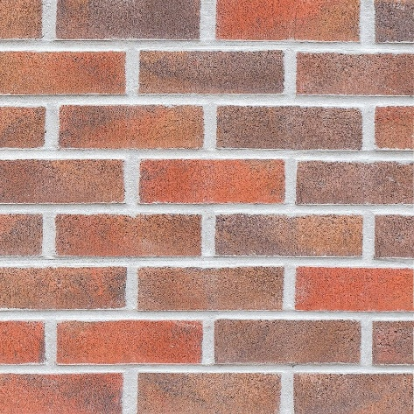
Front Doors Communal | Aluminium entrance door  To Secure by Design Standard  Colour: Black (RAL 9005) on both sides | 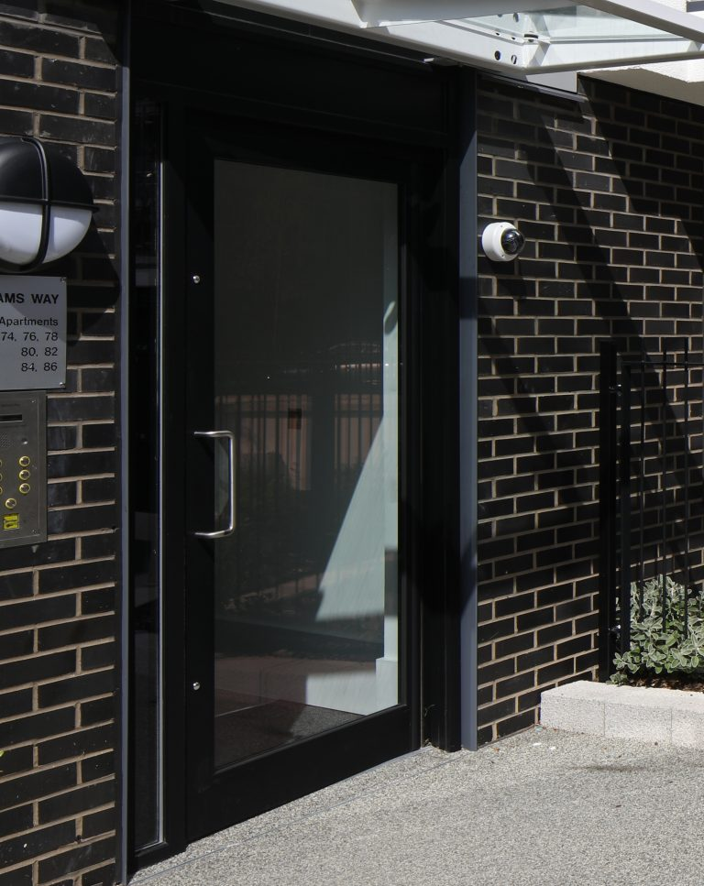
Front Doors Apartment (G/F) | GRP Entrance door  To Secure by Design Standard  Colour: Black (RAL 9005) on both sides | 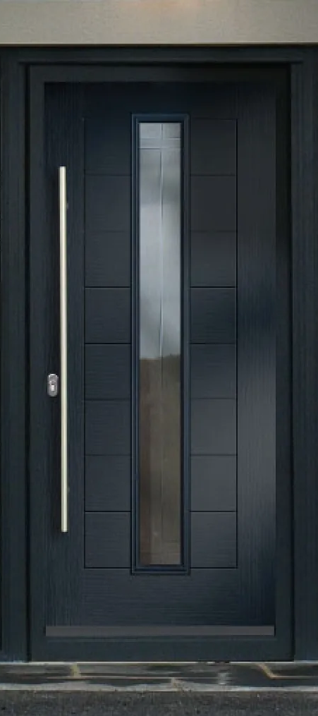
Plant / Bin Store external doors | Steel louvred door to bin store / plant entrance  To Secure by Design Standard  Colour: Black RAL 9005 | 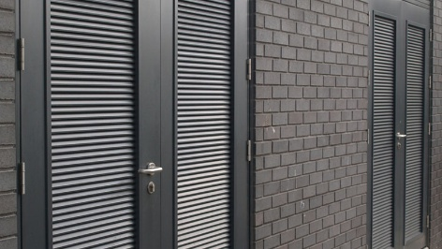
Windows | UPVC Windows with louvred panels above  Colour: Black RAL 9005 outside | 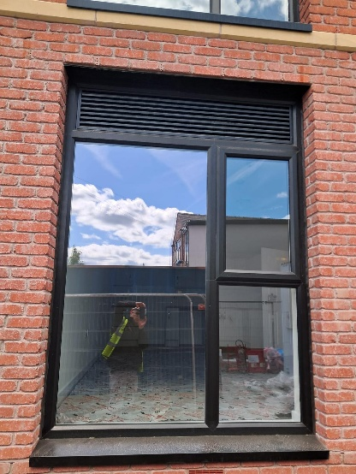
Roof Finish to Flat Roof | Single ply roofing membrane  Colour: Dark Grey e.g. Anthracite | 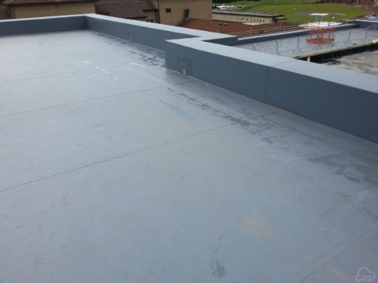
Juliet Balconies | Glass with steel handrail face fixed | 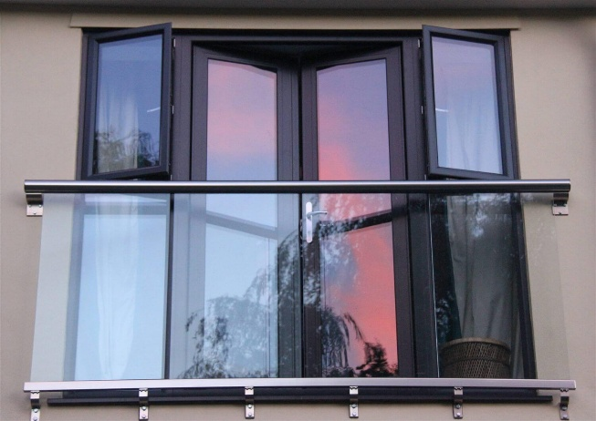
Fascia & Rainwater Goods (lower roofs) | UPVC fascia and rwp  Colour Black - RAL 9005 | 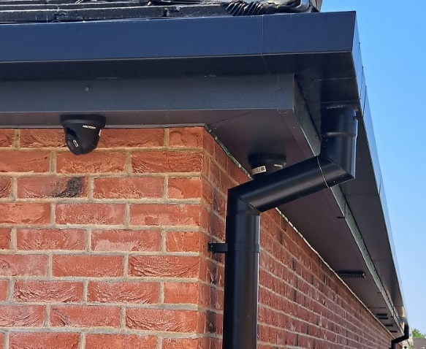
Canopies | GRP Canopies (to building entrances) Colour: Black RAL 9005 | 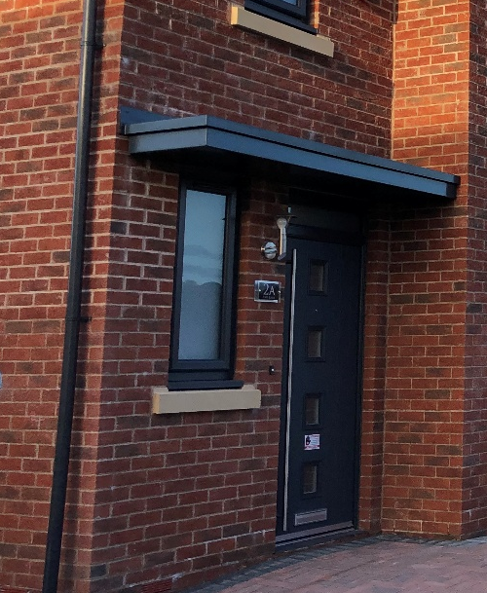
Parapet | Coping system to parapet  Colour: Black RAL 9005 | 