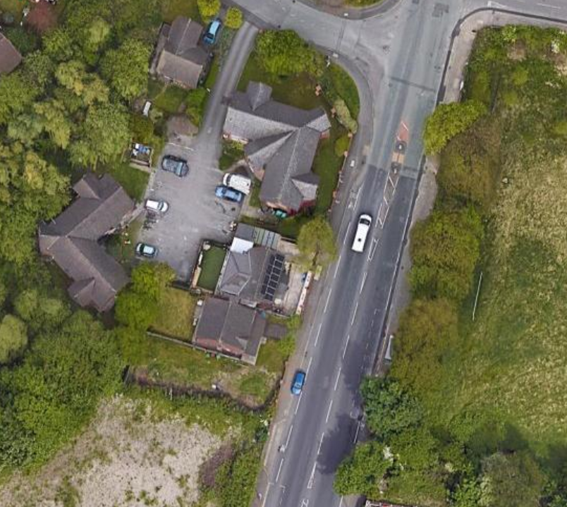
Plan View
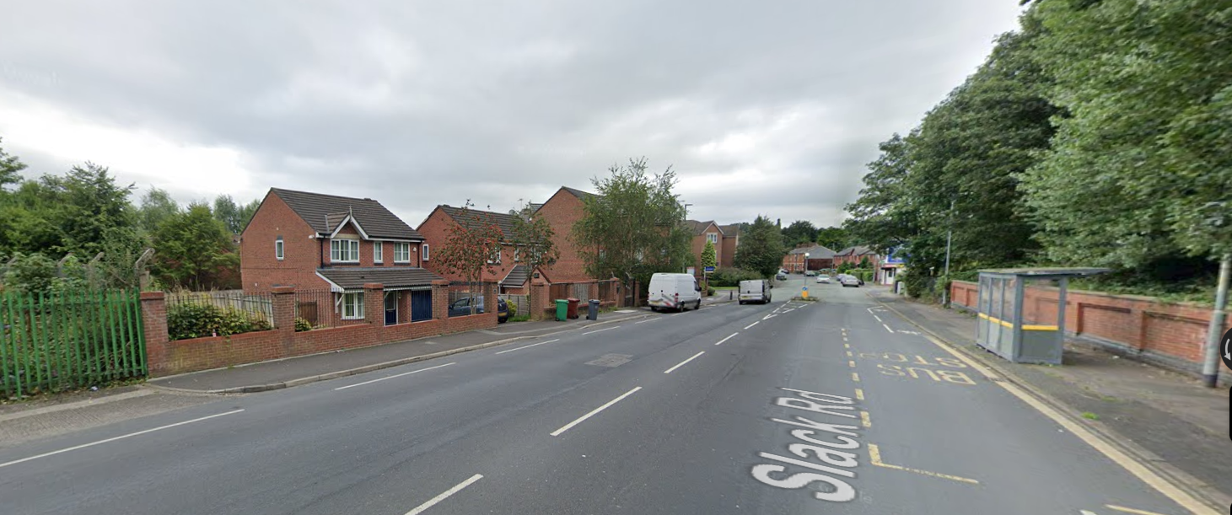

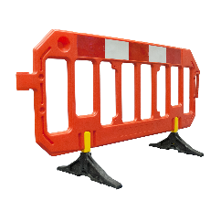

Overview
This section of the planning permission considers that vehicle movements, mostly large construction related vehicles, in/out of proposed worksite adjacent to 55 Slack Road, Manchester.
As part of the construction works, it anticipated that the existing brickwork boundary fence wall, separating the residential boundary from pavement on slack road will be deconstructed to facilitate the works, as per the depiction above.
Once removed this will enable the in/egress of vehicles into and out of the worksite, as well as the erection of worksite perimeter fencing. Vehicle Gates, either in timber or metal form, will be installed as part of the worksite perimeter fencing, as per the exert below.
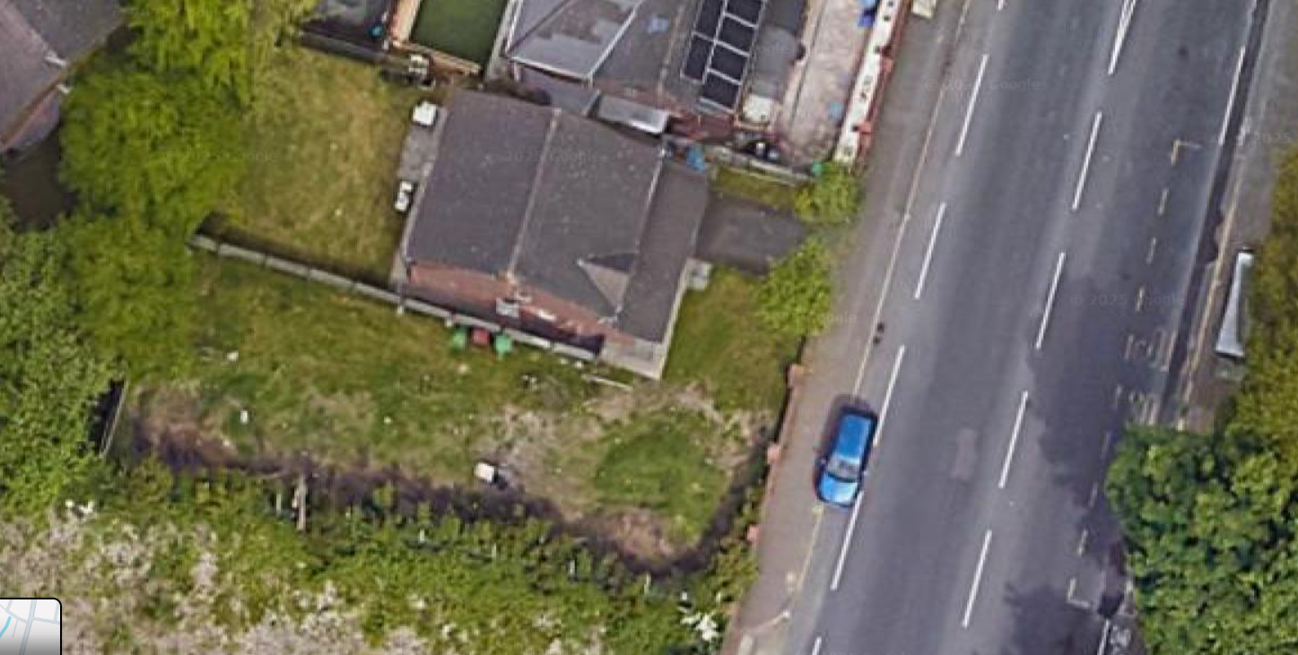
Vehicle gates: Opening inwards towards site only
Worksite Perimeter Fencing
The vehicles gates will be installed so that the hinges open inwards towards the worksite only, allowing for continued throughfare on the adjacent pavement and cycle lane.
In/Egress of Vehicles
Site deliveries and/or collections services will be scheduled to occur outside of ‘rush hour’ times so far as practicable to reduce disruption to road users.
Once construction vehicles arrive to site, say 8 wheel lorry or rear mounted loaders, the site manager and operatives will work in tandem to remove open the vehicle access gates inwards, and marshal the vehicle to reverse into the worksite using handing signals. It is likely that marshalling of 3rd party vehicles, cyclists and pedestrians on the pavement will be required to for a short period whilst the vehicle is reversing into the worksite.
The construction vehicles in length, however it can be noted that Flat Bed Lorrys with Rear Loader compartments have a turning circle of upto 15m whereas large vehicles such as 8 wheel wagons, typically used to delivery aggregates or grabs to collect spoil can have a turning circle of up to 25m.
Up to 25m turning radius.
As such, the site manager will ensure that the vehicle’s starting point is sufficient to enable entry into the worksite. Once the vehicle has entered the worksite, the marshaller shall allow for 3rd party vehicles, cyclists or other pedestrians to continue with their journey.
Following the completion of delivery/collection activities, the vehicle will be marshalled out of the worksite in reverse of the above process.

