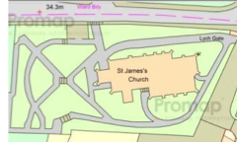
Stenner Lane

Holly Trees position at top of steps leading to the lower garden

