PLANNING CONDITION DISCHARGE REPORT
Condition 41 – Contractor’s Working Compound
Wythenshawe Park Sports Hub, Wythenshawe Road, Manchester, M23 0AB
Planning Application Ref: 144282/VO/2025
Client | Manchester City Council / Alliance Leisure
Principal Contractor | Etec Contract Services Ltd
Employer’s Agent / Principal Designer | Abacus
Document Reference | COND-41-WC-REV02
Date of Issue | June 2026
Condition Status | Prior to Commencement of Works
Submitted By | Etec Contract Services Ltd

1. Planning Condition Wording
The full wording of Planning Condition 41 as imposed by the Local Planning Authority is as follows:

“No development shall commence until full details of:
(a) the works/contractors’ compound (including any buildings, moveable structures, works, plant, machinery, access and provision for the storage of vehicles, equipment and/or materials); and
(b) a scheme for the removal of the works/contractors’ compound and the restoration of the land on which it is situated are submitted to and approved in writing by the Local Planning Authority (in consultation with Sport England).
The works/contractors’ compound shall not be provided and used on the site other than in accordance with the approved details and shall be removed and the land on which it is situated restored in accordance with the approved details before occupation of the development hereby approved.”
Reason: To protect playing fields/sports facilities from damage, loss or availability of use, pursuant to Policy EN10 of the Manchester Core Strategy and National Planning Policy Framework (NPPF).

2. Compound Location and Site Set-Up
The contractors’ working compound has been established within the grounds of Wythenshawe Park in accordance with the Site Set-Up Plan (Drawing No. WS-100-05, prepared by Etec Contract Services Ltd). The compound is situated adjacent to the main park access road off Wythenshawe Road, within the footprint of the existing tarmac car park that currently serves the park.

The compound comprises the following elements, as identified on Drawing No. WS-100-05:
- Site welfare set-up and office facilities (indicated in blue on the Site Set-Up Plan), positioned within the existing tarmac car park area
- Material storage area (located to the north of the compound, within the existing car park footprint)
- Waste area (indicated in yellow on the Site Set-Up Plan)
- Vehicle unloading area (located adjacent to the site access from Wythenshawe Road)
- Contractor parking area
- Defined pedestrian access route (shown as a green dashed line on the Site Set-Up Plan)
- Site boundary during construction works (defined by red line on the Site Set-Up Plan)
- Access and egress routes clearly marked to and from Wythenshawe Road

All works and compound activities are to be undertaken within the red-line site boundary as shown on the Site Set-Up Plan. The existing park access road will remain operational throughout the construction works.

3. Existing Car Park – Permitted Development Note
Important Note: The contractors’ welfare compound and associated site set-up is located within the footprint of the existing tarmac car park serving Wythenshawe Park. It is important to note that this existing car park area does not require reinstatement to its pre-existing condition upon vacation of the site by the contractor. This is because the reconfiguration of the existing car parking area forms a discrete and integral element of the approved development under Planning Application 144282/VO/2025.
Specifically, the approved planning proposal includes the reconfiguration of the existing car parking area and the provision of a new tarmac car park as part of the permitted development works associated with the Sports Hub. The construction of the new car park is therefore a committed and funded element of the main project scope, to be delivered as part of the principal works contract.

As a result, when the contractors’ compound is decanted at the end of the construction programme, the land on which it sits will not revert to its current condition. Instead, it will be comprehensively reconstructed and delivered as a new, fully surfaced tarmac car park in accordance with the approved planning drawings, as part of the completion of the Sports Hub development. This outcome fully satisfies the intent of Condition 41(b) in respect of this area – namely, that the land is restored and put to beneficial use – while also delivering the planned permanent improvement to parking provision within the park.

The new car park design, including layout, surfacing, drainage, tree pit details and associated works, is set out in the approved drawings prepared by Quorum Project Management Ltd, including Drawing No. QPM-DR-C-920 (Access Road / Car Park Layout), Drawing No. QPM-DR-C-923 (Car Park Sections) and Drawing No. QPM-DR-C-930 (Miscellaneous Construction Details). The car park will be constructed using a porous asphalt surface course over a permeable asphalt binder course on a MOT Type 3 sub-base, with integrated tree pits and associated drainage provisions.

4. Compound Details – Buildings, Structures and Equipment
The following details confirm the principal elements of the contractors’ compound in response to Part (a) of Condition 41:

4.1 Temporary Buildings and Welfare
- Welfare cabin and site office unit (single-storey, free-standing temporary cabins)
- 2 no. site storage containers for tools and equipment
- All temporary buildings are free-standing and not contained within any permanent structure
- Temporary buildings positioned a minimum of 6m from the active construction zone boundary

4.2 Plant, Machinery and Materials Storage
- Construction plant and machinery as required for the principal works programme
- Materials to be stored within the designated compound area only – no materials stored on public footpaths, access tracks or within park public areas
- All deliveries pre-booked and managed in accordance with the Traffic Management Plan (Revision 01, May 2026)

4.3 Site Access and Security
- Access to the site via the existing service road off Wythenshawe Road
- Site perimeter secured with temporary Heras fencing panels (minimum 2m high adjacent to public areas) and timber hoarding around the pump track area.
- Padlocked vehicular gates – locked when site is not in operation
- All vehicles to report to Banksman/Site Manager on arrival; site speed limit 5 MPH
- Working hours: Monday–Friday 07:30–17:30; Saturday 08:00–13:00 (no Sunday or Bank Holiday working without written client consent)

5. Removal of Compound and Land Restoration
In response to Part (b) of Condition 41, the following scheme is confirmed for the removal of the contractors’ working compound and the treatment of the land upon completion of the Sports Hub development:

5.1 Compound Removal
- All temporary welfare cabins, site offices and storage containers to be lifted off site by flatbed transport prior to occupation of the Sports Hub
- All Heras fencing, barriers, hoarding, temporary signage and gate infrastructure to be removed and taken off site for reuse or disposal
- All construction materials, plant, equipment and waste to be cleared from the site prior to handover
- Temporary electrical supplies to welfare cabin and site office to be disconnected and removed
- All temporary road markings, cones and delineators to be removed on completion

5.2 Land Treatment Following Compound Removal
As set out in Section 3 above, the land occupied by the contractors’ compound is the existing tarmac car park, which forms part of the approved development scope. Upon removal of the compound, this area will not require ‘restoration’ in the conventional sense; rather, it will be reconstructed as a new tarmac car park as an integral element of the Sports Hub delivery, in accordance with the approved drawings. This constitutes a material improvement to the land and fully meets the objective of the condition.
- New tarmac car park to be constructed and operational prior to occupation of the Sports Hub, in accordance with approved drawings QPM-DR-C-920, QPM-DR-C-923 and QPM-DR-C-930
- Car park surfacing, bay markings, drainage, tree pits, kerbing and associated works to be completed as part of the principal works contract
- Final inspection and sign-off of the completed car park by the Employer’s Agent (Abacus) and Client (Manchester City Council) prior to occupation

6. Programme
The compound will be in use for the duration of the main Sports Hub construction programme, in accordance with the project programme (Drawing No. HC-CO-001, Revision P, dated 27 May 2026). Compound removal and delivery of the new tarmac car park will be completed before occupation of the development.

Milestone | Target Date
Contractors’ Compound Established | Prior to commencement of works
Sports Hub Main Construction Programme | Duration per Programme HC-CO-001 50 weeks
Compound Removal Complete | Prior to occupation of Sports Hub
New Tarmac Car Park Delivered | Prior to occupation of Sports Hub

7. Plans
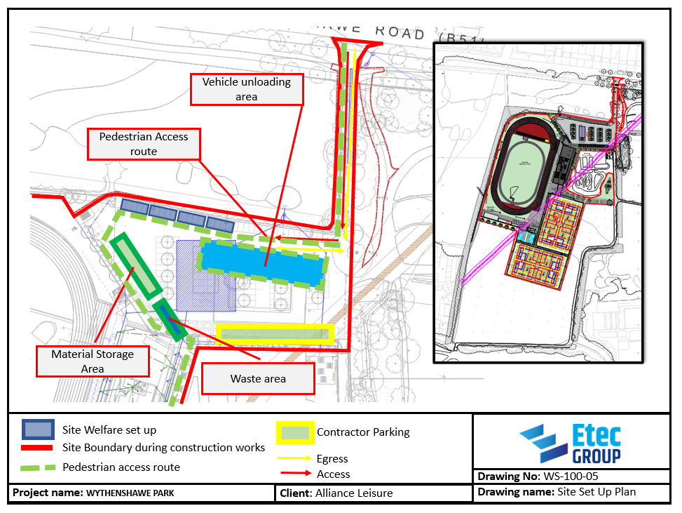

8. Conclusion
This report has been prepared to satisfy the requirements of Planning Condition 41 of Planning Permission 144282/VO/2025, relating to the Contractor’s Working Compound for the Wythenshawe Park Sports Hub development.

Full details of the compound layout, including all buildings, plant, equipment, storage areas, access and vehicle provision, have been provided in the Site Set-Up Plan (Drawing No. WS-100-05) and the associated Construction Phase Plan and Traffic Management Plan.

A scheme for the removal of the compound and treatment of the land has been set out in Section 5 of this report. It is explicitly noted that the compound is sited within the footprint of the existing tarmac car park, which itself forms part of the permitted development under Planning Application 144282/VO/2025. Upon completion of the construction programme and removal of the compound, this area will be reconstructed as a new tarmac car park as an integral element of the Sports Hub delivery. There is therefore no requirement to reinstate the land to its previous condition; the approved development itself delivers the required treatment of this area, as a permanent, improved parking facility for the park.

It is respectfully requested that the Local Planning Authority (in consultation with Sport England) approve these details in discharge of Planning Condition 41.

Prepared by: Etec Contract Services Ltd
On behalf of: Manchester City Council / Alliance Leisure
Date: June 2026
Document Ref: COND-41-WC-REV02

