

Planning

Delegated Officer Report

Summary of application details
Application reference: | 145051/LO/2026
Application type: | Listed building consent (Alt/Ext)
Proposal: | LISTED BUILDING CONSENT for the installation of 1no. projecting sign at the rear elevation, and alterations to existing external seating area including fixing of 2no. existing jumbo parasols with associated heating and lighting, and installation of power supply beneath existing paving.
Site address: | Old Wellington Inn Courtyard  4 Cathedral Gates  Manchester  M3 1SW
Ward(s): | Deansgate
Date application valid: | 09 April 2026

Applicant name:
Agent (if any): | Mr Mark Adams
Case officer: | Lea Joseph
Recommendation: | Approve
Date of recommendation: | 02.06.2026

Description of site, building and/or area
The Old Wellington Inn, A Tudor style, timber framed building The Old Wellington is considered to be Manchester’s oldest pub.

The three-storey building is Grade II listed for its traditional timber framed construction.
Originally erected in the 16th century the building structure and interior details constitute the only surviving example of timber framing techniques in 16th and 17th century Manchester in the City Centre. The site has a large forecourt which operates as an enclosed outdoor seating area for patrons.

The application site has a clear historic value, as one of the last surviving examples of sixteenth century timber framed construction and its location sits within the historic medieval quarter of Manchester. The building is one of the only structures to survive the 1940 air raids on Manchester City Centre during the Second World War. The building has been demolished and rebuilt on two occasions, which limits it’s significance.

The building has a moderate level of aesthetic value as it stands out within its surroundings, the symmetry, materiality and scale of the site make it a visually stimulating backdrop within the busy City Centre environment, there is some overlap between historic and aesthetic value by virtue of the site’s history. The internal timber framing also contribute to the aesthetic value.

Finally, the social value of the site is high, the public house has been present for centuries and sits at the gateway between North Manchester and the City Centre, as well in close proximity to Victoria Rail Station. As a result, the application site is a longstanding gathering space, for residents and visitors alike with high numbers of patrons in the summer months filling the outdoor seating area which sits in front of the building’s primary facade.

Presently, the timber on the facades carries the ‘silvering’ characterise of aged oak. There is also a worn brown paint that can be observed.

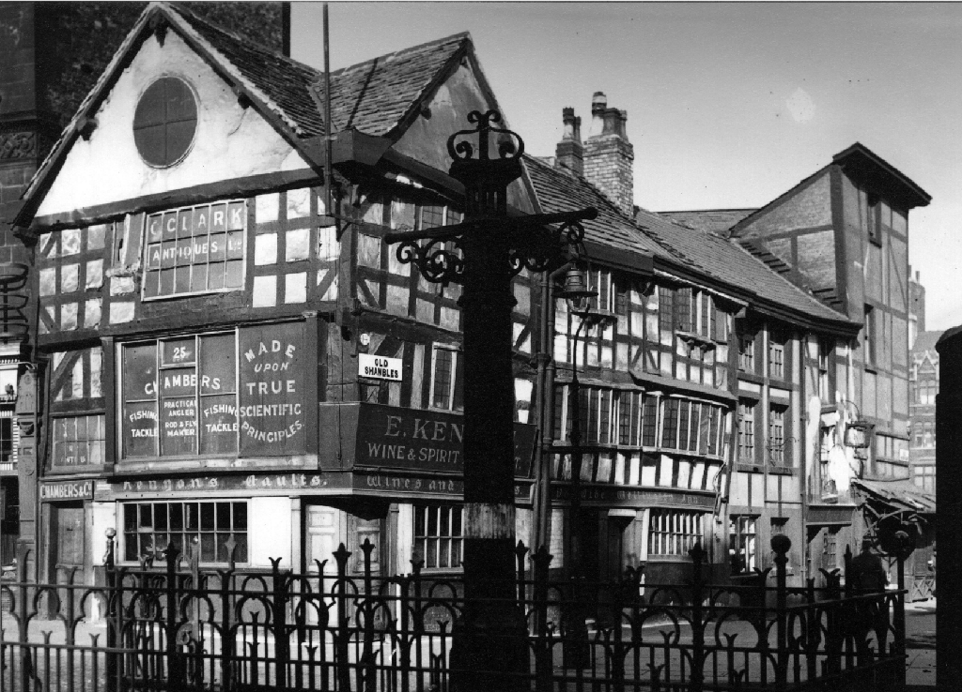
Image of the site in 1946 (Manchester Archives)

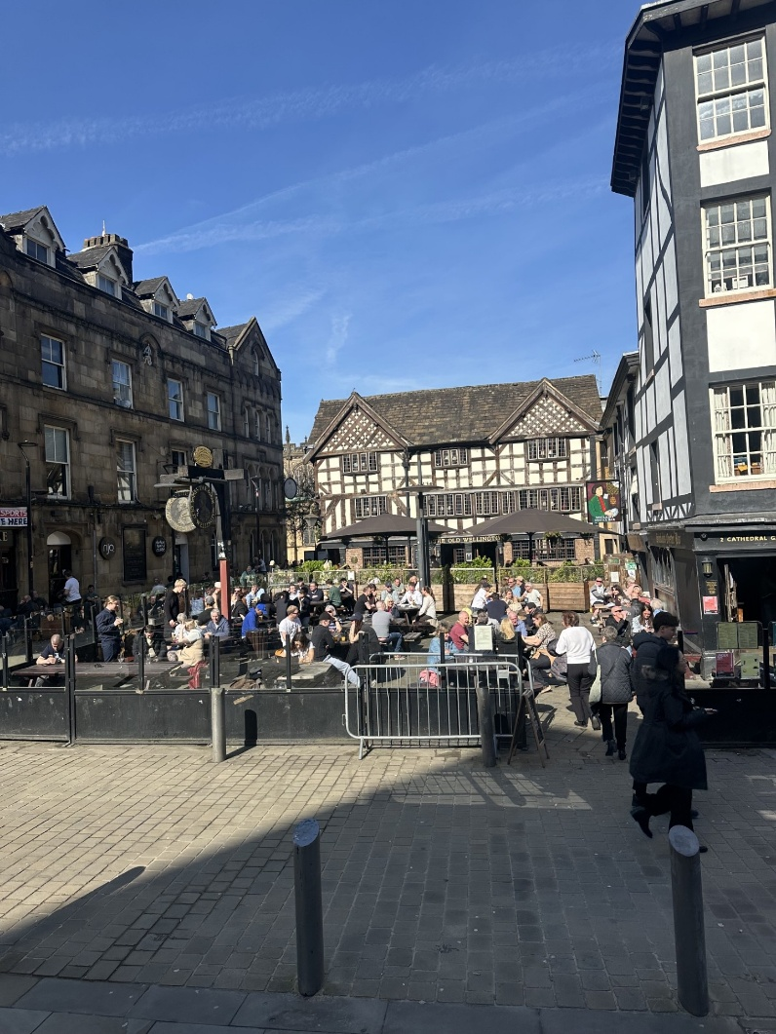
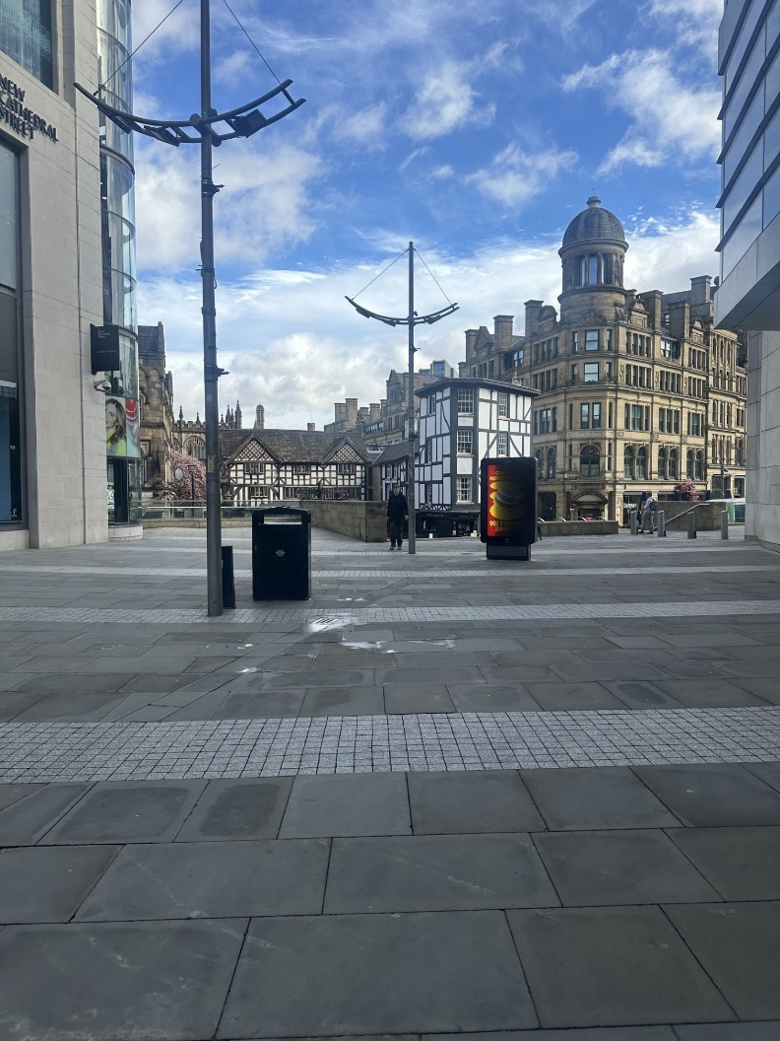
Images if site when viewed from New Cathedral Street and from Cateaton Street.

Description of development
Listed Building Consent is sought for the installation of 2no. jumbo umbrellas (jumbrellas) with heaters and LED lighting attached to the underside of each umbrella. Underground cabling would connect a power source from the site’s basement to the umbrellas.

Relevant planning history
145049/FO/2026 | Installation of 2no. jumbrellas and heaters. (Approved in conjunction with this application).

Consultation, notification and publicity responses

Consultations
Greater Manchester Archaeological Advisory Service – No objections. The level of development proposed is not expected to impact

Historic England – No comment.

Notifications and publicity
A site notice was posted at the site. Letters were sent to surrounding neighbours. No representations have been received.

Relevant policies
Places for Everyone Joint Development Plan (2024-2039)
JP-P2 Heritage

Manchester Core Strategy (2012-2027)
EN1 Design Principles and Strategic Character Areas
EN3 Heritage

Saved Unitary Development Plan (1989) Policies
DC18 Conservation Areas
DC19 Listed Buildings

Other Material Considerations:

National Planning Policy Framework (2024)
Chapter 16 Conserving and enhancing the historic environment

Planning (Listed Buildings and Conservation Areas) Act 1990
Sections 16 and 17

Assessment
Principle of Development

Multiple applications have been made for upkeep and improvement works to the application site in 2026. The council has taken the position that justified remedial works are acceptable provided the impact of the development is outweighed by its public benefits and amenity impacts are mitigated. The development would reduce the footprint of the existing jumbrella, allowing for additional seating.

The scale of development proposed is considered to be acceptable in principle subject to the below considerations of heritage impacts.

Visual Amenity and Impact on Asset and Conservation Area.

Policy DC19 requires that development proposals preserve and retain features that contribute to
the appearance or character of Listed Buildings. Policy JP-P2 requires conservation and
enhancement of the heritage environment, including consideration of the significance and sense
of place of heritage assets.

The proposals are confined to the forecourt of the application site; there are no physical impacts or changes to original features. The presence of jumbo umbrella’s within the forecourt has some impact on the site’s setting, the Conservation Area and views of the application site. However, the development does not change this current arrangement and would retain the umbrella’s currently in situ. While there is some impact on the aesthetic value it should be noted that the external seating area contributes positively to the site’s social value.

The works proposed include the removal and reinstatement of hard landscaping within the forecourt. Stone would be lifted and a base for each umbrella would be installed beneath the York stone. Power cables would also be installed beneath the stone, running a power source within the basement. The intervention is reversible cabling could be removed through the basement area without further ground works, and the umbrella mount could be carefully filled.
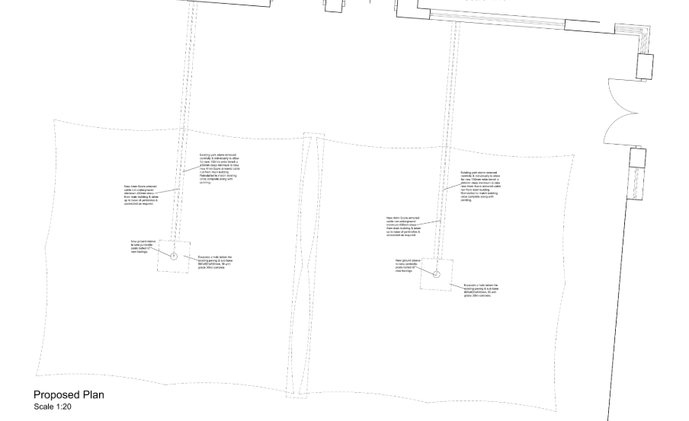
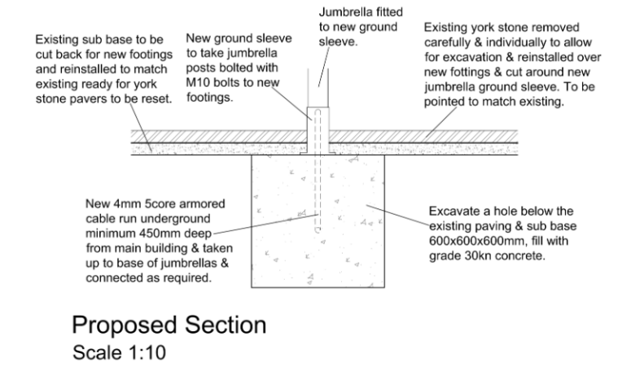

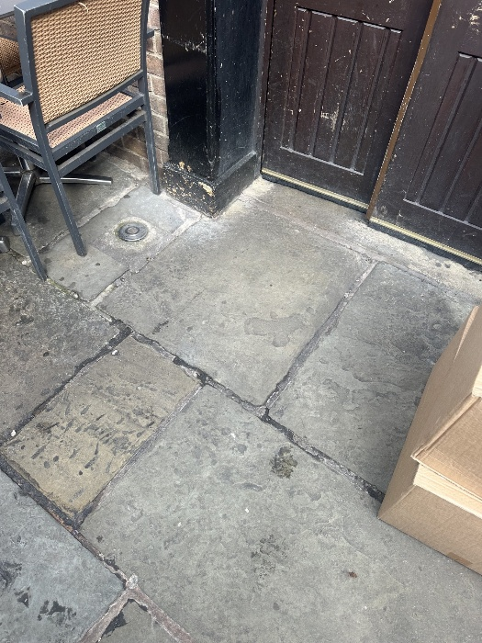
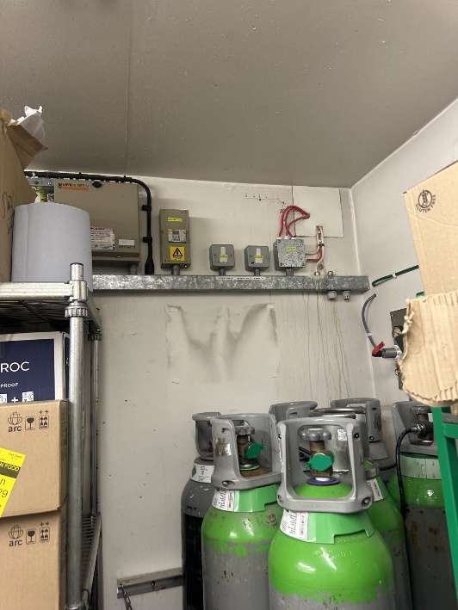

Existing paving at proposed location for entry of cable to site’s basement. Existing modern basement area where power source would be located.

The York Stone, while non-original does contribute to the appreciation of the site’s appearance and character. A pre commencement condition would be attached to an approval for a method statement in order to ensure stone is carefully removed and that in the event of damage replacements are suitably matched in appearance to the existing hard landscaping.

Similarly, in order to ensure the umbrella appearance remains of a similar quality to the application site a maintenance plan for their upkeep would also be required for submission. The LED lighting and heaters are small in size and would be obscured by the canopy when viewed from a distance.

Given these details the scope of works is considered to be conservative, with no physical changes to original features and reuse of the existing umbrellas. Potential visual impacts of the works would be mitigated via condition. The impact on the Conservation Area would be neutral and the jumbo umbrellas are already present on site. The development is therefore considered acceptable under policy DC19, EN3, JP-P1, DM1 and DC18.

The impact of the proposal on the ability to see the whole elevation due to the size and canopy spread of the umbrella’s would result in a low level of less than substantial harm to the asset. In
accordance with section 215 of the NPPF, the harm must be weighed against the proposal’s
public benefits.

The development would rationalise the clutter caused by the existing bulky temporary umbrella arrangement on the site. The lighting and heating would allow for year-round enjoyment of this outdoor space further facilitating the viability and sustainable conservation of the asset. The public benefits of the proposal are considered to outweigh the harm caused by the retention of the jumbo umbrellas.

On the basis of the above the proposals would be consistent with Places for Everyone Joint Development Plan policy JP-P2, Core Strategy policies DM1, EN1, and EN3, Saved Unitary Development Plan Policies DC18 and DC19, Chapter16 of the NPPF and the Planning (Listed Buildings and Conservation Areas) Act 1990.

Archaeology

The application is located within the heart of Manchester’ Medieval Quarter. As such considerations of the impact of below ground works on archaeological remains are required as per policies DM1 and EN1.

Greater Manchester Archaeological Advisory Service have reviewed the proposal and do not expect the scheme to have a significant impact any known or suspected archaeological remains. The proposal is therefore acceptable pursuant to policies EN1 and DM1.

Conclusion
The proposed interventions are considered to create a low level of less than substantial harm to the listed asset which would be outweighed by the public benefits. The scheme is considered to be appropriate on heritage grounds as is required by National Planning Policy Framework Chapter 16, the Saved Unitary Development policy DC19, Core Strategy policies DM1, SP1, and EN3, Places for Everyone Policies JP-P1 and JP-P2 and the Planning (Listed Buildings and Conservation Areas) Act 1990.

Recommendation: Approve

- The works must be begun not later than the expiration of three years beginning with the date of this consent.

Reason - Required to be imposed pursuant to Section 18 of the Planning (Listed Buildings and Conservation Areas) Act 1990 (as amended).

- The development hereby approved shall be carried out in accordance with the following drawings and documents:

Drawing: 3117/LB02 Rev. C (Received 9 April 2026)
Drawing: 3117/LB04 Rev. C (Received 9 April 2026)
Drawing: Location Plan (Received 28 January 2026)
Document: Heating and Lighting Details (Received 1 April 2026)

Reason - To ensure that the development is carried out in accordance with the approved plans pursuant to policies SP1 and DM1 of the Core Strategy.

- Notwithstanding the details as set out in condition 2 above prior to the work being carried out, full and final details of the proposed umbrella canopy colours, LED lighting units and heaters shall be submitted and approved by the City Council as Local Planning Authority.

The approved details shall be implemented as part of the development.

Reason - In the interests of visual amenity and because the proposed works affect a building which is included in the Statutory List of Buildings of Special Architectural or Historic Interest and careful attention to building work is required to protect the character and appearance of this building and to ensure consistency in accordance with policy and EN3 of the Core Strategy and saved policy DC19.1 of the Unitary Development Plan for the City of Manchester

- Prior to the commencement of works, a method statement and product sample for the removal and replacement of hard landscaping (York stone) shall be submitted and approved by the City Council as Local Planning Authority.

The approved details shall be implemented as part of the development.

Reason - In the interests of visual amenity and because the proposed works affect a
building which is included in the Statutory List of Buildings of Special Architectural or
Historic Interest and careful attention to building work is required to protect the
character and appearance of this building and to ensure consistency in accordance with
policy and EN3 of the Core Strategy and saved policy DC19.1 of the Unitary
Development Plan for the City of Manchester.

- Prior to the commencement of works, a maintenance and management plan for the 'jumbrellas' shall be submitted to and approved in writing by the City Council as Local Planning Authority. The maintenance plan shall also include details of replacement procedure in the event the canopys are damaged or worn down.

The development shall then be carried out in accordance with the approved details.

Reason - To ensure an acceptable development, pursuant to policy DM1 of the Core Strategy.

