

Planning

Delegated Officer Report

Summary of application details
Application reference: | 145049/FO/2026
Application type: | Full planning permission
Proposal: | Installation of 2no. jumbrellas and heaters.
Site address: | Old Wellington Inn Courtyard  4 Cathedral Gates  Manchester  M3 1SW
Ward(s): | Deansgate
Date application valid: | 09 April 2026

Applicant name:
Agent (if any): | Mr Mark Adams
Case officer: | Lea Joseph
Recommendation: | Approve
Date of recommendation: | 02.06.2026

Description of site, building and/or area
The Old Wellington Inn, A Tudor style, timber framed building The Old Wellington is considered to be Manchester’s oldest pub.

The three-storey building is Grade II listed for its traditional timber framed construction.
Originally erected in the 16th century the building structure and interior details constitute the only surviving example of timber framing techniques in 16th and 17th century Manchester in the City Centre. The site has a large forecourt which operates as an enclosed outdoor seating area for patrons.

The application site has a clear historic value, as one of the last surviving examples of sixteenth century timber framed construction and its location sits within the historic medieval quarter of Manchester. The building is one of the only structures to survive the 1940 air raids on Manchester City Centre during the Second World War. The building has been demolished and rebuilt on two occasions, which limits it’s significance.

The building has a moderate level of aesthetic value as it stands out within its surroundings, the symmetry, materiality and scale of the site make it a visually stimulating backdrop within the busy City Centre environment, there is some overlap between historic and aesthetic value by virtue of the site’s history. The internal timber framing also contribute to the aesthetic value.

Finally, the social value of the site is high, the public house has been present for centuries and sits at the gateway between North Manchester and the City Centre, as well in close proximity to Victoria Rail Station. As a result, the application site is a longstanding gathering space, for residents and visitors alike with high numbers of patrons in the summer months filling the outdoor seating area which sits in front of the building’s primary facade.

Presently, the timber on the facades carries the ‘silvering’ characterise of aged oak. There is also a worn brown paint that can be observed.

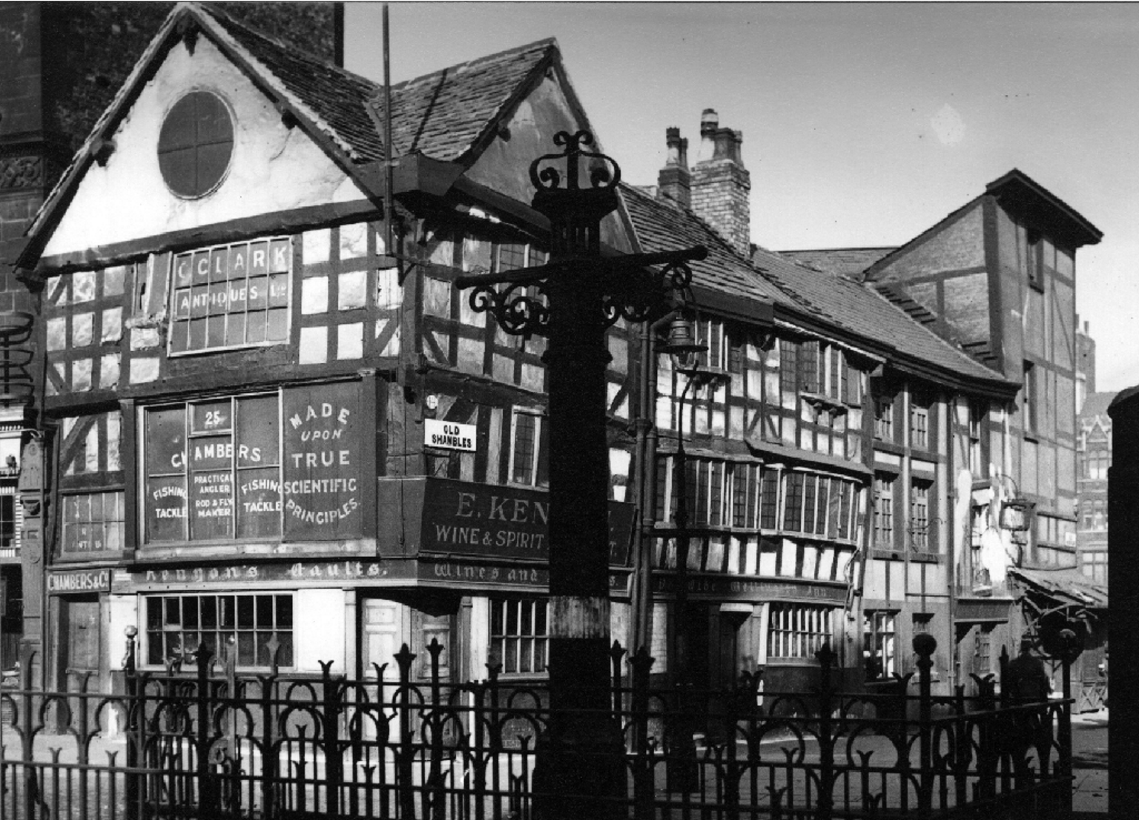
Image of the site in 1946 (Manchester Archives)

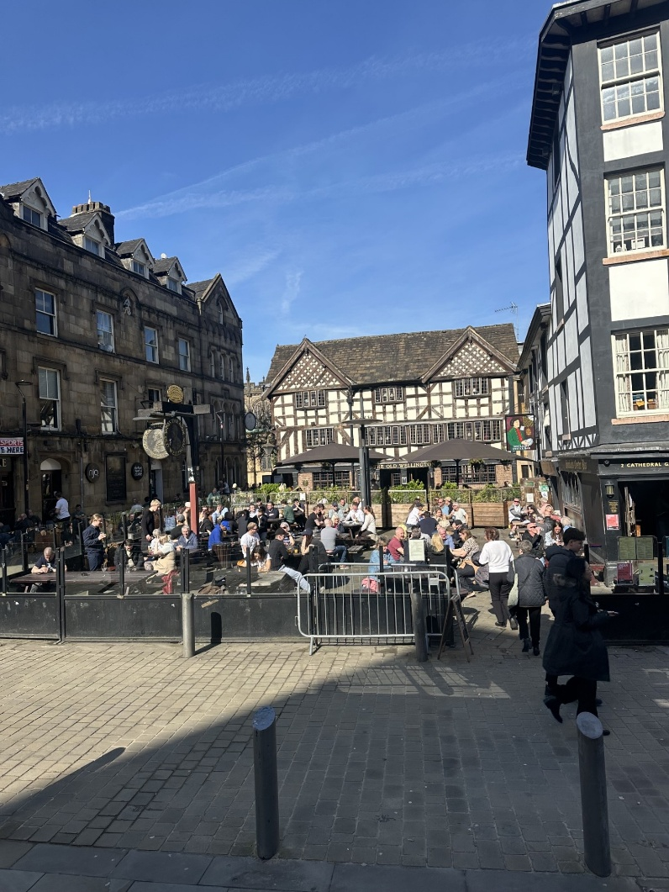
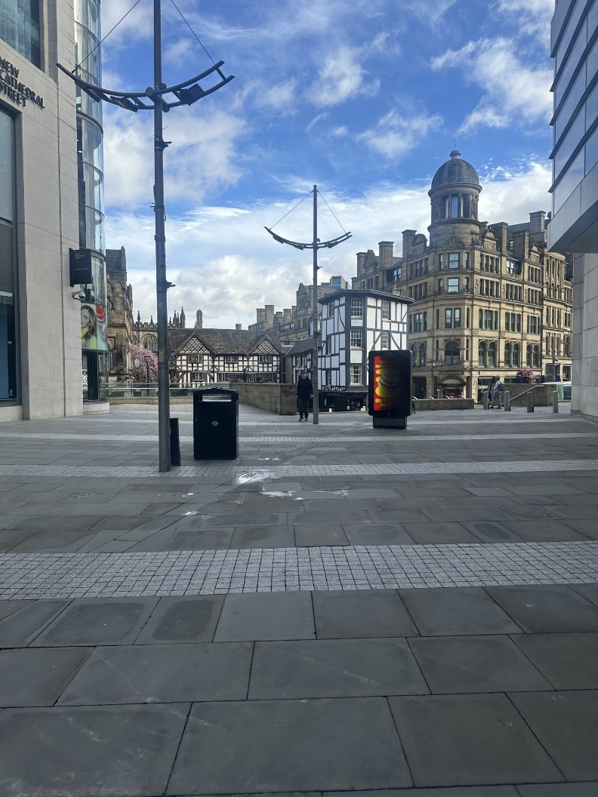
Images if site when viewed from New Cathedral Street and from Cateaton Street.

Description of development
Full planning permission is sought for the installation of 2no. jumbo umbrellas (jumbrellas) with heaters and LED lighting attached to the underside of each umbrella. Underground cabling would connect a power source from the site’s basement to the umbrellas.

Relevant planning history
112631/FO/2016 | External alterations involving redecoration of window, new external lantern to replace existing and a new pair of half glazed doors. (Approved January 2017)

115754/FO/2017 | Installation of new double doors within existing structural opening on side elevation following removal of existing doors. (Approved May 2017).

145051/LO/2026 | LISTED BUILDING CONSENT for the installation of 1no. projecting sign at the rear elevation, and alterations to existing external seating area including fixing of 2no. existing jumbo parasols with associated heating and lighting, and installation of power supply beneath existing paving. (Approved in conjunction with this application).

Consultation, notification and publicity responses

Consultations
Highway Services – No objection. Proposed alterations are within the red line cartilage of the site. Given the scale of the development a significant impact on the highway network is not expected.

Historic England – No comment.

Greater Manchester Police – No comment.

Environmental Health – No comment.

Notifications and publicity
A site notice was posted at the site. Letters were sent to surrounding neighbours. No representations have been received.

Relevant policies
Places for Everyone Joint Development Plan (2024-2039)
JP-P1 Sustainable Places
JP-P2 Heritage

Manchester Core Strategy (2012-2027)
DM1 Development Management
SP1 Spatial Principles
EN1 Design Principles and Strategic Character Areas
EN3 Heritage
C10 Leisure and the Evening Economy
C2 District Centres
CC10 A Place for Everyone
CC4 Visitors, Culture and Leisure

Saved Unitary Development Plan (1989) Policies
DC18 Conservation Areas
DC19 Listed Buildings

Other Material Considerations:

National Planning Policy Framework (2024)
Chapter 12 Achieving well designed places
Chapter 16 Conserving and enhancing the historic environment

Planning (Listed Buildings and Conservation Areas) Act 1990
Sections 16 and 17

Assessment

Principle of Development

Multiple applications have been made for upkeep and improvement works to the application site in 2026. The council has taken the position that justified remedial works are acceptable provided the impact of the development is outweighed by its public benefits and amenity impacts are mitigated. The development would reduce the footprint of the existing jumbrella, allowing for additional seating.

The scale of development proposed is considered to be acceptable in principle subject to the below considerations.

Heritage considerations will form part of the separate Listed Building Consent report.

Amenity
Proposed heaters and lighting would be electric. No fumes or odours would be introduced to the site as a result of the development. There is no noise impact expected as a result of the development. Hours of operation would remain the same and the new tables added to the area through the consolidation of the jumbo umbrella’s is not expected to impact the site’s existing noise levels.

Thus, the existing amenity of the area would remain unchanged, and the development would be acceptable pursuant to policies DM1, SP1 and DC26.

Access
The existing level access to the site’s ground floor would remain unchanged. The development would therefore meet the requirements of policies JP-P1 and CC10.

Crime and ASB

Policy DM1 requires considerations of crime generation and safety. Policy C10 requires consideration of a proposal’s impact on the wider community.

The level of development proposed is limited. The existing security of the application would remain the same. Greater Manchester Police’s Design for Security Team have reviewed the proposal and had no comment to make.

In light of the above, the development is acceptable under the requirements of policy DM1 and C10.

Conclusion
The interventions proposed would not negatively impact the site’s accessibility, the area amenity or crime generation. The proposals impact would be mitigated via conditions relating to hard landscaping and maintenance. Therefore, the scheme is acceptable pursuant to the Saved Unitary Development policy DC26, Manchester Core Strategy (2012-2027) policies DM1, SP1 and EN1 and Places for Everyone Joint Development Plan policy JP-P1.

Recommendation: Approve

- The development must be begun not later than three years beginning with the date of this permission.

Reason - Required to be imposed by Section 91 of the Town and Country Planning Act 1990 (as amended).

- The development hereby approved shall be carried out in accordance with the following drawings and documents:

Drawing: 3117/LB02 Rev. C (Received 9 April 2026)
Drawing: 3117/LB04 Rev. C (Received 9 April 2026)
Drawing: Location Plan (Received 28 January 2026)
Document: Heating and Lighting Details (Received 1 April 2026)

Reason - To ensure that the development is carried out in accordance with the approved plans pursuant to policies SP1 and DM1 of the Core Strategy.

