SITE SPECIFIC SUPPLEMENTARY INFORMATION

- Site Details

Site Name: | Peter House | Site Address: | Peter House  Oxford Street  Deansgate  Manchester  M1 5AN
NGR: | E: 383893, N: 397846 | Site Address: | Peter House  Oxford Street  Deansgate  Manchester  M1 5AN
Site Ref Number: | MAN767 - 10102162 | Site Type: Macro | NTQ Replacement

- Pre-Application Check List

Site Selection

Was an LPA mast register used to check for suitable sites by the operator or the LPA? |  | No
If no explain why:

After a phone call to the LPA it was felt that the industry database was a more up to date source of information.

Was the industry site database checked for suitable sites by the operator: | Yes
If no explain why:

N/A

Pre-application consultation with LPA

Date of written offer of pre-application consultation: | 17th May 2026
Was there pre-application contact: |  | No
Date of pre-application contact: | N/A
Name of contact: | The Director of Planning
Summary of outcome/Main issues raised:

At the time of preparing this submission, and despite our attempt to engage in pre-application dialogue with the LPA, no comments had been received in respect to the proposals.

Ten Commitments Consultation

Rating of Site under Traffic Light Model: | Green

Prior to the submission of this application the applicant initiates pre-consultation discussions with the local planning authority. This provides an opportunity for the LPA to discuss development proposals and identify site specific issues. Further consultation has also been carried out with the Deansgate Ward Councillors Marcus Johns, Anthony McCaul and Sarah Wakefield, the CAA and Northwest Air Ambulance.

Summary of outcome/Main issues raised:

Hello Guy,

Thank you for informing us about the mast. The location is not within our usual flight paths into the MRI and should not pose any difficulties for us.

Best regards,

James

James Holland | NWAA Chief Pilot
Mission Critical Services Onshore | Aviation
Babcock International Group
City Heliport | Liverpool Road | Eccles | Manchester | M30 7RU
Mob: +447815 053127 | James.Holland2@babcockinternational.com
babcockinternational.com

School/College

Location of site in relation to school/college:

There are no schools in close proximity to the site.

Outline of consultation carried out with school/college:

N/A

Summary of outcome/Main issues raised:

N/A

Civil Aviation Authority/Secretary of State for Defence/Aerodrome Operator consultation (only required for an application for prior approval)

Will the structure be within 3km of an aerodrome or airfield? |  | Yes
Has the Civil Aviation Authority/Secretary of State for Defence/Aerodrome Operator been notified? |  | Yes
Details of response:

Hello Guy,

Thank you for informing us about the mast. The location is not within our usual flight paths into the MRI and should not pose any difficulties for us.

Best regards,

James

James Holland | NWAA Chief Pilot
Mission Critical Services Onshore | Aviation
Babcock International Group
City Heliport | Liverpool Road | Eccles | Manchester | M30 7RU
Mob: +447815 053127 | James.Holland2@babcockinternational.com
babcockinternational.com

Site Provider Letter

Copy of Site Provider Letter enclosed? | Yes
Date served: | 31st May 2026

- Proposed Development

The proposed site:
It is imperative to consider that this proposal is to replace an existing installation and is not a new additional installation. The need for this mast stems from MBNL having been issued with an NTQ (Notice to Quit) on their existing site and thus this new mast is urgently required to maintain coverage.
This planning statement has been prepared in support of an application for the replacement of the existing installation. The proposed installation is to be located on the rooftop of Peter House, Oxford Street, Deansgate, Manchester, M1 5AN.

The proposal seeks to provide a replacement telecommunication facility, ensuring , improved mobile network coverage for the surrounding area in line with evolving technological needs. The proposal aims to replace mobile network coverage and capacity in the Deansgate area, aligning with national and local policies that support the development of telecommunications infrastructure.

The site is situated in Deansgate on the rooftop of Peter House, the area has several tall buildings nearby. The area is commercial in nature with office blocks, pubs, restaurants and hotels. The demand for network coverage in this locale will be strong; the proposed installation will ensure that network coverage is maintained and improved. The applicant recognises that the proposed site is in a Conservation Area; by proposing to site the installation on the rooftop of Peter House, the applicant is seeking to respect the Conservation Area and minimize the visual impact.

The replacement site is essential to meet the growing demand for mobile telecommunications services in the area. The existing infrastructure is nearing the end of its operational life and requires replacement to maintain service quality.
The proposed development will:
- Enhance Network Coverage: Improve mobile signal strength and reliability for residents and businesses in Deansgate area.​
- Support Economic Growth: Facilitate better connectivity, which is crucial for local businesses and the wider economy.​
- Comply with Policy Objectives: Align with national and local policies that advocate for the expansion of telecommunications infrastructure.​
The design of the replacement rooftop installation and associated equipment has been carefully considered to minimize visual impact and integrate with the surrounding environment. Positioning the installation on the rooftop seeks to minimise visual intrusion.​
Prior to submitting this application, consultations have been undertaken with relevant stakeholders, including local residents and community groups. Feedback received has been considered and, where possible, incorporated into the proposal to address community concerns and enhance the development's acceptability.
The new installation will improve mobile network capacity and coverage, enhancing the quality of service to residents, businesses, and visitors in the surrounding area. The replacement structure will also feature associated cabinets to house the supporting equipment.
National Planning Policy Framework (NPPF)
The National Planning Policy Framework (NPPF) December 2024 provides guidance on sustainable development and the delivery of infrastructure. Specifically, "Planning policies and decisions should support the expansion of electronic communications networks, including next generation mobile technology (such as 5G) and full fibre broadband connections." The proposed development is in accordance with the NPPF's emphasis on supporting high-quality digital infrastructure and enabling sustainable growth.
As previously stated, this is not a new additional installation but is a replacement for an existing installation that is to be removed. The proposed installation is necessary for the continued and improved wireless connectivity and capacity for local businesses, residents and visitors to this busy area of Manchester.

Site Ref: | MAN747 | Site Address: | Peter House, Oxford Street, Deansgate, Manchester, M1 5AN

Local Planning Authority: Manchester City Council

Development Plan: Manchester Core Strategy (2012) / Manchester UDP (saved policies) / Places for Everyone Joint DPD (2024)

Fig.1: Planning Data England Extract (Reference Only):
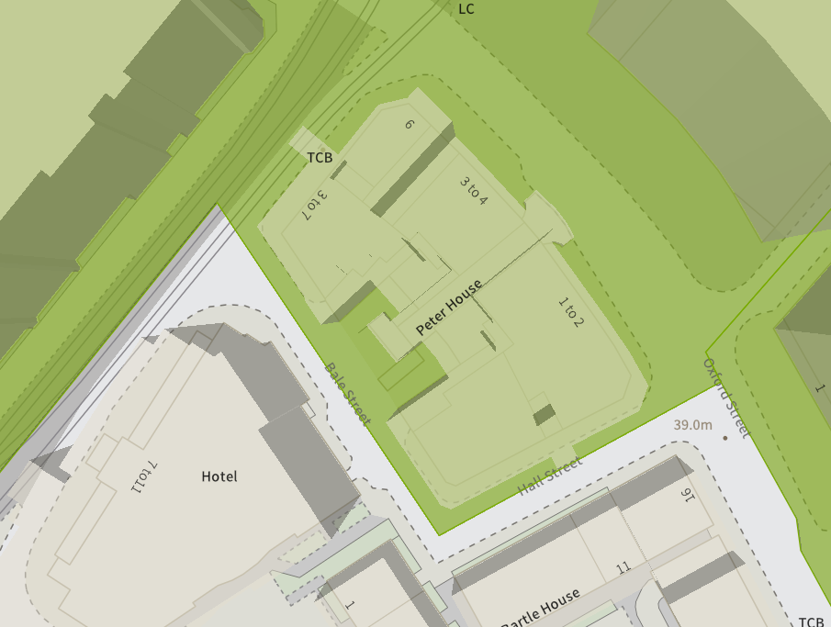

Site and its surrounds

Policy Relevant to the Development Site:

The site is designated as being within the settlement boundary, with urban uses to the north, east, south, and west. The site is in the St. Peter’s Square Conservation Area. The designation is a material consideration.

Manchester Council does have a specific telecoms policy. This, together with the NPPF is of relevance. The National Planning Policy section of this supporting statement goes into detailed analysis of why this site is in compliance with the NPPF.

Policy Analysis:

Policy DC17.1 reads:

“Applications for telecommunications developments will normally be approved if the Council can be satisfied that the development has been sited and designed to minimise its impact on residential amenity and in environmentally sensitive areas. Wherever possible, the Council will expect the potential of existing buildings and masts, including the sharing of such facilities, to be fully explored before agreeing to additional separate development.”

In addition, the following objective is important:

“Objective 9: Ensure access to physical and social infrastructure. We will:

• Improve the capacity and network coverage of digital, energy, telecoms, transport and water in key growth locations.”

Policy JP-P2 reads:

“Heritage

We will proactively manage and work with partners to positively conserve, sustain and enhance our historic environment and heritage assets and their settings. Opportunities will be pursued to aid the promotion, enjoyment, understanding and interpretation of heritage assets, as a means of maximising wider public benefits and reinforcing Greater Manchester's distinct character, identity and sense of place.”

The proposed development at this site is required to deliver the requisite level of electronic communication service on a single installation that is to be adapted to accommodate multiple users (so enable future site sharing opportunities), yet seeks to minimise its impact or change to the character of this location (being utilitarian in appearance, in an elevated rooftop position). The form and design of the proposed configuration would not appear out of context in this location, so according with wider Development Plan policy and would ensure the appearance and character of the area is fully maintained.

In addition to the above, Paragraph 119 of the NPPF (2024) states:

Advanced, high quality and reliable communications infrastructure is essential for economic growth and social well-being. Planning policies and decisions should support the expansion of electronic communications networks, including next generation mobile technology (such as 5G) and full fibre broadband connections. Policies should set out how high-quality digital infrastructure, providing access to services from a range of providers, is expected to be delivered and upgraded over time; and should prioritise full fibre connections to existing and new developments (as these connections will, in almost all cases, provide the optimum solution).

The LPA should look to support this proposal as the equipment will bring “reliable communications” to the area.

Paragraph 122 states that

c) for a new mast or base station, evidence that the applicant has explored the possibility of erecting antennas on an existing building, mast or other structure and a statement that self-certifies that, when operational, International Commission guidelines will be met.

The discounted options section of this planning statement fully illustrates that all other potential masts, roof tops and other locations have been investigated. The proposed site is the optimum location from a planning and coverage perspective.

In this case, the rooftop installation, seen in context with host building, would result in less than substantial harm to the character of the heritage asset, with the public benefits materially outweighing any perceived detrimental change to the location (so ensuring accordance with para. 219 of the NPPF 2024).

The public benefits of a greatly enhanced communications network for businesses, residents and visitors alike in this location would qualify as a substantial benefit with near benign change or impact on amenity.

The enhanced digital service would very much accord with the objectives of the Development Plan policy.

The proposal fully accords with the requirements of the NPPF.

Enclose map showing the cell centre and adjoining cells:
This can be emailed to the LPA upon request.

Type of Structure
Description:

Proposed 1100 high freestanding handrail (Min 2m either side of tripod), to be tied into tripod end posts and existing hooped access ladder uprights.
Proposed EE/H3G 2No antenna apertures at 180° on Valmont tripod. Tripod mounted on new concrete plinths. RRUs and BOBs fixed to poles on tripod
Proposed EE/H3G 2No Ø600 dishes on extension poles on tripod corner posts.
Proposed 300 wide overhead cable tray mounted on new steel support poles. Poles to be fixed down to existing steel grillage using trimming steel if required.
Proposed EE/H3G MK5B Link/AC, EE 2No. unilateral cabinets & H3G 1No. unilateral cabinet to be mounted on existing steel grillage behind existing plant screens. Proposed bottom BOBs mounted on support poles adjacent to cabinets.
Proposed 1No EE & 1No H3G GPS nodes fixed to top of H-frame poles above antennas.
Proposed EE/H3G 2No antenna apertures at 340° on Valmont tripod. Tripod mounted on new concrete plinths. RRUs and BOBs fixed to poles on tripod.
Proposed EE/H3G 1No Ø600 dish on extension pole on tripod corner post.

Overall Height: 45.60m AGL
Height of existing building |  | N/A
Equipment Housing:
Length: |  | See drawings
Width: |  | See drawings
Height: |  | See drawings
Materials
Tower/mast etc – type of material and external colour: | See drawings
Equipment housing – type of material and external colour: | See drawings

Reasons for choice of design:
The proposed rooftop installation is for 2No.EE/H3G antenna apertures at 180° on Valmont tripod and 2No.EE/H3G antenna apertures at 340° on Valmont tripod; 2No.EE/H3G Ø600 dishes on extension poles on tripod corner posts, Proposed 1No.EE/H3G Ø600 dish on extension pole on tripod corner post. 1No EE & 1No H3G GPS nodes fixed to top of H-frame poles above antennas and associated ancillary works. The installation will house both EE and H3G LTE. The sharing of base stations between multiple operators is one of the key strategic policy principles contained within the NPPF.
In keeping with the National Planning Policy Framework (NPPF December 2024). guidelines of using high quality communications infrastructure the proposed design has been selected to minimise visual impact upon the street scene by installing the proposed equipment on the rooftop of Peter House.

- Technical Information

ICNIRP Declaration attached  ICNIRP public compliance is determined by mathematical calculation and implemented by careful location of antennas, access restrictions and/or barriers and signage as necessary. Members of the public cannot unknowingly enter areas close to the antennas where exposure may exceed the relevant guidelines.  When determining compliance the emissions from all mobile phone network operators on the site are taken into account. | Yes

- Technical Justification

Reason(s) why site required
The National Planning Policy Framework clearly states that authorities should not question the need for the service, nor seek to prevent competition between operators. Notwithstanding this fact, the Applicant considers it to be important to explain the technical justification for the site and how the facility fits into the overall network.

Notwithstanding this fact, the Applicant considers it to be important to explain the technical justification for the site and how the facility fits into the overall network.

The site is required to provide new 5G coverage for EE Ltd in order to improve coverage in the Deansgate area of Manchester. The cell search areas for 5G are extremely constrained with a typical cell radius of approximately 250m meaning that it would not be feasible to site the column outside of this locale.

Further detail regarding the general operation of the network can be found in the accompanying document entitled ‘General Background Information on Radio Network Development for Planning Applications’. This information is provided to assist the local planning authority in understanding any technical constraints on the location of the proposed development.

- Site Selection Process – alternative sites considered and not chosen

Discounted Options
In accordance with the sequential approach outlined in the National Planning Policy Framework (NPPF) following search criteria have been utilised. Firstly, consideration is always given to sharing any existing telecommunication structures in the area, secondly consideration is then given to utilising any suitable existing structures or buildings and thirdly sites for freestanding ground-based installations are investigated.

This sequential approach is outlined below:

- Mast and Site Sharing
- Existing Buildings Structures
- Ground Bases Installations

In compliance with its licence and the sequential approach outlined in the NPPF all attempts to utilise any existing telecommunication structures where they represent the optimum environmental solution have been employed. The Ofcom Site Finder mast register is always examined prior to the submission of an application.

Site Type | Site Name and Address | NGR | Reason for not choosing
D1 | The Lexicon | 383779, 397953 | We have surveyed this previously and found it difficult to come up with a design due to the parapet type wall around the top floor. Building is also registered as HRB.
D2 | Manchester Central Library | 383844, 397961 | Discounted for obvious reasons – rooftop unsuitable. Grade II* listed.
D3 | The Midland Hotel | 383807, 397878 | Prominent Hotel building discounted due to the rooftop being unsuitable to house equipment. The building is also noted to be Grade II* Listed.
D4 | St Georges House | 383752, 397888 | Relatively low building compared to the surrounding properties. A site in this location would be partial blocked by the Midland Hotel, and potentially create ICNIRP issues. Unable to progress.
D5 | Theatre Royal | 383734, 397916 | Similar to the above. One of the lowest buildings in the area. Unable to consider due to taller buildings either side, potentially blocking coverage and creating ICNIRP issues.
D6 | The Edwardian Hotel | 383701, 397909 | We have surveyed this rooftop previously and found it difficult to design due to parapet wall around the rooftop, together with limited space for equipment without blocking accesses. Building is also noted to be Grade II* listed.
D7 | South Central | 383585, 397995 | Rooftop design unsuitable to house telecoms equipment.
D8 | 27 Peter Street | 383644, 397980 | Grade II listed building unsuitable to house equipment on the rooftop. The ‘former’ clock tower is also unsuitable.
D9 | 4 Mount Street | 383800, 398016 | Another tall building which could potentially provide the height required, however the rooftop is unsuitable to house equipment so unable to consider. Grade II* Listed also.
D10 | Town Hall | 383871, 398015 | Town Hall extension. Grade II* listed and unsuitable rooftop. Therefore discounted.

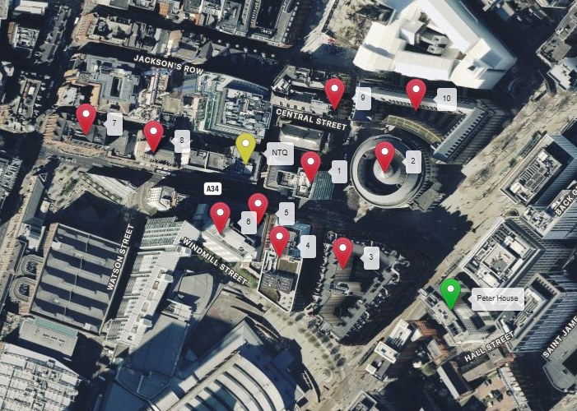

https://gridreferencefinder.com?gr=SJ8390097843|Peter_s_House|2,SJ8372397968|NTQ|4,SJ8377997953|Point_s_V|1,SJ8384497961|Point_s_W|1,SJ8380797878|Point_s_X|1,SJ8375297888|Point_s_Y|1,SJ8373497916|Point_s_Z|1,SJ8370197909|Point_s_BA|1,SJ8358597995|Point_s_BB|1,SJ8364497980|Point_s_BC|1,SJ8380098016|Point_s_BD|1,SJ8387198015|Point_s_BE|1&v=r&labels=1

If no alternative site options have been investigated, please explain why:

N/A

- Additional Relevant Information

Background to the Proposal
This specific proposal forms part of an integral requirement for EE Ltd, ESN and H3G LTE to expand their respective 5G telecommunications network across Manchester specifically in this instance to enhance 5G coverage levels and network capacity within the Deansgate area.

This partnership has resulted in the development and production of an array of “dual user” structures and cabinets, which have the ability to accommodate both operator’s antenna systems and radio equipment.

Mobile phone base stations operate on a low power, and accordingly base stations therefore need to be located in the areas they are required to serve. Increasingly, people are also using their mobiles in their homes, and this means we need to position base stations in, or close to, residential areas.

A further limiting factor is that the position has to be one that fits in with the existing network. Sites have to form a patchwork of coverage cells with each cell overlapping to a limited degree with the surrounding base stations to provide continuous network cover as users move from one cell to the other. However, if this overlap is too great unacceptable interference is created between the two cells.

DEVELOPMENT PLAN POLICY.

Development plan considerations have a special significance in law and re-iterated in Section 38 of the Planning and Compulsory Purchase Act 2004, it is stated that:

“If regard is to be had to the development plan for the purpose of any determination to be made under the planning Acts the determination must be made in accordance with the plan unless material considerations indicate otherwise.”

NATIONAL PLANNING POLICY

The Government remain committed to promoting telecommunications and place emphasis on the importance of telecommunications to the wider economy. The National Planning Policy Framework (NPPF December 2024) sets out the Government’s planning policies for England and how these are expected to be applied at the Local level. It provides a framework within which local people and their accountable Councils can produce their own distinctive local and neighbourhood plans, which reflect the needs and priorities of their communities.

The purpose of the planning system is to contribute to the achievement of sustainable development. There are three dimensions of sustainable development, each of which give rise to the need for the planning systems to perform a number of roles including: -

- economic objective – to help build a strong, responsive and competitive economy;
- social objective – to support strong, vibrant and healthy communities
- environmental objective – to protect and enhance our natural, built and historic environment.
The NPPF contains at its core a presumption in favour of sustainable development which runs through both plan-making and decision-making processes. The NPPF recognises the vital importance of high-quality telecommunications and dedicates a whole chapter to this. Chapter 10 of the NPPF outlines the Governments support for high quality communications. The paragraphs below clearly outline the overarching support from Central Government for telecommunications and how Local Planning Authorities should embrace this vital infrastructure:

NPPF Paragraph 119 states:

“Advanced, high quality and reliable communications infrastructure is essential for economic growth and social well-being. Planning policies and decisions should support the expansion of electronic communications networks, including next generation mobile technology (such as 5G) and full fibre broadband connections. Policies should set out how high-quality digital infrastructure, providing access to services from a range of providers, is expected to be delivered and upgraded over time; and should prioritise full fibre connections to existing and new developments (as these connections will, in almost all cases, provide the optimum solution).”

It continues in Paragraph 120:

“The number of radio and electronic communications masts, and the sites for such installations, should be kept to a minimum consistent with the needs of consumers, the efficient operation of the network and providing reasonable capacity for future expansion. Use of existing masts, buildings and other structures for new electronic communications capability (including wireless) should be encouraged. Where new sites are required (such as for new 5G networks, or for connected transport and smart city applications), equipment should be sympathetically designed and camouflaged where appropriate.”

Operators always follow the sequential site selection process. Where an existing site can be shared or upgraded this will always be adhered to before a new proposal is put forward for consideration.

The support for telecoms and the need not to constrain Operators is laid out in Paragraph 123:

“Local planning authorities must determine applications on planning grounds only. They should not seek to prevent competition between different operators, question the need for an electronic communications system, or set health safeguards different from the International Commission guidelines for public exposure.”

Conclusion

We consider that the development is compliant with the council’s policy and that in accordance with Section 38 (6) of the Planning and Compulsory Purchase Act 2004 permission should be granted for the installation.

We consider the development complies with both central government and local planning policy guidance where the underlying aim is to provide an efficient and competitive telecommunication system for the benefit of the community while minimising visual impact.

Taking into account the factors of technical constraints, available sites and planning constraints we consider that this site and design clearly represents the optimum environmental solution.

On the basis of a recognised need to expand and promote telecommunications networks across the region, it is considered that the proposal fully accords with the requirements of the National Planning Policy Framework and Council’s Local Plan Policies.

Damian Hosker
Planning Manager
Email: d.hosker@whptelecoms.com

Contact Details

Name: (Agent) | Damian Hosker | Telephone: | Emailed on request
Operator: | EE and H3G LTE | Fax no: | N/A
Address: | WHP Telecoms Ltd  1a Station Court Station Road Guiseley  LS20 8EY | Email Address: | d.hosker@whptelecoms.com
Signed: | Damian Hosker | Date: | 31st May 2026
Position: | Planning Manager | Company:  (on behalf of above operator) | WHP

