Planning

Growth & Development

Delegated officer report for planning application

Application no. 145403/LO/2026
Date registered valid: 24 March 2026
Proposal: Listed Building Consent for treatment of existing external timbers.
Address: Old Wellington Inn Courtyard, 4 Cathedral Gates, Manchester, M3 1SW
Ward(s): Deansgate Ward
Applicant: Mitchells & Butlers PLC
Agent (if any): Mr Mark Adams ARC Design Associates
Case officer: Lea Joseph
Tel: 0161 227 3644
Email: lea.joseph@manchester.gov.uk
Recommendation: Refuse
Date of recommendation: 13 May 2026

Application details

Type of application: Listed Building Consent

Development type: Listed building alteration

Date of site visit: 26 March 2026

Standard consultations:
Printed: 26 March 2026 Expired: 18 April 2026

Neighbour notifications
Printed: 26 March 2026 Expired: 18 April 2026

Site notice
Posted: 26 March 2026 Expired: 18 April 2026

Press advert
Published: 31 March 2026 Expired: 23 April 2026

Departure from Development Plan: No

Environmental Statement: Not required

Description of site/building

Listed building: Grade II

Conservation area: Cathedral Conservation Area 1972

Tree Preservation Order:

The Old Wellington Inn, A Tudor style, timber framed building The Old Wellington is considered to be Manchester’s oldest pub.

The three-storey building is Grade II listed for its traditional timber framed construction.
Originally erected in the 16th century the building structure and interior details constitute the only surviving example of timber framing techniques in 16th and 17th century Manchester in the City Centre.

The application site has a clear historic value, as one of the last surviving examples of sixteenth century timber framed construction and its location sits within the historic medieval quarter of Manchester. The building is one of the only structures to survive the 1940 air raids on Manchester City Centre during the Second World War. The building has been demolished and rebuilt on two occasions, which limits it’s significance.

The building has a moderate level of aesthetic value as it stands out within its surroundings, the symmetry, materiality and scale of the site make it a visually stimulating backdrop within the busy City Centre environment, there is some overlap between historic and aesthetic value by virtue of the site’s history. The internal timber framing also contribute to the aesthetic value.

Finally, the social value of the site is high, the public house has been present for centuries and sits at the gateway between North Manchester and the City Centre, as well in close proximity to Victoria Rail Station. As a result, the application site is a longstanding gathering space, for residents and visitors alike with high numbers of patrons in the summer months filling the outdoor seating area which sits in front of the building’s primary facade.

Presently, the timber on the facades carries the ‘silvering’ characterise of aged oak. There is also a worn brown paint that can be observed.

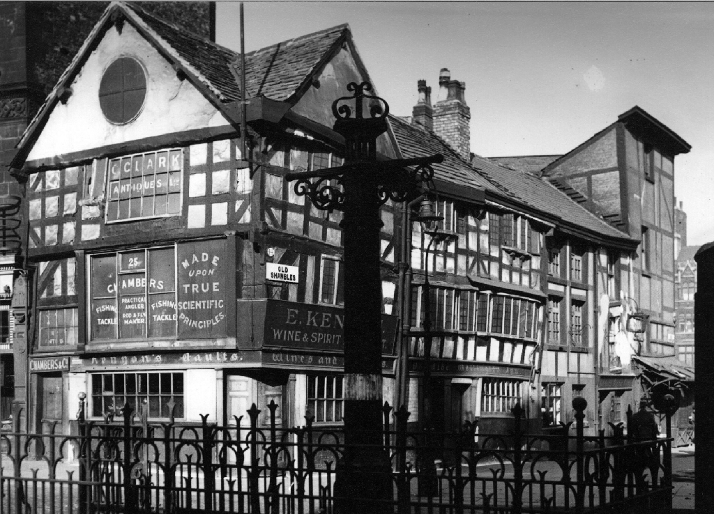
Image of the site in 1946 (Manchester Archives)

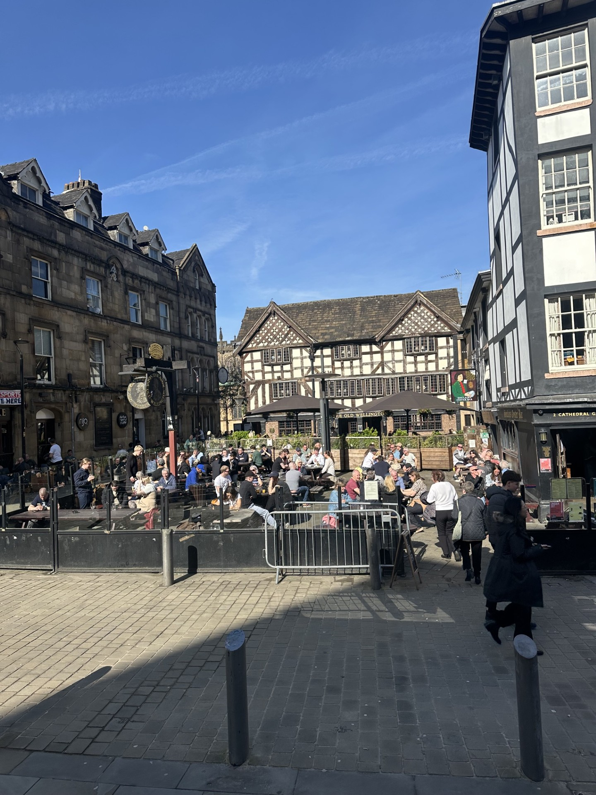
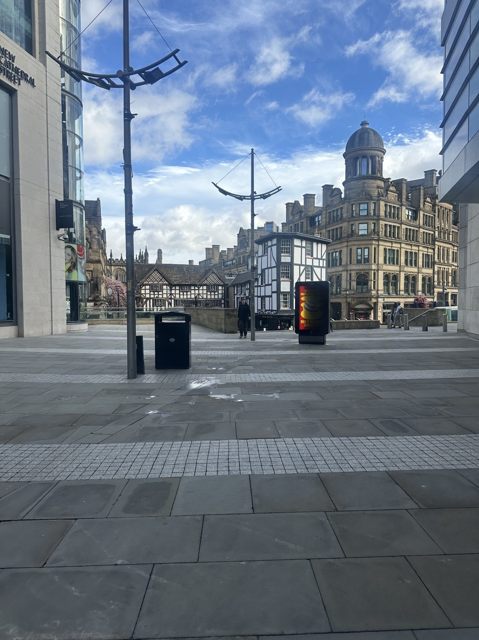
Images if site when viewed from New Cathedral Street and from Cateaton Street.

Description of area

The site is located within the Exchange Square area. The area is defined by a high
concentration of Class E uses, primarily retail, food and beverage and leisure uses. Printworks
and the Arndale Shopping Centre are nearby.

The site is within the Cathedral Conservation Area. Listed buildings including the Corn
Exchange (Grade II), Mynshulls House (Grade II), and Victoria Bridge (Grade II) and the
Cathedral Church of St Mary (Grade I), are nearby to the site

Description of development

Listed Building Consent is sought for the application of water-based silicone liquid to the entirety of the external timbers present on the site. No rot, water or other form of weather damage was observed on site or nor was a condition survey submitted for consideration as part of the application.

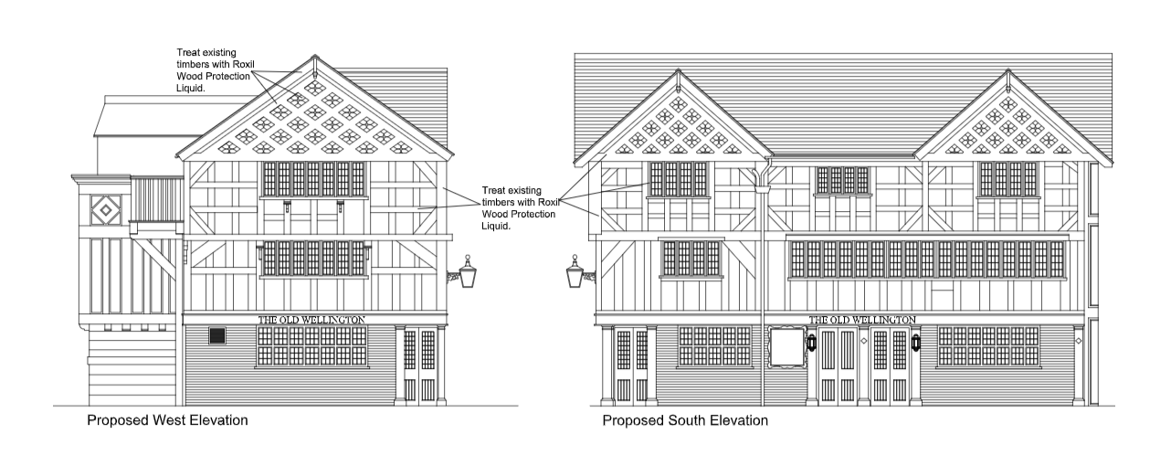

Planning History

052328/LO/CITY1/97 | LISTED BUILDING CONSENT: Demolition of 2no. public
houses prior to re-erection and extension. (Approved August 1997)

112634/LO/2016 | Listed Building Consent for external alterations involving redecoration of window, new external lantern to replace existing and a new pair of half glazed doors.(Approved December 2016)

115755/LO/2017 | LISTED BUILDING CONSENT for the installation of new double doors within existing structural opening on side elevation following removal of existing doors. (Approved May 2017)

144897/LO/2026 | Listed Building Consent for the repair and replacement of historic timbers to external platform. (Approved March 2026)

145051/LO/2026 | LISTED BUILDING CONSENT for the installation of 1no. projecting sign at the rear elevation, and alterations to existing external seating area including fixing of 2no. existing jumbo parasols with associated heating and lighting, and installation of power supply beneath existing paving. (Under Consideration)

Consultations & Notification Responses
Publicity
A site notice was posted, and letters have been sent to surrounding occupiers. No representations have been received.

Heritage England – No comment.

Policy

The following policies are relevant to consideration of this application within the development
plan:

Manchester Core Strategy (2012-2027)
DM1 Development Management
EN3 Heritage
CC9 Design and Heritage

Places for Everyone Joint Development Plan (2024-2039)
JP-P2 Heritage

Saved Unitary Development Plan Policies
DC19 Listed Buildings
DC18 Conservation Areas

Other Material Considerations:

National Planning Policy Framework
Chapter 16 Conserving and enhancing the historic environment

Historic England – Conservation Principles, Policies and Guidance

Planning (Listed Buildings and Conservation Areas) Act 1990
Sections 16 and 17

Issues

Principle of Development

Multiple applications have been made for upkeep and improvement works to the application site in 2026. The council has taken the position that justified remedial works are acceptable provided the impact of the development is outweighed by its public benefits. A similar application, for remediation of wood rot on the non-original timber mezzanine at rear was recently approved after careful review of the condition of the structure, the proposal and it’s impact.

Maintenance of an asset with high significance to facilitate it’s continued use, is acceptable under Chapter 16 of the National Policy Framework. However, there is insufficient information about the public benefits, impact of the proposal and no justification for works was provided, as such the proposal is not considered to be acceptable in principle for the reasons set out in detail below.
Impact of the proposal

Having noted the value provided by the application site in its present form, and its status as a Grade II listed building, the applicant was required to evidence the need for the intervention, the expected visual impact of the intervention, and it’s reversibility.

Historic England’s Conservation Principles Policies and Guidance, state that intervention may be justified if ‘it increases understanding of the past, reveals or reinforces particular heritage values of a place, or is necessary to sustain those values for present and future generations,
so long as any resulting harm is decisively outweighed by the benefits’. The proposal would not reveal or reinforce the historic value of the site; thus, for an approval to be issued the development must be considered necessary to sustain the site’s value for future generations, with harm outweighed by public benefits.

No evidence has been provided by the applicant that the proposed intervention is necessary to maintain the site. A survey of rot and damage was not presented to the Local Planning Authority as part of the submission. Moreover, when a site visit was conducted to review the building’s façade and determine any areas of rot or damage that would require remediation, none were found. Instead, the building façade’s appeared to be in good condition, with the aged oak material taking on a silver appearance due to weathering.

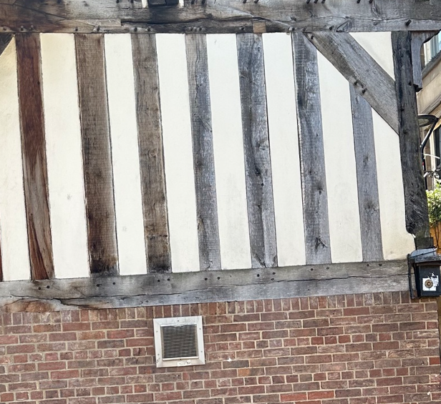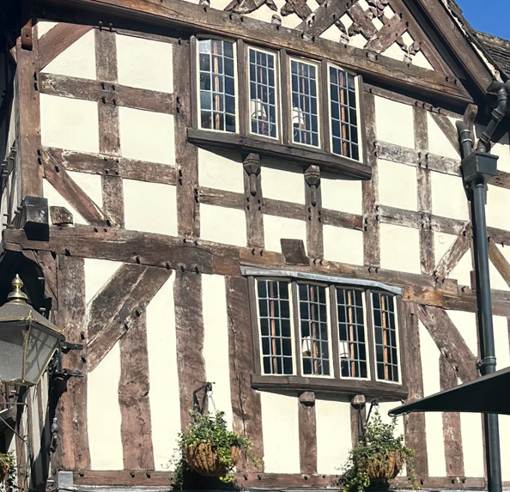
Detail images of timber condition at rear and front.

Policy DC19 states that development should not be permitted where there would be an adverse impact on the architectural or historic character of a site. The external timber positively contributes to the site’s historic and aesthetic value, a non-reversible intervention like that which is proposed would need to be well-evidenced as beneficial to the long-term conservation and stewardship at the site. There is no supporting information that evidences this. The impact of the treatment would likely change the appearance of the facades. The proposed treatment liquid, Roxil, is recommended for softwood, Oak is a hardwood, as such there remains significant questions about the suitability of the treatment, the impact on the appearance and the durability of the treatment when applied to a hardwood.

Further, it should be noted that timber treatments should be employed when there is existing evidence of water damage, because the treatment liquid itself as a sealant would trap moisture within the historic timber, the harm must be mitigated by the risks of damage should no intervention take place. In this case, moisture would be trapped when there is no evidence of water damage, thereby making the 16th century façade vulnerable to rot. This would also be contrary to the provisions of policy DC19, Chapter 16 of the National Planning Policy Framework and policy JP-P2.

Due to the lack of details of the proposed methods, and their impact on the asset the City Council, as Local Planning Authority is unable to assess the level of harm to the asset as set out in paragraph 208 of the National Planning Policy Framework.

Conclusion

Given the details outlined above, the Local Planning Authority is unable to sufficiently assess the development proposal, which would impact areas of the site that contribute to it’s historic, aesthetic and social value, for these reasons the development should be refused as contrary to the requirements of Saved UDP policy DC19, Core Strategy policies DM1, CC9 and EN3, Places for Everyone policy JP-P2, the Historic England – Conservation Principles, Policies and Guidance document, the NPPF, and the Planning (Listed Buildings and Conservation Areas) Act 1990.

Other Legislative Requirements

Equality Act 2010
Section 149 (Public Sector Equality Duty) of the Equality Act 2010 requires due regard to the need to: Eliminate unlawful discrimination, harassment and victimisation and other conduct prohibited by the Act and; Advance equality of opportunity between persons who share a protected characteristic and persons who do not share it. The Equality Duty does not impose a legal requirement to conduct an Equality Impact Assessment. Compliance with the Equality Duty involves consciously thinking about the aims of the Equality Duty as part of the process of decision-making.

Human Rights Act 1998 considerations
This application needs to be considered against the provisions of the Human Rights Act 1998. Under Article 6, the applicants (and those third parties, including local residents, who have made representations) have a right to a fair hearing and to this end the local planning authority must give full consideration to their comments.

Protocol 1 Article 1, and Article 8 where appropriate, confer(s) a right of respect for a person’s home, other land and business assets. In taking account of all material considerations, including Council policy as set out in the Core Strategy and saved polices of the Unitary Development Plan, the Director of Planning, Building Control & Licensing has concluded that some rights conferred by these articles on the applicant(s)/objector(s)/resident(s) and other occupiers and owners of nearby land that might be affected may be interfered with but that that interference is in accordance with the law and justified by being in the public interest and on the basis of the planning merits of the development proposal. She believes that any restriction on these rights posed by the recommendation given is proportionate to the wider benefits of and that such a decision falls within the margin of discretion afforded to the Council under the Town and Country Planning Acts.

Recommendation: Refuse

Article 35 Declaration
In assessing the merits of a planning application, officers will seek to work with the applicant in a positive and proactive manner to seek solutions to problems arising in relation to dealing with the planning application. All such issues have been resolved due to the discussions within the applicant and the conditions.

Reasons for recommendation to refuse

- The application has failed to provide a clear and convincing justification for the proposed treatment of the timbers. The submitted drawings, documents and heritage assessment lack the necessary details to fully justify the proposed intervention in order to demonstrate that the works are necessary and to allow an assessment of the level of harm to the significance of the asset (and accordingly where harm does arise, that the necessary public benefits exist). On this basis the proposal is considered to be contrary to the provisions of Places for Everyone Policy JP-P2, The Manchester Core Strategy policies EN3, DM1, and CC9, Saved Unitary Development Plan Policy DC19, the National Planning Policy Framework Chapter 16 and the Planning (Listed Buildings and Conservation Areas) Act 1990.

Appendix 1 – List of consultees & neighbours notified

Heritage & Urban Design
Historic England (North West)

Sinclairs Oyster Bar, 2 Cathedral Gates, Manchester, M3 1SW
Old Wellington Inn, 4 Cathedral Gates, Manchester, M3 1SW
4 - 8 Cateaton Street, Manchester, M3 1SQ
Mitre Hotel, 1 - 3 Cathedral Gates, Manchester, M3 1SW
Manchester Cathedral, Victoria Street, Manchester, M3 1SX
Top Flat, 6 Cateaton Street, Manchester, M3 1SQ

Appendix 2 – Planning constraints

Article 4 Direction - Removal Of PD Rights Change Of Use From Class C3 To Class C4
Article 4 Direction - City Centre PD Restriction - Class B1(a) To C3
Coal Authority - Development Low Risk - Name: DEVELOPMENT_LOW_RISK_AREA
Conservation Area - Cathedral Conservation Area 1972
Area Team Boundary - Name: CENTRAL

