
Habitat Management and Monitoring Plan
Site Name: | Heatherdale Drive, Manchester
Date: | 08/05/2026
Version: | Final
Author:
Anthony Nickson
Ecologist
Anthony Nickson Ecology Ltd
Suite 10,
Southworth Business Suites,
Southworth Road,
Newton-Le-Willows,
WA12 0HS
anthony@anecology.com
07921571823

Client:
Claire Gallagher
Mosscare St Vincent's (MSV) Housing Group Limited
7th Floor, Trafford House,
Chester Road,
Stretford,
Manchester,
M32 0RS
Claire.gallagher@msvhousing.co.uk
07398709953

Contents
1. Project Background 2
Summary of Management Plan 3
Site Boundary Plan PB-F01 4
Site Context Plan PB-F02 5
Phasing strategy 6
Roles and Responsibilities 6
Land Use Summary 8
Site Context Photos PB-F03 8
Site Baseline, Environmental Information and Associated Impacts Checklist PB-T01 9
2. Planned Management Activities 11
Principles Informed by Design Stage 11
Habitat and Condition Targets PM-T01 12
Habitat Retention 13
Habitat Retention Plan PM-F01 13
Grassland (Low Distinctiveness) 14
Creation, Enhancement and Management Summary (GL-T01) 14
Grassland (Low Distinctiveness) 17
Creation, Enhancement and Management Detailed Methods (GL-T02) 17
Grassland (Low Distinctiveness) Species Lists (GL-T03) 18
Other Supporting Information 18
What Does Success Look Like? (GL-F01) 19
Individual Trees 20
Creation, Enhancement and Management Summary (UT-T01) 20
Individual Trees 21
Creation, Enhancement and Management Detailed Methods (UT-T02) 21
Individual Trees Species Lists (UT-T03) 22
What Does Success Look Like? (UT-F01) 23
Habitat Creation and Management – Risk Register and Remedial Measures PM-T02 24
3. Monitoring Schedule 25
Monitoring Strategy 25
Monitoring Methods and Intervals MS-T01 26
Monitoring Reports 27
Adaptive Management 28

Version Control
The version control is used for updates to the content. Record the initial version and further version control details in this table each time the management plan is altered throughout the management and monitoring period.
Version | Issue Status | Prepared by / Date | Approved by / Date
01 | Draft | Anthony Nickson | Joanne Hughes

Document Details
Provide ownership, copyright and licensing information within this table.
Authorship Details
MSV Housing Group Limited,
7th Floor, Trafford House,
Chester Road,
Stretford,
Manchester,
M32 0RS

Project Background
Summarise the key aspects of your management plan in this section. Table PB-B01 can be extended to suit the specific needs of individual projects.
Site Overview PB-B01
Project type | On-site
Development Name and Address | Heatherdale Drive, Manchester  Land to the south of Alderford Parade, the east of Waterloo Road, the north of Deerhurst & Dinnington Drive and the south of Tamerton Drive & land to the west of Starmoor Drive & the north and east of Heatherdale Drive, Manchester
BNG Project Name and Address | As above
Author Organisation | Anthony Nickson  Ecologist  Anthony Nickson Ecology, Suite 10, Southworth Business Suites, Southworth Road,  Newton-le-willows, Merseyside, WA12 0HS
Landowner | MSV Housing Group Limited,  7th Floor, Trafford House,  Chester Road,  Stretford,  Manchester,  M32 0RS
Land Manager | MSV Housing Group Limited,  7th Floor, Trafford House,  Chester Road,  Stretford,  Manchester,  M32 0RS
Responsible person/organisation for creating or enhancing the habitat | J Greenwood (Builders) Limited,  No1 Howarth Court, 2nd Floor,  Chadderton,  Oldham,  OL9 9XB
Period covered by this management plan | 30+ years from construction completion
Planning authority | Manchester City Council
Planning reference (if applicable) | 140867/FO/2024
BNG register reference (if applicable) | N/A
Central OS grid reference | SD 84040 00669
Metric revision/title | Heatherdale Drive Statutory Biodiversity Metric Tool, V4, E3P, 01 October 2024
Are any Irreplaceable Habitats present onsite | Yes: ☐ No: ☒

Summary of Management Plan
Habitats to be Retained, Created and Enhanced PB-B02
Retained Habitats: Urban tree.
Created: Introduced shrub, modified grassland, urban tree and vegetated garden.
Enhanced: No habitats enhanced.
Timescales for Actions PB-B03
The actions set out within this HMMP will be undertaken over a 30-year period following completion of the proposed development, in line with BNG requirements.
Monitoring Requirements PB-B04
Habitat development will be monitored to ensure the required habitat condition criteria by a suitably qualified ecologist (SQE) as per the monitoring schedule.
The SQE will be at least a FISC Level 3 botanist and attended a Biodiversity Net Gain and UK Habitats Classification course or similar.
Required Consents and Licences PB-B05
N/A
Funding PB-B06
The proposed habitats will be created/provided as part of the redevelopment of the site to construct 70 no. two and three storey dwellings (consisting of 44 no. houses and 26 no. apartments).
The ongoing management of the habitats within the site will be set out in this HMMP will be delivered by MSV Housing Group Limited.
Legal Agreement PB-B07
The proposed measures relate entirely to land within the site boundary under the ownership of MSV Housing Group Limited and no legal provisions are required. The HMMP will be implemented as part of the planning permission for the site and accordingly, no further legal agreements are known to be required in order to secure the delivery of the document.

Site Boundary Plan PB-F01
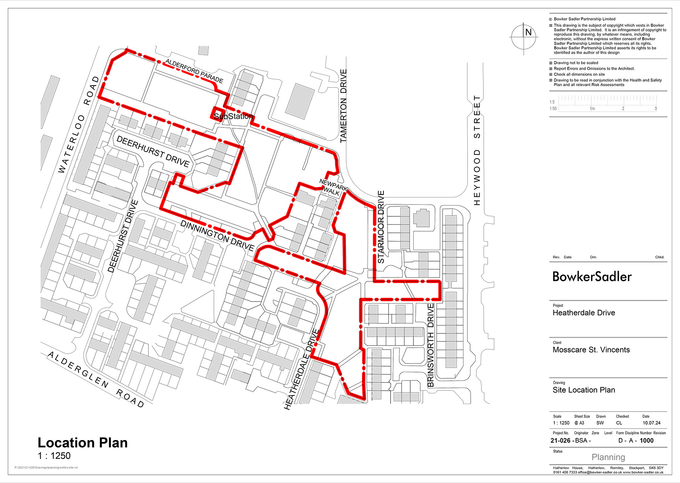

Site Context Plan PB-F02
This plan should show the location of the site, including the LPA, boundary, national character area, and any relevant landscape scale policy or guidance information.
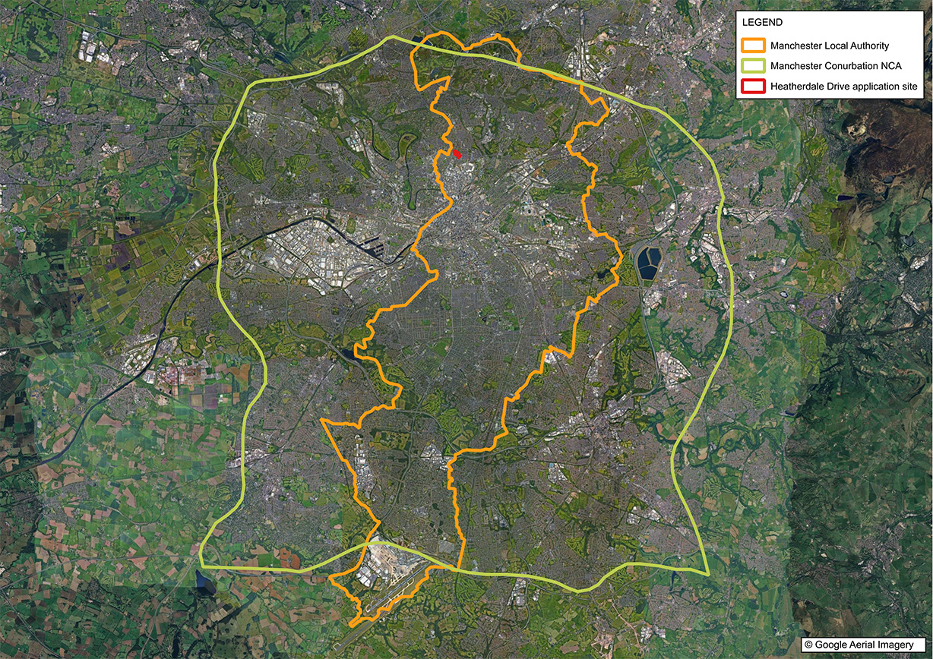

Phasing strategy
Will the proposed work measures be delivered in phases? PB-B08 | Yes: ☐ No: ☒
The scheme will be provided in 3 phases as per the proposed phasing plan below:
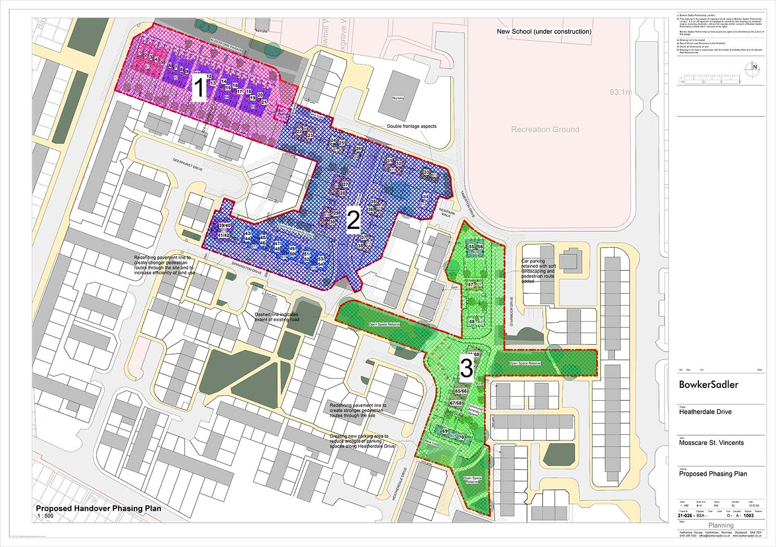

Roles and Responsibilities
Provide details of the responsible persons and organisation(s) for delivering this management plan.

Ecologist or Other Professional Responsible for HMMP PB-B09
Name or Initials |  | Anthony Nickson
Organisation |  | BDP
Responsibility | Start Date: | 01/12/2025 | End Date: | 30/01/56
Responsibility for the production of the HMMP.
Statement of Competency
Anthony Nickson MSc MCIEEM is the author of this document. Anthony has worked as ecologist for over 16 years’ and during that time has authored numerous habitat management plans for projects similar to the Heatherdale Drive project containing similar management prescriptions and monitoring schedules.

Landowner or Land Manager PB-B10
Name or Initials |  | Claire Gallagher
Organisation |  | MSV Housing Group Limited
Responsibility | Start Date: | 30/01/26 | End Date: | 30/01/56
MSV Housing Group Limited as the landowner willingly take on the responsibility for ensuring the implementing of the HMMP.
Statement of Competency
MSV Housing Group Limited owns and manages nearly 9,000 homes across Greater Manchester, Lancashire and West Yorkshire in the Northwest of England. The organisation carries out the management and maintenance of open and communal spaces via the inhouse maintenance team and approved contractors where specialist services are required.

Management Organisation(s) Responsible for Implementing the HMMP PB-B11
Name or Initials |  | Claire Gallagher
Organisation |  | MSV Housing Group Limited
Responsibility | Start Date: | 30/01/26 | End Date: | 30/01/56
MSV Housing Group Limited will be responsible for carrying out the direct implementation of the HMMP.
Statement of Competency
MSV Housing Group Limited owns and manages nearly 9,000 homes across Greater Manchester, Lancashire and West Yorkshire in the Northwest of England. The organisation carries out the management and maintenance of open and communal spaces via the inhouse maintenance team and approved contractors where specialist services are required.

LPA or Responsible Body for Reviewing HMMP PB-B12
Name or Initials |  | TBC
Organisation |  | Manchester City Council / GMEU???
Responsibility | Start Date: |  | End Date:
Summarise the agreed relevant responsibilities of the LPA or Responsible Body in the review, auditing and, or, long-term involvement in the implementation of this HMMP (if applicable)

Land Use Summary
Overview of Baseline Site Use PB-B13
The site is located in Cheetham Hill on public open space within an existing residential development comprising predominately modified grassland and other developed land with urban trees and small areas of bare ground.
Overview of Proposed Site Use PB-B14
The proposed site will comprise 70 no. two and three storey dwellings (consisting of 44 no. houses and 26 no. apartments) together with landscaping works that will comprise retained trees and new tree planting, introduced shrub, modified grassland, vegetated garden and other developed land.
The retained and new habitats will be managed in line with existing habitat practices across the wider MSV Housing Group Limited estate.

Site Context Photos PB-F03
Please include two overview photographs of the site in its current form here. Include additional photographs in an appendix if needed. Tick if additional photographs are provided in the Appendices ☐ Reference: Click or tap here to enter text.
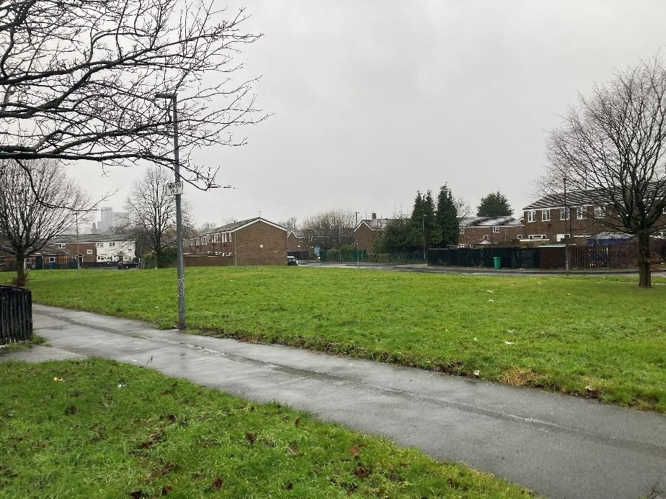
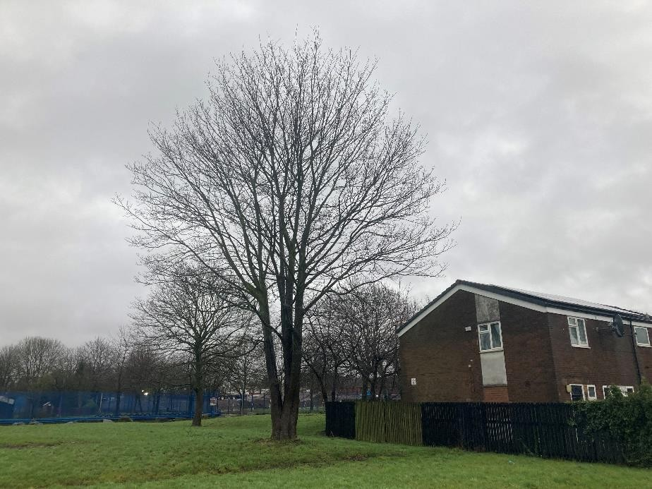

Site Baseline, Environmental Information and Associated Impacts Checklist PB-T01
Consider the Baseline and Environmental Information listed below. These are likely to be appropriate factors informing your proposals and project design. They can provide the reviewer with important contextual information for the management prescriptions provided later in this document. Use your professional judgement to determine which factors are relevant to your specific project.
Please use the check box to indicate which are included in your plan. For any not included, provide brief reasons why the factor is not relevant to your project using your professional judgement. Where this information is provided elsewhere, you can reference existing reports and, or, plans that have informed your decisions. For the templates for each heading see pages 3-20 of the Companion Document.
Baseline and Environmental Information | Prompts for when these may be relevant.  This is not an exhaustive list. Use your professional judgement to determine which are required for your HMMP | Check box if included | Document Reference or Reason if not included
Statutory / Non-statutory Designated Sites | No | ☐
Protected and Notable Species | No | ☐
Invasive Non-Native Species (INNS) | No
Biological Records Plan - Sites and Species | No | ☐
Baseline Habitats Survey | Yes | ☒ | Heatherdale Drive, Cheetham Hill Preliminary Ecological Appraisal Report  (Reference:80-924-R1-1), E3P, February 2024
Public Access | No | ☐
Climate | No | ☐
Geology and Topography | No | ☐
Agricultural Land Status | No | ☐
Soils and Substrates | No | ☐
Contaminated Land | No | ☐
Hydrology and Drainage | No | ☐
Flood Risk Zones | No | ☐
Landscape Character and Designations | No | ☐
Historic Land Use | No | ☐
Historic Environment and Earth Heritage | No | ☐
Other – please specify | N/A | ☐

Planned Management Activities
Provide the site-wide aims and objectives. These should consider the Project Background information section outlined above as well as the outcomes of the Metric.
Management Plan Aims and Objectives PM-B01
The aim of the HMMP is to secure the protection and enhancement of nature conservation interests within the application site through the adoption of a coherent approach to the management and maintenance of the retained and proposed ecological features and soft landscaping for a period of at least 30 years.
The objectives of the HMMP are as follows:
- To ensure provision and establishment of new habitats;
- To ensure long-term management of retained and new habitats to maintain and increase diversity and offer suitable habitat for local wildlife; and
- To provide and maintain visual value within the site for the local community.

Principles Informed by Design Stage
The project's BNG target(s) should be set and documented early in the design process. Outline how background and baseline information influenced key design principles for the project from an early stage. This can provide useful context for the proposed retention, creation and enhancement measures.
Design Principles Informed by Baseline Information PM-B02
Due to the majority of green space on site being private amenity space, biodiversity has been enhanced in public green spaces and shared amenity spaces. See landscaping GA plans (345-01 & 345-02) and detailed planting plans (345-04 & 345-05).

Habitat and Condition Targets PM-T01
This table presents a summary record of what you have agreed to deliver based on the biodiversity metric. These habitat condition targets form the basis of what the management plan is setting out to achieve. Include the relevant ‘Area’, ‘Hedgerow’, and ‘Watercourse’ types to be implemented and managed throughout the period of 30 years or more.
Baseline Habitat Type | Target Habitat Type | Parcel / Feature Refs | Baseline Condition | Targeted Condition | Years to Targeted Condition | Condition Assessment Targets | Comments
Baseline habitat will be cleared site following enabling works and new habitat provided as per detailed planting proposals. | Grass  (modified grassland) | Heatherdale Drive Landscape GA Plans (drawings 345-01-D and 345-02-D), Saville Landscape Design, October 2022 | N/A | Moderate | 4 | - There are 6-8 vascular plant species per m2 present, including at least 2 forbs.  - Any scrub present accounts for less than 20% of the total grassland area.  - Physical damage is evident in less than 5% of total grassland area.  - Cover of bare ground is between 1% and 10%, including localised areas.  - Cover of bracken is less than 20%.  - There is an absence of invasive non-native plant species. | N/A
Baseline habitat will be cleared site following enabling works and new habitat provided as per detailed planting proposals. | Tree  (urban tree) | Heatherdale Drive Landscape GA Plans (drawings 345-01-D and 345-02-D), Saville Landscape Design, October 2022 | N/A | Moderate | 27 | - The tree is a native species (or at least 70% within the block are native species).  - There is little or no evidence of an adverse impact on tree health by human activities. And there is no current regular pruning regime, so the trees retain >75% of expected canopy for their age range and height.  - More than 20% of the tree canopy area is oversailing vegetation beneath. | N/A
Baseline habitat will be cleared site following enabling works and new habitat provided as per detailed planting proposals. | Grass and shrub planting in private gardens  (vegetated garden) | Heatherdale Drive Landscape GA Plans (drawings 345-01-D and 345-02-D), Saville Landscape Design, October 2024 | N/A | N/A | 1 | N/A | N/A
Baseline habitat will be cleared site following enabling works and new habitat provided as per detailed planting proposals. | Ornamental shrub and specimen shrub planting  (introduced shrub) | Heatherdale Drive Landscape GA Plans (drawings 345-01-D and 345-02-D), Saville Landscape Design, October 2024 | N/A | N/A | 1 | N/A | N/A

Habitat Retention
Provide a concise description of the habitats that are to be retained in their baseline condition. Habitats being retained may still require ongoing measures to maintain their baseline condition.
Measures to be Implemented to Protect Retained Habitats PM-03
19 no. urban trees proposed for retention.
Refer to:
- Heatherdale Drive, Cheetham Hill Site 1 (TRE/HDCHS1) Arboricultural Method Statement, Mulberry Tree Management, October 2024
- Heatherdale Drive, Cheetham Hill Site 2 & 3 (TRE/HDCHS2A3) Arboricultural Method Statement, Mulberry Tree Management, October 2024

Specification of Protective Measures to be Used PM-04
Refer to:
- Heatherdale Drive, Cheetham Hill Site 1 (TRE/HDCHS1) Arboricultural Method Statement, Mulberry Tree Management, October 2024
- Heatherdale Drive, Cheetham Hill Site 2 & 3 (TRE/HDCHS2A3) Arboricultural Method Statement, Mulberry Tree Management, October 2024

Habitat Retention Plan PM-F01
Provide a plan with the locations of habitats to be retained (including whether to be protected and, or, enhanced) and those to be created under this HMMP. Include parcel references if needed. Tick box if any additional plans are provided in the Appendices ☐ . Reference: Click or tap here to enter text.
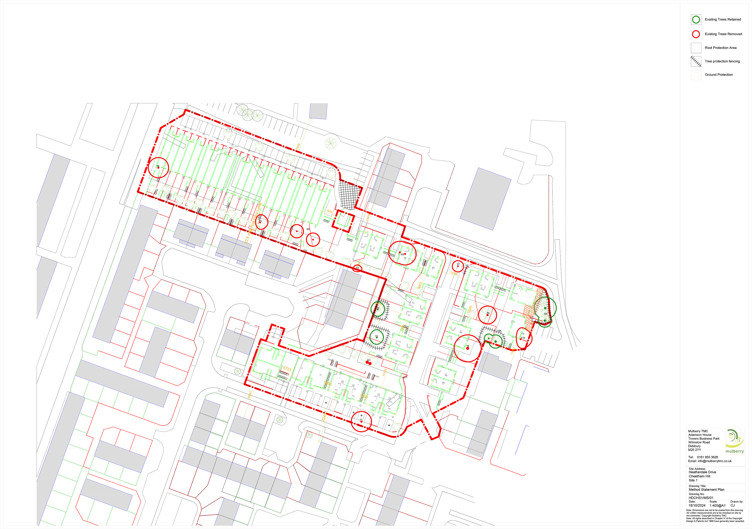
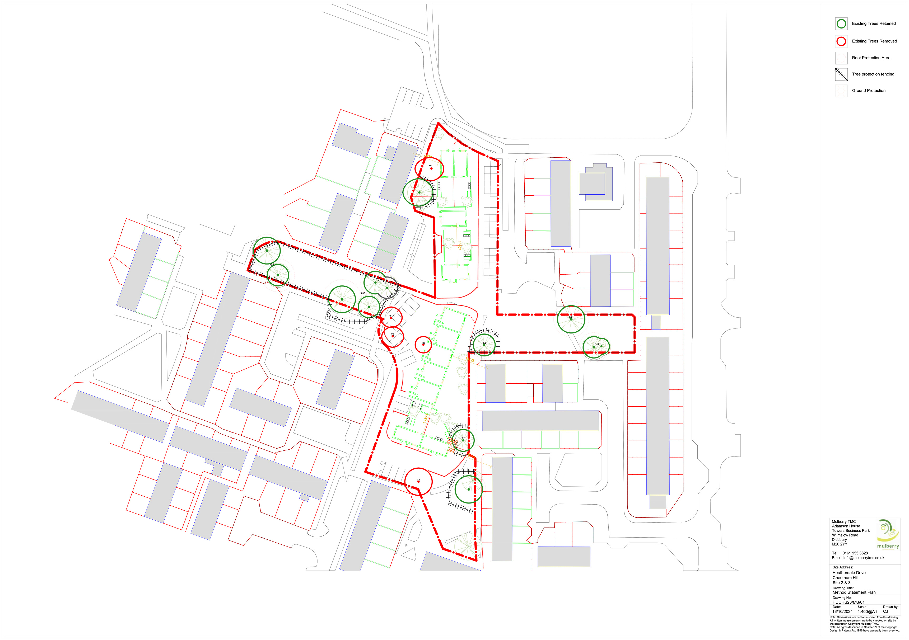

Grassland (Low Distinctiveness)

Creation, Enhancement and Management Summary (GL-T01)
Provide details of the approach to delivering each of the targeted condition criteria and habitat. Conditions from Statutory Biodiversity Metric habitat condition assessment sheets – Sheet 5. Grassland Low
Target Habitat: |  |  | Modified grassland - good condition
Condition Assessment Criteria |  | Targeted | Relevant Parcels | Creation Approach | Enhancement Approach | Management Approach
A | There are 6-8 vascular plant species per m² present, including at least 2 forbs.  Note - this criterion is essential for achieving Moderate or Good condition.  Where the vascular plant species present are characteristic of medium, high or very high distinctiveness grassland, or there are 9 or more of these characteristic species per m², please review the full UKHab description to assess whether the grassland should be classified as a higher distinctiveness grassland. Where a grassland is classed as medium, high or very high distinctiveness, please use the relevant condition sheet. | Yes | All Lawn Areas | Lawn grass mix will comprise ~ 4 grass species with additional amenity grassland forbs included in the mix which were identified in the existing sward. These will include meadow buttercup (Ranunculus acris), ribworth plantain (Plantago lanceolata), selfheal (Prunella vulgaris), white clover (Trifolium repens) and yarrow (Achillea millefolium). | N/A | The lawn will be subject to a regular management regime consistent with the existing modified grassland management and 6-8 species per m² will be maintained.
B | Sward height is varied (at least 20% of the sward is less than 7 cm and at least 20 per cent is more than 7 cm) creating microclimates which provide opportunities for vertebrates and invertebrates to live and breed. | No | All Lawn Areas | N/A | N/A | N/A
C | Any scrub present accounts for less than 20% of the total grassland area. (Some scattered scrub such as bramble Rubus fruticosus agg. may be present).  Note - patches of scrub with continuous (more than 90%) cover should be classified as the relevant scrub habitat type. | Yes | All Lawn Areas | N/A |  | The lawn will be subject to a regular management regime. Passing the scrub criterion is expected in managed modified grassland, as regular mowing prevents woody species from establishing.
D | Physical damage is evident in less than 5% of total grassland area Examples of physical damage include excessive poaching, damage from machinery use or storage, erosion caused by high levels of access, or any other damaging management activities. | Yes | All Lawn Areas | N/A |  | The lawn will be subject to a regular management regime. Passing the physical damage criterion is expected in amenity managed modified grassland, as the habitat will not typically be subject to trampling, poaching or machinery damage, and any such impacts will be rectified through the routine maintenance.
E | Cover of bare ground between 1% and 10%, including localised areas (for example, a concentration of rabbit warrens.) | Yes | All Lawn Areas | N/A |  | Bare ground expected to be between 1% and 10%,
F | Cover of bracken Pteridium aquilinum less than 20%. | Yes | All Lawn Areas | N/A |  | The lawn will be subject to a regular management regime. Passing the bracken criterion is expected in managed modified grassland, as regular mowing prevents bracken from establishing.
G | There is an absence of invasive non-native species (as listed on Schedule 9 of WCA). | Yes | All Lawn Areas | N/A |  | The lawn will be subject to a regular management regime. Passing the invasive non-native species (INNS) criterion is expected in managed modified grassland, as regular mowing prevents INNS from establishing.

Additional Management Prescriptions (GL-B01)
Maintenance of grassed areas shall include mowing, watering as necessary to saturate soil below, trimming edges to pavings & planted areas at every cut, removing all debris & stones over 30mm in size, prior to mowing, weeding by cultivating, forking hoeing & raking & re-seeding any portions considered necessary & removing from site all debris & stones created by the operations.
Grass to be cut fortnightly throughout growing season to height between 25-30mm & remove clipping to tip (April to October) Any areas of grass where bulbs are planted must not be mown until leaves turn yellow or show signs of die-back. Spike and scarify periodically to promote free drainage and remove moss and thatch. In drought conditions the following modifications to specified mowing operations shall be implemented: Cutting heights shall be raised to 45mm, mowing shall only continue so long as grass growth continues to reach maximum advisable height.

Grassland (Low Distinctiveness)

Creation, Enhancement and Management Detailed Methods (GL-T02)
Provide detailed prescriptions for the creation and management of the habitat.
Action | Relevant Parcels | Timing | Prescriptions
Ground preparation | All Lawn Areas | Ideally Autumn or spring | Ground preparation is essential to successful establishment of grassland habitats. Prior to sowing, a good quality seed.  Bed should be prepared by: removing weeds, ploughing the substrate to turn the surface vegetation, harrowing or raking to produce a medium tilth and then rolling or treading to produce a firm surface.  Seed should be sown in the autumn or spring but can be sown at other times of the year if there is sufficient warmth and moisture. The seed must be surface sown and can be applied by machine or broadcast by hand. To ensure an even  distribution and cover, seed should be divided into two or more parts and sown in overlapping sections. Avoid incorporating or covering the seed. Instead, firm in with a roll or by treading to give good soil/seed contact.
First year management | All Lawn Areas | As prescription | • The grass and forb species in this mix are perennial; they will be slow to germinate and grow and will not usually flower in their first growing season. There will often be a flush of annual weeds from the soil in the first growing season. This annual weed growth is easily controlled by repeated mowing.  • Mow newly sown flowering lawns regularly (every 7 -10 days during growing season) throughout the first year of establishment. Cut to a height of 40-60mm, removing cuttings if dense. This will gradually develop a good sward structure, help maintain balance between faster growing grasses and slower developing forbs, and control annual weeds. Dig out any residual perennial weeds such as docks.
Management once established | All Lawn Areas | As prescription | • Mow regularly as a lawn but not too short (~40mm). To permit flowering, mowing can be relaxed from May. Cut again when the sward gets untidy (after 4-8 weeks).. Heavy quantities of cuttings should be collected and removed from site.

Grassland (Low Distinctiveness) Species Lists (GL-T03)
Provide a detailed species list for the habitat to be created.
Common Name | Scientific Name | Abundance / % | Comments
Red Fescue | Festuca rubra | 45.0%
Perennial Ryegrass | Lolium perenne | 25.0%
Smooth-stalked Meadow-grass | Poa pratensis | 20.0%
Common Bent | Agrostis capillaris | 4.0%
Ribwort Plantain | Plantago lanceolata | 2.0%
Meadow Buttercup | Ranunculus acris | 1.0%
Selfheal | Prunella vulgaris | 1.0%
Yarrow | Achillea millefolium | 1.0%
White Clover (ag) | Trifolium repens | 0.5%
Dandelion | Taraxacum officinale | 0.5%

Other Supporting Information
Supporting Information (GL-B02)
N/A

What Does Success Look Like? (GL-F01)
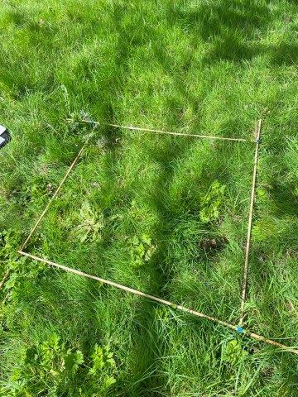  Existing ‘good’ condition modified grassland | 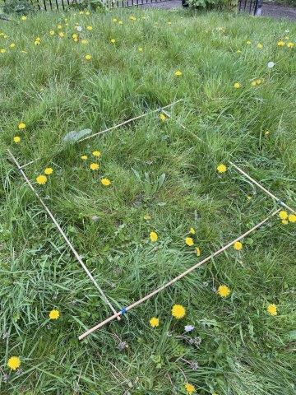  Existing ‘good’ condition modified grassland

Individual Trees

Creation, Enhancement and Management Summary (UT-T01)
Provide details of the approach to delivering each of the targeted condition criteria and habitat. Conditions from Statutory Biodiversity Metric habitat condition assessment sheets – Sheet 9. Individual Trees
Target Habitat: |  |  | Individual trees - poor condition
Condition Assessment Criteria |  | Targeted | Relevant Features | Creation Approach | Enhancement Approach | Management Approach
A | The tree is a native species (or more than 70% within the block are native species). | No | Proposed urban trees | Native  7 no. Acer campestre, 11 no. Betula pendula, 11 no. Prunus padus and 3 no. Sorbus aucuparia.  Non-native  12 no. Betula pendula ‘Fatigiata’, 7 no. Pyrus calleryana ‘Chanticleer’ and 4 no. Prunus ‘Sunset Boulevard’. | N/A | N/A
B | The tree canopy is predominantly continuous, with gaps in canopy cover making up <10% of total area and no individual gap being >5 m wide (individual trees automatically pass this criterion). | No | Proposed urban trees | Not achievable based on proposed locations of trees. | N/A | N/A
C | The tree is mature (or more than 50% within the block are mature). | No | Proposed urban trees | Young trees do not meet criteria. | N/A | N/A
D | There is little or no evidence of an adverse impact on tree health by human activities (such as vandalism, herbicide or detrimental agricultural activity). And there is no current regular pruning regime, so the trees retain >75% of expected canopy for their age range and height. | Yes | Proposed urban trees | N/A | N/A | Trees managed to retain >75% of expected canopy.
E | Natural ecological niches for vertebrates and invertebrates are present, such as presence of deadwood, cavities, ivy or loose bark. | No | Proposed urban trees | Young trees do not meet criteria. | N/A | N/A
F | More than 20% of the tree canopy area is oversailing vegetation beneath. | Yes | Proposed urban trees | 20% of canopies oversailing vegetation beneath. | N/A | N/A

Individual Trees

Creation, Enhancement and Management Detailed Methods (UT-T02)
Provide detailed prescriptions for the creation and management of the habitat.
Action | Relevant Features | Timing | Prescriptions
Establishment | Proposed urban trees | As per prescription. | • Trees shall be positioned in compliance with the original specification for the site. Any replacements required should be provided in the first dormant period as appropriate. Tree pits and planting shall be undertaken to the original specification standard.  • Tree planting should be undertaken between November and March whilst trees are dormant.  • Prior to planting, the vegetation within the planting area should be weeded, as required, to reduce competition for water and nutrients.  • During periods of dry weather, the ground surrounding the tree should be sufficiently saturated at each visit to allow water to fully penetrate the rooting zone.  • Damaged, diseased, or dead wood should be pruned immediately after first leaf break.  • Replace dead, dying or damaged stock with the same species as soon as practicable in the first planting season following failure.  • Regular monitor to make sure guards, canes and/or stakes are upright and pushed firmly into the soil, particularly after periods of strong winds or storms. Pull up any grass growing inside the guard and loosen tree ties as the tree grows to prevent damage to stems.
Years 1 -3 | Proposed urban trees | N/A | • A 1m radius around the tree should be kept clear of weeds and grass by hand pulling. Alternatively, weeds can be suppressed with adding additional mulch, such as bark chips or straw bales. Apply it to a depth of around 10cm to prevent it being blown away or dispersed and top up annually.  • When mulching or weeding isn’t appropriate, chemical-based products may have to be used to suppress weeds. Spray around the base of each tree to create a weed-free ring, approximately 1m in radius. As with all pesticides, take care when applying and be careful not to touch the tree with the chemical.  • Take care when using any machinery near the tree to avoid damaging the trees and guards. • Regular monitoring to ensure guards, canes and/or stakes are upright and pushed firmly into the soil. Pull up any grass growing inside the guard and carefully replace the guard.
Years 3+ | Proposed urban trees | N/A | • Remove guards as soon as they split and before they start to disintegrate (usually after 5-10 years). They have now done their job and may hamper growth.  • Regular pruning to be undertaken to maintain fastigiate structure. Ideally, pruning should be carried out in winter, prior to budbreak and outside of the active nesting season for breeding birds. Pruning will encourage trees to grow upwards rather than outwards once established and help to create a diverse canopy structure.

Individual Trees Species Lists (UT-T03)
Provide a detailed species list for the habitat to be created
Common Name | Scientific Name | Abundance / % | Comments
Field maple | Acer campestre | 7 no. | Native
Silver birch | Betula pendula | 11 no. | Native
Silver birch 'Fastigiata' | Betula pendula ‘Fatigiata’ | 12 no. | Non-native
Callery pear 'Chanticleer' | Pyrus calleryana ‘Chanticleer’ | 7 no. | Non-native
Bird cherry | Prunus padus | 11 no. | Native
Cherry 'Sunset Boulevard' | Prunus ‘Sunset Boulevard’ | 4 no. | Non-native
Rowan | Sorbus aucuparia | 3 no. | Native

What Does Success Look Like? (UT-F01)
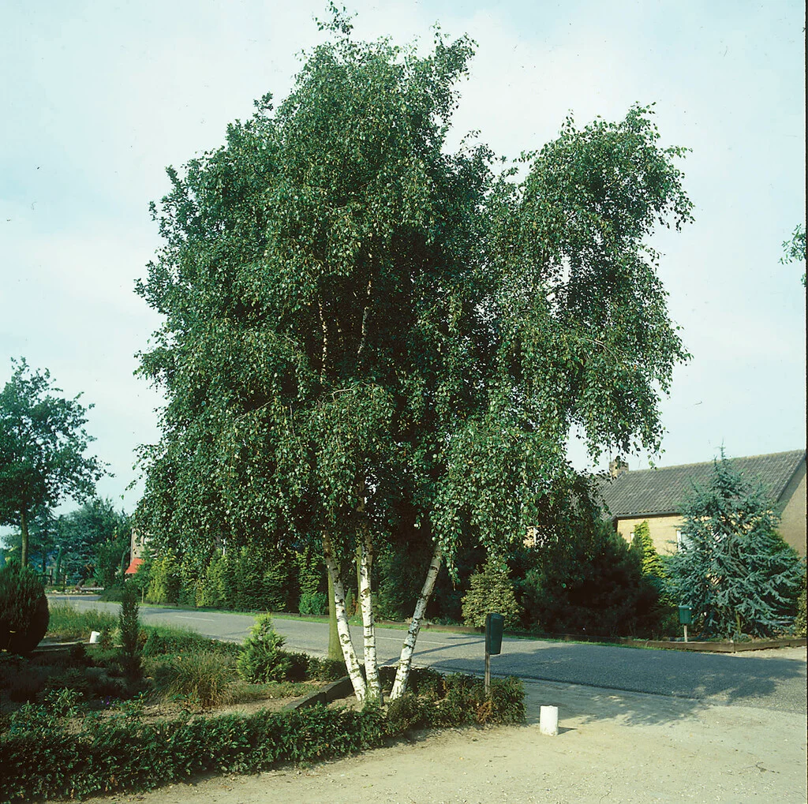  Silver birch | 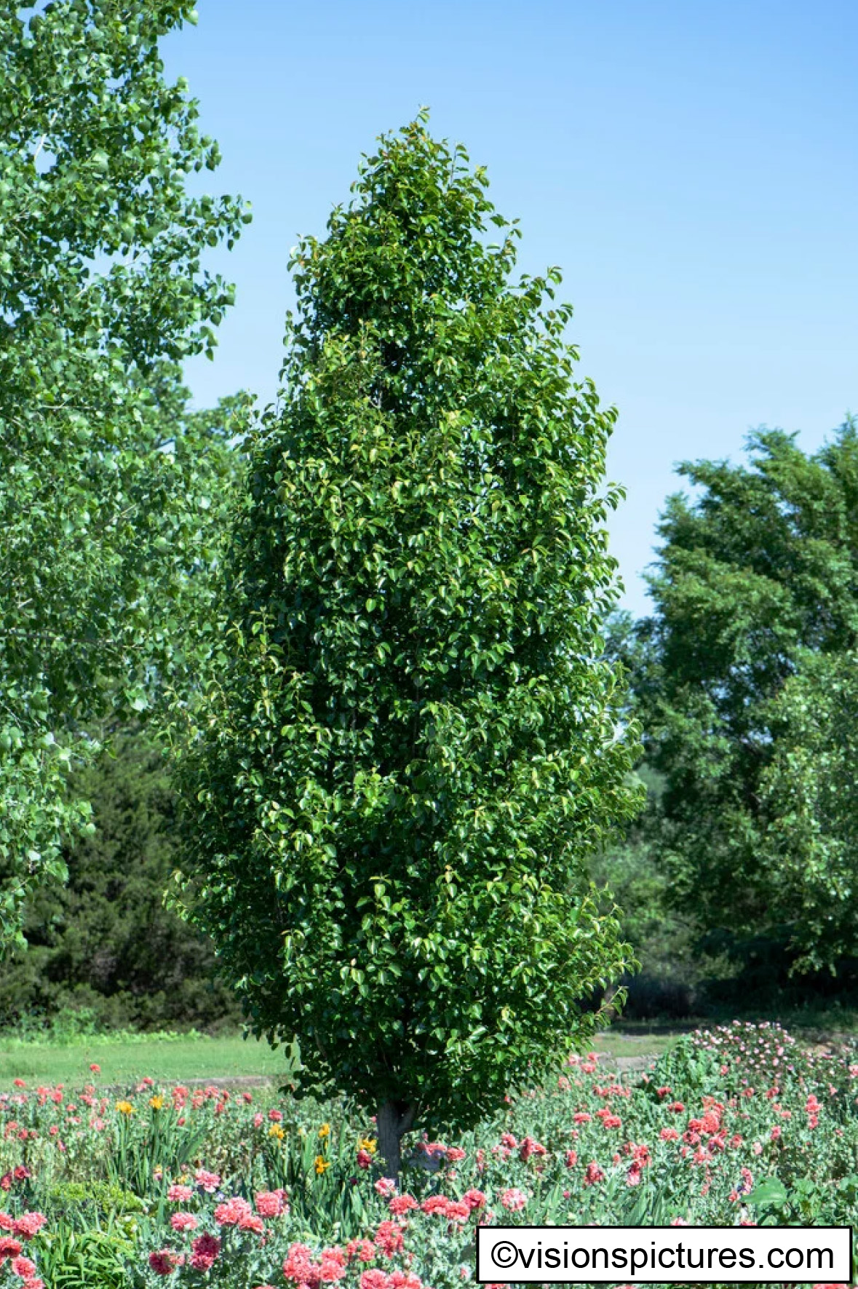  Pyrus calleryana 'Chanticleer'

Habitat Creation and Management – Risk Register and Remedial Measures PM-T02
Provide a site-wide risk register associated with creating, enhancing and, or, managing each habitat type. Consider your approach to delivering the BNG targets in case the management prescriptions do not deliver as expected.
This is a pre-emptive list. The list of potential risks should be as comprehensive as possible to provide confidence in the delivery of the management plan objectives. Complete each habitat's management targets and prescriptions first, then consider the likelihood of the risk occurring and what impacts it may have if it was to occur. Consider how these may feed back into monitoring requirements.
Risk Identification Date | Habitat Type | Risk Factor | Trigger for Action | Remedial Measure
08/05/2026 | Urban tree | Tree(s) lost through as unsuccessful and/or vandalism. | Dead tree | Plant replacement tree. New location maybe required if tree unsuccessful due to location.

Monitoring Schedule
To deliver BNG, a robust strategy is critical to monitor successes and challenges. Routine monitoring informs progress and facilitates the required management plan updates at set intervals.

Monitoring Strategy
Provide details of the monitoring strategy to encourage successful implementation of the management plan (MS-B01)
Habitats retained and created to be surveyed annually from years 1-5, then every 5 years.
- As part of each survey the surveyor will:
- Establish whether habitats and urban trees have been planted/are still present onsite as per approved proposed site wide landscape masterplans.
- Produce species lists for each habitat type to be produced to determine whether habitats have succeeded as per planting schedules.
- Complete statutory biodiversity metric condition assessments for each applicable habitat type to validate the habitat creation condition scores provided.

Monitoring Methods and Intervals MS-T01
Provide details of the methods you will use to adequately monitor the progress towards the targets stated in the management plan and as agreed with the Local Planning Authority.
Monitoring methods and frequency need to be considered according to habitat type. The text below is only for illustrative purposes. Plan according to your own project and habitat requirements.
Habitat Type | Monitoring Methods | Monitoring Interval and Timing
Modified grassland | Undertake survey of grassland habitat including quadrat sampling. Species lists to be produced to determine habitat type and whether target species have established.  Complete Condition Sheet Grassland Habitat Type (Low distinctiveness) on each survey visit. | Annually from years 1-5, then every 5 years.  Surveys to be completed between May and August.
Urban trees | Ensure trees have been planted / are still present as per approved proposed site wide landscape masterplans.  Complete Condition Sheet ‘INDIVIDUAL TREES Habitat Type’ on each survey visit. | Annually from years 1-5, then every 5 years.  Surveys to be completed between May and August.

Monitoring Reports
Following completion of habitat creation and initial enhancement works, prepare for your monitoring report for the Local Planning Authority or Responsible Body. You should monitor each habitat type comprising the BNG project. Provide sufficient detail for the reviewing authority to assess the progress. The ‘Monitoring Report Template’ can help you do this. The requirements and regularity with which the monitoring reports are required are at the discretion of the LPA or Responsible Body. Prepare the monitoring requirements below.

Monitoring Report Schedule MS-T02
Provide details of the person or organisation that will be responsible for submitting the monitoring reports. Also state the responsible organisation for receiving and reviewing the reports.
Organisation Responsible for Submitting the Monitoring Reports | Organisation Receiving and Responsible for Reviewing Reports
Great Places Housing Group or specialist subcontractor. | Greater Manchester Ecology Unit (GMEU)

Provide details of when the monitoring surveys and reports will be undertaken and submitted. You can extend the table and adjust according to your required schedule.
Project Year | Month Report to be Submitted | Month Management Plan to be reviewed | Comments
Y1 | September | September / October | Report on initial habitat creation success.
Y5 | September | September / October | UK Hab survey of site and condition assessment of each applicable habitat type.
Y15 | September | September / October | UK Hab survey of site and condition assessment of each applicable habitat type.
Y20 | September | September / October | UK Hab survey of site and condition assessment of each applicable habitat type.
Y25 | September | September / October | UK Hab survey of site and condition assessment of each applicable habitat type.
Y30 | September | September / October | UK Hab survey of site and condition assessment of each applicable habitat type.

Adaptive Management
Summary of Adaptive Management Approaches (MS-B02)
Monitoring report to be produced by MSV Housing Group Limited or subcontractor. If any habitats are not progressing or not met their targeted condition score during any of the monitoring surveys, then appropriate prescriptions will be provided in the monitoring report to support the achievement of the desired condition score. If appropriate prescriptions are required, then the site will be visited the following year to determine the success of the intervention(s).

