 |  | 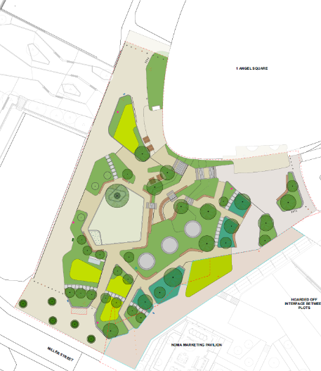
Project Number and Title | : | Angle Square Public Realm
Client | : | Noma Angle Square Marketing Suite

Bethell Acceptance:

 | Print Name: | Signed: | Position: | Date:
Prepared by: | Gary Hunt | Gary Hunt | Contracts Manager | 14/10/2025
Reviewed by:
Approved by:

Client Acceptance (if required):

Reviewed and accepted by: | Name:
(On behalf of Client xxx) | Signature:
 | Position:
 | Date:

REVISION RECORD

This document should be reviewed at specified intervals throughout a project’s duration.
Review dates are to be recorded, including any changes within the ‘details’ section.

Issue No: | Issue Date: | By: | Date Approved: | Comments: | Next Review Date:
1 | 15/10/2025 | Gary Hunt |  | Draft
2
3

Contents
Project Details 3
1.1 CDM Details 3
1.2 Location of the Works 4
1.3 Nature of Construction Works 4
1.4 Timescale for Completion of the Construction Work 4
2.0 The Existing Environment 4
2.1 Surrounding Land Uses 4
2.2 Existing Services 4
2.3 Existing Structures 4
2.4 Traffic/Planning Restrictions 4
3.0 Management Structure (Refer to Appendix A attached) 4
3.1 Management Structure 4
3.2 Health and Safety Goals for this Project 7
3.3 Interface Arrangements 7
3.3.1 Liaison between Parties / Specialist Sub-Contractors Onsite 7
3.3.2 Consultation with The Workforce 7
3.3.3 Exchange of H & S information between Contractors 7
3.3.4 Exchange of Design Information 8
3.3.5 Handling Design Changes 9
4.0 Overlap with other Undertakings 9
5.0 Plan Objectives 9
6.0 Contractors Responsibilities 10
7.0 Responsibilities of Personnel 11
8.0 Selection Procedure 11
9.0 On Site Training and Induction 11
10.0 Working Restriction 12
11.0 Welfare 12
12.0 Temporary Electrical Installations 13
14.0 Emergency Incident Procedures 13
14.1 Procedures 13
14.2 Emergency Contact Numbers 14
14.3 Nearest Hospital 14
14.4 Reporting and Investigation of Incidents 14
16.0 Safety Signs 15
17.0 Registers and Statutory Notices 15
18.0 Working at Height 16
19.0 Housekeeping 16
20.0 COSHH 16
21.0 Noise at Work 17
22.0 Vibration and Manual Handling 17
23.0 Alcohol and Drugs 17
24.0 First Aid 18
25.0 COVID 19 18
26.0 Monitoring and Inspection 19
27.0 Personal Protective Equipment 19
28.0 Deep Excavations 20
29.0 Confined Spaces 20
30.0 Booking in Procedure 21
31.0 Sub-Contractors 21
32.0 Contaminated Ground 21
33.0 Site Rules 22
34.0 Site Security 22
35.0 Health and Safety File 22

Project Details

1.1 CDM Details

Project Details | Stakeholders Details | Contact Numbers
Project and location

Client  Contact | Noma Manchester  Angle Square Marketing Suite  28 Miller St, Manchester M4 4GL | Jon Grafton  07552169205
Principal Designer  Contact | Buro Happold  2nd Floor Eastgate  2 Castle Street  Castlefield  Manchester  M3 4LZ  United Kingdom | Francisco Rodriguez  07548 971139
Designer  Contact | Buro Happold  2nd Floor Eastgate  2 Castle Street  Castlefield  Manchester  M3 4LZ  United Kingdom | Francisco Rodriguez  07548 971139
Principal Contractor  Operations Director  Contracts Manager  HSQE Manager | Bethell Construction, Dane House, Stoneclough Rd, Europa Business Park, Kearsley. M26 1GE  Gary Hunt  Martin Burke | 0330 9122500  07766991392  07880 146784
Contractor

1.2 Location of the Works
The location of the works: Angle Square Dantzic Street Manchester M4 4G.
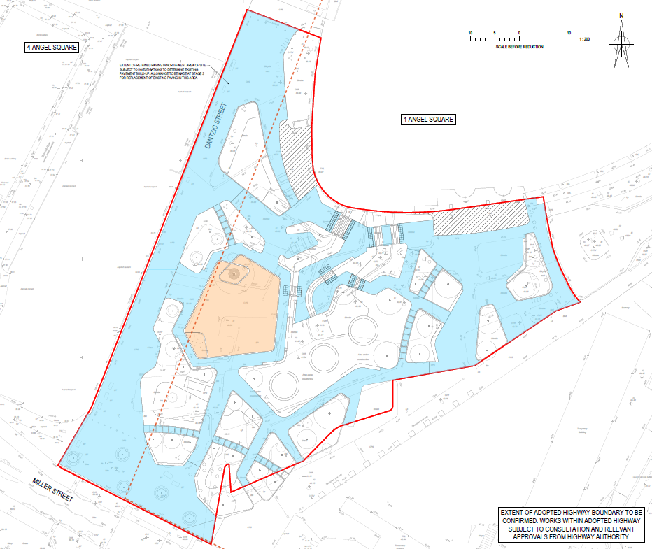
The nearest Accident and Emergency Hospital is located at: North Manchester General Hospital Delaunays Rd, Crumpsall, Manchester M8 5RB
Telephone number: 0161 795 4567

1.3 Nature of Construction Works
The works briefly comprise of- Public Realm work to the area of new development on Angle Square Manchester.
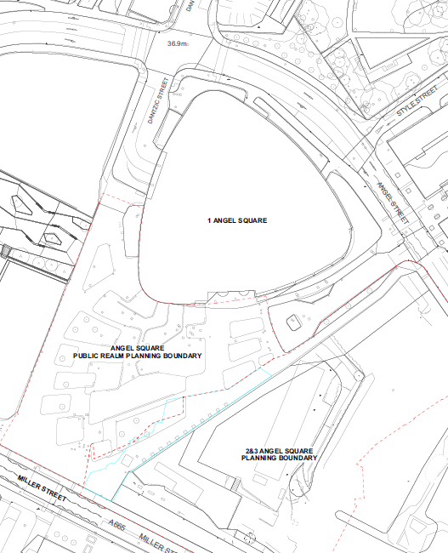
The scope of work will comprise of the following activities-
- Site Clearance,
- Drainage,
- Street Lighting,
- Paving,
- Surfacing,
- Kerbing,
- Edging
- Street furniture
- Utility Covers
- Hard and soft landscaping works.

1.4 Timescale for Completion of the Construction Work
Construction work is due to commence in TBC for an estimated period of Est 40 weeks.

2.0 The Existing Environment

2.1 Surrounding Land Uses
The surrounding land is occupied by various residential and commercial properties with access to the businesses to remain at all times this will be done with local pedestrian management. All works is on unadopted land and will not require highway permits.

2.2 Existing Services
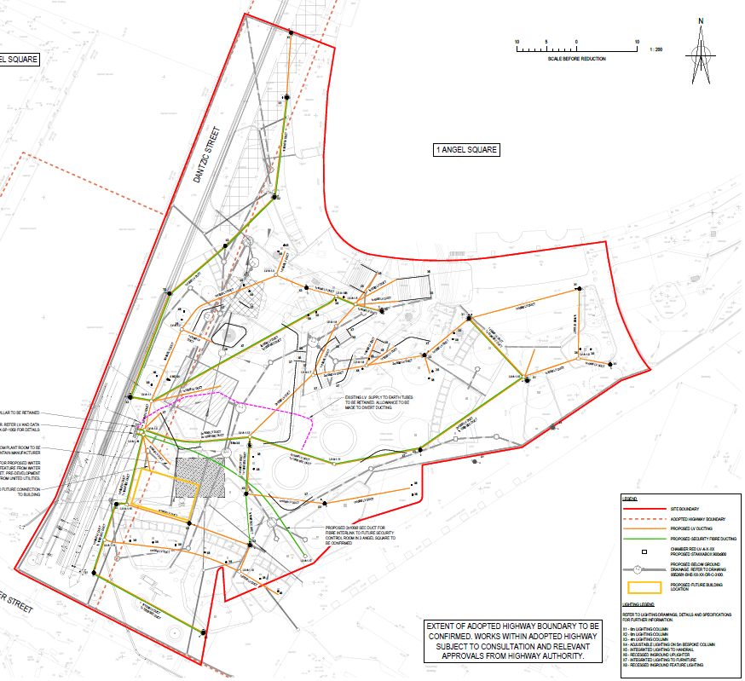

2.3 Existing Structures
The extent of the statutory undertakers known existing plant is shown on drawings and are for guidance purposes only. All live services on site will have their locations confirmed by using existing searches information along with the use of suitable detection equipment and safe hand digging practices. Specific attention to the
requirements of all the relevant statutory undertakers when working adjacent to their plant and (or) services will be employed Risk Assessments and method statements relating to the above will be generated and submitted to the overseeing authority prior to service location works commencing.

BCL will be mindful that there may be unrecorded services on site. If these are located, they shall be protected, and the client informed as soon as possible.

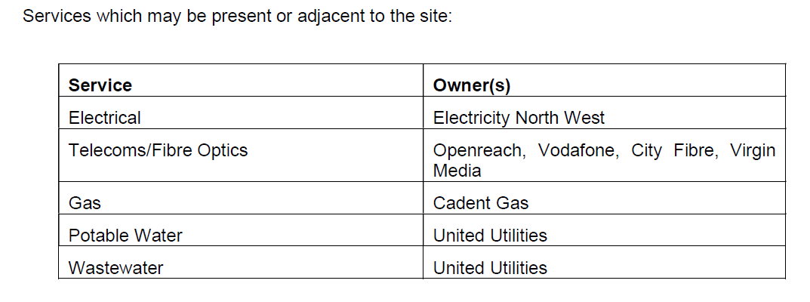

2.4 Traffic/Planning Restrictions

No restrictions all work on unadopted land off the highways. Pedestrian management will be required for access to buildings.
Unaware of the planning restrictions at this time.
All open vehicles will be sheeted prior to leaving the site.

3.0 Management Structure (Refer to Appendix A attached)

3.1 Management Structure
Each member of the management team will ensure all responsibilities and duties are upheld throughout the duration of the project.
The management structure for the project is as follows-
The Operations Director is responsible for;
- Ensuring the appointed Contracts and Works Managers are fully adhering to Bethell’s, the Client’s and statutory requirements for health and safety standards being achieved on site throughout the project.
- Ensuring that the Client’s requirements regarding the contract and the works are being met.
- Ensuring that all works requiring a temporary works design have been designed by bodies on Bethell’s approved supply chain list.
- Approval of safe systems of work for complex activities.
The Contract’s Manager is responsible for;
- Ensuring the appointed Works Manager is fully adhering to Bethell’s, the Client’s and statutory requirements for health and safety standards being achieved on site throughout the project.
- He must also ensure that all levels of staff are trained to the required level.
- Ensuring that adequate resources are afforded to the project to ensure its safely and timely execution.
- Ensuring that the required levels of PPE are identified, supplied, and correctly utilised.
- Ensuring that Bethell’s procedures for safety, environmental and quality are being followed on site.
- Ensuring that all live documents are kept up to date.
- Monthly safety and quality audit of the site.
The HSQE Manager is responsible for;
- Any direct communication with the HSE or Environment Agency regarding reporting incidents or supplying required information.
- Any required investigation works after an incident regarding the works.
- Ensuring that Bethell’s Safety and Environmental procedures comply with current legislation.
- Ensuring that safety data (i.e. tool box talks, inductions, safety audits, training etc.) are collated and recorded.
The Works Manager is responsible for the following.
- Keeping Bethell safety, environmental and quality records maintained and up to date.
- Weekly safety audit of the site.
- Temporary works co-ordination.
- Compilation of Lifting Plan.
- Gathering and compilation of information regarding the Health and Safety File.
- All site workers are briefed and sign up daily to the method statements and risk assessments applicable to their work to confirm understanding and acceptance.
- All employees receive a site specific Bethell induction.
- Toolbox talks are given at regular intervals on relevant subjects.
- All sub-contractors and visitors to site receive a site specific Bethell induction.
- Ensure no sub-contractor is used on site that has not been previously approved via the company supply chain approval.
- Ensure site specific method statements and risk assessments are in place for all construction activities.
- Ensure all plant operators have correct training and experience for the item they are operating.

3.2 Health and Safety Goals for this Project
The health and safety goals for this project are to complete the works with zero incidents, accidents and near misses. Bethell operate a hazard spotting reporting policy and actively encourage this by holding monthly prize draws for all those who have reported a hazard spot in that previous month. Regular audits and visits from the HSQE team will take place during the works. Senior management visibility at a site level will be prominent throughout the works in terms of promoting health and safety.

3.3 Interface Arrangements

3.3.1 Liaison between Parties / Specialist Sub-Contractors Onsite
It is envisaged that other parties will be onsite during the completion of the works namely sub-contractors working for Bethell. Bethell operate an open-door policy with regards to sub-contractors and they will be seen as our own workforce.
There will be continuous liaison between Bethell Construction and the works management parties, in the form of telecommunication and electronically via email. Bethell Construction will give continuous performance indications and updates as required by the contract. Pre-start meetings will be held with each sub-contractor and regular progress meetings will be held as works are on-going to ensure the safe and successful delivery of each element of works.

3.3.2 Consultation with The Workforce
BCL have written procedures for consultation with the workforce on all matters pertaining to the company including Health and Safety. The procedures form part of the Bethell Construction Management Plan and are available for inspection if required.
On a site basis this includes daily briefings to the operatives and sub-contractors by the Works Manager or trade foreman, as well as regular toolbox talks on current relevant subjects along with regular visits from the Contracts Manager and the HSQE Team.

3.3.3 Exchange of H & S information between Contractors
Bethell will inform its sub-contractors or any other parties on site of H & S information relevant to them. This will be done either in the daily morning briefings, weekly toolbox talks or instantly by verbal “face to face” briefing as necessary.

3.3.4 Exchange of Design Information
Any change of the proposed construction design will be notified immediately by the Designers for approval to the Client and any other party relevant to that item for which the design is applicable.
All designers (Client, Contractor, and Sub-Contractor) will communicate and co-ordinate with each other through the Client’s Project Manager, with regard to identification of hazards and control of risk. Design development or changes during the construction period should receive the same consideration and must not be overlooked. A communication / liaison process will be agreed between Bethell Construction and the Client and Designers to comply with the respective QA procedures.

It is essential that the Contract Administrators representative and Clients Project Manager are informed of the following:
- Appointment of any other project designers.
- Appointment of specialist designers (including temporary works).
- Design development or changes where safety considerations are required.
- Proof that safety is considered for all design variations (however minor)

The procedures for the consideration and acceptability of the Health and Safety implications of any prepared designs shall follow the principles of prevention and protection.

Details of Health and Safety issues, risk assessments and hazards which cannot be designed out are to be submitted to the Contract Administrators Representative, Clients Project Manager, together with the proposals for mitigation or control required during construction, maintenance, repair, replacement, dismantling and disposal.

All such information, including the implications arising from the design of temporary works is to be submitted in sufficient time to allow adequate consideration by the Contract Administrators Representative, Clients Project Manager and where appropriate design consultants.

3.3.5 Handling Design Changes
Prior to any installation / construction of a changed design Bethell’s designers will confirm these changes to the Contract Administrators Representative & Clients Project Manager before cascading down to any Subcontractors as required.
Procedures for dealing with unforeseen events during the project which result in substantial design changes, and which might affect resources are as follows-

- In the event of any unforeseen circumstances occurring, the Contract Administrators Representative & Clients Project Manager are to be informed immediately by Bethell Construction Ltd.

- The Health and Safety issues arising from any unforeseen occurrence are to be submitted to the Contract Administrators Representative & Clients Project Manager, as soon as is possible after the occurrence.

- In the event that any re-design is required, for whatever reason, the Health and Safety implications are to be reviewed by the Contract Administrators Representative, Clients Project Manager, the Design Team and Bethell Construction Ltd in due time before execution of the works.
3.3.6 Liaison with Local Community
The client will liase with the local community, businesses and resident to keep them aware . of the progress of the works with Bethell input.

4.0 Overlap with other Undertakings

None

5.0 Plan Objectives

Bethell Construction Limited will complete the project and all associated works as defined in the contract, to the design specifications applying due regard to the welfare of staff, reduction and control of significant risk to their health and safety, and others who may be affected by the project activities. This will be achieved by application of the following objectives:

- That all operations are performed in accordance with the pertinent legislation and in the event of an accident or incident, that robust procedures are in place to provide an adequate response.
- To ensure co-operation between Client, Principal Contractor, Designer and all Sub contractors and highlight any limitations imposed on them by relevant provisions and regulations relating to the construction work.
- To ensure as far as reasonably practicable that all operatives on site comply with the Construction Phase Plan.
- To take reasonable measures to ensure only authorised persons enter the construction site.
- To provide, as is reasonably practicable, information and instruction to all employees on the risks involved on the construction site by means of a site induction to all new staff upon arrival.
- To provide a channel for communication between Bethell Construction, the Client, the Designers, the Contract Administrator, and all Sub Contractors.

6.0 Contractors Responsibilities

Bethell Construction Limited will be known as the Principal Contractor under the Construction (Design and Management) Regulations 2015 and will undertake their responsibilities accordingly.

In addition, Bethell Construction Limited will be responsible for the following-
  - Storage of materials.
  - Establishment and maintenance of all associated traffic management schemes, including signing and guarding for safe pedestrian passage, for the duration of the contract.
  - Cleanliness of the surrounding area and general tidiness of the site.
  - Reinstatement of all disturbed surfaces damaged during the course of the works.
  - Welfare of labour.
  - Safeguard of all third parties.
  - Security of all equipment and materials on site.

7.0 Responsibilities of Personnel

All persons employed upon or visiting site are required to:
- Receive a site-specific induction and confirm their understanding of site rules and procedures.
- Correctly use the personal protective equipment provided.
- Maintain all common routes of access and egress.
- Report any unsafe acts or emissions.
- Co-operate with site security requirements and emergency/evacuation procedures.
- Co-operate with Bethell Construction to ensure that this Health and Safety Plan is successfully implemented.

8.0 Selection Procedure

BCL employees engaged on the scheme shall have all necessary suitable experience. All plant operators will hold the appropriate CPCS training scheme accreditation prior to the commencement of any works on the construction site.

Construction operatives, employed by BCL or sub-contractors will evidence the appropriate training certification. All subcontractors employed will be required to evidence the same certification as Bethell employees prior to commencing works.

All plant, materials, equipment, and tools will be acquired for the contract in accordance with the company's ISO 9001:2015 procedures.

9.0 On Site Training and Induction

All personnel working on site will undergo induction training specific to the site and surrounding areas. All present at the time of inductions will be required to sign an attendance certificate as proof of presence at the induction. The induction will consist of, but not be limited to, the following:

- The client’s specific safety requirements where different to Bethell.
- Bethell safety requirements
- Safety expectations of operatives
- Access to/from the site
- Limitations of the construction site / boundaries
- Consideration for pedestrians
- Dangers of other's work
- Construction work to be carried out
- Location of welfare, office and sanitary facilities
- Any other hazards identified when or if they occur
- Environmental considerations
- Complete a short multiple choice questionnaire to ensure an understanding of the site induction and Bethell Construction’s protocol.

10.0 Working Restriction
Site working hours Monday to Friday unless otherwise instructed are to be between 07.30 & 17.00hrs

11.0 Welfare
The site compound will be set up temporary Welfare facilities shall be in accordance with CDM 2015 and the Construction (Health, Safety and Welfare) Regulations 1996 and shall comprise:

- Office accommodation for Bethell Project Manager and Engineer
- Office space for Client Management team
- Rest room / Mess facility for workforce with hot water facility
- Sanitary facility with hot and cold running water
- Drying room facility
- Drinking water
- Storage facilities for tools and equipment
- Vehicle wheel wash facility will be provided for the main programme of works

12.0 Temporary Electrical Installations
The electrical supply for the site cabin will be means of silent running diesel powered generators.

13.0 Provision of Fire Fighting Equipment
BCL will arrange for the provision of suitable firefighting equipment positioned at agreed locations. The locations of firefighting equipment and the location of fire assembly points will be clearly identified on site and briefed to all during the main site induction process. The equipment is to be suitable to extinguish fires associated with flammable materials and/or electrical equipment as installed or used in the vicinity of each fire point.
It is everyone’s duty to ensure that precautions are taken to avoid the occurrence of the outbreak of fires and that the firefighting equipment is available for use and is not abused.

14.0 Emergency Incident Procedures

14.1 Procedures
All incidents on site must be reported to the Project Manager. The Project Manager will then inform the Contract Administrators Representative, & Clients Project Manager, as soon as practicable following the incident.

- All incidents are then to be recorded in the appropriate manner i.e. BI 510 for accidents followed by F2508 if reportable (see RIDDOR Regulations), as well as the company reporting procedure for accidents.
- Any Major accidents or Major incident must be reported to the HSE immediately by Email www.hse.gov.uk and by telephone to the ICC on 0345 300 9923, or out of hours to the duty officer on 0151 922 9235
- If the emergency services are required, then contact is to be made by the quickest possible means i.e., telephone dialing 999.
- If the emergency services are called, then access to the site is to be always maintained whilst the emergency is in operation.

In addition, Bethell Construction will adhere to all site rules and regulations imposed at the time of the contract by the client.

14.2 Emergency Contact Numbers
The Following Emergency Numbers are to be displayed on site:

Fire, Police, Ambulance 999
Joe O Leary (Contracts Director) 07979596531
Gary Hunt (Contracts Manager) 07766991392
Martin Burke (Senior H & S Manager) 07880 146784
TBC (Works Manager) XXXXXXXXXXXXXXXXX
Environment Agency 0800 807060
Health & Safety Executive 0345 300 9923
A+E Infirmary 0161

14.3 Nearest Hospital

The nearest hospital with an A & E Department is located at; North Manchester General Hospital Delaunays Rd, Crumpsall, Manchester M8 5RB
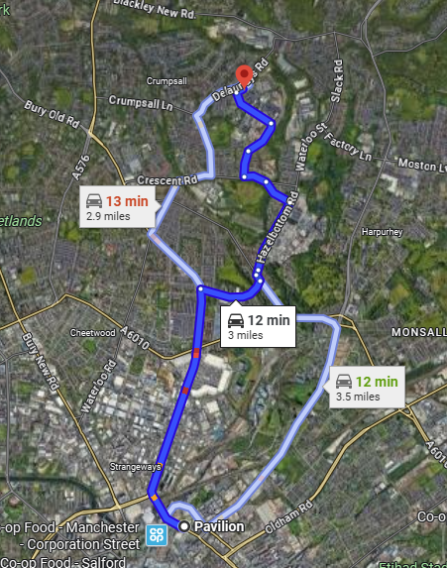
Telephone number: 0161 795 4567

A location map and access route shall be displayed in a prominent position on site.

14.4 Reporting and Investigation of Incidents

All accidents, whether minor or major, and/or dangerous occurrences must be recorded on A-Site following 2-2-2 as per Bethell Accident and Emergency Procedure. If in doubt ring Martin Burke, the Bethell HSQE Senior Manager or Nana Sarpong for advice.

15.0 Method Statements
Method Statements and Risk Assessments will be produced for all elements of the construction work. This is a stand-alone document that covers the technical aspect as well as related Health and Safety issues. It will cover the precautions to be taken with respect to work processes, co-coordinating lifting, temporary works, access, handling and any other hazardous operations. The method statement is to be produced by a person competent in the management of that task and will be forwarded to the relevant members of the project team for approval prior to works being undertaken.

16.0 Safety Signs

Safety signs are to be displayed as appropriate to the anticipated hazard. All signs displayed are to be adhered to.

All signs are to be maintained and in a safe and clean manner to allow clear sight at all times by all on site and any visitors (authorised or not), this is also to include any signs at access points to the construction site.

17.0 Registers and Statutory Notices
The following notices shall be displayed in a suitable location as appropriate to the operation being undertaken.
- Health and Safety Law poster
- Employees Liability Insurance
- Controlled Waste Transportation Certificate
- Completed F10 Form

The Works Manager is to ensure that the appropriate paperwork is available for inspection within the site files (including the statutory inspection registers for excavations, scaffold, LOLER and PUWER) for any equipment being used on site which requires a test certificate, e.g. lifting accessories, operated plant etc.

Any access platform hand over certificates and other daily or weekly inspections will also be held in the relevant site files.

Lifting plans will be compiled for any item to be lifted by any item of plant. The plans will be compiled by the Works Manager and approved by an Appointed Person.

Daily plant checks will be undertaken by the operator of each plant item prior to use each day, with copies of checks maintained weekly within the site files.

We will arrange, coordinate and implement any temporary TRO’s covering any temporary closures or amendments to footpaths and highways necessary for undertaking the Works.

18.0 Working at Height
Working at height may be required in completing certain elements of the project. Such work will be done from guarded specifically erected working platforms and in accordance with Bethell Safe Systems of Working at Heights.

Excavation shoring will be as per a relevant and approved Temporary Works Design that will incorporate edge protection.

19.0 Housekeeping

Bad housekeeping is the main cause of accidents on any construction site. All contractors are to maintain their own general work area in a clean and tidy manner. Rubbish and waste materials shall be placed in such a manner that will ease the collection and will then be placed within the enclosed site skip.

20.0 COSHH
BCL will meet fully the requirements under the COSHH Regulations. The purpose of these regulations is to ensure that every employer prevents the exposure of his employees to substances hazardous to health. All employees are to wear any protective equipment provided to protect him/her against exposure to substances.

Assessments for the substances that will be used during the construction of the works will be available for consulting within the site cabins.

21.0 Noise at Work

It is not anticipated that the work activities will generate any prolonged undue noise, however, should noise become a problem a full assessment will be undertaken, and control measure applied. As a general rule any operator working within the proximity of compressors, pneumatic tools, cut off saws and compaction equipment are to wear hearing defenders which will be available from the site management team. Under no circumstance should operatives proceed with noisy works without wearing the appropriate protective equipment.

Plant being utilised on the works will be recently inspected/tested & certified and in good order to minimise noise from such equipment.
Any compressors / generators etc. will be sited in such a location so as to be as least disruptive as reasonably practicable.

22.0 Vibration and Manual Handling

Personal hand vibration (HAVS) will be controlled by monitored trigger times for items of handheld plant. These trigger times will be briefed at the daily morning briefings and operatives will be rotated on use of this equipment.

The Manual Handling Operations Regulations 1992 shall apply and be complied with by all working on site. In accordance with Regulation 4, employers will carry out assessments when employees are required to lift, move, carry, or push a load which is likely to injure themselves. Operatives are advised within the induction to use mechanical means (i.e., crane or excavator) wherever possible to lift materials.

23.0 Alcohol and Drugs

The consumption of alcohol or the use of drugs on any part of the site, including offices or stores, is strictly forbidden. Alcohol or drugs are not to be brought onto the site.

All contractors are to recognise their duty and shall do what is reasonably practicable to identify alcoholism and drug abuse. They should also ensure that no employee is allowed on site or at their place of work under the influence of alcohol or drugs as this could endanger others at the workplace.
Bethell operate a random drug testing regime and this can happen at any time whilst work activities are being undertaken. Anyone found to provide a positive result for drugs or alcohol will be immediately suspended awaiting an investigation and subsequent internal disciplinary hearing. The outcome of this may include termination of employment for the individual.

24.0 First Aid

First aid equipment will be made available at the site office, mess and in the site vehicles. Offices and vehicles containing first aid equipment will display the appropriate signs.

There will be at least one appointed person responsible for first aid on site at any time. A list of all persons will be displayed in a prominent position within the site welfare facilities and made known to all upon induction. The first aiders will change throughout the duration of the contract owing to the different contractors on site. The changes will be briefed to all parties during the daily morning briefings.

In time of emergency the Works Manager will act as the appointed person and act accordingly by contacting the emergency services to get assistance.

Notices stating the location of the first-aiders and facilities are to be displayed within the site area. The Works Manager and visiting Contracts Manager/HSQE team will regularly check contents of the first aid box.

At least one person from each team will be trained in first aid procedures. Sub-contractors will be required to provide first-aid trained personnel to cover their work operations.

25.0 COVID 19

The Coronavirus Pandemic affects everyone, every industry, every trade, private individuals and public alike.

Government Guidelines, the Construction Leadership Council (CLC) guidelines as recommended by the HSE are the legislative documents that BCL follow and base our Covid 19 assessments on.

Specific Risk Assessments relating to Covid 19 are provided as part of each activity and must be adhered to at all times and a specific power point presentation is also provided at induction. Warning signs will also be in place around the site.

26.0 Monitoring and Inspection

Bethell Construction Limited and its sub-contractors will, as a matter of course, carry out continual monitoring and surveillance of all operations and activities under their control to ensure that, so far as reasonably practicable, all operations are conducted safely and without risk to health.

In addition the Works Manager will undertake a weekly safety audit and inspection. Reports are to be filed in the safety file for future reference along with a copy being forwarded to the HSQE Dept.

27.0 Personal Protective Equipment

BCL shall maintain adequate stocks of suitable protective clothing and equipment on site and provide all personnel under their control with relevant PPE required for a particular operation.

The site will be designated a hard-hat and light eye protection site and all personnel will wear suitable protective headgear and eyewear. All other statutory requirements in respect of protective clothing and equipment will be mandatory on the construction site.
Minimum PPE will be highlighted in the relevant RAMS for the specific tasks being undertaken but as a minimum it will be;

- Safety footwear with ankle support (No Rigger Boots) and mid sole protection.
- Hard Hat within its validity date.
- High visibility vest.
- Gloves that are appropriate to the task being carried out.
- Eye Protection to conforming to European Standard EN166.
- Ear defenders and Hi impact goggles when breaking or using a cut off saw.
- Dust suppression equipment.
Any operations requiring the use of a dust mask must only be done by operatives who have undergone the face fit testing procedure. Sun cream of a high protection factor will be freely available for the work force from the Works Manager or Site Supervisor. Toolbox talks on working in the sun and self-protection will be undertaken if this topic becomes relevant.

28.0 Deep Excavations
Specific shoring Temporary Works Designs will be produced as required, prior to excavation works commencing. Bethell will employ a reputable shoring design and supply company to produce temporary shoring designs and relevant design checks. Designs will be co-ordinated by the Works Manager and issued to the Client’s Project Manager for review prior to works commencing. The installation of shoring in accordance with these designs will be continually monitored by site management as the works progress. A register of excavations shall be kept and a record of inspections entered daily at the start of each shift. Excavation inspections will be undertaken by the Works Manager or Site Supervisor at the start of every working shift. Excavations are also to be inspected after any periods of heavy rainfall, any times of excessive sewer flows entering the trench or any displacement of ground. It is proposed that trench sheets required for shoring will be ordered a minimum of 1.2 metres longer than the actual length required to support the excavated surfaces. This will ensure a height of 1.2 metres protruding above existing site ground levels to provide suitable, robust edge protection to the trench sides. Relevant warning signs shall be provided at the top to ensure no unauthorised persons enter the excavation area. Designated safe access and egress points from excavations will be provided and maintained throughout the works.

29.0 Confined Spaces
Any work involving access into a possible confined space will be subject to a permit to work system and executed by suitably trained and experienced personnel. Correct equipment to be made available and all work undertaken in accordance with Bethell SSOW for confined space working and specific United Utilities requirements.

30.0 Booking in Procedure
All personnel visiting the site are to book in at the site offices where a visitor’s book for this purpose will be displayed. When booking in for the first time all personnel will be inducted (see Section 9). When booking in on subsequent occasions induction will only be required if the scope of works has changed dramatically.

For personnel who visit the site for such occasions as delivering materials etc., a brief induction will be sufficient unless the personnel will have to visit areas of high risk such as lifting operations. In this instance they are to be escorted around the site to the delivery area and escorted off site once complete. All personnel will be required to book out at the end of the working day or when they leave site.

31.0 Sub-Contractors
All Subcontractors chosen to carry out any aspect of the works will be selected from the Bethell Approved Contactors data base. In order to get onto this database various aspects of that company’s performance are checked which includes but is not limited to safety; insurances; past performance and financial stability. New Subcontractors will be required to undergo the selection process laid out in Bethell Quality Procedures.

The following work elements will be sub-contracted as part of the project:

Sub contractors will be advise on award of project

All Subcontractors will be included in the Site Induction process, as per BCL Induction Procedures. Method Statements & Risk Assessments will be requested from the Subcontractors prior to their arrival on site, to ensure that they meet the minimum safety requirements detailed in this document.

32.0 Contaminated Ground
Part of the site is on a redundant Gas Works and certain contaminants are present, however all material is to remain on site and any contaminated ground disturbed will be placed as per the Materials Management/Soil remediation plan which will be validated by an external source.

33.0 Site Rules
BCL Site Rules have been developed into a Top Ten Safety Rules Protocol. These will be displayed within the welfare facilities, issued to individuals, and discussed at the induction.

34.0 Site Security
The site will be fully secured with Heras type 1.8m high security fencing fitted with backstays and debris netting on all perimeters of the working area. Secure gates will be appropriately positioned to allow safe access and egress from the highway. In addition, the site may be manned by a security guard outside normal working hours.

All open excavations within the working area will be individually barriered & fenced with Heras type fencing. Operated plant used on site will be fitted with de-mobilising devices to be utilised outside of working hours.

35.0 Health and Safety File
Bethell Construction will compile the Health and Safety file for the project in line with the contractual (PCI Summary report section 7) and legislative (CDM 2015 regulations) requirements. Information from all parties involved in the works (Principal Contractor, Sub-Contractors, and Designer etc.) will be correlated and submitted in an agreed layout and format.

Information for the Health and Safety file will be gathered and compiled throughout the duration of the contract and copies of this information will be made available to the CDMC as required.

Appendices

Appendix 1 – Drawings issued at tender
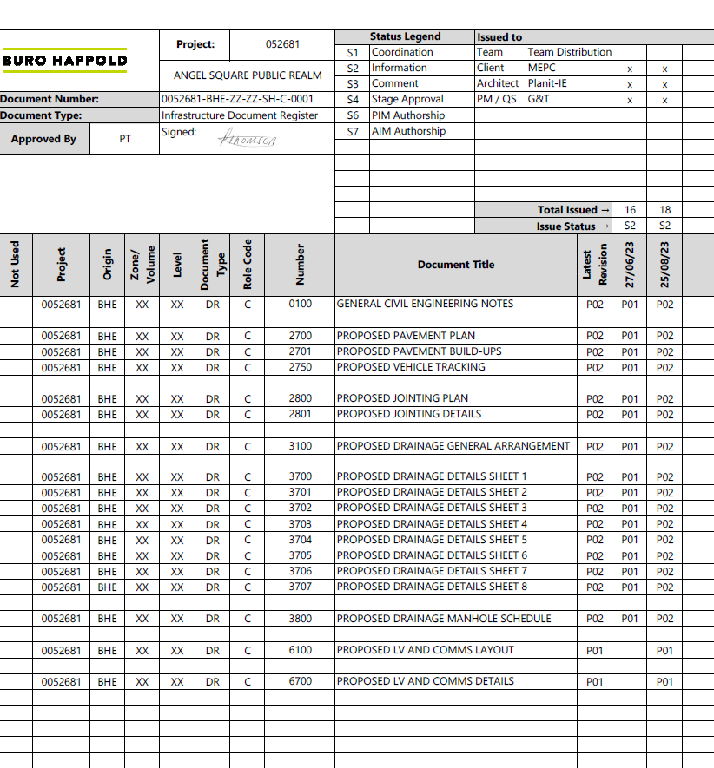

Appendix 2 - Site Layout and Welfare Plan

TBC

Appendix 3 – Emergency Response Plan
TBC

Appendix 4 – Temporary Works Designs
TBC

