



Calibre Metalwork Ltd Work Package Plan
Reference Numbers
Client Ref No: |  |  | Contractor Ref No: | 692
Purchase Order No: | Rylands Building, Manchester |  | Purchase Order Date: | Prestart meeting 27/01/2025
The Basics (in brief)
Who will be carrying out the works? |  | Calibre Metalwork Limited
Works to be covered in these RAMS |  | Removal / Restoration & Re installation of 2no Level 6 Balconies.
Why are these works needed |  | At client’s request
Proposed date of works
Pre-start meeting details.

Location of Works |  | Rylands Building,  Market Street,  Manchester,  M60 1TA

Covid 19
• Hand sanitiser will be available and must be used
• Your temperature needs be taken daily prior to commencing work
• Face masks will be issued and must be worn when working in close proximity to others
• Regularly and thoroughly clean your hands with an alcohol-based hand rub or wash them with soap and water
• Company vehicles must have all contact areas thoroughly cleaned with disinfectant wipes on completion of your journey, wipes are then to be disposed of correctly

SOCIAL DISTANCING
You must follow the principles of social distancing when reasonably practicable while travelling to and from work and at work, maintain at least 2 metres distance between yourself and others where possible.
Where people cannot be 2 metres apart, manage transmission risk by employees wearing face masks, working side by side or facing away from each other.

COVID19 MAIN SYMPTOMS
• High temperature – this means you feel hot to touch on your chest or back
• Continuous cough – this means coughing a lot for more than an hour, or 3 or more coughing episodes in 24 hours (if you usually have a cough, it may be worse than usual)

If you develop any of these symptoms:
• Notify your manager or supervisor
• Return home immediately
• Avoid touching anything

You can be tested all you need to do is go on the internet and apply for either of the following.
• Self-referral – this enables workers and members of their households who have symptoms to book a test directly using the online system
• Employer referral – this allows employers to refer workers for a test via a secure portal.

Personnel, Plant, Equipment and PPE
Personnel and Training
Detail the operatives involved in the project and list their relevant competencies (e.g., CSCS, IPAF, PASMA, 18th Edition Electrician)
Craftsmen all possess current relevant qualifications, CSCS CCNSG SMSTS IPAL CPCS NPORS IPAF PASMA Manual Handling, Abrasive wheels, Basic Disclosure etc.
Plant and Equipment
Mobile workshop (Van), hand tools,
Personal Protective Equipment
Hard hats, protective footwear, high visibility clothing
STC Boots – S1- P SRC. BS EN ISO 20345: 2011
Hi visibility clothing (clean numbered and in good condition)
Gloves- cut 4/5 (So cut Extra – EN420 – EN 388:1994)
Safety Glasses
P3 Dusk mask
Ear defenders
Waterproof coveralls
Fire extinguisher
Fire blanket

CSCS |  |  | CSCS
To be provided on the day |  |  | To be provided on the day
 | Contract supervisor, |  |  | Craftsman,

Other cards |  |  | Other cards
To be provided on the day |  |  | To be provided on the day
 | Contract supervisor, |  |  | Craftsman,

Delivery of materials / travelling to worksite
Delivery Methodology
Step 1. | On Arrival  Arrive on site then park vehicles in the designated parking area (if provided)  Ensure the vehicles are locked at all times.  The operation will be carried out within the allocated work areas provided by others/barriered zone with no public access. Other operatives not directly involved in the operations will be kept outside of the established exclusion zone.  - Report to site office and sign in.  - Attend site induction if required.  - Un-load equipment and transport to the exclusion zone.  - Restricted access, site personal only.
Step 2. | Agree limits of worksite with the client/PC.
Details of works to be completed
The Grade II listed Rylands Building in Manchester is a historically significant structure recognized for its distinctive architecture and cultural heritage. Any works carried out on or around the building must respect its listed status, ensuring that all interventions are sympathetic to its character and preserve its historic fabric. It is imperative that if any unexpected features, materials, or conditions are encountered during the course of works, all activity must be halted immediately. These findings must be reported to and reviewed by the relevant authorities, specifically SLHA (Stephen Levrant Heritage Architecture) and Manchester City Council (MCC), before any further work can proceed.
Working Methodology
Level 6 Balcony – Restoration Methodology

Dismantling and Removal
Using drawings / photographs carefully tag and remove the five (5no) full balcony panels from site. The 'half' castings at either end, along with the iron base, will remain in situ as per the findings in our Condition Survey Report.

Labelling and Recording
Each element will be assigned a unique reference code. This will be linked to detailed photographic records and condition notes to aid future reinstallation.

Protection and Packaging
Panels will be wrapped in acid-free tissue, buffered foam, and rigid protective boards. Each unit will then be placed in bespoke, cushioned crates that prevent movement and vibration during transport.

Storage
Elements will be stored in a secure, dry, and environmentally controlled location. Storage will be arranged to allow easy identification and minimal handling.

Transportation
Transport will be carried out using a suitable vehicle with shock absorption and secure strapping systems. Routes will be planned to avoid excessive vibration or impact risk. Handling will only be carried out by experienced personnel.

Workshop Preparation & Assessment
Upon return to our workshop, we will blast-clean all removed iron components to SA 2.5 standard.
Following this, each item will be closely inspected. Any unforeseen repairs will be documented, and a quotation will be issued for your approval prior to any further work. At this stage, we have assumed all components are in sound condition and will require only decorative treatment. Paint sample analysis has been conducted prior to cleaning; the historic paint will be considered/inform proposed element. In the event of any unexpected discovery, damage, or deviation from plan, all works will cease immediately, and the issue will be referred to SLHA and MCC for guidance and resolution before any further action is taken.

Repairs & Finishing
Upon receiving approval, any necessary repairs will be undertaken.
All components will then be finished in a single BS or RAL colour of your choice, using our high-quality, heritage-approved paint system.

On-Site Preparation & Treatment
Prior to reinstallation, all accessible areas of the remaining in-situ ironwork will be cleaned back by hand.
These areas will then be treated with our acidic rust converter and hand-painted on site.

Note:
As part of the on-site preparation works, we will be cleaning back only the accessible areas of the retained in-situ ironwork (including the base and end ‘half’ castings). It is important to highlight that Calibre does not hold Professional Indemnity (PI) insurance and therefore cannot assess or confirm the structural integrity of the in-situ iron components, particularly the cast iron stubs or fixings left embedded in the stonework.
We strongly recommend that a suitably qualified structural engineer be appointed by the client to assess the condition and structural adequacy of these elements prior to reinstallation of the balcony panels.
Our restoration work assumes that the existing iron stubs and base remain structurally sound unless otherwise advised by the appointed engineer.

Reinstallation & Final Works
The restored sections will be installed into prepared and drilled stonework.
Any paintwork that is bruised during the installation will be touched up.
We will leave the site clean, tidy, and free from all work-related waste.

Main Contractor to provide welfare facilities and medical area.
Main Contractor to provide suitable access for all window removals.
Main contractor to remove plasterwork from the inside of the windows to allow the timber sub-frames to be removed where required.
Main contractor to board up window opening following our removal works if required.
Main contractor to provide all access requirement for removals and installations.
Main Contractor to remove any stonework which restricts the removals of any ironwork.

Appropriate PPE (listed above) will be worn at all times.

Before-

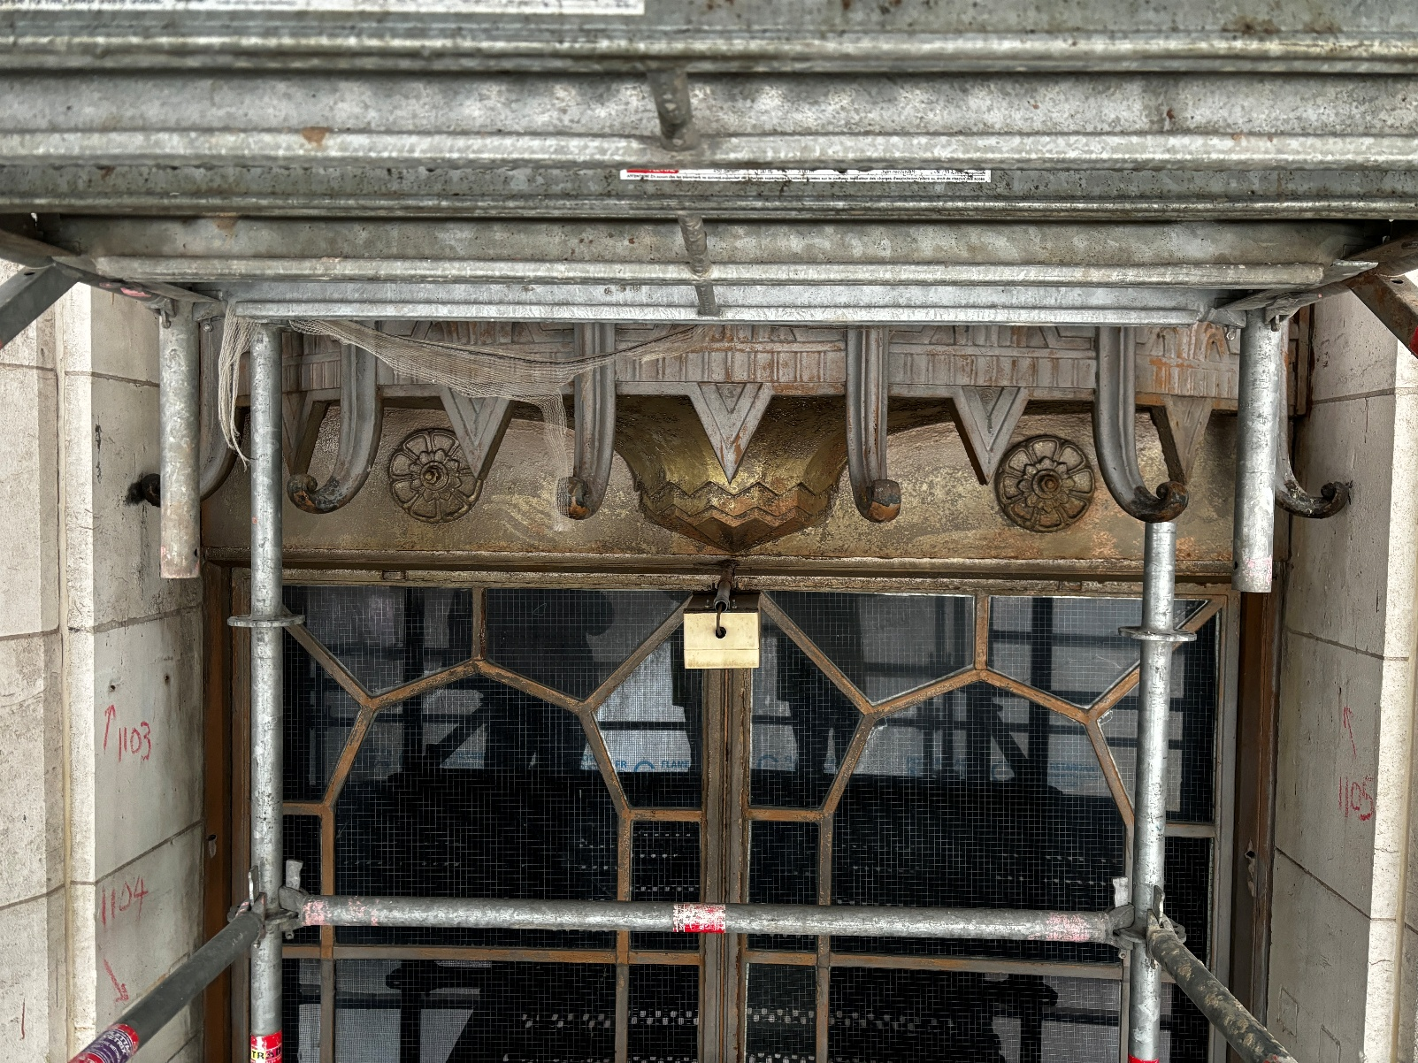

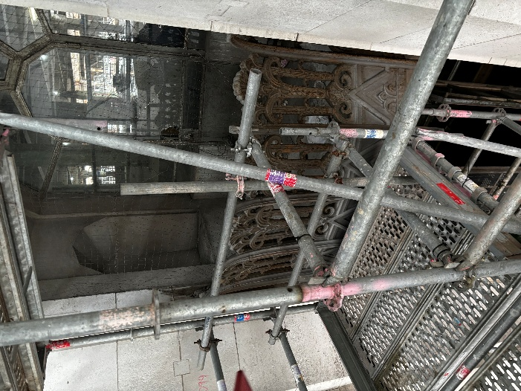
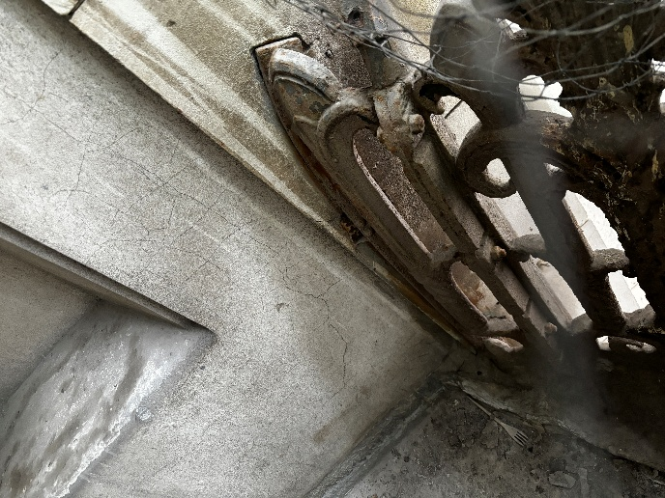

After-

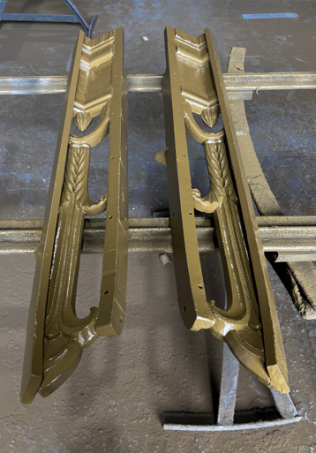
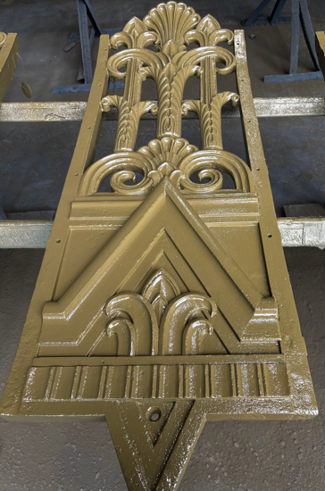

Working at Height
Working at Height Methodology
The area around and below where you are working must be cordoned off using Solid Physical barriers to protect other personnel and members of the public.
All tools are to be secured by lanyard. No loose objects are to be left at high-level when you are not working in the area. Access equipment to all high-level works must be secured at all times.
Are you able to avoid working at height through the use of readily available equipment?  NB: working at height must be avoided where practicable | M/C
Will you be working on an even and flat surface?  If not your access equipment must be of a type to ensure the working platform is level and secure. | Yes
What access equipment will you be using? | M/C
Is this access equipment the most suitable for the proposed work activity in the proposed working environment? | M/C
Does the access equipment prevent the risk of falls from height? | M/C
If no to the last question, what equipment will be used to reduce the consequence of a fall from height? | M/C
Are all staff trained and competent in the safe use of access equipment? | M/C
Are maintenance records available for all access equipment? | M/C
Will pre-use checks be undertaken prior to access equipment being used? | M/C
Detail your system of working below:
All operatives will be given the Rams to read and sign to accept the method of work and risk assessment
A toolbox talk and briefing will be given prior to work
If any faults are found with the plant/equipment this will not be used – Inspection forms Attached with this WPP.

Manual Handling
Manual Handling Methodology
The area around where you are working must be cordoned off using Solid Physical barriers to protect other personnel and members of the public.

Does your company undertake and record relevant assessments of manual handling operations? | Yes manual handling will be covered in the risk assessment attached.
Where practicable will mechanical means of lifting and transporting items be used? | Yes all lifting will if possible and practicable be carried out using mechanical means
Where mechanical means is impracticable will you ensure sufficient persons are made available to lift loads, taking into account the size, shape and weight? | All lifting of loads will be assessed before any lifting is carried out. Weights above 20kg will be managed via team lifts of 2 or more operatives with each operative stating the ability to take part in the lift, nobody that is suffering any physical injury or discomfort will be permitted to take part in the operation.
Are all operatives trained and competent in manual handling techniques? | All operatives will be trained in manual handling
Will you ensure access areas are clear of obstacles and that lighting is sufficient? | No lifting will be carried out if the Access path is not sufficiently lit  And clear of obstacles
What PPE will be used by the operatives as highlighted by your risk assessment? | STC boots hi visibility clothing and gloves
Will you ensure sharp edges are protected? | Operatives will wear robust hand protection –riggers gloves
Will items be stored such that heaviest loads are in the most convenient position for the operative to lift? | All items will be stored in the most convenient position for the operative /operatives to lift
Detail your system of working below:
All operatives will be assessed as to whether they are capable of lifting the loads that are required on this task, a risk assessment will be made prior to any manual handling tasks.

Waste Storage and Disposal
Waste Storage and Disposal Methodology
The area around where you are working must be cordoned off using Solid Physical barriers to protect other personnel and members of the public.
ALL WASTE ARISING FROM THE WORKS MUST BE REMOVED DIRECTLY FROM SITE.
No waste or waste bags are to be left unattended at any time.
Where will waste receptacles be positioned? | M/C
Will waste skips be of sufficient capacity or quantity to hold all foreseeable waste produced by this job? |  | M/C
Will all waste be promptly removed to secure waste receptacles or secured within a locked and hoarded worksite when the worksite is unattended? |  | M/C
Will all wheeled waste receptacles used by you be fitted with a serviceable and lockable lid? |  | M/C
Will any receptacles with faulty locks be immediately removed from site? |  | M/C
If using a compactor will staff be trained and competent in its use? |  | M/C
Will the compactor be secured and locked out of use after each operation, unless it is permanently staffed? |  | M/C
Detail your system of working below:
N/A

Hoarding / Worksite Protection
Hoarding / Worksite Protection Methodology
Any hoarding and fencing must conform to the specification detailed at the end of this document.
How will you protect your worksite?  Hoardings, HERAS fencing, temporary rigid barriers? | M/C
Will hoardings, fencing, or barriers be constructed and erected in accordance with HSE guidance? | M/C
Will the hoarding or fencing be inspected on a daily basis to confirm compliance with this procedure and the check certificate is updated daily? | M/C
Will copies of all checks be maintained for inspection by JCDecaux? | M/C
Detail your system of working below:
N/A

Clearing Up / Leaving Site
Clearing Up / Leaving Site Methodology
Outline how you will be returning your works area back to full usage this should include you clean up regime, and how you will be leaving site. This should be site and job specific and go into as much detail as possible.
As a minimum you must:
- Remove waste materials and equipment and clean as required.
- Offer worksite for inspection to the client.
Detail your method of working below:
- Clear the area of all associated waste materials.
- If required- offer worksite for inspection to the client.

Welfare Arrangements – details of nearest toilets etc.
All facilities to be provided by main contractor on site
Environmental Controls
Every effort will be made to keep noise, dust and waste levels to a minimum and to ensure that they do not cause a hazard or become a nuisance to others.
Working areas will be tidied and waste removed prior to leaving site.
All vehicles will carry Chemical Spill Kits
All vehicles carry documentation and operatives are aware of procedures for Hazardous Waste
Hazardous waste will be controlled, continued and removed from site by a licensed hazardous waste carrier
All required documentation, permits, consignment notes and licences will be provided or made available for inspection
Fill in all non-shaded cells
Emergency Arrangements
All accidents, incidents and near misses must be reported immediately to the Principal Contractor
All works are under the control of the site Management.
In the event of an emergency, personnel are advised to:
- Raise the alarm;
- Make safe the working area, all plant and equipment;
- Vacate the area;
- Notify the site Manager and the Project Manager
- Report to the assembly point and wait for further instruction.
Fill in all non-shaded cells
Hospital Location, the Nearest Hospital with Accident and Emergency Department:
Manchester Royal Infirmary
Oxford Rd,
Manchester,
M13 9WL
Tel: 0161 276 1234

Communication & Contact Details
Enter details below of persons that will be carrying out the works
Name | Michael Ell |  |  |  |  |  | Role |  |  | Supervisor - craftsman
Contact No. | 07718380983
Principal Contractor Contact Details
Name | Carl Addison |  |  |  |  |  | Role |  |  | Senior QS
Contact No. | Tel: 07596 156416
Name |  |  |  |  |  |  | Role
Contact No.
Emergency Contact Numbers
Emergency Services |  |  | 999
Other |  |  | 0161 789 7373
Client Approval and Risk Assessment
Risk Assessed and Approved By |  |  |  |  |  | Signature
Contractor Name |  | Calibre Metalwork Ltd
Date of Approval
Name |  |  |  |  | Signature
Principal Contractor Health and Safety Department Approvals (if applicable)
Approved By
Safety Reviewers Name
Date of Approval
Name |  |  |  |  | Signature
APPENDIX A: FORM - Risk Assessment
Death – 5 | L/5 | M/10 | M/15 | H/20 | H/25
Major Injury – 4 | L/4 | L/8 | M/12 | H/16 | H/20
Lost Time Injury – 3 | L/3 | L/6 | M/9 | M/12 | M/15
First Aid Injury – 2 | L/2 | L/4 | L/6 | L/8 | M/10
Minor Injury- 1 | L/1 | L/2 | L/3 | L/4 | L/5
Severity/Likelihood | Very Unlikely - 1 | Unlikely - 2 | Fairly Likely - 3 | Likely - 4 | Very likely - 5

 | Hazards | Persons Affected | Control Measures | Risk Rating
 |  |  |  | S | L | R
1 | Working at height | Operatives Contractor | - Information/instruction/training. (PASMA)  - Compliance with manufacturer guidelines  - Pre-use inspection of the scaffold  - Adhere to manufacturers operating instructions  - Safety procedures/instructions  - Establish a suitable exclusion zone and ensure other operatives are prevented from entering the danger area  - Ensure the ground conditions are able to support the intended loading | 5 | 1 | 5
2 | Falling objects – struck by | Operatives  Pedestrians | - Information/instruction/training  - Barrier off work area  - Safety procedures  - PPE - hard hat | 1 | 1 | 1
3 | Manual handling – strains/sprains | Operatives | - Information/instruction/training  - Mechanical lifting wherever possible  - Assistance if required  - Limit individual handled loads to 20kg max  - Team lifts when assessed as necessary | 3 | 2 | 6
4 | Cutting, grinding and drilling | Operatives Contractor | - Information/instruction/training  - Safety procedures | 5 | 1 | 5
5 | Spillages – slip/trip/fall | Operatives Contractor | - Information/instruction/training  - Safety procedures  - Barrier off work area  - STC boots  - Vigilant housekeeping practices  - Bunding trays to be applied | 3 | 1 | 3
6 | Weather  High winds | Operatives  Contractor  Pedestrians | - Information/instruction/training  - Appropriate PPE – STC boots with steel insoles – hand protection (gloves)  - No works carried out if wind conditions become excessive | 5 | 2 | 10
7 | Overturning of plant  Crush – impact injuries | Operatives  Other site Operatives  Pedestrians | - Ensure ground conditions are stable.  - Ensure thorough inspection certificates are current and valid  - Use vehicle matts if the ground conditions are found to be soft (weather related)  - Do not exceed the lifting capacity  - Check operatives have current and valid Pasma cards  - Ensure all non-essential operatives remain clear of exclusion zone during plant operations  - Cease operations if stray pedestrian traffic is present | 5 | 2 | 10
8 | Uneven ground/debris slip-trip or fall | Contractor | - Information/ instruction training  - Good housekeeping  - Walk the area to ensure all even and free of trip hazards  - Remove any debris  - Safety boots | 2 | 2 | 4
9 | Painting  of steel work  Chemical contamination  Inhalation of fumes | Contractor | - Information/instruction/training  - Safety procedures  - Barrier off work area  - Vigilant housekeeping  - Correct Respiratory equipment if required | 3 | 2 | 6
10 | Paint removal  (Lead based)  Lead Work | Contractor | - Wear any necessary protective clothing and respiratory protective equipment provided.  - Make sure that equipment provided for your health and safety fits correctly  - Report any damaged or defective equipment  - Only eat and drink in designated areas  - High standard of personal hygiene  Ref: HSE Doc - INDG305(rev2) | 1 | 2 | 2

TOOLBOX TALK
Toolbox talk by:
Project: |  |  | Date/Time:
Number of employees on site: |  |  | Number attending talk:
Relevant Health and safety issues: Tick appropriate subjects
Welding & Fire Safety |  | Weather |  |  | PPE
Falls, Protection & Awareness |  | Manual Handling |  |  | Housekeeping
Lead Exposure |  | Lifting & Carrying |  |  | Access/Egress to work areas
Plant and Equipment |  | Other trades |  |  | Public Safety
Issues raised from site safety inspection |  |  | By who |  |  | When
Plan to Eliminate/Control/ Reduce Hazard

APPENDIX B: FORM - Staff Briefing Sheet

Works Detail: Rylands Building – 2no Balconies Removal / Restoration / Installation

Location: Rylands Building, Market Street, Manchester, M60 1TA

Commencement Date:

Staff Briefing: Time:_________________ (Date) ______________________

I confirm that I have been briefed by Management/the Site Supervisor on the detail of the work to be carried out and my responsibilities. I have been given the opportunity to ask any question and raise any health and safety concerns that I may have. I fully understand the requirements set out in this method statement and agree to comply with them.

Name _______________ (Sign) ____________________ (Date) ________

Name ____________ (Sign) ____________________ (Date) ________

Name ____________ (Sign) ____________________ (Date) ________

Contractor Declaration:

I confirm that I have briefed each member of the team on the detail of the work to be carried out and their responsibilities. They have been given the opportunity to ask any question and raise any health and safety concerns.

Name (Sign) (Date)

