FLOOR PLAN
Two-Story Residential Property | 4 Bedrooms
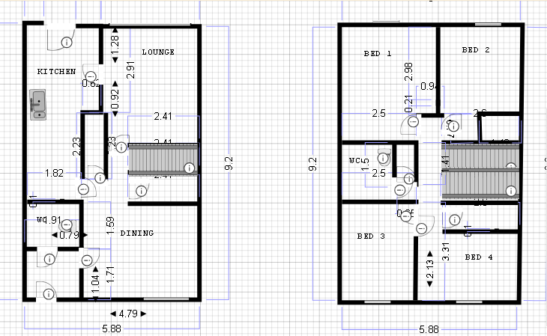

Property Summary
Specification | Details
Total Floors | 2 (Ground Floor + First Floor)
Bedrooms | 4 (All located on First Floor)
Bathrooms | 1.5 (Full bathroom on First Floor, Half bath on Ground Floor)
Width | 5.88 meters
Depth | 9.2 meters (approximate)

Ground Floor
The ground floor features an open-plan living space with modern amenities and convenient access to outdoor areas.
Room | Dimensions | Description
Kitchen | 1.82m × 1.28m | Compact kitchen with modern appliances and efficient layout
Lounge | 2.41m × 2.44m | Spacious living area connected to central stairway
Dining | Variable | Open dining area adjacent to kitchen and lounge
Bathroom | 0.73m × 0.91m | Half bath (powder room) for guests
Stairway | Central | Central staircase providing access to first floor

First Floor
The first floor is dedicated to the private sleeping quarters, featuring four bedrooms and a full bathroom.
Room | Dimensions | Description
Bedroom 1 | 2.98m width | Primary bedroom with good natural light
Bedroom 2 | 0.9m width | Comfortable secondary bedroom
Bedroom 3 | Variable | Third bedroom with flexible layout
Bedroom 4 | 2.4m × 2.13m | Fourth bedroom offering versatility
Bathroom | 2.5m × 1.0m | Full bathroom with modern fixtures
W/C | 2.5m × 1.0m | Separate water closet for convenience

Key Features
- Two-story design maximizing living space
- Four bedrooms providing ample accommodation
- Open-plan ground floor for modern living
- Central staircase for efficient circulation
- Compact 5.88m width ideal for narrow lots
- 1.5 bathrooms strategically located on both floors
- Functional kitchen with adjacent dining area

Floor Plan Documentation

