Retrospective Planning Statement
Capital&Centric
December 2025

- Proposal:
This Planning Statement is submitted in support of the installation of two murals and associated signage within the Piccadilly East neighbourhood. One mural is located on the courtyard-facing elevation of Crusader Mill, and the second mural is located on the courtyard-facing elevation of Neptune Mill. The associated signage is proposed on the Neptune Mill elevation.
Both murals were painted by the renowned Sheffield-based artist Rob Lee, whose works are recognised for their contribution to contemporary urban art. The artworks were installed in 2025 as part of the wider regeneration and placemaking strategy for Piccadilly East.
- Characteristics
Size: Each mural has been designed to sit proportionately within the existing brickwork openings of the host buildings, ensuring the scale respects the historic fabric
Materials: The artworks are painted directly onto the brickwork using Belton Molotow Premium paint, a professional-grade, UV-resistant and durable spray paint widely used for exterior murals. This medium is reversible, and the surface can be returned to its original state without permanent impact on the brickwork.
Design Intent: To bring vibrancy, colour and a sense of identity to Piccadilly East, the murals transform otherwise blank elevations into engaging, high-quality artworks that celebrate and complement the area’s industrial heritage. Cotton Café, currently the only food and beverage offering in Piccadilly East, acts as a central hub for both existing residents and those soon to arrive in the new Capital&Centric residential block. It is therefore vital that the courtyard adjoining the café is a lively, welcoming and characterful space that draws the community together and creates a strong sense of place.
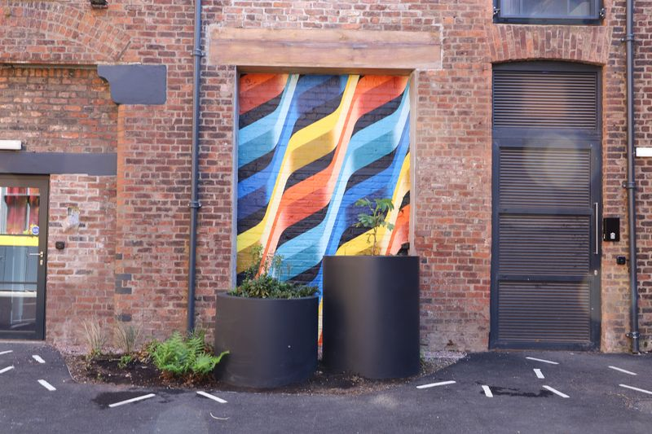
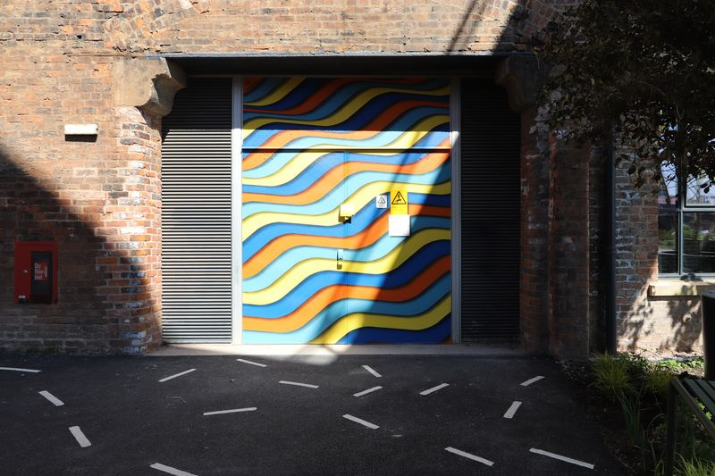
- Design Plans
Figure 1: Neptune Mural Figure 2: Crusader Mural
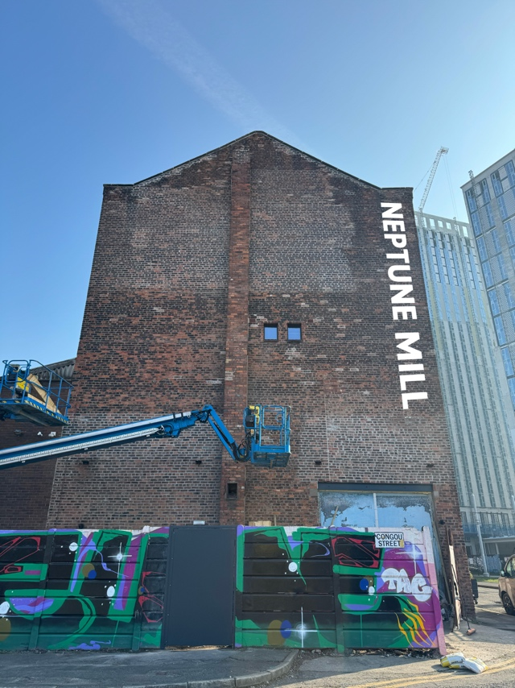
Figure 3: Neptune Mill signage
- Planning Context:
Under Section 55(2)(a)(ii) of the Town and Country Planning Act 1990, minor alterations to buildings may not constitute “development” where they do not materially affect the building’s external appearance. Notwithstanding this, planning permission is sought retrospectively to regularise the murals and ensure alignment with local policy.
  - Relevant Planning Policy:
The proposal has been assessed against the following frameworks:
- National Planning Policy Framework (NPPF)
- Development in Manchester SPD (2007)
- Manchester City Cultural Strategy - “Always, Everywhere: Manchester’s Cultural Ambition 2024-2034”
- Planning Assessment

  - National Planning Policy Framework (NPPF)

- Cultural Significance: The murals enhance, rather than detract from, the character of the historic mill buildings, adding cultural value to the conservation context.
- Economic Vitality: The artworks contribute to sustainable placemaking by encouraging visitors and supporting nearby businesses, including Cotton café, through increased footfall and dwell time.
- Good Design: The murals represent a well-considered design intervention that respects local character whilst fostering distinctiveness and creativity.

  - Development in Manchester SPD (2007)

- The strategy explicitly emphasises the importance of accommodating active ground floor uses, entrances, art and signage to reinforce the character of the street and sense of place.

  - Manchester City Cultural Strategy

- The Strategy explicitly supports integrating culture into regeneration through public art and high-quality design features, aimed at enriching both city centre and neighbourhood spaces.
- Encourages culture to be accessible, dispersed, and embedded within daily urban life, reinforcing the murals’ role in activating local spaces through everyday engagement.
- Design and Justification

  - Placemaking & Local Identity
The murals at Neptune Mill and Crusader aren’t just decorative, they help shape the visual identity of an emerging creative hub. By adorning blank industrial façades, the artworks contribute to crafting the distinct, welcoming character that development plans aspire to deliver.
  - Activation & Connectivity
Public art visually enriches routes and surfaces that might otherwise feel inert. In line with SRF objectives for “active frontages” and “pedestrian-friendly corridors,” the murals animate underutilised façades and help to guide people towards Cotton café, community destinations, and encourage dwell time.
  - Community, Cultural and Economic Impacts
The murals extend Capital&Centric’s ethos of community inclusion, reinforcing Piccadilly East as a cultural “neighbourhood of choice,” not just a property-led district.
  - Enhancing historic buildings
The addition of the mural to the listed building
  - Existing Planning Permission
Plans have evolved from a large-scale mural on the outer-facing wall of Neptune Mill to a more modest design. The new design is a simple signage spelling out ‘Neptune Mill’. This approach better aligns with Policy CC 9 of the Shopfront and Signage Design Guide which emphasises the need for new building features to achieve a high standard of visual appearance. After consideration, it was concluded that the proposed mural, selected through a community competition, would not sufficiently meet this policy. The design was therefore revised to a more restrained yet visually attractive signage solution.
- Conclusion
The murals and signage at Neptune Mill and Crusader are an inspired and contextually sensitive addition to Piccadilly East. In this design-led and emerging urban neighbourhood, where Cotton Café currently serves as the sole food and beverage offering, creating visual interest is vital to attracting and sustaining footfall. By transforming blank façades into vibrant, animated frontages, the murals encourage movement toward the café and surrounding pedestrian areas, reinforcing wayfinding and increasing dwell time. In doing so, they not only enrich the physical environment but also advance wider placemaking goals, celebrating cultural identity, supporting local economic vitality, and strengthening Piccadilly East’s reputation as one of Manchester’s most distinctive and creative districts.

