Design and Access Statement
24 Dale Street, Manchester, M1 1FY

Introduction
The unit is a mixed use development of which the proposal refers to the ground floor and basement levels.
The unit is currently empty, having previously traded as a public house under various ownerships, but it has been closed for a number of months. This proposal is to carry out minor works internally to create a new feel to the site whilst retaining the existing layout, toilets, kitchen and basement as existing.
The bar would be accessed via the existing entrance to Dale Street, utilising the existing stone steps, with the existing exit route to the rear being retained. This is also a stepped access.
The building is a Grade II property, located on the corner of Dale Street and Little Lever Street, with the existing entrance located to the Dale Street Elevation.
The building consists of a cellar with 3 storeys above. Previously three town houses, now public house and offices above.
The building dates from late C18 and has been altered so that No. 24 now incorporates No. 26 and is double fronted. The front façade is red brick with scored stucco at ground floor level, which is currently painted white. No. 24 has a central round-headed doorway with open-pedimented doorcase of engaged columns, altered windows at ground floor and chamfered corner with inserted window, raised doorway approached by three stone steps.
For this application we are only concerned with the external elevations.

Proposal:
The proposal for the elevations is to redecorate the external façade to Ground floor level, to both the Dale Street and Little Lever Street Elevations. To the Dale Street (front) elevation it is proposed to install a new, handmade artisan tile to the section above the painted plinth and beneath the windowsill (approx. 800mm band).
The existing windows are to be retained and redecorated and the existing stone steps be repaired to make safe.
To the Little Lever Street (side) elevation, we propose to decorate the ground floor section of wall in a dark charcoal colour to allow for maintenance and upkeep against anticipated graffiti. Should any graffiti be painted on this wall it will be easy to cover over and maintain the building.
Externally it is proposed to install new signage to the existing timber fascia using individual wooden letters, painted gold. The existing modern signage lights are proposed to be replaced with antique brass signage lights in existing positions.
Finally, we propose to install a new lantern over the entrance, fixed on a bracket to highlight the entrance and enhance the visibility of the site and enhancing the history of the unit as a Public House.
The entrances and exits of the property will remain as existing.
Design
The proposal is to enhance the front façade to enhance the elevation and improve the visibility of the site. The use of a handmade artisan tile in a crimson colour is proposed as a reference to traditional public houses of the time. The extensive use of tiles to the façade of public houses was driven by the Industrial Revolution’s mass production capabilities and allowed pubs to use large quantities to stand out from competitors. The benefit was that the tiles were hard wearing and easy to clean which provided a good surface finish which was both striking and practical. The proposed use of tiles to the façade of 24 Dale Street will enhance the frontage and indicate the use of the site through the historical reference.
The elevation will remain as existing with the existing windows retained and redecorated and the scored stucco render being retained and redecorated only.
A new painted wood door will be installed to fit within the existing opening.
A new signage scheme will be proposed to advertise the bar to encourage patrons to visit. Signage design to be submitted for planning separately.
Access
The current access into the building is from Dale Street, using the 3no. existing stone steps. The rear entrance is also accessed by a stepped approach. There is currently no permanent disabled access into the unit and following investigation we have concluded that this will not be possible to achieve for a number of reasons as outlined below;
Option 1: Provide a platform lift.
We investigated installing a platform lift, however the existing entrance door is too narrow to accommodate a platform lift within the lobby space. In addition there would be substantial changes required to the façade to accommodate this method, something which we feel would not be acceptable.
The second option we investigated was the rear exit door, however the platform lift would impede the existing escape route and therefore make it impractical.
Option 2: Install a ramp.
The installation of a DDA compliant ramp was investigated, however this would cause extensive changes to the façade and entrance and would impede a public highway to an impractical width. The length of the ramp would also be over 5m and therefore would protrude beyond the building.

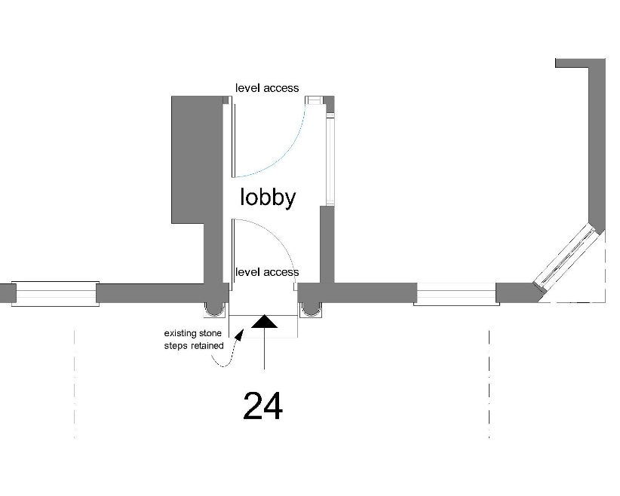

Image A: Entrance Layout from Dale Street

In addition to the restrictions and issues with providing disabled access, there are complications with providing egress from the site should there be an emergency situation. The existing exits which are to be retained are located to the rear and side of the site, both of which have steps. The exits would not be suitable for DDA route due to the steps and the existing enclosure is not large enough for a refuge to be positioned within the space.
The second exit is through the right side of the site, which joins a shared exit route with other units. This exit is also stepped and does not have a space suitable for a refuge as it is currently.

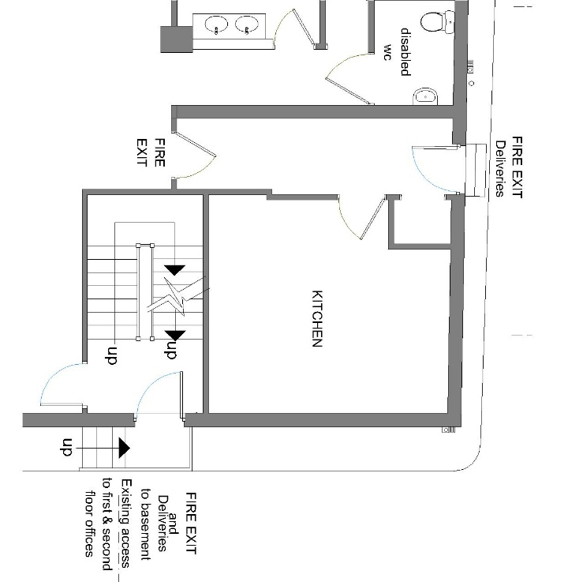
Image B: Existing exits with stepped access.

As exits from the building are not satisfactory for disabled use, we feel that the building will not be able to be accessible and in doing so would present a risk.
In conclusion we do not think the site will be able to provide a suitable safe access option due to the restrictions of the existing building and it’s heritage status. Due to this we propose that the entrance is retained as existing.

Conclusion
The proposed changes to the property are to enhance the elevation and encourage customers to enter the site as it is not clearly a public house currently.
The improved visibility of the site where there is limited space for traditional signage will be welcoming and in keeping with a traditional pub façade.
In terms of the building, we intend to retain and enhance the key existing features, being sympathetic to the existing design and improving the entrance door for longevity.
In regard to access and egress from the building, following investigation into alternative options we have concluded that the site cannot provide suitable access to comply with DDA requirements. Therefore we propose to retain the existing entrance stairs and exit routes as noted above.

