

CONSTRUCTION MANAGEMENT PLAN

FOR

Wren House,
108 Palatine Road,
West Didsbury,
Manchester
M20 3ZA

Churchill Living
Churchill House
The Courtyard
Buntsford Gate
Bromsgrove
Worcestershire
B603DJ
Tel: 01425 462100
www.churchillretirement.co.uk

CONTENTS

- INTRODUCTION
- WORKING HOURS
- DUST SUPPRESSION MEASURES.
- SITE SET UP.
- PARKING FOR SITE OPERATIVES AND VISITORS.
- ENVIRONMENTAL IMPACT MEASURES FOR SITE DELIVERIES.
- ROUTES FOR CONSTRUCTION TRAFFIC.
- SCHEDULE OF DELAPIDATION.
- SUMMARY AND CONCULSIONS

APENDICES

- SITE SET UP PLAN
- CONSTRUCTION TRAFFIC ROUTE MAP
- VEHICLE TRACKING FOR THE SITE ENTRANCE
- SCHEDULE OF DELAPIDATION TO LOCALISED ROADS.

- INTRODUCTION

  - Introduction

This Construction Management Plan (CMP) has been prepared to address condition 5 of the schedule of conditions which form a section of the granted planning permission (referenced below)

It is Churchill Living’s (CL) intention that its work will be carried out in accordance with all relevant statutory provisions and all reasonable practicable measures will be taken to avoid any risk to its employees or others who may be associated or affected thereby.

1.2 The application reference is 138765/FO/2023.

Schedule of conditions: 5.

‘’Prior to the commencement of the development hereby permitted, a Construction Management Plan (CMP) shall be submitted to and approved in writing by the Local Planning authority and shall cover:
a) days/hours of work;
b) dust suppression measures;
c) compound locations/areas within the site for loading/unloading, storage of waste, the site office/welfare facilities;
d) details of parking for site operatives and visitors;
e) a delivery schedule, including timetabling, covering the expected number and type of vehicles likely to require access to the site during construction, together with evidence that this can be safely achieved;
f) routes for construction traffic;
g) a dilapidation survey of surrounding carriageway and footways; and
an emergency contact telephone number.
The development shall then be implemented in accordance with the approved CMP.’’

1.3. Location

Wren House, 108 Palatine Road, West Didsbury, Manchester M20 3ZA

1.4 Existing Development
The site is a rectangular shaped parcel of land accessed from Lapwing Ln. with the Eastern boundary facing Palatine Road.
The south and Western boundaries face onto residental properties.

  - Proposed Development

.
The development proposed is erection of 37 retirement living apartments (comprising 24 1-bed and 13 2-bed) including communal facilities, access, car parking and landscaping, and reconfigured car parking arrangement to Wren House.

  - Context & Scope

The principal aim of this CMP is to ensure that constructions phases from excavation and construction to finishing works are organised and delivered in a manner that safeguards the highway impact, highway safety and the receptors of the area surrounding the development site whilst protecting the environment.

- WORKING HOURS

It is proposed that all work will be conducted between 07:30 to 18:00 hrs Monday - Friday and between 08:00 to 13:00hrs on Saturdays, there will be no Sunday working on site.

Due to the close proximity of surrounding residential buildings and business premises, and the associated traffic congestion at the beginning and the end of the day. Churchill Retirement Living will seek to restrict material deliveries to the site through this period. Nor shall the any HGVs associated with the development be laid up, waiting, in the surrounding residential streets during these times. These conditions will be conveyed to all relevant parties when placing material and subcontract orders.

For any noisy works where there is a direct impact upon surrounding properties within the specified times, the site manager will make contact with the neighbours to consult on the duration, extent and impact of the works to see if an informal agreement can be reached to minimise the duration of these works or carry them out at specific times.

3, DUST CONTROL

Dust and debris is regarded as one of the main environmental nuisances and safety problems arising from construction sites.

Measures will be put in place to control the arrisings of dust from the site. It can be appreciated that on days where adverse weather i.e days of wind gusts it can be difficult to prevent general dust on the ground from being carried away.
We will put the following control measures in place to mitigate and control dust from the development.

Hoarding will be erected to site boundaries where possible. Along with reducing the visual impact and providing protection for the construction workers and public, this will also act as a barrier for dust and dirt originating from within the site.

During works the main air pollution emissions are the dust generated when building materials are broken up (removal of existing carpark), loading of lorries, inparticular the excavation and carting of dry earth during the groundworks phase of construction and the use of portable petrol cut off saws. Transport leaving the development can also be a source of creating dust to rise into the air.

After a study of the existing site, it is proposed that a section of the existing carpark tarmacadam be left in situ during the construction phase. This will be to provide a suitable hardstanding for the site office, welfare, delivery and storage areas. Allowing the site team to adequately maintain an area of the development that is cleanable with a contract road brush. Significantly reducing the dust and detritus generated and allowing the site team to better manage the area.

During the ground working phase of construction all excavated spoil will be correctly bunded and sealed in anticipation of removal from the site. Any bunded, excavated earth will be sited as far from residential properties as is practicable. All machinery will be switched off when not in use to minimise emissions as well as noise.

All HGVs removing spoil from the site will be fully sheeted to minimise the risk of any mud over spilling onto the highway. A wheel washing facility will be provided for the duration of the construction works to ensure levels of soil on roadways near the site are minimised. The wheel washing facilities will be in the form of a hose down point located adjacent to the development entrance. Vehicle wheels will be cleaned whenever a vehicle leaves the site, if required.

A banksman will be provided during periods of spoil removal to ensure safe access and egress from the site entrance and to ensure no debris is carried onto the highway.
The contractor will ensure that the area around the site including the public highway is regularly and adequately swept to prevent any accumulation of dust and dirt.

During periods of cart away for excavated material, if deemed necessary a contract road brush will be in attendance.

The portable petrol cut off saws can be a source of dust. Materials where possible will be purchased for the development to mitigate any cutting. However on occasion when materials do need to be cut on site the saw will be operated with an automatic water applicator. The water application is designed to dampen any arising debris and dust as well as reduce wear to the blade. Use of cut off saws without water attachments will not be tolerated under any circumstances.

Burning of materials on site is strictly prohibited.

- SITE SET UP

Please refer to a drawing in Appendix 1

The site set up has been laid out to enable safe access and egress from the site for vehicles and pedestrians. The drawing in appendix 1 indicates areas for loading and off loading of vehicles and lay down area for the storage of materials.
There is a segregated area for the welfare cabins and office allowing safe areas to be traversed by site operatives.
We will be erecting a luffer crane (indictated on the drawing with radius’ from the crane position) within the development to assist with the loading / unloading and distribution of materials. No materials will be allowed to pass through the site boundaries.
A designated area for waste has been identified.

- PARKING FOR SITE OPERATIVES AND VISITORS.

Parking in the local area is very limited. Due to the restrictive nature of the site, onsite parking will not be permissible. Site visitors will be encouraged to use dedicated public car parks within the area, the nearest car park is off Wilmslow Road near to the hospital. Contractors will be instructed to use the pay and display car parks. This instruction would be via site inductions prior to operatives commencement on site. Churchill Living is also to approach the local businesses and land owners with a view of renting space for the car parking for the site management and workforce, if available.

There is great potential for construction workers to travel to the site by sustainable modes such as walking, cycling, public transport and car sharing. It is therefore deemed appropriate to continue to promote the local services available as well as the following measures to promote sustainable travel by construction staff.

- Include local public transport timetables and route maps are accessible from the internet and can be conveyed to site operatives if required.

- Give construction staff the opportunity to change clothes within the site compound if walking to the site in inclement weather. A drying room and shower are available on site.

- Minimise where possible the number of contractors on site at any one time to reduce trips generated and promote car sharing.

Where possible the Site Manager will try and minimise any deliveries on waste collection days in order to reduce the conflict with refuse trucks operating.

The site is located within reasonable proximity of the strategic highway network and travel routes described in section 7. As such, construction vehicle trips associated with the site will have a minimal impact on less substantial routes which are more influenced by changes in traffic volumes.

Contractors, where feasible, will seek to recruit construction workers from the local area. This will help maximise the potential for construction workers to walk and cycle to the site.

It is therefore deemed that there are opportunities for the construction worker trips to be undertaken by public transport.

There is great potential for construction workers to car share to work; especially given the fact that some sub-contractors will be travelling from the same origin to the same destination (the site).

Car sharing represents a relatively convenient form of travel offering a significant potential to reduce overall private mileage of construction workers and visitors. It is this mode of transport which often forms one of the most convenient methods of sustainable travel with construction workers.

The construction site will provide facilities in accordance with requirements set out in the HSE guidelines. As such the site will provide a drying room, storage facilities, toilets and offices. In addition to this a canteen area is provided. This will further encourage people to travel to the site by sustainable modes such as walking and cycling whilst having the added benefit of reducing the number of trips made off site during lunch breaks.

- ENVIRONMENTAL IMPACT MEASURES FOR SITE DELIVERIES.

6.1 INTRODUCTION.

This section outlines the proposed development schedule, construction methodology and the way in which deliveries will be controlled with regards to the local highway network.

Site management and supervising staff have responsibility for implementing the Company’s Health and Safety Policy and will ensure that Health and Safety considerations are always given priority when planning and during the day to day supervision of the work.

All Employees and Sub Contractors are expected to co-operate with Churchill Retirement Living in carrying out their duties and will ensure that their work, so far as is reasonably practicable, is carried out without risk to themselves or others.

6.2 DELIVERIES AND SCHEDULING

All deliveries to the site will be arranged by the site manager or agreed with the site manager in advance. who will keep a record of the schedule and all deliveries. All deliveries will then be met by the Banksman who will assist vehicles entering, exiting and manoeuvring into and out of the site.
The Banksman will co-ordinate the transfer of materials from the loading area. Through this arrangement it is hoped that the dwell time of the delivery vehicles can be reduced to less than 30 minutes, where possible.

Signage will be placed as required to advise road users and pedestrians of the construction site ahead. Deliveries will be coordinated where possible to avoid simultaneous arrivals and congestion on the surrounding roads.

Dedicated pedestrian routes will be provided offering safe, direct access to the site office from the pedestrian entrance and routes will be adequately signed.

The site manager will be in control of scheduling material deliveries and will usually employ a 5 week rolling schedule for deliveries to meet the requirements of the construction phasing.

Deliveries will be scheduled between times when there will be expected higher volumes of traffic on the surrounding roads.

All delivery drivers and construction workers will be advised of the preferred route (see appendix 2) prior to making their delivery or commencing work.
Route to be conveyed to delivery and contractors.
From the A5103 Princess Road, routing along Barlow Moor Road, or the A34, routing along Wilmslow road, onto Barlow Moor Road which both routes lead into Palatine Road, which are strategic road routing to the site. Followed by the reversal when leaving the site.

It is considered that the proposed routing avoids the use of minor roads and maximises the use of the major strategic roads where possible.

6.3 Size and type of delivery vehicles.

It is anticipated that the proposed redevelopment of the site will commence in the year 2026 and complete in approximately 18 months from the start date. It should be noted that the construction programme and corresponding construction traffic strategies may be subject to change prior to work commencing on site. Any significant changes to the CMP that may occur would need to be agreed with officers at the local planning authority with Manchester City council.

Please see appendix 3 for the vehicle tracking.
Vehicle tracking indictated is for an articulated lorry. This type of lorry is the largest anticipated to be used for deliveries of the crane and will be infrequent. At the start and end of the project.
When engaging suppliers it will be conveyed that smaller ridged load vehicles are to be used for deliveries as much as practicable to ensure that the turning and reversing from Lapwing Lane and be achieved.

    - Phase 1 – Groundwork’s

It is expected that the groundwork’s will take approximately 12 weeks with the key activities on site involving the site strip, muck away, foundations, and drainage.

It is envisaged that during this phase there will be between 5 and 10 deliveries per day with the majority of these movements made up of concrete, muck away trucks and rigid vehicles delivering materials. Some of these deliveries will be larger plant movements.

    - Phase 2 – Superstructure & Roof

The second phase of the construction period is likely to last for a 8-month period and will involve the construction of the development including floors, masonry work, roof structures, gutters and drainpipes.

The Company will employ a qualified Banksman whose duties will include the management of delivery vehicles. The Banksman will wear high visibility clothing at all times and will direct vehicles and pedestrians when delivery vehicles require access and egress to the site. A tower crane is to be deployed to assist with the construction process. The vast majority of material deliveries will be off-loaded by the crane and distributed directly to its designated area of installation, however, a dedicated storage area will be provided for when this is not possible.

Macadam temporary roads and hard standings will be provided for storage areas, traffic, parking and pedestrian routes. This will provide a clean surface for manoeuvre and prevent vehicles from carrying mud and debris onto the public highway.

Vehicle movements to the site during this phase are not expected to be significant with articulated vehicles for masonry deliveries and roof construction and heavy vehicles for bulk materials such as sand and cement. We estimate that this phase is likely to result in a maximum 6 deliveries per day.

    - Phase 4 – Internal Works

The fourth phase of the construction period is likely to last for 6 months and will involve the internal works such as the fitting of plasterboards, windows, carpentry, tiling, electric, plumbing, floor coverings and painting.

Vehicle movements to the site during this phase will primarily be smaller vehicles such as vans delivering internal fittings such as bathrooms and kitchens. However, there will be some articulated vehicle deliveries associated with the delivery of plasterboard, doors and windows. It is anticipated that this phase is likely to generate a maximum of 4 deliveries per day.

    - Phase 5 – Landscaping & Utilities

The fifth and final phase of the development will be the least intensive with respect to vehicle movements to the site. It includes landscaping and installation of utilities and is anticipated to last for 2 months. Vehicular activity is likely to involve circa 1 van movement per day although turf deliveries may involve larger vehicles.

        - Dwell Times

- Delivery vehicles are unlikely to attend the site for any longer than 45 minutes. The delivery scheduling system would allow sufficient times between deliveries to ensure that no vehicles would have to wait on the surrounding highway network before entering the site.

The following dwell times are expected for the vehicles accessing the site during the construction phases.

      - Skip Delivery / Spoil Collection – between 5 to 15 minutes
      - Plant Delivery / Collection – between 15 to 30 minutes
      - Materials delivery – between 15 and 30 minutes
      - Concrete delivery – up to 30 minutes

6.4 MEASURES, MANAGEMENT & CONTROL PROCESSES

  - Introduction

This section sets out the measures, management structure and control processes that will be put in place to implement, monitor and manage the CMP. The Site Manager will be responsible for the site works which will ensure that the control processes are efficiently communicated and implemented.

  - Transportation Co-ordination

The Site Manager for the project will undertake the transport co-ordination role for the site. In this respect, their main responsibilities will include:

      - Managing the implementation of the CMP
      - Vehicle scheduling
      - Informing local residents of any low loader deliveries associated with construction of the site to avoid / minimise disruption
      - Checking for scheduled road works on http://roadworks.org
      - Checking for scheduled refuse collections with the Local Authority
      - Handling any complaints
      - Acting as a point of contact for employees, contractors and the general public.

The Site Manager will also be responsible for keeping neighbours adjacent to the development informed of the construction progress, particularly with regards to when high frequencies of deliveries are expected. In this respect, the Site Manager will ensure that there is adequate liaison between the following key stakeholders throughout the construction period:

- Site neighbours

- Local stakeholders such as emergency services or local transport providers

- Local Authority

  - Booking System

On a weekly basis the Site Manager will evaluate details of the daily profile of deliveries proposed for the upcoming week.

Hauliers will be required to contact the site and indicate their delivery schedule for the following day. The proposed deliveries will be checked against the weekly delivery schedule. This will be overseen by the Site Manager to ensure that no two construction deliveries occur simultaneously at the site, thereby ensuring that there is always space at the site to accommodate the necessary plant and deliveries.

It is not considered necessary to implement a holding area for delivery vehicles. However, to avoid stacking on the local highway, hauliers will be required to notify the Site Manager before the expected delivery time to ensure that the delivery space and banksmen are ready for their arrival onsite.

Sufficient time will be given between deliveries to allow for any delays as a result of the delivery vehicle getting held-up in traffic or the loading/unloading taking longer than expected and to avoid any vehicles waiting on the surrounding highway network.

  - Route Compliance

Use of the agreed vehicle routes shall be included when communicating with the supply chain and individuals associated with the works. It is envisaged that this information will be communicated in the form of email and will include information with regard to times of operation, delivery routes, the call up procedure and delivery slot information.

- ROUTES FOR CONSTRUCTION TRAFFIC.

Please refer to appendix 2 for map.

The site benefits from being within reasonable distance from the A5103 Princess Road, routing along Barlow Moor Road, or the A34, routing along Wilmslow road, onto Barlow Moor Road which both routes lead into Palatine Road. Turning onto Lapwing Lane and left onto the development 100meters from the junction. These are the strategic road routing to the site. Followed by the reversal when leaving the site.

- SCHEDULE OF DELAPIDATION.

Please refer to Appendix 4

Prior to any construction works being carried, a local highway condition survey has been carried out and recorded by means of photographs referenced with a site plan. Once all development work has been completed, a further survey will be carried out and comparisons made with the original survey. Any damage or change to the highway condition will be notified to Manchester City Highways for further discussion.

- SUMMARY & CONCLUSIONS

  - Summary

This Construction Management Plan (CMP) has been prepared by CL and relates to the proposed development works at
Wren House, 108 Palatine Road, West Didsbury, Manchester M20 3ZA. The CMP provides information to ensure that the development works are organised and delivered in a manner that mitigates and safeguards the highway impact, highway safety and amenity of the area surrounding the development site.

The construction period is anticipated to last for approximately 18 months, beginning in the year 2026. It should however be noted that the construction programme and corresponding construction traffic strategy may be subject to change.

Access to the site will be taken from Lapwing Lane. This area will remain presentable and tidy at all times. The entire highway facing boundaries of the site will be hoarded; tree protection will be maintained throughout the development process.

CL will be leading the build element of the project. CL estimate that the site will require 2-3 direct employees supported by 15 sub-contractors at different phases of the construction. As such on average it is estimated that there will be between 5 and 30 construction workers on site each day.

All materials associated with the development process will be stored within the footprint of the site. Skips and other plant will also be stored within the curtilage of the site.

Based on the analysis presented within this CMP it is estimated that, during the busiest period, up to 6 HGVs each day are forecast to service the site. The largest vehicle is expected to be an articulated lorry. The scale and volume of vehicle movements associated with the development construction period is not considered to have significant impacts on the operation of Lapwing Lane, whilst larger vehicles access the site.

All deliveries to the site will have to schedule in advance with the Site Manager who will keep a record of the schedule and all deliveries. All deliveries will then be met by the Banksman who will assist vehicles entering, exiting and manoeuvring around the site as well as low loader deliveries.

The construction process will be managed by the appointed Site Manager employed by Churchill Living Ltd. The Site Manager’s responsibilities will include acting as a point of contact for the local authority, stakeholders and members of the public. Further to this, the Site Manager will also be responsible for delivery scheduling, construction route compliance and managing other contractors employed on-site.

To further control the environmental impacts of the development, measures to be employed include covering skips and vehicles to prevent overspill, wheel washing facilities, employing local contractors and the implementation of a waste management strategy.

Whilst the principles of the construction strategy in relation to transport are established with this CMP it should be noted that the construction programme and corresponding construction traffic strategy may be subject to change prior to work commencing on site.

Overall it is considered that the measures and control processes outlined in this CMP are appropriate to overcome the identified constraints associated with the site

  - Delivery of Plant & Materials

All materials associated with the development process will be stored within the site boundaries. Skips and other plant will also be stored within the curtilage of the site. A dedicated loading and unloading area for plant and materials will be created.

Swept path analysis of the movement of articulated delivery vehicles has been carried out to ensure access and egress can be achieved. It is envisaged that there will be approximately four deliveries to the site per day over the course of the construction period.

The Company will employ a qualified Banksman whose duties will include the management of delivery vehicles. The Banksman will wear high visibility clothing at all times and will direct vehicles and pedestrians when delivery vehicles require access and egress to and from the site. A tower crane is to be deployed to assist with the construction process. The vast majority of material deliveries will be off-loaded by the crane and distributed directly to its designated area of installation, however, a dedicated storage area will be provided for when this is not possible.

Macadam temporary roads and hard standings will be provided for storage areas, traffic and pedestrian routes. This will provide a clean surface for manoeuvre and prevent vehicles from carrying mud and debris onto the public highway.

APPENDIX 1 – SITE SET UP PLAN

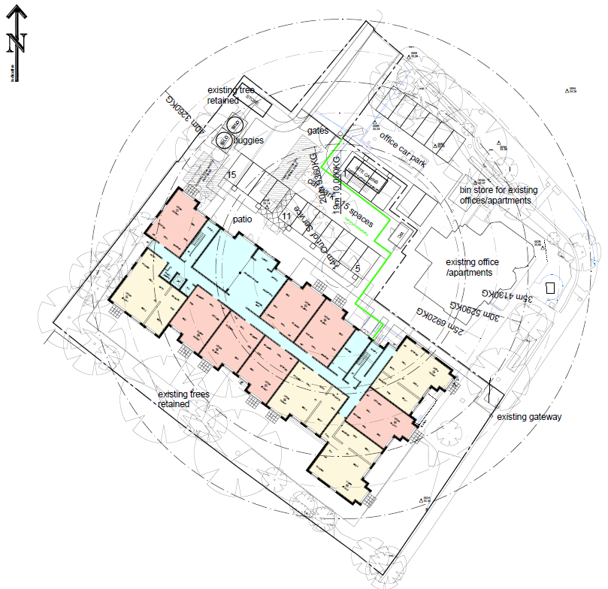

APPENDIX 2 –CONSTRUCTION TRAFFIC ROUTE MAP

A3103
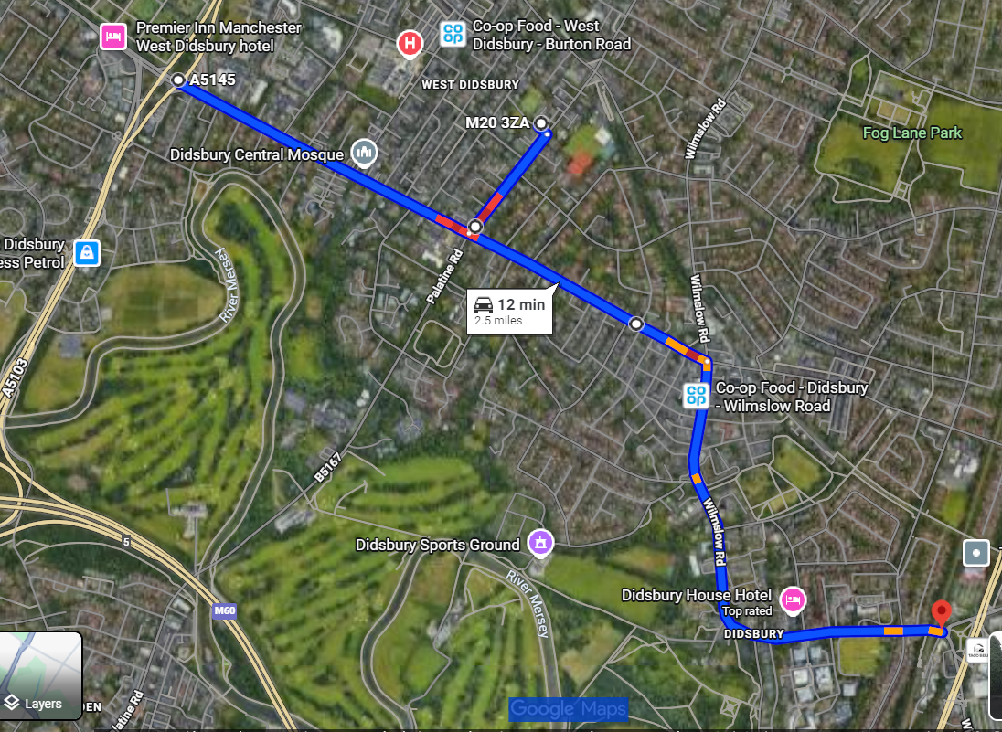
A34

APPENDIX 3. VEHICLE TRACKING.
Vehicle tracking for articulated lorry. This type of lorry is the largest anticipated to be used for deliveries of the crane and will be infrequent. At the start and end of the project.
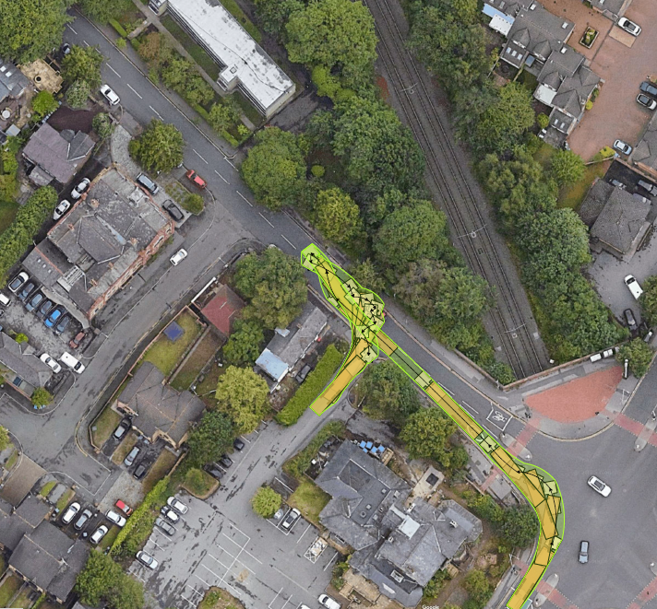

APPENDIX 4. Dilapidation Survey.

Dilapidation Survey to footpath and roads adjacent to the proposed development at
Wren House, 108 Palatine Road, West Didsbury, Manchester, M20 3ZA.
The below site plan indicates numbers within red boxes that correspond with the below photos.

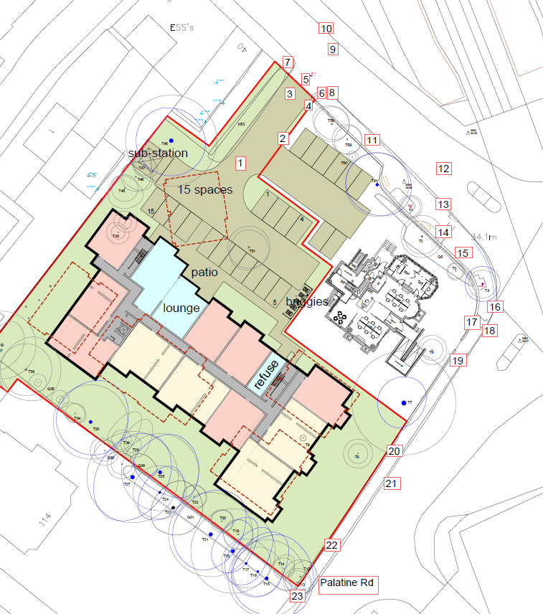

Photo 1.
View from the site access road, looking Northwest towards Lapwing Ln.
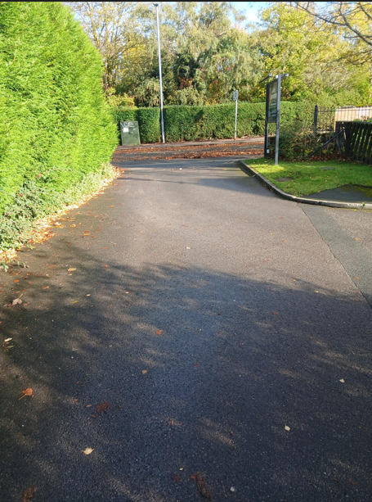

Photo 2.
Radius kerbs leading from the site access road into Wren Properties carpark.
Damaged radius kerbs and previous scarring across the carpark entrance.
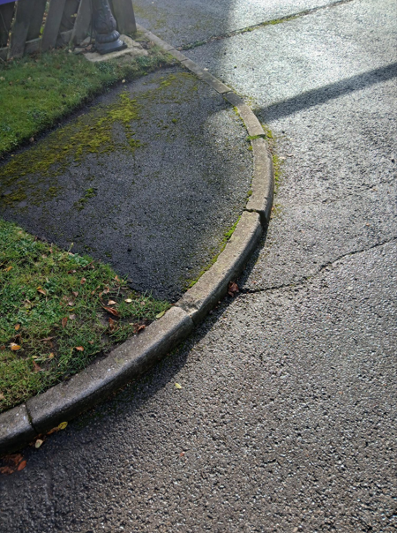

Photo 3.
View from Lapwing Ln along the shared access road
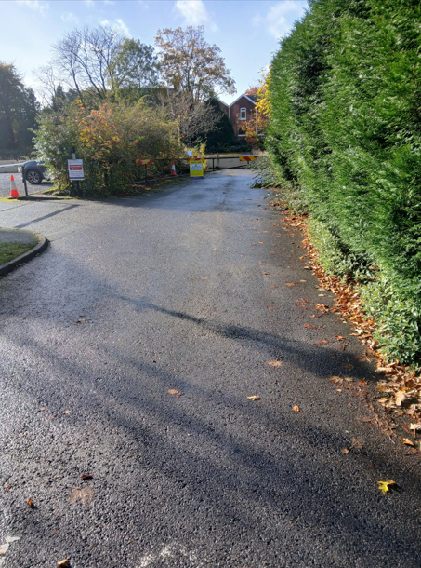

Photo 4.
Shared access road. Kerbs and grass verge in reasonable condition.
Scarring to access road from radius kerb into the proposed development.
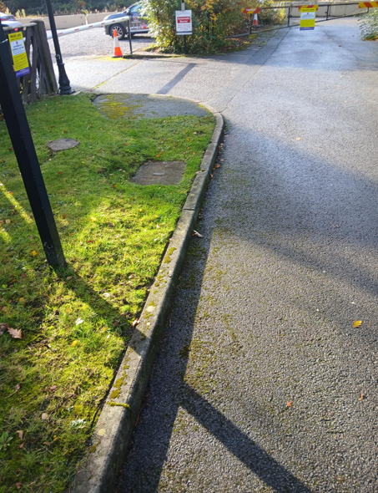

Photo 5.
Site access bell mouth. Looking towards the road junction of Lapwing Ln and Palatine Rd.
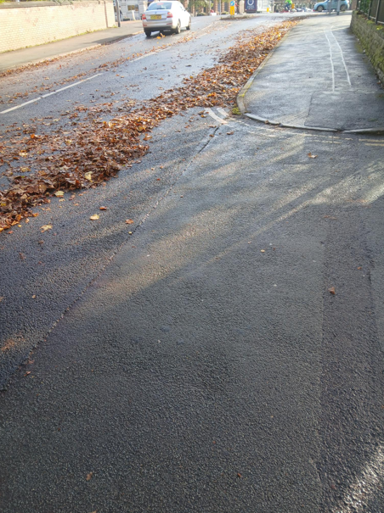

Photo 6.
Radius kerbs on the Western side of the site entrance.
Majority of the radius kerbs are damaged and misaligned.
Two road scarring’s across the entrance, showing settlement of the trench.
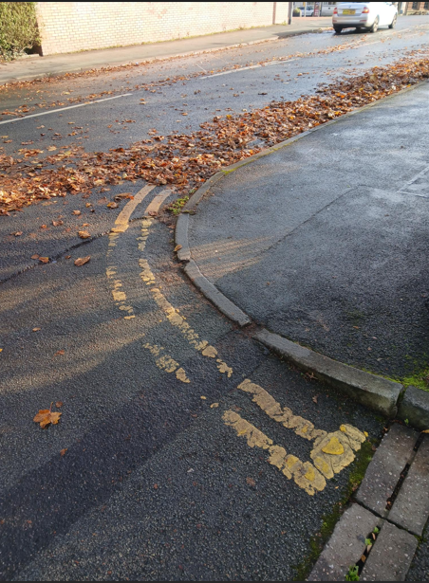

Photo 7.
Radius kerbs to the Eastern side of the access road.
Broken kerb adjacent to the tarmac scarring and on the radius.
Previous scarring following installation of footpath services has settled below the footpath level.
Deterioration of double yellow lines.
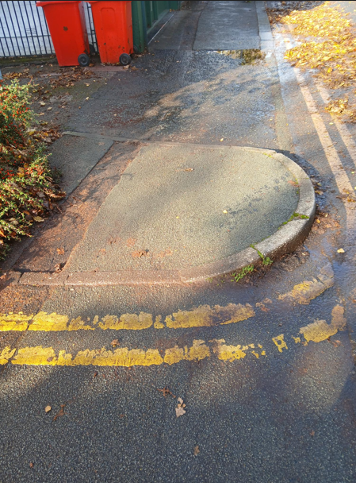

Photo 8.
View west from the kerb radius leading into the shared access road.
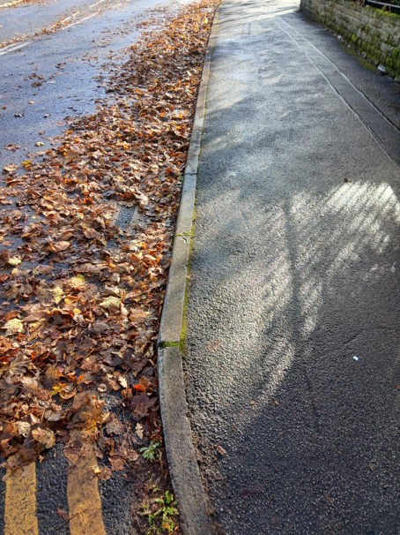

Photo 9
View looking North from the site entrance.
The Tarmacadam to the road appears to be in good condition.
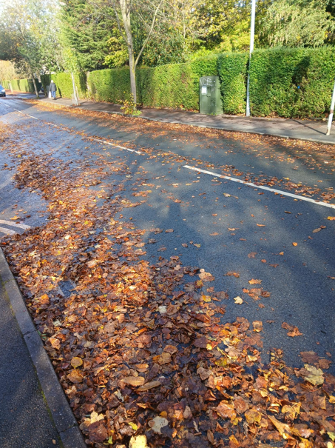

Photo 10.
Footpath directly opposite the share site entrance.
Substantial line of kerbs is raised from tree roots and miss aligned.
The footpath is unlevel.
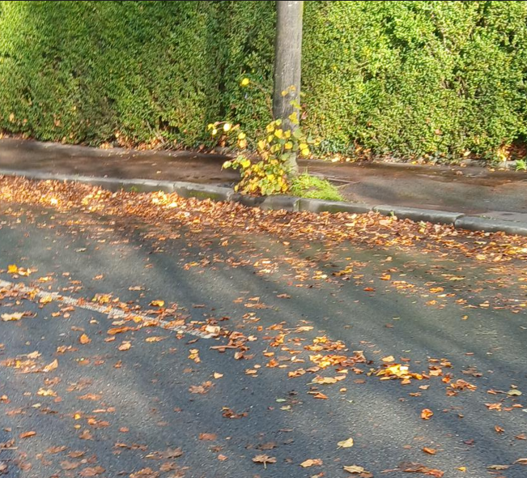

Photo 11.
Looking West towards the Junction of Lapwing Ln and Palatine Rd.

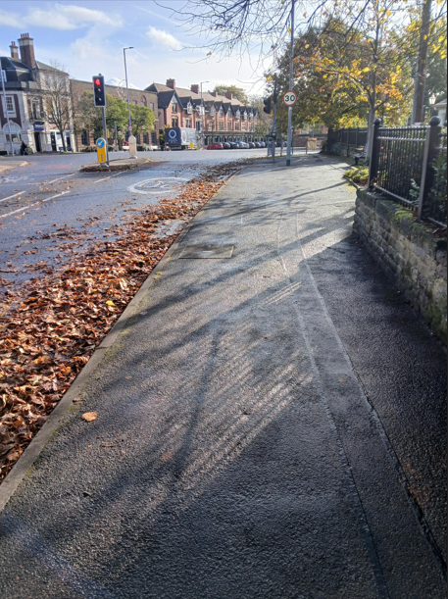

Photo 12
View towards the junction of Lapwing Ln and Palatine Rd.
General road condition appears to be reasonable.
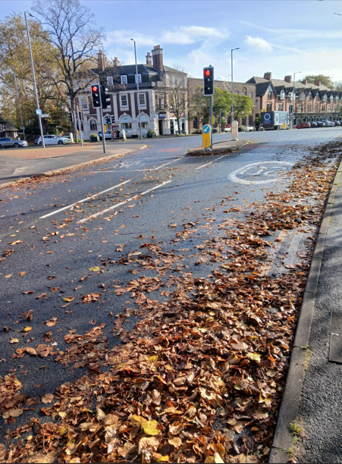

Photo 13
Approximately 150mm diameter hole in the tarmac adjacent to the kerb, within scarring from previous excavation. Road crossing is visible in the photo, crossing Lapwing Rd.
Scarring is visible across the road.
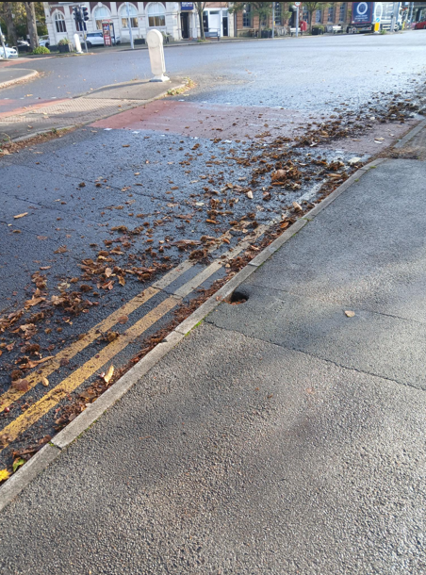

Photo 14.
Misalignment of tactile paving to the pedestrian crossing on the junction of Lapwing Ln adjacent to Wren properties.
Several areas of scarring to the footpath, previous trench excavation has settled.
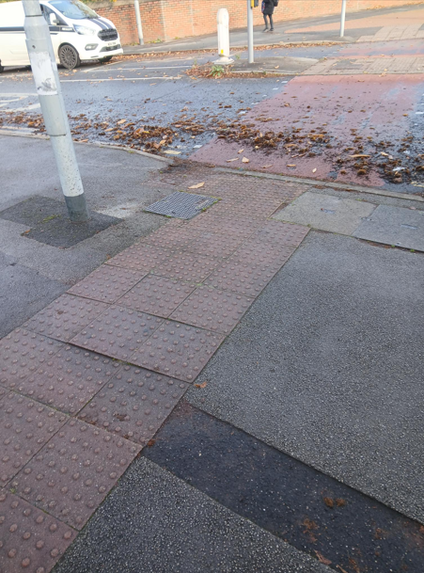

Photo 15
Looking East on the corner of Lapwing Ln.
Settlement of previous trench excavation.
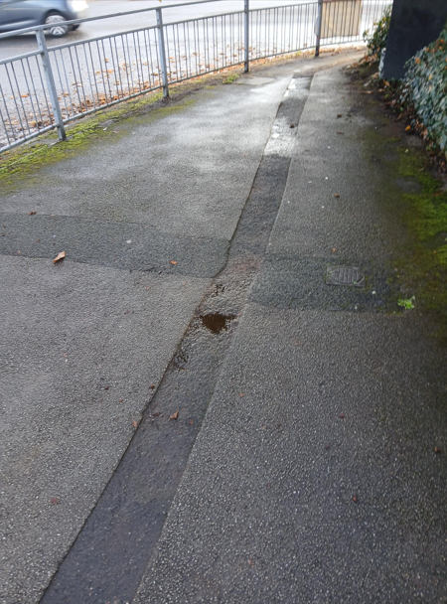

Photo 16
North view across the junction of Lapwing Ln meeting Palatine Rd.
Misalignment of radius kerbs adjacent to previous footpath excavation.
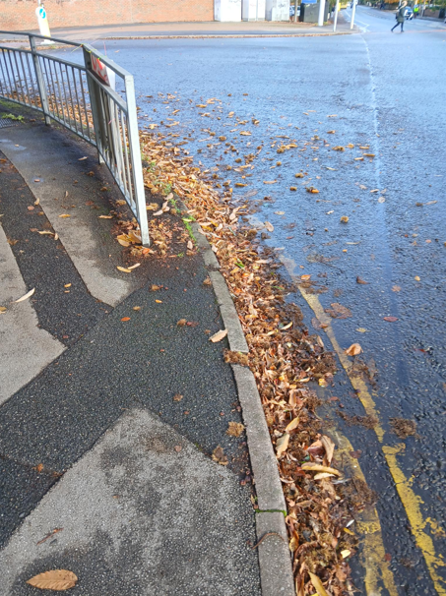

Photo 17.
Street furniture. Both the lamp post and the traffic lights are out of plumb.
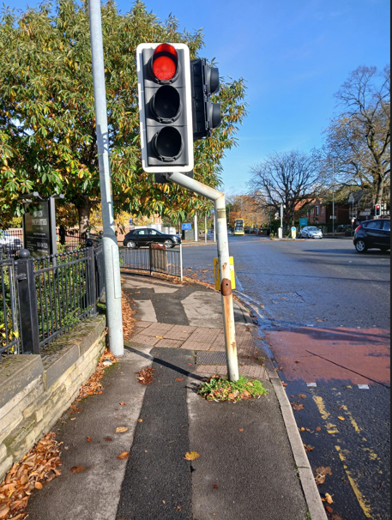

Photo 18.
Pedestrian crossing, crossing Palatine Rd adjacent to Wren Properties.
Miss alignment of tactile paving.
Slightly raised UPVC cover.
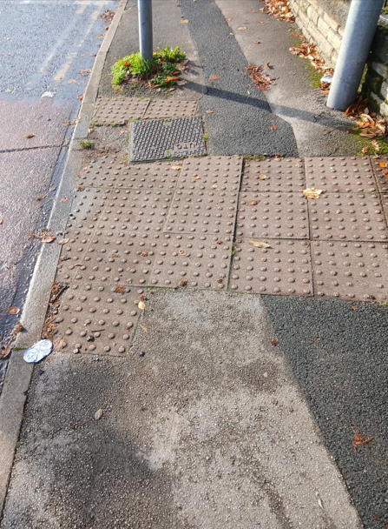

Photo 19.
Looking Southeast along Palatine Rd adjacent to Wren Properties.
Damaged and misaligned kerb.
Significant scarring to footpath following excavations.

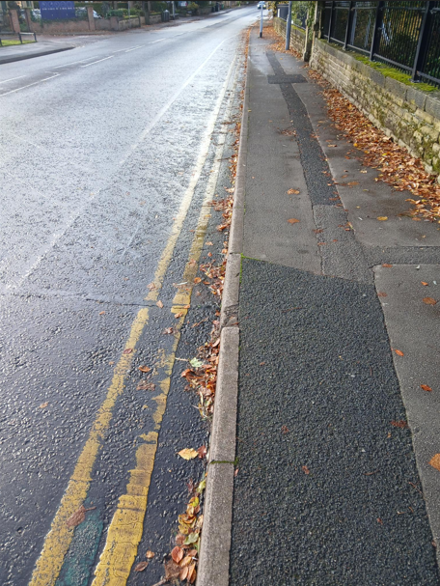

Photo 20.
Looking towards the junction of Lapwing Ln and palatine Rd.
The road appears to be in reasonable condition.
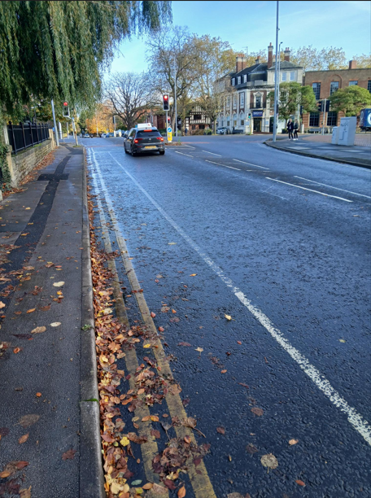

Photo 21.
Looking South along Palatine Rd.
The road appears to be in reasonable condition.
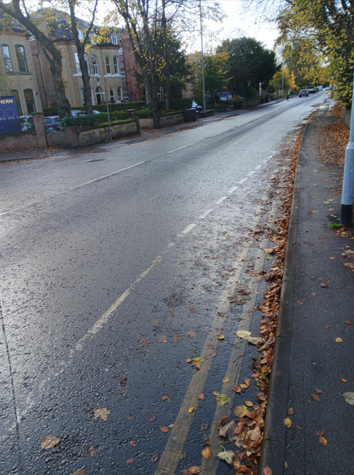

Photo 22.
View of footpath along Palatine Rd, across the entrance of number 114.
The footpath has numerous areas of scarring from previous excavations and has settled.
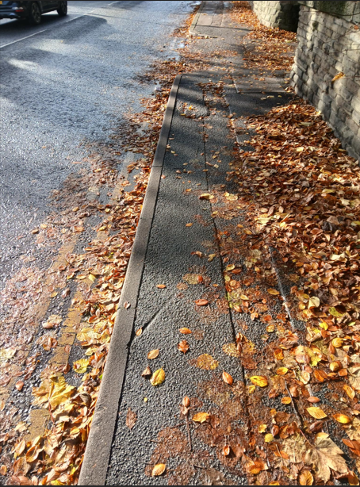

Photo 23.
Entrance into number 114 Palatine Road.


