Planning and Heritage Statement

Introduction
This Planning Statement has been prepared to support the Planning Application for 33 Whitelow Road.

Proposal
A new roof dormer.

Use
The property is currently a single residential dwelling. There is no change of use.

Location
The property faces South on Whitelow Road, approximately halfway between High Lane and Beech Road.

Site Location Plan
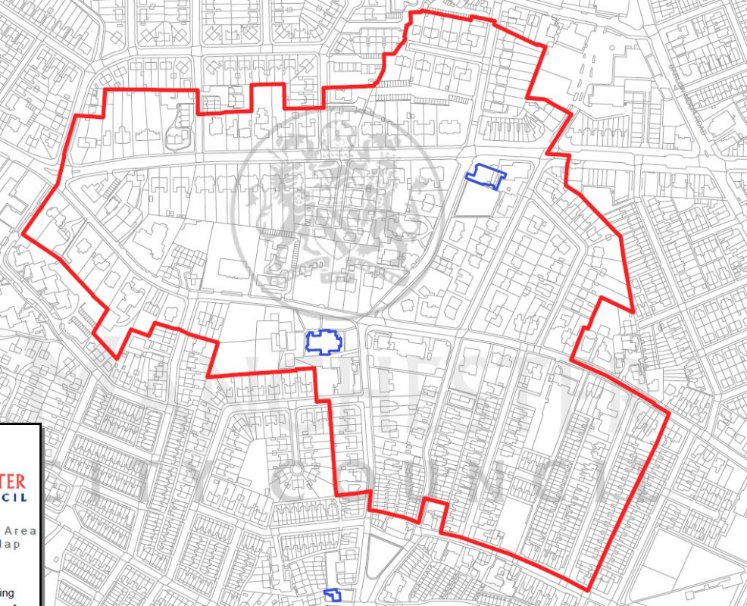
Key
_____ Chorlton Conservation Area
_____ Listed Buildings
33 Whitelow Road

Access
Access from Whitelow Road is unchanged.

Existing and Proposed Layout
The proposed dormer does not affect the basement, ground or first floor. The top (second) floor proposal is for dormer facilitating a shower room, complementing the original existing rear dormer.

Size & Appearance
The proportions of the proposed dormer match that of the original existing rear dormer and sits comfortably within the existing building proportions. There is no increase in footprint to the building as the dormer sits within the existing 5th bedroom and is providing valuable head height to a shower room which is contained within the original bedroom area housed within the roof space of the house.

The dormer is set back from the existing eaves and is not higher than the existing ridge. It is not visible from the principal elevation and has very little presence on the side elevation, which only overlooks the adjacent substation on Whitelow Road. A small, fixed pane window with obscure glazing is installed to provide natural light into the space, although provides no views in or out.
The dormer is clad in black with a black rubber roof, giving it a roof-like appearance, blending into the existing tiled roof and matching the existing original dormer materiality, which does not detract from the existing brickwork and facades. The materiality is of high quality and robust with a long life and low maintenance requirements. These materials are a common feature on dormers within surrounding properties and has been an acceptable approach on many properties in the area.

Landscaping
The garden remains unchanged.

Precedents Within Immediate Vicinity
Planning application number 131043/FH/2021
Planning approval has been granted on a neighbouring property, 39 Whitelow Road, for a rear and side elevation, L shaped dormer. This extends the full length of both the rear and side elevations of the property.

Planning application number 124917/FH/2019
Planning approval has been granted for a full width rear dormer.

Heritage Statement
33 Whitelow Road is a semi-detached Victorian Villa situated within the Chorlton Conservation Area. Whitelow Road consists of a mix of property styles from the same era. All properties have street facing façades which have attractive feature brickwork and feature woodwork. Whereas the sides and rear façades have no architectural merit as they are much plainer, compared to the front façade, which was common for properties within this period.

Many of the properties on Whitelow Road and the surrounding Stockon Road and St. Clements Roads have rear and side contemporary extensions, along with rear and side dormers, that have set a precedent for the street and surrounding streets. These additions do not detract from the character of the street(s) and the attractive road facing façades. The recent rear and side dormers on Whitelow Road and the surrounding streets present no adverse impact on the streetscape or the wider Chorlton Conservation Area.

Summary
The proposed dormer is subservient to the existing facades and easily blends into the roof scape. The materials are suited to the building and surrounding buildings and are a common feature on roofs of neighbouring properties with dormers, along with being in keeping with the look and materiality of the existing original dormer. The flat roof is in keeping with the existing ground floor extension and the existing original dormer. The dormer is also not visible from the street, resulting in no negative impact on the conservation area. As there is only an adjacent substation, it has no impact to neighbouring properties as there are none.

