Bee Network Cycle Hire Design Access Statement
SECTION 1 – Introduction and scheme objectives
Mandate to introduce a public cycle hire scheme
1.1 Andy Burnham, Mayor of Greater Manchester, made delivering an iconic public bike hire scheme a pledge in his original election manifesto and appointed Chris Boardman as Greater Manchester’s Cycling and Walking Commissioner in September 2017. In 2021, the Mayor of Greater Manchester reiterated his commitment to a GM Cycle Hire Scheme with the aim of introducing it in 2021.
1.2 In September 2018, the Cycling and Walking Commissioner gained approval from the GMCA, via correspondence with the GM district leaders, to deliver a viable, operational model for a region-wide bike share scheme. The cycle hire offer will complement and align with other TfGM initiatives to increase public access to bikes such as the offer of reconditioned bikes to support access to employment, the availability of pool bikes to support businesses and community groups, e-cargo bikes, and a structured approach to all cycle parking provision across GM.

Contract and delivery

1.3 In Summer 2021, Beryl were appointed as the supplier to deliver Bee Network Cycle Hire. Beryl is the UK’s leading micromobility company, and the only BCorp certified operator. Meaning we place people, social responsibility and environmental sustainability at the same level as financial sustainability.
Founded on safety and sustainability principles, our first product, the Laserlight, was created to tackle city cyclists’ biggest problem: being caught in the blind spot. The core laser technology is integrated into all Beryl schemes and bikes of London, Montreal, Edinburgh and Glasgow.
We partner with cities to achieve their active and sustainable transport goals that enable modal shift away from cars, becoming a city’s integrated micro mobility partner. We deliver shared micro mobility systems in partnership with cities in two ways:
1. We operate our own systems, where we own the relationship with both the city and the riders.
2. We sell our platform and are paid to operate the systems of major cities, inc. London, Birmingham and Manchester.
Beryl’s mission is to build a better world by getting more people moving sustainably and removing the barriers to active transport. Beryl believes in building a better world by making greener travel; safer, simpler, more affordable and accessible.
The Beryl platform is used across the 3 largest city and city-regions in the UK to power Transport Authority owned bike and ebike systems across London, Birmingham and Manchester, with a minimum contract length of 5 years and the ability to add future vehicles and modes. The platform delivers millions of journeys a year and is connected to 10,000 non-Beryl owned assets. Therefore, Beryl is the backbone to the UK’s bike and micro mobility services. We are vertically integrated as the OEM, platform owner and operator.

Strategic Context / Scheme aims and objectives
GM2040 Strategy
1.4 Delivering a cycle hire scheme is outlined as a priority in TfGM’s Greater Manchester Transport Strategy 2040, the latest refreshed version of which was endorsed by Manchester City Council’s Executive in December 2020 and serves the statutory Local Transport Plan for each of the 10 GM districts:

Policy 1: We will work with partners to ensure that supporting modes of transport, including taxis, private hire, demand responsive services, car clubs and cycle hire, are available and fully integrated into the Greater Manchester transport network.³
1.5 The GM2040 Strategy aims to deliver the ‘Right Mix Vision’ under which 1 million more journeys per day across GM will take place, as a result of growth and development, with no net increase in private car journeys overall. In order to do this, the pattern of journeys must alter and modal shift to sustainable modes must be enabled, and this is set out in a series of steps.
1.6 Step 5 of ‘Right Mix’ states an aim that “Transformational cycling policies lead to a switch to cycle from other modes – reaching a 10% mode share for Regional Centre and Neighbourhood trips and a 5% mode share for Wider City Region trips by 2040” We predict the Phase 1 cycle hire service will deliver nearly 5,000,000 rides over the course of the contract, greatly contributing to the target to reach 10% mode share for cycling.
1.7 The GM2040 strategy seeks to develop a more customer focussed transport system based on seven core principles; ‘Integrated’, ‘Inclusive’, ‘Healthy’, ‘Environmentally Responsible’, ‘Reliable’, ‘Safe and Secure’ and ‘Well Maintained and Resilient. These principles have been embedded in both the physical (bike, dock and scheme area), digital (mobile application, services website, partner dashboards) and operational design of the scheme. Beryl’s service system can be developed to integrate cycle hire with other forms of transport services to provide a single mobility service. (MaaS - Mobility as a Service) which is seen as key to delivering the Bee Network integrated public transport system across GM.
City Centre Transport Strategy to 2040
1.8 Widening access to cycles as part of the overall aim of increasing cycling’s modal share is a key element of the City Centre Transport Strategy to 2040 (CCTS), a joint strategy produced by Manchester City Council, Salford City Council and TfGM, adopted by Manchester City Council Executive in March 2021.
1.9 The CCTS presents seven ambitions for the city centre and a series of proposals to deliver these ambitions.
1.10 Central to the CCTS vision is the target to increase the percentage of trips to the city centre by public transport and active travel in morning peak to 90% before 2040, from a pre-COVID level of around 70%. There are up to 110,000 more jobs and 50,000 more residents in the city centre anticipated by 2040, and a projected rise in morning peak trips from around 110,000 in 2019 to over 160,000 by 2040.
1.11 Within this context and the strong support expressed by the public and city centre businesses in the CCTS consultation process for more space for walking, cycling and public transport, less space for private cars and a cleaner, greener city centre, the CCTS aims to set the framework for how the city centre will change over the next 20 years and the transport and public realm interventions to deliver this vision.
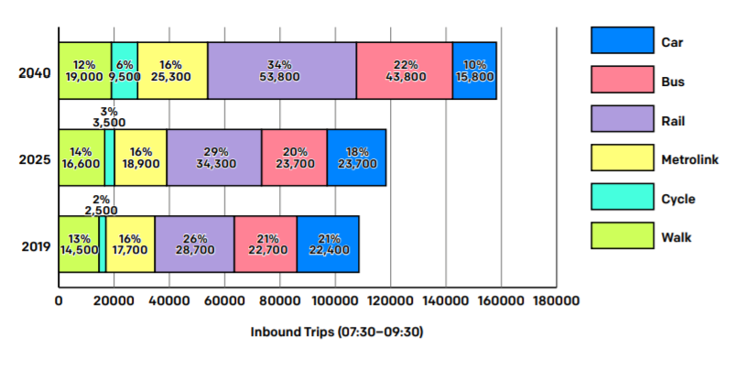
Fig 1 – CCTS mode split targets (City Centre Transport Strategy to 2040, p21)
1.12 As Fig 1 shows above, the CCTS plans for an increase of 1,000 daily cycle trips by 2025, along the road to achieving the 90% target by 2040. This is only one aspect of the CCTS vision for cycling, which is expanded upon in Ambition 3:
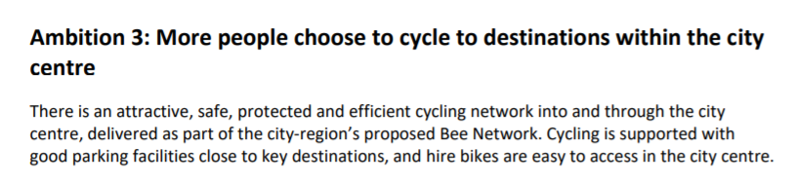

Fig 2 – CCTS Ambition 3 (City Centre Transport Strategy to 2040, p36)
1.13 Ambition 3 also lists a series of improvements necessary to deliver the ambition, amongst which are “Bikes can easily and quickly be hired in the city centre”. In addition, during the consultation process, availability of safe cycle parking was identified as a major barrier to adoption – whilst there is a programme of cycle parking funding being rolled out through various channels, delivery of the Bee Network Cycle Hire scheme will also remove this barrier by solving the parking issue with the secure docking stands.
1.14 In addition, within Phase 1 of the scheme, there will be 300 pedal-assist e-bikes deployed, to enable wider access to cycling for people who may not feel capable or comfortable in using a conventional pedal cycle. Within Phase 1.2, under which this application sits, there will be 50 e-bikes alongside approximately 200 conventional pedal cycles.
1.15 Bee Network Cycle Hire is a key part of the overall package of infrastructure improvements such as segregated cycle lanes, Active Neighbourhoods, traffic free streets, cycle parking, behaviour change and activation activity which aims to deliver the ambitions of the GM2040 Strategy, Made to Move and Change a Region to Change A Nation at the GM level, all of which have been endorsed by GM councils through their role on GMCA and have a mandate to be implemented at the district level.
Manchester Climate Change Framework 2020-25
1.16 Manchester City Council, as well as the Greater Manchester Combined Authority, have declared the ambition to achieve net zero carbon by 2038. The Manchester Climate Change Framework 2020-25 (CCF) is the city's high-level strategy for tackling climate change. It sets out how Manchester will 'play its full part in limiting the impacts of climate change', a commitment in the Our Manchester Strategy 2016-25.
1.17 Transport is one of the seven key areas for urgent action set out in the CCF. Ground transport makes up approximately 32% of the city’s direct carbon emissions, so reducing this is essential to achieving the overall goal of zero carbon. Part of the solution to this is ensuring more people are able to cycle and opt to do so as opposed to using a car.
1.18 All scheme operational assets will be zero emission, either e-cargo bikes or electric vans. All workshop energy (including for battery charging) will be generated from renewable sources. Based on predicted ridership, the cycle hire scheme will save 685 tonnes of C0₂ over the contract.
1.19 Another element of the CCF is “Engaging and empowering Manchester residents and organisations to take action” – so by widening access to cycles and enabling an easy, affordable, flexible way to travel around the city, beginning in the city centre, the Bee Network Cycle Hire scheme is an important part of the Council’s overall package of action on climate change.
1.20 1 in 5 journeys taken by existing Beryl users removes a vehicle from the road. Additionally, their advanced redistribution tool and methodologies seek to minimise ‘wasted redistributions’. In addition, e-cargo bikes will be the only vehicle type used for redistribution in the daytime.
Made to Move
1.21 In 2018 the [then] Cycling and Walking Commissioner set out a 15-step plan to transform Greater Manchester and was adopted unanimously by the region’s ten district leaders. The first step was the publication of a detailed, Greater Manchester-wide walking and cycling infrastructure proposal, in collaboration with all ten local authorities. Step 13 is to deliver greater levels of public access to bikes across GM; working with the private sector to deliver low cost and innovative solutions. This is a clear aim of the Scheme. The core aim of this strategy is “to double and then double again cycling in Greater Manchester and make walking the natural choice for as many short trips as possible.” The scheme is designed to maximise ridership. The high number of docking stations, equitably placed across the Phase 1 area, will ensure that 80% of residents live within 300m of a docking station, equating to 198,000 people. Docking station density (and accessibility) is a primary driver for ridership.

Grow Green
1.22 GrowGreen is a project funded by the EU Horizon 2020 programme for Research and Innovation to create climate and water resilient, healthy, and liveable cities by investing in nature-based solutions. The GrowGreen partnership, led by Manchester City Council, joins forces with cities and experts in Europe and around the world to overcome these barriers and implement nature-based solutions, to create harmony between people, the economy and the environment

1.23 The Type 2 docking stations [see Fig 8 below] provide additional greening across the Phase 1 area assisting with sustainable urban drainage (SUDS).

Scheme Mission and Objectives
1.24 The Bee Network Cycle Hire Mission is to provide a public bike hire scheme that:
- Is an accessible and affordable transport option;
- Is easy to use by GM’s target bike hire market;
- Is safe and secure;
- Is respected and valued by GM’s communities; and
- Encourages cycling and facilitates a long term “modal shift”.

Objectives

1.25 The scheme objectives have been developed in line with the SMART methodology and so are drafted to be specific, measurable, achievable, realistic and timebound. It is also important to consider the objectives for Phase 1 of the Bee Network Cycle Hire programme within the wider cycling and walking programmes delivered by the GM districts, including Manchester, in partnership with TfGM.

Objective 1: Access to Bikes

1.26 To provide access to bikes to 198,000 residents, 30,000 daily visitors⁴ and 140,000 workers within the scheme coverage area by introducing a publicly accessible, 24/7, self-service bikes and ebikes at fixed docking stations. Docking stations will be distributed across the scheme so they are within 5 minutes’ walk of residents, visitors and workers within the Phase 1 scheme area. This will be measured at the end of the Phase 1 implementation. Scheme cycles should be distributed around the network so that stations are neither full nor empty for more than 3hrs (50 key stations) & 6hrs (all other stations).

1.27 Measure: Each docking station will serve users within a 400m radius (5min walk). Data for the availability of bikes at each docking station is reported across the scheme in real time. It will also be useful to consider how the availability of bikes at stations is representative of demand (i.e. bikes are available where users want to ride from).

Objective 2: Increased Cycle Use in GM
1.28 It is expected that the scheme will be used for 3.2m trips over the five-year contract period with ridership increasing year on year. Fig 3 shows the target number of trips taken by users of the scheme over the five years of operation.

Year | Y1 | Y2 | Y3 | Y4 | Y5 | Total
Trips p/bike p/day | 0.78 | 0.94 | 1.13 | 1.35 | 1.63 | -
Annual Trips | 0.43m | 0.51m | 0.62m | 0.74m | 0.89m | 3.2m
Fig 3: GM Cycle Hire Usage Targets
1.29 The number of trips is derived from the average number of trips per bike per day (“TPBPD”). The UK average for cycle hire schemes is 2.4 TPBPD, Mobike TPBPD in GM was 0.94, and the established scheme in Glasgow is 1.9 TPBPD. In GM, 32,000 cycling trips are made each day in the regional centre. Bee Network Cycle Hire is expected to deliver an average of 1,755 daily cycling trips in the regional centre over lifetime of the scheme.

1.30 Measure: Data from each trip (including origin, destination and route data) taken via the scheme will be collected in real time by Beryl on behalf of TfGM. This data will be combined with data from user surveys (e.g. asking users what they would have done if the scheme was not available) to understand the level of increase in cycle use that the scheme has enabled. It will be important to consider this figure in conjunction with Objective 3: Modal Shift, to understand what type of trip a cycle hire trip has replaced.

Objective 3: Modal Shift
1.31 Bee Network Cycle Hire will contribute to modal shift in Greater Manchester towards sustainable modes of transport. TfGM 2040 target is for sustainable modes to make up 50% of trips. More specifically for Phase 1 of Bee Network Cycle Hire, the objective in the CCTS is for 90% of morning peak journeys to be made by sustainable travel. Cycle Hire is one of the Active Travel schemes that will contribute to modal shift. ComoUK state that for bike share trips in the UK, these trips would otherwise have been taken using a car (driver or passenger) or taxi in 29% of cases⁵, the objective is for Bee Network Cycle Hire to match this result.

1.32 Measure: Annual quantitative survey. GM Cycle Hire users will be invited to take part in the ComoUK bike share survey each year and users will be asked which mode they would have used for their last trip if bike share wasn’t an option.

Network and Scheme Planning

1.33 A significant amount of research and planning has gone into the design and scope of the scheme, the procurement process to identify and appoint a supplier and the implementation of the scheme infrastructure.

1.34 Several key factors contribute to the success of a bike hire scheme (and/or failure to actively recognise them leads to failure). These factors include:

- Accessibility: must provide a predictable and reliable transport offer and cater for a range of physical attributes and/or abilities.
- Ease of use: must use available/emerging technologies to aid accessibility and efficiency whilst also being available to users without access to/ability to use smart phones, computers, credit/debit cards etc.
- Affordability: must be a cost-effective mode of transport for the user given other modes on offer and the target user market.
- Safety: must comply with industry standards and be safe for users, the provider and the wider GM community to use.
- Security (Physical): must be resilient to vandalism and misuse and supported by a user registration scheme.
- Security (Data): must be secure and compliant with statutory regulations to protect user data and payment information.

1.35 Historically, a variety of approaches have been adopted by other scheme operators to meet these factors and based on the feedback received and the specific challenges that GM presents, a Minimum Viable Product (“MVP”) was developed which formed the basis of the tender for the procurement of the Service Provider.

Lessons Learned and Feedback
1.36 Engagement with the market was conducted with nine leading bike scheme suppliers in the industry to inform the development of the scope of the scheme and procurement strategy. This led to the adoption of a scope that specified:

- a docked system – essential for security and reliability
- public subsidy for operations (funded by Mayor’s Challenge Fund)
- a full-service contract rather than a concession model
- early engagement with stakeholders, ie. Universities and hospital trusts

1.37 The scope for Phase 1 has been developed based on previous research by transport consultants Systra (into the viability of a Manchester City Centre Bike Hire Scheme) together with the feedback from a Market and Demand Analysis. An analysis of other UK schemes (available on request) was also used to validate the ‘minimum viable product’ and the assumptions that underpin it. The approach has been validated by the bids for the scheme returned as part of the procurement process. All bidders submitted proposals which were congruent with this approach and proposed schemes which met and exceeded the minimum requirements.

1.38 The scope for Phase 1 includes:

- A scheme which serves the regional centre with a residential population of 198,000, defined boundary with an area of 40km².
- 213 fixed docking stations across the scheme area (so the stations are never more than 300-400m apart.
- 1,500 bikes available for use, with at least 95% available or in use between 7am and 7pm.
- Asset and system compliance with current CoMoUK requirements, UK industry standard.
- Bikes and docks to provide space/options for future sponsor branding.
- A blend of mechanical (80% / 1200) and e-bikes (20% / 300).
- ‘Virtual’ docking capability across via GPS geo-fencing.
- Smartphone app capable of taking payments.
- Ability to hire bike without having smartphone/internet access and/or a credit/debit card facility.
- Data collection and management capability.
- All data to be collected and managed by the Service Provider on behalf of TfGM who retain ownership of it.
- All IS systems to be design API-first to allow broad integration with other systems in the future.

Demand Analysis

1.39 A detailed assessment was carried out to identify the areas with the greatest propensity for Scheme usage and determine the extent of the first phase [“Phase 1”]. Based on the methodology used in the Systra report, the GM city region was analysed.

1.40 Each area was assessed against the following factors and given an aggregated score out of 100:
- Existing key destinations/ attractions and major people generators
- Propensity to cycle (based on socio-demographic data)
- Levels of cycling
- Main cycle routes (existing/proposed)
- Cycling potential (based on DfT PCT tool)
- Public transport provision
- Workplace density
- Population density

1.41 The study concluded that GM and more specifically the regional centre and the inner southern and northern suburbs have the necessary socio-demographic characteristics to support a successful bike hire scheme given:
- The large student population
- High numbers of tourists and temporary visitors
- Several high-profile visitor attractions;
- High cycling propensity amongst residents
- Scheme support from a wide range of public and private sector bodies

1.42 The demand analysis demonstrated that the Scheme should initially focus on the following areas:
- Regional centre (Manchester, Trafford and Salford city centres)
- Salford Quays / Media City
- East from the regional centre to the Etihad Campus
- South from the regional centre along Oxford Road and Chorlton corridors to Wilbraham Road

1.43 Based on the analysis, Phase 1 covers an area of approximately 40km² and is shown in Figure 4:.
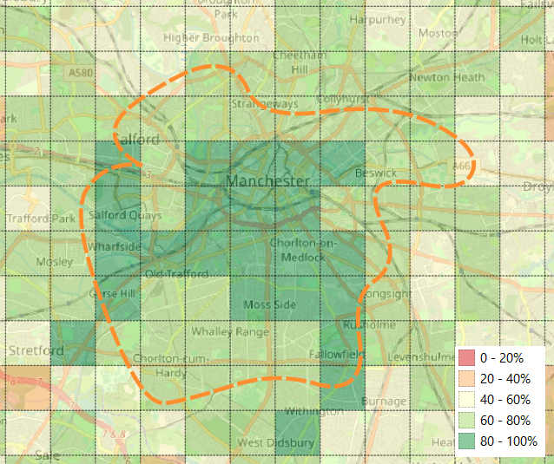
Figure 4: Phase 1 coverage and demand analysis
1.44 The remainder of the area covered by the GMCA that is not included in Phase 1, along with the possibility of further development in the Phase 1 area, will be considered for inclusion under subsequent phases. These will be the subject of future business cases once further analysis and lessons learned from Phase 1 have been captured and considered.

1.45 Although subsequent phases are not covered by the current business case, provision has been made within the contract for delivery of Phase 2 through this contract vehicle without further market engagement or the risk of a challenge under the OJEU Procurement Legislation. TfGM’s strategy is to adopt a contract arrangement with a provider that is “adaptive” and engenders a “partner” approach that allows TfGM to capture Service Provider knowledge and experience in the development of Phase 2.

1.46 TfGM commissioned AECOM to undertake customer research within the proposed Phase 1 operating zone. The key findings were:

- 42% would consider using the scheme (54% for those living in the zone)
- A further 18% are ‘not nows’ who might consider the scheme in future
- The scheme should help support our objective around increasing access to cycling
- Numbers suggest the scheme makes sense economically and in terms of its attractiveness to the population travelling into the cycle hire zone
- E-cycles are likely to be important if we want to attract as many people as possible to use the scheme, and people are willing to pay more for them
- Covid should not negatively affect the viability of the scheme from an attitudes perspective, and if anything has made people look on the scheme more favourably

Scheme Phasing
1.47 Phase 1 of the scheme is planned to be rolled out in three phases:
1.48 The scheme will be rolled out in three phases. Phase 1.1 is a private beta trial around Salford University campus beginning in November 2021.

1.49 Phase 1.2 will see around 35 bays with around 200 conventional cycles and 50 e-cycles at Media City and along the Oxford Road corridor. This Design and Access Statement supports the Planning approval of Phase 1.2 within the Manchester City Council area.

1.50 Phase 1.3 will see around a further 200 locations in the city centre and surrounding neighbourhoods from June 2022, providing around 1,200 cycles and 300 e-cycles for a total of 1,500 conventional and 500 e-cycles.

Stakeholder engagement and consultation
1.51 All proposed locations for stations have been through a thorough consultation process with a wide range of stakeholders. Once a longlist of candidate sites was formulated, consultation letters were sent to all residential and business addresses within a 50m radius of each location. This entailed a total of 740 letters, to which there were 5 responses. Several proposed locations were discounted due to objections from affected businesses as well as via issues raised through the consultation around footway clearance and concerning impact on Listed Buildings by Manchester City Council’s Planning service.
1.52 During the consultation process, all Manchester City Council local ward members from relevant wards were consulted, 21 Councillors representing seven wards. No objections were received through this process, and the general responses from ward members was positive. Private landowners have also been engaged with in detail where sites are proposed on their land, as well as on MCC Highway, where in close proximity. The scheme overall has been supported by key institutions and landowners in this phase of the scheme delivery, including University of Manchester, Manchester Metropolitan University, Network Rail, Manchester Foundation Hospitals Trust and Bruntwood.
Design and operation of the docks
1.53 We have used the principles from ‘Streets for All’, ‘Global Street Design’ and ‘Bee Network’ to develop our docking station designs. We are proposing two types of docking stations for Greater Manchester:
- Type 1: Includes Beryl Docking Points and can include wayfinding elements.

- Type 2 “Hubs”: Includes Beryl Docking Point(s), wayfinding elements and ‘Streets for All’ aligned infrastructure, e.g. seating, planting, lighting. These docking stations will be prioritised and provided at strategic locations across the network where they will deliver maximum benefit.

1.54 Each Cycle Hire Station will provide individual stands that allows for secure and neatly docked bikes on street.
1.55 The bike is held securely in place via a custom latching mechanism between the bike’s rear dropouts and Beryl Dock. At the bottom of the dock there are two large gussets that help guide the back wheel into position for simple use.
1.56 When a rider finishes a journey there is a two-step process:
- The rider rolls the bike into the dock, this movement will lift the wheel slightly off the ground and hold the bike in place attaching the bike via the basket to the docking point. At this point our systems record the bike is in a docking location.

- The rider then depresses the lock on the rear wheel, ending the journey and immobilising the bike. At this point the rider is notified of the journey ending.

1.57 If a rider fails to lock the rear wheel after docking, they receive a push notification after a configurable amount of time (e.g. 20 seconds) requesting that they lock the bike with a simple instruction. Our control centre can manually, or systems be automatically configured to fine riders who fail to lock appropriately.
Fig 5: Type 1 Docking Station, materials and branding details:
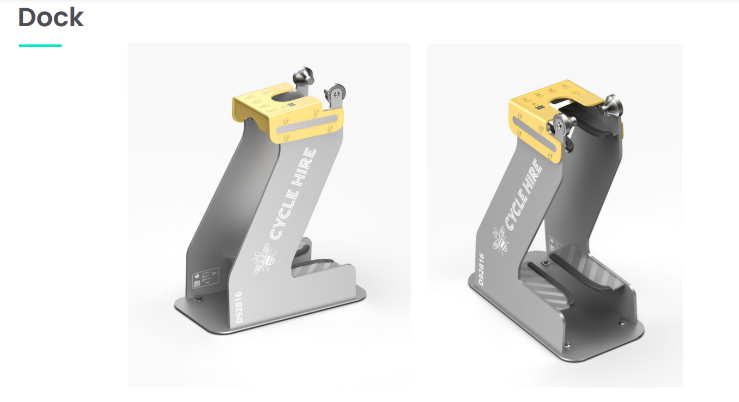

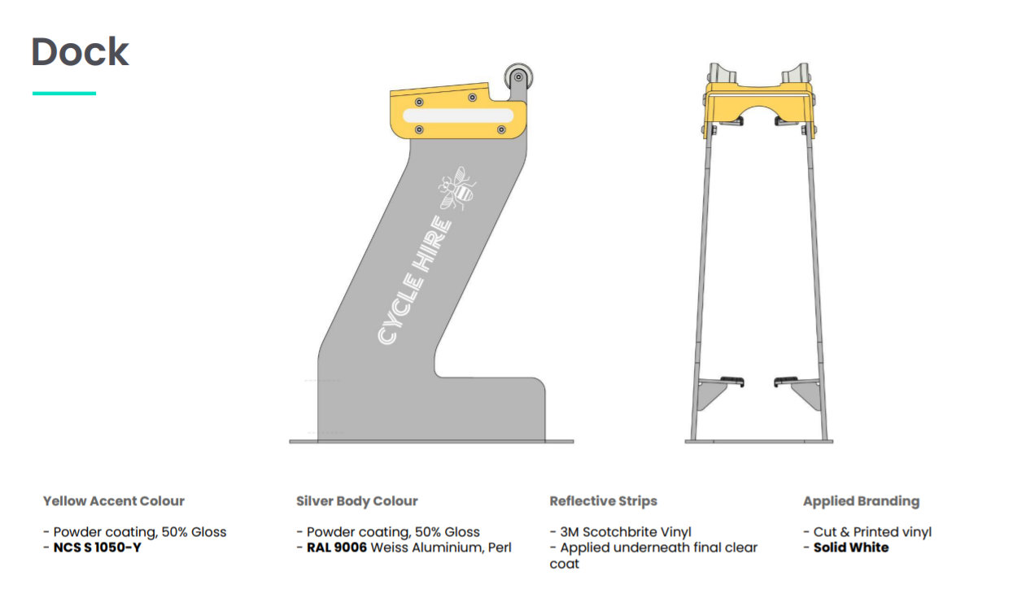
Fig 6
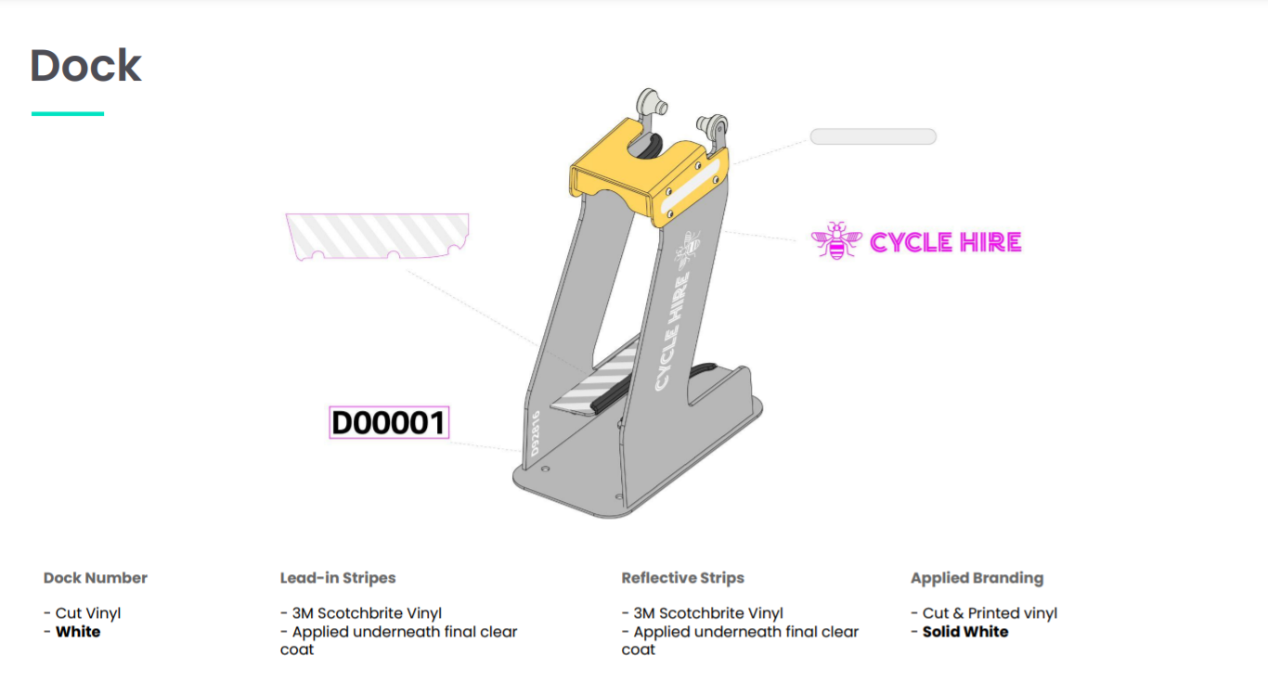
Fig 7

Fig 8 - Type 2 docking station with seats and planters
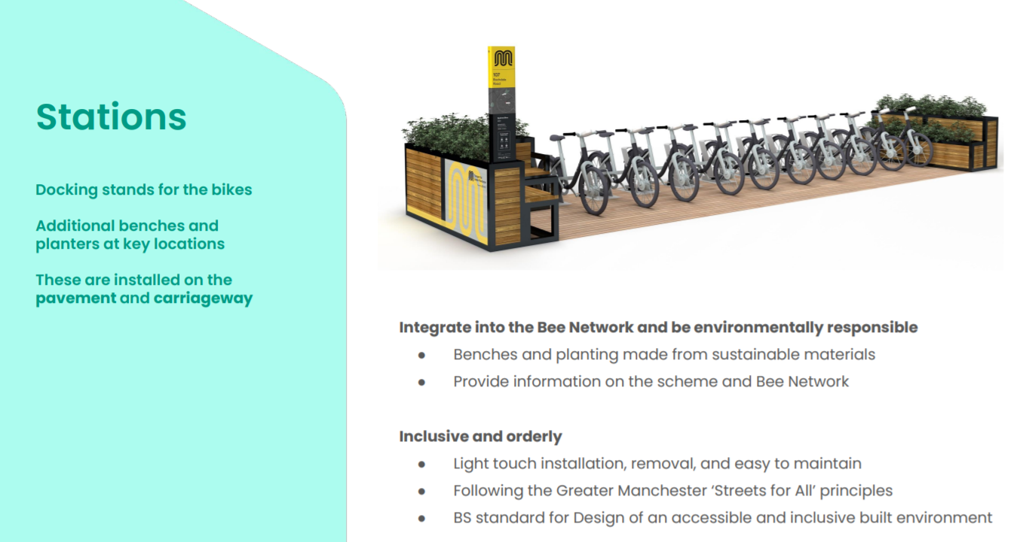

Inclusive access
1.58 A detailed site visit to each proposed location was undertaken in August 2021 by officers from Manchester City Council’s Transport Strategy and Highways Road Safety teams along with Beryl’s operational staff. The site visits and appraisals used the following principles for approving, rejecting or moving the sites identified by the initial desktop site search (set out in sections 1.39 - 1.43 above)
- Adequate footway clearance for continued unobstructed access by pedestrians, including those with mobility or sensory impairments
- Circulation space to enable bikes to be removed from and returned to the docks safely
- CCTV coverage
- Tree coverage
- Natural surveillance from footfall in the surrounding area
Security and installation
1.59 All bay installations are undertaken by Beryl’s installations team, all of whom have Streetworks S1 (signing, lighting and guarding) and O1 (monitoring signing, lighting and guardian) certificates. Streetworks is the industry and government-recognised certification scheme for safe working on the highway.
1.60 The docks do not require excavation of foundations or power supply. They are fixed to the ground using M10X70 screws. The installation process is reviewe by Peninsula, Beryl’s external health and safety advisors, and installations will be carried out under the Greater Manchester-wide GMRAPS (GM Road Access Permit) scheme, in common with other works on the highway such as roadworks or utilities maintenance. The process is compliant with CDM Regulations 2015 and the stands design and configurations comply with British Standard BS 8300-2-2018 (Design of an accessible and inclusive built environment).
1.61 Testing is conducted by an external engineering agency (CVB Technical Solutions) and covers a salt / fog test, fatigue testing, impact testing, tensile tests and a weld review to ensure that the fabric and construction of the docks can withstand the rigours of the urban street environment.
A full description of the anti-theft and vandalism approach can be found at Appendix A to this statement.
Highway Safety
1.62 All sites have been appraised by Manchester City Council’s Highways Road Safety officers and confirmed as not causing any concerns regarding their installation and operation on the highway. This process has taken the form of an appraisal at the site visit to each location and subsequent assessment of drawings of each location. Manchester City Council’s Highways Design Team has overseen all deployment and final design specification of each location.
Maintenance
1.63 Maintenance of Docking Stations: The importance of keeping the assets clean and well maintained, is critical to ensure the scheme is respected and valued. There are planned be 40 Type 2 Hubs across Phase 1 of the scheme that have additional functionality (seating, planting) and will require a strong cleaning and maintenance regime. All docking stations will be inspected visually daily, and receive a Station Check every 10 days. The checks will be recorded for a full audit history.
1.64 The Station Check is a 10-point inspection, covering cleaning, watering plants if applicable, and checking for damage. Type 2 docks include specially selected planting. The soil contains osmocote which is a controlled release food system which lasts six months and we also add water retention materials. We select very hardy (drought tolerant) plants that require little or no maintenance after they have taken root during the first six months, they include; Phormium 'yellow wave' or dwarf New Zealand flax 'amazing red', Carex buchananii 'red rooster', Imperata Cylindrica 'red baron' and Festuca Glauca. The soil is also covered in a generous covering of bark to help improve water retention. If any graffiti or posters are found on the docking stations these will be removed within five days in line with Beryl’s contract with TfGM. The team will be provided with graffiti remover spray and we are using Interpon Easy Clean powder coating on the docking stations which allows for graffiti spray to be effectively removed repeatedly without sacrificing the appearance, durability, or weathering of the dock.
1.65 There are multiple channels in place for the public and TfGM / local authorities (and other stakeholders) to report damage and vandalism. Beryl’s Manchester Control Room will provide second line support to the TfGM Contact centre and first line support for any contacts (eg in-app chat) as relevant. Beryl’s customer support service can receive and monitor messages via In-app messaging, webform, phone, Email, web live chat, social media.
1.66 Disabling docking stations is easily managed through Beryl’s Core control screens. TfGM will be given access to relevant system functionality such that either TfGM or Beryl are able to turn docking stations off at short notice if needed for major events or police requests. Once disabled if users attempt to park there they will be charged an out of dock fee. If the intention is for the dock to remain disabled for longer than 24 hours then the Beryl on-street team will cover the docking point to prevent use, as with a damaged station below. A disabled station will also not appear in the app.
1.67 If damage to a station is reported, a Field Operative will make it safe within 12 hours and fit a hood to prevent users from parking bikes at the specific docks affected, until they can be repaired or swapped out. The remaining docks will be left in use. Docks are manufactured in the UK, and spares for docks will be stored in Beryl’s GM workshops. If the station requires significant repairs, the whole station will be taken offline and repaired within 5 working days.
1.68 Reporting planned and reactive maintenance activities to TfGM is important in the interests of partnership and transparency. We believe that the change in use of the highway and pavement space in GM, for the bike share system, delivers a powerful opportunity to normalise active travel. Maintenance of the docking stations will shape how residents and visitors to GM perceive the investment in the cycle hire system.
1.69 Concerning e-bikes, the battery swapping process on-street takes less than a minute for a bike to become fully charged and available for customers. This is an economical and efficient solution for keeping e-bikes charged and available for customers. Beryl e-Bikes will use swappable batteries and the Field Operatives will replace low power batteries. The e-Bike has a range of 37 miles (60km), and automatic battery replacement jobs are created once batteries are below 15%.
Access / replenishment
1.70 Beryl operatives work daily to ensure that cycles are evenly distributed across the network, using real time data to monitor cycle availability and to ensure that cycle are replenished across the network. Cycles are transported where necessary by e-cargo bike, a zero emissions mode that does not add to vehicular traffic or require access and egress of a vehicle across footways.
2. Proposed Locations
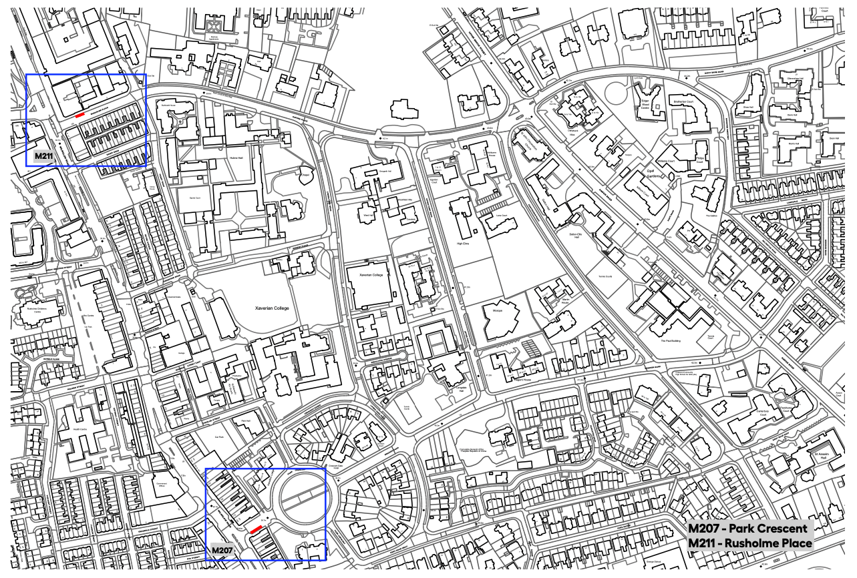
Location M211 – Rusholme Place
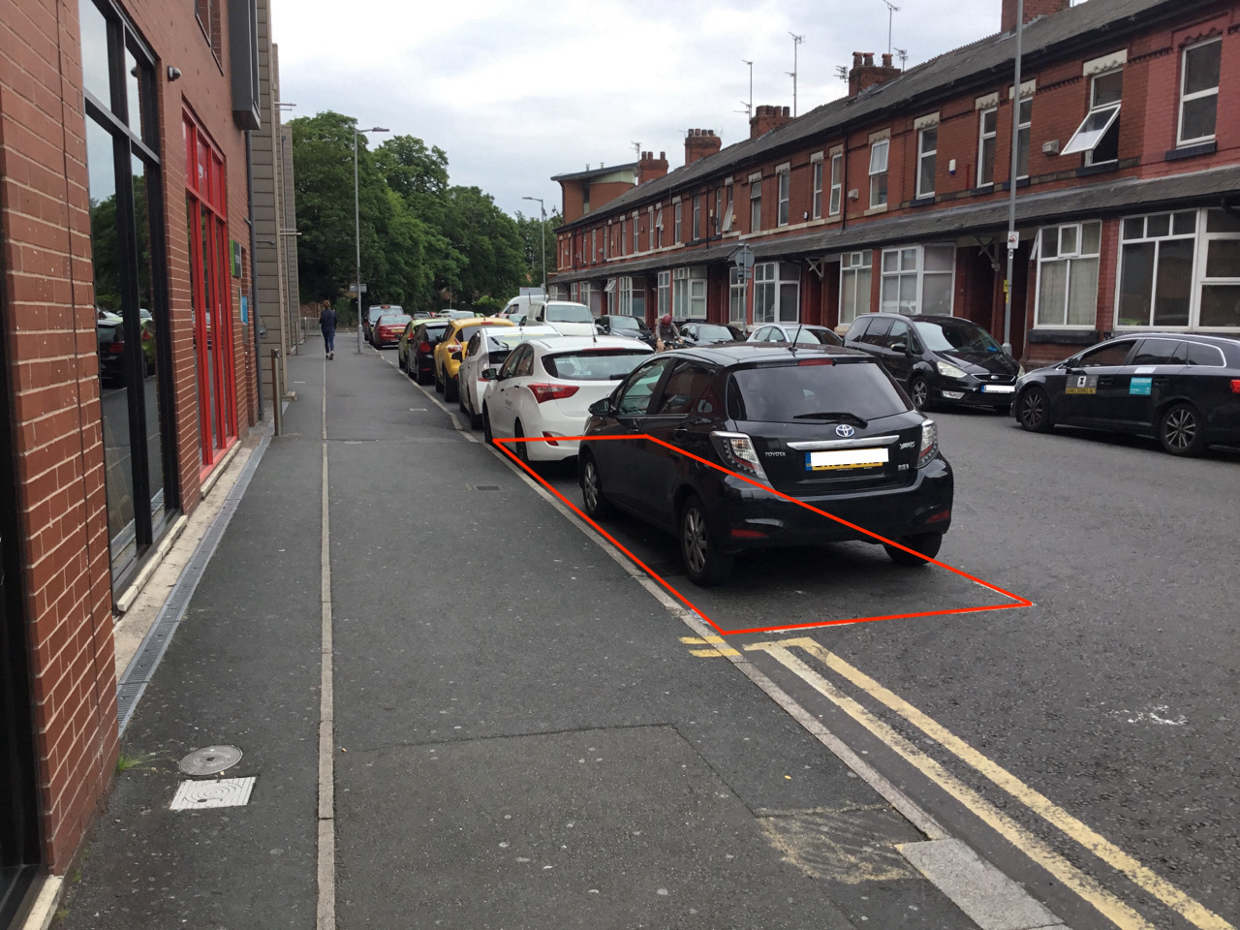

Site Details and Heritage Statement
This site is proposed for 8 stands in a Type 2 hub with seats and planters, on Rusholme Place, a residential street directly off Wilmslow Road in Rusholme. It is currently occupied by one pay and display parking space. The site was appraised on a site visit and desktop study by MCC Highways Network Management Road Safety officers and has been confirmed to not pose any safety issues. There are no listed buildings in the vicinity.
Location 207 – Park Crescent
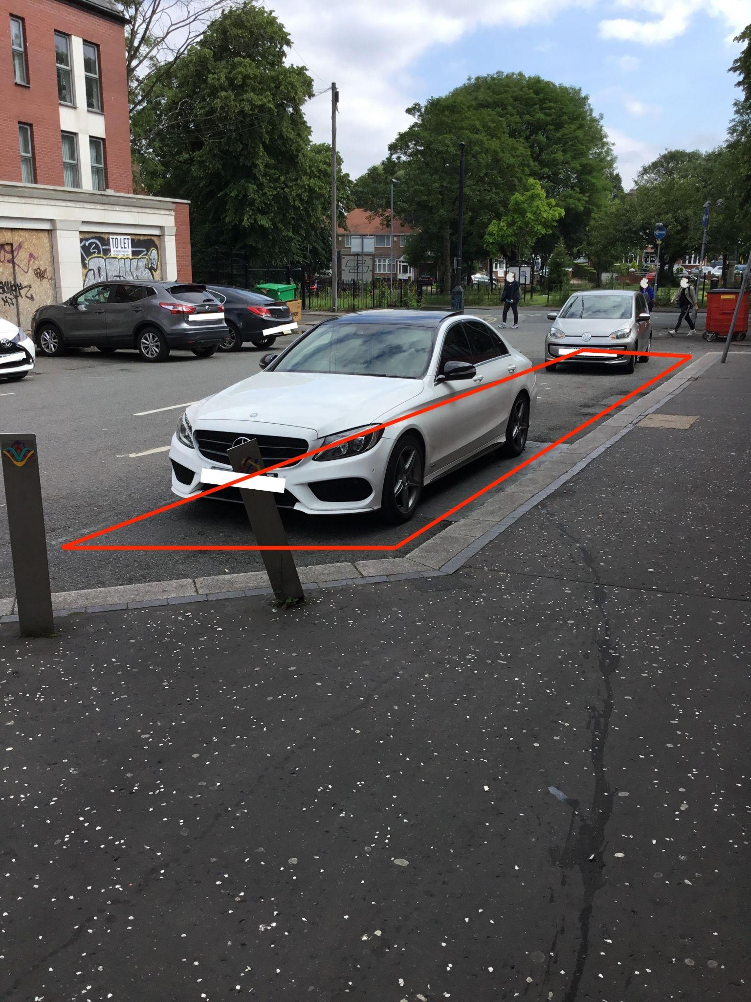
Site Details and Heritage Statement
This site is proposed for 13 stands in a Type 1 station, on Park Crescent, Rusholme. It is currently occupied by two pay and display car parking spaces. The site was appraised on a site visit and desktop study by MCC Highways Network Management Road Safety officers and has been confirmed to not pose any safety issues. There are no listed buildings in the vicinity.

Appendix A – Theft and Vandalism

Theft and Vandalism

  - Introduction: Through our UK operations and having designed and delivered TfL’s missing bike product response, we have learnt that managing vandalism and theft requires:

    - Products that are safe and secure by design;
    - Proactive operations;
    - Reliable technology and sophisticated reporting;
    - Transparency between operator, authority and police;
    - Working with local organisations so the scheme meets the needs of residents.

We understand the local challenges we will face in delivering across our Phase 1 service area. In Greater Manchester (GM) there is also the added risk that antisocial behaviour towards bike hire has been normalised from the Mobike scheme. We have proven experience facing this challenge through our deployment in Norwich (where Ofo previously operated) where we have lost only 8 bikes in a year of operation.

An adaptive approach to bike security is required with physical measures, digital alerting and tracking and operational procedures evolving to keep ahead of vandals. However there is always the risk of vandalism. Beryl count on an experienced team whose roles and main tasks are to prevent any act of vandalism and react promptly when they happen (see Figure 12.0.1)

Designing out crime through on the Bikes, Docking stations and Site locations
    - Bikes
- Smart bike tracking: Dynamo and solar panels are used to keep our technology powered. A bike stored indoors and stationary (for example in a garage) has a life of up to 3 months, but as soon as it rides again it comes back online. Beryl Smart bike and associated bike reporting software is at the leading edge of bike security technology. Reliable and accurate GPS tracking paired with an array of additional sensor data including accelerometer and temperature give our operations team unrivaled visibility of all bikes. Developed by Beryl, and enhanced through a project with TfL, every new bike launched into the London scheme is equipped with the Beryl smart bike hardware and alerting software. Additional functionality is available through the Beryl platform for the TfGM scheme. The software combines intelligent alerting, location specific and dynamic reporting to search for bikes, and a mobile app for targeted tasking and live reporting of bike status for on-street recovery teams, or use by third parties including the Police. Across the entire Beryl fleet, 3 to 5 bikes are lost per month.
- Custom-engineered rear wheel lock that withstands attack: The lock is tried and tested in the UK market and deployed on all of our bikes in all Beryl service areas. We have a lock that can withstand attacks from a hacksaw, bolt croppers or blunt force. The lock itself has no GPS tracking hardware. We track the bike through the smart bike unit mounted on the stem. A warning message is provided on the lock to inform users that the bike is GPS tracked and that riding without payment is considered theft. It is a robust, simple and effective tool for immobilising the bike and preventing theft. We can also remotely control the locking status of a bike so that a missing bike cannot be unlocked and ridden.
- Anti-tampering devices proven to prevent tampering and interference: The bikes use anti-vandal fixings such as counter-sunk screws and bespoke fittings to prevent tampering and interference. All critical cables linked to tracking and connectivity are armoured and hidden in the frame. The bikes use high-strength paint coatings and lacquers to increase durability, increasing their resistance to scratches and surface level damage. The team will be provided with graffiti remover spray, and we are utilising Interpon Easy Clean powder coating on the docking stations which allows graffiti spray to be effectively removed repeatedly without sacrificing the appearance, durability, or weathering.
- Bikes designed for modular repair: If one part of the bike has been damaged that part is easily accessed, replaced and swapped out to extend the working life of the bike. This also means that when a bike is severely damaged Beryl is able to salvage parts that are still in good working order, subject to necessary checks, avoiding landfill waste.
- Inbuilt horizontal bike detection: Beryl’s on-bike accelerometer is detects when a bike is on its side, sending an alert to Beryl’s system and a task is created by the Control Centre for the on-street team to resolve

- Anti-theft e-Bike battery enclosure: The valuable lithium-ion batteries are secured within metal casing on the rear of the eBike. A bespoke Beryl manufactured tool is required to remove the battery. A bike rack above the battery container deters users from sitting on the battery box. Beryl has never had a battery stolen.
- Rear wheel light flashing warning alert: In conjunction with Police we have deployed new software on the smart bike unit so that the rear light emits a distinctive flashing pattern automatically on a bike that the system has marked as being ridden illegitimately. This is visible in daylight and night time. Should a suspect damage the light in order to avoid detection, it remains a tell-tale of a suspect journey.

    - Docking Stations: Our docking infrastructure is simple with few moving parts and a low risk of damage from vandalism. The docking points and tethers have been thoroughly tested on street and in laboratory conditions. Each individual dock is made from a 10mm thick piece of individual folded steel and can withstand attempts to forcibly bend or move the metalwork. Engineering test reports are available on request.

    - Beryl Payment Technology: Our Payment Gateway Provider runs sophisticated fraud prevention systems to protect us from dealing with negative balances or refund claims on the basis of fraud. The Beryl payment provider (Stripe) uses a machine learning system that continuously monitors all payments for signs of fraud. Beryl also implements pre-authorisation checks at key parts of the user journey to prevent fraud without preventing legitimate use or excluding any customer demographics. We also conform to the latest Strong Customer Authentication requirements as part of the 3D Secure 2 standards.

  - Location Planning: Beryl have scoped (and installed) over 700 docking stations across 5 urban areas in the UK in the past 18 months. This experience has provided unique insight into situational factors that can influence theft and vandalism; deprivation, crime reports, CCTV, natural surveillance, (sufficient) lighting, and proximity to water. As part of the docking station planning process we have applied our standard scoring criteria (including the above risk factors) to the site locations provided by TfGM (DR0025). This has highlighted ‘higher’ risk locations where our Community and Police Liaison team members will proactively monitor these locations particularly at launch. Our experienced risk management team will work with TfGM and GMP to assign an agreed risk score to every location to help to prioritise docking stations that will require closer monitoring by both Beryl and GMP. It is important to note that risk also has a ‘time’ based element, meaning vandalism risk can be more marked at specific locations at specific times of the day or night, or day of the week.

In higher risk areas, engagement programmes will be required to build support and understanding of the scheme with the local community and all community safety stakeholders (primarily GM Police, BTP, the local authority and the TravelSafe partnership). Beryl has included the resources to support this in our financial proposal but working with TfGM and relevant district council officers will be vital to support the efforts. Docking locations will be reviewed quarterly following launch with key stakeholders to identify docking stations with incidents of anti-social behaviour, theft and vandalism. Due to the simple nature of our docking stations, they can be quickly moved to a new location if required.

  - Working and sharing information (such as GPS and customer data) with relevant stakeholders: We have extensive experience working with police and local authorities to share information and build collective knowledge of antisocial behaviour. We will work with the TfGM’s Data Protection Officer to agree data sharing protocols and capture them in Schedule 13 Appendix B Data Sharing Protocol.

Location specific reporting: A variety of tools allow for simple historic querying of bike data to help identify specific frame numbers. With a specific frame number identified Beryl and TfGM operators are able to identify journey history and the current status of a bike including its precise location, and identify through sensors whether the bike is upright, indoors, underwater etc. We can also update all sensor information immediately. Operators are able to: (i) draw a polygon on a map and select a time range to identify all bikes that were in a specific area of as small as a few square meters within a specific time, this allows for a specific bike to be identified after a TfGM or public report on suspicious bike activity. In London, this feature is also used by the Met police while investigating crime where a bike or bike journey is of relevance to the investigation (see Figure 12.4.3); (ii) generate real time reports and historic journeys all all bikes moving without a legitimate journey associated to it; (iii) identify bikes that have been on hire

for more than a specific (configurable) time e.g. 12 hours (iv) bikes that are outside of the service area; (v) report on docking locations with high incidence of criminal activities.

The Beryl Contract manager will be trained on data sharing policies. Our DPO Paul Sexby will also advise the local team on specific issues that may arise. The flowchart of sharing information in relation to vandalism or damage (Figure 12.3.1) sets out what we currently do and in what circumstances we may share particular information and will be confirmed with TfGM’s Data Protection Officer. In case of criminal investigation, journey data and vehicle maintenance records are retained according to documented data retention policies. If a crime has taken place involving a bike, we are able to provide journey data and bike location information. If customer details are required, under Schedule 2, Part 1, paragraph 2 of the DPA 2018 and GDPR Article 6(1)(d) Beryl can sign a Data Release form (DPA) issued by Police in order to release this data. Data may include the customer email, driving licence (if for an e-Scooter), card details used, phone number, name and postcode. We support police fully in their investigations, which might also involve establishing communication with our payment provider. We will engage with GM Police early on to establish protocols of data sharing.
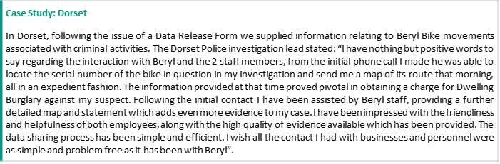

We will work with the TravelSafe partnership and the police to effectively build a shared understanding of criminal activities associated with the scheme. Our dealing with the police is important to build respect for the scheme.
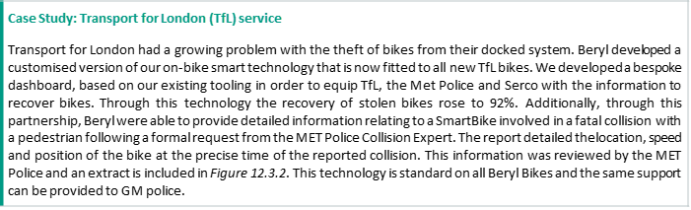

  - When a bike has been vandalised detail the process and steps you will take to identify those responsible and reduce vandalism (and the allocation of responsibilities between yourself and TfGM): Beryl are able to recover bikes without requiring support from other services as set out in the Process for collecting and reporting missing and vandalised assets (identified by Control Room and identified on-street) flowcharts (Figures 12.4.1). However, as shown in Figure 12.0.1, Beryl team will report to TfGM daily while trying to recover any missing asset. The Control Centre receives automatic alerts for bikes left away from a dock, left unlocked, with lock faults, fallen over, and bikes moving without a paid hire. Using this data, on-street tasks are created to attend the bike. On-street operatives use the Engineering App to track bikes using live GPS and both the Control Room and On-Street operatives can use the

‘request telemetry’ tool to get a location update. The “No Pay No Play” dashboard (see Figure 12.4.2) shows bikes moving without paid journeys and the ‘missing bike moved tool’ shows tagged missing bikes that have moved and can be searched for again.

The Trouble Hunter tool allows us to track a specific bike at a time or location, Figure 12.4.3. When a frame number is not provided, BBox Finder allows us to draw a polygon to identify the latitude and longitude of the area of interest in order to conduct a Trouble Hunter search, see Figure 12.4.4 and Figure 12.4.5. In order to ensure we are able to conduct bike collections safely, all new Beryl employees who will be working on-street conducting collections, receive Conflict Resolution training practises and wear body cameras to record evidence.

Bicycles that are missing more than 12 hours will be flagged to TfGM in daily reports, with latest known GPS coordinates. If the bike cannot be recovered within 48 hours (PI 7 Schedule 5), Beryl will inform TfGM. Beryl will continue attempting to recover the bike, and monitor for changes in location. Assets that are lost, stolen, or damaged beyond repair will be replaced within a specified time as agreed with TfGM by Beryl (PI 7 Schedule 5). Improvements to the bike will be managed by the Beryl Centre of Excellence (CoE) using the ISO 9001 methodology. All failed payments are reviewed on a daily basis by the Control Room team to identify any users with linked accounts (using the card fingerprint) and multiple failed charges; bikes left away from a dock or bikes left unlocked. If the vehicle's location cannot be identified with the GPS tracking, cell triangulation tracking will use the nearest cell towers to triangulate the best possible location for the vehicle. If the vehicle cannot be seen, staff can use the Engineering App to ask the bike lock to make the "alert" sound in order to hear where the vehicle is.

Using the Beryl Engineering App, staff are able to record the location of a vandalised vehicle collection at the scene and add a "vandalism" tag that will apply to the vehicle until repairs are made and it can be returned to the scheme. The location recording assists Beryl in being able to monitor "risk" locations where damaged bikes are frequently collected; visualised on a heatmap on the Vandalism Dashboard (see Figure 12.4.6). The tag applied helps Beryl track the number of vehicles collected vandalised on a given date from each scheme; visualised using the Vandalism Dashboard and enriching the data we record and can report on. The nature of the damage can be recorded using the Engineering App allowing the data to be analysed using the Vandalism Dashboard to help in tracking trends over any given period of time. This tracking using the Vandalism Dashboard helps the Centre of Excellence determine new risks and the impact of mitigations in terms of damage to assets within the scheme.

Reducing Vandalism - all of these are parameters recommended to TfGM.

    - Removing Users: Users with multiple failed charges or undocked bikes are blocked from their accounts and the connected cards are removed. We have also set up custom reports including a dashboard that shows users who have purchased more than 400 minutes in 24 hours as this may suggest fraudulent activity.
    - Improving Docking Station security: We have seen a positive impact at “higher” risk docking stations after installing CCTV in cooperation with the local authority.
    - Moving Docking Stations: If improving security does not reduce vandalism occurrence, we are able to quickly and simply move docking stations due to the low intervention.
- Product Development: An adaptive approach to bike security is required with physical measures to keep ahead of vandals. With an in-house product design team, we are well placed to ensure the quickest adaptive response.

12.5. Cooperate with GMP Unit, BTP and TravelSafe Partnership: We will establish partnership with key stakeholders who form a team around the bike with the purpose of preventing vandalism and responding when issues do occur. Using past experience, Beryl has set out a Police Engagement Plan detailing the steps to take prior to launch in order to brief and set up protocols with GMP. We have developed an initial stakeholder map (Figure 12.5.1) to indicate the organisations we will consult with prior to launch. Community engagement is intended to create a network around the bike scheme from which we can learn from and support communities in a way that is proportionate and appropriate.

Figures

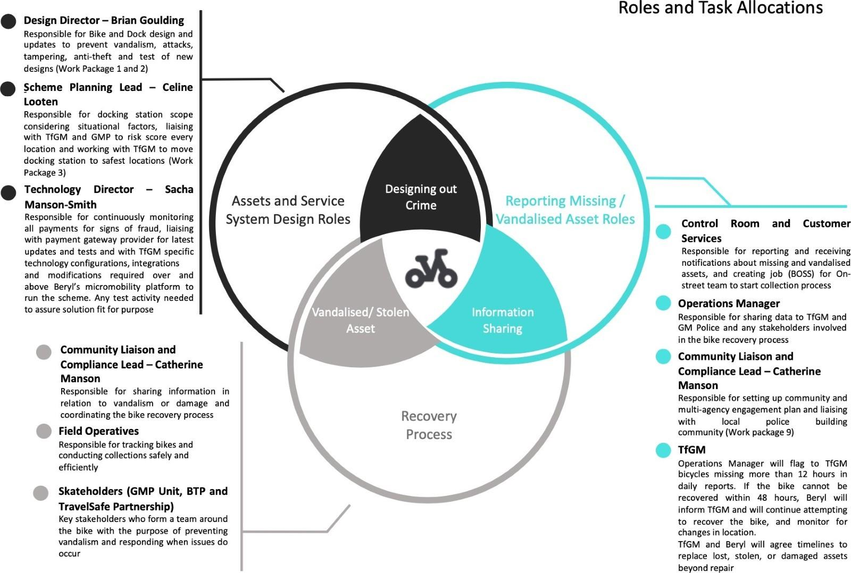

Figure 12.0.1: Team Roles and Tasks Allocation

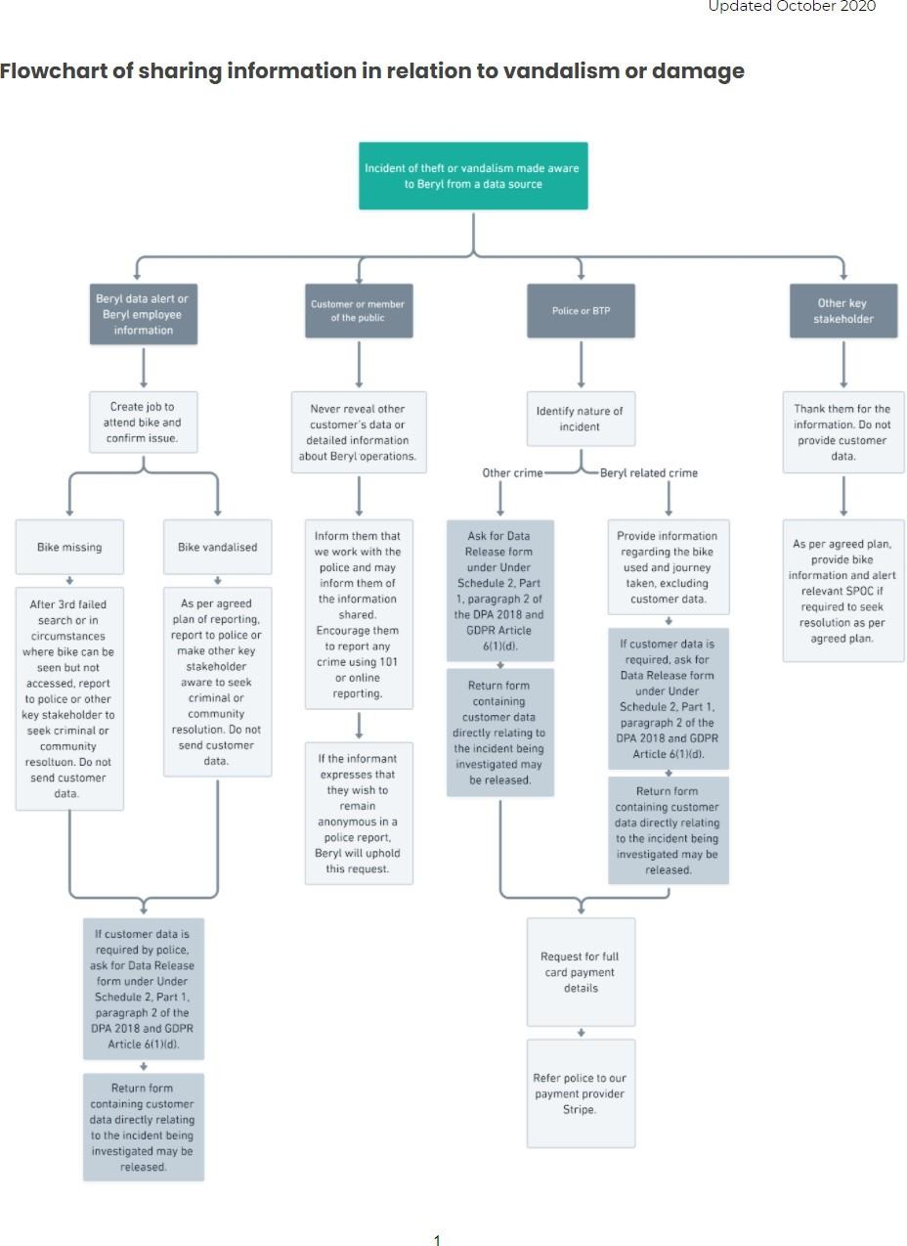

Figure 12.3.1: Flowchart of sharing information in relation to vandalism or damage

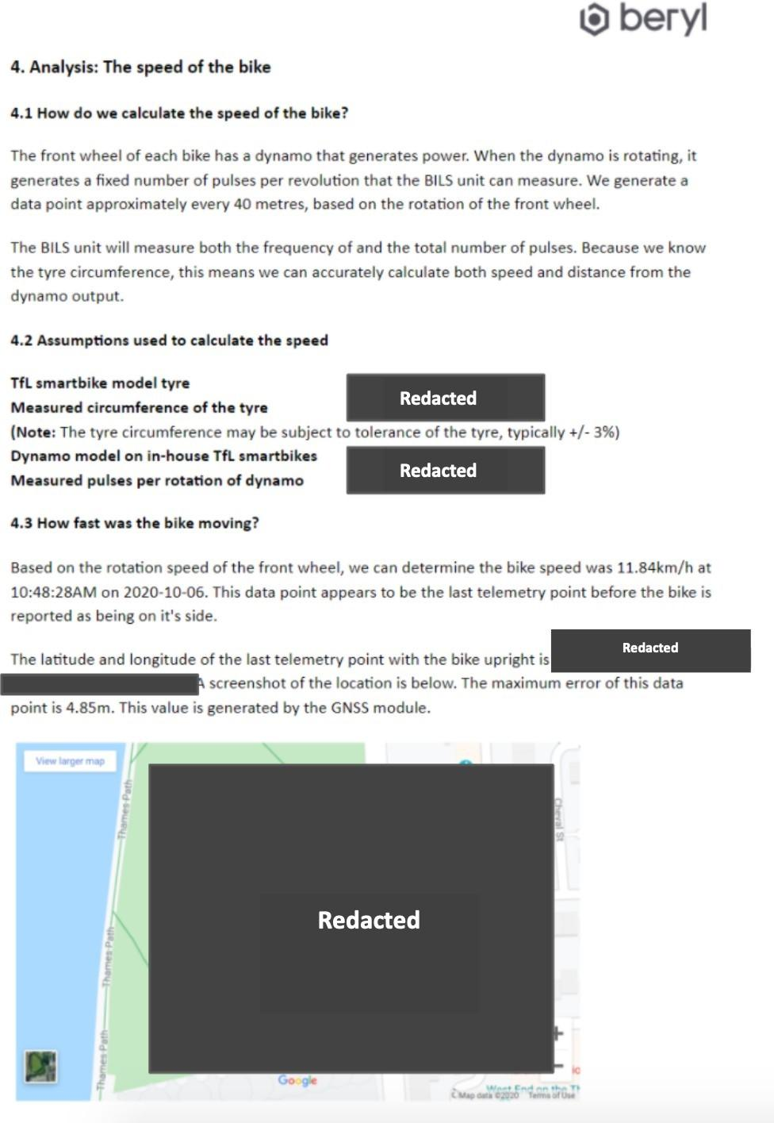

Figure 12.3.2: Extract from Beryl report submitted to the MET police regarding the TfL Smartbike collision report
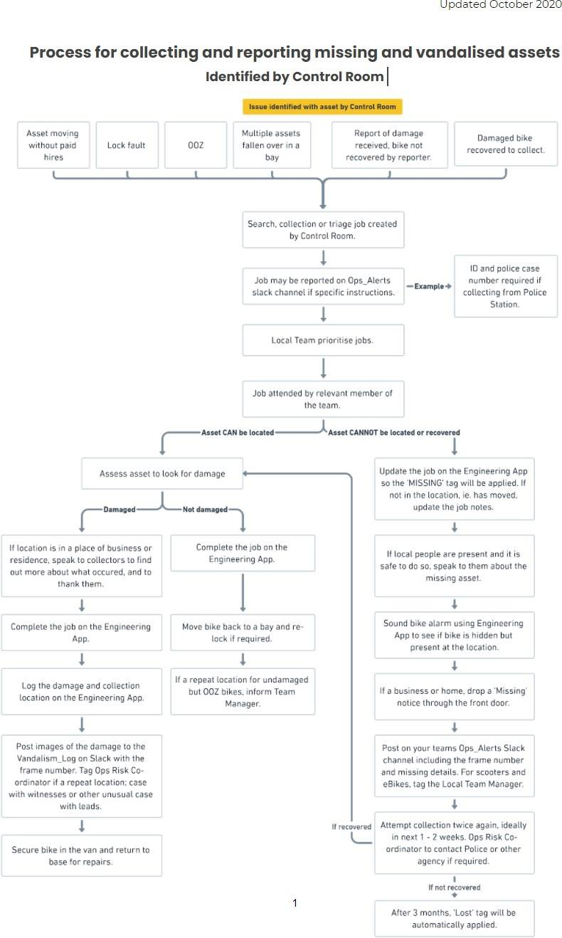
Figure 12.4.1: Process for collecting and reporting missing and vandalised assets ﬂowchart

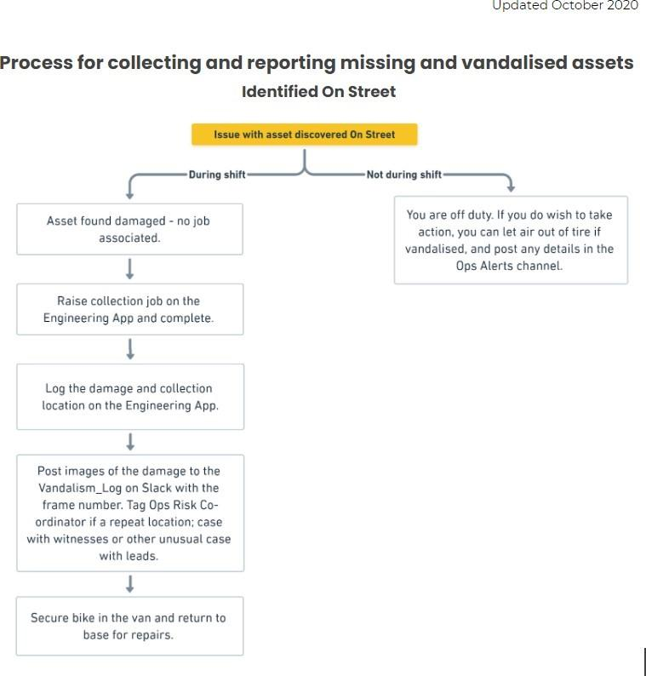

Figure 12.4.1: Process for collecting and reporting missing and vandalised assets ﬂowchart

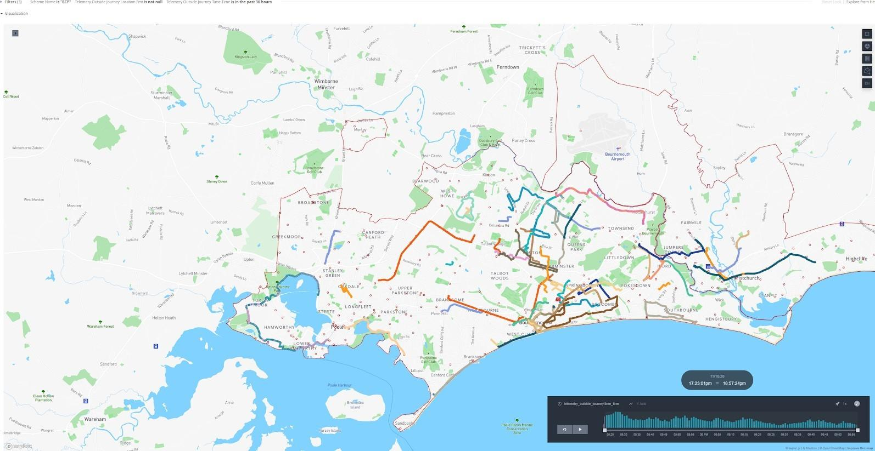
Figure 12.4.2: Image of the No Pay No Play tool used in an example scenario
This is an example of the visualisation of illegitimate journeys used to track missing bikes and identify hot spot areas.

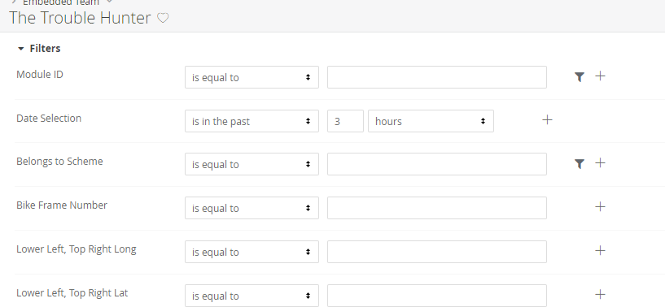

Figure 12.4.3: TroubleHunter input dashboard

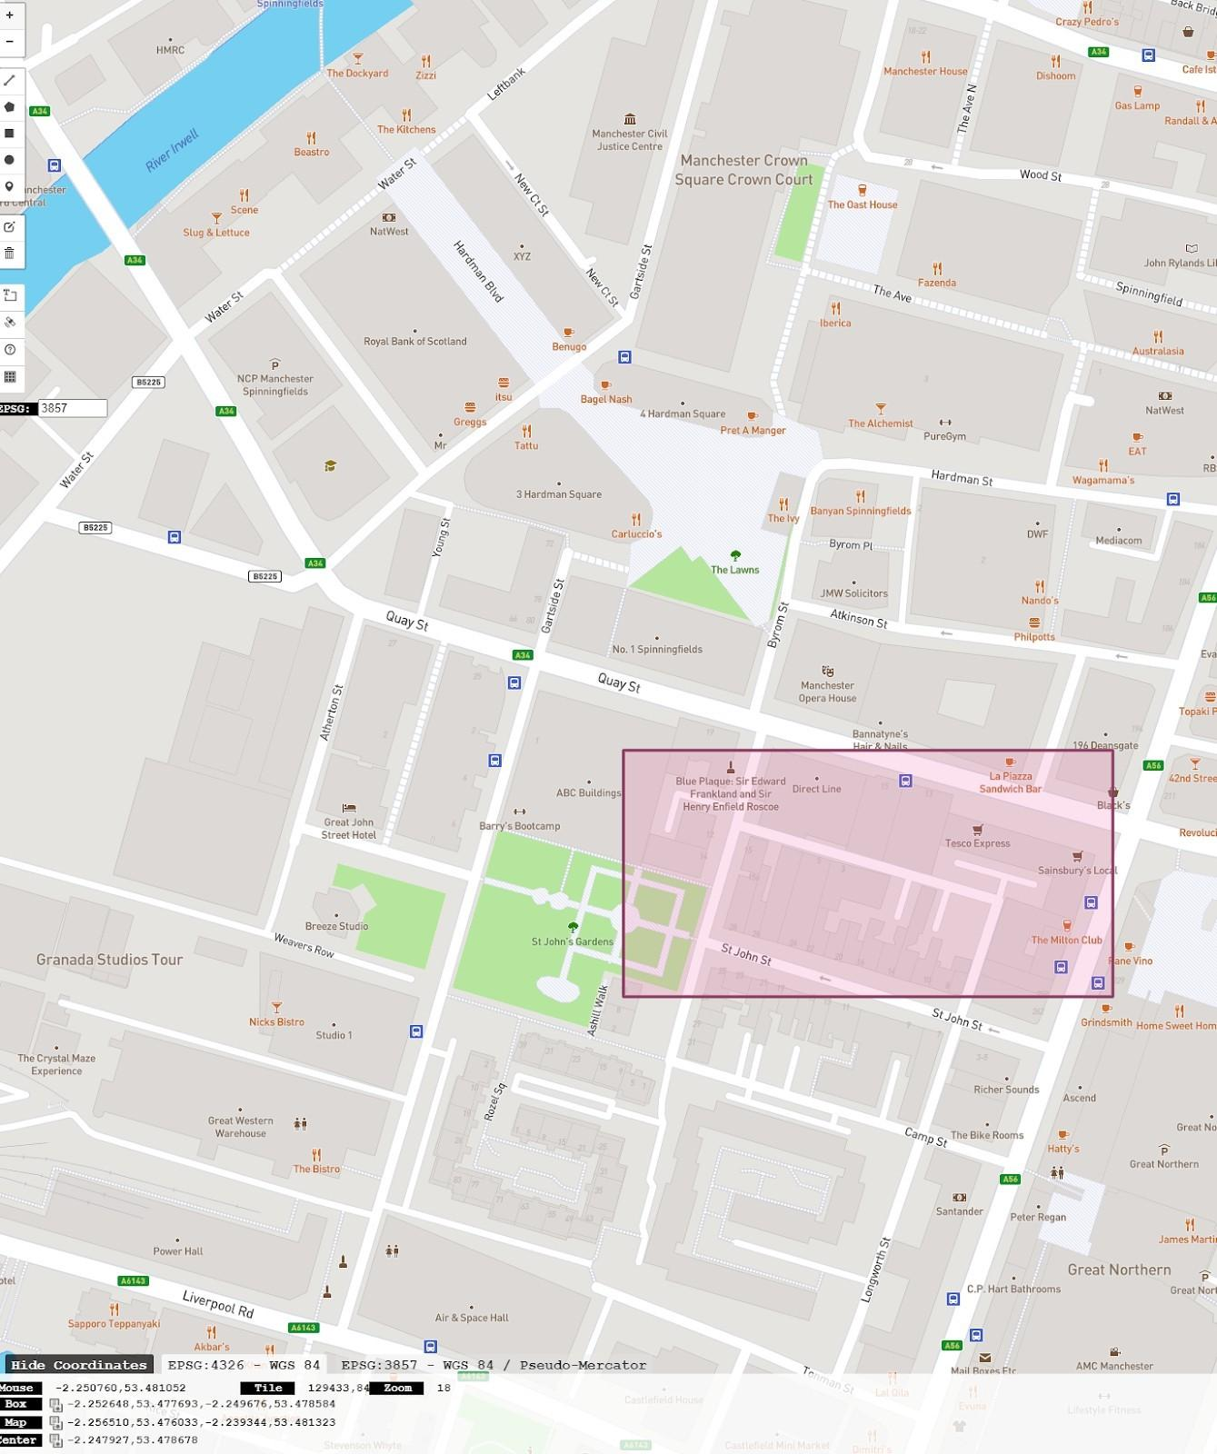

Figure 12.4.4: BBox ﬁnder tool being used in a location example to generate the latitude and longitude of the area to be searched using the TroubleHunter

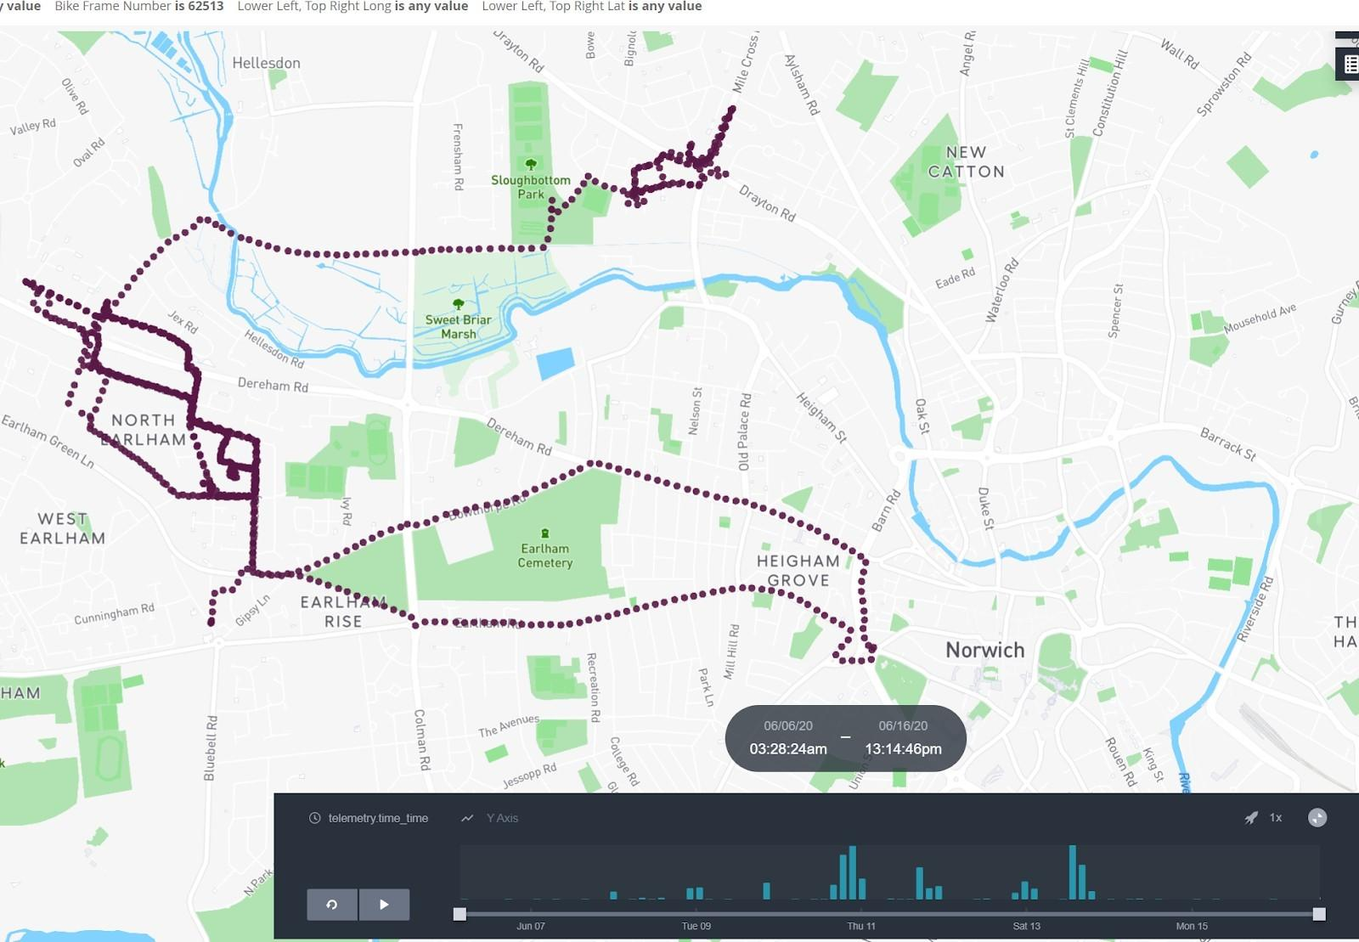
Figure 12.4.5: Image of the TroubleHunter tool used in an example

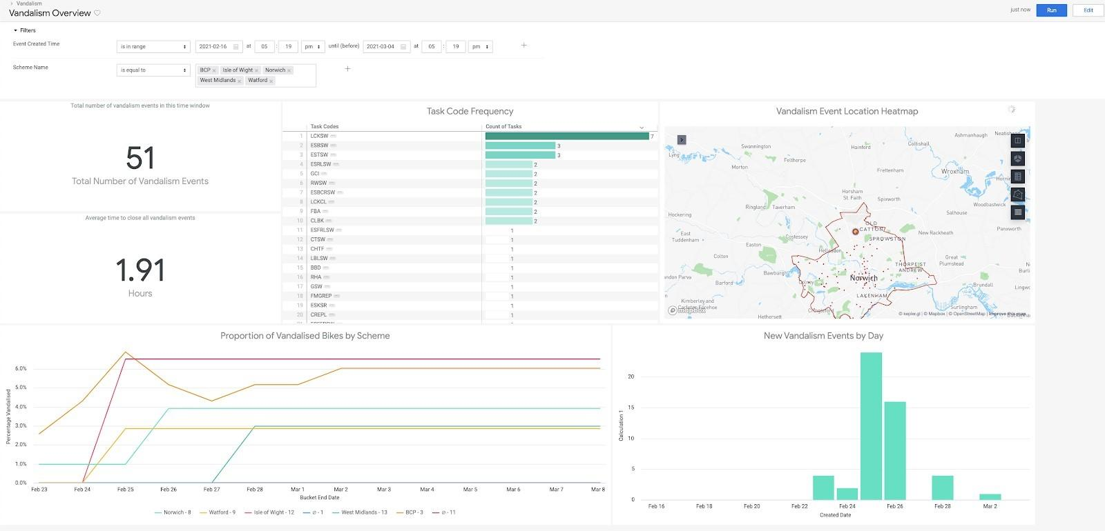
Figure 12.4.6: Vandalism Overview Dashboard

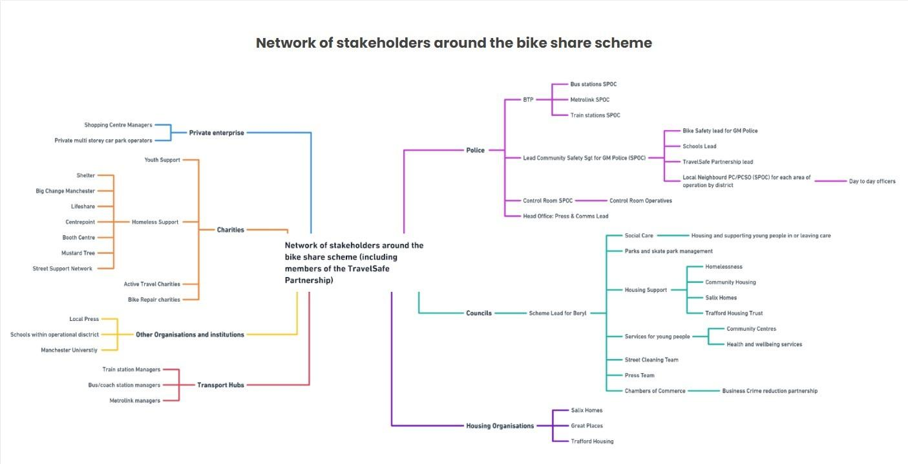
Figure 12.5.1. Network of stakeholders Map

229

