Main Staircase Proposal of Works

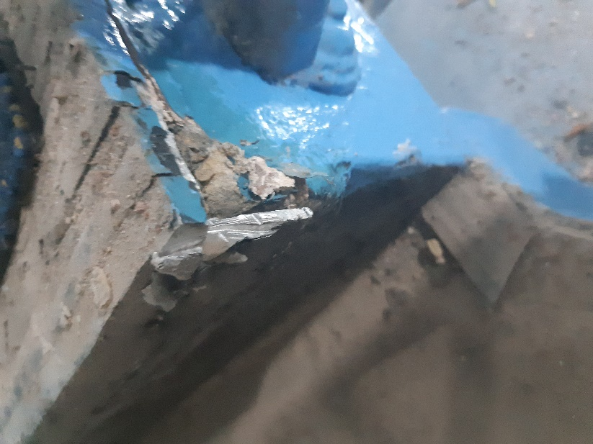
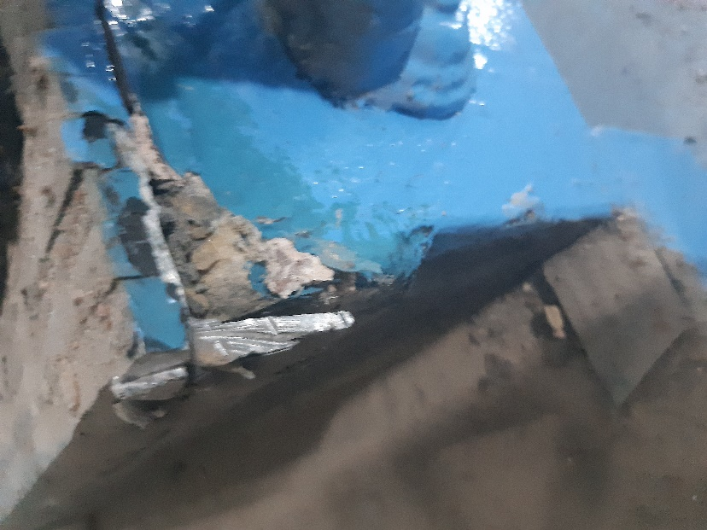
The original central staircase at Mosley Street has been overclad using timber and then finished with carpet and a feature nosing. As part of our investigation works, we explored the possibility of uncovering the original staircase from underneath timber cladding. The conclusion of these investigation works was that we would be unable to remove the timbers from the staircase without significant damage to the stone underneath. Due to this, we will be installing a vinyl flooring and a feature nosing as per the previously issued flooring installation method statement.

