140 A Kirkmanshulme Road, Longsight, Manchester, M12 4WB

Evidence
2.3 – Transport for Greater Manchester and Manchester City Council contracts.


3.3 – Martin Garlick, from VOSA, provided a maintenance assessment on the 27th July 2011, deeming all facilities and management of vehicles to be satisfactory.
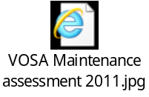

3.4 – Doofast Limited provided a letter to confirm they built two vehicle pits on site for the company director, in July 2011.


3.5 – 2011 Report from Robinson’s Transport Consultants, confirming changes and repairs to vehicles to deem them acceptable for TfGM.


3.6 – Report produced by Robinson’s Transport consultants: 26th August 2012 confirmed PMI records were found to be carried out at or before eight weeks.


3.7 – DVSA Maintenance assessment, 2016.
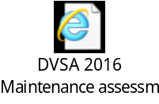

3.8 – A letter to client received from Robinson’s Transport Consultants Ltd confirms Managing Director has been providing operator’s licence compliance services and advice to M Travel Ltd since March 2009.


