Planning

Growth & Development

Delegated officer report for planning application

Application no. 136251/NMC/2023
Date registered valid: 3 March 2023
Proposal: Non-Material Amendment to planning permission 132580/FH/2021 to allow for changes to the front elevation
Address: 21 Rolls Crescent, Manchester, M15 5FT
Ward(s): Hulme Ward
Applicant: Helena Patasiova
Agent (if any):
Case officer: Tracie Simpson
Tel: 0161 234 4537
Email: tracie.simpson@manchester.gov.uk
Recommendation: Approve
Date of recommendation: 28th March 2023

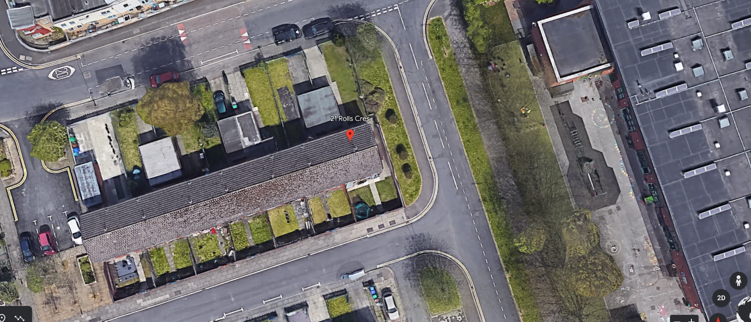

Application details

Type of application: Non-Material Change Application
Development type: Notifications
Date of site visit: Not required
Standard consultations: No consultations have been printed and sent.
Neighbour notifications No neighbour notifications have been printed and sent.
Site notice No site notice has been produced
Press advert No press advert had been published
Departure from Development Plan: No
Environmental Statement: Not required

Description of site/building

The site relates to a two storey end terraced property in the Hulme ward area of Manchester situated at the corner of Rolls Crescent and Shearsby Close. The properties along this row typically have single storey front garages with gardens to the front and rear and driveway.

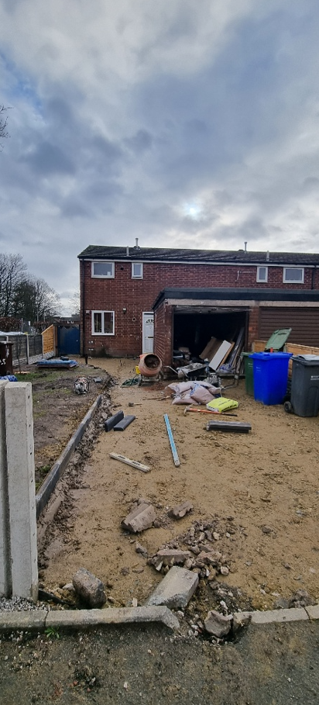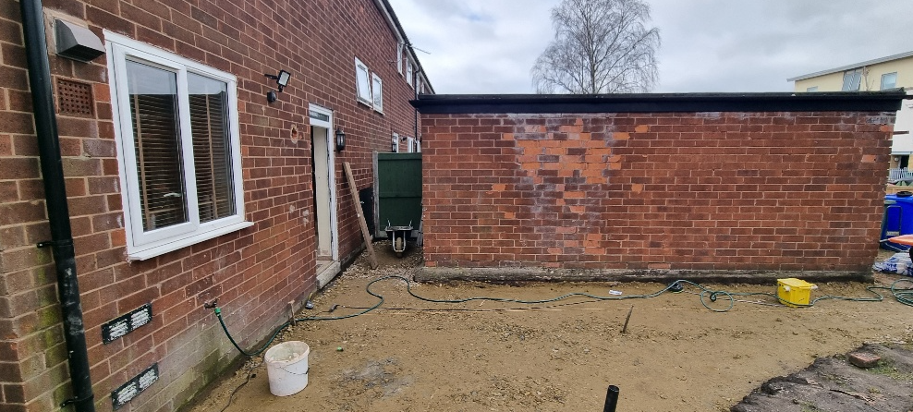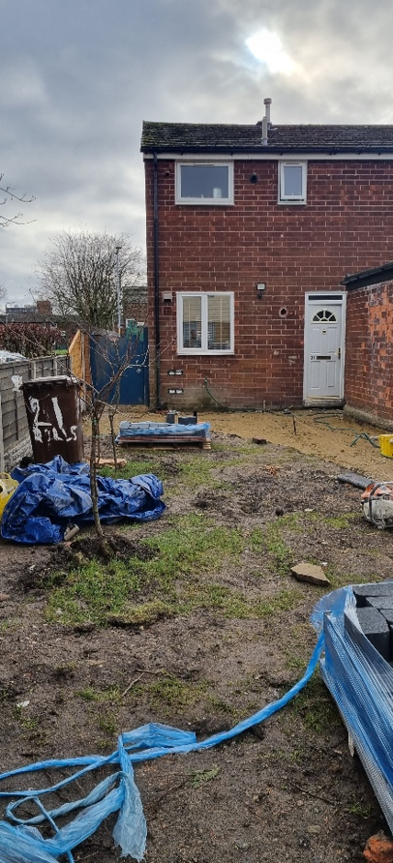

Listed building: Not applicable
Conservation area: Not applicable
Tree Preservation Order: Not applicable

Description of area

The area is predominantly residential in nature located within close proximity to Rolls Crescent Primary School.

Description of development

Non-Material Amendment to planning permission 132580/FH/2021 to allow for changes to the front elevation

Consultations & Notification Responses

Not required for this type of application

Policy and Issues

The following policies are considered relevant in the consideration of this application.

o Unitary Development Plan (UDP) - The UDP has been superseded by the Core Strategy Development Plan.
o Policy DC1 for Residential Extensions is still considered of relevance, in particular policy DC1.5 - The Council will consider on their merits exemptions to the above policies in the case of applications from disabled people who may require particular adaptations to their homes.
o The Manchester Core Strategy Development Plan Document 2012-2027 ("the Core Strategy") was adopted by the City Council on 11th July 2012.
o Policy DM 1 - Development Management
o Policy SP1 - Spatial Principles
o Policy EN1 - Design Principles
o Policy EN 19 - Waste Management
o The National Planning Policy Framework (NPPF)

For reasons to be outlined below, it is considered the proposal accords with the principles of this policy document.

History

Previous planning application relating to this site as follows:

132580/FH/2021 - Application Approved - 15.02.2022
21 Rolls Crescent, Manchester, M15 5FT
Erection of a single storey front extension together with the conversion of existing garage to form additional living accommodation

097556/FO/2011/S1 - Application Approved - 14.02.2012
BBC/Loreto Estate , Hulme, Manchester, M15 5EJ
Environmental improvements to the "BBC/Loreto" estate, consisting of improvements to the Rawkin Close open space (including the installation of a multi-use games area) and the green spaces at Elverdon Close and Culmington Close; improvements to existing boundary treatment and installation of new fencing and gates; creation of new landscaped areas

038830 - Application Approved - 06.06.1991
South Hulme (BBC) Estate,, bounded by, Rolls Crescent/Chichester, Road, Hulme HULME,
CITY COUNCIL DEVELOPMENT Environmental improvement works to City Council estate including new fencing, walls, gardens, car parking and lighting

Materiality

Section 96A of the 1990 Act (as inserted on 1st October 2009 by sec.190 of the Planning Act 2008) allows a local planning authority in England to make a change to any planning permission relating to land in its area if it is satisfied that the change is not material. In deciding whether a change is material, the authority must have regard to the effect of the change, together with any previous non-material changes, on the planning permission as originally granted.

The application relates to an approval for the non-material changes to planning permission 132580/FH/2021 to allow for changes to the front elevation. The proposed changes are relatively minor and are considered appropriate for its residential context, this is considered that any harm as the result of the proposal to be less that substantial.

Overall, it is considered that the proposed revisions are of a minor nature and would have no more impact upon either visual or residential amenity than the approved scheme. The amendments would accord with policies SP1 and DM1 of the Core Strategy and the National Planning Policy Framework (NPPF) and saved policy DC1 of the UDP

Other Legislative Requirements

Equality Act 2010
Section 149 (Public Sector Equality Duty) of the Equality Act 2010 requires due regard to the need to: Eliminate unlawful discrimination, harassment and victimisation and other conduct prohibited by the Act and; Advance equality of opportunity between persons who share a protected characteristic and persons who do not share it. The Equality Duty does not impose a legal requirement to conduct an Equality Impact Assessment. Compliance with the Equality Duty involves consciously thinking about the aims of the Equality Duty as part of the process of decision-making.

Human Rights Act 1998 considerations
This application needs to be considered against the provisions of the Human Rights Act 1998. Under Article 6, the applicants (and those third parties, including local residents, who have made representations) have a right to a fair hearing and to this end the local planning authority must give full consideration to their comments.

Protocol 1 Article 1, and Article 8 where appropriate, confer(s) a right of respect for a person’s home, other land and business assets. In taking account of all material considerations, including Council policy as set out in the Core Strategy and saved polices of the Unitary Development Plan, the Director of Planning, Building Control & Licensing has concluded that some rights conferred by these articles on the applicant(s)/objector(s)/resident(s) and other occupiers and owners of nearby land that might be affected may be interfered with but that that interference is in accordance with the law and justified by being in the public interest and on the basis of the planning merits of the development proposal. She believes that any restriction on these rights posed by the recommendation given is proportionate to the wider benefits of and that such a decision falls within the margin of discretion afforded to the Council under the Town and Country Planning Acts.

Recommendation: Approve

Article 35 Declaration

Condition(s) to be attached to decision for approval OR Reasons for recommendation to refuse

1) The proposed amendment relates to allow for changes to the front elevation

2) Following an assessment of the details submitted, the Council can confirm that the proposed amendments are considered to be of a non-material nature and acceptable to the City Council as the Local Planning Authority. The City Council is satisfied that the proposed changes will have no significant material impact upon the appearance of the development and it is also considered that the proposals would not have any impact on the amenity of residential properties or on the visual amenity of the wider area.

3) The development hereby approved shall be carried out in accordance with the following drawings and documents:

Received on 6th February 2023 numbered 04 Rev A Proposed Floor Plans
Received on 6th February 2023 numbered 06 Rev A Proposed Roof Plan
Received on 6th February 2023 numbered 09 Rev A Proposed Elevations
Received on 6th February 2023 numbered 10 Rev A Proposed Elevations

Reason - To ensure that the development is carried out in accordance with the approved plans. Pursuant to policies SP1 and DM1 of the Core Strategy.

Appendix 1 – List of consultees & neighbours notified

Appendix 2 – Planning constraints

Article 4 Direction - Removal Of PD Rights Change Of Use From Class C3 To Class C4
Aircraft Safeguarding Zone - Aircraft Safeguarding Zone - All Exceeding 90M
Coal Authority - Development Low Risk - Name: DEVELOPMENT_LOW_RISK_AREA
Susceptible to Surf Water Flood (Less) -
Area Team Boundary - Name: SOUTH AREA

