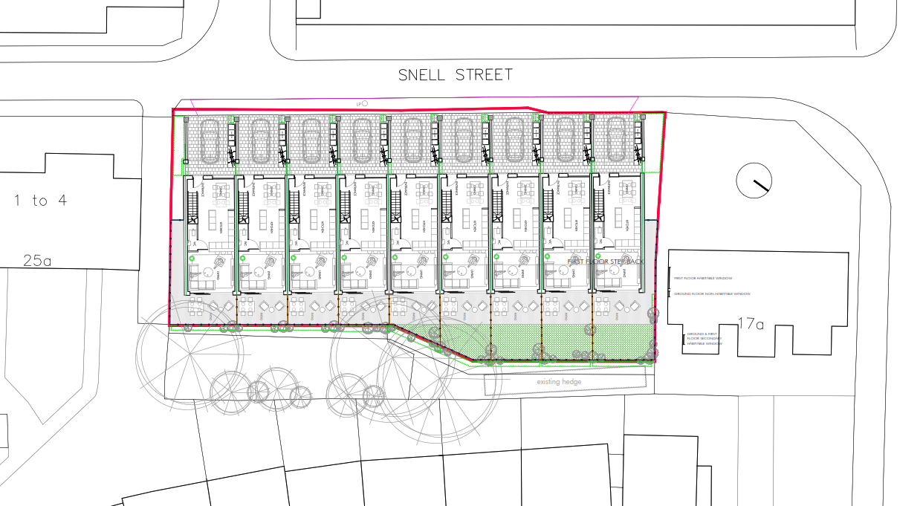

LOCAL BENEFITS PROPOSAL

9 NO. TOWN HOUSES SNELL STREET- LOCAL LABOUR PROPOSAL

The Snell Street Project provides an exciting opportunity to deliver employment and training benefits to the local community.

We are committed to:

• Identifying and promoting accessible, entry level opportunities for local people
• Targeting local businesses for subcontract or material supply opportunities where appropriate
• Targeting 40% locally employed businesses within 40 mile radius
• Notifying Manchester City Council of all vacancies
• Listening and understanding the local community and business needs
• Providing training to support a qualified, skilled, competent and motivated workforce to deliver the contract.
• Liaising with local employment schemes and education providers to maximise legacy.

We will develop an Employment and Skills Plan that will detail our labour requirements to meet any Employer’s Requirements. The plan will provide our ‘Ways into Work’; providing a clear strategy for job roles to be filled from within the local community.

The plan will identify:

Measures proposed to recruit local people.

Local office: Colbre Have been operating in around Manchester from its inception in 1999. All Colbre Projects staff engaged in the delivery of the scheme are either based within our Haslingden office which is located in Deardengate, Haslingden less than 20 miles from site or live within the Manchester area within a 10-mile radius of the site.

New positions: We will ensure that all /any new positions are advertised through local employment stakeholders, such as Job Centre Plus and other Social Enterprises. With the aim of ensuring that young people in the local area, particularly those not already in education, training or employment, have direct access to available positions. We will also liaise with our supply chain companies to advertise their vacancies through these channels.

Due to our Group structure, other than the management team, we do not directly employ staff and operatives, and therefore, look to optimise time on site by using local labour, subcontractors and local material stockist. Specifically, we will develop an Employment & Skills Plan for the project that will detail our labour requirements. The plan will provide a clear strategy by identifying the following:

• Work placement opportunities
• Local school and college visits
• Adult improver/graduates
• Local employment requirements
• NVQ course requirements for site personnel
• On-site training for subcontractor employees
• Advertise all new positions via the council or their preferred job brokerage scheme
• Leadership and management training courses for site personnel
Local supply chain: Whilst we will employ labour to deliver components through our off-site construction methodology, for significant processes of this scheme we will use a traditional build approach. This will include the majority of the internal fit-out and façade trades allowing the consideration of using local labour. Where we employ subcontract partners to build out the project we will aim to maximise the use of the North West supply chain companies using locally sourced material suppliers and local labour where practicable, supported by the use of Barbour ABI.

Apprenticeships: We will discuss with all suppliers the potential for the appointment of new apprentices or other training opportunities arising from this scheme.

Mechanisms for the implementation and delivery of the Local Labour Proposal

Systems: Our Approved Supplier Database is regularly updated to ensure we identify and implement an effective local supply chain that considers geography, local knowledge, capability and availability of resources as work packages become active, this is supported by using Barbour ABI services in the selection of opportunities. As part of the approval process, we will ensure that wherever possible, preferred subcontractors secure products and materials from within the local area which is monitored and reported on as part of our sustainability commitments.

Processes: We follow our Internal Supply Chain selection and management procedures, utilising the Barbour ABI service and our internal selection questionnaires. Prior to project commencement, suppliers must demonstrate minimum levels of mandatory training and competence.

Resources: Our Rossendale based Project Quantity Surveyor operating from our Haslingden office and then site, will select and manage our integrated supply chain in accordance with the above systems and processes, supported by the Project Manager and our wider project team.

Measures to monitor and review the effectiveness of the Local labour proposal in achieving the objective of recruiting and supporting local labour objectives.

We will record the effectiveness of our proposed local people recruitment measures in alignment with Manchester City Councils Tiers as follows:

• Tier 1: City Centre, East Manchester and North Manchester- Hulme, Ardwick, Deansgate, Piccadilly, Ancoats & Beswick, Cheetham, Crumpsall, Harpurhey, Higher Blackley, Charlestown, Moston, Miles Platting and Newton Heath, Clayton and Openshaw, Longsight, Rusholme and Levenshulme.
• Tier 2: Greater Manchester Authorities
• Tier 3: North West

The metrics we propose to record are shown below:

Trade | Subcontract Package Value | Postcode | Subcontractor  Located  Tier Tier Tier |  |  | Values %  Tier 1 Tier 2 Tier 3
Trade | Subcontract Package Value | Postcode | 1111 | 2 | 3 | L P M |  |  | L P M |  |  | L P M
Total
Subcontract
Value

Our Project Manager will have overall responsibility for the implementation of our Employment and Skills Plan.

Due to our Group structure, and as we operate on a Management type basis we do not have exposure to increase direct Employment opportunities, other than the selection of using a Local labour Agency and Material partners.

Our Employment and Skills opportunities will be discussed with the Local Authority or their preferred job brokerage scheme to ensure our team and the scheme benefits from their expertise.

• Job Starts (unemployed or economically inactive)
• Adult Improver / Graduate
• Work Experience
• Work Placements
• Curriculum Support Activities
• Traineeships (age 18 - 24) Minimum 6 weeks
• Reporting and Monitoring
• Supply Chain Compliance

Benefit to the Local Community |  | Colbre Project commitment
Paying above Northern Living Wage |  | √
Targeting local businesses for subcontract  or material supply opportunities |  | √
Liaising with local employment schemes  and education providers to maximise legacy |  | √
NVQ course requirements for site  Personnel where applicable |  | √
On-site training for subcontractor  employees |  | √
Advertise all new positions via the council  or their preferred job brokerage scheme |  | √
Work experience/placements |  | √
Curriculum support activity |  | √
Local school and college visits to site/at  school |  | √

Benefit to the Local Community |  | Colbre Commitment
Employment and skills events |  | √
Apprenticeship existing |  | 0
Job starts |  | 40%  ocal
Graduates |  | 0

`

