Introduction

As part of the Crown St development, a previous application to discharge condition 121 was made (CDN/23/0218). This application was rejected on the basis that the air quality report refers to 10% EVC’s where MCC have stated that this is insufficient and 20% should be provided (see extract below).

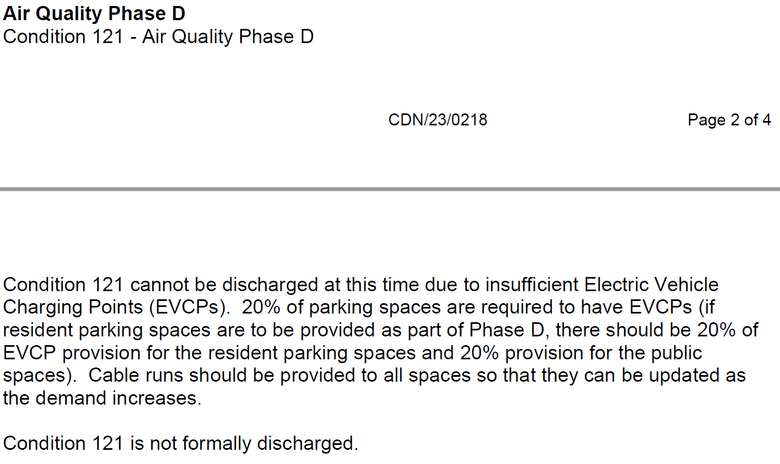

Number of EVC’s in planning documents and approval

It should be noted that Condition 130 for this development is related specifically to EVC’s and states that we need to provide the quantities set out in the drawings and documents. See wording of Condition 130 below.

“The electric vehicle charging (EVC) infrastructure (including appropriate cable provision and provision for charging points) set out in the drawings and documents hereby approved shall be put in place before the car park use within Phase D commences and shall be retained thereafter.”

The document submitted at planning stage that referred to EVC’s, was the Design and Access statement. Below is an extract from the Design and Access Statement which states that we should provide 10% EVC’s.

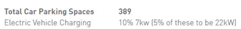

Correspondence after Decision Notice

This fact was later checked with the planning officer and the following response was received.

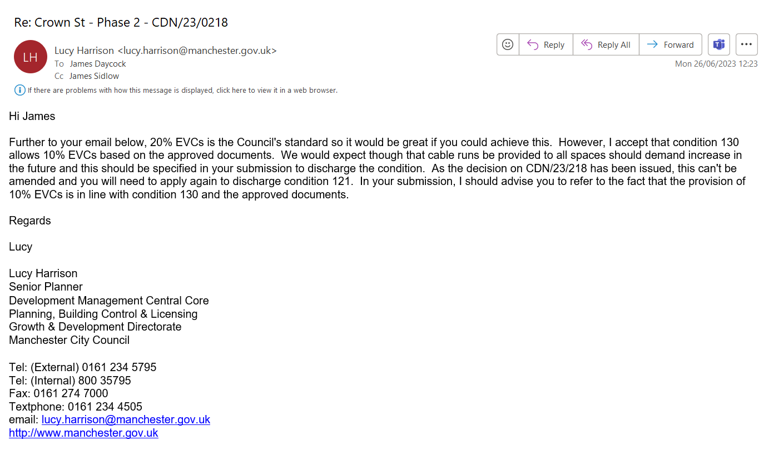

Following receipt of the above e-mail, the application to discharge Condition 121 is being re-submitted with the same Air Quality Report and accompanied by this note.

