ANTONY RATCLIFF, Dip.Arch. R.I.B.A.
Cestria Partnership Limited,
Chartered Architects.

5 SPATH LANE, HANDFORTH, WILMSLOW,
CHESHIRE, SK9 3QN. [Registered Office]

Telephone: 01625 529594
Mobile Telephone; 07954 132168
Email; cestriarch@gmail.com

DESIGN AND ACCESS STATEMENT IN RESPECT OF No. 31 PATCH CROFT ROAD, WYTHENSHAW ON BEHALF OF Mr. L. SYLANSKAS

CLIENT’S BRIEF:

It is required to enlarge the house to conform to the current standards for a growing family with home working and study needs. To this end the building should comprise four bedrooms with appropriate sanitary provision and car parking facilities for three vehicles.

Free flowing, open plan areas should characterise the ground floor living dining areas.

DESIGN:

The existing vehicular access is retained as being currently adequate for three cars while the unused detached garage can be easily converted to a Garden Room or Garden Store.

To accommodate the terms of the client’s brief, the building will need to be extended at both ground and first floor levels. This is best achieved at ground and first floor along the East side, as the neighbouring house, number 33 has a vehicle access pathway beyond the joint boundary allowing for the general street scene to be maintained. The extended kitchen and dining facilities can then be accommodated across the rear garden elevation within a single storey extension. To allow maximum daylight penetration into the extended ground floor, the new dining area will be extensively glazed and have a substantial lantern light set into the roof.

The main roof form, window and door details and all external materials match the existing.

The western side of the house will be predominantly utilitarian, comprising an expanded entrance facility – originally extremely cramped – cloakroom, utility room and kitchen store.

ACCESS:

The principle front access remains unchanged other than being augmented by an appropriately graded access ramp and wall mounted safety handle. Internally, the open plan ground floor and spacious toilet facility optimises the convenience of wheelchair users. Access into the back garden via the spacious bifold doors will be likewise served by a wheelchair friendly ramp and safety handles.

The internal staircase will be suitable for a stairlift should one be required

_________________________________________________________________________

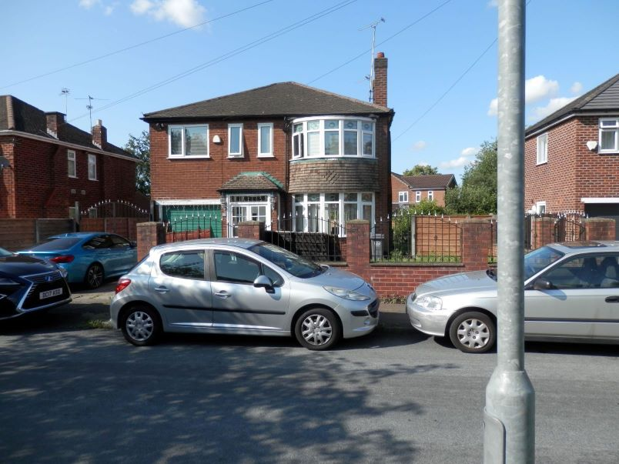 Street View No. 31

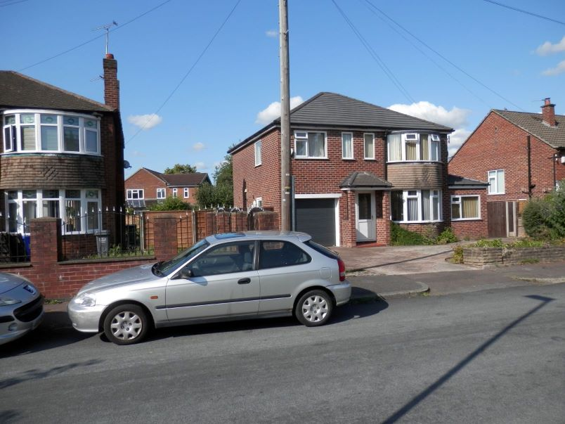Street View No.33

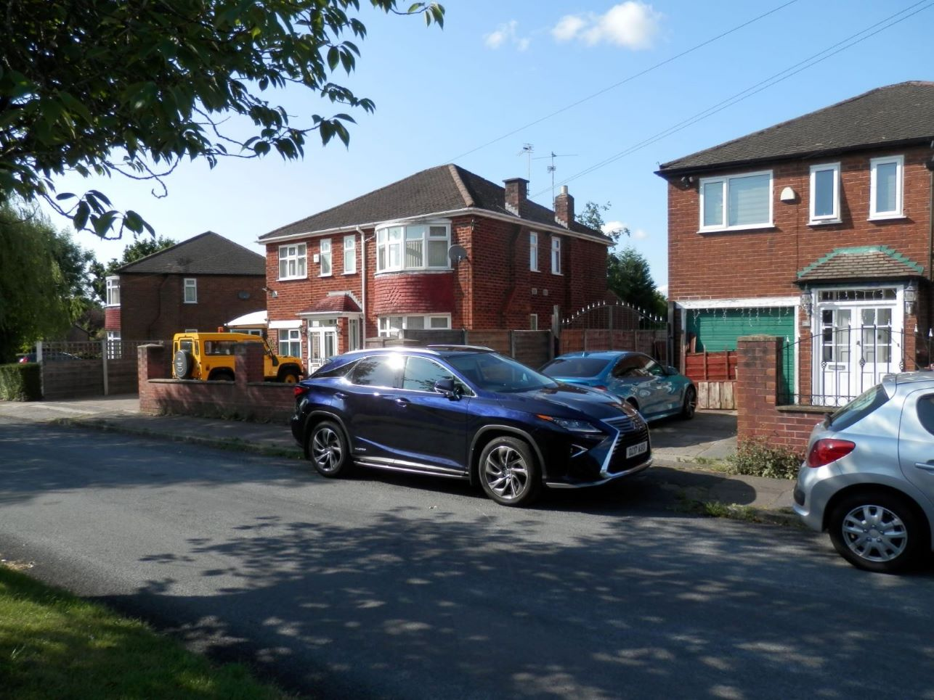 Street View No. 29

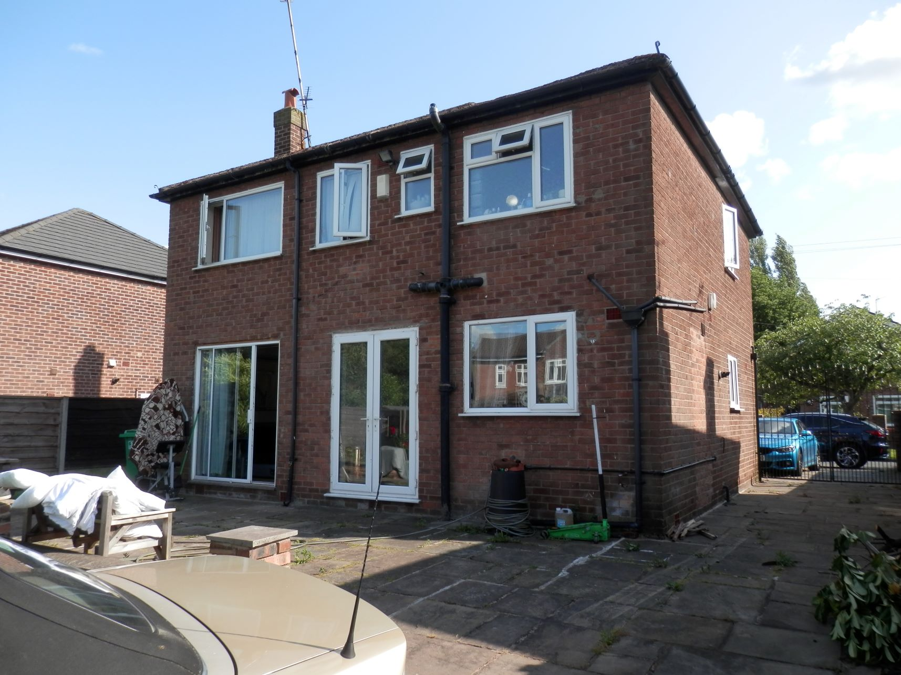 Rear View No.31

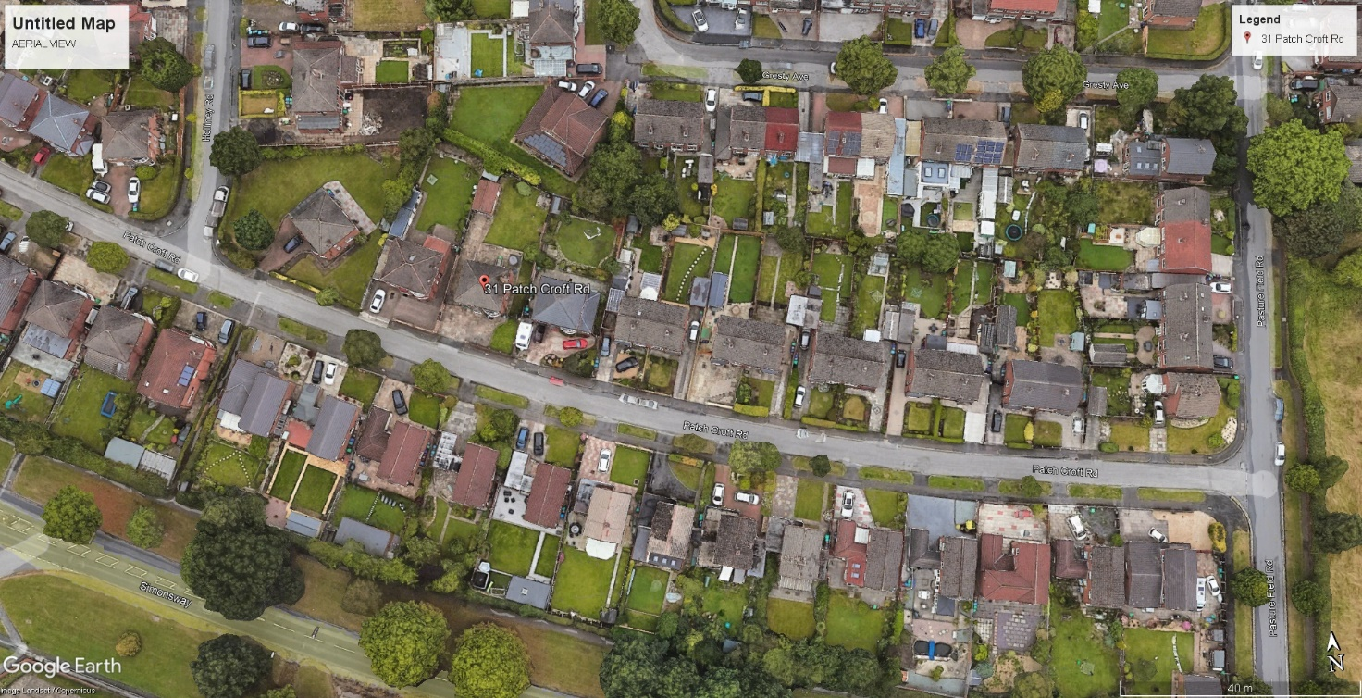 Aerial view, Patch Croft Road

